MONTREAL PROTOCOL ON SUBSTANCES THAT DEPLETE THE
OZONE LAYER

Report of the Scientific Assessment Panel

September 2025

Response to Decision XXXVI/3: Emissions of HFC-23

September 2025
Report of the Scientific Assessment Panel in response to Decision XXXVI/3: Emissions of HFC-23
Lead Authors:

S. A. Montzka, NOAA Global Monitoring Laboratory, USA;
J. B. Burkholder, NOAA Chemical Sciences Laboratory, USA

Authors:

Co-Chairs of the Montreal Protocol Scientific Assessment Panel:
L. J. Carpenter, University of York, UK;
D. W. Fahey, NOAA Chemical Sciences Laboratory, USA;
K. W. Jucks, NASA Earth Science Program, USA;
B. Safari, University of Rwanda, Rwanda

Contributors:

Campbell, N., United Kingdom
Manning, A., UK Met Office, United Kingdom
Reimann, S., Swiss Federal Laboratories for Materials Science and Technology, Switzerland
Western, L., Massachusetts Institute of Technology, USA
Members of the Advanced Global Atmospheric Gases Experiment (AGAGE) Global Network
ISBN: 978-9914-733-72-3
Table of Contents:

Executive Summary: 1
1 Introduction 5
2 Updated results on the global scale 7
2.1 Global scale HFC-23 concentrations and emissions derived from atmospheric data 7
2.2 Reported production of HCFC-22 9
2.3 On the global emission gap 9
3 Regional contributions to HFC-23 emissions 15
4 Photo-chemical production of HFC-23 in the atmosphere 19
4.1 Knowledge gaps related to atmospheric production of HFC-23 20
5 References 23

Executive Summary:
This Supplemental Report serves as an update to the Report of the Scientific Assessment Panel in response to Decision XXXV/7: Emissions of HFC-23 that was submitted to and posted by the United Nations Environment Programme Ozone Secretariat in September 2024 (Montzka et al., 2024, hereafter referred to as SAP, 2024). In that report, emissions estimates for HFC-23 were derived from atmospheric observations through 2022. In this Supplemental Report, emissions estimates are updated with atmospheric observations through 2023. The fundamental conclusions in this report remain unchanged based on the additional year of measurements, derived emissions, and updates to reported quantities and quantities derived from reporting that have become available for 2023.
During 2023 the global mean atmospheric abundance of hydrofluorocarbon-23 (HFC-23; CHF₃) continued to increase. The measured global mean abundance in 2023 was 36.8 ± 0.9 ppt, which was 0.97 ± 0.04 ppt greater than the 35.9 ± 0.9 ppt measured in 2022. This annual increase was slightly less than the mean change observed from 2015 to 2023 of 1.10 ± 0.13 ppt yr⁻¹.
Global HFC-23 emissions in 2023 derived from measured atmospheric abundances totaled 14.2 ± 0.7 kt yr⁻¹ and were 2.7 ± 0.9 (16 ± 6%) lower than peak emissions derived for 2018-2019 of 16.9 ± 0.7 kt yr⁻¹. Emissions in 2023 were similar to emissions in 2022 (14.4 ± 0.6 kt yr⁻¹). The small change in emissions from 2022 to 2023 contrasts with the larger annual decline during 2019 to 2022 that averaged 0.8 kt yr⁻¹. Reported HCFC-22 production for all uses, which remains the largest known source of HFC-23 by-product, was 1.9% smaller in 2023 compared to 2022 (1197 kt in 2022 and 1175 kt in 2023).
New scientific results confirm that HFC-23 is produced in oxidation reactions of some fluorinated gases present in the atmosphere. This HFC-23 source is estimated to be less than 0.22 kt yr⁻¹ in 2023. This revised value is smaller than estimated previously (SAP, 2024) and remains an upper limit, meaning that the actual value is likely smaller.
The difference or gap between global emissions derived from atmospheric measurements and those reported or estimated from information provided to the United Nations Framework Convention on Climate Change (UNFCCC), the Multilateral Fund for the Implementation of the Montreal Protocol (MLF), and the Ozone Secretariat persisted in 2023 and remains substantial.
With the small changes from 2022 to 2023 in emissions derived from global atmospheric abundance changes and available reported emissions, the gap in our understanding of HFC-23 emissions in 2023 of 11.4 – 12.8 kt yr⁻¹ is similar to the gap estimated for 2022 in the previous HFC-23 report (SAP, 2024) of 10.5 – 12.5 kt yr⁻¹.
The gap between reported HFC-23 emissions and those inferred from atmospheric abundances is not reconciled by considering all known sources beyond HCFC-22 production. An updated assessment by the Technology and Economic Assessment Panel (TEAP) (TEAP, 2025) estimates HFC-23 emissions from all known sources and reported abatements after 2020 to be in the range of 1.6 – 3.7 kt yr⁻¹, which is substantially smaller than the atmospherically-derived emission of 14.2 ± 0.7 kt yr⁻¹ during 2023. Adding production from the atmospheric oxidation of fluorinated industrial gases to TEAP’s updated estimates results in an emissions gap in 2023 of 9.6 – 13.3 kt yr⁻¹.

The increasing emission gaps between 2015 and 2018 coincide with increases in reported abatement of HFC-23 from a limited number of A5 countries. After 2019, the emission gap decreased from a high of 15 kt yr⁻¹ to 11 – 12.5 kt yr⁻¹ in 2023; reported abatements from all countries increased during these years to a value of 23 kt yr⁻¹ in 2023.

The decrease in emission gaps after 2019 was concurrent with a declining ratio of emissions derived from global observations relative to reported total HCFC-22 production (E₂₃/P₂₂). The E₂₃/P₂₂ ratio in 2023 of 1.1% is unchanged from 2022.

The declines in the emission gaps and E₂₃/P₂₂ values after 2019 are consistent with an increase in overall abatement of HFC-23 emissions, improved optimization of HCFC-22 production to further minimize HFC-23 by-product generation and associated emission, or reduced emissions of HFC-23 from sources that are unknown or not accurately accounted for.
Our understanding of regional contributions to global HFC-23 emissions remains incomplete. The sum of all available observationally derived regional emission estimates accounted for only 6.1 ± 0.7 kt yr⁻¹ of HFC-23 in 2023, or 43 ± 10 % of global emissions in that year. These estimates include emissions for a number of countries or portions of countries that have been updated through 2023 based on continued atmospheric measurements. HFC-23 emission estimates from a significant number of regions remain unavailable because of gaps in atmospheric monitoring.
From continued measurements made at the Gosan Station in the Republic of Korea: HFC-23 emissions in 2023 were estimated to be 5.6 ± 0.7 kt yr⁻¹ from the eastern portion of China; 0.23 ± 0.02 kt yr⁻¹ from the Republic of Korea (ROK); 0.10 ± 0.07 kt yr⁻¹ from the western portion of Japan; and 0.01 ± 0.01 kt yr⁻¹ from the Democratic People's Republic of Korea (DPRK).

HFC-23 emissions from eastern China in all years after 2019 were smaller than the peak value derived for 2019 of 8.0 ± 0.4 kt yr⁻¹. Emissions from eastern China in 2023 were 4.7 ± 0.7 kt greater than the 0.9 kt reported to the Ozone Secretariat for all of China in that year, and this emission accounts for 40 ± 10% of the global emission gap in 2023. The sum of emissions for the ROK, western Japan, and the DPRK were notably smaller in 2023 than they were during 2018-2022 and remained greater than reported to the Ozone Secretariat or UNFCCC in recent years, by approximately 0.3 ± 0.07 kt, accounting for 1.5 to 3% of the global emission gap.
From continued atmospheric measurements at a network of sites in Europe: HFC-23 emissions in 2023 were estimated to be 0.15 ± 0.04 kt yr⁻¹ from the sum of countries in the north-western Europe including Ireland, the United Kingdom (UK), France, the Netherlands, Belgium, Luxembourg, and Germany. This emission was 0.13 ± 0.04 kt greater than reporting to the UNFCCC in 2022 (latest available year), and this region accounts for 0.7 to 1.5% of the global emission gap.
From continued atmospheric measurements made at the Cape Grim Baseline Air Pollution Station in southern Australia, HFC-23 emissions in 2023 from Australia were estimated to be 0.025 kt yr⁻¹ (no uncertainty specified), which is 0.03 kt yr⁻¹ less than reported to the UNFCCC in that year.
The countries or portions of countries for which regional emissions in 2023 have been estimated, i.e., China, the ROK., the DPRK, Japan, the European Union and the UK, accounted for the majority (93%) of reported generation of HFC-23 in that year. For the countries that accounted for the remaining HFC-23 generation reported to the Ozone Secretariat during 2023 (Argentina, India, Mexico, the Russian Federation, and the United States of America (USA)), atmospherically derived HFC-23 emission estimates remain unavailable in the Kigali era (i.e., after 2019).

1 Introduction
For nearly a decade, global emissions of the fluorocarbon HFC-23 (CHF₃) have been substantially larger than expected (Simmonds et al., 2018; Stanley et al., 2020; Liang and Rigby et al., 2022; SAP, 2024). These unattributed emissions have persisted despite controls on production, consumption, and emission of HFC-23 enacted in line with the 2016 Kigali Amendment to the Montreal Protocol, national regulations, and other commitments. The Kigali Amendment brought controls on HFC-23 into the framework of mechanisms and obligations for reporting, ensuring compliance, outlining consequences in cases of non-compliance, etc., that already applied to other Montreal-Protocol-controlled substances (e.g., chlorofluorocarbons (CFCs), hydrochlorofluorocarbons (HCFCs), halons, etc.). In the case of HFCs, production and consumption for dispersive uses are to be phased down on multiple schedules, depending on the country. The controls specified in the Kigali Amendment apply beginning in 2019 or upon ratification, or in some instances, after ratification.
In the case of HFC-23, additional controls apply that are intended to reduce emissions of HFC-23 arising from the production of controlled HCFCs and HFCs, particularly HCFC-22, the largest known source of HFC-23 by-product (TEAP, 2025). Controls on by-product emissions of HFC-23 are not subject to country-specific phase-down schedules but instead came into force on 1 January 2020 or upon ratification, whichever occurred later. By the end of 2023, the period of interest in this updated analysis, all countries reporting production of HCFC-22 and associated generation of HFC-23 had ratified the Kigali Amendment and, as a result, had been operating under a commitment to destroy “to the extent practicable” by-product-related emissions of HFC-23 for over a year.
The gap between observed and expected HFC-23 emissions has gained attention from the parties in recent years, with decisions taken at several Meetings of the Parties in an effort to clarify the reasons for the greater than expected and persistent emissions.
A decision taken at the Thirty-Fifth Meeting of Parties of the Montreal Protocol on Substances that Deplete the Ozone Layer in the fall of 2023 asked for a Supplemental report from the Scientific Assessment Panel on the issue. In September of 2024, this report (SAP, 2024) was provided to the Parties.
In the thirty-Sixth Meeting of Parties of the Montreal Protocol on Substances that Deplete the Ozone Layer in the fall of 2024, another decision, XXVI/3, was agreed to that included a request for the Scientific Assessment Panel to prepare an update to their 2024 report on HFC-23 and present it at the Thirty-Seventh Meeting of the parties in November 2025:
To request the Scientific Assessment Panel and the Technology and Economic Assessment Panel to update decision XXXV/7 reports on HFC-23 to reflect any additional or new information that becomes available, and to submit their reports on the matter to the Thirty-Seventh Meeting of the Parties
The following 2025 report updates information and conclusions of the September 2024 Report of the Scientific Assessment Panel in Response to Decision XXXV/7: HFC-23 (hereafter referred to as SAP, 2024). This update is based on information made public and scientific studies published in the peer-reviewed literature since the SAP (2024) report was completed, specifically:
- New peer-reviewed atmospheric measurement studies related to HFC-23
- New peer-reviewed laboratory studies that refine our understanding of the production of HFC-23 during the atmospheric oxidation of fluorinated chemicals
- An updated report by the Technology and Economic Assessment Panel (TEAP, 2025)
- Updated reporting by countries to the Ozone Secretariat on the production, generation, and emission of halocarbons including HFC-23
The authors acknowledge the important assistance and input from a number of additional people in preparing this report: a representative from the Multilateral Fund for the Implementation of the Montreal Protocol; members of the Technology and Economic Assessment Panel, B. Adam, and a representative from the Ozone Secretariat for prompt and informative sharing of updated quantities associated with data reporting in response to Article 7 of the Montreal Protocol (hereafter called “A7 reporting”).

2 Updated results on the global scale

2.1 Global scale HFC-23 concentrations and emissions derived from atmospheric data
Updated abundance measurements of HFC-23 in the remote atmosphere provided by the Advanced Global Atmospheric Gases Experiment (AGAGE) show a continued increase through 2023 (Figure 1; Adam et al., 2024; Prinn et al., 2018; and Park et al., 2023). The global surface mean concentration in 2023 reached 36.8 ± 0.9 ppt, which was 0.97 ± 0.04 ppt greater than the 35.9 ± 0.9 ppt annual mean measured in 2022. The global mean of HFC-23 accounts for 7.1 mW m⁻² of direct radiative forcing to Earth’s atmosphere in 2023.
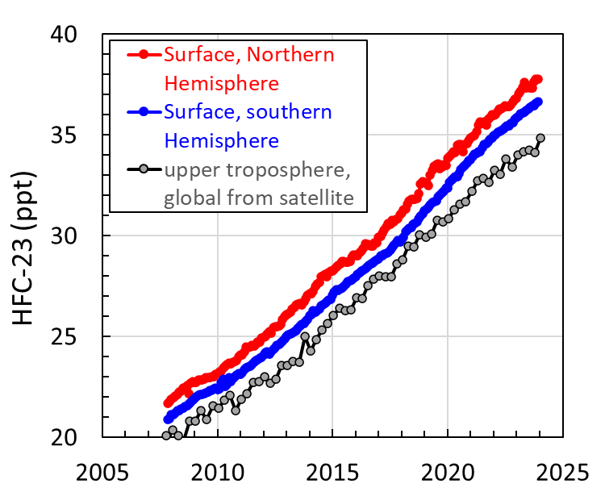
Figure 1: Atmospheric abundance of HFC-23 over time. Monthly hemispheric surface means in parts per trillion (ppt) are estimated from measurements at remote sites by AGAGE (red = northern hemisphere; blue = southern hemisphere; Adam et al., 2024; Prinn et al., 2018 and Park et al., 2023), and for the upper atmosphere via a spectrometer onboard the SCISAT satellite (the Atmospheric Chemistry Experiment-Fourier transform spectrometer (Dodangodage et al., 2025)).
While surface concentrations of HFC-23 have increased throughout the entire measurement record, the 0.97 ± 0.04 ppt increase from 2022 to 2023 was slightly less than annual changes measured from 2015 to 2023, which averaged 1.10 ± 0.13 ppt yr⁻¹. Concurrent with this slower increase in global mean concentration, the hemispheric difference also decreased from a peak in 2019 of 1.40 ppt to 1.13 ppt in 2023 (Figure 2).
The satellite SCISAT includes the Atmospheric Chemistry Experiment Fourier Transform Spectrometer (ACE-FTS), which has provided estimates of HFC-23 concentrations in the atmosphere from 2004 through 2023. Results from the ACE-FTS instrument have been updated and improved recently (version 6; Dodangodage et al., 2025). Annual changes retrieved by the ACE-FTS instrument averaged over the atmospheric box bounded by ~9.5 to 15.5 km altitude and 30° north to 30° south latitude are similar to those derived for the surface with AGAGE data; the mean increase during 2012 to 2024 was 1.03 ppt yr⁻¹ from ACE-FTS and 1.07 ppt yr⁻¹ from AGAGE (Figure 1).
Total global emissions of HFC-23 have been derived from mean surface abundances (also used in this report as being equivalent to concentration or mole fraction) and their change over time measured by AGAGE updated through 2023 (Adam et al. 2024; Figure 2). Emission variations are highly correlated with hemispheric abundance differences for substances that are primarily emitted in one hemisphere. Thus, the correlated values in Figure 2 provide confidence that the interannual emission changes are valid and that the emissions emanate primarily from the northern hemisphere. HFC-23 global emissions in 2023 remained below values observed in 2018-2019, which were the highest estimated emissions in the measurement record. Emissions in 2023 were 14.2 ± 0.7 kt yr⁻¹, which is 16 ± 6 % (2.7 ± 1.0 kt) below the 2018-2019 mean of 16.9 ± 0.7 kt yr⁻¹. While the decline in emissions from 2019 to 2022 averaged 0.8 kt yr⁻¹, emissions in 2023 were comparable to the 14.4 ± 0.6 kt estimated for 2022.
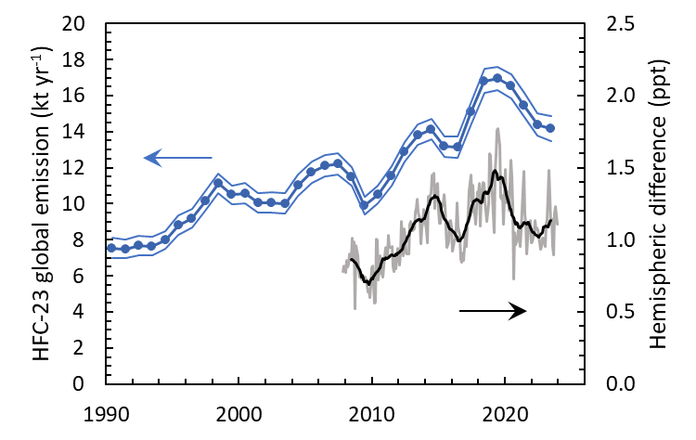
Figure 2. Global HFC-23 annual emissions and hemispheric concentration differences. Global emissions were estimated using established methods (12-box model) from measured concentrations and trends at remote sites by AGAGE (left scale, blue points connected by line, 1-sigma uncertainties are shown as thinner lines; Adam et al., 2024; Prinn et al., 2018 and Park et al., 2023). Hemispheric mean differences (right-hand scale; north minus south) are shown as 12-month running means (dark black line) and monthly differences (gray line) and are estimated from measurements at two to three surface sites in each hemisphere.

2.2 Reported production of HCFC-22
The decline in global HFC-23 emissions from 2019 to 2023 occurred as a substantial increase (15%) in production of HCFC-22 was reported for all uses (Figure 3). The production trend reflects sharp increases in production of HCFC-22 for feedstock uses in A5 countries; in non-A5 countries, production for feedstock uses has remained flat for over a decade. Summed production for controlled uses from A5 countries has decreased by about 50% since 2012. From non-A5 countries, production for controlled uses has decreased since 1995 from a peak value of 297 kt; this controlled production was less than 0.4 kt in 2023. Global HCFC-22 production reported in 2023 was 1180 kt, or slightly (2%) less than production in 2022 of 1200 kt.
Reported production of HCFC-22 overall and for feedstock uses was dominated by China from 2010 to 2018 (years when publicly reported values are available; Figure 3). Related to this, HFC-23 generation associated with controlled fluorocarbon production has also been dominated by China. In 2023, China generated 19.2 kt of by-produced HFC-23, or 79% of the global total in that year (UNEP, 2024).
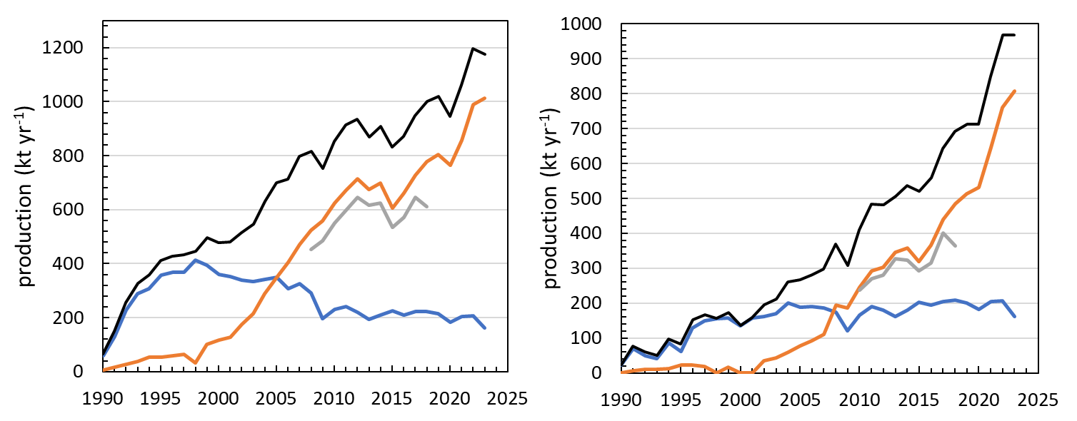
Figure 3: Global reported production of HCFC-22. Production of HCFC-22 reported to the Ozone Secretariat for all uses (left panel) and for only feedstock uses (right panel). Global totals in each panel (black lines) are broken out by contributions from A5 parties (tan lines), non-A5 parties (blue lines), and China (gray lines). Sources of China’s totals: TEAP (2021, 2023); UNEP (2015).

2.3 On the global emission gap
Based on the updated information discussed herein, the difference or “emission gap” that emerged in 2015 between global HFC-23 emissions derived from observations in the remote-atmosphere and those that are reported has persisted through 2023 (Figure 4). The emission gap in 2023 is 11.4 – 12.8 kt yr⁻¹ and is similar to the gap estimated for 2022 of 10.5 – 12.5 kt yr⁻¹, which was provided in the previous analysis by SAP (SAP, 2024). The updated gap estimate was derived with global emissions estimated for 2023 from atmospheric observations, A7 emissions reported for A5 countries in 2023 (UNEP, 2025) and UNFCCC reporting of HFC-23 emissions for Annex 1 countries through 2023, where available (the most recent reporting year for most countries; UNFCCC, 2024; 2025a; 2025b; 2025c; 2025d; 2025e, Manning et al., 2022 updated).
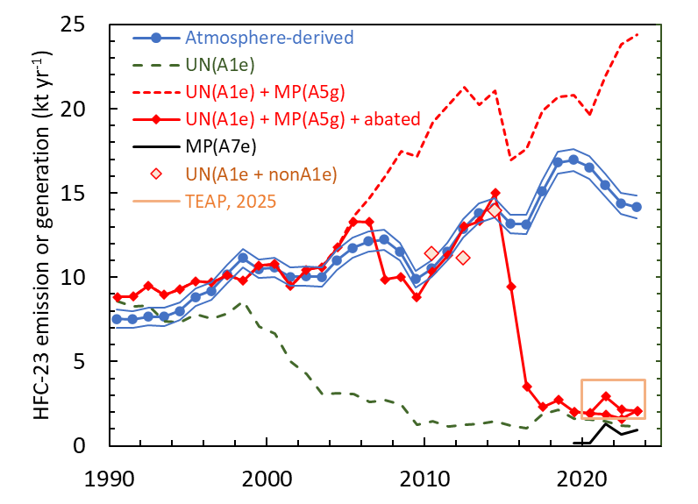
Figure 4: Comparisons of HFC-23 emissions and reported generation over time.
“Atmosphere derived”: global emission estimates derived from measured atmospheric abundances in remote areas (blue line with dots, with ±1 standard deviation uncertainty shown by surrounding thin lines; Adam et al., 2024).
“UN(A1e)”: sum of emissions from Annex 1 countries reported to the UNFCCC (UNFCCC, 2024; 2025a; 2025c; 2025d; 2025e; updates to Manning et al., 2022) (green dashed line). Note: UNFCCC emissions from the USA are unavailable for 2023 and were assumed to be unchanged from 2022.
“UN(A1e) + MP(A5g)”: sum of emissions from Annex 1 countries reported to the UNFCCC plus HFC-23 generated from A5 countries (reported abatements are not included) (red dashed line) (Data from Stanley et al. (2020) through 2019 and from voluntary A7 reporting in 2020-2023, UNEP, 2025).
“UN(A1e) + MP(A5g + abated)”: sum of emissions from Annex 1 countries reported to the UNFCCC plus HFC-23 generated from A5 countries (MP(A5g)) minus amounts abated (destroyed or used as feedstock) of generated HFC-23 during HCFC-22 production (red solid line with diamonds). This sum is defined as “expected” HFC-23 emissions in the text. They are estimated through 2012 as in Liang and Rigby et al. (2022) and Stanley et al. (Figure 5) (2020) and are based on reports under the UNFCCC Clean Development Mechanism (CDM) projects; after 2012, expected emissions are based on reported emissions, where available, or estimated emissions based on reported HCFC-22 production (for all uses) in the respective Article 5 countries, the assumed generation rates for HFC-23 by-production during HCFC-22 production (UNEP, 2018a;b), and information on HFC-23 management practices submitted by Article 5 countries. Note: the two values plotted for 2021 and 2022 show the difference in reporting by a single party in different publications (UNEP, 2022).
“MP(A7e)”: emission totals from A7 reporting to the Ozone Secretariat for reporting countries; (black line; UNEP, 2025).
“UN(A1e + nonA1e)”: the sum of UNFCCC net or actual emissions in 2010, 2012, and 2014 from all available countries (UNFCCC, 2025a; 2025b) (red diamonds with light-red fill). Note: values include emissions from only India and China in 2010 and only China in 2012 and 2014.
“TEAP, 2025”: the sum of MP(A7e) emissions and from all other industrial processes estimated to be sources of HFC-23 (tan-colored square; TEAP, 2025).
As pointed out in the previous HFC-23 report (SAP, 2024), the last Scientific Assessment of Ozone Depletion report (Liang and Rigby et al., 2022), and additional scientific studies (Adam et al., 2024; Stanley et al., 2020; Simmonds et al., 2018), the emergence of an emission gap beginning in 2015 occurred after 20+ years of good agreement between emissions derived from concentrations measured in the remote atmosphere and those from reporting-based expectations (the average difference from 1995 to 2014 was 0.7 ± 1.0 kt yr⁻¹) (Figure 4 & 5). This earlier period includes substantial declines in reported HFC-23 emissions in non-A5 countries and, in A5-countries, substantial destruction of HFC-23 (approaching 10 kt yr⁻¹ in 2010 and 2011), mostly in China, which was facilitated and verified through UNFCCC’s Clean Development Mechanism (CDM) projects.
The global emission gap increased from being negligible in 2014 to a value of about 15 kt yr⁻¹ in a span of 4 to 5 years; after 2019 the gap decreased slightly and by 2023 it was 11.4 – 12.8 kt yr⁻¹. The emergence of the gap occurred at the same time as a large increase (greater than 15 kt yr⁻¹) in the reported abatement (destroyed or used as feedstock) of HFC-23 generated during HCFC-22 production by a limited number of A5 countries (Figure 5). In contrast, global annual emissions derived from atmospheric measurements increased by only 4 kt over 2014 to 2023 (Figure 4).
A clear understanding of the underlying causes for the emergence and persistence of the emission gaps after 2014 remains elusive. Potential causes are abatements being smaller than reported, or an increasing trend in HFC-23 emissions beginning in 2015 either from an unknown source or from a known source with underestimated emissions. TEAP’s recent assessments (2024; 2025) have not identified any unaccounted-for emission sources or processes that could explain this discrepancy or its rapid beginning in 2015. Furthermore, while atmospheric data on regional and global scales indicate that emissions continue at rates inconsistent with available reporting, they do not currently provide insight as to why emissions continue, be it from unexpected sources or from inaccurate reporting.

TEAP’s reassessed estimates of known sources (TEAP, 2025), and their updated emission totals from these sources remain unchanged compared to TEAP (2024) values. HFC-23 emissions from all known sources and reported abatements after 2020 are estimated to be 1.6 to 3.7 kt yr⁻¹. By including this range of emissions and a revised upper limit of 0.215 kt yr⁻¹ for production from atmospheric oxidation of fluorinated gases (see Section 4), the difference in 2023 between emissions from all known sources and global emissions derived from atmospheric measurements in the remote atmosphere is 9.6 – 13.3 kt.

From 2015 to 2019, the emission gaps increased at the same time as reported destruction in A5 countries, with the gap in emission being about 4 kt yr⁻¹ smaller, on average, than reported destruction in A5 countries during these years (Figure 5). This difference is additional evidence for HFC-23 destruction occurring during those years.

From 2019 to 2023, magnitudes of reported annual destruction becomes increasingly larger than the emission gap in each year, consistent with the destruction of HFC-23 continuing to exceed any unaccounted-for emission. Furthermore, through these latter years as reported destruction increases in A5 countries and overall, the gap declines, potentially indicating even more effective abatements, possibly associated with the Kigali Amendments coming into force or a drop in emissions from unknown and/or unaccounted-for sources during this period.
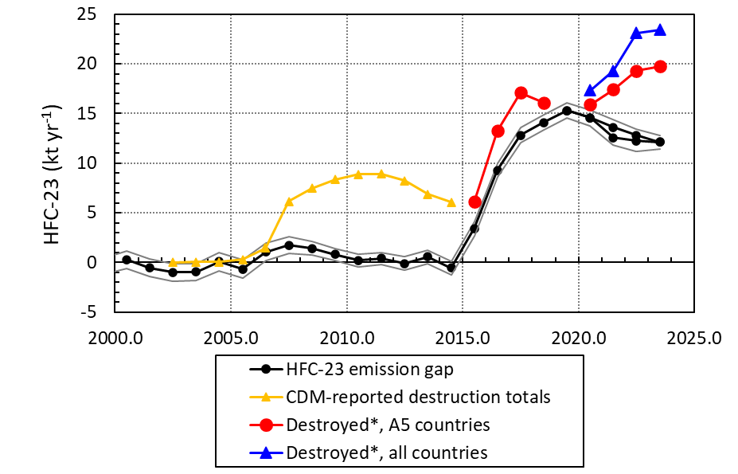
Figure 5. Time evolution of the emission gap and reported emission abatements.
“HFC-23 emission gap”: the difference between observationally derived and reporting-based estimates (black lines with dots and thin black lines showing uncertainties associated with observationally derived emission estimates). The values are the difference between the blue line with dots and solid red line with diamonds from Figure 4). The two results shown for 2021 and 2022 reflect the different values reported by a single party in different publications (UNEP, 2022).
“CDM-reported destruction totals”: total reported destruction associated with CDM projects in all participating countries (yellow line with triangles; Stanley et al., 2020; with China accounting for approximately 75% of the totals in most years).
“Destroyed* by A5 countries”: the amounts reported as destroyed or used as feedstock in various public sources (red lines with circles; TEAP, 2021; 2023; UNEP, 2018a; 2018b; 2020; 2025).
“Destroyed* by all countries”: the amounts reported as destroyed or used as feedstock in voluntary A7 reporting from all countries (blue line and triangles; UNEP, 2025).
Current reporting indicates that the dominant source of HFC-23 by-production (accounting for around 95% of all processes) remains over-fluorination of chloroform during the manufacture of HCFC-22 (TEAP, 2025). In the absence of mitigation, by-production generation of HFC-23 ranges from 1 to 4% of the HCFC-22 produced. As a result, the ratio of total HFC-23 emissions from all sources relative to HCFC-22 production for all uses (E₂₃/P₂₂) has been used to provide an understanding of the overall effectiveness of HFC-23 emissions mitigation associated with HCFC-22 production (Montzka et al., 2010; Montzka and Velders et al., 2018; Liang and Rigby et al., 2022; SAP, 2024).
The E₂₃/P₂₂ ratio calculated for 2023 is 1.1% and is very similar to the value in 2022 (Figure 6). These values are about half of what they would be if all HFC-23 directly associated with HCFC-22 production were released to the atmosphere (generated₂₃/E₂₂; dashed red line in Figure 6), but they remain substantially larger than expected based on reported abatements and emissions (E₂₃/P₂₂ of between 0.1 and 0.3%). Reporting-based values are in line with expectations by, for example, the MLF in its funded projects, where the Kigali Amendment requirement that emissions of by-produced HFC-23 be destroyed “to the extent practicable” corresponds to an E₂₃/P₂₂ of 0.1% (UNEP, 2022). While the cause for this discrepancy is not known, it may arise from a combination of factors such as overall mitigation rates being less than reported and/or substantial emissions of HFC-23 from sources not directly associated with HCFC-22 production or that are currently unidentified. TEAP (2025) estimates that HFC-23 emissions not directly associated with the HCFC-22 production process are 0.6 to 2.7 kt yr⁻¹ and arise from multiple processes including the manufacture of trifluoroethylene and hexafluoropropylene, production of other fluorochemicals, from manufacturing of semiconductor and electronics equipment, from fire protection, from use as a feedstock, in low-temperature refrigeration, and others. Including these other sources in reporting-based emission magnitudes would not appreciably diminish the discrepancy apparent in Figure 6 between reporting-based and atmosphere-based estimates. The time-variations in the E₂₃/P₂₂ ratio suggest that one or both of these factors substantially increased after 2014.
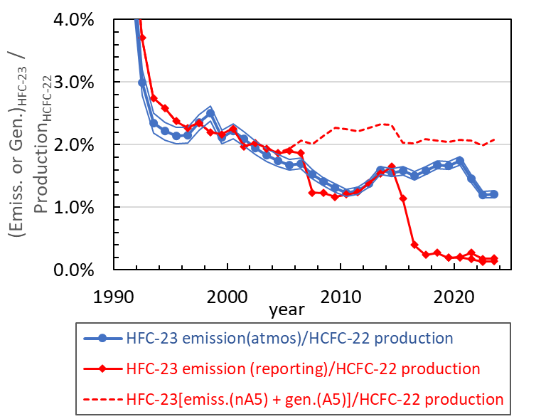
Figure 6: Amounts of emitted or generated HFC-23 relative to reported HCFC-22 production. Different estimates of HFC-23 emissions or emitted plus generated HFC-23 are plotted relative to total reported HCFC-22 production for all uses. HFC-23 emissions were estimated from atmospheric abundance measurements at remote sites (blue lines and dots, with 1 s.d. uncertainty shown by surrounding thin lines), and they were estimated from emissions reporting after subtractions associated with abated quantities as described in Figure 4 (red lines with diamonds). Also appearing is the sum of HFC-23 emissions from Annex 1 countries (UNFCCC, 2025a) plus HFC-23 generated in A5 countries without any subtractions to account for reported abatements (dashed red line here and in Figure 4). All three timeseries of emissions have been divided by total production of HCFC-22 reported to the Ozone Secretariat for all uses.

3 Regional contributions to HFC-23 emissions
As discussed in the SAP report (SAP, 2024), the understanding of the underlying causes for unusual or unexpected global emission magnitudes and trends of controlled gases may be improved by considering emissions on country-wide or regional scales. Since that report, emission estimates for a number of regions have been updated through 2023. The updates appeared in the scientific literature (Adam et al., 2024), and reporting to the UNFCCC (UNFCCC, 2025c; 2025d; updates to Manning et al., 2022).
In eastern Asia, updated results have been derived from continued measurements at the Gosan station located on Jeju Island in the Republic of Korea (Adam et al., 2024). These results extend the Park et al. (2022) HFC-23 measurement record past 2019 and through 2023. In both studies, HFC-23 emissions are estimated from eastern China, the Democratic People’s Republic of Korea, western Japan, and the Republic of Korea. Results from this work are relevant to the HFC-23 issue as the majority of global HCFC-22 production and HFC-23 by-production has historically occurred in this region (TEAP, 2021; 2023; UNEP, 2018a; 2018b; 2024). In particular, HFC-23 generation in China in 2023 was 19.3 kt, or 79% of global total generation reported to the Ozone Secretariat in that year. This value is slightly larger than China’s average contribution to global HFC-23 generation in 2013-2017 of 67-75% (or 13.6 – 17.3 kt yr⁻¹) (TEAP, 2021; 2023; UNEP 2015).
The main conclusions provided in Adam et al. (2024) are consistent with those described in Park et al. (2022): a) eastern China was the largest contributor (>95%) to HFC-23 emissions from this region during 2008 to 2019, b) emissions from eastern China increased from 2015 to 2019, opposite to expectations for emissions from China as a whole based on large increases in HFC-23 emissions abatement associated with HCFC-22 production during those years, and c) emissions from eastern China were substantially larger after 2015 than suggested by information provided to the MLF on by-product abatement of HFC-23 generated during HCFC-22 production, which is consistent with obligations related to the HPPMP agreement with the Executive Committee.
In the updated results provided by Adam et al., the increasing HFC-23 emission trend during 2015-2019 from eastern China reversed after 2019 (Figure 7). Eastern China’s HFC-23 emissions in each of the four years between 2020 and 2023 were less than they were in 2019. Annual emissions in 2020 (6.0 ± 0.7 kt yr⁻¹) were well below those in 2019 (8.0 ± 1.1 kt yr⁻¹), and emissions in 2021 (4.6 ± 0.5 kt yr⁻¹) were even smaller, but this decreasing trend did not continue after 2021. Emissions in 2022 (4.9 ± 0.7 kt yr⁻) were similar to those in 2021, and those in 2023 were slightly enhanced (5.6 ± 0.7 kt yr⁻¹) compared to 2021 and were indistinguishable from those in 2022. The Adam et al. (2024) emission estimate for eastern China in 2022 is consistent with a mean emission during 2021-2022 derived for this same region of 6.7 ± 3.1 kt yr⁻¹, based on high-frequency HFC-23 measurements at the southern Chinese Guangzhou Institute of Geochemistry station (Huang et al., 2024). The 5.6 ± 0.7 kt yr⁻¹ emission from eastern China in 2023 is larger than the 0.9 kt reported to the Ozone Secretariat, by 4.7 ± 0.7 kt yr⁻¹, and amount equivalent to 40 ± 10 % of the global emission gap in 2023.
The decline in emissions estimated for eastern China after 2019 brings the observationally derived emissions closer to reporting-based estimates for all of China, but they remain substantially different (Figure 7). A precise measure of this difference and how it has changed over time in China remains elusive, however, because the observationally derived estimates do not capture emissions from the entire country. The fraction of China’s HFC-23 emissions that contribute annually to measured concentrations at Gosan is not known.
The HFC-23 emissions estimated for eastern China in 2023 account for approximately 40 ± 5% of global total emissions in 2023, which is less than the value for 2008-2019 of 49 ± 11% (Adam et al., 2024). The change in emissions from 2019 to 2023 in eastern China can account for about 80% of the concurrent change in total global emission.
Adam et al. (2024) also provided updated emissions of HFC-23 from three other nearby countries or portions of countries in eastern Asia. Emissions for 2023 from these regions totaled 0.34 kt yr⁻¹, with the ROK. accounting for 0.23 ± 0.02 kt yr⁻¹, western Japan accounting for 0.10 ± 0.07 kt yr⁻¹, and DPRK accounting for 0.01 ± 0.01 kt yr⁻¹. Although emissions from these countries represent a very small fraction of total global emissions and the emission gap, and suggest smaller emissions in 2023 than earlier years, those from ROK and western Japan were substantially larger than reported to the Ozone Secretariat (less than 0.01 kt for both countries) from controlled sources in 2023 and to the UNFCCC for all industrial sources in available years (0.01 kt in 2023 for Japan (UNFCCC, 2025e) and 0.04 kt in 2018 for ROK). In reporting to the Ozone Secretariat, emissions from the DPRK in 2023 (0.008 kt) are consistent with the observationally derived estimate. When taken together, the unreported emissions from these countries account for between 1.5 and 3% of the global emission gap in 2023.
In both the Park et al. (2022) and Adam et al. (2024) studies, emission estimates for the Korean peninsula are representative of those entire countries, while the studies only provided reliable estimates for western Japan. This region of Japan includes only a portion of their facilities producing HCFC-22. All three of these countries (i.e., ROK, DPRK and Japan) reported generation of HFC-23 to the Ozone Secretariat during 2023, and the sum total from these countries was less than 4% of total global reported generation during that year.
In Adam et al. (2024), a slightly different analysis method was used to infer regional emissions than in Park et al. (2022). The different approach yielded less variable year-to-year changes in emissions; however, the updated regional emission estimates are similar (within 1 standard deviation) to those published by Park et al. (2022) in nearly all overlapping years and regions (exceptions are eastern China in 2009 and ROK in 2015).
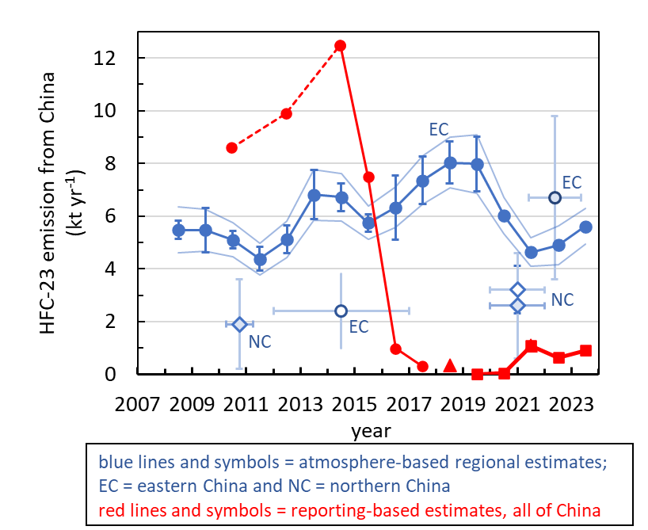
Figure 7. Atmosphere-based and reporting-based emissions of HFC-23 from China.
Emissions derived for different regions within China from atmospheric abundance measurements (blue lines and symbols; EC = eastern China, NC = northern China) are contrasted to emissions estimated for all of China from reports of emissions and abatements (red lines and symbols). Atmosphere-based estimates for these different regions cannot be combined to supply an estimate of emissions from all regions of China.
Notes and sources: emissions from different portions of eastern China (EC) are derived from atmospheric measurements at Korea’s Gosan Station (filled blue circles with 1-s.d. error bars; Adam et al., 2024); from measurements at the Guangzhou Institute of Geochemistry (light-blue-filled blue circle using measurements from mid-2021 to mid-2023; Huang et al., 2024); and from measurements at the Lin’an regional station (Pu et al., 2020; white-filled blue circle labeled as EC*, measurements from mid-2012 through 2016). Emissions from northern China are derived from atmospheric measurements at the Shangdianzi Station (blue diamonds, derived using interspecies correlation with CO (light-blue filled diamonds in multiple years; Yao et al., 2012 in 2010-2011; and Yi et al., 2023 in 2020-2021) or HCFC-22 (white-filled diamond from 2020-2021) (Yi et al., 2023). Reporting-based emissions for all of China (red filled symbols and lines) are derived for 2010, 2012, and 2014 from reporting to the UNFCCC (UNFCCC, 2025); for 2015-2017 from reported by-product generation from HCFC-22 production and abatements (solid circles; UNEP, 2018a,b; TEAP, 2021, 2023); for 2018 as abated quantities for a fraction of total HCFC-22 production in China (TEAP, 2021, 2023); and for 2020-2023 from A7 reporting of emissions (UNEP, 2025).
Emissions of HFC-23 from countries or portions of countries in north-western Europe (NWEU; Ireland, the UK, France, Belgium, the Netherlands, Luxembourg, and Germany) have also been derived and updated from atmospheric observations at multiple sites in Europe and the UK (updates to Manning et al., 2022). These observationally derived emissions averaged 0.15 ± 0.04 kt yr⁻¹ in 2022 and 2023. This value is substantially larger than the sum of emissions reported by these countries to the UNFCCC in 2022 (latest available reporting year; updates to Manning et al., 2022; UNFCCC, 2025d) of 0.02 kt. When taken together, the unreported emissions from these countries account for between 0.7 and 1.5% of the global emission gap in 2023.
In Australia, atmosphere-based emissions are derived from measurements at the Cape Grim, Tasmania station in southern Australia. National emissions of HFC-23 for Australia in 2023 were estimated to be 0.025 kt yr⁻¹ (no uncertainty specified), which is 0.03 kt yr⁻¹ less than the value reported to the UNFCCC for that year of 0.0547 kt (UNFCCC, 2025c).
Summing observationally derived emissions in 2023 associated with NWEU, Australia, ROK, western Japan, and DPRK, yields a total emission of HFC-23 in 2022-2023 of approximately 0.5 ± 0.1 kt yr⁻¹. This value is substantially larger than the emission sum of 0.14 kt reported for these years to the UNFCCC (UNFCCC, 2025c; 2025e; Manning et al., 2022 updated) or the 0.014 kt reported to the Ozone Secretariat for controlled uses in 2023 (UNEP, 2025), suggesting that unaccounted-for emissions from these countries are substantially larger than reported emissions but are much smaller (approximately 0.4 ± 0.1 kt yr⁻¹ or between 2 and 4%) than the global emission gap of 11.4 – 12.8 kt yr⁻¹ in 2023.
The regional HFC-23 emission estimates available in 2023 (as discussed above) include countries or portions of countries that accounted for the majority (93%) of HFC-23 by-production in that year. Atmosphere-based estimates of HFC-23 emissions are not available in the Kigali era (post 2019) for the remaining countries reporting HFC-23 generation in 2023: Argentina, India, Mexico, the Russian Federation, and the USA. For reference, summed emissions of HFC-23 in 2022 and 2023 from these latter countries averaged 0.05 kt HFC-23 in A7 reporting to the Ozone Secretariat in those years (UNEP, 2025), and for those countries reporting emissions from all uses to the UNFCCC (the USA and the Russian Federation; UNFCCC, 2024; 2025f) HFC-23 emissions summed to approximately 1 kt in 2022.

4 Photo-chemical production of HFC-23 in the atmosphere
In information provided in response to Decision XXXV/7 (SAP, 2024), source gases and the mechanisms that could lead to the chemical formation of HFC-23 in the atmosphere were identified and discussed. HFC-23 is produced in the atmosphere during the oxidation of certain fluorocarbons by the hydroxyl radical and by ozone. In the hydroxyl-radical pathway, fluorocarbons oxidize to produce CF₃CHO, which can chemically degrade to form HFC-23. The magnitude of the combined source from hydroxyl radical and ozone reactions in 2022 was estimated to be a flux of less than 0.43 kt HFC-23 yr⁻¹, which accounted for less than 3.1% of global HFC-23 emissions in that year.
After the SAP (SAP, 2024) report was finalized, two experimental studies were published that substantially refine our understanding of the atmospheric chemical source of HFC-23 from hydroxyl radical reactions (Thomson et al., 2025 and Van Hoomissen et al., 2025). Product yields of HFC-23 were quantified for the first time from the photolysis of CF₃CHO at wavelengths relevant to the troposphere; previously only upper limits to product yields had been determined. Both studies found only a small molar yield of HFC-23 in the UV photolysis of CF₃CHO (0.17%, at 308 nm, a wavelength relevant for atmospheric photolysis in the troposphere), which is an intermediate formed in the atmospheric degradation of a number of source gases (e.g., HFC-143a (CH₃CF₃), HFO-1234ze(E) ((E)-CHF=CHCF₃), and HCFO-1233zd(E) ((E)-CF₃CH=CHCl); see Table 1). Confidence in this measured value is enhanced by the excellent agreement reported for this yield in the two studies, particularly because they used different experimental approaches.
Synthetic gases having the chemical structure that can lead to the formation of HFC-23 via hydroxyl radical reaction and that have measurable atmospheric abundances in 2023 are given in Table 1. Included in this table are estimates of HFC-23 product yields (as the HFC-23 produced per source gas oxidized; Van Hoomissen et al., 2025). These yields were derived by quantifying the fraction of the CF₃CHO formed in photooxidation reactions that leads to the formation of HFC-23 given the current understanding of the atmospheric chemistry of CF₃CHO. The yields are upper-limits for HFC-23 formation in part because the shortest CF₃CHO photolysis lifetime in the literature (4 days) was used for the estimations. An even smaller upper limit estimate would be derived if a longer lifetime for photolysis was included or if additional degradation processes for CF₃CHO that do not create HFC-23 (e.g., the possible reaction between CF₃CHO and HO₂) were considered in the analysis.
In addition, Van Hoomissen et al. (2025) evaluated the chemical source flux of HFC-23 (in kt yr⁻¹) for each of these molecules given their measured atmospheric abundance in recent years (Table 1).
Ozonolysis of certain hydrofluoroolefins (HFOs) can also lead to the chemical production of HFC-23 in the atmosphere (McGillen et al., 2023). This process accounts for less than 5% of the atmospheric chemical source of HFC-23 (Table 1 and 2) (Van Hoomissen et al., 2025).
Based on these new studies, the contribution of fluorocarbon oxidation reactions to HFC-23 in the atmosphere is estimated to be less than 0.215 kt yr⁻¹ (Table 1, Table 2), which is a factor of 2 smaller than the estimate in the earlier SAP report (2024). As discussed above, this value is a conservative upper limit, meaning that the actual value is likely smaller.

4.1 Knowledge gaps related to atmospheric production of HFC-23
The recent experimental studies of Thomson et al. (2025) and Van Hoomissen et al. (2025) have addressed the primary gap in the understanding of HFC-23 production in the UV photolysis of CF₃CHO relevant for the lower atmosphere. Further refinements to our understanding await studies that address some other processes relevant to the atmospheric chemical production of HFC-23 as discussed below.
Thomson et al. (2025) and Van Hoomissen et al. (2025) measured HFC-23 production in the photolysis of CF₃CHO as a function of pressure at 308 nm, a key photolysis wavelength relevant for the troposphere. Van Hoomissen et al. provided further constraints on the HFC-23 yield by measuring it at 248, 266, and 281 nm. While these results form the basis for constraining the yield at all wavelengths relevant to the troposphere, measurements at other wavelengths (particularly in the 295 to 308 nm region) would further refine the overall yields. Additional experimental measurements in this region, however, are challenging due primarily to limited high-power photolysis light sources available for use in this wavelength range.
A more accurate estimate of the chemical production of HFC-23 (less than 0.215 kt yr⁻¹; Van Hoomissen et al., 2025) requires a better quantification of a number of processes that have significant uncertainties, such as (i) CF₃CHO loss to processes not producing HFC-23, for example by deposition or by the potential gas-phase reaction with HO₂ (Long et al., 2022); these processes would result in even smaller production rates of HFC-23, and (ii) production rates of CF₃CHO from very short-lived substances (e.g., HFOs) that will depend strongly on the atmospheric abundance distributions of these gases that are not well known.
A better estimate of the atmospheric chemical source of HFC-23 may come from a global modeling analysis incorporating updated loss estimates for CF₃CHO and other constraints. A modeling analysis could also help refine our understanding of chemical production in the stratosphere at the temperatures and pressure relevant to that atmospheric region. A box modeling analysis has been conducted (Pérez-Peña et al., 2023) to evaluate the chemical production of HFC-23. The fluxes they derive likely overestimate the true flux, as they were derived with a yield of HFC-23 that has been substantially revised and reduced by the results of Tomson et al. (2025) and Van Hoomissen et al. (2025).

Table 1. Estimated photochemical sources of CF₃CHO and HFC-23 under conditions relevant for the global troposphere, for hydrofluorocarbons (HFCs) and hydrochlorofluorocarbons (HCFCs) with reported atmospheric abundances. (Table S5 in Van Hoomissen et al., 2025) ª
Name | Formula | Global Atmospheric Abundance ^{b} (ppt) | Global Lifetime(yr) | Tropo-  spheric  Lifetime (yr) | CF₃CHOProduct Yield ^{c} (%) | HFC-23 Flux  (kt yr⁻¹) | kt HFC-23 Produced  per kt Source  Gas Emitted
Hydrofluorocarbons (HFCs)
HFC-143a | CH₃CF₃ | 32 | 51.8 | 57.2 | 100 | 0.022 | 0.0011
HFC-236fa | CF₃CH₂CF₃ | 0.25 | 213 | 253 | 100 | 0.00008 | 0.00060
HFC-245fa | CF₃CH₂CHF₂ | 3.75 | 7.74 | 8.16 | 56 | 0.012 | 0.00038
HFC-365mfc | CF₃CH₂CF₂CH₃ | 1.1 | 8.86 | 9.3 | 76 | 0.005 | 0.00046
Hydrochlorofluorocarbons (HCFCs)
HCFC-133a | CH₂ClCF₃ | 0.45 | 4.48 | 4.74 | <5 | 0.0002 | <0.000038
Hydrofluoroolefins (HFOs)
HFO-  1234ze(E) | (E)-CHF=CHCF₃ | (0.15) ^{d} | 19 days | 19 days | 100 | ≤0.075 | 0.00079
HFO-  1336mzz(Z) | (Z)-CF₃CH=CHCF₃ | (0.05) ^{d} | 27 days | 27 days | 200 | ≤0.049 | 0.0011
Hydrochlorofluoroolefins (HCFOs)
HCFO-  1233zd(E) | (E)-CF₃CH=CHCl | (0.15) ^{d} | 42.5 days | 42.5 days | 100 | ≤0.043 | 0.00070
 |  |  |  |  | Totals | ≤0.206
a Lifetimes are taken from the 2022 WMO Ozone Scientific Assessment Annex (Burkholder and Hodnebrog, 2022), the HFC-23 yield in the ozonolysis reactions of saturated halocarbons is assumed to be zero.
b Atmospheric abundances of saturated HFCs and HCFCs are global surface means updated for the end of 2023 (updates to Prinn et al., 2018 provided by AGAGE).
c CF₃CHO product yields are taken from the literature for HFC-143a, HFC-245fa, and HFC-365mfc. In the absence of experimental data, CF₃CHO product yields are estimated based on reactivity trends.
d Atmospheric abundances appearing in parentheses are not global means, they are mole fractions measured at the European Jungfraujoch station in 2020 (Liang and Rigby et al., 2022) or 2022 (Rust et al., 2024), which are updates to Vollmer et al. (2015) for HFC1234yf and HCFO-1233zd(E); global mean abundances for these short-lived gases are likely substantially smaller than the values in the table.

Table 2. Ozonolysis reaction sources of HFC-23 under conditions relevant for the global troposphere, for hydrofluoroolefins (HFOs) and hydrochlorofluoroolefins (HCFOs) (taken from Van Hoomissen et al. (2025))
Name | Formula | Atmospheric  Abundance  (ppt) | Tropo-  spheric  Ozonolysis Lifetime ª  (days) | HFC-23  Product  Yield ^{b}  (%) | Tropospheric  HFC-23  Flux  (kt yr⁻¹) | kt HFC-23 Produced  per kt Source  Gas Emitted
Hydrofluoroolefins (HFOs)
HFO-  1243zf | CH₂=CHCF₃ | – ^{c} | ~1150 | 0.37 ± 0.02 | – | 0.000019
HFO-  1234ze(E) | (E)-CHF=CHCF₃ | (0.15) ^{d} | ~4600 | 3.11 ± 0.05 | ≤ 0.009 | 0.000078
HFO-  1336mzz(Z) | (Z)-CF₃CH=CHCF₃ | (0.05) ^{d} | ~19300 | 0.42 ± 0.02 | ≤ 0.00009 | 0.0000025
Hydrochlorofluoroolefins (HCFOs)
HCFO-  1233zd(E) | (E)-CF₃CH=CHCl | (0.15) ^{d} | ~8000 | – | – | –
 |  |  |  | Total | ≤ 0.00909
a Lifetime calculated using literature available O₃ reaction rate coefficients (see Table S7 in Van Hoomissen et al. (2025)) and an O₃ mixing ratio of 50 ppb.
b The HFC-23 yield in the ozonolysis reactions of unsaturated HFOs was taken from McGillen et al.(2023).
c Atmospheric measurements not available.
d Atmospheric abundances appearing in parentheses are not global means, they are mole fractions measured at the European Jungfraujoch station in 2020 (Liang and Rigby et al., 2022) or 2022 (Rust et al., 2024), which are updates to Vollmer et al. (2015) for HFC1234yf and HCFO-1233zd(E); global mean abundances for these short-lived gases are likely substantially smaller than the values in the table.

5 References
Adam, B., Western L.M, Muhle, J. et al., Emissions of HFC-23 do not reflect commitments made under the Kigali Amendment, Commun. Earth & Environ., 5, 783 (2024) https://doi.org/10.1038/s43247-024-01946-y.
Burkholder, J.B. and Ø. Hodnebrog, Annex: World Meteorological Organization (WMO). Scientific Assessment of Ozone Depletion: 2022, GAW Report No. 278, 509 pp.; WMO: Geneva (2022).
Dodangodage, R., P.F. Bernath, C. Boone, M. Lecours, M. Schmidt, HFC-23 from updated Atmospheric Chemistry Experiment Fourier transform spectrometer (ACE-FTS) retrievals, J. Quant. Spectros. Rad. Trans., 338, 109416 (2025) https://doi.org/10.1016/j.jqsrt.2025.109416.
Huang, X., Y. Zhang, C. Xiao, W. Song, Y. Wang, and X. Wang, Constraining trifluoromethane (HFC-23) emission in eastern China based on two-year online measurements, J. Geophys. Res. Atmos, 129, e2023JD040199 (2024) https://doi.org/10.1029/2023JD040199.
Liang, Q., and M. Rigby (Lead Authors) et al., Chapter 2: World Meteorological Organization (WMO). Scientific Assessment of Ozone Depletion: 2022, GAW Report No. 278, 509 pp.; WMO: Geneva (2022).
Long, B., Y. Xia, and D.G. Truhlar, Quantitative kinetics of HO₂ reactions with aldehydes in the atmosphere: high-order dynamic correlation, anharmonicity, and falloff effects are all important, J. Amer. Chem. Soc., 144, 19910–19920, doi:10.1021/ jacs.2c079 94 (2022).
Manning, A., S. O’Doherty, D. Young, Al. Redington, D. Say, J. Pitt, T. Arnold, C. Rennick, M. Rigby, A. Wisher, A. Wegner, and P. Simmonds, Long-term atmospheric measurements and interpretation of radiatively active trace gases, October 2020 - September 2021 (2022) https://assets.publishing.service.gov.uk/media/62d7b9bee90e071e7e59c97e/verification-uk-greenhouse-gas-emissions-using-atmospheric-observations-annual-report-2021.pdf.
McGillen, M. R., Z. T. P. Fried, M. A. H. Khan, K. T. Kuwata, C. M. Martin, S. O’Doherty, F. Pecere, D. E. Shallcross, K. M. Stanley, and K. Zhang, Ozonolysis can produce long-lived greenhouse gases from commercial refrigerants, Proc. National Acad. Sci., 120(51), e2312714120 (2023) doi:10.1073/pnas.2312714120.
Montzka, S.A., et al., Recent increases in global HFC-23 emissions, Geophys. Res. Lett., 37, L02808, doi:10.1029/2009GL041195 (2010).
Montzka, S. A., G. J. M. Velders, (Lead Authors), P.B. Krummel, J. Mühle, V.L. Orkin, S. Park, N. Shah, and H. Walter-Terrinoni, Hydrofluorocarbons (HFCs), Chapter 2 in: Scientific Assessment of Ozone Depletion: 2018, Global Ozone Research and Monitoring, World Meteorological Organization, Geneva, Switzerland (2018).
Montzka, S.A., J. Burkholder, L.J. Carpenter, D. Fahey, K. Jucks, and B. Safari, Report of the Science Assessment Panel in response to Decision XXXV1/7: Emissions of HFC-23, UNEP (2024). https://ozone.unep.org/system/files/documents/SAP_Report_on_HFC23_September2024.pdf
Park, H., J. Kim, H. Choi, S. Geum, Y. Kim, R.L. Thompson, J. Mühle, P.K. Salameh, C.M. Harth, K.M. Stanley, S. O'Doherty, P.J. Fraser, P.G. Simmonds, P.B. Krummel, R.F. Weiss, R.G. Prinn, and S. Park, A rise in HFC-23 emissions from eastern Asia since 2015, Atmos. Chem. Phys., 23, 9401–9411 (2023) https://doi.org/10.5194/acp-23-9401-2023.
Pérez-Peña, M. P., J. A. Fisher, C. Hansen, and S. H. Kable, Assessing the atmospheric fate of trifluoroacetaldehyde (CF₃CHO) and its potential as a new source of fluoroform (HFC-23) using the AtChem2 box model, Environ. Sci.: Atmos., 3, 1767-1777 (2023) doi:10.1039/d3ea00120b.
Prinn, R.G., R.F. Weis, J. Arduini, T. Arnold, H.L. DeWitt, P.J. Fraser, A.L. Ganesan, J. Gasore, C.M. Harth, O. Hermansen, J. Kim, P.B. Krummel, S. Li, Z.M. Loh, C.R. Lunder, M. Maione, A.J. Manning, B.R. Miller, B. Mitrevski, J. Mühle, S. O’Doherty, S. Park, S. Reimann, M. Rigby, T. Saito, P.K. Salameh, R. Schmidt, P.G. Simmonds, L.P. Steele, M.K. Vollmer, R.H. Wang, B. Yao, Y. Yokouchi, D. Young, and L. Zhou, History of chemically and radiatively important atmospheric gases from the Advanced Global Atmospheric Gases Experiment (AGAGE), Earth Syst. Sci. Data, 10, 985–1018 (2018) https://doi.org/10.5194/essd-10-985-2018.
Pu, J., H. Xu, B. Yao, Y. Yu, Y. Jiang, Q. Ma, and L. Chen, Estimate of hydrofluorocarbon emissions for 2012–16 in the Yangtze River Delta, China, Adv. Atmos. Sci., 37, 576–585 (2020).
Rust, D., M.K. Vollmer, S. Henne A. Frumau, P. van den Bulk, A. Hensen, K.M. Stanley, R. Zenobi, L. Emmenegger, and S. Reimann, Effective realization of abatement measures can reduce HFC-23 emissions. Nature 633, 96-100 (2024) https://doi.org/10.1038/s41586-024-07833-y.
Simmonds, P. G., M. Rigby, A. McCulloch, M.K. Vollmer, S. Henne, J. Mühle, S. O'Doherty, A.J. Manning, P.B. Krummel, P.J. Fraser, D. Young, R.F. Weiss, P.K. Salameh, C.M. Harth, S. Reimann, C.M. Trudinger, L.P. Steele, R.H.J. Wang, D.J. Ivy, R.G. Prinn, B. Mitrevski, and D.M. Etheridge, Recent increases in the atmospheric growth rate and emissions of HFC-23 (CHF₃) and the link to HCFC-22 (CHClF₂) production, Atmos. Chem. Phys., 18, 4153–4169 (2018) https://doi.org/10.5194/acp-18-4153-2018.
Stanley, K.M., D. Say, J. Mühle, C.M. Harth, P.B. Krummel, D. Young, S.J. O’Doherty, P.K. Salameh, P.G. Simmonds, R.F. Weiss, R.G. Prinn, P.J. Fraser, and M. Rigby, Increase in global emissions of HFC-23 despite near-total expected reductions. Nat. Commun. 11, 397 (2020) https://doi.org/10.1038/s41467-019-13899-4.
TEAP (Technology and Economic Assessment Panel), Report of the Technology and Economic Assessment Panel, Volume 6: Assessment of the funding requirement for the replenishment of the Multilateral Fund for the period 2021-2023, UNEP Ozone Secretariat, Nairobi; ISBN: 978-9966-076-93-9 (2021).
TEAP (Technology and Economic Assessment Panel), Report of the Technology and Economic Assessment Panel, Volume 3: Assessment of the Funding Requirement for the Replenishment of the Multilateral Fund for the Period 2024-2026; UNEP Ozone Secretariat, Nairobi; ISBN: 978-9914-733-88-4 (2023).
TEAP (Technology and Economic Assessment Panel), Report of the Technology and Economic Assessment Panel, Volume 5: Response to Decision XXXV/7: Emissions of HFC-23 (2024) https://ozone.unep.org/system/files/documents/TEAP-reponse-to-decision-XXXV-7-report-september-2024.pdf
TEAP (Technology and Economic Assessment Panel), Report of the Technology and Economic Assessment Panel, Volume 2: Response to Decision XXXVI/3: Emissions of HFC-23 (2025).
Thomson, J.D., J.S. Campbell, E.B. Edwards, C. Medcraft, K. Nauta, M.P. Pérez-Peña, J.A. Fisher, D.L. Osborn, S.H. Kable, and C.S. Hansen, Fluoroform (CHF₃) production from CF₃CHO photolysis and implications for the decomposition of hydrofluoroolefins and hydrochlorofluoroolefins in the atmosphere, J. Am. Chem. Soc., doi:10.1021/jacs.4c11776 (2025).
UNEP (United Nations Environment Programme), Executive Committee of the Multilateral Fund for the Implementation of the Montreal Protocol, Country Programme data and prospects for compliance, 74th meeting, UNEP/OzL.Pro/ExCom/74/11, United Nations Environment Programme, Montreal, Canada (2015) [available at: https://www.multilateralfund.org/api/drupal-documents/download/file/c10263d8-f57f-4148-b980-e51b9aa3cb05?filename=7411.pdf].
UNEP (United Nations Environment Programme), Executive Committee of the Multilateral Fund for the Implementation of the Montreal Protocol, Cost-effective Chapter 2 151 Options for Controlling HFC-23 By-product Emissions (Decision 81/68(e)), United Nations Environment Programme, Montreal, Canada (2018a) [available at: https://www.multilateralfund.org/api/drupal-documents/download/file/f2afb7a1-99bc-4856-b69b-71107139b9d8?filename=8268.pdf].
UNEP (United Nations Environment Programme), Executive Committee of the Multilateral Fund for the Implementation of the Montreal Protocol, Corrigendum: Cost-effective Options for Controlling HFC-23 By-product Emissions (Decision 81/68(e)), United Nations Environment Programme, Montreal, Canada (2018b) [available at: https://www.multilateralfund.org/api/drupal-documents/download/file/bf95e959-8d1c-4c51-a272-6067c595bf7b?filename=8268c1.pdf].
UNEP (United Nations Environment Programme), Executive Committee of the Multilateral Fund for the Implementation of the Montreal Protocol, Report of the sub-group on production sector (reissued), United Nations Environment Programme, Montreal, Canada (2020) [available at: https://www.multilateralfund.org/api/drupal-documents/download/file/d9de4464-f1cf-4bb9-9ec9-bda022dbe581?filename=8474ri.pdf] .
UNEP (United Nations Environment Programme), Executive Committee of the Multilateral Fund for the Implementation of the Montreal Protocol, Report on the subgroup on the production sector, United Nations Environment Programme, Montreal, Canada (2022) [available at: https://www.multilateralfund.org/api/drupal-documents/download/file/42701818-11fe-430d-8437-8044eba552fc?filename=9171ri.pdf].
UNEP (United Nations Environment Programme), Executive Committee of the Multilateral Fund for the Implementation of the Montreal Protocol, Report on the subgroup on the production sector, United Nations Environment Programme, Montreal, Canada (2024) [available at: https://www.multilateralfund.org/api/drupal-documents/download/file/6111d09c-c71e-410d-bc9c-ecdfda38ebfc?filename=9593r1.pdf]
UNEP (United Nations Environment Programme) Ozone Secretariat, Country Data, Additional Reported Information, Other information reported by the parties, HFC-23 Emissions (2025) [available at: https://ozone.unep.org/additional-reported-information].
UNFCCC (United Nations Framework Convention on Climate Change), United States of America. 2024 Common Reporting Table (CRT). (2024) [available at: https://unfccc.int/documents/646590]
UNFCCC (United Nations Framework Convention on Climate Change), Greenhouse Gas Inventory Data - Flexible Queries Annex 1 Parties; (2025a) https://di.unfccc.int/flex_annex1.
UNFCCC (United Nations Framework Convention on Climate Change), Greenhouse Gas Inventory Data - Flexible Queries non Annex 1 Parties; (2025b) https://di.unfccc.int/flex_non_annex1.
UNFCCC (United Nations Framework Convention on Climate Change), Australia. 2023 National Inventory Report (NIR), Volume 1 (2025c) [available at: https://unfccc.int/documents/647190].
UNFCCC (United Nations Framework Convention on Climate Change), United Kingdom. 2023 National Inventory Document (NIR). Annex, (2025d) [available at: https://unfccc.int/documents/646507].
UNFCCC (United Nations Framework Convention on Climate Change), Japan. 2025 Common Reporting Table (CRT) (2025e) [available at: https://unfccc.int/documents/646590]
UNFCCC (United Nations Framework Convention on Climate Change), Russian Federation. 2025 Common Reporting Table (CRT) (2025f) [available at: https://unfccc.int/documents/646538]
Vollmer, M. K., et al., S. Reimann, M. Hill, and D. Brunner, First observations of the fourth-generation synthetic halocarbons HFC-1234yf, HFC-1234ze(E), and HCFC-1233zd(E) in the atmosphere, Environ. Sci. Technol., 49 (5), 2703-2708, doi:10.1021/es505123x (2015)
Van Hoomissen, D., A. Chattopadhyay, S.A. Montzka, and J.B. Burkholder, CHF₃ (HFC-23) and CF₃CHO quantum yields in the pulsed laser photolysis of CF₃CHO at 248, 266, 281, and 308 nm, ACS Earth Space Chem., 9, 589–602, doi:10.1021/acsearthspacechem.4c00316 (2025).
Yao, B., M. K. Vollmer, L. X. Zhou, S. Henne, S. Reimann, P. C. Li, A. Wenger, and M. Hill, In-situ measurements of atmospheric hydrofluorocarbons (HFCs) and perfluorocarbons (PFCs) at the Shangdianzi regional background station, China, Atmos. Chem. Phys., 12, 10181–10193 (2012) www.atmos-chem-phys.net/12/10181/2012/.
Yi, L, M. An, H. Yu, Z. Ma, L. Xu, S. O’Doherty, M. Rigby, L. M. Western, A. L. Ganesan, L. Zhou, Q. Shi, Y. Hu, B. Yao, W. Xu, J. Hu, In Situ observations of halogenated gases at the Shangdianzi background station and emission estimates for Northern China, Environ. Sci. Technol., 57, 18, 7217–7229 (2023) https://doi.org/10.1021/acs.est.3c00695.

