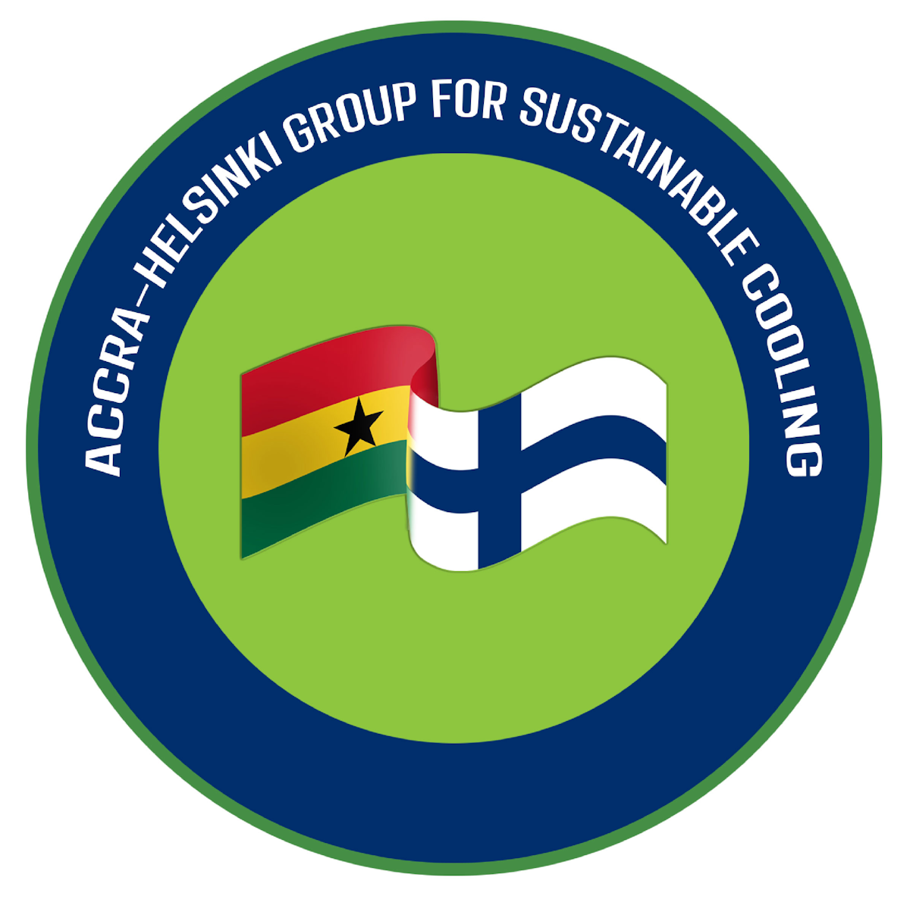 | The Accra-Helsinki Group for Sustainable Cooling  Side Event at the 37th Meeting of the  Parties to the Montreal Protocol on Substances that Deplete the Ozone Layer
Title: Addressing Sulfur Hexafluoride (SF6) in Multilateral Environmental greements, including the Montreal Protocol: Monitoring, Mitigation, and Alternatives for a Sustainable Grid
Time: Monday, 3 November 2025, 13:00–15:00 Nairobi time, Room CR-11
Co-Chairs: Tapio Reinikainen and Kofi Agyarko, Accra-Helsinki Group for Sustainable Cooling
Co-Host: Climate & Clean Air Coalition (CCAC)
Facilitator/Rapporteur: Institute for Governance & Sustainable Development (IGSD)

Time | Segment | Speaker(s)
13:20–13:25 | Welcome & Opening Remarks | Kofi Agyarko (Ghana) and Tapio Reinikainen (Finland)  Accra-Helsinki Group co-chairs
13.25–13.26 | Chatham House Rule application for  Accra-Helsinki Group discussions | Tad Ferris  IGSD Senior Counsel
13:26–13:45 | Sulfur hexafluoride (SF6) in the atmosphere today | Dr. Steven Montzka (online)  NOAA Global Monitoring Laboratory
13:45–13:55 | SF₆ and its applications | Sinisa Prodanovic  Ökö-Recherche
13:55–14:10 | Alternatives to SF6 in electronic switch gear | Dr. Mark Kuschel  Siemens Energy
14:10–14:25 | SF6 in the EU’s new F-gas regulation | Dr. Arno Kaschl/Xenia Messariti  EU Commission
14:25–14:30 | SF6 and MEA’s. Could current efforts under the United Nations Framework Convention on Climate Change be complemented by including SF6 to the Montreal protocol | Experiences from the audience
14:30–14:50 | Moderated Panel Discussion & Audience Q&A | Moderator: Accra-Helsinki Group (Kofi, Tapio, Tad)
14:45–15:00 | Closing Remarks & Breaking news | Dr. Stephen O. Andersen  IGSD Director of Research

