**MONTREAL PROTOCOL ON SUBSTANCES THAT DEPLETE THE OZONE LAYER**

**Report of the Technology and Economic Assessment Panel**

**May 2021**

**Volume 3: Decision XXXI/3 TEAP Task Force Report on Unexpected Emissions of Trichlorofluoromethane (CFC-11)**



**Montreal Protocol on Substances that Deplete the Ozone Layer**

**United Nations Environment Programme (UNEP)**

**Report of the Technology and Economic Assessment Panel**

**May 2021**

**Volume 3: Decision XXXI/3 TEAP Task Force Report on Unexpected Emissions of Trichlorofluoromethane (CFC-11)**

The text of this report is composed in Times New Roman.

Co-ordination: **Technology and Economic Assessment Panel**

Composition of the report: Jose Pons, Helen Tope, Helen Walter-Terrinoni

Layout and formatting: Helen Tope (UNEP TEAP)

Date: May 2021

Under certain conditions, printed copies of this report are available from:

UNITED NATIONS ENVIRONMENT PROGRAMME

Ozone Secretariat

P.O. Box 30552

Nairobi, Kenya

This document is also available in portable document format from the UNEP Ozone Secretariat's website:

https://ozone.unep.org/science/assessment/teap

No copyright involved. This publication may be freely copied, abstracted and cited, with acknowledgement of the source of the material.

**ISBN: 978-9966-076-89-2**

**Disclaimer**

The United Nations Environment Programme (UNEP), the Technology and Economic Assessment Panel (TEAP) Co-chairs and members, the Technical Options Committees Co-chairs and members, the TEAP Task Forces Co-chairs and members, and the companies and organisations that employ them do not endorse the performance, worker safety, or environmental acceptability of any of the technical options discussed. Every industrial operation requires consideration of worker safety and proper disposal of contaminants and waste products. Moreover, as work continues - including additional toxicity evaluation - more information on health, environmental and safety effects of alternatives and replacements will become available for use in selecting among the options discussed in this document.

UNEP, the TEAP Co-chairs and members, the Technical Options Committees Co-chairs and members, and the TEAP Task Forces Co-chairs and members, in furnishing or distributing this information, do not make any warranty or representation, either express or implied, with respect to the accuracy, completeness, or utility; nor do they assume any liability of any kind whatsoever resulting from the use or reliance upon any information, material, or procedure contained herein, including but not limited to any claims regarding health, safety, environmental effect or fate, efficacy, or performance, made by the source of information.

Mention of any company, association, or product in this document is for information purposes only and does not constitute a recommendation of any such company, association, or product, either express or implied by UNEP, the Technology and Economic Assessment Panel Co-chairs or members, the Technical and Economic Options Committee Co-chairs or members, the TEAP Task Forces Co-chairs or members or the companies or organisations that employ them.

**Acknowledgements**

The Technology and Economic Assessment Panel, its Technical Options Committees and the TEAP Task Force Co-chairs and members acknowledge with thanks the outstanding contributions from all of the individuals and organisations that provided support to Panel, Committees and TEAP Task Force Co-chairs and members. The opinions expressed are those of the Panel, the Committees and the TEAP Task Forces and do not necessarily reflect the reviews of any sponsoring or supporting organisation.

# Foreword

**The 2021 TEAP Report**

The 2021 TEAP Report consists of 4 volumes:

*Volume 1: TEAP Progress Report*

*Volume 2: Interim Evaluation of 2021 Critical Use Nominations for Methyl Bromide and Related Issues*

*Volume 3: Decision XXXI/3 Task Force Report on Unexpected Emissions of Trichlorofluoromethane (CFC-11)*

*Volume 4: Decision XXXI/7 Task Force Report on Continued Provision of Information on Energy-Efficient and Low-Global-Warming-Potential Technologies*

This is Volume 3.

**The UNEP Technology and Economic Assessment Panel (TEAP):**

|  |  |  |  |
| --- | --- | --- | --- |
| Bella Maranion, co-chair | US | Kei-ichi Ohnishi | J |
| Marta Pizano, co-chair | COL | Roberto Peixoto | BRA |
| Ashley Woodcock, co-chair | UK | Fabio Polonara | IT |
| Omar Abdelaziz | EGY | Ian Porter | AUS |
| Paulo Altoe | BRA | Rajendra Shende | IN |
| Suely Machado Carvalho | BRA | Helen Tope | AUS |
| Adam Chattaway | UK | Dan Verdonik | US |
| Ray Gluckman | UK | Helen Walter-Terrinoni | US |
| Marco Gonzalez | CR | Shiqiu Zhang | PRC |
| Sergey Kopylov | RF | Jianjun Zhang | PRC |

Table of Contents

Disclaimer v

Foreword vi

Key Messages 1

Executive summary 3

1 Introduction and updates 11

1.1 Decision XXXI/3: Unexpected emissions of trichlorofluoromethane (CFC-11) 11

1.2 Composition of the Task Force 11

1.3 Overview of the 2019 Task Force Final Report 12

1.4 The 2021 Task Force Report 13

1.5 Background to the unexpected CFC-11 emissions 14

1.6 Summary of Science findings since 2019 15

1.6.1 The Report on Unexpected Emissions of CFC-11, World Meteorological Organization 15

1.6.2 Additional Studies: Atmospherically derived CFC-11 emissions. 17

1.6.3 CFC-12 18

1.6.4 Carbon tetrachloride (CCl4) 18

1.6.5 Stratospheric Ozone Depletion Recovery 18

1.6.6 Published studies of CFC-11 bank and emissions estimates 19

2 Updated Task Force modelling of CFC-11 emissions and banks 21

2.1 Summary of inventory-based model 21

2.2 Inventory-based model methodology 21

2.3 Model assumptions for CFC-11 market sectors and production 22

2.3.1 Centrifugal chillers 23

2.3.2 Closed-cell foams 25

2.3.3 Emissive uses (aerosols, open-cell foams, tobacco expansion) 26

2.3.4 CFC-11 production 26

2.4 CFC-11 emissions and banks based on the updated methodology 26

2.5 Analysis of CFC-11 foam banks by geographic location and foam type 31

2.5.1 Estimated global use of CFC-11 by foam type 34

3 CFC-11 production 41

3.1 Estimated unreported CFC-11 production to account for unexpected emissions 41

3.2 Updates to the possible fate of any co-produced CFC-12 43

3.3 Linkages between production of anhydrous hydrogen fluoride and carbon tetrachloride and unexpected emissions of CFC-11 44

3.3.1 Linkages between the level of production of carbon tetrachloride and unexpected emissions of CFC‑11 44

3.3.2 Monitoring and control of CTC feedstock use 47

4 Possible drivers of illegal production of and trade in CFC-11 49

4.1 Demand for CFC-11 in foams 49

4.1.1 Drivers and feasibility of converting to CFC-11 49

4.1.2 Technical feasibility and implications of reverting to CFC-11 use in foams 49

4.1.3 Economic and technical viability of transition from HCFC-141b to CFC-11 50

4.1.4 Regulations and costs impacting blowing agent selection 50

4.1.5 Impact of HCFC-141b production control measures 52

4.1.6 Impact of the availability of fluorocarbon alternatives to HCFC-141b in 2012 to 2018 period 53

4.2 Production and supply of CFC-11 55

4.2.1 Economic factors and technical requirements for swinging HCFC-22 and HFC-32 plants to CFC-11 and for use of small-scale production plants 55

4.2.2 Technical requirements and economic factors for small-scale production plants 56

5 Types of CFC-11 products and their disposition, and opportunities for detection and potential recovery of CFC-11 59

5.1 Foam products 59

5.1.1 Methods to detect CFC-11 in foam products 63

5.1.2 Recovery of CFC-11 from foam products 63

5.2 Centrifugal chillers 66

5.2.1 Methods to detect CFC-11 in refrigerants 68

5.2.2 Availability of CFC-11 for recovery from centrifugal chillers 68

5.2.3 Recovery and disposition of CFC-11 from centrifugal chillers 69

5.3 Aerosols, solvents and other uses 70

5.4 Opportunities to detect CFC-11 70

5.4.1 Methods to detect CFC-11 70

5.4.2 Detection of illicit international trade in CFC-11 and CFC-11 containing products 72

5.4.3 CFC-11 fingerprinting as a detection method to identify production sources 74

5.5 Opportunities for potential recovery and disposition of CFC-11 in products 74

5.5.1 Quantities of CFC-11 entering the waste stream available for potential recovery 75

5.5.2 Opportunities and challenges for recovery and disposition of CFC-11 84

5.5.3 Opportunities and challenges for destruction 87

Appendix 1: Summary of 2019 Task Force Report findings 91

Appendix 2: Model description 93

Appendix 3: Product lifetimes in the global and regional models 99

Appendix 4: Foam model assumptions 101

Appendix 5: 2006 FTOC Assessment report regional summaries 103

Appendix 6: Polyurethane foam blowing agent CFC-11 replacement 105

Appendix 7: Regional CFC-11 foam product sectors distribution based on FTOC 2006 Assessment Report 109

Appendix 8: CFC and HCFC production and consumption phase-out schedules 113

# Key Messages

* Based on refined global and regional inventory-based modelling of CFC-11 production, usage, and a comparison of resulting emissions against derived CFC-11 emissions, the 2021 Task Force has confirmed results of the 2019 Task Force and concluded new results, as outlined below.
* The 2021 Task Force analysis shows a difference between the inventory-based model’s estimation of expected CFC-11 emissions and CFC-11 emissions derived from atmospheric observations. This difference is indicative of unreported CFC-11 production and use; emissions from CFC-11 banks alone cannot explain the unexpected increase in CFC-11 emissions between 2013 and 2018.
* A new conclusion of the 2021 Task Force is that unreported CFC-11 production would seem to have been already occurring in the period from 2007 to 2012. This unreported production is necessary to explain the difference between inventory-based expected emissions and derived CFC-11 emissions during this earlier period[1].
* Based on estimations of the additional CFC-11 production necessary for the inventory-based expected emissions to align with the derived emissions, unreported CFC-11 production can be estimated to be:
  + 10 to 40 kilotonnes per year between 2007-2012
  + 40 to 70 kilotonnes per year between 2013-2018, the same as estimated in the 2019 Task Force Report for this period
  + 15 to 40 kilotonnes of new production, or use from recent inventory, for 2019[2].
* The estimated cumulative total of unreported CFC-11 production is 320-700 kilotonnes in the period 2007-2019. Assuming usage in closed-cell foam production, this cumulative unreported CFC-11 production would lead to an estimated increase in the magnitude of the CFC-11 bank of 300 (266-333) kilotonnes by the end of 2019.
* Any additional unexpected emissions of CFC-12 are likely to be as a co-product associated with the production of CFC-11, rather than from any specific production initiated to supply CFC-12 in its own applications.
* Between 45 to 120 kilotonnes of CTC would be required to supply between 40 to 70 kilotonnes of CFC-11 production annually in the period 2013 to 2018, depending on the proportion of co-produced CFC-12 and expected to be at the lower end of the range. In the period 2007-2019, the cumulative CTC quantity required to produce 320-700 kilotonnes of CFC-11 is at least 360 kilotonnes.

# Executive summary

Following reported scientific findings of an unexpected increase in global emissions of CFC-11 after 2012 and the 2019 Task Force Report in response to decision XXX/3, parties at the Meeting of the Parties in 2019 requested the Technology and Economic Assessment Panel (TEAP) to provide an update report, including any new available compelling information and a response to specific instructions in decision XXXI/3, paragraph 7.

CFC-11 (trichlorofluoromethane, CFCl3) was used primarily as a foam-blowing agent (for flexible and polyurethane closed-cell insulating foams), as an aerosol propellant, as a refrigerant (for centrifugal chillers used in large commercial buildings), and in a range of other smaller uses, including asthma inhalers, and tobacco expansion. A bank of CFC-11 remains present in closed-cell foams and centrifugal chillers, from which CFC-11 is released slowly into the atmosphere over time, until reaching end-of-life.

Global reported production of CFC-11 peaked in 1987 at 434 kilotonnes in mostly non-Article 5 parties, and in 1997 at 46 kilotonnes in Article 5 parties. Under the Montreal Protocol, the phase-out of CFC-11 production and consumption were mandated in non-Article 5 parties by 1996 and by 2010 in Article 5 parties. Exceptions were made for small amounts of CFC-11 production for essential uses (i.e., metered dose inhalers for the treatment of asthma and chronic obstructive pulmonary disease), as authorised by parties, and for non-Article 5 parties to produce CFC-11 for the basic domestic needs of Article 5 parties.

Despite these successful measures, Montzka *et al.* [3], in a letter to Nature in 2018, reported the estimated mean global emission derived for 2014–2016 (67 ± 3 kilotonnes yr-1) to be 13 ± 5 kilotonnes yr-1 larger than for 2002–2012, which was an unexpected, global increase in CFC-11 emissions. Emissions in 2018 (70 ± 10 kilotonnes yr-1) were subsequently found to be similar to the 2014–2017 mean in an updated study. CFC-11 atmospheric concentrations declined at a mean rate of –0.7% yr-1 from 2018 to 2019. The faster concentration decline measured after 2018 indicated that global emissions in 2019 were 18 ± 6 kilotonnes yr-1 lower than they had been during the 2014-2018 period. The abrupt decline of CFC-11 emissions in 2019 returned global emissions to a level comparable to pre-2013, before the unexpected increase in CFC-11 emissions occurred, according to a new study by Montzka *et al*.[4]

Increasing hemispheric differences in CFC-11 concentrations (with larger values in the northern hemisphere) suggest that the sources of unexpected emissions from 2012 to 2018 were predominantly in the northern hemisphere. Rigby *et al.*[5] reported increased emissions of CFC-11 from eastern mainland China, with emissions shown to be 7.0 ± 3.0 (±one standard deviation) kilotonnes (or gigagrams) per year higher in 2014–2017 than in 2008–2012, arising primarily from the northeastern provinces of Shandong and Hebei. In an updated study[6] in 2021, emissions from Eastern China in 2019 had declined by 10 ± 3 kilotonnes yr-1 relative to emissions during 2014 to 2017. This regional emission decrease accounted for 60 ± 30% of the global decline.

Emissions of carbon tetrachloride (CCl4) and CFC-12 were higher than expected after 2013 and then declined by 2019. The presence and location of elevated emissions of CCl4 and CFC-12 were suggestive of CFC-11 production in eastern China between 2013-2017. CCl4 is used as a feedstock for the production of CFC-11, and CFC-12 is co-produced with CFC-11. Global CCl4 emissions have remained elevated above expectations for many years, and year-to-year changes have significant uncertainty, which currently precludes a robust assessment of the relationship between global emissions of CCl4 and CFC-11.

Based on modelling of CFC-11 production, usage, emissions and comparison against atmospheric-derived emissions, the 2019 Task Force Report[7] concluded that:

* It was unlikely that past production and historic usage could account for the unexpected CFC-11 emissions, including from foam banks.
* It was unlikely that there has been a resumption of newly produced CFC-11 usage in refrigeration and air-conditioning uses, flexible foams, aerosols, solvents, feedstock uses, tobacco expansion and other miscellaneous applications.
* It is likely that there has been a resumption of newly produced CFC-11 usage in closed-cell foams.

Building on the modelling work of the 2019 Task Force, an inventory-based model has been utilised by the 2021 Task Force; the inventory-based model is a detailed inventory and representation of historic reported global CFC-11 production and use. The model represents the behaviour of CFC-11 over time at points in the life cycle of CFC-11 production, usage, in products, at end-of-life, and is based on available information, such as emissions rates, product lifetimes, sectoral and regional practices. The CFC-11 that remains in products and equipment is described as a bank, which is characterised as active if the product is still in use or as inactive if the product has been landfilled. The compilation of emissions from different products and at different stages produces the expected emissions profile of CFC-11. A range of assumptions is tested and bound based on literature and expert input. The expected emissions produced by the inventory-based model are then compared to global emissions derived for CFC-11 from atmospheric concentration measurements (derived emissions) and our understanding of its global loss rate, or lifetime. The Task Force incorporated updated derived emissions estimations from 1979 through 2019 based on NOAA and AGAGE data using the same methodologies given in Engel and Rigby *et al*. 2018[8] into this updated inventory-based analysis.

For this report, the Task Force refined the model using a Weibull distribution[9] to better represent varying chiller and foam lifetimes rather than using average lifetimes, which were used in the model for the 2019 Task Force Report[10]. The model also incorporates new information regarding refrigerant management practices, especially with respect to reclaimed refrigerant.

The Task Force also developed regional and product-based foams models for both banks and emissions to respond to the decision of the parties and incorporated the total results into the overall model. The regional and product-based models provided similar emissions results but have some marked differences in timing of retirement of foams containing CFC-11, and consequently, the timing of the transitions of CFC-11 from the active bank to the inactive bank.

A mid-range scenario was developed by the 2019 Task Force titled the “most-likely” scenario using assumptions defined by that Task Force, which is illustrated in the Figure below as the solid blue line. The 2021 Task Force investigated a range of assumptions, resulting in the range of emissions uncertainties represented by the blue ribbon. The purple shaded area indicates the range of derived CFC-11 emissions, whereas the dashed line indicates the mean atmospherically derived emissions.

Figure ES.1 CFC-11 derived emissions and inventory-based estimated emissions (kilotonnes)

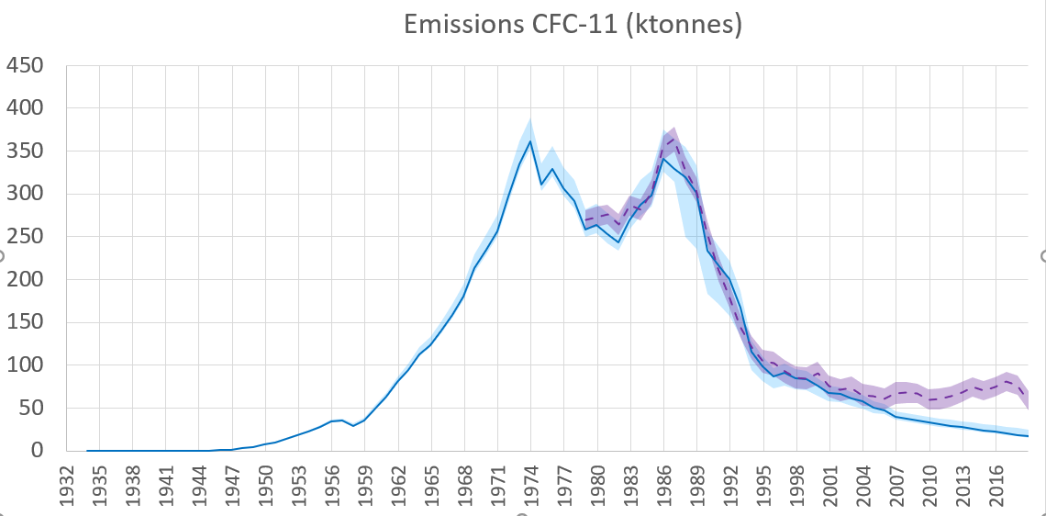

The refinement of the model yielded similar results to those of the 2019 Task Force Report. Although, the use of a lifetime distribution for both chillers and closed-cell foams resulted in a more stable emissions curve.

The analysis shows a difference between inventory-based estimated expected CFC-11 emissions (represented by the blue band and line) and the derived CFC-11 emissions (the purple band and dashed line). With the inventory-based model representing expected emissions based on historic CFC-11 production and use, the difference with derived emissions, and the period over which the difference occurs, is indicative of unreported CFC-11 production and use; emissions from CFC-11 banks alone cannot explain the unexpected increase in CFC-11 emissions between 2013 and 2018. Based on this analysis, unreported CFC-11 production and use would seem to have been already occurring earlier in the period 2007-2012.

The model was used to reconcile the differences between the estimated inventory-based emissions and those derived from atmospheric concentrations, assuming that those emissions were associated with closed-cell foam production and use (as concluded in the 2019 Task Force Report) [11]. Based on estimations of the additional CFC-11 production necessary for the inventory-based expected emissions to align with the derived emissions, unreported CFC-11 production can be estimated to be:

* 10 to 40 kilotonnes per year between 2007-2012[12]
* 40 to 70 kilotonnes per year between 2013-2018, the same as estimated in the 2019 Task Force Report for this period[13]
* 15 to 40 kilotonnes of new production, or use from recent inventory, for 2019[14].

Based on this analysis, the estimated cumulative total of unreported CFC-11 production is 320-700 kilotonnes in the period 2007-2019. Assuming usage in closed-cell foam production, this cumulative unreported CFC-11 production would lead to an estimated increase in the magnitude of the CFC-11 bank of 300 (266-333) kilotonnes by the end of 2019.

***Response to decision XXXI/3, paragraph 7(a): An analysis of CFC-11 banks by geographic location and by market sector***

An analysis of CFC-11 foam banks by geographic location and foam type is reported in response to decision XXXI/3. The majority of reported global CFC-11 production and use in closed-cell foams was in non-Article 5 parties, specifically in North America and Europe. The quantities of CFC-11 used in closed-cell foams in Article 5 parties were much smaller. The majority of this CFC-11 was used in closed-cell insulating foams for construction and refrigeration. The majority of the remaining global CFC-11 active bank remains in closed-cell insulating foams used in construction in North America and Europe. Nearly all foams used in appliances have been decommissioned and either landfilled or destroyed.

Globally, there are an estimated 750 ± 50 kilotonnes of CFC-11 in active foams banks, the majority remaining in building stock in North America and Europe, and an estimated 700 ± 50 kilotonnes in inactive foam banks in 2021[15]. For refrigeration foams, there are only an estimated 100 kilotonnes of CFC-11 blown foams remaining in the active bank in appliances and an estimated 400 kilotonnes remaining in the inactive bank in addition to the construction foam banks. The active bank of CFC-11 used in chillers is estimated to be small compared to the active banks for closed-cell foams.

***The possible fate of any co-produced CFC-12***

The quantity of CFC-12 co-produced with CFC-11 is dependent on the production route chosen, and how the plant is set up and operated. With CFC-11 as the target chemical, the range of CFC-12 co-production is up to 30% of total CFC-11/12 production for the most likely production routes. While substantial uncertainties exist, a number of factors suggest that global CFC-12 emission changes may be associated with unreported CFC-11 production: the indication of increased global CFC-12 emissions in the 2010 to 2017 period, the subsequent indicated significant reduction in global CFC-12 emissions in 2019, and the geographic origin of these changes. There are no technical reasons to believe that the conclusion of the 2019 Task Force has changed; any additional unexpected emissions of CFC-12 are likely to be as a co-product associated with the production of CFC-11, rather than from any specific production initiated to supply CFC-12 in its own applications.

***Response to decision XXXI/3, paragraph 7(b): Linkages between production of anhydrous hydrogen fluoride and carbon tetrachloride and unexpected emissions of CFC-11***

There are direct linkages between unreported CFC-11 (CCl3F) production, associated unexpected CFC-11 emissions, and the production of anhydrous hydrogen fluoride (HF) and carbon tetrachloride (CTC or CCl4), based on the normal and most likely chemical production route and its associated chemistry. However, there are important differences between the HF and CTC production linkages with CFC-11 production, which make the linkage between CTC production and unreported CFC-11 production and CFC-11 emissions the most important linkage.

Between 45 to 120 kilotonnes of CTC would be required to supply between 40 to 70 kilotonnes of CFC-11 production annually, to account for the increased CFC-11 emissions in the period 2013 to 2018, depending on the proportion of co-produced CFC-12. The CTC quantity required for CFC-11 production is expected to be at the lower end of the range if, as predicted, the objective is higher CFC-11 selectivity. In the period 2007-2019, the cumulative CTC quantity required to produce 320-700 kilotonnes of CFC-11 is at least 360 kilotonnes and could be considerably higher depending on the CFC-11 selectivity. Given the scale of production and that CTC supply to unreported CFC production was undetected for years, it seems more likely that CFC-11 production occurred within the same country, and even on the same site.

CTC is produced in chloromethanes plants as an unavoidable part of the production of dichloromethane and chloroform. China (<3,000 kilotonnes/year), the European Union (<500 kilotonnes/year), and the United States (<400 kilotonnes/year) have the largest chloromethanes production capacities, and therefore also the largest potential availability of CTC. Only China has the spare annual capacity on chloromethanes plants that might allow CTC production to supply the amounts of CTC required for large-scale CFC-11 production.

CTC is also produced (or processed) in perchloroethylene/CTC (PCE/CTC) plants, which have the flexibility to produce up to 100% of either substance according to demand. Five PCE/CTC plants are operative in Europe and the United States, and at least nine are operating in China. Spare global capacity to produce CTC by this process is estimated to be between 50-100 kilotonnes/year, existing mainly in the European Union. Many of the chloromethanes producers in China elected to build CTC to PCE plants, which transform otherwise surplus CTC into PCE.

For China, additional CTC could have been made available either by increasing the amount of CTC produced on chloromethane plants or by diverting CTC from PCE production or a combination of both. Since 2019, China has imposed additional control measures on enterprises generating CTC as by-product to prevent illegal CFC-11 production. The measures require all chloromethanes production enterprises to install a whole-process, real-time monitoring system.

***Response to decision XXXI/3, paragraph 7(d): Possible drivers of illegal production of and trade in CFC-11***

The higher pricing and lack of availability of HCFC-141b related to the ODS phase-out combined with the technical ease of conversion to CFC-11 could have been a driver for reverting to use of CFC-11 as a blowing agent. CFC-11 as a blowing could also be of interest to companies who believe that it may reduce foam flammability without using expensive fire retardants. It would be economically attractive and technically straight-forward to revert to using CFC-11 from HCFC-141b, or another fluorocarbon, as the other raw materials and equipment used to produce polyurethane closed-cell foams are compatible, with only slight modifications to ingredient ratios. There are a number of drivers that might encourage the transition back to CFC-11, including the technical and economic challenges of the phase-out of HCFC-141b in the spray foam sector and in SMEs, and challenges with alternatives.

Based on technical similarities with production routes, a liquid phase plant producing one of CFC-11/12, HCFC-22 and HFC-32 can be successfully swung to produce one or the others. Production plants with a larger range of allowable operating pressures and temperatures, such as purpose designed swing plants, can make a larger range of products. Purpose-built swing plants are designed to have the required technical requirements to change products and minimise economic impacts when swinging. Large plants built for production of a single product are technically capable of swinging to another product, but this can come at the cost of reduced capacity and product quality and are economically less suited to swinging. Micro-scale plants would be low tech and low cost, easy to relocate, hard to detect, and limited economically by small annual production capacity.

***Response to decision XXXI/3, paragraph 7(c): Types of CFC-11 products and their disposition, and opportunities for detection and potential recovery of CFC-11***

Opportunities to recover CFC-11 from products containing CFC-11 are limited to a few: active banks, mainly of insulation foams, and to a lesser extent, centrifugal chillers. Other technologies that used CFC-11, i.e., aerosols, solvents and other uses, are no longer available for disposal, detection or potential recovery of CFC-11. As the definition suggests, inactive banks, primarily as waste foam products in landfills, do not present a readily available or economically feasible opportunity to recover the associated CFC-11.

For foams, the most commonly adopted disposal practice globally is to landfill foam waste. The foam is buried and often partially crushed in the process, leading to emissions of a portion of the CFC-11contained in the foam cells. The remaining CFC-11 is emitted from landfills slowly over time, except for possibly some relatively small amounts that may undergo anaerobic degradation. Foam waste is occasionally recycled for secondary uses. Up to 50% CFC-11 can be emitted if foam is shredded/ground in waste handling.

Foams and blowing agents are incinerated (using rotary kiln incinerator, cement kiln, or municipal solid waste incinerator) in some countries. Economies of scale are important in maximising benefits and minimising costs of recovery/destruction of CFC-11 foams. Recovering CFC-11 foams only, and in isolation of foams containing other blowing agents, is less practical and less likely to succeed. Combining foam wastes containing ODS and HFCs would realise the largest economies of scale and accrue the greatest benefits.

The few remaining CFC-11 centrifugal chillers, largely in the United States, are likely to continue to be in operation for the next 10-20 years. Centrifugal chillers leak very little during operation. CFC-11 is generally carefully recovered for reuse or destruction in the United States. CFC-11 recovery rates are thought to be mostly below 10% in developing countries. Once recovered, CFC-11 is either destroyed or, if recovered for reuse, is reclaimed for re-sale. Stationary air conditioning, including centrifugal chillers, is one of the sub-sectors that is the most cost-effective for recovery/destruction of ODS and HFCs (once recycling and reclamation/reuse opportunities are exhausted).

The total active and inactive CFC-11 banks (foams, refrigerants and storage) are estimated to be 1500 ± 100 kilotonnes in 2021[16]. The total active CFC-11 bank is estimated to be 800 ± 50 kilotonnes, 3.8 Gt CO2eq, in 2021.

The global peak of decommissioned CFC-11 from the largest portion of active banks (foams), when dismantled at end-of-life, is estimated to have occurred around the year 2010, at about 45 kilotonnes/year, then decreases slowly over time, to less than 10 kilotonnes by 2050. There are underlying variations to the regional peaks in CFC-11 foam decommissioning that are obscured within the global analysis, where some regions and foam types, are likely yet to reach their decommissioning peak, e.g., Europe for foam panels in buildings. The opportunity for CFC-11 recovery and destruction lies in higher management of active foam banks at end-of-life, with potential diversion of foam wastes away from landfill and emissive secondary usage towards destruction, which mitigates the majority of emissions.

Relative investment and operating costs in ODS waste recovery and destruction present a challenge compared with cheaper forms of disposition (venting and landfill disposal). The low internalised waste disposal costs for cheaper forms of recovery and disposal can be weighed against the externalised costs to society of future health and environmental impacts of ODS emissions from venting or landfill disposal. With long building lifetimes, the drivers for recovery and destruction of building insulation foams may change over time. The evolution of net zero carbon requirements and the circular economy may improve end-of-life choices.

While encouraging parties to undertake environmentally sound destruction of surplus or contaminated end-of-life ODS/HFCs, the Montreal Protocol does not mandate the destruction of ODS or Annex F Group I HFCs. The exception is HFC-23 (Annex F, Group II) generated in manufacturing facilities, from which emissions must be destroyed to the extent practicable using technologies approved by parties. The use of destruction technologies approved by parties applies to the amounts of controlled substances destroyed and accounted for within the Protocol’s definition of “production”.

Whether a destruction technology is approved or not approved for each group of controlled substance by the Montreal Protocol does not determine if the technology is suitable to destroy ODS or HFC wastes and should not necessarily be considered a barrier to the destruction of ODS wastes. ODS foam waste recovery and destruction using a technology with reasonable ODS destruction efficiency will still result in significantly less ODS emissions than landfill disposal[17].

Destruction costs represent a minor proportion of total costs of recovery and destruction, with recovery costs being the major portion and dependent on factors such as the sector waste type, infrastructure, logistics, and transport distances. It is also important to appreciate that the recovery and destruction of waste foam is essentially considered to be a broader waste management issue.

At the global, regional and national level, detection of CFC-11 occurs through the systems of globally representative continuous measurement networks and other atmospheric measurements. Highly effective methods are used to detect unexpected activities, as evidenced by the discoveries that led to increased awareness and mitigating actions being taken by parties. Parties may wish to consider reviewing their enforcement programs and associated training to ensure that opportunities to detect CFC-11 (or any controlled substance) are not being overlooked through a lack of technical awareness about sampling and detection methods. Parties may also wish to investigate incentives and tools to encourage increased industry reporting of potentially illegal or suspicious activities to authorities.

# 1 Introduction and updates

## 1.1 Decision XXXI/3: Unexpected emissions of trichlorofluoromethane (CFC-11)

Following reported scientific findings of an unexpected increase in global emissions of CFC-11 after 2012 and the 2019 Task Force Report in response to decision XXX/3[18] in 2019, parties at the Meeting of the Parties in 2019 requested the Technology and Economic Assessment Panel (TEAP) to provide an update report, which would include any new compelling information that becomes available, and specific information as instructed in decision XXXI/3, paragraph 7.

*Decision XXXI/3: Unexplained emissions of trichlorofluoromethane (CFC-11)*

7. To request the Technology and Economic Assessment Panel to provide the parties with an update to the information provided pursuant to paragraph 2 of decision XXX/3, and to provide a report thereon to the Thirty-Second Meeting of the Parties, including any new compelling information that becomes available, as well as providing information on the following:

(a) An analysis of CFC-11 banks by geographic location and by market sector;

(b) Linkages between the level of production of anhydrous hydrogen fluoride and carbon tetrachloride and unexpected emissions of CFC-11;

(c) The types of CFC-11 products, the disposition of any such products, and opportunities and methods to detect such products and potentially recover the associated CFC-11;

(d) Identification of possible drivers of illegal production of and trade in CFC-11, such as the availability of technically and economically feasible alternatives to CFC-11 and HCFC-141b and their sustained effectiveness.

## 1.2 Composition of the Task Force

In response to decision XXXI/3, TEAP formed a temporary subsidiary body, in the form of a Task Force on Unexpected CFC-11 Emissions (the Task Force), which combines expertise from TEAP and its Technical Options Committee (TOCs), and also outside experts, to address the requirements of this decision. The membership of the Task Force is listed below. At MOP-32, parties confirmed that the Task Force could continue its work up until and including MOP-33. The Task Force differs in composition from the Task Force formed by TEAP in response to decision XXX/3 (the 2019 Task Force).

The Task Force includes a number of consulting experts, who have provided an invaluable resource. Disclosures of interests for members and consulting experts are posted on the Ozone Secretariat’s website.

|  |  |  |  |
| --- | --- | --- | --- |
| **Members** | **Relevant Expertise to the Task Force** | **Affiliation** | **Party** |
| Jose Pons (co-chair) | Production, aerosols, solvents | MCTOC member | Venezuela |
| Helen Tope (co-chair) | Production, aerosols, solvents | MCTOC co-chair | Australia |
| Helen Walter-Terrinoni (co-chair) | Foams, banks, emissions modelling | FTOC co-chair | USA |
| Paulo Altoé | Foams | FTOC co-chair | Brazil |
| Paul Ashford | Foams, banks, emissions modelling | FTOC member | UK |
| Nick Campbell | Production, supply chain | MCTOC member | France |
| Marco Gonzalez | Montreal Protocol and institutions | TEAP Senior Expert | Costa Rica |
| Jianxin Hu | Production, phase-out | MCTOC member | PRC |
| Rabinder Kaul | Production, supply chain | MCTOC member | India |
| Lambert Kuijpers | Refrigeration and air conditioning, banks, emissions modelling | RTOC member | Netherlands |
| Andy Lindley | Production, supply chain | MCTOC member | UK |
| Bella Maranion | Montreal Protocol and institutions | TEAP co-chair | USA |
| Elvira Nigido | Disposal, detection | HTOC member | Australia |
| Fabio Polonara | Refrigeration and air conditioning | RTOC co-chair | Italy |
| Miguel Quintero | Foams | FTOC member | Colombia |
| Enshan Sheng | Foams | FTOC member | Singapore |
| David Sherry | Production, supply chain | MCTOC member | UK |
| Peter Sleigh | Production, supply chain | MCTOC member | UK |
| Christina Theodoridi | Catalyst, emissions modelling | NRDC | Greece |
| Jianjun Zhang | Production, supply chain, solvents | MCTOC co-chair | PRC |
| **Consulting Experts** | **Relevant Expertise to the Task Force** | **Affiliation** | **Party** |
| Paul Fraser | Atmospheric science | CSIRO | Australia |
| Nick Harbeck | Modelling | Air-Conditioning, Heating, and Refrigeration Institute | USA |
| Steve Montzka | Atmospheric science | NOAA | USA |
| Matt Rigby | Atmospheric science | University of Bristol | UK |
| Susan Solomon | Atmospheric science | MIT | USA |
| Guus Velders | Atmospheric science and modelling | Utrecht University | Netherlands |

## 1.3 Overview of the 2019 Task Force Final Report

Decision XXX/3 requested TEAP to “*provide information on potential sources of emissions of CFC-11 and related controlled substances from potential production and uses, as well as from banks, that may have resulted in emissions of CFC-11 in unexpected quantities in the relevant regions*” and to prepare a preliminary report for OEWG-41 and a final report for MOP-31. The 2019 Task Force Final Report added directly to the preliminary report to conclude TEAP’s response to decision XXX/3.

The key messages from the 2019 Task Force Report are reproduced in Appendix 1 and summarised below:

* Pre-2010 CFC-11 production and usage is unlikely to explain the unexpected increase in CFC-11 emissions, including existing foam banks.
* It is unlikely that there has been a resumption of newly produced CFC-11 usage in refrigeration and air-conditioning uses, flexible foams, aerosols, solvents, feedstock uses, tobacco expansion and other miscellaneous applications.
* It is likely that there has been a resumption of newly produced CFC-11 usage in closed-cell foams.
* Newly produced CFC-11 usage in closed-cell foams results in immediate CFC-11 emissions increase, and long-term emissions increase resulting from enlarged foam banks.
* An estimated 40 to 70 kilotonnes/year CFC-11 production would be required to supply the post-2010 foams usage and other associated emissions.
* 45 to 120 kilotonnes/year CTC would be required to supply the estimated CFC-11 production, likely at lower end of the range.
* Most likely CFC-11 production routes were considered to be:
  + CTC to CFC-11/12 on a large-scale (≥ 50 kilotonnes/year) in an existing liquid phase plant (HCFC-22 and/or HFC-32 plant)
  + CTC to CFC-11 on micro-scale (0.1 to 2 kilotonnes/year) plants using minimal equipment (to make low grade CFC-11 for foam blowing use)

## 1.4 The 2021 Task Force Report

The 2021 Task Force Report addresses the elements of decision XXXI/3 with updates to information provided in the 2019 Task Force Report, new compelling information that has become available, as well as information on specific requests contained in sub-paragraphs 7(a) to 7(d).

The 2021 Task Force Report is organised as follows:

* Chapter 1 provides an introduction to this report and background on the 2019 Task Force Report, the unexpected CFC-11 emissions, summary updates to the science findings relating to CFC-11 emissions, summary science findings on CFC-12 and carbon tetrachloride, and a summary of published studies on CFC-11 bank estimates.
* Chapter 2 provides information on the methodology for the inventory-based model used by the 2019 and 2021 Task Forces, and further refinements made to this methodology, historic CFC-11 production and use-patterns, and an analysis of CFC-11 banks by geographic location and foam type (decision XXXI/3, para. 7(a)).
* Chapter 3 provides updates to estimated CFC-11 production quantities based on the modelling and the newest atmospheric observations for 2019, updates to the possible fate of any co-produced CFC-12, and information on linkages between the production of anhydrous hydrogen fluoride and carbon tetrachloride and unexpected CFC-11 emissions (decision XXXI/3, para. 7(b)).
* Chapter 4 provides information on possible drivers of illegal production of and trade in CFC-11, addressing technical and economic factors in the demand for CFC-11 in foams and in the production and supply of CFC-11 (decision XXXI/3, para. 7(d)).
* Chapter 5 provides information on the types of CFC-11 products and their disposition, and opportunities for detection and potential recovery of CFC-11 (decision XXXI/3, para. 7(c)).
* Appendices include key messages from the 2019 Task Force Report and more detailed information about the inventory-based model, product lifetimes in the global and regional models, foam model assumptions, regional summaries of foam sectors and distribution from the 2006 FTOC Assessment Report, and polyurethane foam blowing agent CFC-11 replacement.

## 1.5 Background to the unexpected CFC-11 emissions

CFC-11 (trichlorofluoromethane, CFCl3) was used primarily as a foam-blowing agent (for flexible (open cell) polyurethane foams for furniture and other comfort uses and for rigid (closed-cell) polyurethane thermal insulating foams), as an aerosol propellant, as a refrigerant (for centrifugal chillers mostly used in large commercial buildings), and in a range of other smaller uses, including asthma inhalers, and tobacco expansion. There are alternative chemicals or products available as replacements for CFC-11. However, a bank of CFC-11 remains present in closed-cell foams and centrifugal chillers, from which CFC-11 is released slowly into the atmosphere over time, until reaching end-of-life.

Global reported production of CFC-11 peaked in 1987 at 434 kilotonnes in mostly non-Article 5 parties, and in 1997 at 46 kilotonnes in Article 5 parties. Peak emissions were about 350 kilotonnes/year in the late 1980s[19]. Under the Montreal Protocol, production and consumption of CFC-11 in non-Article 5 parties was phased out by 1996; production and consumption of CFC-11 in Article 5 parties was phased out by 2010. Exceptions were made for small amounts of CFC-11 production for essential uses (i.e., metered dose inhalers for the treatment of asthma and chronic obstructive pulmonary disease), as authorised by parties, and for non-Article 5 parties to produce CFC-11 for the basic domestic needs of Article 5 parties. As of 1995, there have been alternative chemicals or products available as replacements for CFC-11, including non-fluorocarbon and fluorocarbon blowing agents for foams and fluorocarbons for centrifugal chillers[20].

The Montreal Protocol was established to protect the stratospheric ozone layer by phasing out the production and consumption of ozone-depleting substances (ODS), such as chlorofluorocarbons (CFCs). Successful measures were taken, and the abundance of fully halogenated ODS peaked in the late 1990s and continuously decreased thereafter.

However, Montzka *et al.*[21], in a letter to Nature in 2018, reported an unexpected, global increase in CFC-11 emissions of 13 ± 5 kilotonnes/year after 2012. The study strongly suggested a concurrent increase in CFC-11 emissions from eastern Asia although the contribution of this region to the global increase was not quantified. The study also suggested that the CFC-11 emissions increase had arisen from new production had not been reported to the Ozone Secretariat, which is inconsistent with the agreed Article 5 phase-out of CFC production by 2010.

Subsequently, in July and November 2018, the Environmental Investigation Agency published findings of its investigations into potential sources of the increased CFC-11 emissions from eastern Asia[22]. Parties and the international media[23] also investigated and identified and/or reported on potential sources of these emissions. In November 2018, parties responded with decision XXX/3 on the unexpected emissions of CFC-11 and, among other things, requested the SAP and the TEAP to prepare reports.

In a letter to Nature, in 2019, Rigby *et al.*[24] reported increased emissions of CFC-11 from eastern mainland China, with emissions shown to be 7.0 ± 3.0 (±one standard deviation) kilotonnes/year higher in 2014–2017 than in 2008–2012, arising primarily from the northeastern provinces of Shandong and Hebei. These regional emissions were found to account for at least 40-60% of the global increase in CFC-11 emissions. The paper reported that there was no evidence of any significant increase in CFC-11 emissions from any other regions of the world that were adequately monitored by atmospheric measurements, and that there are some regions where there is limited available data[25]. Between 2008 and 2012, annual global derived emissions of CFC-11 were 64 ± 2 kilotonnes/year based on observations from AGAGE or 63 ± 2 kilotonnes/year, based on observations from NOAA[26]. Based on several considerations, Rigby *et al.* suggested that the increase in CFC-11 emissions from eastern mainland China was likely to result from new production and use of CFC-11.

## 1.6 Summary of Science findings since 2019

*Decision XXXI/3: Unexplained emissions of trichlorofluoromethane (CFC-11)* requested that TEAP provide an update of any new compelling information available. This section summarises the most recent scientific findings related to this topic.

### 1.6.1 The Report on Unexpected Emissions of CFC-11, World Meteorological Organization[27]

In 2018, parties requested the Scientific Assessment Panel (SAP) (Decision XXX/3) to review newly available information related to the unexpected increase in CFC-11 emissions, which is provided in *The Report on Unexpected Emissions of CFC-11* (the SAP Report)[28]. The following briefly summarises the findings from that report as background for this 2021 Task Force Report.

Global annual totals for CFC-11 emissions are derived from atmospheric concentration measurements of CFC-11 at remote sites throughout the globe and an understanding of global loss rates, or CFC-11's global atmospheric lifetime. These “atmosphere-based” or “atmosphere-derived” global emissions are inferred from estimates of globally averaged concentrations and their changes interannually as supplied by the Advanced Global Atmospheric Gases Experiment (AGAGE) and the National Oceanic and Atmospheric Administration (NOAA) global atmospheric monitoring networks. These measurement programs continually monitor the atmospheric abundances of CFC-11, other ozone-depleting substances and most long-lived substitute chemicals. New information from those networks was incorporated into the SAP Report.

The SAP Report notes that there was an expectation that global emissions of CFC-11 would continue to gradually decrease after 2010 because of the phase-out of production and consumption of CFC-11 globally. If this had happened, the decline in global mean concentration would have accelerated until emissions were negligible, but instead, the concentration decline slowed after 2012. Global CFC-11 atmospheric abundances declined by approximately 0.8% yr-1 from 2002 to 2012, but during the period from 2014 to 2018, the decline was reduced or slowed to 0.5% yr-1.

Notably, the mean global emissions derived for 2014–2016 (67 ± 3 kilotonnes yr-1) was estimated to be 13 ± 5 kilotonnes yr-1 larger than for 2002–2012. Emissions in 2018 (70 ± 10 kilotonnes yr-1) were similar to the 2014–2017 mean. CFC-11 atmospheric concentrations declined at a mean rate of –0.7% yr-1 from 2018 to 2019. The faster concentration decline measured after 2018 indicated that global emissions in 2019 were 18 ± 6 kilotonnes yr-1 lower than they had been during the 2014-2018 period.

Concurrent with the slower decline in atmospheric abundance was a notable increase in the mean hemispheric concentration difference. Increasing hemispheric differences in CFC-11 concentrations, with larger values in the northern hemisphere, suggest that the sources of unexpected emissions from 2012 to 2018 were predominantly in the northern hemisphere.

Measurements taken from the Hateruma, Japan and Gosan, Korea stations, allowed regional emissions to be estimated from eastern Asia. The regional estimate indicated an increase in CFC-11 emissions from Eastern China by 7 ± 4 kilotonnes yr-1 from 2014–2017 compared to 2008–2012 periods, thus accounting for 60 ± 40% of the global increase. In 2019, emissions from Eastern China declined by 10 ± 3 kilotonnes yr-1 relative to emissions during 2014 to2017. This regional emission decrease accounted for 60 ± 30% of the global decline.

Although there is continued refinement of estimated bank calculations, the increase of global CFC-11 emissions after 2012 and the subsequent reduction in 2019 is not considered to be the result of changes in CFC-11 bank releases. The World Meteorological Organization noted in its 2021 SAP Report, “*emission increases observed to date are small enough so that they will not have a major impact on CFC-11 atmospheric abundances and therefore will not have a major impact on the expected stratospheric ozone recovery. However, increases in banks and how they might augment future emissions remains to be tightly constrained.*”

The unreported production since 2010 likely enhanced banks globally as well as leading to unexpected emissions, although the precise quantification is not yet clear. According to the SAP Report, a simplified model estimated that the bank of CFC-11 is 1475 kilotonnes for 2018 while another study by Park *et al.*[29] estimates the range of 900 to 2300 kilotonnes without consideration of the unreported production and suggest that the additional banks in eastern China as of 2019 could be as high as 112 kilotonnes.

### 1.6.2 Additional Studies: Atmospherically derived CFC-11 emissions.

The unexpected increase of global CFC-11 emissions that first emerged in 2013 continued through 2018 and then declined to pre-2013 levels by 2019, according to a new study by Montzka *et al*.[30] The global atmospheric concentration measurements were obtained through the National Oceanic and Atmospheric Administration (NOAA) and the Advanced Global Atmospheric Gases Experiment (AGAGE) monitoring networks. Global emissions are derived from atmospheric mole fraction measurements with consideration of the lifetime of CFC-11 and changes in atmospheric transport and mixing. Measurements from all remote sites concur that atmospheric CFC-11 concentrations declined at a substantially accelerated rate during 2019. Emissions of CFC-11 declined abruptly to 52 ± 10 kilotonnes/year in 2019, which is comparable to global emissions before the unexpected uptick occurred.

Expectations of future emission magnitudes are uncertain because they rely on estimates of the total amount of unreported CFC-11 production, how it was used and estimates of the banks. These factors influence estimates of new CFC-11 produced and added to the bank. The most likely use of the newly produced CFC-11 is for manufacturing closed-cell foams[31]. Based on that assumption, and using industry estimates for fugitive emissions from foams, Montzka *et al*. calculate that global unreported production between 2013 and 2018 averages 25−100 kilotonnes/year. This implies that unreported CFC-11 production resulted in a 90−725 kilotonnes increase of the global foam banks by the beginning of 2020.

Emission reductions in eastern mainland China contributed to 60 ± 30% of the global emission decline of CFC-11 in 2019, according to measurements from sites sensitive to that region (Gosan Island in South Korea, Hateruma Island in Japan). Other, still unknown, regions also must have contributed to the post-2017 reduction. A significant amount of the emission enhancements observed during 2014-2018 and subsequent emission reduction in 2019 have likely occurred in regions not directly monitored by the current network of monitoring stations; for clarity, this could include other regions within China that are not monitored.

According to Rigby *et al.*[32], the CFC-11 emissions magnitude from eastern China in 2019 (5.0 ± 1.0 kilotonnes yr-1) is comparable to pre-2013 levels. Rigby *et al.* also estimates that cumulatively, the excess emissions of CFC-11 from eastern mainland China between 2013 and 2018 are 34–60 kilotonnes. If additional production was used in the manufacture of closed-cell foams or other non-emissive applications, a larger quantity of CFC-11 would have been produced since a fraction of what was produced would have augmented the bank.

### 1.6.3 CFC-12

CFC-12 is typically (but not necessarily) co-produced during the manufacture of CFC-11 and was mandated to cease by 2010 under the Montreal Protocol, except for small quantity exemptions for metered-dose inhalers until 2015. The rate of decline of global derived atmospheric emissions of CFC-12 (CCl2F2) was slower in the 2010–2017 period compared to the 2000–2009 period. Global CFC-12 emissions decreased at 12 ± 2% yr-1 during 2000–2009 which slowed to 5 ± 2% yr--1 during 2010–2017. Global CFC-12 emissions in 2019 were 21 ± 7 kilotonnes yr--1, which is 38 ± 15% lower than estimated for 2018, indicating a significant reduction in global CFC-12 emissions, which is similar to the timing of the global CFC-11 emission decline. Significant emission decreases for CFC-12 were also observed to originate from Eastern China during the 2016-2019 period compared to 2000 to 2009[33].

### 1.6.4 Carbon tetrachloride (CCl4)

Global CCl4 emissions have remained elevated above expectations for many years, and year-to-year changes have significant uncertainty, which currently precludes a robust assessment of the relationship between global emissions of CCl4 and CFC-11. Global CCl4 emissions did not significantly decline during the 2010–2019 period (0.1 ± 0.2 kilotonnes yr-1); compared to the 2000–2009 period (1.6 ± 0.3 kilotonnes yr-1). However, the SAP Report suggests that an inverse analysis of CCl4 observations indicates that CCl4 emissions increased from Eastern China after 2012 and then subsequently decreased around 2017 estimating that regional emissions of CCl4 from Eastern China increased from 6.0 ± 1.4 kilotonnes yr-1 during 2011–2012 to 10 ± 2 kilotonnes yr-1 for 2014–2017, before declining over 2017–2019 to values which were consistent with the 2011–2012 average.

### 1.6.5 Stratospheric Ozone Depletion Recovery

The SAP Report[34] anticipates recovery from stratospheric ozone depletion will not be substantially delayed by these enhanced CFC-11 emissions because they were significantly elevated only for a brief time, assuming future compliance with the Montreal Protocol phase-out of CFC-11 production. Ozone recovery, measured as a return to 1980 levels, will be delayed by 0.4–1.3 years globally and by 0.5–3.1 years for the Antarctic ozone hole as a result of these emission enhancements.

Additions of newly produced CFC-11 to foam banks that would continue to increase future CFC-11 emissions above expectations and uncertainty around bank magnitudes and release rates in general adds imprecision to estimates of total future ozone depletion associated with the unreported CFC-11 production.

Assuming decreasing CFC-11 emissions from banks, the projected global cumulative CFC-11 emissions for 2020–2060 are estimated to be 580–780 kilotonnes based on only reported production in estimates from previous Assessments. Emissions from unreported production after 2012 are expected to total 60-200 kilotonnes for 2020-2060 depending on the assumed rate of release from the banks.

Note that additional CFC-12 and CCl4 emissions to date, possibly associated with the enhanced CFC-11 production, will lead to small additional impacts on future ozone depletion, delayed ozone recovery, and greater climate forcing. CFC-11 atmospheric abundances are projected to continue to decline in emission scenarios that assume future compliance with the Montreal Protocol.

Rigby *et al.* confirms the SAP conclusion and estimates that the cumulative increase inferred for CFC-11, CFC-12, and carbon tetrachloride production and use in eastern mainland China between 2013 and 2018 accounts for 71 (52–90) kilotonnes of CFC-11-equivalent emissions in terms of stratospheric ozone depletion and 362 (247–479) Tg of CO2–equivalent emissions[35]. The harm of these additional regional emissions to the ozone layer has been dampened by the relatively short duration of the unexpected emissions spike.

The 2021 SAP Report estimates that, in total, Antarctic ozone loss associated with these additional emissions will be less than 0.2%[36].

### 1.6.6 Published studies of CFC-11 bank and emissions estimates

The fraction of CFC-11 that has been historically manufactured but not yet emitted resides in the bank; mostly overwhelmingly contained in insulating foams in buildings.The magnitude and characteristics of the CFC-11 bank affect ongoing and future CFC-11 emissions and how emissions are expected to change in the absence of unreported production. There are several parameters that affect our estimates of the size of the bank, many of which are not well constrained.

In the absence of unreported production after 2010, the increase in CFC-11 emissions would have originated from an accelerated depletion or loss of CFC-11 from banks or other stocks. The 2019 Task Force, using an inventory-based model, had previously estimated that the bank in 2018 was approximately 1400 to 1700 kilotonnes[37]. A different probabilistic modelling technique used by Lickley *et al.* suggests a bank range of 878– 2264 kilotonnes for 2018[38]. Both analyses concur that the elevated emissions detected during 2013-2018 suggest unreported production and cannot be attributed to increased releases from the pre-existing CFC-11 bank.

According to the Lickley *et al.* model, uncertainties in CFC banks have been underestimated by previous estimates, in part due to apparent underreporting of production and potential underestimation of the atmospheric lifetime, and that substantial CFC-12 banks are likely still present. The analysis also concurs that the observed uptick in CFC-11 emissions was likely due to production after the 2010 global phase-out. This additional production would also likely increase the CFC-11 bank size. Finally, CFC-113 was found to have substantially higher emissions than what was expected from the banks alone after 2010. CFC-113 is a feedstock used for production of other chemicals which may help explain its emissions, but further analysis is warranted.

Another recent study by Lickley *et al*.[39] (2021) simultaneously considered time-dependent atmospheric lifetimes, banks, and emissions of CFC-11, CFC-12, and CFC-13 in a probabilistic framework. Their best estimate of the 2014-2016 unexpected emissions of CFC-11 is 23.2 kilotonnes/year (with a 95% confidence range of 13.7-35.8). Their analysis also indicates unexpected emissions of CFC-12 over these years at a comparable level to CFC-11, about 18 kilotonnes/year (with an increase at 95% confidence of 11.8 to 22.7). They found emissions of CFC-113 (CFC-113 and CFC-113a) of about 8 kilotonnes/year (with a 95% confidence range of 6 to 11), which they suggest is substantially larger than expected from its allowed reported global use in feedstocks.

# 2 Updated Task Force modelling of CFC-11 emissions and banks

## 2.1 Summary of inventory-based model

The inventory-based model is an inventory-based analysis, built on historically reported global CFC-11 production and use. This model builds on the work conducted for the 2019 Task Force Report[40]. CFC-11 was used in several applications that can be broadly grouped in 3 market sectors: closed-cell foams, centrifugal chillers (R/AC), and emissive uses (e.g., open-cell foams, solvents, aerosols). CFC-11 remains in chillers and foams and is gradually released in part to the atmosphere over the product’s useful lifetime. CFC-11 is emitted at different stages of the product’s lifetime of the products. The fractions of CFC-11 that are released vary by product, life-cycle stage (servicing, end-of-life dismantling) and regional practices. Identifying the appropriate emission rates for each stage and product is important to confidently estimate expected emissions[41]. The CFC-11 that remains in products and equipment is described as a bank, which is characterised as active if the product is still in use or as inactive if the product has been decommissioned. The time-series of emissions from different products and at different stages over the lifetime produces the expected emissions profile of CFC-11. The estimated expected emissions, produced by the inventory-based model, are then compared to global emissions derived for CFC-11 from atmospheric concentration measurements (derived emissions) and our understanding of its global loss rate, or lifetime.

## 2.2 Inventory-based model methodology

Total sales of CFC-11 from 1930 were voluntarily reported by industry to the Alternative Fluorocarbons Environmental Acceptability Study (AFEAS)[42]. The AFEAS database includes audited production and sales data from Argentina, Australia, Brazil, Canada, France, Germany, Greece, Italy, Japan, Mexico, Netherlands, South Africa, Spain, United Kingdom, the United States and Venezuela. While extensive, the database did not encompass data from China, Czech Republic, India, North Korea, South Korea, Romania and Russia[43].

Since 1989 parties are required by the Montreal Protocol to report their national annual total production, import, and export quantities of controlled substances, including CFC-11, to the Ozone Secretariat. The present global inventory-based analysis uses total production quantities from both AFEAS and the Ozone Secretariat, adjusted to include estimates of CFC-11 produced in countries not reporting to AFEAS between 1968-2000[44].

CFC-11 was historically produced for use in centrifugal chillers, closed-cell foams, and for several emissive applications such as open-cell foam production, aerosols etc (referred to as emissive uses). The quantification of expected CFC-11 emissions is based on several assumptions regarding losses during the charging, operation and decommissioning of chillers, the foam blowing process and during the life of the foam *in situ* as well as the use of aerosols, and solvents. The model also incorporates assumptions about fugitive emissions from the chemical production plants, the lifetime of products, the market breakdown among applications and the handling of products at the end of their useful life. A range of assumptions is tested and bound based on literature and expert input.

**Figure 2.1 Pictorial of CFC-11 lifecycle**

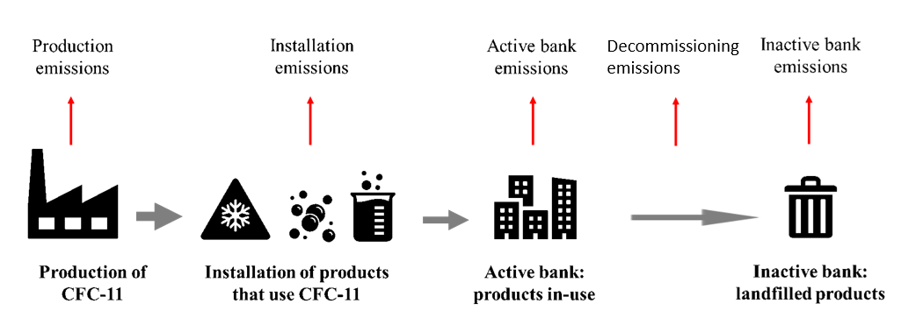

Historically, CFC-11 production was concentrated in non-Article 5 parties in the mid-1980s. Production in Article 5 parties gradually increased over the mid-1990s. Global reported production of CFC-11 peaked in 1987 at 434 kilotonnes in non-Article 5 parties, and in 1997 at 46 kilotonnes in Article 5 parties. Complete phase-out of CFC-11 production and consumption were mandated by 1996 in non-Article 5 parties and by 2010 in Article 5 parties.

## 2.3 Model assumptions for CFC-11 market sectors and production

The following section provides a short overview of each of the CFC-11 market sectors, which is important information for establishing inputs and parameters for the inventory-based model. For this report, the Task Force refined the model using a Weibull distribution[45] (Appendix 3) to better represent varying chiller and foam lifetimes rather than using average lifetimes, which were used in the model for the 2019 Task Force Report[46]. The model also incorporates new information regarding refrigerant management practices, especially with respect to reclaimed refrigerant.

### 2.3.1 Centrifugal chillers

CFC-11 was extensively used as a refrigerant in large, water-cooled centrifugal chillers (referred to as R/AC in previous reports). Approximately 80-90% of centrifugal chillers in the 1970s and 1980s used CFC-11[47]. They have historically been over-designed, well-engineered equipment. Chillers represent a significant capital investment and difficult to access as they were often installed in second basements in North America. As a result, they have been largely well-maintained, and there are still chillers in service using CFC-11 today.

Centrifugal chillers leak very little during operation (0.5%-2% of their refrigerant charge per year). An operating chiller evaporator temperature would be approximately 0-5oC indicating a CFC-11 pressure of 40-50 kPa (0.4-0.5 bar), which is below atmospheric pressure. With the inside evaporator remaining below atmospheric pressure, the smallest opening would result in air leaking into the evaporator instead of CFC-11 refrigerant leaking out of the system[48].

*Technology adoption—* The use of CFC-11 in centrifugal chillers commenced in the mid-1930s and peaked in the late 1980s. For many years, the vast majority of most CFC-11 chillers were manufactured and installed in North America and Japan[49]. Installation of centrifugal chillers in the United States and Canada peaked between 1980-1989, whereas exports from the United States expanded in the 1990s. United States’ manufacturers started switching their production lines to alternative refrigerants around 1992. More than 90% of total CFC-11 chiller production ceased around 1996.

Some chillers were shipped to other regions[50]; however, not all countries around the world adopted this technology. CFC-11 chillers did not become popular in Europe and the few that existed were generally retrofitted to other refrigerants years ago[51].

Article 5 parties represent a much smaller fraction of the CFC-11 chiller market. Equipment manufacturers in China started producing CFC-11 chillers in the 1960s and 1970s. Some CFC-11 chillers were installed in the Middle East and Asia where it is likely that a few are still running. Most countries in Latin America largely adopted air-cooled technologies instead of CFC-11 centrifugal chillers. Brazil, nevertheless, had a significant inventory of CFC-11 centrifugal chillers[52].

Procedures were developed to convert CFC-11 chillers to HCFC-123, a low-pressure refrigerant with better energy performance, which was commercialized in the mid- to late 1990s. Servicing companies estimated that 30,000-70,000 CFC-11 chillers were in operation in the United States in 1994-1996. They also note that approximately 50% of CFC-11 chillers were converted to HCFC-123 in the United States largely prior to 2010. The proportion replaced with alternative technologies is unknown. A small number of CFC-11 chillers may have been converted in other countries prior to 1998.

*Equipment lifetime—*For this report, CFC-11 chillers are assumed to have a 29-year average lifetime[53] before decommissioning and retirement from service. Since they are well-engineered equipment with very low leak rates during operation, they are often kept online for several decades, sometimes reaching lifetimes of up to 50 years. Although there are some chillers still in operation in other parts of the world, the vast majority of remaining CFC-11 are largely still in service in the United States[54]. In this analysis, the Task Force used a Weibull[55] function to provide a probabilistic analysis for the lifetime of CFC-11 chillers, with an average of 29 years. For comparison, in the 2019 Task Force assumed a single-point average lifetime of 25 years. The Weibull distribution is used by the California Air Resources Board and the U.S. Department of Energy for appliance lifetimes.

*Refrigerant losses—* Due to the low-pressure environment in the evaporator of centrifugal chillers, air flows into the system when a leak occurs in the evaporator. To release the air, purges are usually employed. A purge separates the air from the refrigerant, vents the air, and returns the refrigerant to the chiller. According to industry experts, prior to the phase-out when the cost of refrigerant was estimated to be $1 per pound, the use of low-efficiency purges resulted in the release of refrigerant alongside any air being removed from the system. Any CFC-11 chillers still in operation today are likely to have low-emission purges and the resulting very low CFC-11 releases.

Leaks can also occur in the condenser, which, in contrast to the evaporator operates at positive pressure (higher than atmospheric pressure) and therefore leaks would result in refrigerant released to the atmosphere. In addition, a fraction of the CFC-11 that was sold into the chiller sector was used to clean equipment. The Task Force assumed that prior to 1990, 5% of the CFC-11 refrigerant sold in the chiller sector is either used as a cleaner or released prior to the adoption of high-efficiency purges. For later years, the fraction was reduced to 1% with the adoption of better practices.

Refrigerant that leaks from an appliance is periodically replaced during servicing. Leak rates are used to calculate the quantity of refrigerant needed to regularly charge the equipment. The model offers some useful insight on the minimum amount of reclaimed CFC-11 that would be necessary to service the existing stock of CFC-11 chillers. Industry experts noted that reclamation increased in North America around 1993. The Task Force assumed for modelling purposes that after 1995, when CFC-11 was phased out in non-Article 5 parties, chillers were serviced using reclaimed refrigerant as needed. Some companies reportedly stockpiled CFC-11 to service equipment after the phase-out and some small quantities of that inventory still exists in the United States.

The End- of-Life model assumptions reflect this additional information, assuming that reclamation started becoming common practice in the United States, where the majority of remaining CFC-11 chillers are installed, following the production bans.

Less than 8% of the AFEAS CFC-11 sales data were reportedly sold for use in chillers. The overall bank of CFC-11 used in chillers was consequently estimated to be comparatively small compared to the banks for closed-cell foam after 1970. Based on the small number of remaining chillers in service, the low emissions rates (0.5% per annum) of centrifugal chillers and end-of-life management in regions with a remaining centrifugal chiller bank, the estimated emissions today from CFC-11 chillers are dwarfed by emissions from closed-cell foams.

### 2.3.2 Closed-cell foams

CFC-11 was sold as a blowing agent for the manufacture of closed-cell foams. The use of CFC-11 in closed-cell polyurethane foams (e.g., insulating foams in appliances and construction) started to increase in the mid-1960s. The majority of the global CFC-11 bank was installed in the 1970s and 1980s in North America and Europe in response to the energy shortages and pricing at that time. CFC-11 blown foams used to insulate appliances (e.g., refrigerators) are unlikely to still be in the active bank except in relatively small quantities. Numerous buildings containing CFC-11 blown foam insulation are likely still in service in North America, Europe and in other parts of the world.

The 2019 Task Force assumed that the principal market for CFC-11 after the late 1990s was likely for use in closed-cell foams as lower cost, efficacious options were available for flexible foams and other emissive uses as well as for chillers. The 2019 Task Force Report concluded that it is likely that a resumption of newly produced CFC-11 usage in closed-cell foams in some regions was the dominant cause for the emission increase after 2012, due to technical ease and economic advantage of its use[56].

The majority of the blowing agent remains trapped in the foam’s closed cells during the product’s operational life. During decommissioning, there is generally a notable release of a portion of foam blowing agent; although, there are some technologies such as appliance reclamation processes that collect the blowing agent. Closed-cell foams are mostly used in building envelopes and in appliances, the rate, timing, and manner of decommissioning of buildings and appliances determines the timing of the release of a portion of the blowing agent from the bank.

Additional information was incorporated in the global emissions model to provide more detail based on region, foam product and varying production and bank handling techniques. Two modelling techniques were used in this report.

A Weibull distribution for the lifetime of closed-cell foams was used, with an average global lifetime of 30 years and it incorporated a 2% average release rate from the active bank. An inventory-based build of regional and product-based lifetimes was also created using the Weibull distribution and varying lifetimes based on product-type and regional use with limited differences in outcome and is included in the Appendix 3. Details of the Weibull distribution analysis can be found in the appendices. Note that anaerobic degradation or bioremediation have not been incorporated into any of the models in this report which has been theorized to potentially reduce emissions of CFC-11 from landfills[57].

### 2.3.3 Emissive uses (aerosols, open-cell foams, tobacco expansion)

CFC-11 was sold for use in several highly emissive applications. The main use of CFCs until the 1980s was as a pressurized propellant liquid in aerosols and for other emissive applications including open-cell foams, and tobacco expansion. These applications are characterized as being highly emissive because the vast majority of CFC-11 is emitted during product manufacture or product usage. There have been cost-effective, suitable alternatives to CFC-11 in these uses for more than 20 years. It is unlikely that any significant resulting banks remain for this market sector. The Task Force did not make any additional refinements to these uses in the model.

### 2.3.4 CFC-11 production

In both the 2019 Task Force Report and the 2021 Task Force Report, AFEAS data and data from the Ozone Secretariat were combined with additional data from parties to build a production model.

## 2.4 CFC-11 emissions and banks based on the updated methodology

The Task Force incorporated updated atmospherically derived emissions estimates from 1979 through 2019 based on AGAGE data from Engel and Rigby *et al*., 2018[58] into this analysis. The data is derived from a 12-box model, assuming a constant 52-year atmospheric lifetime of CFC-11[59].

The refined TEAP inventory model calculates expected emissions and bank magnitudes based on an understanding of industry practices, release rates during different stages of each product type’s lifecycle, and refrigerant management during operation and at end-of-life.

Without incorporating additional production from the unexpected emissions increase after 2012, the inventory model yields a CFC-11 bank in 2019 of 1500 ± 100 kilotonnes and 22 ± 7 kilotonnes of CFC-11 emissions. The Task Force investigated a range of assumptions, resulting in the range of emissions uncertainties represented by the blue ribbon in Figure 2.2 (see Appendix 2 for details).

A mid-range scenario was developed by the 2019 Task Force titled the “most-likely” scenario using assumptions defined by that Task Force. The “most-likely” scenario is illustrated in the Figure below as the solid blue line. The emissions predicted by the model are particularly sensitive to the assumptions made regarding the level of potential increased production over the years (i.e., where production was assumed to be higher than reported), the installation emissions rates, as well as the emissions rates from rigid foam banks. In the later years, the model is also sensitive to the lifetime of chillers and foams as well as the emissions rate from the inactive foam bank. The full range of uncertainty has not been probed here, but the calculations are illustrative of expected behaviour.

The purple shaded area indicates the range of atmospherically derived CFC-11 emissions, whereas the dashed line indicates the mean atmospherically derived emissions. The purple uncertainty region would be larger if uncertainties and time-dependence in atmospheric lifetimes were considered with a single constant value of 52 years[60].

The refinement of the model yielded similar results compared to the 2019 Task Force Report. The following Figures compare the results of the current model with the 2019 Task Force Report. The purple line indicates current modelling, whereas the blue indicates the results presented in the 2019 Task Force Report. The use of a lifetime distribution for both chillers and closed-cell foams resulted in a more stable emissions curve.

Less than 8% of the AFEAS CFC-11 sales data were reportedly sold for use in chillers. The overall bank of CFC-11 used in chillers was consequently estimated to be comparatively small compared to the banks for closed-call foam after 1970. However, the simple average used for lifetimes in the model in the 2019 Task Force Report clustered decommissioning of chillers such that there was a noticeable increase in emissions from 2008 to 2011. The Weibull distribution eliminates the discrete emissions peaks during decommissioning introduced by the simple average

The lifetime distribution, combined with revised end-of-life assumptions for chillers leads to a larger bank from 1990 to 2020 due to the use of the Weibull distribution rather than the simple average lifetime. The model concurs with previous research that the banks are not sufficient to explain the spike in CFC-11 emissions observed from 2012 to 2018 notably during a period of a decline in the retirement of foam and chillers containing CFC-11.

The analysis shows a difference between inventory-based expected CFC-11 emissions (represented by the blue band and line) and the atmospherically derived CFC-11 emissions (the purple band and dashed line). With the inventory-based model representing expected emissions based on historic CFC-11 production and use, the difference with atmospheric derived emissions, and the period over which the difference occurs, is indicative of unreported CFC-11 production and use. Based on this analysis, unreported CFC-11 production and use would seem to have been already occurring earlier in the period 2007-2012. Chapter 3 provides the conclusions for estimated unreported CFC-11 production that can be deduced from this analysis to account for the unexpected CFC-11 emissions.

Figure 2.2 CFC-11 derived and inventory-based estimated emissions (kilotonnes)



Figure 2.3 CFC-11 bank as calculated from the updated inventory-based TEAP model (kilotonnes)

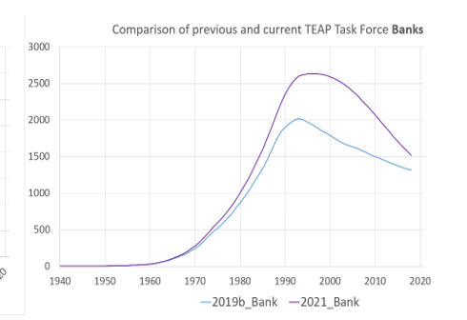

The refinement of the model yielded moderately different results compared to the 2019 Task Force Report. The following Figures compare the results of the current model compared with that of the 2019 Task Force’s previous report. The purple line indicates current modelling, whereas the blue indicates the results presented in the 2019 Task Force Report. The use of a lifetime distribution for both chillers and closed-cell foams resulted in a smoother emissions curve. The lifetime distribution, combined with revised end-of-life assumptions for chillers leads to a slightly larger bank from 1990 onward. The model concurs with previous research that the banks are not sufficient to explain the spike in CFC-11 emissions observed from 2012 to 2018.

The rate of decline of both emissions and bank size is substantial post-2007. Looking at the source of emissions it is clear that the decline is largely driven by active bank emissions as well as emissions during the dismantling process of chillers (“inactive chiller bank 1st year emissions”). The rate of decline in the active bank is dominated by the decline in the closed-cell foam bank emissions and to a lesser degree the chiller bank emissions. The Task Force also estimated emissions and banks based on individual regional and foam sector estimates of emissions rates and sales based on the 2006 Flexible and Rigid Foams Technical Options Committee (FTOC) Assessment Report and latest research of lifetime of equipment and buildings containing foams. These models were created to better respond to the requests by the parties for information regarding which products might still contain CFC-11 and where those products may be located. More detail is discussed in Chapter 5 and the appendices. The graphs below also include the output of those models. The grey and yellow lines indicate the results of the more granular, region-by-region model. They are very similar to the average foam lifetime model showing that the sensitivity during various periods is dominated by other features and that the overall average is a reasonable proxy for the Task Force assumptions for emissions[61].

Figure 2.4 Comparison of the 2019 and the 2021 Task Forces’ emissions models (kilotonnes)

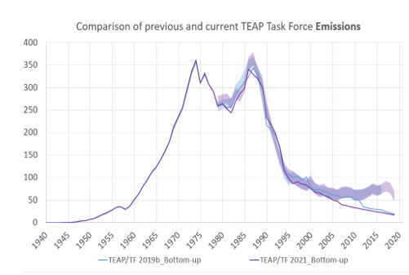

Figure 2.5 Comparison of the 2019 and the 2021 Task Forces’ bank models (kilotonnes)



## 2.5 Analysis of CFC-11 foam banks by geographic location and foam type

The history of closed-cell foams and CFC-11 usage is offered as necessary background to respond to the parties’ request in decision XXXI/3 for the TEAP to provide information regarding the location and specific types of foams related to the remaining CFC-11 banks.

Polyurethanes were invented in the 1930s and are used in wide variety of products. In 1948, closed-cell foams were initially introduced as an insulation in very small quantities and the market slowly increased. Use of steel sandwich building panels and integral skin began in the 1960s. In the late 1970s and 1980s closed-cell polyurethane insulation expanded to include spray foam and sandwich panels. Separately, open cell foams such as flexible and cushioning foams (e.g., shoe soles and cushions) were commercialized in the 1950s.

The closed-cell foam market developed gradually as confirmed by AFEAS CFC-11 sales values showing that CFC-11 sales into closed-cell foams were relatively small until the 1970s with continuous growth throughout the 1980s.

Figure 2.6 AFEAS cumulative CFC-11 sales into closed-cell foams

After non-Article 5 parties banned the use of CFC-11 by 1996, except for essential uses, total quantities of CFC-11 production and consumption reported to the Ozone Secretariat by Article 5 parties from 1996 and beyond were much smaller than the early peak in reported data in 1986, which included non-Article 5 parties.

The overwhelming majority of both the production and consumption of CFC-11 reported to the Ozone Secretariat prior to 1996 was in non-Article 5 parties specifically in North America and Europe.

The use of CFC-11 in Article 5 parties gradually increased. In the midst of this gradual growth, the Montreal Protocol phase-out of CFCs in Article 5 parties was already underway.

HCFC-141b was introduced as a replacement for CFC-11 for use as a closed-cell foam blowing agent during the phase-out of CFC-11. HCFC-141b is also undergoing a phase-out as agreed by the parties to the Montreal Protocol. The schedules can be found in Appendix 8.

Non-Article 5 parties were already transitioning from ozone depleting blowing agents by the time the 2006 FTOC Assessment Report was written. The phase-out of CFC-11 for non-Article 5 parties was completed by 1996 and reductions were already well under way for HCFC-141b prior to the phase-out scheduled to be completed by 2020, but many parties regulated HCFC-141b early using a “worst-first” strategy, given its higher ozone depletion potential. For example, the United States banned the use of HCFC-141b for use in foam for appliances in 2003 and then in imports of products containing HCFC-141b in 2015.

It is important to note that each transition in non-Article 5 parties resulted in much lower use of halocarbons as foam blowing agents as foam manufacturers shifted to other alternatives including water and hydrocarbons.

Figure 2.7 Non-Article 5 party consumption of CFC-11 and HCFC-141b

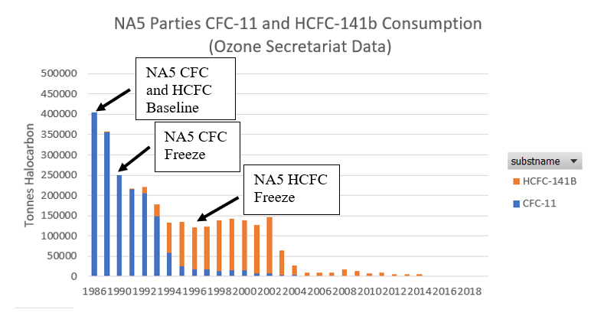

The Article 5 party baselines were determined in 1995-97 for CFCs and in 2009-10 for HCFCs. The Article 5 party freeze and phase-down started in 1999 for CFCs and in 2013 for HCFCs. Many parties again regulated HCFC-141b using the same “worst-first” approach that non-Article 5 parties used.

Figure 2.8 Article 5 party consumption of CFC-11 and HCFC-141b

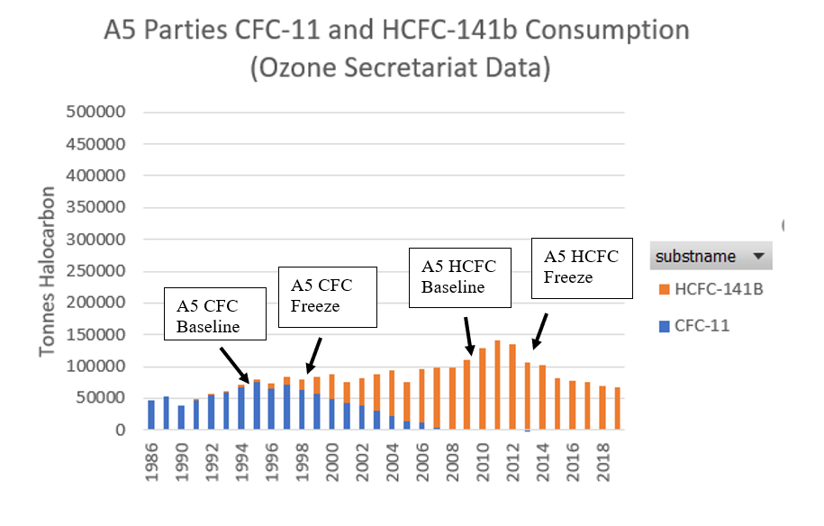

Again, it is important to note that the quantities of CFC-11 consumed in Article 5 parties were much smaller than the quantities consumed in non-Article 5 parties. The vast majority of CFC-11 production and consumption took place in non-Article 5 parties.

### 2.5.1 Estimated global use of CFC-11 by foam type

The Flexible and Rigid Foams Technical Options Committee (FTOC) completed a detailed analysis of the use of foam blowing agents by foam sector by region in the 2006 FTOC Assessment Report. The 2006 FTOC Assessment Report provided regional estimates as noted in the Appendix 7. The Task Force has used the same regions.

The FTOC described large, mature foam markets in North America (NA) and Europe (EU) for the types of foams that historically used CFC-11. Other regions all using less than one-third of the quantities used by either North America or Europe. Closed-cell foam markets in Article 5 parties had slowly been growing prior to 2006 as shown above.

Figure 2.9 2006 FTOC Assessment Report: Total foam blowing agent usage for foam sectors that historically used CFC-11 (tonnes)[62]

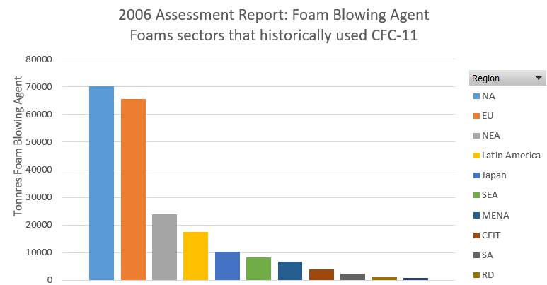

The 2006 FTOC Assessment Report sectoral and regional analysis was used to create an estimate of foam use for CFC-11 to determine banks and emissions based on the losses of blowing agents during different foaming processes and foam lifetimes. The 2006 FTOC breakdown of products and regional uses of blowing agents skews CFC-11 quantities to be larger than they would have been for Article 5 parties as blowing agent usage in A5 parties would have been nascent and still growing from 1990 onward; however, the quantities are still very small. The pie chart below shows the relative size of the regional markets in 2006 showing the overwhelming majority of the closed-cell foam production took place in North America and Europe (non-Article 5 parties) even as late as 2006. An even larger percentage was produced in non-Article 5 parties in early years before the development of the closed-cell foam market in Article 5 parties.

Figure 2.10 Historic foam production by region for 2006 FTOC Assessment Report, which estimated that approximately 360 kilotonnes/year of blowing agents were in use around the timeframe of that report

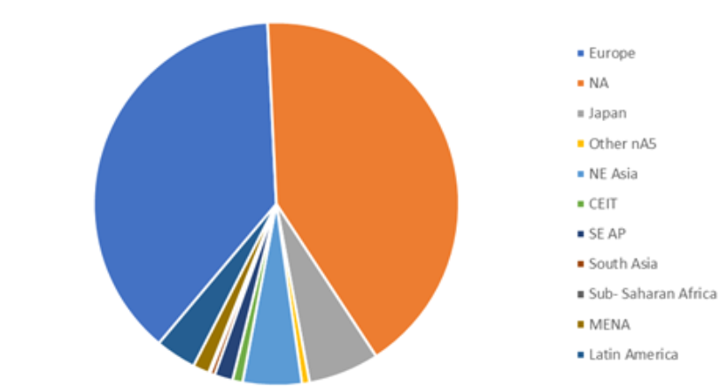

Figure 2.11 Estimated consumption of CFC-11 by region (data reported to the Ozone Secretariat)

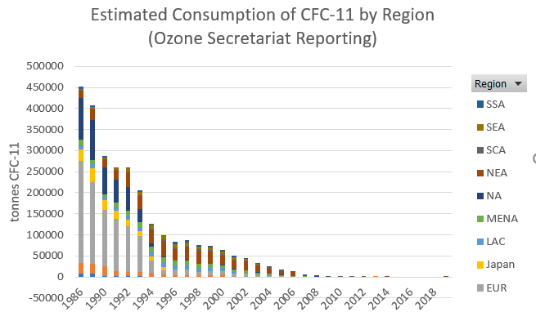

The analysis in this report incorporated a Weibull function to create a probabilistic distribution of the life cycle of foams including the rate of decommissioning, estimated timing of various life stages, emissions and the size of foam banks by types of closed-cell foam products. There is a distinct bifurcation of lifetimes for foams used in refrigerating applications and foams used in construction of buildings. Nearly all of the active bank is comprised of foam panels and boardstock in buildings. Nearly all of the remaining bank of foams used in refrigerating applications have been decommissioned and either landfilled or destroyed[63]. CFC-11 from the relatively small quantities of other types of foams have largely been decommissioned. By this analysis, there are an estimated 750 ± 50 kilotonnes of CFC-11 in active foams banks and 700 ± 50 kilotonnes in inactive banks in 2021[64].

Figure 2.12 Estimated CFC-11 in active and inactive foam banks (kilotonnes)[65]

Figure 2.13 Estimated CFC-11 in active and inactive banks of panels, boardstock, and spray foams (kilotonnes)[66]

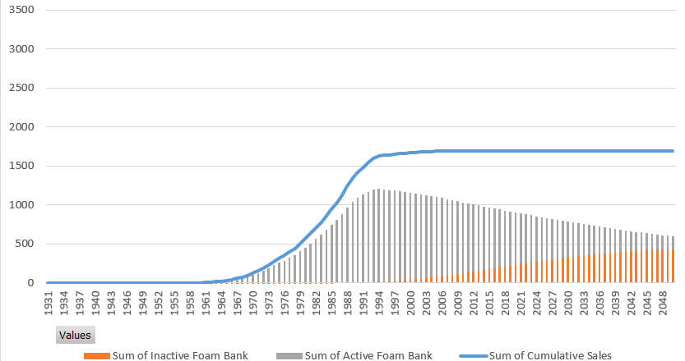

By this analysis, and using an average 25-year lifetime, there are an estimated 500 kilotonnes remaining in the inactive bank of refrigerating foams, which has nearly all been dismantled and landfilled or, in Europe after 2002, destroyed. ICF International estimated in 2010 that in 2020 there would be approximately 4 kilotonnes of CFCs available for destruction from all types of foam[67].

Figure 2.14 Estimated CFC-11 in active and inactive banks of refrigerating foams (kilotonnes)[68]

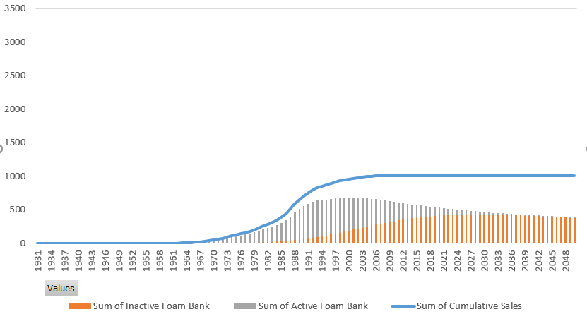

Figure 2.15 Estimated CFC-11 in active and inactive banks of foams other than in construction and refrigeration (kilotonnes)[69]

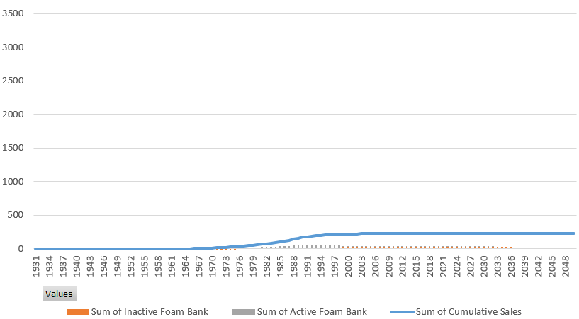

As noted above, most of the remaining active CFC-11 bank is contained in panels and boardstock installed in buildings. The majority of remaining foams from refrigerating appliances along with a significant volume of decommissioned foams from building has been landfilled (inactive bank), or in Europe, appliance foams were destroyed.

The largest quantities of panels and boardstock containing CFC-11 were manufactured in North America and Europe as noted below. Also of note, significant numbers of appliances containing CFC-11 were sold, used and ultimately decommissioned and landfilled in North America and Europe.

The majority of the remaining global CFC-11 bank is in North America and Europe in construction foams in buildings or in landfills. More details can be found in the Appendix7.

Figure 2.16 Estimated regional CFC-11 use in various foam sub-sectors (kilotonnes) using 2006 FTOC Assessment Report as a proxy

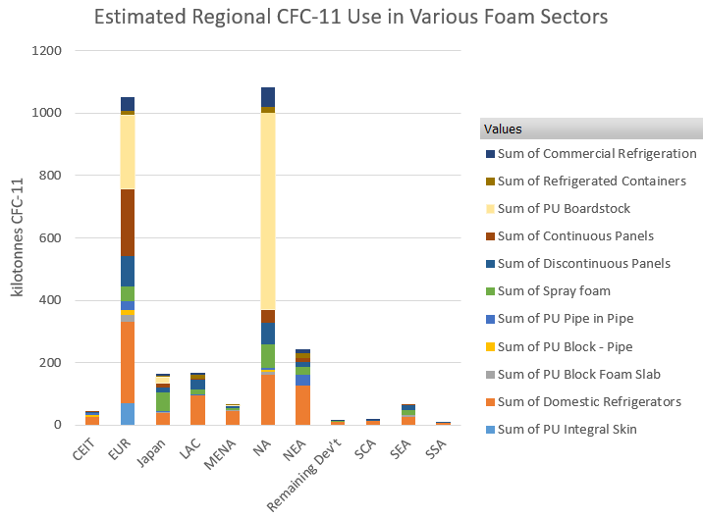

# 3 CFC-11 production

This Chapter includes updates to estimated unreported CFC-11 production to account for emissions based on banks and emissions modelling, comments on the fate of co-produced CFC-12, updates to the CTC required to supply the estimated unreported CFC-11 production, and responds to decision XXXI/3, paragraph 7(b), relating to production issues.

## 3.1 Estimated unreported CFC-11 production to account for unexpected emissions

Based on the modelling described in Chapter 2, this section provides the conclusions for estimated unreported CFC-11 production that can be deduced from this analysis to account for the unexpected CFC-11 emissions. This section updates the information provided in the 2019 Task Force Report.

Even with the minor refinements to the banks modelling using the Weibull distribution of CFC-11 product lifetimes, this 2021 Task Force Report concurs with the 2019 CFC-11 Task Force Report; emissions from CFC-11 banks alone cannot explain the unexpected increase in CFC-11 emissions between 2013 and 2018.

The relationship between CFC-11 emissions and production was based on the historical estimates and assumptions included in the model. The model was used to reconcile the differences between the estimated inventory-based emissions and those derived from atmospheric concentrations, assuming that those emissions were associated with closed-cell foam production and use[70]. Based on estimations of the additional CFC-11 production necessary for the inventory-based expected emissions to align with the derived emissions[71], unreported CFC-11 production can be estimated to be:

* 10 to 40 kilotonnes per year between 2007-2012[72]
* 40 to 70 kilotonnes per year between 2013-2018, the same as estimated in the 2019 Task Force Report for this period[73]
* 15 to 40 kilotonnes of new production, or from recent inventory, for 2019[74].

Based on this analysis, and with the assumptions described, the estimated cumulative total of unreported CFC-11 production is 320-700 kilotonnes in the period 2007-2019. Assuming usage in closed-cell foam production, this cumulative unreported CFC-11 production would lead to an estimated increase in the magnitude of the CFC-11 bank of 300 (266-333) kilotonnes by the end of 2019.

Figure 3.1 Atmospheric derived and estimated inventory-based CFC-11 emissions, including those from estimated unreported CFC-11 production between 2007-2019 (kilotonnes)

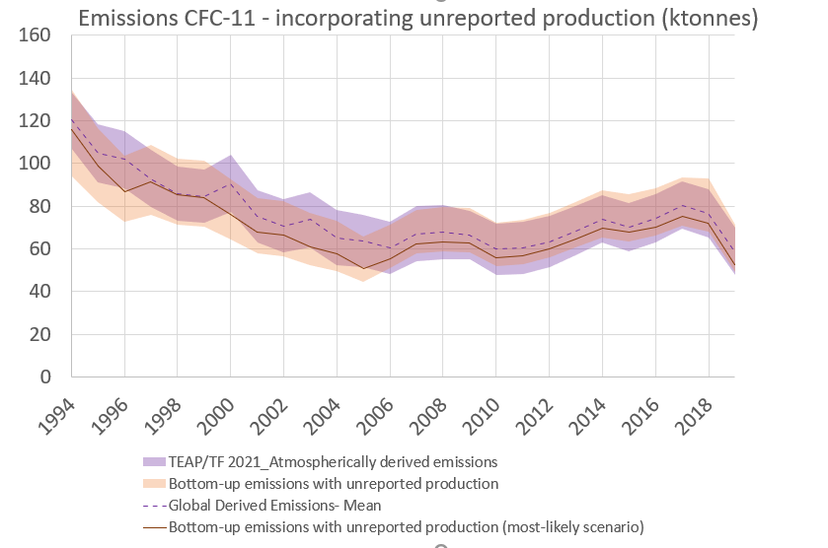

Figure 3.2 Estimated CFC-11 bank, including contribution from estimated unreported CFC-11 production (kilotonnes)

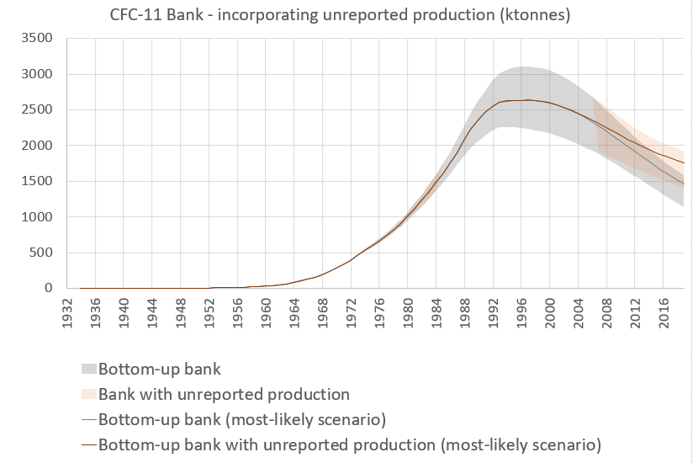

## 3.2 Updates to the possible fate of any co-produced CFC-12

The quantity of CFC-12 co-produced with CFC-11 is dependent on the production route chosen, and how the plant is set up and operated. With CFC-11 as the target chemical, the range of CFC-12 co-production is up to 30% of total CFC-11/12 production for the most likely production routes.

According to the SAP Report[75], understanding of the expected decline in global CFC-12 emission in recent years has substantial uncertainties, making an assessment of observationally derived emission changes relative to expectations difficult. However, the rate of decline of global derived atmospheric emissions of CFC-12 in the 2010 to 2017 period (indicative of increased CFC-12 emissions), the subsequent indicated significant reduction in global CFC-12 emissions in 2019, and the geographic origin of the changes, together suggest that the CFC-12 emission changes may be associated with unreported production of CFC-11.

The 2019 Task Force Report (September 2019, page 95) concluded that, “*It is unlikely that there is a significant resumption of CFC-12 usage in any R/AC sub-sector in both non-Article 5 and Article 5 parties. This implies that no significant new CFC-12 production would be needed for all R/AC sub-sector uses, and that this would not be the reason for possible CFC-11 co-production.*” There are no technical reasons to believe that this conclusion has changed; any additional unexpected emissions of CFC-12[76] are likely to be as a co-product associated with the production of CFC-11, rather than from any specific production initiated to supply CFC-12 in its own applications.

## 3.3 Linkages between production of anhydrous hydrogen fluoride and carbon tetrachloride and unexpected emissions of CFC-11

There are direct linkages between unreported CFC-11 (CCl3F) production, associated unexpected CFC-11 emissions, and the production of anhydrous hydrogen fluoride (HF) and carbon tetrachloride (CTC or CCl4), based on the normal and most likely chemical production route and its associated chemistry. These linkages can be summarised in the following chemical equation (where HCl is hydrogen chloride):

CCl4 + HF -> CCl3F + HCl

However, there are important differences between the HF and CTC production linkages with CFC-11 production.

***Regulation***: Anhydrous hydrogen fluoride is not a heavily regulated substance; it lacks formal international reporting requirements for production or consumption. CTC is an ODS, with its production strictly controlled globally and virtually all CTC is used as feedstock.

***Production volume***: The estimated HF demand for unreported CFC-11 production would be only a small fraction (less than 1 %) of the global HF production. In contrast, a large fraction of CTC production would be needed to supply the unreported CFC-11 production, e.g., for CTC a quantity equivalent to about 20% to 50% of the 2016 reported CTC production for feedstock use is estimated to be required for unreported CFC-11 production.

***Use patterns***: Anhydrous HF is an essential raw material for all fluorocarbons, fluoropolymers, aluminium trifluoride, and virtually all synthetic substances containing fluorine. Carbon tetrachloride has more limited patterns of use as a feedstock for HFC and HFO production and a range of other substances[77].

In conclusion, the linkage between CTC production and unreported CFC-11 production and CFC-11 emissions is the most evident linkage.

### 3.3.1 Linkages between the level of production of carbon tetrachloride and unexpected emissions of CFC‑11

Being an ODS, the production of CTC is strictly controlled globally with virtually all used as feedstock. Between 45 to 120 kilotonnes of CTC annually would be required to supply between 40 to 70 kilotonnes of CFC-11 production annually, to account for the increased CFC-11 emissions in the period 2013 to 2018, depending on the proportion of co-produced CFC-12. This is equivalent to about 20% to 50% of the 2016 reported global CTC production for feedstock use (221.6 kilotonnes). In 2019, the reported global CTC feedstock quantity increased to 316.4 kilotonnes. The CTC quantity required for CFC-11 production is expected to be at the lower end of the range if, as predicted, the objective is higher CFC-11 selectivity.

In the period 2007-2019, the cumulative CTC quantity required to produce 320-700 kilotonnes of CFC-11 is at least 360 kilotonnes and could be considerably higher depending on the CFC-11 selectivity.

CTC is produced in chloromethanes plants as an unavoidable part of the production of dichloromethane and chloroform. China (<3,000 kilotonnes/year), the European Union (<500 kilotonnes/year), and the United States (<400 kilotonnes/year) have the largest chloromethanes production capacities, and therefore also the largest potential availability of CTC. When there is limited demand for CTC, chloromethanes plants can reduce the amount of CTC produced to approximately 5% of total output: however, there is the versatility to increase the amount of CTC produced to up to 15% of the total chloromethane output without significant plant modifications[78]. In 2016, the global maximum amount of potential CTC available from chloromethanes production, after existing local supply commitments had been met, was estimated at 305 kilotonnes, and by 2018 had increased to 350 kilotonnes. Some regions have the spare annual capacity that might allow CTC production in the amounts required for small-scale CFC-11 production. Only China has the spare annual capacity on chloromethanes plants that might allow CTC production to supply the amounts of CTC required for large-scale CFC-11 production. In China, there are seven chloromethanes production plants, held by 5 companies, each with 300 kilotonnes/year capacity. At least three of these companies also produce fluorocarbons.

Assuming, the CTC quantity is at the lower end of the range for the 2013-2018 period, if 45 kilotonnes/year were to be shipped from a stand-alone chloromethanes plant to an off-site fluorocarbon producer, this would mean over 2250 road tankers per year or 6 road tankers every day. CTC imports and exports are reported to the Ozone Secretariat under Article 7 data reporting requirements. Any imported CTC requires an import licence, and the export is subject to export controls through licensing, meaning that enforcement detection of imports or exports would be likely. Within a country, there is also a potential risk of enforcement detection when shipping controlled substances in these large quantities. Transfers of CTC off-site would not be needed if fluorochemical/CFC-11 production was on the same site as chloromethanes/CTC production. Furthermore, a 300 kilotonnes/year chloromethanes plant (collection of units) could produce an additional 45 kilotonnes/year CTC without significant technical modifications. It appears that CTC supply to unreported CFC-11 production has avoided detection over a number of years. Therefore, it seems more likely that both the CTC and CFC-11 production occurred within the same country. Depending on the scale of CFC-11 production for individual plants, the location of CFC-11 and CTC production on the same site could also be advantageous in avoiding detection.

CTC is also produced (or processed) in perchloroethylene/CTC (PCE/CTC) plants, which have the flexibility to produce up to 100% of either substance according to demand. Five PCE/CTC plants are operative in Europe and the United States, and at least nine[79] are operating in China. Spare global capacity to produce CTC by this process is estimated to be between 50-100 kilotonnes/year, existing mainly in the European Union.

Many of the 15 chloromethanes producers in China elected to build CTC to PCE plants, which transform otherwise surplus CTC into PCE. These PCE/CTC plants appear to have been repurposed to consume feedstocks other than, and in addition to, CTC, with the primary objective to meet demand for increased fluorocarbon-grade PCE production for the manufacture of HFC-125 and CFC-113[80]. The capacity of chloromethanes complexes in China to produce PCE from CTC and other feedstocks is estimated at over 250 kilotonnes/year. These plants could readily be used to produce CTC at the purity required for fluorocarbon manufacture, although this would be contrary to the original intent of transforming surplus CTC to PCE. In recent years, China has been importing large quantities of PCE, which might imply that there is either no spare capacity on the PCE/CTC plants in China, or that they are not supplying PCE at high capacity.

In conclusion, for China, additional CTC could have been made available either by increasing the amount of CTC produced on chloromethane plants or by diverting CTC from PCE production or a combination of both.

Park *et al.* reported that regional inferred emissions of CCl4 from Eastern China[81] increased from 6.0 ± 1.4 kilotonnes yr-1 during 2011–2012 to 10 ± 2 kilotonnes yr-1 for 2014–2017, a mean increase of 4 kilotonnes yr-1 during this period. They caution that while CCl4 emissions are known to originate from a wide range of industrial sources, making attribution to one process highly uncertain, such an increase could be suggestive of increased CCl4 feedstock use in CFC-11 production. Applying the TEAP 2020 Progress Report[82] emissions factor range of between 0.5% to 4% by weight of the quantity of CTC produced for feedstock uses to the mean increase of 4 kilotonnes yr-1 infers an indicative estimate of potential additional CTC production between 100 kilotonnes (4% emission factor) and 800 kilotonnes (0.5% emission factor). This is consistent with the estimated additional annual CTC production of 45 to 120 kilotonnes required for CFC-11 production in the period 2013-2018. This would be additional to the known CTC production in China, as reported at ExCom 84[83] (reproduced in Table 3.1).

Table 3.1 Production of chloromethanes and CTC in China (tonnes) (*taken from UNEP/OzL.Pro/ExCom/84/22/Add.2*)

|  |  |  |  |
| --- | --- | --- | --- |
| **Particulars** | **2015** | **2016** | **2017** |
| Chloromethane production | 2,055,221 | 2,264,813 | 2,586,052 |
| CTC production | 97,161 | 105,675 | 122,759 |
| Percentage of CTC production | 4.73% | 4.67% | 4.75% |

The CTC production in China, about 123 kilotonnes in 2017, were accounted as 32% (39 kilotonnes) used as feedstock for external plants for non-ODS production (including HFC-245fa), and 68% (84 kilotonnes) converted to methyl chloride, chloroform or PCE within the chloromethanes plants[84].

### 3.3.2 Monitoring and control of CTC feedstock use

The linkage between CTC production and potential CFC-11 production is disrupted by a range of measures implemented by parties that produce or import CTC. There are a range of measures that can contribute to the prevention of prohibited uses arising from CTC production for legitimate feedstock uses. Three are outlined below.

**International Trade Controls**: CTC imports and exports are reported to the Ozone Secretariat under Article 7 data reporting requirements. Any imported CTC requires an import licence, and exported CTC is also subject to controls through licensing.

**Reporting of CTC production and use as feedstock**: Production within a party must be reported to the Ozone Secretariat under Article 7 data reporting requirements. Some parties ensure that the quantities of CTC produced or imported are matched to the quantities used as feedstock through statutory reporting requirements.

In the European Union, regulation 1005/2009 requires undertakings that use feedstock to report the quantities used, specify the chemical process and indicate the final chemical produced. Japan, Russia and the United States also produce CTC for their own use as feedstock, with associated regulatory reporting requirements.

In China, feedstock use is subject to an annual statutory registration management system. Enterprises that supply CTC are subject to annual sales registration management. They are only allowed to sell CTC to enterprises holding CTC consumption quotas or with registration qualification from the Ministry of Ecology and Environment (MEE) for feedstock use. All CTC enterprises must report relevant CTC production, sales and consumption data to the MEE. Only three CMs producers are allowed to sell CTC for feedstock uses. Feedstock users are not allowed to sell CTC and can only use it for the use for which they were registered, which is specified in their Environmental Impact Assessment (EIA)[85].

In India, all production of CTC is during the production of chloromethanes, where CTC gets co-produced. CTC is allowed to be used exclusively as a feedstock. The monitoring of CTC production for feedstock uses is integrated into the country’s statutory framework to make it enforceable under the prevailing reporting system. All the CTC producers and consumers are registered under the ODS (Regulation and Control) Rules, there is an annual statutory reporting requirement for monitoring CTC production and feedstock use that is applicable to all enterprises and use of CTC is prohibited for non-feedstock applications. The monitoring system, requires all enterprises manufacturing CTC for feedstock use to annually report to the regulatory authorities their CTC production, opening and closing stocks. CTC feedstock users are also subjected to statutory reporting requirements on an annual basis. The import of CTC for feedstock is under a licence issued by the Directorate General of Foreign Trade, Ministry of Commerce and Industry, based on the recommendations of the Ozone unit. The application for import details the nature of use and the process to be followed, which is certified independently, if required, for conformity with the feedstock processes.

**Enhanced monitoring:** In China, since 2019, the MEE has imposed additional control measures on enterprises generating CTC as by-product to prevent illegal CFC-11 production. The measures require all chloromethanes production enterprises to install a whole-process, real-time monitoring system. Mass flow meters for CTC by-product have been installed, covering CTC measurement in, *inter alia*,production, storage, conversion, sales, and residual liquid. The system aims to enable online monitoring of chloromethanes production enterprises. Starting from June 2019, the MEE has dispatched supervisory working groups to all 16 chloromethanes production enterprises nationwide to carry out on-site inspections of CTC crude output, purification, residue, storage, conversion and sales and other key processes to ensure compliance. The MEE has committed to continue to improve the system of laws and regulations and intensive supervision and law enforcement[86].

# 4 Possible drivers of illegal production of and trade in CFC-11

## 4.1 Demand for CFC-11 in foams

### 4.1.1 Drivers and feasibility of converting to CFC-11

The 2019 Task Force concluded it likely that there has been a resumption of newly produced CFC-11 usage in closed-cell foams. The 2019 Task Force considered it economically feasible and technically straight-forward to revert to using CFC-11 from HCFC-141b, or another fluorocarbon, for manufacturing closed-cell foams as the associated raw materials and equipment used to produce these foams are compatible, with only slight modifications to ingredient ratios needed. In addition, there are a number of regulatory, cost and technical drivers that might further encourage the reversion to CFC-11, including a shortage of HCFC-141b resulting from its phase-out.

The 2019 Task Force also concluded that it was economically unlikely that CFC-11 would replace the very low-cost dichloromethane in open-cell foams, or that emissions could be explained by traditional end-of-life handling of foams manufactured with CFC-11 and produced before 2010.

There are concerns related to conversion of enterprises in the spray foam sector, with small and medium enterprises (SMEs) experiencing the most challenging issues, that could have driven some further use and release of CFC-11. However, the 2019 Task Force concluded that it was unlikely that the emissions could be explained solely by CFC-11 use by SMEs or in the spray foam sector.

The higher pricing and lack of availability of HCFC-141b related to the ozone-depleting substances (ODS) phase-out combined with the technical ease of conversion to CFC-11 could be a driver for reverting to use of CFC-11 as a blowing agent. CFC-11 as a blowing agent could also be of interest to companies who erroneously believe that it may reduce foam flammability without using expensive fire retardants.

### 4.1.2 Technical feasibility and implications of reverting to CFC-11 use in foams

A brief summary of the technical feasibility and implications of reverting to CFC-11 in foam use is provided below.

CFC-11 conversion to HCFC-141b required significant adjustments to the formulation because of HCFC-141b solvent properties. However, replacing HCFC-141b by CFC-11 in an HCFC-141b formulation would require minimal adjustment. More adjustments would be required for use of CFC-11 in hydrocarbon or HFC formulations.

Many of the additives used for foams produced with CFC-11 are also used for foams produced with other foam blowing agents. (e.g., surfactants and catalysts). For example, gelling/blowing catalysts and surfactants that were used for CFC-11 foams and are still used today.

Under certain circumstances, CFC-11 can decompose to form chloride and fluoride ions creating hydrochloric and hydrofluoric acid, which reacts with amine catalysts reducing their activity in the foam. Amine catalysts are commonly used in polyol blends and facilitate the reaction of the polyol with diisocyanate to form the urethane polymer foam matrix. Therefore, CFC-11 was supplied with a stabilizer (e.g., alloocemine, alphamethylstyrene). Alloocemine stabilizer was not used for HCFC-141b, HFCs or hydrocarbons. However, at least one company added alphamethylstyrene to HCFC-141b.

### 4.1.3 Economic and technical viability of transition from HCFC-141b to CFC-11

It would be economically attractive and technically straight-forward to revert to using CFC-11 from HCFC-141b, or another fluorocarbon, as the other raw materials and equipment used to produce polyurethane closed-cell foams are compatible, with only slight modifications to ingredient ratios. In addition, there are a number of drivers that might further encourage the transition back to CFC-11.

Conversion from HCFC-141b back to CFC-11 in polyurethane foams and pre-blended systems would be low-cost with almost no technical changes needed. A single instance of a recently quoted CFC-11 price is lower than market price of HCFC-141b[87].

The phase-out of HCFC-141b in the spray foam sector and in SMEs has created technical and economic challenges that might promote the use of CFC-11 for article 5 parties, although actual usage has not been confirmed. There is a lack of available HCFC-141b supply due to production phase-out which by design would result in increasing price of HCFC-141b due to the allocation-based supply and demand imbalance. This imbalance would likely be further exacerbated by continued market growth and demand for blowing agents. The phase-out of HCFC-141b in the spray foam sector and in SMEs in Article 5 parties has created technical and economic challenges that might promote the use of CFC-11, although actual usage has not been confirmed.

There are some challenges with alternatives. For example, the flammability of hydrocarbons and associated capital investment for conversion, and for HFCs and HFOs, their higher cost. In addition, not all companies in Article 5 parties are funded by the MLF. MLF funding for HCFC-141b conversions for funded companies is limited to a single year.

In addition, there may have been issues with access to HFCs as a replacement for HCFC-141b in article 5 parties due to patent and capacity issues which was not the case for non-article 5 parties.

In summary, the higher pricing and lack of availability of HCFC-141b related to the ODS phase-out, combined with the technical ease of conversion to CFC-11, could have been a driver for reverting to the use of CFC-11 as a blowing agent. CFC-11 as a blowing agent could also be of interest to companies who believe that it may reduce foam flammability without using expensive fire retardants[88].

### 4.1.4 Regulations and costs impacting blowing agent selection

The major blowing agent transitions being driven by regulation at present are those in Article 5 parties resulting from the enactment of Decision XIX/6 (accelerated phase-out of HCFCs) and being funded under a series of national HCFC Phase-out Management Plans (HPMPs). Since Decision XIX/6 required a “worst first” approach, the phase-out of HCFC-141b was targeted first. CFC-11 had largely converted to HCFC-141b for rigid insulating polyurethane foams and to dichloromethane (DCM)[89] or water in flexible foams in both Article 5 and non-Article 5 parties. The conversion from HCFC-141b has been largely successful within larger and some medium enterprises where the critical mass of the operation is sufficient to justify investment in hydrocarbon technologies. Indeed, in several instances, individual enterprises have been willing to co-fund the investment where the funding thresholds available under the Multilateral Fund have been insufficient, despite the economies of scale.

The multitude of SMEs manufacturing foams posed a challenge for non-Article 5 parties and continues to pose a challenge for Article 5 parties. The lack of economies of scale does not allow for the adoption of hydrocarbons, while the adoption of high GWP alternatives such as HFCs will result in high levels of emission within processes which are either less well engineered or are unavoidably emissive because they are used in-situ (e.g., polyurethane spray foams). Although there is increasing pressure now to switch to low-GWP technologies, approximately one third of HCFC consumption was converted to HFCs in many non-Article 5 jurisdictions.

As a result of the trade-offs in properties and costs of various alternatives, the HCFC-141b conversion has resulted in more diverse transitions than the CFC-11 conversion with an estimated 2/3 of rigid polyurethane foams converting to hydrocarbons, water (carbon dioxide), HFCs (e.g., HFC-245fa and HFC-365mfc blended with HFC-227ea) and a small portion of the market converting to methyl formate. HFCs were used largely in products or facilities where it would be very costly to convert to flammable fluids such as SMEs and in spray foam and other uses that are applied *in situ*. In general, HCFCs are less than half of the cost of high GWP HFCs and hydrofluoroolefin/hydrochlorofluoroolefin (HFO/HCFO or unsaturated HCFCs and HFCs) blown foams remain more expensive than HFC foams due to the total cost of blowing agent and required additives.

More specifically, pricing of HCFC-141b based on historical feedback within the FTOC has been within the range of $1.5 to $3/kg before duties. The CFC-11 price quote that the FTOC received was $2.2/kg and previous FTOC progress reports have cited pricing of $11-$17/kg for HFOs and $8-11/kg for HFCs. Prices can vary greatly by country, and these are only a snapshot. However, they do show the relative prices of various foam blowing agent products.

Under HCFC Phase-out Management Plans (HPMPs), projects that transition from HCFC-141b used in polyurethane foam to low GWP alternatives have been funded and many have been completed or are in progress. However, unfunded companies (e.g., companies that were established after September 2007, multi-national companies and companies in unfunded parties) operating in Article 5 parties may convert from HCFCs to high GWP HFCs to meet HCFC phase-out deadlines rather than converting directly to low GWP alternatives.

Most parties used a command-and-control regulatory structure banning the consumption HCFC-141b altogether in specific uses. This has been coupled with the requirement to reduce production by steps. As designed, the production phase-out creates a mismatch between supply and demand in the market which increases the price of HCFC-141b. This is meant to create an impetus for industry to self-select a lower cost alternative that has a smaller environmental footprint.

At times, rising prices have also created a “black” market for illegal trade. There have been imports of illegal substances labeled as other products; while in other cases, no effort has been made to mask the sale of the banned chemical. When discovered, these cases have largely been addressed within the party where the illegal trade has taken place or in customs at borders. However, foams add another level of complexity in detecting illegal trade as pre-blended polyol systems containing the foam blowing agent are shipped from parties that produce polyols to parties that do not produce them. If the blowing agent is not documented, collecting and analysing a sample requires more steps than collecting a refrigerant sample.

Some parties have taken measures to reduce import of ODS-containing polyol blends establishing regulations to phase out HCFC-141b in polyurethane foam through a quota system, with a permit for the import of bulk HCFC-141b. Additional regulations in development in these parties include a restriction on the import of HCFCs and polyols containing HCFC-141b after conversion projects are completed and a prohibition of the expansion of existing HCFC-based manufacturing capacities or building new facilities. In Article 5 parties, HCFC-141b in spray foam is still allowed in many Article 5 parties because of technical, safety and cost concerns about replacement products. This mismatch of supply and demand may be influencing blowing agent selection.

Some parties require labelling of pre-blended polyols and insulation boardstock containing HFCs as of 1 January 2015, and “included in descriptions used for advertising” of finished goods. In addition, there is an annual reporting obligation on manufacturers of pre-blended polyol containing HFCs (covering imports and exports).

While HCFC phase-out and HFC avoidance are being pursued in tandem, the more challenging areas such as spray foam safety, blend requirements and SMEs are yet to be fully addressed. Much still depends on the future availability and cost of low-GWP blowing agents. Whether or not this has resulted in usage of previously banned blowing agents on a large-scale basis has not been confirmed.

### 4.1.5 Impact of HCFC-141b production control measures

Although there would have been spare capacity to produce HCFC-141b above the limits established in China, as part of the HPMP, China has implemented monitoring and control measures to prevent excess production for use in foam.

The sector plan to phase-out HCFC-141b in the foam sector (Foam Sector Plan), sets out that *“*The Government of China will issue policies and regulations supporting the activities proposed in the Foam Sector Plan, such as controls for production, import/export, consumption, safety management, environmental labelling, and technical standards. It proposes to establish a production quota system to curb the supply of HCFCs by early 2013, which is critical for ensuring sustainable phase-out of HCFCs particularly in the foam sector. In addition, a ban on the use of HCFC-141b used for the production of insulation foam for refrigerators, freezers, refrigerated trucks, reefers, and small household appliances will be put in place by 1 January 2015. The Government is also considering submitting the HCFC production phase-out sector plan, including HCFC-141b, to the Executive Committee in 2011. The production phase-out schedule will take into account the effort being made to control the consumption sector. The import and export of HCFC-141b will also be strictly controlled and monitored.”[90]

The 2017 annual progress report[91] noted that for sectors with large number of small and medium-sized enterprises (SMEs) (i.e., XPS foam, polyurethane foam, ICR, and servicing sector) consumption is monitored through the national system of licensing and quotas for HCFC imports, exports, production and consumption. The domestic production quotas control HCFC sold in the local market and subsequent consumption in SMEs. Quotas are also issued to enterprises with an annual consumption of HCFCs over 100 tonnes, for each of the different sectors. The World Bank commissioned an independent verification of 2016 HCFC production and consumption in China. The verification confirmed that the consumption of HCFCs in 2016 was within the limits established by the Agreement for the consumption sector. Consumption of HCFC-141b in the polyurethane foam manufacturing sector in 2016 was 34,821.19 tonnes (3,830.34 ODP tonnes), which is lower than the maximum allowable consumption established for the same year in the Agreement between the Government of China and the Executive Committee. The reduction in consumption has been achieved through the application of the HCFC production quota and domestic sale quota issued for each producer; the HCFC consumption quotas issued to manufacturing enterprises using more than 100 tonnes per year; and the conversion of foam enterprises to HC and water-blown technologies.

In summary, existing HCFC-141b plants are tightly scrutinised, ensuring that it would be extremely difficult, if not impossible, to produce any extra tonnes (not least because the accounting issues associated with raw materials would be so complex). In contrast, without enhanced monitoring of CTC, such as that introduced in 2019 (section 3.2.2), production of CFC-11 on HCFC-22 plants cannot be ruled out.

### 4.1.6 Impact of the availability of fluorocarbon alternatives to HCFC-141b in 2012 to 2018 period

In non-Article 5 parties, HCFC-141b had been phased out completely by end 2003. In Article 5 parties, the HCFC-141b phase-down would not begin until the freeze in 2013. Capacity had grown rapidly to over 160 kilotonnes/year in China. A 4-5 kilotonnes/year plant in the Republic of Korea ran sporadically and had closed in about 2008. India did not produce HCFC-141b and demand was met by imports. Consumption for non-feedstock use (mainly foams) peaked at over 110 kilotonnes/year, including exports, in the period 2010-2012. Part of the production was for the solvent market (4 kilotonnes), which was expected to see 10% growth in some sectors [92] , and peaked in 2012 (5 kilotonnes)[93]. At that time in Article 5 parties there was no regulatory requirement to replace HCFC-141b, and the market HFC replacements (HFC-245fa and HFC-365mfc) was small due to their much higher cost (estimated at about 5 times more expensive) and limited availability.

The capacity for HFC-245fa in the United States in 2010 was permitted at 25 kilotonnes/year, and in Europe the HFC-365mfc capacity was about 10-15 kilotonnes/year. For patent reasons, the European plant did not sell in the United States or Asia until the early 2010s. In the early 2000s, a 5 kilotonnes/year HFC-245fa plant started in Japan and it is thought this plant brought on a second 5 kilotonnes/year train in the 2010s. In the period 2012 to 2018, there were no apparent exports to Article 5 parties.

At this time, in Article 5 parties, there was a small 3-4 kilotonnes/year capacity HFC-245fa plant in China, which is believed to be based on licenced technology, but it is thought that this may have stopped production in 2018 as the company stopped requesting a CTC quota for this plant; CTC is used as a feedstock to this process. There was also a small HFC-365mfc pilot plant in China, which may have been developed locally. In mid-2014 a 20 kilotonnes/year. HFC-245fa plant opened in China based on licenced technology. However, the HFC-245fa capacity is now stated to be 12 kilotonnes/year, and it is possible that the plant is also used to produce HFO-1233zd, which can be isolated as it is an intermediate in the process to produce HFC-245fa. Another plant in China produces a maximum 6-7 kilotonnes/year HFC-245fa since 2011. Some HFC-245fa was exported to the United States, but the sales in the United States and production in China were made subject to patent infringement proceedings[94],[95]. This process had not been licenced and was subject to a preliminary patent injunction in 2015[96].. However, the plant continued to operate and after a successful appeal, on the grounds that there was no compelling novelty in the process, the matter was dropped in January 2018[97].

There are now four HFC-245fa producers in China, with nominal 32 kilotonnes/year capacity. In 2017 they consumed collectively 16.5 kilotonnes of CTC[98], used for both HFC-245fa and HFO-1233zd production. Production of HFC-245fa in China is shown in Table 4.1.

Table 4.1 Production of HFC-245fa in China (tonnes)

|  |  |  |  |  |  |  |
| --- | --- | --- | --- | --- | --- | --- |
| **Year** | **2014** | **2015** | **2016** | **2017** | **2018** | **2019** |
| Production | 2200 | 5800 | 6600 | 9935 | 14000 | 12300 |

In summary, it seems that at no stage of the phase-down of HCFC-141b, during the 2012-2018 period, has there been a viable opportunity for the HFCs (-245fa and -365mfc) to substitute more than a very small fraction of the foaming agent required by the insulation industry in China. In the future, there is more likely to be a focus on the use of HFO-1233zd as a foam blowing agent, but this was also not available during this period.

## 4.2 Production and supply of CFC-11

### 4.2.1 Economic factors and technical requirements for swinging HCFC-22 and HFC-32 plants to CFC-11 and for use of small-scale production plants

Based on the high degree of similarity between the liquid phase production routes for CFC-11 (and CFC-12), HCFC-22 and HFC-32 (e.g., similar raw materials and co-products, catalyst and process steps, that is, reaction, HCl removal, product cleaning and product purification) it might be expected that a liquid phase production plant making one of the products (CFC-11/12, HCFC-22 and HFC-32) can successfully be swung to make one or the others. However, the production route is not the only factor, the differences in the physical properties of the product are also a major technical consideration. For instance, the production plants will need to operate at different temperatures and pressures depending on the product being made. Production plants with a larger range of allowable operating pressures, and a larger range of achievable cooling and heating media temperatures, such as purpose designed swing plants, should be able to make a larger range of end products. In addition, there are several other technical requirements that need to be addressed, for example

* Swinging from one product to another will vary the production capacity for the different products, due to bottlenecks inherent in the plant design e.g., heat exchange capability, pumping rates and availability of heating and cooling media. In general production capacity would be expected to be highest for CFC-11 and lowest for HFC-32.
* Different operating conditions usually mean significant changes to process control parameters and could possibly require instrument re-ranging.
* Liquid phase reactors hold a significant inventory of the organic raw material (CTC, chloroform, or methylene chloride) meaning that the reactor catalyst charge may need to be changed when swinging from one organic raw material to another to avoid cross contamination.
* Other chemical properties such as the fact that HFC-32 is mildly flammable will have a bearing on process safety considerations when changing product.
* Constraints on unit processes that could also affect the ability of the plant to make the product to the required specification.

In summary, purpose-built swing plants are designed to have the required technical requirements to change products. Large plants built for the production of a single product may be able to be swung to another product, but this may well come at a cost of reduced plant capacity and possibly product quality.

There are a range of economic factors that need to be considered when deciding to swing from one product to another, including:

* Raw material prices and availability
* Product value
* Relative plant throughputs
* Additional equipment requirements
* Operator training
* Duration of product changeover outages, typically several days, even weeks, are required to de-inventory then restart the plant.

Many of these economic factors are influenced by the technical requirements and hence similar conclusions can be drawn. Purpose-built swing plants should have been designed to minimise on-going economic factors to an acceptable level when swinging from one product to another, whereas swinging to a different product on single product plants would be less economically attractive.

### 4.2.2 Technical requirements and economic factors for small-scale production plants

The technical requirements for the micro scale CFC-11 plant envisioned in the 2019 Task Force Report would centre around a design that utilised a minimum number of low tech and readily available items of process equipment. The materials of construction, construction techniques and equipment such as pumps, vessels and instruments, would, most likely, be specified such that they would all be readily accessible locally. The equipment requirements could be further minimised by

* Producing a low grade (high impurity) CFC-11 hence reducing and simplifying the process steps necessary,
* Using the containers (e.g., drums) that the raw materials were purchased in as the feed vessels,
* Local dumping of any waste materials produced, including catalyst, washings and waste gases.

Any design would also seek to employ readily available ancillary services such as electrical power, low pressure steam or electrical elements for heating and ambient temperature water for cooling.

Further small batch sizes would limit the size of the items of equipment, allowing the plant to take up a relatively small space (a few 10s m2), and be both comparatively easy to relocate and comparatively hard to detect.

Favourable economic factors for these micro plants could include:

* Relative low capital outlay due to the simplicity, availability and size of equipment
* Use of potentially low quality and low-cost raw materials
* Little or no disposal costs
* Use of readily available and inexpensive ancillaries such as electricity and water
* Low manpower requirements
* Proximity to customers minimising transport costs
* Avoiding official scrutiny and hence avoiding payment of taxes, etc.

The economic downside of these plants includes only producing small batches limiting the annual production.

It is considered extremely unlikely that purpose-built CFC-11 micro plants could be swung to produce another product such as HCFC-22 or HFC-32 due to the specificity and inflexibility of its inherent design.

# 5 Types of CFC-11 products and their disposition, and opportunities for detection and potential recovery of CFC-11

The following sections respond to paragraph 7(c) of decision XXXI/3, to provide information on “*The types of CFC-11 products, the disposition of any such products, and opportunities and methods to detect such products and potentially recover the associated CFC-11*”. The earlier sections address different product types containing CFC-11 and applicable methods of recovery, disposition, and detection of CFC-11 in the product. The later sections address the opportunities for detection and for potential recovery and/or disposition of CFC-11.

Opportunities to recover CFC-11 from products containing CFC-11 are limited to a few: active banks, mainly of insulation foams, and to a lesser extent, centrifugal chillers. Other technologies that used CFC-11, i.e., aerosols, solvents and other uses, are mentioned briefly for completeness; these historic uses are no longer available for disposal, detection or potential recovery of CFC-11. As the definition suggests, inactive banks, primarily as waste foam products in landfills, do not present a readily available or economically feasible opportunity to recover the associated CFC-11, although some anaerobic degradation may take place.

## 5.1 Foam products

Table 5.1 outlines each type of foam product historically manufactured using CFC-11, associated methods to detect CFC-11, options for potential recovery of associated CFC-11, and disposition of the product.

The uses of CFC-11 outlined in the Table are included for the purpose of addressing decision XXXI/3, paragraph 7(c), and includes historic CFC-11 use in foam products. The 2019 Task Force concluded that it was likely there was a resumption of newly produced CFC-11 usage in closed-cell foams only. It also concluded that after 2010 it was unlikely that past production and historic usage accounted for the unexpected CFC-11 emissions, including from existing foam banks. It was also considered unlikely that there was a resumption of newly produced CFC-11 usage in refrigeration and air-conditioning uses, flexible foams, aerosols, solvents, feedstock uses, tobacco expansion and other miscellaneous applications.

**Table 5.1 Types of CFC-11 foam products, their emissions profile, detection, recovery of associated CFC-11, and disposition**

| **Generic Foam** | **Type of product** | **Purpose of CFC-11** | **CFC-11 emissions profile** | **Methods to detect CFC-11 in the product** | **Recovery of associated CFC-11 in the product** | **Disposition of the product** |
| --- | --- | --- | --- | --- | --- | --- |
| Rigid Polyurethane (Closed-Cell) | Insulation foam in building construction and refrigeration. Polyol/blowing agent mixtures, that are the raw materials for foam production, also contain CFC-11. | Blowing agent with beneficial product properties | Spray foam has relatively higher emissions during installation. Insulation boardstock foam has relatively lower emissions. CFC-11 remains within the foam structure and is only slowly emitted over an extended period. CFC-11 emissions occur during equipment dismantling, building demolition, foam collection, shredding, transportation and disposal. Landfill waste material emits CFC-11 over an extended period. | Field detection of CFC-11 in foam products, e.g., in the drum headspace of polyol/blowing agent mixture, can occur by using a portable analyser set up to identify CFC-11.  Laboratory detection of CFC-11 in foam products occurs by sampling the product and conducting a chemical analysis using Gas Chromatography or Gas Chromatography/ Mass Spectrometry | Recovery of CFC-11 is only applicable when insulation foam products are collected, and the CFC-11 is reclaimed. Recovery is not applicable to polyol/blowing agent mixtures, which are ingredients for foam products. Disposal by destruction or disposal to landfill necessitates that CFC-11 is either destroyed or becomes inaccessible through landfill disposal of the product. | Insulation foams remain installed for an extended period of time. During building demolition or at refrigeration equipment end-of-life, CFC-11 foam products are either: segregated, collected and reclaimed or destroyed; or disposed to landfill where the foam becomes inaccessible. |
| Phenolic | Insulation foam in buildings (with fire retardant properties). | Blowing agent with beneficial product properties | CFC-11 remains within the foam structure and is only slowly emitted over an extended period. CFC-11 emissions occur during building demolition, foam collection, shredding, transportation and disposal. Landfill waste material emits CFC-11 over an extended period. | Field detection of CFC-11 in foam products, e.g., in the drum headspace of polyol/blowing agent mixture, can occur by using a portable analyser set up to identify CFC-11.  Laboratory detection of CFC-11 in foam products occurs by sampling the product and conducting a chemical analysis using Gas Chromatography or Gas Chromatography/ Mass Spectrometry | Recovery of CFC-11 is only applicable when insulation foam products are collected, and the CFC-11 is reclaimed. Disposal by destruction or disposal to landfill necessitates that CFC-11 is either destroyed or becomes inaccessible through landfill disposal of the product. | Insulation foams remain installed for an extended period of time. During building demolition, foam products are either: segregated, collected and reclaimed or destroyed; or disposed to landfill where the foam becomes inaccessible. |
| Flexible Polyurethane (Open Cell) | Furniture and bedding foam.  Polyol/blowing agent mixtures, that are the raw materials for foam production, also contain CFC-11. | Auxiliary blowing agent | CFC-11 emissions occur at time of production. | Field detection of CFC-11 in the drum headspace of polyol/blowing agent mixture, can occur by using a portable detector set up to identify CFC-11. | Recovery of CFC-11 is not applicable because CFC-11 does not remain in the product. | CFC-11 does not remain in the product. |
| Polyurethane Elastomers (Flexible Integral Skin) | Shoe soles, furniture mouldings, automotive fascia and steering wheels | Blowing agent | CFC-11 emissions mostly occur at time of production. | Field detection of CFC-11 in the drum headspace of polyol/blowing agent mixture, can occur by using a portable analyser set up to identify CFC-11. | Recovery of CFC-11 is not applicable because CFC-11 does not remain in the product at end-of-life. | CFC-11 does not remain in the product after 1 or 2 years. |

### 5.1.1 Methods to detect CFC-11 in foam products

Field detection of CFC-11 in foam products, i.e., in the drum headspace of a polyol/blowing agent mixture, can occur by using a portable analyser configured to identify CFC-11. A simple halogen detector can also determine the presence of halogen present in CFCs, HCFCs, or HFCs, however further analysis would be needed for specific identification of CFC-11.

Laboratory methods are well suited to the qualitative identification of CFC-11 in samples of foam products. Laboratory detection of CFC-11 in foam products occurs by sampling the product and conducting a qualitative or quantitative chemical analysis using Gas Chromatography (GC) or Gas Chromatography/Mass Spectrometry (GC/MS). For qualitative analysis, a foam sample is crushed in a gas-tight syringe and the cell gas is injected into the GC. This qualitative method will measure blowing agent in the foam cells but not the blowing agent dissolved in the foam polymer.

GC separates a chemical mixture into its component chemicals (the GC component). Calibration with internal standards allows chemical components to be identified qualitatively and/or quantitatively. The MS component further identifies the chemical components at a molecular level (the MS component). GC and GC/MS are accurate and reliable methods for analysing environmental samples.

More information about methods used to detect CFC-11, and opportunities and challenges for the detection of CFC-11 in foam and in other CFC-11 products, are outlined in section 5.4.

### 5.1.2 Recovery of CFC-11 from foam products

The recovery of foam products during the dismantling of equipment is technically and economically feasible and, in some countries, mandatory. When CFC-11 is recovered from foam products, it is primarily sent for destruction rather than for reclamation and reuse because low demand for CFC-11, the presence of contaminants, and other factors, make reclamation and reuse of CFC-11 from foam products uneconomic.

Despite early positive indications of feasibility[99], the cost of recovery *and reclamation* of CFC-11 from insulating foams, for subsequent CFC-11 reuse, has generally been considered too high to sustain its broad implementation, e.g., as part of government or industry policies and programs that support recycling and reuse or extended producer responsibility.

Some countries encouraged or mandated recovery and/or destruction of CFC-11 from insulation foams in appliances. From the 1990s onwards, commercial scale foam shredding and blowing agent recovery has been used successfully for appliance foams in some regions. The resulting waste streams have been typically mixed ODS, HFCs and, more recently, hydrocarbons. The additional steps required for reclamation have made reclamation uneconomic compared with disposal.

In 2005, the IPCC and TEAP Special Report[100] concluded, “*For CFC-11, recovery from foams is discouraged by the chemical’s low market value and by laws requiring the destruction of CFCs. For HFCs, recovery may be more attractive due to the higher market values of the chemicals. Even if the chemicals are not recovered, however, a major abatement option will be the recovery of used foam products and their subsequent destruction[101]. Either destruction or chemical recovery could substantially reduce emissions of CFCs, HCFCs and HFCs from the banks in foams.*”

It is technically and economically feasible for steel faced insulation foam panels and refrigeration appliance foams to be segregated and collected with varying degrees of effort for CFC-11 recovery and/or destruction. Refrigeration appliance foams are often mandated for recovery, while steel-faced panels generally are not. Spray insulation foam, which is adhered onto building surfaces, however, cannot be segregated without unreasonable effort or without causing the CFC-11 to be emitted in the process.

For insulation foams in buildings, some countries[102], e.g., Germany and Austria, have made it mandatory to remove and treat insulation foam, including those containing CFCs (and HCFCs, HFCs), prior to the demolition of a building.

A German standard is available for the de-manufacturing of CFC foam products (appliance and building foams). The RAL Institute for Quality Assurance and Certification [Deutsches Institut für Gütesicherung und Kennzeichnung e.V.] in Germany has published a set of quality assurance and test specifications (RAL GZ 729). These provide qualitative guidance on how to treat end-of-life foam products. This quality assurance scheme requires treatment companies to demonstrate that they can carry out the environmentally compatible and resource-friendly treatment of CFC-containing foams and that their treatment technology meets a set of quantitative test specifications. Treatment plants that meet the quality criteria are awarded the RAL GZ 729 quality mark (RAL Gütezeichen) for the de-manufacture of foam products containing ODS[103].

Recovery of insulating foams containing CFC-11 in appliances, for subsequent destruction, is practiced in a number of countries, including in Europe and Japan. European Union Regulation 1005/2009 on substances that deplete the ozone layer sets out measures that CFCs in insulation foams shall be recovered for destruction, recycling or reclamation if technically and economically feasible, or shall be destroyed without prior recovery using approved destruction technologies. For domestic fridges, these must be disposed of at a licenced fridge treatment facility using contained processes that ensure that the CFCs or HCFCs are not emitted to atmosphere, by recovery followed by destruction.

Promotion of voluntary practice occurs mainly for appliances, e.g., in Canada and the United States. In developing countries, e.g., Colombia practices recovery of waste foams from refrigeration equipment with an extended producer responsibility system. The recovery process requires segregation of waste and materials for separate processing. In the case of refrigeration appliances, refrigerant, metals and plastics are separated from other components, often undertaken as part of a broader waste management program.

To recover CFC-11 from appliance foams, the appliance is shredded within an airtight system to capture the foam blowing agent, which is partially released during the process. The shredded foam, still containing CFC-11 foam blowing agent, is separated from the metals and then is incinerated to destroy the foam and CFC-11 together, or the CFC-11 can be separated from the foam for reclamation or destruction. This process is relatively energy and cost intensive. However, an analysis of the relative environmental impacts concludes that energy consumption for disposal processes, measured in CO2 equivalents, has a negligible impact compared to the impact of emissions avoided from the destruction of ODS blowing agent[104]. Most appliance foams containing CFC-11 have already reached their end-of-life leaving an estimated 100 kilotonnes in the active bank[105]. Note that the majority of appliances containing CFC-11 foams were likely manufactured after 1995 in Article 5 parties, many of which may have been exported.

The challenge with building insulation foam is its separation and collection during building demolition. Depending on the foam type and application method, this might be feasible with medium effort, e.g., steel-faced panels or is not feasible without emitting the CFC-11, e.g., spray foams. The level of effort also relies on existing practices of segregating material during demolition. Building insulating foams can be collected with lower effort where the segregation of demolition material is common practice[106]. Based on these previous analyses, the cost of collection and destruction of steel-faced foam panels is between 3-15 times higher than the recovery and destruction of refrigerants from stationary AC (including chillers). By comparison, the cost of recovery and destruction of appliance foams is estimated to be as little as a quarter the cost, and up to a similar equivalent cost, as the recovery and destruction of steel-faced foam panels.

Up to 10-20% of closed-cell CFC-11 foam lifecycle emissions occur during dismantling and/or segregation processes, e.g., during the recovery and recycling of metals and plastics from insulating foam panels in buildings or from refrigerators in the instances where the process is not enclosed. The separated foam is rarely shredded before disposal by destruction or to landfill; instead, undivided portions of foam waste are supplied for disposal.

Foam waste is occasionally recycled for secondary uses, such as in road base, e.g., in China, where it is sometimes ground up and incorporated as road aggregate. If foam is shredded or ground as part of waste handling, up to about half of the CFC-11 can be emitted.

When destroyed, the foam is incinerated, e.g., in a rotary kiln incinerator, a cement kiln, or municipal solid waste incinerator. While some emissions will occur during associated waste transportation and handling, the CFC-11 remaining within the foam product will be largely destroyed during the process, assuming optimal thermal destruction conditions apply. It should be noted that while cement kilns are not an approved destruction technology for ODS foams under the Montreal Protocol, there is no technical reason why they could not be utilised as an efficient and effective method of destruction for foams, assuming local requirements for air pollutants can be maintained. Developing countries that do not have incinerators might instead have cement kilns suitable for this purpose.

The *most commonly* adopted disposal practice globally is to landfill foam waste. The foam is buried and often partially crushed in the process, leading to emissions of a portion of the CFC-11 contained in the foam cells. Crushing the foam within the landfill reduces its displacement volume in the landfill, where space has a value. Remaining CFC-11 in the foam is emitted over time (estimated at 0.5% per year), except for possibly some relatively small amounts that may undergo anaerobic degradation (bacterial digestion, whereby CFC-11 is chemically broken down) in the landfill.

The internalised costs of landfill disposal are relatively low, compared with the costs of recovery and destruction, making landfill disposal ostensibly attractive in market-based economies. The externalised costs associated with landfill disposal of foam products, passed on to governments and society in other ways, include the value of landfill space occupied by foam wastes (and associated need to build future landfills) and the costs associated with health, climate and other impacts arising from long-lived ODS emissions. This is why some countries regulate and incentivise the management of waste foam products (and other demolition and equipment wastes) to drive market decisions that prioritise resource recovery or destruction and to mitigate the externalised long-term costs to society of landfill disposal of ODS wastes.

Identifying and capitalising on economies of scale are important in maximising the benefits and minimising the costs of any program for the recovery and destruction of CFC-11 containing foams. This means that a program to recover insulation foams containing CFC-11 only, and in isolation of foams containing other ODS or HFCs, is less practical and less likely to succeed. The October 2009 Decision XX/7 TEAP Task Force Report[107] concluded that a waste stream combining ODS and HFCs would realise the largest economies of scale and accrue the greatest benefits. The opportunities (and challenges) are described further in section 5.5.

## 5.2 Centrifugal chillers

For centrifugal chillers, Table 5.2 outlines the type of product, associated methods to detect CFC-11, options for recovery of associated CFC-11, and disposition of the product.

The use of CFC-11 in chillers outlined in the Table is included for the purpose of addressing decision XXXI/3, paragraph 7(c). The 2019 Task Force concluded that it was likely there was a resumption of newly produced CFC-11 usage in closed-cell foams only. It also concluded that after 2010 it was unlikely that past production and historic usage accounted for the unexpected CFC-11 emissions, including from existing foam or chiller banks. It was also considered unlikely that there was a resumption of newly produced CFC-11 usage in refrigeration and air-conditioning uses, flexible foams, aerosols, solvents, feedstock uses, tobacco expansion and other miscellaneous applications.

**Table 5.2: CFC-11 centrifugal chillers, emissions profile, detection, recovery of associated CFC-11, and disposition**

|  |  |  |  |  |  |
| --- | --- | --- | --- | --- | --- |
| **Type of product** | **Purpose of CFC-11** | **CFC-11 emissions profile** | **Methods to detect CFC-11 in the product** | **Recovery of associated CFC-11 in the product** | **Disposition of the product** |
| Centrifugal chillers used for building air conditioning. | Refrigerant in large, water-cooled centrifugal chillers | CFC-11 chillers are low or negative pressure systems where operating emissions are mainly related to the air-purge system. When properly maintained, emissions are relatively low during product lifetime. In some regions, without incentive to do otherwise, CFC-11 is released to the atmosphere at a chiller’s end-of-life. | Field detection of CFC-11 contained in chillers, or supplied for the servicing sector, can occur using a portable analyser set up to identify CFC-11.  Laboratory detection of CFC-11 occurs by sampling the product and conducting a chemical analysis using Gas Chromatography or Gas Chromatography/ Mass Spectrometry | Centrifugal chillers are decommissioned and dismantled at their end-of-life. Recovery, reclamation/ recycling or reuse of CFC-11 has been successfully practised to supply CFC-11 for the maintenance of remaining equipment. Otherwise, it is destroyed. In some regions, without incentive to do otherwise, CFC-11 is released to the atmosphere at a chiller’s end-of-life. | Centrifugal chillers are decommissioned and dismantled at their end-of-life. In some regions, without incentive to do otherwise, CFC-11 is released (disposed) to the atmosphere at a chiller’s end-of-life. Where incentives exist, recovered CFC-11, which is not suitable for reclamation/recycling or reuse, is destroyed. |

### 5.2.1 Methods to detect CFC-11 in refrigerants

Field detection of CFC-11, as a refrigerant in equipment, in recovered refrigerant, or in storage vessels, can occur by using a portable analyser configured to identify CFC-11. A simple halogen detector can also determine the presence of halogen present in CFCs, HCFCs, or HFCs, however further analysis would be needed for specific identification of CFC-11.

Laboratory detection of CFC-11 occurs by sampling the product and conducting a qualitative or quantitative chemical analysis using Gas Chromatography (GC) or Gas Chromatography/Mass Spectrometry (GC/MS). GC separates a chemical mixture into its component chemicals (the GC component). Calibration with internal standards allows chemical components to be identified qualitatively and/or quantitatively. The MS component further identifies the chemical components at a molecular level (the MS component). GC and GC/MS are accurate and reliable methods for analysing environmental samples.

More information about methods used to detect CFC-11, and opportunities and challenges for the detection of CFC-11 in foam and in other CFC-11 products, are outlined in section 5.4.

### 5.2.2 Availability of CFC-11 for recovery from centrifugal chillers

CFC-11 was used as a refrigerant in large, water-cooled centrifugal chillers (referred to as R/AC in previous reports). Approximately 80-90% of centrifugal chillers in the 1970s and 1980s used CFC-11. These large capacity chillers, with 1500 to -3500 kW of cooling capacity, are used to cool large buildings such as offices, commercial spaces and multi-family residences.

The use of CFC-11 in centrifugal chillers commenced in the mid-1930s and peaked in the late 1980s. Adoption of the technology varied globally with most CFC-11 centrifugal chillers manufactured and installed in the United States and Japan, with some products also shipped globally. However, the vast majority (85%) of CFC-11 chillers were manufactured and installed in the United States.

Centrifugal chillers have historically been over-designed, well-engineered equipment, leaking very little during operation (0.5%-2% of their refrigerant charge per year). Chillers have also been largely well-maintained, and there are still chillers in service using CFC-11 today. Many CFC-11 centrifugal chillers were also converted to HCFC-123; almost half of those in the United States. The global rate of conversion has likely been low during the past decade.

The lifetime of the equipment determines the rate of decommissioning and recovery of CFC-11. For this report, an average lifetime of CFC-11 centrifugal chillers of 29 years has been assumed. In operation, equipment lifetimes vary and can reach up to 50 years. It is likely that the few remaining CFC-11 centrifugal chillers, largely in the United States, will continue to be in operation for the next 10-20 years. Very few chillers remain in operation outside of the United States.

CFC-11 is generally carefully recovered for reuse or destruction in North America, where most CFC-11 centrifugal chillers remain. CFC-11 recovery rates are thought to be mostly below 10% in developing countries[108]. Supply chain representatives have reported anecdotally that in developing countries refrigerant management practices to recover CFC-11 from chillers for reuse or destruction are not regularly performed, resulting in venting during operation and often at end-of-life.

### 5.2.3 Recovery and disposition of CFC-11 from centrifugal chillers

Once recovered, CFC-11 is either destroyed or, if recovered for reuse, is reclaimed to AHRI 700 specifications for re-sale.

The recovery of CFC-11 from equipment such as chillers should occur using trained technicians, fit for purpose recovery units, hoses, pressure gauges, filter driers, scales, empty under vacuum recovery tanks, leak monitoring detectors, recovery operations (direct or push pull liquid & vapour recovery methods), etc. Recovery operations need to occur safely and in accordance with the relevant regulatory standards in the respective location as these can vary from country to country. Technicians need to ensure that recovery operations are performed and monitored so recovery tanks are not being over-filled thereby potentially causing the relief valves on the recovery tanks to discharge and vent; furthermore, recovery operations need to ensure that contaminants are not being inadvertently introduced, potentially impacting CFC-11 purities that could affect the refrigerants ability to be adequately reclaimed after recovery and returned to the necessary to specifications for reuse.

Previous studies have concluded that stationary air conditioning, including centrifugal chillers, is one of the sub-sectors of ODS and HFC waste streams that is the most cost effective for recovery and destruction (once recycling and reclamation/reuse opportunities are exhausted)[109],[110]. There are successful large commercial operations in countries and regions that specialise in systems and infrastructure for recovery, reclamation, sale for reuse, and destruction of ODS and other refrigerants. There are also many smaller operations throughout the chain.

Countries have implemented a range of market-based and/or regulatory incentives to encourage refrigerant recovery programs; these include industry-run extended producer responsibility programs and regulatory requirements to support recovery, recycling, reclamation, reuse or destruction.

The challenges in recovery and disposition include having adequate training of technicians or having adequate capacity and infrastructure at the times they are needed to recover CFCs, e.g., cylinder capacity. Access to technology can be a barrier for destruction in many countries. The barriers can be enough to erode commitment to best practice and encourage venting. If a country lacks either mandatory requirements or industry incentives (e.g., product stewardship and economic incentives) for the recovery and destruction of ODS, or the infrastructure and systems (including suitably trained and qualified people) for the safe recovery of the ODS, or technology capable of destroying ODS, these countries will lack adequate end-of-life solutions. The outcome is potential release of refrigerant to the atmosphere.

## 5.3 Aerosols, solvents and other uses

Due to its unique properties, CFC-11 found widespread use as an aerosol propellant/solvent, limited use as a solvent, as a process agent in synthetic polyolefin fibre sheet manufacture (which is on-going in the United States), and specialised use in some niche applications, such as tobacco expansion and uranium enrichment.

Aerosols, tobacco expansion and uranium enrichment are historic emissive CFC-11 uses which were replaced by alternatives more than 15 years ago. No CFC-11 remains in any product associated with these uses, and as such is not considered further in the context of current detection, potential recovery and disposition of CFC-11.

CFC-11 used as a process agent in the manufacture of synthetic polyolefin fibre sheet is considered as a very low emission application and treated like a feedstock use for the purposes of the Montreal Protocol. This process agent use was described in detail by the Process Agents Task Force in May 2001 in Case Study #10 and takes advantage of the physical properties of CFC-11 to vaporize and recover it for reuse. The current Decision XXIX/7 Table A lists the production of synthetic fibre sheet with CFC-11 as a process agent, which is permitted for use only in the United States. Total emissions for all process agent applications in the United States were 24.65 ODP tonnes in 2017; production of synthetic fibre sheet is one of five process agent applications that constitute those emissions. Since the process reuses CFC-11, and CFC-11 does not remain in the product associated with this use, this use is not considered further in the context of current detection, potential recovery and disposition of CFC-11.

The 2019 Task Force concluded that it was likely there was a resumption of newly produced CFC-11 usage in closed-cell foams only. It also concluded that after 2010 it was unlikely that past production and historic usage accounted for the unexpected CFC-11 emissions, including from existing foam banks. It was also considered unlikely that there was a resumption of newly produced CFC-11 usage in refrigeration and air-conditioning uses, flexible foams, aerosols, solvents, feedstock uses, tobacco expansion and other miscellaneous applications.

## 5.4 Opportunities to detect CFC-11

Previous sections outlined detection methods for relevant product types. This section provides additional information, including the opportunities and challenges for the discovery and detection of CFC-11 in products.

### 5.4.1 Methods to detect CFC-11

At the global, regional and national level, *detection* of CFC-11 occurs through the systems of globally representative continuous measurement networks established by NOAA and AGAGE and other atmospheric measurements, e.g., from airplane and balloon campaigns. A description of these networks and monitoring systems, and their capabilities in measuring levels, and changes in levels, of CFC-11 and other controlled substances is included in the 2021 SAP Report on Unexpected Emissions of CFC-11[111]. Within the monitoring and enforcement toolkit, these are technically and economically feasible, scientifically objective, and highly effective methods to detect illegal and unexpected activities, as evidenced by the discoveries that led to increased awareness and mitigating actions being taken by parties.

As stated earlier, field detection of CFC-11, as a refrigerant in equipment, in recovered refrigerant, in storage vessels, or in pre-blended foam polyol systems, is feasible using a portable analyser configured to identify CFC-11. There are many analyser options available.

One of the most commonly used analysers is a portable analyser that determines refrigerant composition and purity in storage cylinders or directly in refrigerant systems using non-dispersive infrared (NDIR) technology for multiple refrigerant types, including CFC-12, HCFC-22, HFC-134a, R-404A, R-407C, HFC-32, R-410A, and hydrocarbons. Results can be given in percent by weight concentrations for identified refrigerants. While the analyser is not set up specifically to identify CFC-11, a feature allows the user to develop a fingerprint for refrigerants that the analyser does not already analyse through a simple procedure using a known sample of that refrigerant. Other analysers would function similarly.

According to UNEP OzonAction, the most common refrigerant detector that is provided to many customs authorities as part of UNEP HPMP projects is this same analyser. It is not known whether these are the current model of the analyser of the same name that allows CFC-11 identification following procedures provided in the instruction manual. However, based on information provided by UNEP OzonAction, it appears that awareness of this available feature may not be well known because these analysers are reportedly not being used by customs and enforcement officers to detect CFC-11 in the field.

Laboratory detection of CFC-11 occurs by sampling the product and conducting a qualitative or quantitative chemical analysis using Gas Chromatography (GC) or Gas Chromatography/Mass Spectrometry (GC/MS). GC separates a chemical mixture into its component chemicals (the GC component). Calibration with internal standards allows chemical components to be identified qualitatively or quantitatively. MS further identifies the chemical components at a molecular level (the MS component). GC and GC/MS are accurate and reliable methods for analysing environmental samples.

Laboratory methods are the most ideal to identify CFC-11 in products. Laboratory methods are well suited to the qualitative identification of CFC-11 in samples of foam products and are commonly used to identify CFC-11 in refrigerant samples (quantitative or qualitative analysis). While methods are available, many countries would not routinely test foam products as part of their customs and enforcement programs. It is understood by UNEP OzonAction that the testing of substances contained in foam products is not performed by customs authorities in Article 5 parties.

Laboratory detection methods for enforcement purposes are developed and installed into analytical standards and guidelines. For example, in China, two new standards for detection of CFC-11 in polyurethane foam and in pre-blended polyols were issued by the Ministry of Ecology and Environment Protection in 2019, with accompanying training in their use for local governments and law enforcement[112]. Several detection methods on ODS, including CFC-11 in gaseous and liquid refrigerants, and in industrial cleaning agents, will be issued in 2021 or 2022 in China. A technical guideline for monitoring ODS in chemical products for industrial use is also under development.

In early UNEP OzonAction’s customs training materials, a detection method was included previously to identify ODS using temperature and pressure. Due to the multitude of mixtures available, this method is now rarely used. However, this test is also not feasible for CFC-11 because it is a liquid at room temperature.

Parties may wish to consider reviewing their enforcement programs and associated training to ensure that opportunities to detect CFC-11 (or any controlled substance) are not being overlooked through a lack of technical awareness about sampling and detection methods.

### 5.4.2 Detection of illicit international trade in CFC-11 and CFC-11 containing products

The 2019 Task Force Report summarised the methods that could be used for potential illicit international trade in CFC-11. Illegal shipments would most likely use smuggling methods such as concealment, mis-declaration, or false labelling. False labelling could potentially be a plausible smuggling method, but would require illicit export and import, and absence of detection to maintain significant flows. Enforcement programs and training are designed to detect illicit trade in ODS and HFC, including false labelling. Pre-blended polyols could be mislabelled and used by a recipient without knowledge of the actual blowing agent in the foam system. As an indicator of market scale, Multilateral Fund Secretariat (MLFS) data from both Article 5 and non-Article 5 parties indicate that up to 7,500 tonnes per year fluorocarbon blowing agent was reported as being incorporated into foam systems and/or imported by various parties.

The Task Force consulted with the Secretariat of the Multilateral Fund regarding programs supported by the Fund in Article 5 parties that assist in the detection of illegal trade in CFC-11. Following the phase-out of CFCs, the Multilateral Fund has supported activities to strengthen Article 5 parties’ import and export licensing and quota systems for controlled substances, including those contained in pre-blended polyols. This support has been provided through, *inter alia*, institutional strengthening, UNEP Compliance Assistance Programme, and specific activities included in HCFC phase-out management plans. The Multilateral Fund has not supported activities to detect CFC-11 contained in insulation foam in appliances (e.g., domestic and commercial refrigerators). The Secretariat reports that it is unaware of Article 5 parties detecting CFC-11 contained in imported pre-blended polyols, with the exception of a limited number of cases recently reported by China[113].

An overview of current monitoring, reporting, verification and enforceable licensing and quota systems developed with support from the MLF is provided in a recent ExCom document[114]. This document outlines opportunities for improvement and also vulnerabilities that might exist within the policies and procedures of the MLF in relation to the unexpected emissions of CFC-11. While this document focusses mostly on neat CFC-11, it also includes recommendations for the monitoring and reporting of the export of ODS contained in pre-blended polyols.

UNEP OzonAction is the implementing agency that assists Article 5 parties to meet and sustain compliance with the Montreal Protocol and its Amendments, with priority areas of work in strengthening the capacity of customs and other enforcement officers in their compliance-related work. UNEP OzonAction collaborates to develop and deploy information materials and training tools for customs and enforcement officers and supports national capacity building and regional and national training workshops. These enforcement and training activities involve all of the controlled substances under the Montreal Protocol.

However, at any given time the focus is on commonly traded substances and those most frequently associated with illegal trade. Over the past few decades, attention has been mainly directed towards CFCs (principally CFC-12), HCFCs (principally HCFC-22 and some common mixtures), and more recently HFCs. The focus is on bulk substance because trade in products containing ODS (such as insulating foam contained in appliances) is not controlled under the Montreal Protocol.

Key CFC-11 information provided for customs officers includes: main uses; physical properties; modes of storage and transport; chemical nomenclature and categorisation, such as HS code[115], ASHRAE designation, UN number[116], chemical name and formula, CAS number[117], trade names; and identification and packaging. However, CFC-11 has not been a major focus because illegal trade in CFC-11 is rarely detected or identified; nor since the phase out has CFC-11 been a major topic of interest during training and capacity building and other interactions with National Ozone Units or customs and enforcement officers.

The 2019 Task Force Report outlined some of the challenges associated with enforcement. For example, regulations associated with the movement of controlled substances contained in pre-blended polyols vary by country and can raise challenges when those regulations and reporting mechanisms differ.

Information provided by UNEP OzonAction indicates only limited illegal trade in CFC-11, or detection of it, *inter alia*: one example related to trade of CFC-11 for MDI use in 2014 where informal prior informed consent approved the trade; two examples related to smuggling using false identification as recycled CFC-11. There are other limited examples reported, including those in the 2019 Task Force Report.

Despite these measures, there has been only limited enforcement detection of illegal trade in CFC-11. Nevertheless, there were repeated plausible and authoritative indications of marketing of CFC-11 for use in foams circulating within the industry itself, as reported by the 2019 Task Force. Parties may wish to investigate incentives and tools to encourage increased industry reporting of potentially illegal or suspicious activities in relation to controlled substances to authorities.

### 5.4.3 CFC-11 fingerprinting as a detection method to identify production sources

The relative levels of impurities in a substance (its impurity profile) can, in theory, be used to inform on the production route used for the substance and even potentially the exact production facility utilised. However, in most cases the numerous factors that impact on a substance’s impurity profile vary to such a degree that only a weak correlation exists between a substance impurity profile and its precise origin.

The factors that determine the impurities present in ODS include production route, impurities in the feedstock, reactor operation, catalyst condition, post-reaction processing, post-production handling and storage. Changes to any of these factors will have an impact on the impurity profile of the product. Additional variations in the measured impurity profile can also arise from differences in sampling and analysis techniques.

Substances that are produced on an integrated site, with tight specifications for the feedstocks used and a stable, well-controlled operation, are likely to have the most consistent impurity profiles. Substances that are produced from spot feedstock purchases via a number of different suppliers, with manual or less tightly controlled process operations using a batch process where reactor conditions constantly change, are likely to have far greater variability in their impurity profiles.

For example, a micro- CFC-11 production described in Chapter 3 that uses poor quality CTC, containing significant levels of chloroform and manual operational controls, may be expected to produce CFC-11 with elevated level of impurities, such as HCFC-21 (originating from the chloroform in the CTC feedstock), CTC and CFC-12 (originating from the batch style process and manual process controls). Large-scale, re-purposed, modern, well-controlled HCFC plant that uses high quality CTC may be expected to produce CFC-11 with low levels of all impurities.

Similarly, the further down the supply chain the ODS sample originates from other factors, such as contamination in storage or repackaging, blending and use, and decomposition of CFC-11 due to poor storage or absence of stabiliser, can have an impact on the measured impurity profile.

In general, CFC-11 fingerprinting would not be considered a reliable enforcement method to identify the potential source of production of CFC-11 that might be discoverable as bulk raw material or in downstream applications.

## 5.5 Opportunities for potential recovery and disposition of CFC-11 in products

CFC-11 product emissions from banks, at end-of-life, during waste processing, and from inactive banks of waste disposed in landfill, cause ozone layer depletion and delay recovery of the ozone layer. They also swell global atmospheric greenhouse gases that cause climate change.

The SAP concluded in its 2018 Assessment Report that,

“*Emissions from current ODS banks continue to be a slightly larger future contribution than ODS production to ozone layer depletion over the next four decades, assuming maximum production levels allowed by the Montreal Protocol. Future business-as-usual emissions from HCFCs and from banks of CFCs and banks of halons are each projected to contribute roughly comparable amounts to EESC in the next few decades.*”

While the phase-out of production of ozone-depleting substances under the Montreal Protocol has mitigated, and will continue to mitigate, ozone layer depletion, what are the current opportunities (and challenges) for recovery of CFC-11 in products that would prevent emissions and damage to the ozone layer?

This report, and its companion 2019 Task Force Report, provide new TEAP estimates of the quantity of CFC-11 that will be emitted over time from active and inactive banks, and an estimate of additional bank resulting from unreported CFC-11 production and use. Recent studies by Lickey *et al*.[118], and related commentaries[119], point to the environmental legacy of, and opportunity and imperative to address, emissions from ODS banks. Lickley *et al.* also report that CFCs, including CFC-11, were being emitted from banks in greater quantities than had previously been estimated and bank emissions were estimated to delay ozone layer recovery by six years and contribute 9 billion tonnes of carbon dioxide equivalent to the atmosphere.

Active CFC-11 banks are fulfilling their intended technical and economic purpose, providing insulation or air conditioning for the duration of their useful lifetime; associated lifetime CFC-11 emissions are a repercussion of those beneficial outcomes. Waste management choices determine the extent of CFC-11 emissions at a product’s end-of-life.

CFC-11 foam products produced prior to 2010, with a lifetime of between 20 to 50 years, have been, and will continue to, reach their end-of-life, providing opportunities for recovery and destruction. Illegally produced CFC-11 was most likely recently used in insulation foam, which means that the resulting foam products’ end-of-life could be in another 20 to 50 years. Recycling or reclamation and reuse provide opportunities for CFC-11 used in centrifugal chillers, with servicing requirements reducing as an increasing number of chillers reach their end-of-life, after which there are opportunities for recovery and ultimate destruction.

Earlier sections in Chapter 5 outline the technical options available and common practice for recovery and disposition of CFC-11 products. The following sections outline estimated quantities of CFC-11 entering the waste stream available for potential recovery, and opportunities and challenges for the recovery and disposition of CFC-11 products.

### 5.5.1 Quantities of CFC-11 entering the waste stream available for potential recovery

Based on the Task Force’s modelling analysis, developed and used for this report and the 2019 Task Force Report and building on TEAP’s earlier body of work, the total active and inactive CFC-11 banks in 2021, including foams, refrigerants and storage, are estimated to be 1500 ± 100 kilotonnes[120]. The total active CFC-11 banks in 2021, including foams, refrigerants and storage, are estimated to be 800 ± 50 kilotonnes, 3.8 Gt CO2eq.

Figure 5.1 below shows the estimated timing of decommissioning of products containing CFC-11 from active CFC-11 banks[121].

Figure 5.1 Estimated CFC-11 decommissioned from active banks, 1931-2050 (kilotonnes)

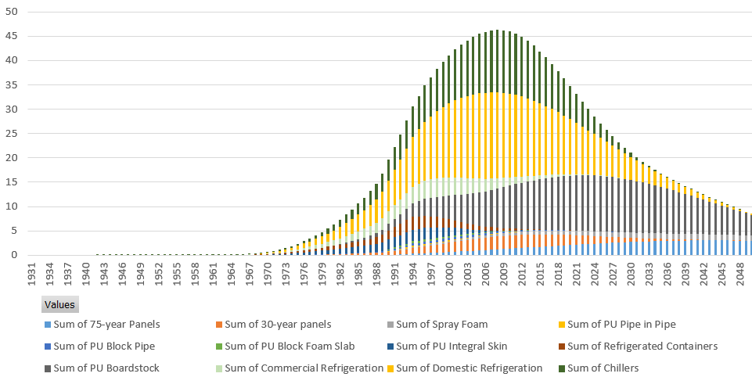

The Task Force adopted assumptions for emissions and lifetimes based on the 2019 Report and adjusted by the Weibull distribution, which results in a prediction that the majority of total global CFC-11 foams from refrigerating foams would likely have been decommissioned prior to 2021. The global peak of the CFC-11 decommissioned from the largest portion of active banks, i.e., all foams, when dismantled at end-of-life, is estimated to have occurred around the year 2010, at about 45 kilotonnes/year, and then subsequently decreases slowly over time to under 10 kilotonnes/year by 2050. These global peaks are dominated by the foam banks, foam products, and decommissioning patterns in the United States and Europe, owing to their overwhelming size.

There are underlying variations to the regional timing of peaks in foam decommissioning and/or variations for different foam product types, that are obscured within this global analysis. For example, studies and surveys estimate a 30-year lifetime of construction foams in Northeast Asia (NEA)[122] and a portion of foams used in commercial buildings in the United States[123],where premature demolishing of buildings prior to the expected lifetime has been recorded.

Figure 5.2 Estimated CFC-11 decommissioned from active foam banks, 1931-2050 (kilotonnes)[124]

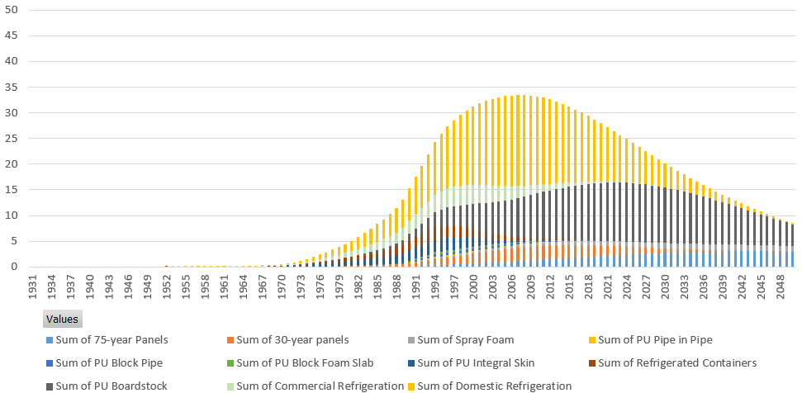

The Figure below represents the retirement of insulating foam used in building envelopes by foam type over time. Foam panels have been divided into two categories based on regional decommissioning practices using a 30-year lifetime for the United States and China and a 75-year lifetime for panels for all other regions of the world.

Figure 5.3 Estimated CFC-11 decommissioned from active construction foam banks, 1931-2050 (kilotonnes)[125]

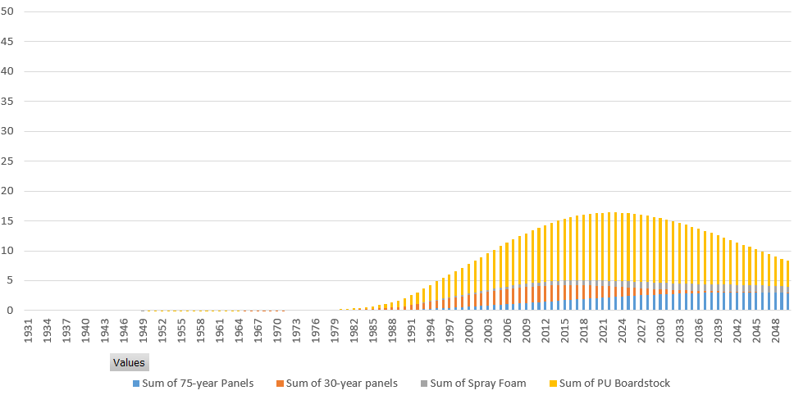

Retirement of refrigerating equipment containing CFC-11 blown foams is largely complete even with an assumption of a 25-year lifetime for domestic appliances as shown in the Figure below.

Figure 5.4 Estimated CFC-11 decommissioned from active refrigerating foam banks, 1931-2050 (kilotonnes)[126]

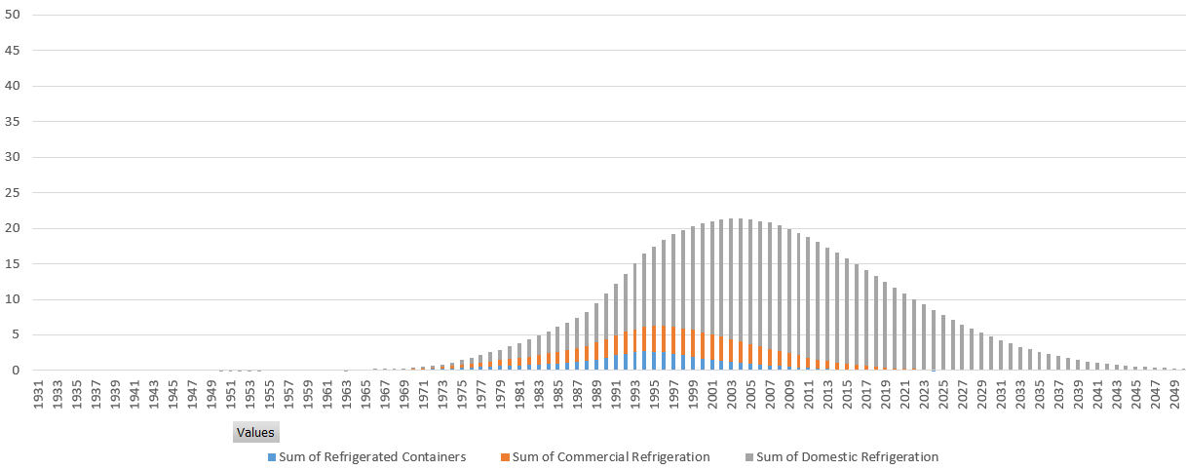

The Figure below presents the estimated quantities of CFC-11 in active foam and chiller banks until 2050. Past and present end-of-life waste management practices of foams result in the majority of CFC-11 being emitted from active and inactive foam banks, which is the assumption made for future practices in this analysis excluding destruction practices as required in Europe. The opportunity for recovery and destruction of CFC-11 lies in the higher management of active foam banks at end-of-life, with potential diversion of foam wastes before disposal in landfill or other forms of disposition, such as emissive secondary usage, e.g., in road aggregate, towards destruction that mitigates the majority of emissions. The estimated total quantity of CFC-11 in the active CFC-11 foam banks in 2021 is 750 kilotonnes, or 3.6 Gt CO2eq[127].

There are now very small quantities of CFC-11 in chillers, with the majority of the remaining chillers in United States[128]. CFC-11 refrigerant management practices have resulted in high levels of recovery, reclaim and destruction, consistent with the expected quantities reaching their end-of-life.

Figure 5.5 Estimated remaining CFC-11 in active chiller and foam banks, 1931-2050 (kilotonnes)[129]

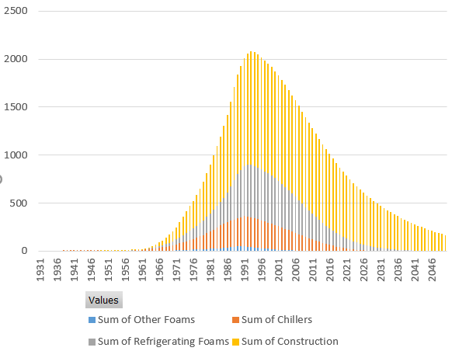

Different published analyses vary in their global peaks, trends, and annual outputs of CFC-11 waste streams due to differences in modelling assumptions. However, some noteworthy characteristics do not vary. The bulk of the remaining CFC-11 bank is in non-Article 5 parties and will typically be contained in thermal foam insulation in the built environment. The remainder of this section describes a selection of other studies of CFC-11 banks and resulting waste streams. Variations are indicative of the sensitivity in modelling to the assumptions adopted, including lifetimes of buildings and appliances.

Recent studies by GIZ Proklima estimated global CFC foam banks (CFC-11 and CFC-12) to the year 2100 (see Figure below) [130]. For the CFC foam banks as waste, it was assumed that waste foam is untreated and continues to release the blowing agent at a constant rate[131]. The active foam bank was estimated to be 1500 kilotonnes CFCs in 2020, or 8.5 Gt of CO2eq. While the foam bank containing CFC-11 is decreasing, GIZ Proklima estimated that available CFCs equivalent to 6.1 Gt CO2eq.[132] were yet to enter the waste stream (in 2020) and were still reachable for treatment, which is greater than the annual GHG emission of the European Union (4.3 Gt CO2eq. in 2016).

Figure 5.6 Global CFC Foam Banks (active and inactive) until 2100 (kilotonnes)[133]

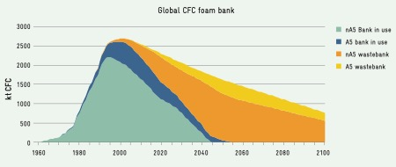

With the majority of the foam banks located in developed countries, and assuming an average building lifetime of 50 years, GIZ Proklima concluded in 2020 that, for insulation foam waste from buildings, there was the opportunity to avoid an estimated 870 kilotonnes of CFC-11 and CFC-12 emissions, equivalent to 4.5 Gt CO2eq.

Figure 5.7 CFC Foam Banks (active and inactive) in developed countries (summed) until 2100 (kilotonnes)[134]

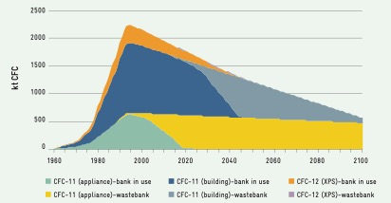

In other studies that reported the estimated flow of ODS reaching the waste stream in any given year, the 2018 MCTOC Assessment Report[135] highlighted that the annual amount of *all ODS* reaching the waste stream, and potentially available for ODS management and destruction, was estimated to have peaked in 2016 at ~200 kilotonnes, based on an earlier 2015 report on ODS banks by GIZ Proklima[136]. These reports’ estimations were based on the same earlier data used to derive Figure 3-1 of the October 2009 Report of the Decision XX/7 TEAP Task Force[137], which predicted ODS waste arisings for 2010 to 2030.

Estimates of ODS and other refrigerants entering the waste stream were presented in Figures 3-7 and 3-8 of that Decision XX/7 Task Force Report. Based on data used in the 2009 report, estimated annual quantities of ODS decommissioned for 2010 to 2030 are presented below[138].

**Figure 5.8 Estimated annual quantities of ODS entering the waste stream, 2010 to 2030 (tonnes) (based on data from the Decision XX/7 TEAP Task Force)[139] [140]**

The peak of total ODS entering the waste stream (unless intercepted) was estimated to occur at in 2016 by the Decision XX/7 Task Force; 2015 GIZ Proklima concluded likewise[141]. A closer look at the sources of ODS shown in the graph indicates that very little ODS was expected to come from foam sources in that year. Indeed, all CFC-11 sources represented only 4.2% (9,388 tonnes) of total ODS, with the dominant contributor to the decommissioning levels in 2016, and over the period, being HCFC-22 from refrigeration applications in Article 5 parties. Of the projected 9,388 tonnes of CFC-11 reaching the waste stream in 2016, it was estimated that 78% was from foams, with the balance potentially arising from chillers. The proportion of foam products containing CFC-11 was relatively evenly divided between Article 5 and non-Article 5 parties, as is shown in the following pie chart.

Figure 5.9 Estimated proportions and types of CFC-11 foams entering the waste stream, 2016 (tonnes) (based on the Decision XX/7 Task Force Report)

These decommissioning forecasts were based on time series that assumed specific product lifetimes for each product type. For example, the assumed lifetime for a domestic appliance was 15 years for the Decision XX/7 TEAP Task Force analysis. More recent investigations by GIZ Proklima (2020)[142] suggested that these previously estimated lifetimes may have been under-estimated, even in non-Article 5 parties where there are indications that appliance lifetimes could be 25 years or longer in some countries. The 2019 and the 2021 Task Forces also used 25-year appliance lifetimes.

If longer appliance lifetime assumptions were adopted for the analysis using the Decision XX/7 Task Force model, in 2016 there would still have been some CFC-11 in the appliance waste stream in non-Article 5 parties. In Article 5 parties, there would also have been less CFC-11 in the appliance waste stream in 2016 than with shorter appliance lifetimes. Either way, the amounts of CFC-11 in the waste stream are relatively small as a percentage of the overall ODS in the waste stream for 2016. The estimated total CFC-11 in the domestic appliances waste stream in Article 5 parties (2,750 tonnes) represents the disposal of around 11 million appliances. These appliances are spread throughout Article 5 parties, making it difficult to establish the critical mass of collected waste appliances needed to support investment in the refrigerator de-manufacturing plants needed to process them. This is why combining CFC/HCFC/HFC waste streams can provide the best opportunity for recovery and destruction of CFC-11, as well as for other ODS and HFC wastes.

An analysis by SKM Enviros[143], conducted for the European Commission in 2012, suggested that the peak of decommissioned CFC-11 in Europe from thermal insulating foam sources would occur in the decade from 2030-2040 (see Figure below, which reproduces Figure B-10 from the foam Enviros report).

Figure 5.10 Trends in foam blowing agent wastes reaching end-of-life on a GWP-weighted basis (kilotonnes CO2eq.)



There needs to be some caution in interpreting this Figure in the context of CFC-11 foam waste only because it covers all CFC blowing agents arising in the waste stream, including CFC-12 from extruded polystyrene (XPS) and polyethylene (PE) foams, as well as CFC-11 from polyurethane (PU) and phenolic foam (PF) boardstock products.

### 5.5.2 Opportunities and challenges for recovery and disposition of CFC-11

Opportunities for the recovery and disposition of CFC-11 wastes can be found in combining ODS, HFC and other waste streams to maximise returns in economies of scale and investment in infrastructure for recovery and destruction. The global peak in decommissioning of CFC-11 foam wastes is estimated to have occurred around the year 2010, when global CFC-11 recovery and destruction opportunities were at their highest. Nevertheless, there are underlying variations to the regional peaks in CFC-11 foam decommissioning that are obscured within the global analysis, where some regions and foam types, are likely yet to reach their decommissioning peak e.g., Europe for foam panels in buildings.

Relative investment and operating costs in ODS waste recovery and destruction present a challenge compared with cheaper forms of disposition (venting and landfill disposal). The low internalised waste disposal costs for cheaper forms of recovery and disposal can be weighed against the externalised costs to society of future health and environmental impacts of ODS emissions that result from venting of refrigerant wastes or landfill disposal of foam wastes. Regulatory incentives can shift these market forces in favour of recovery and destruction in most sectors and place a value on the benefits to society of protecting the environment through avoided human health costs.

Previous analyses have concluded that stationary air conditioning, including centrifugal chillers, is one of the sub-sectors of ODS and HFC waste streams that is the most cost effective for recovery and destruction of refrigerants (once recycling and reclamation/reuse opportunities are exhausted) [144]. Centrifugal chillers constitute a small proportion of the active CFC-11 bank. The cost of recovery and destruction of ODS insulating foams is relatively higher. Insulating foams now constitute the majority of the active CFC-11 bank (of which, one third is foam insulation in appliances, two thirds is building foam insulation). The costs for steel-faced foam building panels are between 3-15 times higher than for refrigerants from stationary AC (including chillers). The cost of recovery and destruction of appliance foams is relatively lower, estimated to be between about the same to 10 times higher than the cost for refrigerants from stationary AC (including chillers).

Climate change benefits of recovery and destruction of thermal insulating foam wastes may decrease relative to costs over time. The European Commission analysis[145] of the recovery and destruction of CFCs emerging from thermal insulating foam sources suggests that relative GWP-based cost-effectiveness will decrease substantially with time. To illustrate the point, selecting foam products in the built environment that are the simplest to recover (i.e., continuous and discontinuous steel-faced panels), the cost of emissions abatement per tonne of CO2 saved is predicted to increase with time (see the Figure below, which reproduces Figure B-18 from the SKM Enviros report). The reason for this is that insulating panels containing CFC-11 cannot be targeted in isolation from other steel-faced insulating panels containing other blowing agents; the average GWP of the waste stream decreases as the use of lower GWP blowing agents increases over time, thereby increasing the cost of emissions abatement per tonne of CO2 saved and reducing the cost effectiveness of recovery and destruction when considered on a GWP basis.

These trends in cost effectiveness also show a window of opportunity before around 2045 after which abatement costs per tonne of CO2 saved for steel-faced panels show an accelerated increase, presumably as the average GWP of the foam waste decreases.

Figure 5.11 Trends in GWP-weighted abatement costs for steel-faced foam panels reaching end-of-life (Euro/kilotonnes CO2 saved)



The European analysis of the GWP-based cost-effectiveness of recovery and destruction of CFCs suggests that for any newly produced (unreported) CFCs recently incorporated in the built environment, the cost of emissions abatement through its recovery and destruction will remain relatively high per tonne of CO2 saved when it enters the waste stream in the future, especially if diluted by other lower GWP blowing agents. Of course, the value placed on a tonne of CO2 saved may have already increased substantially over the same time period, or may increase in the future, which may act as an increased incentive to recovery of CFC-11, even dilute waste streams of CFC-11. These are relative comparisons for the purpose of drawing specific conclusions in the context of decision XXXI/3. However, this is an economic argument based on an analysis in 2012 and is not intended to make the broader case that it would be impractical or imprudent to destroy CFC-11 foams now or in the future, with associated opportunities in reducing ODS emissions and avoiding health and environmental costs.

With long building lifetimes, the drivers for recovery and destruction of building insulation foams may change over time. The evolution of net zero carbon requirements and the circular economy may improve cost effectiveness and end-of-life choices.

In voluntary carbon markets, there is an opportunity for ODS (and HFC) recovery and destruction in the offsetting of Scope 3 greenhouse gas emissions within construction product supply chains. The impacts of the total lifecycle emissions must be accounted for as Scope 3 emissions in the year of manufacture, according to the current Greenhouse Gas Protocol. For decommissioned foams, these could be considered as an offset to stimulate extended producer responsibility and for those seeking to reduce their net carbon footprints.

A comprehensive study of ODS disposal by ICF[146] has defined five categories of challenges that hinder the effective collection and destruction of ODS in developing and developed countries and gives recommendations on how to address them. These challenges are informational, financial, technological, logistical and legal. Some of the significant challenges for recovery and destruction in developing countries include the availability of, and access to, destruction facilities, transboundary movement of waste, recovery equipment, transportation infrastructure, and cost. According to the 2015 GIZ Proklima report on ODS banks[147], the most important factors that decide the success of ODS lifecycle management in developing countries are the creation of financial incentives for returning ODS or ODS-containing equipment, and regulatory controls for the management of ODS waste, including destruction if substances cannot be reused.

Even in a relatively large refrigeration and air conditioning market, a key challenge in destroying end-of-life ODS/HFCs is their recovery and collection and having the capability to collect minimum quantities at predictable rates for viable destruction. For destruction to be part of an overall end-of-life strategy, selecting suitable approved and/or effective destruction technologies, and achieving the required investments, is mainly dependent on this recovery and collection capability, and a reliable analysis of the material available for destruction. A major determinant of viable destruction infrastructure is having achievable economies of scale that might then also utilise already available destruction capacity[148],[149].

The October 2009 Decision XX/7 TEAP Task Force Report[150] concluded that recovery and destruction of a waste stream combining all ODS and HFCs would realise the largest economies of scale and accrue the greatest benefits. This approach also presents the best opportunity for recovery and destruction of CFC-11 waste streams.

### 5.5.3 Opportunities and challenges for destruction

Numerous studies have described the technical and economic feasibility of the range of technologies available to destroy ODS, including CFC-11, and supporting programs[151].

While encouraging parties to undertake environmentally sound destruction of surplus or contaminated end-of-life ODS/HFCs, the Montreal Protocol does not mandate the destruction of ODS or Annex F Group I HFCs. The exception is HFC-23 (Annex F, Group II) generated in manufacturing facilities, from which emissions must be destroyed to the extent practicable using technologies approved by parties. The Protocol’s definition of ‘production’ of controlled substances subtracts the amounts destroyed from the amounts produced. The use of destruction technologies approved by parties applies to the amounts of controlled substances destroyed and accounted for within the Protocol’s definition of ‘production’. The Protocol also allows parties to manufacture an amount of controlled substance almost equivalent to the quantity destroyed with technology listed as approved, within the same year as destruction, and within the same group of substances.

Parties have taken a number of decisions to approve destruction technologies for the purposes of Montreal Protocol production data reporting requirements. Over time, the list of destruction technologies approved by parties has been updated, with the most recent list of approved destruction processes contained in Annex II to the 30th Meeting of the Parties under decision XXX/6.

Adoption of destruction technologies varies by country, depending on the demand for destruction, the requirements of national regulations and related standards, national and local air quality guidelines, availability of appropriate technology, and viability of the market for destruction.

Other than for HFC-23, if a destruction technology is approved or not approved for each group of controlled substance by the Montreal Protocol does not determine whether the technology is suitable to destroy ODS or HFC wastes and should not necessarily be considered a barrier to the destruction of ODS wastes. For example, landfill disposal of waste foam will emit the majority of ODS over time, whereas ODS foam waste recovery and destruction using a technology with reasonable ODS destruction efficiency[152] e.g., more than 80% and less than 95%, will still result in significantly less ODS emissions than landfill disposal.

Using a destruction technology approved by the Montreal Protocol is pertinent if a party is interested in accounting for destroyed amounts of controlled substances for the purposes of reporting production or for destroying HFC-23. For a party that is not interested in accounting for destroyed amounts of controlled substances for the Montreal Protocol, or not destroying HFC-23, a destruction technology that meets the minimum local regulatory environmental standards and provides reasonably acceptable ODS destruction efficiencies is likely to be a better option for emissions abatement than venting or landfill disposal of ODS wastes.

There might be circumstances where the choice of technology to maximise destruction efficiencies and the accounting of destroyed ODS wastes are important, e.g., for voluntary carbon markets. This need not necessarily preclude the use of destruction technologies that are not approved by the Montreal Protocol to destroy controlled substances, with the exception of HFC-23 and countries that have introduced laws mandating ODS destruction using technologies approved by the Montreal Protocol.

Destruction technologies can be grouped into three categories: thermal oxidation, plasma technologies, and conversion (non-incineration) technologies.

Thermal oxidation technologies involve large plants that require large volume waste streams to sustain economic viability, and where economic benefits can be found with the co-destruction of a range of other wastes, such as persistent organic pollutants (POPs).

Most destruction facilities are concentrated in developed countries, predominantly the European Union, Japan, and the United States. Developing countries are establishing and expanding their destruction capacities, e.g., Brazil, Cuba, and Mexico.

Depending on the technology, destruction capacities per facility range between 40 to 600 tonnes/year with average destruction costs of about US$7/kg[153]. An evaluation of pilot demonstration projects in Article 5 parties for ODS disposal and destruction indicated average cost-effectiveness of a similar magnitude[154].

Destruction costs represent a minor proportion of total costs of recovery and destruction, with recovery costs being the major portion and dependent on factors such as the sector waste type, infrastructure, logistics, and transport distances.

It is also important to appreciate that the recovery and destruction of waste foam is essentially considered to be a broader waste management issue, with ODS emissions needing to be managed within a range of other waste management considerations. Foams might have some small value as waste derived fuel; however, the foam waste mass will be a low proportion of the waste feed, e.g., to a cement kiln, and therefore its relative contribution will be small or not significant as a qualified contribution for fossil fuel replacement. With long building lifetimes, the drivers for recovery and destruction of building insulation foams may change over time. The evolution of net zero carbon requirements and the circular economy may improve cost effectiveness and end-of-life choices.

In voluntary carbon markets, there is an opportunity for ODS (and HFC) recovery and destruction in the offsetting of Scope 3 greenhouse gas emissions within construction product supply chains. The impacts of the total lifecycle emissions must be accounted for as Scope 3 emissions in the year of manufacture, according to the current Greenhouse Gas Protocol. For decommissioned foams, these could be considered as an offset to stimulate extended producer responsibility and for those seeking to reduce their net carbon footprints.

The Medical and Chemicals TOC will report further in its 2022 Assessment Report about opportunities for ODS and HFC collection and destruction.

Appendix 1: Summary of 2019 Task Force Report findings

**2019 Task Force Report: Key Messages**

In response to scientific findings of an unexpected increase in global emissions of CFC-11 after 2012, parties requested the Technology and Economic Assessment Panel (TEAP) to provide them with relevant information on potential sources of emissions of CFC-11 and related controlled substances.

Based on modelling of CFC-11 production, usage, emissions and comparison against atmospheric-derived emissions, it is unlikely that past production and historic usage can account for the unexpected CFC-11 emissions, including from existing foam banks.

It is unlikely that there has been a resumption of newly produced CFC-11 usage in refrigeration and air-conditioning uses, flexible foams, aerosols, solvents, feedstock uses, tobacco expansion and other miscellaneous applications.

It is likely that there has been a resumption of newly produced CFC-11 usage in closed-cell foams.

There are a number of economic drivers that might have encouraged the reversion to CFC-11 in closed-cell or rigid foam, including price increases and reduced availability of HCFC-141b due to the global phase-out. Reversion from HCFC-141b to CFC-11 can be made with technical ease.

Based on modelling using reported CFC-11 production data, it seems that the expected emissions from the CFC-11 foam banks in Northeast Asia are insufficient to account for the atmospheric-derived emissions from eastern mainland China in Rigby *et al.*

Various parties imported up to 7,500 tonnes per year HCFC-141b in foam systems. Foam systems could be mislabelled and used by a recipient without knowing what blowing agent is in the system.

The “most likely” modelling scenario predicts 40,000 to 70,000 tonnes per year CFC-11 production would have been required from 2012 onwards to account for the increased CFC-11 emissions.

The most likely production routes are CTC to CFC-11 on micro-scale plants using minimal equipment (to make low grade CFC-11 for foam blowing use); and CTC to CFC-11/12 on a large-scale in an existing liquid phase plant (HCFC-22 and/or HFC-32 plant).

Between 45,000 to 120,000 tonnes of CTC would be required to supply between 40,000 to 70,000 tonnes of CFC-11 production, depending on the proportion of co-produced CFC-12. The CTC quantity required for CFC-11 production is expected to be at the lower end of the range if, as predicted, the objective is higher CFC-11 selectivity.

The quantity of CFC-12 co-produced as a result of any CFC-11 production is dependent on the exact production option chosen, and how the plant is set up and operated. With CFC-11 as the target chemical, for the most likely production routes, the range of CFC-12 co-production is between 0-30% of total CFC-11/12 production.

Appendix 2: Model description

To produce an estimate of emissions, the model uses a number of assumptions regarding emissions losses during the charging, operation and decommissioning of chillers, releases during the foam blowing process and during the life of the foam *in situ* as well as the use of aerosols, and solvents. CFC-11 is emitted very quickly when used as in aerosols, as a cleaning agent, or in tobacco expansion (emissive uses). For closed-cell foams and chillers, only a fraction of CFC-11 is emitted upon installation. The remaining chemical remains in the CFC-11 bank and is gradually emitted in subsequent years. This time-series approach is the typical model for all foam types and allows differing assumptions to be applied depending on the foam type, thickness and cell properties.

CFC-11 banks are calculated using this “inventory-based” approach as an important part of CFC-11 emissions in future years. The banks can be described as “active” banks where CFC-11 is still in use in foam insulation, chillers or other uses. Meanwhile, banks are described as “inactive” at the end-of-life of the product when they enter the waste stream (i.e., foams in landfills or remaining CFC-11 in an aerosol can). Other terms that are used to describe banks are “accessible” meaning that the CFC-11 could be relatively easily collected and destroyed or recovered at a cost. Inaccessible banks describe CFC-11 that would be difficult to recover (i.e., from a landfill). Not all inactive banks are inaccessible.

The Task Force uses a “inventory-based” emissions model to estimate the magnitude of CFC-11 emissions and banks. The model relies on the reported production of CFC-11 and then applies a range of educated assumptions that were developed based on the existing literature and refined following extensive discussions with industry experts. The “inventory-based” emissions that are produced by the model are then compared to the derived global atmospheric emissions to check the model’s ability to describe the atmospheric observations.

Emissions model parameters relate to CFC-11 production, installation (e.g., into foams or chillers) and disposal at end-of-life.

* Production: emissions from chemical plants during production, maintenance, drum heel and packaging,
* Installation: de minimis emissions when charging chillers, emissions from the foaming process, and discharge of a propellant in aerosol products or as a solvent; and,
* Banks: emissions during a product’s lifetime (active banks) as well as at the end-of-life when the foam product or the chillers are landfilled, recycled or destroyed (inactive banks). CFC-11 from banks leak gradually to the atmosphere or leak abruptly when refrigerant is vented or partially released when foam is shredded or crushed.

In the “inventory-based” calculation of the bank size, the bank is divided into three sectors: chillers, closed-cell (rigid) foams and emissive uses (open-cell foams, aerosols and solvents).

Emissions during production vary significantly from plant to plant and are dependent on operating conditions, system setup and handling. An outline assessment of the likely CFC-11 emission points and rates from a large-scale CFC-11 production facility suggests that a 4-6% CFC-11 emission would be a reasonable base case for production emission assumptions, and account for variations in production emission rates over the time period for which data is available, from 1930 onwards. This assumption is also consistent with the current draft refinements to the IPCC estimate of the default emission rate for fluorocarbon production. For smaller scale, less sophisticated production plants (micro plants), where there are likely to be fewer process steps and recovery systems, and more manual operations, an overall CFC-11 emission rate of 10-15% is considered a reasonable assumption.

The Task Force investigated a range of scenarios the assumptions for which are shown in the Table below. These parameters produce the graphs shown in section 2.4.

Table A1.1 Inventory-based model assumptions without regional and product assumptions.

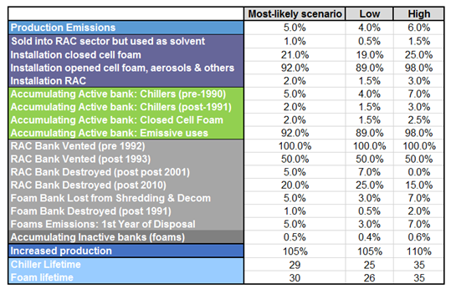

**Sensitivity analysis of the CFC-11 emissions “inventory-based” model**

In the “inventory-based” calculation of the bank size, the bank is divided into three sectors: chillers, closed-cell foams and emissive uses (open-cell foams, aerosols, etc.). Production and installation emission rates and bank emission rates were estimated based on industry knowledge and literature.

To evaluate the importance of specific parameters in estimating atmospheric emissions through 2016. Each parameter was increased by 10%. The sensitivity of the model is shown in the Table below.

Table A1.2 Sensitivity analysis parameter considered in the inventory-based model without regional and product assumptions.

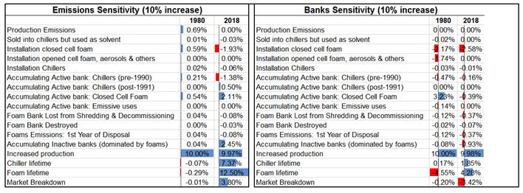

The emissions predicted by the model are particularly sensitive to the assumptions made regarding the level of potential increased production over the years (i.e., where production was assumed to be higher than reported), the installation emissions rates, as well as the emissions rates from rigid foam banks. In the later years, the model is also sensitive to the lifetime of chillers and foams as well as the emissions rate from the inactive foam bank. The full range of uncertainty has not been probed here, but the calculations are illustrative of expected behaviour. Even with the limited uncertainty tests, the range in calculated recent emissions is large. However, none of the scenarios align with the recent emissions increase. Therefore, based on the broad range of scenarios examined, it seems unlikely that previous production and historic usage can account for the recent emissions rise unless there has been a significant change in the treatment of a large volume of banked CFC-11.

The rate of decline of both emissions and bank size is substantial post-2007. Looking at the source of emissions, the model indicates that the decline is largely driven by active bank emissions as well as emissions during the dismantling process of chillers and foams. The rate of decline in the active bank is dominate by the decline in the closed-cell foam bank emissions and to a lesser degree the chiller bank emissions.

Figure A.2.1 CFC-11 emissions by source (kilotonnes)[155]

The decline in the total bank volume is dominated by the decline in the active foam bank, which is expected since large amounts of closed-cell foams reach their end of life and are dismantled during that period. The decline in the bank size is also a result of a declining active chiller bank.

Figure A.2.2 CFC-11 banks by type (kilotonnes)[156]

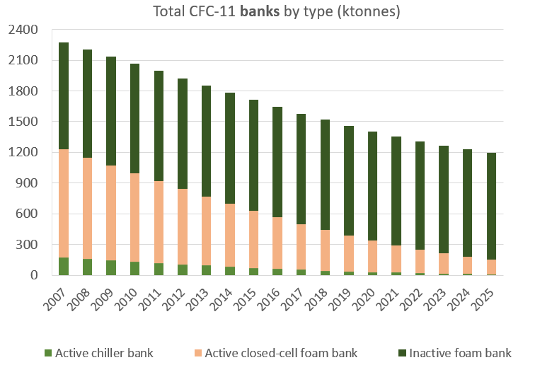

The Task Force also estimated emissions and banks based on individual regional and foam sector estimates of emissions rates and sales based on the 2006 Flexible and Rigid Foams Technical Options Committee (FTOC) Assessment Report and latest research of lifetime of equipment and buildings containing foams. These models were created to better respond to the requests by the parties for information regarding which products might still contain CFC-11 and where those products may be located. More detail is discussed in Chapter 5. The graphs below also include the output of those models. The blue line in the emissions graph shows the slightly lower peak in the 1980s and slightly higher curve from 2006. The emissions curves are very similar showing that the model is most influenced by other parameters such as use of CFC-11 in emissive products prior to 2006 and that the overall average lifetime model is a reasonable proxy for the Task Force assumptions for emissions.

Although the overall banks from the various models are similar, the timing of retirement of products containing CFC-11 (chillers and foams) varies in the different models[157]. The sectoral, regional inventory model has a larger bank than the single lifetime bank until 2050, as shown below.

Figure A.2.3 Banks incorporating regional and sectoral analysis (kilotonnes)[158]

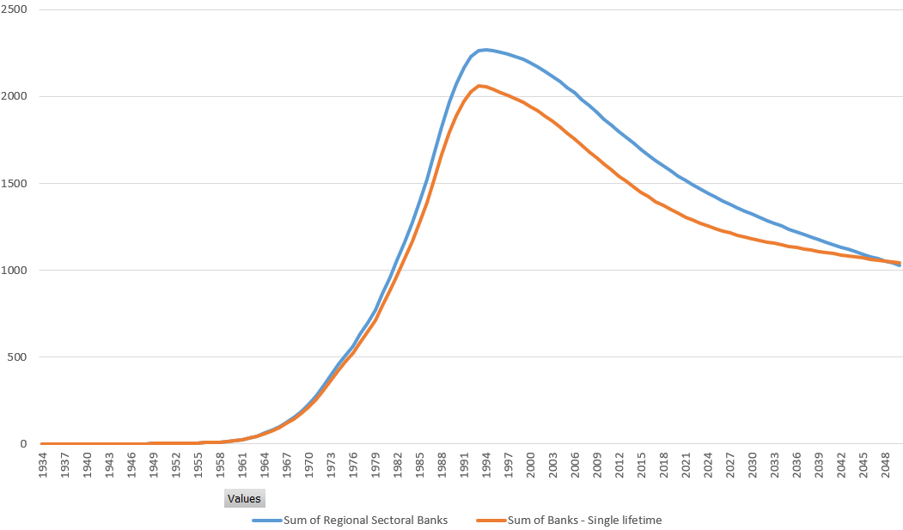

Figure A.2.4 Emissions incorporating regional and sectoral analysis (kilotonnes)[159]

Appendix 3: Product lifetimes in the global and regional models

Due to the very large body of modelling work in previous reports, a simplifying assumption was made for the lifetime of products containing CFC-11 using average lifetimes. An average lifetime was used in the global model and average lifetimes were also used by foam type in the regional models instead of incorporating the variability of chiller and closed-cell foam lifetimes.

The global and regional models now include probabilistic product lifetimes. Chillers, foam end-uses, and other CFC-containing product retire at the end-of-life, but calculating this lifetime is a probabilistic function. Weibull functions[160] are a type of survival function used by many industries and researchers, including the U.S. Department of Energy[161] and the California Air Resources Board[162], to estimate product failure rates over time. Weibull curves can be fit to individual types of products by defining a scale and shape of the function based on the average product lifetime and the rate of product failure. Previous research on product lifetimes can be used to estimate its scale. The shape parameter is deduced by the rate at which product failure occurs. Analysis from the U.S. Department of Energy[163] found that a shape of 2 was appropriate for other types of HVACR equipment that use refrigerant, so equipment like chillers likely has a similar shape. These parameters can be tuned to increase product failure accuracy and create a useful distribution of retirement curves.

The California Air Resources Board also uses Weibull functions to better estimate emissions from products containing hydrofluorocarbons (HFCs) and has generously shared their modelling strategy with the Task Force.

Because product lifetime varies with time, 2-parameter Weibull survival functions were applied to each year of product shipments and used to estimate a probabilistic distribution of surviving products at each year after shipment. The scale and shape parameters can also vary in each year to capture changes in technology and resulting product lifetimes. Each shipment year’s surviving equipment volume were summed to estimate that year’s total volume of remaining products and its associated CFC-11 volume. Modifying the shape parameter skews the failure rate and dissociates the statistical mean, median, and mode. This model's application assumed that the average lifetime was equal to the scale parameter to represent the median failure point of equipment. This new approach is meant to better represent the decommissioning of equipment and improve the accuracy of the aggregate emissions models. An example of the Weibull application can be found in the Figure below.

Figure A.3.1 Weibull Distribution differentiated by shape parameters.

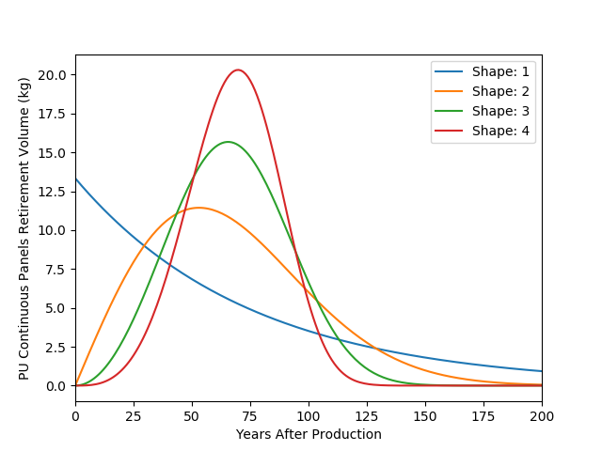

Appendix 4: Foam model assumptions

A Weibull distribution with a shape parameter of 3 was used for foams based on the 2009 American Housing Survey[164] except for the small foam market for refrigerated transport which used a shape parameter of 2 due to the very short timeline of containers where the higher shape parameter skewed the timeframe of the distribution.

The same assumptions used in the 2021 Task Force report were used in the 2019 Task Force report for foam lifetimes and emission rates except for the lifetime of boardstock which was increased from 25 years to 50 years since the majority of boardstock was used in single-family homes in the United States which have a longer lifetime. The lifetime of foamed panels in commercial building in North America[165] and China[166] was considered to be 30 years based on recent assessments of building stock while continuing to use 75-year lifetime in Europe and the rest of the world for panels

Consideration of integral skin was included in the 2021 report, and the lifetime of polyurethane pipe-in-pipe foams was increased for China usage in district heating to 30 years.

Table A4.1 Emission rates, Weibull distribution and lifetime assumptions

|  |  |  |  |  |  |  |
| --- | --- | --- | --- | --- | --- | --- |
|  | Weibull Shape | FTOC Foam Lifetime* | FTOC: Installation Emissions Rates % | Emissions from Finished Product % | Emissions during decommissioning % | Emissions from Landfill % |
| Domestic Refrigeration | 3 | 25 | 10 | 1 | 20 | 1 |
| Commercial Refrig & other Appliances | 3 | 15 | 20 | 1 | 20 | 1. |
| Refrigerated Containers | 2 | 7 | 20 | 1 | 20 | 1 |
| PU Boardstock | 3 | 50 | 10 | 1 | 20 | 1 |
| PU Continuous Panels | 3 | 75 | 10 | 1 | 20 | 1 |
| Discontinuous Panels | 3 | 75 | 20 | 1 | 20 | 1 |
| PU Spray Foam | 3 | 50 | 25 | 1.5 | 20 | 1 |
| PU Pipe in Pipe | 3 | 15 | 10 | 25 | 20 | 1 |
| PU Block & Pipe | 3 | 15 | 45 | 7.5 | 20 | 1 |
| PU Block Foam Slab | 3 | 15 | 15 | 1 | 20 | 1 |
| Integral Skin | 3 | 10 | 40 | 2 | 20 | 1.0 |

Appendix 5: 2006 FTOC Assessment report regional summaries

Table A5.1 Regions in 2006 FTOC Assessment Report

|  |
| --- |
| Latin America Caribbean (LAC): Antigua and Barbuda, Argentina, Bahamas, Barbados, Belize, Bolivia, Brazil, Chile, Colombia, Costa Rica, Cuba, Dominica, Dominican Republic, Ecuador, El Salvador, Grenada, Guatemala, Guyana, Haiti, Honduras, Jamaica, Mexico, Nicaragua, Panama, Paraguay, Peru, Saint Kitts and Nevis, Saint Lucia, Saint Vincent and The Grenadines, Suriname, Trinidad and Tobago, Uruguay, Venezuela. |
| Middle East/North Africa (MENA): Algeria, Bahrain, Egypt, Iran, Islamic Republic, Iran, Islamic Republic of Iraq, Israel, Jordan, Kuwait, Lebanon, Libyan Arab Jamahiriya, Mauritania, Morocco, Oman, Palestine, Qatar, Saudi Arabia, Syrian Arab Republic, Tunisia, Turkey, United Arab Emirates, Yemen. |
| Sub-Saharan Africa (SSA): Angola, Benin, Botswana, Burkina Faso, Burundi, Cameroon, Cape Verde, Central African Republic, Chad, Comoros, Congo, Congo, Democratic Republic of, Cote d'Ivoire, Djibouti, Equatorial Guinea, Eritrea, Ethiopia, Gabon, Gambia, Ghana, Guinea, Guinea-Bissau, Kenya, Lesotho, Liberia, Madagascar, Malawi, Mali, Mauritius, Mozambique, Namibia, Niger, Nigeria, Rwanda, Sao Tome and Principe, Senegal, Seychelles, Sierra Leone, Somalia, South Africa, Sudan, Eswatini, Tanzania, United Republic of Togo, Uganda, Zambia, Zimbabwe |
| Countries with Economies in Transition (CEIT): Armenia, Azerbaijan, Belarus, Georgia, Kazakhstan, Kyrgyzstan, Russian Federation, Tajikistan, Turkmenistan, Ukraine, Uzbekistan |
| North America: Canada, USA |
| Japan: Japan |
| South-East Asia (SEA): Brunei Darussalam, Cambodia, Indonesia, Lao People's Democratic Republic, Malaysia, Myanmar, Philippines, Singapore, Thailand, Viet Nam. |
| North-East Asia (NEA): China, Mongolia, North Korea, South Korea |
| Australia, New Zealand & The Pacific (ANZP): Australia, Cook Islands, Fiji, Kiribati, Marshall Islands, Micronesia, Nauru, New Zealand, Niue, Palau, Papua New Guinea, Samoa, Solomon Islands, Tonga, Tuvalu, Vanuatu |
| Europe: Albania, Andorra, Austria, Bosnia and Herzegovina, Belgium, Bulgaria, Croatia, Cyprus, Czech Republic, Denmark, Estonia, Finland, France, Germany, Greece, Holy See, Hungary, Latvia, Iceland, Ireland, Italy, Liechtenstein, Lithuania, Luxembourg, Macedonia, Malta, Moldova, Monaco, Netherlands, Norway, Poland, Portugal, Romania, San Marino, Slovakia, Slovenia, Spain, Sweden, Switzerland, United Kingdom, Yugoslavia |
| South/Central Asia (SCA): Afghanistan, Bangladesh, Bhutan, India, Maldives, Nepal, Pakistan, Sri Lanka. |

Appendix 6: Polyurethane foam blowing agent CFC-11 replacement

The transition from CFC-11 to HCFC-141b was examined to look for anomalies in the Task Force models. None were determined based on this brief analysis. The matrix below also highlights the comparatively small quantities of CFC-11 and HCFC-141b usage in many regions. Of note, non-Article 5 parties fluorocarbon usage as a foam blowing agent was reduced considerably during the transition to HCFCs and also to HFCs. This report notes earlier that the global capacity of HFCs used as blowing agents in closed-cell foams was less than 45 kilotonnes until 2018.

**Global Consumption of CFC-11 and HCFC-141b**

Global consumption of CFC-11 and HCFC-141b were compared as transitions occurred in the various foam regions determined by FTOC in 2006 for their Assessment Report and noted here by region to further confirm the reasonable range of assumptions for foam models. The regions are identified below. A Weibull distribution of 2 was used for refrigerated containers because of their generally short lifecycle.

Figure A6.1 CFC-11 and HCFC-141b consumption (tonnes)

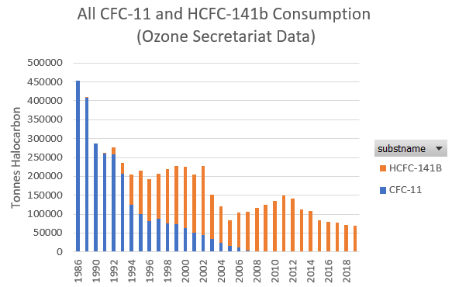

Figure A6.2 CFC-11 and HCFC-141b consumption in Article 5 parties (tonnes)

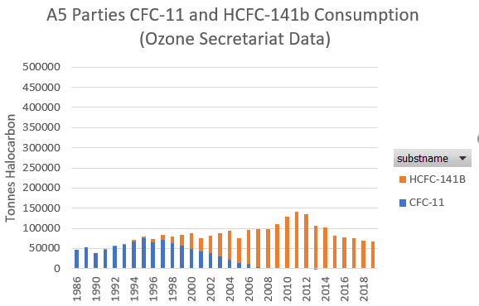

Figure A6.3 CFC-11 and HCFC-141b consumption in non-Article 5 parties (tonnes)

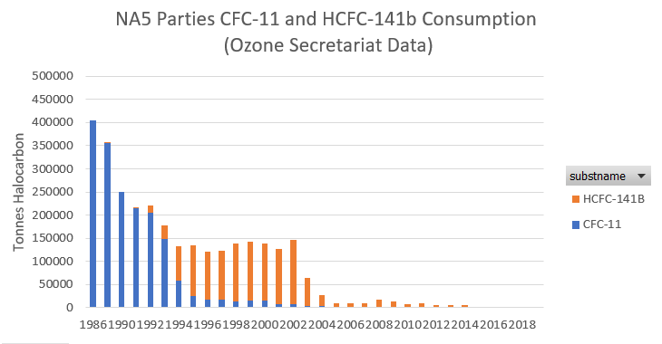

Figure A6.4 Regional CFC-11 and HCFC-141b consumption (tonnes)

|  |  |
| --- | --- |
| CEIT | European Union |
| SEA | SSA |
| NEA | SCA |
| Japan | LAC |
| MENA | North America |
| ANZP | |

Figure A6.5 Regional CFC-11 consumption (tonnes)

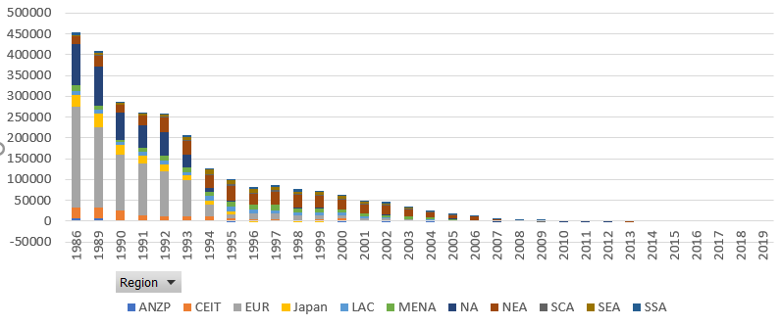

Figure A6.6 Regional HCFC-141b consumption (tonnes)

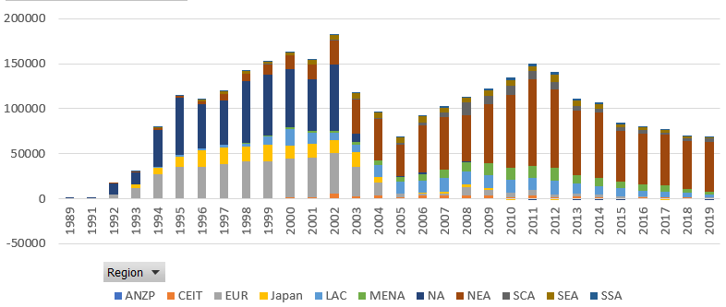

Appendix 7: Regional CFC-11 foam product sectors distribution based on FTOC 2006 Assessment Report

In 2006, the primary use of closed-cell foams was in domestic appliances followed by boardstock (primarily used in North America). Smaller quantities of CFC-11 were used in panels and spray foam and very small quantities were used for other foam types comparatively.

Regional product-type distributions show CFC-11 dominant usage in appliances and boardstock in North America, in panels and appliances in Europe, and in appliances in Northeast Asia and Latin America and the Caribbean (LAC) region. The Figures below also highlight the very small relative quantities of foam historically used in Article 5 parties in 2006.

Figure A7.1 Global foam product-type distribution based on 2006 FTOC Assessment Report (tonnes)

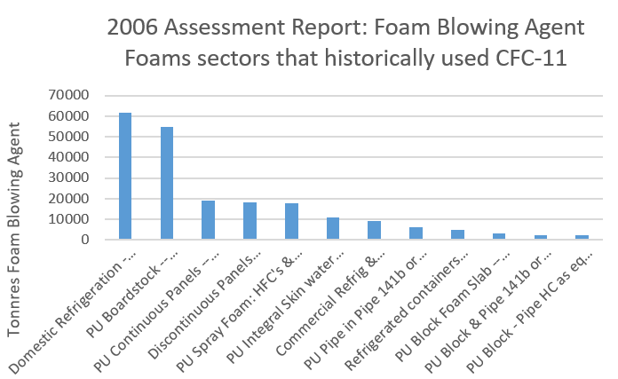

The Task Force also examined foam product distribution temporally in its build-up model estimating emissions and banks. It is important to note that this model creates a slight bias toward larger consumption of CFC-11 consumption in early years in Article 5 parties. The consumption in Article 5 parties is shown to be small and was likely even smaller as the introduction of products likely happened at a slower rate.

Figure A7.2 Global CFC-11 foam sector use assumptions based on the 2006 FTOC Assessment Report (kilotonnes)

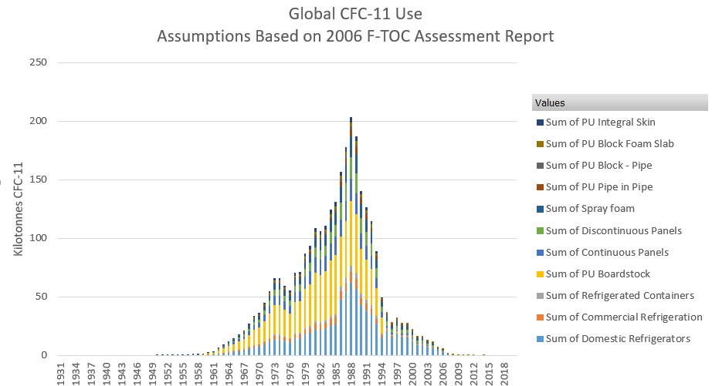

Figure A7.3 Regional foam product-type distribution based on 2006 FTOC Assessment Report (kilotonnes)

|  |  |
| --- | --- |
| Europe | North America |
| Japan | NEA |
| SCA | SEA |
| CEIT | LAC |
| MENA | SCA |
| SSA | |

Appendix 8: CFC and HCFC production and consumption phase-out schedules

Table A.8.1 Production and consumption phase-out schedule for Montreal Protocol Annex A, Group I, controlled substances: chlorofluorocarbons[167]

|  |  |  |  |
| --- | --- | --- | --- |
| *Non-Article 5(1) Parties* | | *Article 5(1) Parties* | |
| Base level: | 1986 | Base level: | Average of 1995-97 |
| Freeze: | July 1, 1989 | Freeze: | July 1, 1999 |
| 75 per cent: reduction | January 1, 1994 | 50 per cent: reduction | January 1, 2005 |
| 100 per cent: reduction | January 1, 1996* | 85 per cent: reduction | January 1, 2007 |
|  |  | 100 per cent: reduction | January 1, 2010* |

*\*Except for essential use exemptions*

Table A.8.2 Consumption phase-out schedule for Montreal Protocol Annex B, Group II, controlled substances: hydrochlorofluorocarbons[168]

|  |  |  |  |
| --- | --- | --- | --- |
| *Non-Article 5(1) Parties: Consumption* | | *Article 5(1) Parties: Consumption* | |
| Base level: | 1989 HCFC + 2.8 % 1989 CFC consumption | Base level: | Average 2009-10 |
| Freeze: | 1996 | Freeze: | January 1, 2013 |
| 35 per cent: reduction | January 1, 2004 | 10 per cent: reduction | January 1, 2015 |
| 75 per cent: reduction | January 1, 2010 | 35 per cent: reduction | January 1, 2020 |
| 90 per cent: reduction | January 1, 2015 | 67.5 per cent reduction | January 1, 2025 |
| 100 per cent: reduction | January 1, 2020  Allowance of 0.5 per cent of base level consumption until January 1, 2030 for servicing equipment existing on 1 January 2020. | 100 per cent: reduction | January 1, 2030  Allowance of 2.5 per cent of base level consumption when averaged over ten years 2030-40 until January 1, 2040 for servicing equipment existing on 1 January 2030. |

1. It is important to note that there is a difference between the estimated CFC-11 emissions from foams in banks (including landfills), based on observed foam emission rates (<1.5%), and the derived atmospheric emissions (3-4%), including in regions where CFC-11 has not likely been used in foam manufacture in decades. This continues to be an important disparity between the inventory-based model and derived emissions, which was also noted in the 2019 Task Force Report.
2. It is plausible that unreported CFC-11 produced in the years immediately prior was carried over as inventory to be used in 2019.
3. Montzka, S. *et al.*, An unexpected and persistent increase in global emissions of ozone-depleting CFC-11, *Nature*, 2018, **557**, 413–417. https://doi.org/10.1038/s41586-018-0106-2.
4. Montzka, Stephen A., Geoffrey S. Dutton, Robert W. Portmann, Martyn P. Chipperfield, Sean Davis, Wuhu Feng, Alistair J. Manning, *et al.*, A decline in global CFC-11 emissions during 2018-2019, *Nature*, 2021, **590**, 428–432 (2021). <https://doi.org/10.1038/s41586-021-03260-5>.
5. Rigby, M. *et al.*, Increase in CFC-11 emissions from eastern China based on atmospheric observations, *Nature*, 2019, **569**, 546-550. https://doi: 10.1038/s41586-019-1193-4.
6. Park, Sunyoung, Luke M. Western, Takuya Saito, Alison L. Redington, Stephan Henne, Xuekun Fang, Ronald G. Prinn, *et al.*, A decline in emissions of CFC-11 and related chemicals from eastern China, *Nature*, 2021, **590**, 433–437. <https://doi.org/10.1038/s41586-021-03277-w>.
7. Report of the Technology and Economic Assessment Panel, September 2019, Volume 1: Decision XXX/3 TEAP Task Force Report on Unexpected Emissions of CFC-11, Final Report, September 2019. <https://ozone.unep.org/system/files/documents/TEAP-TF-DecXXX-3-unexpected_CFC11_emissions-september2019.pdf>.
8. Engel, A. and Rigby, M.: Chapter 1: Update on Ozone Depleting Substances (ODSs) and Other Gases of Interest to the Montreal Protocol, in: Scientific Assessment of Ozone Depletion: 2018, vol. 58, World Meteorological Organization, Geneva, Switzerland, 2019.
9. The Weibull distribution is widely used in reliability and life data analysis due to its versatility. Depending on the values of the parameters, the Weibull distribution can be used to model a variety of life behaviours. http://reliawiki.org/index.php/The_Weibull_Distribution.
10. Report of the Technology and Economic Assessment Panel, September 2019, Volume 1: Decision XXX/3 TEAP Task Force Report on Unexpected Emissions of CFC-11, Final Report, September 2019. <https://ozone.unep.org/system/files/documents/TEAP-TF-DecXXX-3-unexpected_CFC11_emissions-september2019.pdf>.
11. It is important to note that there is a difference between the estimated CFC-11 emissions from foams in banks (including landfills), based on observed foam emission rates (< 1.5%), and the derived atmospheric emissions (3-4%), including in regions where CFC-11 has not likely been used in foam manufacture in decades. This continues to be an important disparity between the inventory-based model and derived emissions, which was also noted in the 2019 Task Force Report.
12. A new conclusion of the 2021 Task Force is that unreported CFC-11 production would seem to have been already occurring in the period from 2007 to 2012. This unreported production is necessary to explain the difference between inventory-based expected emissions and derived CFC-11 emissions during this earlier period.
13. These estimates for unreported production are identical to those for the period 2013-2018 included in the 2019 Task Force Report.
14. It is also plausible that unreported CFC-11 produced in the years immediately prior was carried over as inventory to be used in 2019.
15. Excludes estimated additional bank resulting from unreported CFC-11 production and use.
16. Excludes estimated additional bank resulting from unreported CFC-11 production and use.
17. Destruction technologies must always meet minimum local regulatory environmental standards.
18. Report of the Technology and Economic Assessment Panel, September 2019, Volume 1: Decision XXX/3 TEAP Task Force Report on Unexpected Emissions of CFC-11, Final Report, September 2019. <https://ozone.unep.org/system/files/documents/TEAP-TF-DecXXX-3-unexpected_CFC11_emissions-september2019.pdf>.
19. Montzka, S. *et al.*, An unexpected and persistent increase in global emissions of ozone-depleting CFC-11, *Nature*, 2018, **557**, 413–417. https://doi.org/10.1038/s41586-018-0106-2.
20. There are hydrofluorocarbon, hydrochlorofluorocarbon, hydrofluoro-olefin, and hydrochlorofluoro-olefin solutions for both foams and chillers.
21. Ibid., Montzka, S. *et al.*, 2018.
22. Environmental Investigation Agency, *Blowing It: Illegal Production and Use of Banned CFC-11 in China’s Foam Blowing Industry*, July 2018, <https://eia-international.org/report/blowing-it/>. *Tip of the Iceberg: Implications* *of Illegal CFC Production and Use*, November 2018, <https://eia-international.org/report/tip-iceberg-implications-illegal-cfc-production-use/>. Both accessed May 2019.
23. *Inter alia*, The New York Times, *In a High-Stakes Environmental Whodunit, Many Clues Point to China*, By Chris Buckley and Henry Fountain, June 24, 2018.
24. Rigby, M. *et al.*, Increase in CFC-11 emissions from eastern China based on atmospheric observations, *Nature*, 2019, **569**, 546-550. https://doi: 10.1038/s41586-019-1193-4.
25. No significant emission increase was derived for other eastern Asian countries or regions where atmospheric data enables the quantification of regional emissions. It is possible that variations in atmospheric circulation may have contributed in part to the slow-down of the global atmospheric concentration decline of CFC-11, but the available evidence compiled in Montzka *et al.* and Rigby *et al.* clearly point to a global emission increase in CFC-11 emissions that is explained in large part by increased emissions from two provinces in eastern China.
26. Using a two-dimensional model of atmospheric transport and chemistry, and assuming a lifetime of 52 years.
27. WMO, Global Atmospheric Watch, Ozone Research and Monitoring, *Report on the Unexpected Emissions of CFC-11, A Report of the Scientific Assessment Panel of the Montreal Protocol on Substances that Deplete the Ozone Layer*, April 2021.
28. Ibid., WMO, 2021.
29. Park, Sunyoung, Luke M. Western, Takuya Saito, Alison L. Redington, Stephan Henne, Xuekun Fang, Ronald G. Prinn, *et al.*, A decline in emissions of CFC-11 and related chemicals from eastern China, *Nature*, 2021, **590**, 433–437. <https://doi.org/10.1038/s41586-021-03277-w>.
30. Montzka, Stephen A., Geoffrey S. Dutton, Robert W. Portmann, Martyn P. Chipperfield, Sean Davis, Wuhu Feng, Alistair J. Manning, *et al.*, A decline in global CFC-11 emissions during 2018-2019, *Nature*, 2021, **590**, 428–432 (2021). <https://doi.org/10.1038/s41586-021-03260-5>.
31. Ibid., Technology and Economic Assessment Panel, 2019.
32. Ibid., Rigby, M. *et al.*, 2019.
33. Ibid., Park, *et al.*, 2021.
34. Ibid., WMO, 2021.
35. Based on 100-year time horizon for each chemical.
36. Ibid., WMO, 2021.
37. Ibid., Technology and Economic Assessment Panel, 2019.
38. Lickley, M., S. Solomon, S. Fletcher, G.J.M. Velders, J. Daniel, M. Rigby, S.A. Montzka, L.J.M. Kuijpers, and K. Stone, Quantifying contributions of chlorofluorocarbon banks to emissions and impacts on the ozone layer and climate, Nature Comm., 2020, **11**(1), 1-11. doi:10.1038/s41467-020-15162-7.
39. Lickley, M., Solomon, S., Fletcher, S., Velders, G. J., Daniel, J., Rigby, M., Montzka, S., Kuijpers, L., Stone, K., Quantifying contributions of chlorofluorocarbon banks to emissions and impacts on the ozone layer and climate. Nature communications, 2020, **11**(1), 1-11. doi:10.1038/s41467-020-15162-7.

    Lickley, M., Fletcher, S., Rigby, M., Solomon, S., Joint inference of CFC lifetimes and banks suggests previously unidentified emissions,*Nature Communications,* 2021, **12**, 2920, https://doi.org/10.1038/s41467-021-23229-2.
40. Report of the Technology and Economic Assessment Panel, September 2019, Volume 1: Decision XXX/3 TEAP Task Force Report on Unexpected Emissions of CFC-11, Final Report, September 2019. <https://ozone.unep.org/system/files/documents/TEAP-TF-DecXXX-3-unexpected_CFC11_emissions-september2019.pdf>.
41. Identifying emissions due first addressed in some depth in the 2006 IPCC Reporting Guidelines.
42. The sales analysis provided within the AFEAS dataset was split between the main applications (e.g., foam and refrigeration), but the further disaggregation was at a fairly high level (e.g., open-celled vs closed-cell foams). This made it difficult to fully assess emission functions for the wide range of product types manufactured and used. This was addressed subsequently by additional historical analysis coupled with the development of the 2005 Special Report on Ozone and Climate (SROC) to examine maximum emissions rates and their impact to stratospheric ozone. Different assumptions were used in the 2019 and the 2021 TEAP Task Force Reports.
43. McCulloch, A., Ashford, P., & Midgley, P., Historic emissions of fluorotrichloromethane (CFC-11) based on a market survey, *Atmospheric Environment*, 2001, **35**(26), 4387–4397.
44. Section 2.3, Report of the Technology and Economic Assessment Panel, September 2019, Volume 1: Decision XXX/3 TEAP Task Force Report on Unexpected Emissions of CFC-11, Final Report, September 2019. <https://ozone.unep.org/system/files/documents/TEAP-TF-DecXXX-3-unexpected_CFC11_emissions-september2019.pdf>.
45. The Weibull distribution is widely used in reliability and life data analysis due to its versatility. Depending on the values of the parameters, the Weibull distribution can be used to model a variety of life behaviours. http://reliawiki.org/index.php/The_Weibull_Distribution.
46. Report of the Technology and Economic Assessment Panel, September 2019, Volume 1: Decision XXX/3 TEAP Task Force Report on Unexpected Emissions of CFC-11, Final Report, September 2019. <https://ozone.unep.org/system/files/documents/TEAP-TF-DecXXX-3-unexpected_CFC11_emissions-september2019.pdf>.
47. Other chillers used CFC-12 and CFC-114.
48. There are also emissions from maintaining systems and system failures. System failures can result in equipment needing additional maintenance and refrigerant charge.
49. According to industry estimates, the vast majority (85%) of CFC-11 chillers were manufactured and installed in North America.
50. In the late 1990s it was estimated that there were about 80,000 CFC-11 chillers in North America and about 18,000 in other parts of the world. These large capacity chillers, with 1500-3500 kW of cooling capacity, are used to cool large buildings such as offices, commercial spaces and multi-family residences. The average refrigerant charge of such systems is 0.35 kg/kW capacity.
51. Although there were CFC-12 centrifugal chillers, less air conditioning was installed from 1970-1990 in Europe.
52. Large countries in Latin America such as Brazil had a significant inventory of CFC-11 centrifugal chillers (MLF/GEF approved project on Chillers’ replacement in Brazil in the years 2000 to 2008 mentions about 1,000 CFC-11 chillers to be replaced in Brazil. At that time there were also HCFC-123 chillers which were not part of the project. CFC-11 chillers were sold by different companies and when replaced not all went to HCFC-123. Other technologies were commercialized mostly 134a or replaced with several smaller units with HCFC-22.
53. According to industry experts and based on data from North America.
54. Section 4.3.1, Report of the Technology and Economic Assessment Panel, September 2019, Volume 1: Decision XXX/3 TEAP Task Force Report on Unexpected Emissions of CFC-11, Final Report, September 2019. <https://ozone.unep.org/system/files/documents/TEAP-TF-DecXXX-3-unexpected_CFC11_emissions-september2019.pdf>. Notes that it is unlikely that CFC-11 containing chillers were installed after 2010.
55. Details around the Weibull function use in the model are included in the Appendix 3.
56. Section 3.1, Report of the Technology and Economic Assessment Panel, September 2019, Volume 1: Decision XXX/3 TEAP Task Force Report on Unexpected Emissions of CFC-11, Final Report, September 2019. <https://ozone.unep.org/system/files/documents/TEAP-TF-DecXXX-3-unexpected_CFC11_emissions-september2019.pdf>.
57. ICF International 2010, Assessment of Refrigerator/Freezer Foam End-of-Life Management Options, Scheutz *et al.* (2007b) have shown that under laboratory-simulated, ideal landfill conditions (i.e., uniform mixing of moderately sized chunks of foam with anaerobic sludge and no compaction), there is the potential for bioremediation of up to 94% of the blowing agent (i.e., CFC-11) that reaches a landfill; this translates to 0-54% bioremediation of the blowing agent available at EOL, depending on the type of blowing agent. There were no non-ideal simulations or field-testing associated with the report, and the Task Force could not find evidence of additional studies.
58. Engel, A. and Rigby, M.: Chapter 1: Update on Ozone Depleting Substances (ODSs) and Other Gases of Interest to the Montreal Protocol, in: Scientific Assessment of Ozone Depletion: 2018, vol. 58, World Meteorological Organization, Geneva, Switzerland, 2019.
59. Including time-dependent atmospheric lifetimes based on model calculations or the NOAA data would change the derived emissions and broaden their uncertainties, as discussed in Lickley *et al*. (2020, 2021).
60. Including time-dependent atmospheric lifetimes based on model calculations or the NOAA data would change the derived emissions and broaden their uncertainties, as discussed in Lickley *et al*. (2020, 2021).
61. It is important to note that there is a difference between the estimated CFC-11 emissions from foams in banks (including landfills), based on observed foam emission rates (< 1.5%), and the derived atmospheric emissions (3-4%), including in regions where CFC-11 has not likely been used in foam manufacture in decades. This continues to be an important disparity between the inventory-based model and derived emissions, which was also noted in the 2019 Task Force Report.
62. Note that the regions are listed in Appendix 5 as defined in FTOC 2006 Assessment Report.
63. Note that the European Union requires ODS blowing agents to be captured and destroyed under the WEEE Directive 2002/96/EC, ICF estimates that 78-88% of 55 kilotonnes could be destroyed between 2010 and 2030
64. Excludes estimated additional bank resulting from unreported CFC-11 production and use.
65. Excludes estimated additional bank resulting from unreported CFC-11 production and use.
66. Excludes estimated additional bank resulting from unreported CFC-11 production and use.
67. ICF International Identifying and Assessing Policy Options for Promoting the Recovery and Destruction of Ozone Depleting Substances (ODS) and Certain Fluorinated Greenhouse Gases (F-Gases) Banked In Products and Equipment <https://ec.europa.eu/clima/sites/clima/files/ozone/docs/ods_f-gas_destruction_report_en.pdf>
68. Excludes estimated additional bank resulting from unreported CFC-11 production and use.
69. Excludes estimated additional bank resulting from unreported CFC-11 production and use.
70. It is important to note that there is a difference between the estimated CFC-11 emissions from foams in banks (including landfills), based on observed foam emission rates (< 1.5%), and the derived atmospheric emissions (3-4%), including in regions where CFC-11 has not likely been used in foam manufacture in decades. This continues to be an important disparity between the inventory-based model and derived emissions, which was also noted in the 2019 Task Force Report.
71. A broader range of additional CFC-11 production was considered but due to the higher associated uncertainties these were not included in the report.
72. A new conclusion of the 2021 Task Force is that unreported CFC-11 production would seem to have been already occurring in the period from 2007 to 2012. This unreported production is necessary to explain the difference between inventory-based expected emissions and derived CFC-11 emissions during this earlier period.
73. These estimates for unreported production are identical to those for the period 2013-2018 included in the 2019 Task Force Report.
74. It is also plausible that unreported CFC-11 produced in the years immediately prior was carried over as inventory to be used in 2019.
75. WMO, Global Atmospheric Watch, Ozone Research and Monitoring, *Report on the Unexpected Emissions of CFC-11, A Report of the Scientific Assessment Panel of the Montreal Protocol on Substances that Deplete the Ozone Layer*, April 2021.
76. Any co-produced CFC-12 was probably used in refrigeration and would remain in inventory for some time.
77. For a more comprehensive list of CTC feedstock uses see the UNEP TEAP, May 2020, Volume 1: Progress Report, Table 5.1 Common feedstock applications of ozone-depleting substances (this list is not exhaustive)
78. Table 3.1 (to follow) shows that, in 2015-2017, CTC production in China was around 4.7% of total chloromethanes production.
79. These plants have also been described as “CTC→PCE” units. At the time of the 2019 Task Force Report, the sole purpose of the plants in China was to produce PCE from surplus CTC. They now take mixed feedstock and operate in a similar fashion to the other global PCE/CTC plants in Europe and USA.
80. CFC-113 is used as a feedstock for several substances see UNEP TEAP, May 2020, Volume 1: Progress Report, Figure 5.4 Main Feedstock and Intermediate Uses of CFC-113 and CFC-113a
81. Park, S., L.M. Western, T. Saito, A.L. Redington, S. Henne, X. Fang, R.G. Prinn, A.J. Manning, S.A. Montzka, P.J. Fraser, A.L. Ganesan, C.M. Harth, J. Kim, P.B. Krummel, Q. Liang, J. Mühle, S. O’Doherty, H. Park, M.K. Park, S. Reimann, P.K. Salameh, R.F. Weiss, and M. Rigby, Significant recent reductions in the emissions of CFC-11 and related ozone- depleting substances from Eastern China, *Nature*, in press, 2021, as reported in, WMO, Global Atmospheric Watch, Ozone Research and Monitoring, *Report on the Unexpected Emissions of CFC-11, A Report of the Scientific Assessment Panel of the Montreal Protocol on Substances that Deplete the Ozone Layer*, April 2021.
82. UNEP Technology and Economic Assessment Panel, May 2020, Volume 1: Progress Report, page 49.
83. UNEP/OzL.Pro/ExCom/84/22/Add.2, *Reports on Projects with Specific Reporting Requirements*, *Addendum,* 28 November 2019.
84. *CTC Production, Conversion Technology and Management in China*, Chun-xi Li, College of Chemical Engineering, Beijing University of Chemical Technology. Presentation given to the “Workshop on Capacity Building for the Implementation of the Montreal Protocol”, Beijing, China, March 2019.
85. From ExCom UNEP/OzL.Pro/ExCom/84/22/Add.2 para. 30 and Add.3, December 2019, *Report on the production of carbon tetrachloride and its feedstock uses in China (Decision 75/18 (b) (iii)*).
86. Ibid.
87. Single quoted price was $2.2/kg while HCFC-141b is advertised at $3.5-3.7/kg which is a price that has been confirmed with industry. <https://www.alibaba.com/product-detail/Direct-factory-Dichlorofluoroethane-Hcfc-Refrigerant-141b_60622055923.html?spm=a2700.7724857.normalList.21.19567508vByNqX>.
88. After some serious fires, some Article 5 parties have strengthened fire codes related to foams. Some companies may assume that CFC-11 would reduce the need for fire retardant. However, flammability is very specific to foam formulation, and this would not necessarily be the case.
89. Dichloromethane is very low cost compared to fluorocarbon alternatives.
90. UNEP/OzL.Pro/ExCom/64/29, 15 June 2011, *Project controls: China*, paragraph 44.
91. UNEP/OzL.Pro/ExCom/80/37, 21 October 2017, *China HCFC phase-out management plan (stage I) (annual progress report)*, extracts from paragraphs 9, 11, 39 and 40.
92. 59th Meeting of the Executive Committee for the Implementation of the Montreal Protocol, UNDP Amendment to the 2009 Work Programme, 2008.
93. Wang *et al*., Past, present, and future emissions of HCFC-141b in China, *Atmospheric Environment*, 2015, **109**, 228e233.
94. <https://www.fluorineproducts-honeywell.com/blowingagents/press-releases/honeywell-files-lawsuit-against-mek-chemical-corporation-for-patent-infringement/> accessed 29 June 2020.
95. http://uto.flywheelsites.com/news/honeywell-loses-china-patent-fight-on-hfc-process/.
96. <https://cen.acs.org/articles/93/i29/Chinese-Court-Sides-Honeywell.html>. Accessed 29 June 2020.
97. “Honeywell loses patent fight on HFC Process”, Urethanes International Technology,19 Mar 2018.
98. *CTC Production, Conversion Technology and Management in China*, Chun-xi Li, College of Chemical Engineering, Beijing University of Chemical Technology. Presentation given to the “Workshop on Capacity Building for the Implementation of the Montreal Protocol”, Beijing, China, March 2019.
99. Bruce J. Wall, Appliance Recycling Centers of America, Inc., *CFCs in Foam Insulation: The Recovery Experience*, 1994, <https://www.aceee.org/files/proceedings/1994/data/papers/SS94_Panel4_Paper28.pdf> (accessed April 2021).
100. Bert Metz, Lambert Kuijpers, Susan Solomon, Stephen O. Andersen, Ogunlade Davidson, José Pons, David de Jager, Tahl Kestin, Martin Manning, and Leo Meyer (Eds), *IPCC/TEAP Special Report: Safeguarding the Ozone Layer and the Global Climate System*, page 419, Cambridge University Press, UK. <https://www.ipcc.ch/report/safeguarding-the-ozone-layer-and-the-global-climate-system/>
101. Destruction generally by incineration.
102. GIZ Proklima, *Banks and Emissions of CFC-11 and CFC-12, Country data and possible consequences for global modelling*, 2020.
103. *RAL-GZ 729 standard for demanufacturing CFC-blown foam products*, Recycling Magazine, 18 August 2020, <https://www.recycling-magazine.com/2020/08/18/ral-gz-729-standard-for-demanufacturing-cfc-blown-foam-products/>
104. GIZ Proklima, *Management and destruction of existing ozone depleting substances banks*, August 2015.
105. Excludes estimated additional bank resulting from unreported CFC-11 production and use.
106. Report of the Decision XX/7 TEAP Task Force on Environmentally Sound Management of Banks of Ozone-Depleting Substances, Phase 2 Report, October 2009. <https://ozone.unep.org/sites/default/files/2019-05/teap-october-2009-decisionXX-7-task-force-phase2-report.pdf>.
107. Ibid., Decision XX/7 TEAP Task Force, 2009.
108. ICF, *Identifying and Assessing Policy Options for Promoting the Recovery and Destruction of Ozone Depleting Substances (ODS) and Certain Fluorinated Greenhouse Gases (F-Gases) Banked in Products and Equipment*, 2010. Prepared for the European Commission.
109. Ibid., GIZ Proklima, 2015.
110. ICF, *Study on the Collection and Treatment of Unwanted Ozone-Depleting Substances in Article 5 and Non-Article 5 Countries*, 2008. Prepared for the Multilateral Fund.
111. WMO, Global Atmospheric Watch, Ozone Research and Monitoring, *Report on the Unexpected Emissions of CFC-11, A Report of the Scientific Assessment Panel of the Montreal Protocol on Substances that Deplete the Ozone Layer*, April 2021.
112. HJ 1058-2019 Determination of ozone-depleting substances including HCFC-22, CFC-11 and HCFC-141b in rigid polyurethane and pre-blended polyether polyols-Portable headspaces/gas chromatography-mass spectrometry, and HJ 1057-2019 Determination of ozone-depleting substances including HCFC-22, CFC-11 and HCFC-141b in pre-blended polyether polyols-headspaces/gas chromatography-mass spectrometry.
113. UNEP/OzL.Pro/ExCom/83/11/Add.1, *Reports on Projects with Specific Reporting Requirements*, *Addendum,* 3 May 2019; UNEP/OzL.Pro/ExCom/84/22/Add.1, *Reports on Projects with Specific Reporting Requirements*, *Addendum,* 28 November 2019; UNEP/OzL.Pro/ExCom/86/21/Add.1, *Reports on Projects with Specific Reporting Requirements*, *Addendum,* 6 November 2020.
114. UNEP/OzL.Pro/ExCom/86/83, *Overview of Current Monitoring, Reporting, Verification and Enforceable Licensing and Quota Systems Developed with Support from the Multilateral Fund (Decision 84/85)*, 21 December 2020.
115. The Harmonized System (HS Code) is a standardized numerical method of classifying traded products. It is used by customs authorities around the world to identify products when assessing duties and taxes and for gathering statistics.
116. UN numbers are four-digit numbers that identify dangerous goods, hazardous substances and articles, such as explosives, flammable liquids, toxic substances, etc., in the framework of international transport. They are assigned by the United Nations Committee of Experts on the Transport of Dangerous Goods.
117. A CAS Registry Number, or CAS Number, is a unique numerical identifier assigned by the Chemical Abstracts Service (CAS) to every chemical substance described in published scientific literature.
118. Lickley, M., Solomon, S., Fletcher, S. *et al.*, Quantifying contributions of chlorofluorocarbon banks to emissions and impacts on the ozone layer and climate, *Nature Commun*ications, 2020, **11**, 1380. https://doi.org/10.1038/s41467-020-15162-7
119. Editorial, Decades-old refrigerators and insulation from buildings are leaking ozone-destroying chemicals: nations must act, *Nature,* 2020, **579**, 472. <https://doi.org/10.1038/d41586-020-00883-y>.
120. Excludes estimated additional bank resulting from unreported CFC-11 production and use.
121. Excludes estimated additional bank resulting from unreported CFC-11 production and use.
122. Zhou *et al*., Estimating Lifetimes and Stock Turnover Dynamics of Urban Residential Buildings in China, https://www.mdpi.com/2071-1050/11/13/3720/pdf#:~:text=The%20specified%20Weibull%20distribution%20had,design%20lifetime%20of%2050%20years.
123. Aktas, Can and Bile, M, Lifetime on U.S. Residential Building LCA Results, https://digitalcommons.newhaven.edu/cgi/viewcontent.cgi?referer=&httpsredir=1&article=1002&context=civilengineering-facpubs.
124. Excludes estimated additional bank resulting from unreported CFC-11 production and use.
125. Excludes estimated additional bank resulting from unreported CFC-11 production and use.
126. Excludes estimated additional bank resulting from unreported CFC-11 production and use.
127. Excludes estimated additional bank resulting from unreported CFC-11 production and use.
128. The Task Force consulted with industry associations, industry experts that service and dismantle equipment to confirm the reasonableness of current estimates of CFC-11 remaining in centrifugal chillers and in inventory to service chillers, and end-of-life practices including reclamation and destruction of CFC-11.
129. Excludes estimated additional bank resulting from unreported CFC-11 production and use.
130. GIZ Proklima, *Banks and Emissions of CFC-11 and CFC-12, Country data and possible consequences for global modelling*, 2020.
131. This may over-estimate the accumulating inactive bank compared the approach taken by the CFC-11 Task Force.
132. Personal communications, Heat-International, Germany, update to GIZ Proklima report.
133. Ibid., GIZ Proklima, 2020. With acknowledgment, the figure is reproduced with the permission of the consultant.
134. Ibid., GIZ Proklima, 2020. With acknowledgment, the figure is reproduced with the permission of the consultant.
135. Report of the Medical and Chemicals Technical Options Committee, 2018 Assessment Report, December 2018.
136. Ibid., GIZ Proklima, 2015.
137. Ibid., Decision XX/7 TEAP Task Force, 2009.
138. The Report of the Decision XX/7 TEAP Task Force (2009) included all ODS and used different models to estimate CFC-11 banks (compared with the estimations by Decision XXX/3 and Decision XXXI/3 CFC-11 Task Forces in 2019 and 2021). These newly generated estimations of ODS entering the waste stream, based on data from the 2009 Decision XX/7 TEAP Task Force study, are provided for comparative purposes, including to show relative proportions of CFC-11 within the ODS waste stream.
139. Ibid., Decision XX/7 TEAP Task Force, 2009.
140. The “Appliance and Foams” category includes all refrigerants and blowing agents available from domestic refrigerators and other hermetic refrigeration appliances (e.g., freezers, stand-alone display cabinets etc.) and all other foams, such as building insulation foams. The “Other Refrigeration” category includes refrigerants from other refrigeration applications, including commercial, industrial, transport, mobile air conditioning and stationary air conditioning (e.g., CFC-11 centrifugal chillers).
141. The 2015 GIZ Proklima report uses data from the 2009 Decision XX/7 TEAP Task Force Report.
142. Ibid., GIZ Proklima, 2020.
143. SKM ENVIROS, *Further Assessment of Policy Options for the Management and Destruction of Banks of ODS and F-Gases in the EU*, Final report, 2012. Prepared for the European Commission. With acknowledgment, the figure is reproduced with the permission of the consultant.
144. GIZ Proklima, *Management and destruction of existing ozone depleting substances banks*, August 2015.

     ICF, *Study on the Collection and Treatment of Unwanted Ozone-Depleting Substances in Article 5 and Non-Article 5 Countries*, 2008. Prepared for the Multilateral Fund.
145. Ibid., SKM ENVIROS, 2012. With acknowledgment, the figure below is reproduced with the permission of the consultant.
146. Ibid., ICF, 2008.
147. Ibid., GIZ Proklima, 2015.
148. Destruction and projects in Article 5 parties are discussed in greater detail in the MCTOC 2018 Assessment Report. Report of the Medical and Chemicals Technical Options Committee, 2018 Assessment Report, December 2018.
149. Early replacement of equipment due to changes in energy efficiency regulations would generate the quantities to make recovery and destruction viable. See UNEP Report of the Technology and Economic Assessment Panel, May 2020, Volume 3: Assessment of the Funding Requirement for the Replenishment of the Multilateral Fund for the Period 2021-2023.
150. Ibid., Decision XX/7 TEAP Task Force, 2009.
151. *Inter alia:*

     GIZ Proklima, *Management and destruction of existing ozone depleting substances banks*, August 2015.

     UNEP TEAP Report, April 2018, Volume 2: Decision XXIX/4 TEAP Task Force Report on vii Destruction Technologies for Controlled Substances, April 2018. <https://ozone.unep.org/sites/default/files/2019-04/TEAP-DecXXIX4-TF-Report-April2018.pdf>

     UNEP TEAP Report September 2018, Volume 1, Decision XXIX/4 TEAP Task Force Report on Destruction Technologies for Controlled Substances, Addendum to the May 2018 Supplemental Report, September 2018. <https://ozone.unep.org/sites/default/files/2019-04/TEAP-DecXXIX4-TF-Addendum-to-May2018-Report_September2018.pdf>

     UNEP/OzL.Pro/ExCom/75/10, *Desk study on the evaluation of the pilot demonstration projects on ODS disposal and destruction*, 24 October 2015.

     UNEP/OzL.Pro/ExCom/84/11, *Final Report on the Evaluation of the Pilot Demonstration Projects on ODS Disposal and Destruction*, 14 November 2019 and its Corrigendum, UNEP/OzL.Pro/ExCom/84/11/Corr.1.
152. 95% is the destruction and removal efficiency criteria established as a baseline for recommendation to the Montreal Protocol approved list of technologies to destroy dilute wastes such as foams, recalling that the approved list has a purely administrative purpose for reporting production under Article 7. Destruction technologies must always meet minimum local regulatory environmental standards.
153. Ibid., ICF, 2008.
154. UNEP/OzL.Pro/ExCom/84/11, *Final Report on the Evaluation of the Pilot Demonstration Projects on ODS Disposal and Destruction*, 14 November 2019 and its Corrigendum, UNEP/OzL.Pro/ExCom/84/11/Corr.1.
155. Excludes estimated additional bank resulting from unreported CFC-11 production and use.
156. Excludes estimated additional bank resulting from unreported CFC-11 production and use.
157. More details about the banks by sector can be found in Chapter 5. A summary of the active and inactive banks in the inventory-based model that does not incorporate the regional and product differences can be found in the Appendix 2.
158. Excludes estimated additional bank resulting from unreported CFC-11 production and use.
159. Excludes estimated additional bank resulting from unreported CFC-11 production and use.
160. Weibull, W., A Statistical Distribution Function of Wide Applicability, *Journal of Applied Mechanics*, 1951, **18**, 293-297.
161. U.S. Department of Energy, 2016-12 Final Rule Technical Support Document: Energy Efficiency Program for Consumer Products: Residential Central Air Conditioners and Heat Pumps, 2016. Accessed from <https://www.regulations.gov/document/EERE-2014-BT-STD-0048-0098>.
162. Gallagher, G., California Air Resources Board (CARB), Retirement/Survival Curves used by CARB for Refrigeration and Air-Conditioning Equipment.
163. U.S. Department of Energy, 2016-12 Final Rule Technical Support Document: Energy Efficiency Program for Consumer Products: Residential Central Air Conditioners and Heat Pumps, 2016. Accessed from <https://www.regulations.gov/document/EERE-2014-BT-STD-0048-0098>.
164. Aktas, Can and Bile, M Lifetime on U.S. Residential Building LCA Results https://digitalcommons.newhaven.edu/cgi/viewcontent.cgi?referer=&httpsredir=1&article=1002&context=civilengineering-facpubs.
165. O’Connor, Jennifer Survey on actual service lives for North American buildings https://cwc.ca/wp-content/uploads/2013/12/DurabilityService_Life_E.pdf
166. Zhou et al, Estimating Lifetimes and Stock Turnover Dynamics of Urban Residential Buildings in China https://www.mdpi.com/2071-1050/11/13/3720/pdf
167. This includes CFC-11, CFC-12 and others.
168. This includes HCFC-141b, HCFC-142b, HCFC-22 and others.