MONTREAL PROTOCOL
ON SUBSTANCES THAT DEPLETE
THE OZONE LAYER

Report of the
Technology and Economic Assessment Panel

May 2021

Volume 4: Decision XXXI/7 - Continued provision of information on energy-efficient and low-global-warming-potential technologies

Montreal Protocol on Substances that Deplete the Ozone Layer
United Nations Environment Programme (UNEP)
Report of the Technology and Economic Assessment Panel

May 2021

Volume 4: Decision XXXI/7 - Continued provision of information on energy-efficient and low-global-warming-potential technologies

The text of this report is composed in Times New Roman.
Co-ordination: Technology and Economic Assessment Panel
Composition of the report: Hélène Rochat, Roberto Peixoto, Ashley Woodcock,
Layout and formatting: Hélène Rochat
Date: May 2021

Under certain conditions, printed copies of this report are available from:
UNITED NATIONS ENVIRONMENT PROGRAMME
Ozone Secretariat
P.O. Box 30552
Nairobi, Kenya

This document is also available in portable document format from the UNEP Ozone Secretariat's website:
https://ozone.unep.org/science/assessment/teap

No copyright involved. This publication may be freely copied, abstracted and cited, with acknowledgement of the source of the material.

ISBN: 978-9966-076-88-5

Disclaimer
The United Nations Environment Programme (UNEP), the Technology and Economic Assessment Panel (TEAP) Co-chairs and members, the Technical Options Committees Co-chairs and members, the TEAP Task Forces Co-chairs and members, and the companies and organisations that employ them do not endorse the performance, worker safety, or environmental acceptability of any of the technical options discussed. Every industrial operation requires consideration of worker safety and proper disposal of contaminants and waste products. Moreover, as work continues - including additional toxicity evaluation - more information on health, environmental and safety effects of alternatives and replacements will become available for use in selecting among the options discussed in this document.
UNEP, the TEAP Co-chairs and members, the Technical Options Committees Co-chairs and members, and the TEAP Task Forces Co-chairs and members, in furnishing or distributing this information, do not make any warranty or representation, either express or implied, with respect to the accuracy, completeness, or utility; nor do they assume any liability of any kind whatsoever resulting from the use or reliance upon any information, material, or procedure contained herein, including but not limited to any claims regarding health, safety, environmental effect or fate, efficacy, or performance, made by the source of information.
Mention of any company, association, or product in this document is for information purposes only and does not constitute a recommendation of any such company, association, or product, either express or implied by UNEP, the Technology and Economic Assessment Panel Co-chairs or members, the Technical and Economic Options Committee Co-chairs or members, the TEAP Task Forces Co-chairs or members or the companies or organisations that employ them.

Acknowledgements
The Technology and Economic Assessment Panel, its Technical Options Committees and the TEAP Task Force Co-chairs and members acknowledges with thanks the outstanding contributions from all of the individuals and organisations that provided support to Panel, Committees and TEAP Task Force Co-chairs and members. The opinions expressed are those of the Panel, the Committees and TEAP Task Forces and do not necessarily reflect the reviews of any sponsoring or supporting organisation.

Foreword
The 2021 TEAP Report
The 2021 TEAP Report consists of 4 volumes:
Volume 1: TEAP Progress Report
Volume 2: Interim Evaluation of 2021 Critical Use Nominations for Methyl Bromide and Related Issues
Volume 3: Decision XXXI/3 Task Force Report on Unexpected Emissions of Trichlorofluoromethane (CFC-11)
Volume 4: Decision XXXI/7 Task Force Report on Continued Provision of Information on Energy-Efficient and Low-Global-Warming-Potential Technologies
This is Volume 4.
The UNEP Technology and Economic Assessment Panel (TEAP):
Bella Maranion, co-chair | US | Kei-ichi Ohnishi | J
Marta Pizano, co-chair | COL | Roberto Peixoto | BRA
Ashley Woodcock, co-chair | UK | Fabio Polonara | IT
Omar Abdelaziz | EGY | Ian Porter | AUS
Paulo Altoe | BRA | Rajendra Shende | IN
Suely Machado Carvalho | BRA | Helen Tope | AUS
Adam Chattaway | UK | Dan Verdonik | US
Ray Gluckman | UK | Helen Walter-Terrinoni | US
Marco Gonzalez | CR | Shiqiu Zhang | PRC
Sergey Kopylov | RF | Jianjun Zhang | PRC

Table of Contents
ACRONYMS xi
EXECUTIVE SUMMARY 1
1 Introduction 5
1.1 Approach 6
1.2 Summary of Key Messages 2017-2019 7
1.3 Operationalising the Kigali Amendment: Progress so far. 8
1.4 2021 Update: Scientific and Political developments in Cooling, HFCs and Energy Efficiency 10
2 2021 Update on Lower GWP Refrigerants with Energy Efficiency Technologies 17
2.1 Alternative Lower GWP Refrigerants 17
2.1.1 Background 17
2.1.2 New Refrigerants 19
2.1.3 Flammability and Safety 19
2.1.4 Lower GWP Refrigerant Options for Room Air Conditioning 20
2.1.5 Refrigerant Options for Self-contained Commercial Refrigeration Equipment (SCCRE) 21
2.1.6 Refrigerant Cost Considerations 22
2.1.7 Barriers for EE Improvement using Lower GWP Refrigerant 22
2.2 Developments in Energy Efficient Technologies for Room AC 23
2.2.1 2021 Update 23
2.2.2 Sensors and Controls 23
2.2.3 Condenser precooling 24
2.2.4 Technical Barriers 25
2.2.5 Case Study: Global Cooling Prize 25
2.3 Development in Energy Efficient Technologies for Self-Contained Commercial Refrigeration 26
2.4 Incremental Manufacturing Capital Costs Related to EE and Low GWP Refrigerants for Room AC 27
2.5 Incremental Manufacturing Capital and Operating Costs Related to EE and Low GWP Refrigerants for Commercial Refrigeration 27
3 Availability and Accessibility 31
3.1 Findings from the 2019 EETF report 31
3.2 Definition of Availability and Accessibility 32
3.3 Availability of high efficiency residential air conditioning and commercial refrigeration units with lower-GWP refrigerants 32
3.3.1 Local manufacturing landscape in A5 parties 33
Window Units vs. Split Systems 34
3.3.2 What do A5 parties need to adopt new technologies for HFC phase-down and higher EE? 34
3.3.3 Technical capabilities enterprises need to implement the technology 34
3.3.4 Limitations of technology transfer and influence of scale 35
3.3.5 Effect of patents and IPR on technology transfer 36
3.3.6 Availability in the different regions 37
3.4 Accessibility from the end-user point of view 37
3.4.1 Influence of the Supply chain on accessibility: Imports versus local manufacture 38
3.4.2 Influence of Regulatory Environment on Accessibility 39
MEPS 40
Labels 43
Safety standards 43
Certification Body 44
Trade policy 44
Affordability and payback period 45
3.4.3 Other factors: use limitations, trained service technician capacity, spare parts and refrigerants, quality of power supply & logistics 46
Use limitations 46
Trained service technician capacity 47
Supply chain for parts and refrigerant 49
Quality of Power Supply & Logistics 50
3.5 Improving Accessibility to High Efficiency Equipment Using Lower GWP Refrigerants 51
3.5.1 Variability of Accessibility 51
3.5.2 Equipment Receivers vs. Equipment Producers 52
3.5.3 Improving accessibility for equipment receivers 53
3.5.4 Improving Accessibility for Equipment Producers and Receivers 54
3.5.5 Improving Accessibility for Significant Equipment Producers 55
3.5.6 Working with the Electricity Supply Industry 56
4 Synthesis of Case Studies Illustrating Developments with Respect to Best Practices 57
4.1 Overview of Best Practices to Advance Energy-Efficiency Technologies in the RACHP Sector 57
4.2 Case Studies of Institutional Arrangements and National Action Cooling Plans 59
4.3 Best Practices in National and Regional Capacity Building 61
4.3.1 National capacity building 62
4.4 Supply Chain & Skilled Workforce (Installation, Maintenance & Servicing) 63
4.5 Regulatory environment 63
4.5.1 International harmonization of test standards and metrics 65
4.6 Market-pull policies 65
4.6.1 Financial incentives 65
4.6.2 Rebate and tax incentives programmes 66
4.6.3 Private & Public bulk purchasing 66
4.6.4 Market surveillance 67
4.6.5 Awareness raising 68
5 Modelling the Benefits Enhancing Energy Efficiency while Phasing Down HFCs 69
5.1 Background 69
5.2 Modelling Requirements 70
5.3 Modelling Tools and Resources 71
Green Cooling Initiative 72
The Cool Calculator Model 72
HFC + Energy Outlook Model 72
MEPSY 72
U4E Country Savings Assessments 72
Lawrence Berkeley National Laboratory (LBNL) 72
5.4 The HFC + Energy Outlook Model 73
5.5 Key Outputs from the HFC + Energy Outlook Model 74
5.5.1 Example Outputs from the HFC Outlook Refrigerant Model 75
5.5.2 Example Outputs from the HFC Outlook+ Integrated Refrigerant and Energy Model 76
5.6 Modelling the GHG Benefits of Heat Pumps 78
5.7 Overall Modelling of Carbon Footprint of RACHP 79
5.8 Next Steps for Modelling 80
6 A draft framework for outputs from previous TEAP and EETF Reports 81
6.1 Options and costs related to capacity-building 81
6.2 Options and costs related to the servicing sector 82
6.3 Options and costs related to equipment manufacturing 82
6.3.1 Options for manufacturers of key components 82
6.3.2 Options for manufacturers using purchased components 83
6.4 Options and costs for not-in-kind technologies 83
7 For the consideration of Parties 85
8 References 87
Annex 1 Case Studies on Best Practices 94
1. Institutional Arrangements & National Cooling Plans 94
1.1 Institutional Arrangements in Ghana 94
1.2 India Cooling Action Plan 95
1.3 China Green and High-Efficiency Cooling Action Plan 97
1.4 National Cooling Action Plans 99
1.5 Rwanda National Cooling Strategy 101
1.6 Mexico Roadmap to Implement the Kigali Amendment 104
1.7 National Cooling Action Plan Methodology 105
1.8 Cooling in the context of COP26 and updated Nationally Determined Contributions (NDCs) 108
2. Best practices in national and regional capacity building 110
2.1 Twinning Workshop 110
2.2 Prohibition on importation of used refrigerators and used ACs 112
2.3 Product Registration Systems in ASEAN Region 114
3. Supply Chain & Skilled Workforce (Installation, Maintenance & Servicing) 115
3.1 Effect of good service and maintenance on energy efficiency 115
3.2 Argentina’s Experience Creating a Training Framework for RACHP Technicians 117
3.3 Towards Changing the Landscape of the Air Conditioning Market in Brazil 119
3.4 Case study on installation and servicing (A2L and A3 alternatives) in India for better accessibility 121
3.5 Accessibility of chest freezers and ACs in tier 3 and tier 4 cities 123
4. Regulatory Environment 123
4.1 United for Efficiency (U4E) Model Regulations 123
4.2 Energy efficiency metrics for air conditioners and impact on the product development 126
4.3 Kenya AC MEPS update 127
4.4 Case Study: Brazilian new national labeling for energy efficiency of Air Conditioners 129
4.5 EU Ecodesign and GWP “bonus” 130
4.6 Indian 24°C mandatory default setting 131
4.7 Integrating GWP into EE labels 134
5. Market-pull policies 135
5.1 Global Cooling Prize 135
5.2 Rebate/replacement programme for low GWP energy efficient plug-in commercial refrigeration appliances. 137
5.3 Bulk purchase of commercial plug-in 139
5.4 Demonstration project of HFC conversion by hydrocarbons as a coolant in manufacturing domestic refrigerators in Mexico 140
Annex 2 Refrigerant safety 142
Annex 3 Incremental capital cost for Room AC production line conversion from HCFC-22 to HC-290 144

ACRONYMS
A5 Article 5
AC Air conditioner
ANSI American National Standards Institute
ASEAN Association of Southeast Asian Nations
ASHRAE American Society of Heating, Refrigerating and Air-Conditioning Engineers
ATEX ATEX relates to 2 different EU directives addressing the risks of potentially EXplosive ATmospheres (derived from French): one directive covers the safety of workers, and the other covers requirements for equipment intended to be used in explosive atmospheres.
BEE Bureau of Energy Efficiency
CaaS Cooling as a Service
CDV Committee Draft Vote
CO₂-eq Carbon Dioxide Equivalent using 100-year Global Warming Potential, unless otherwise noted
ECM Electronically Commutated Motor
EE Energy Efficiency
EER Energy Efficiency Ratio
EESL Energy Efficiency Services Limited
EETF Energy Efficiency Task Force
EGYPRA Egyptian Programme for Promoting Low-GWP Refrigerants' Alternatives
EU European Union
FDD Fault Detection and Diagnostics
GCP Global Cooling Prize
GHG Greenhouse Gas
GWP Global Warming Potential
HC Hydrocarbon
HCFC Hydrochlorofluorocarbons
HFC Hydrofluorocarbons
HPMP HCFC Phase-out Management Plan
Hz Hertz
IATA International Air Transport Association
ICC Incremental Capital Cost
IEC International Electrotechnical Commission
IGU Insulated Glazing Unit
IOC Incremental Operating Cost
IOT Internet of Things
ISO International Standardisation Organisation
JRAIA The Japan Refrigeration and Air Conditioning Industry Association
KPMP Kigali Phase-down Management Plan
LCC Life Cycle Costs
LED Light Emitting Diode
LLCC Least Life Cycle Costs
LVC Low Volume Consuming
MCHX Microchannel Heat Exchangers
MEPS Minimum Energy Performance Standards
NCP/NCAP National Cooling Plan or National Cooling Action Plan
NOU National Ozone Unit
ODS Ozone Depleting Substance
OEM Original Equipment Manufacturer
PRAHA Promoting low GWP Refrigerants for Air-Conditioning Sectors in High-Ambient. Temperature Countries
RAC Room Air Conditioner
RACHP Refrigeration, Air-Conditioning and Heat Pumps
RDL Refrigerant Driving License
RTF Replenishment Task Force
RTOC Refrigeration Technical Options Committee
SCCRE Self-Contained Commercial Refrigeration Equipment
SEER Seasonal Energy Efficiency Ratio
SME Small and Medium Enterprise
TEAP Technology and Economic Assessment Panel
U4E United 4 Efficiency
VIP Vacuum Insulating Panels
W Watt

EXECUTIVE SUMMARY

- The Montreal Protocol has proved to be effective for the protection of the ozone layer, and at the same time has made a substantial contribution to avoiding emissions of powerful greenhouse gases, complementing the global efforts of the UN Framework Convention on Climate Change (UNFCCC).
- The Parties to the Montreal Protocol have an opportunity through the Kigali Amendment to further contribute to significant mitigation of climate impacts by improving energy efficiency of refrigeration and air conditioning and heat pump (RACHP) equipment during the phase-down of high GWP refrigerants.
- In the context of the Climate Emergency, demand for cooling is increasing rapidly. If unmanaged, this will result in a cycle of increasing global warming through greater emissions from fossil-fuelled energy consumption combined with the emissions of high GWP refrigerants.
- This year, both the MOP of the Montreal Protocol and the COP of UNFCCC will discuss matters related to the cooling sector. Cooling underpins all five themes chosen for UNFCCC COP-26. One COP-26 initiative aims to double efficiency standards in four product categories including room air conditioners and refrigerators. It specifically cites the Montreal Protocol in the context of opportunities to work collaboratively with the broader climate and energy communities and leveraging the Protocol’s years of experience working with the cooling sector. As efficient cooling gains traction at COP-26, there is likely to be substantial “pull through” to benefit from the synergies with HFC phase-down under the Montreal Protocol.
- Reports from TEAP, UNEP, International Energy Agency (IEA), Kigali Cooling Efficiency Program (K-CEP), Climate and Clean Air Coalition (CCAC) and other institutions all emphasise the opportunity to mitigate global warming from a coordinated transition to lower GWP HFC and higher efficiency cooling. Recent initiatives such as the Cool Coalition, the twinning programme for senior energy and environment officials from A5 parties, and government leadership on developing national cooling plans, all support this initiative.
- The TEAP Energy Efficiency Task Force (EETF) continues to identify technical improvements to increase equipment energy efficiency (EE) and cost such as sensors, controls, variable speed drives and condenser precooling.
- In general, new equipment using lower GWP alternatives has higher efficiency than the equipment it replaces.
- The Global Cooling Prize awarded in April 2021, showed that it is technically and economically feasible with innovative design in room air conditioners to potentially achieve five times lower climate impact with a cost that is close to twice that of the baseline technology when manufactured at scale. The winners have developed units using higher performance components and lower or ultra-low GWP refrigerants.
- The EETF has confirmed it is possible to jump from HCFCs directly to lower GWP options in many sectors in different regions whilst maintaining/enhancing energy efficiency.
- The coordination of energy efficiency with the implementation of HCFC phase out and HFC phase-down enables industry to explore the synergies related to redesigning equipment and retooling manufacturing lines, in which the MLF and the implementing agencies have great experience. A good example is the adoption of a national cooling plan and revised energy efficiency standards for room AC in China which has coincided with an over 30% decrease in the weighted-GWP of domestic sales between 2015 and 2020 as manufacturers recognize the benefits of redesigning their products for both energy efficiency and refrigerant transition (Case study 1.3). The in-depth knowledge of RACHP technologies held within the “Montreal Protocol family” can strongly enable this combined reduction of direct and indirect GHG emissions.
- Availability (as defined in Section 3.2): Technology and refrigerants are now widely available to replace most high GWP HFCs, with both natural and lower GWP fluorinated refrigerants options covering key market sectors. This is supported by the numerous best practice case studies presented in this report.
- Accessibility (as defined in Section 3.2): Access to high EE / lower GWP products is improving, although it remains limited in many A5 parties and even in some non-A5 parties.
- Improved availability and accessibility to high EE/lower GWP products in A5 parties could be achieved sooner by:
  - faster ratification of the Kigali Amendment,
  - progress in operationalising the Kigali Amendment,
  - enabling individual Parties for fast action,
  - supporting policies designed to improve accessibility, e.g., tackling market barriers affecting the end consumer,
  - adopting ambitious and progressive energy performance standards across regions that are appropriately harmonized and coordinated with HFC phase-down strategies (e.g., U4E model regulations),
  - coordinating multi-agency funding for A5 enterprise conversions for both high EE and lower GWP refrigerants.
- A5 parties creating a large installed base of low EE equipment, will be economically disadvantaged, as valuable electricity capacity is lost from other uses and because of the need to build more generating capacity. The economic disadvantage could last for decades due to the long product lifetimes of cooling equipment. Support for the development and enforcement of policies and regulations to avoid the market penetration of low efficiency RACHP equipment could stop environmentally harmful dumping and limit these economic impacts.
- Individual parties could consider adopting a fast mover status, with ambitious synergistic regulation for the HCFC phase out and HFC phase-down with progressive EE improvement.
- One facet of governmental cooperation that has proven absolutely essential is the coordination between senior energy efficiency officials and ozone officers. This expedites the further transition to lower GWP and higher EE equipment by the coordinated adoption of refrigerant policies with broad energy efficiency policies including the revision of minimum energy performance standards (MEPS) and labels. In contrast, the implementation of ambitious MEPS alone can undermine the HFC phase-down by encouraging improved EE of cooling equipment, but with the use of high GWP refrigerants, especially in countries that are primarily equipment receivers.
- Integrated modelling of the direct (refrigerant-related) GHG emissions and indirect (energy-related) GHG emissions from refrigeration, air-conditioning and heat pump (RACHP) markets provides valuable insights into the importance of linking improvements in energy efficiency with the HFC phase-down. A number of modelling tools are available and in development. Early outputs from the “HFC + Energy Outlook Model” suggest:
  - indirect energy-related GHG emissions represent around 70% of total GHG emissions from the RACHP sector,
  - there are substantial benefits from earlier action to prevent the increase in high GWP HFC use in reducing the total cumulative emissions,
  - combining faster phase-down of high GWP HFCs and improving efficiency provides substantial additional benefits in reducing the total cumulative emissions,
  - there is a large potential to reduce both direct (>90%) and indirect emissions (>98%) by 2050, compared to a business-as-usual scenario,
  - how to identify the measures that yield the greatest benefits through addressing both the refrigerant-related and the energy-related GHG emissions,
  - transitioning to the use of heat pumps is important in terms of the abatement of fossil fuel emissions from heating.
- Individual Parties could be encouraged to utilise outputs from such modelling as part of their HFC phase-down planning process.
- Parties may wish to consider asking TEAP to develop a detailed regional and world model to further assess the integration of energy efficiency and HFC phase-down measures.
- This report builds on the 2018 report in response to Decision XXIX/10 and subsequent EETF reports in response to Decision XXX/5 and Decision XXXI/7. The TEAP EETF has compiled information on relevant funding agencies, technology options, costs, availability, accessibility, and best practices for maintaining and/or enhancing energy efficiency in refrigeration, air-conditioning and heat pump (RACHP) sectors while phasing down HFCs under the Kigali Amendment.
- As part of this update and to assist parties with future planning, the EETF has proposed a draft framework to catalogue the diverse and extensive information that has been compiled in these reports and to assist Parties’ understanding. This framework considers options related to capacity-building, servicing sector, manufacturing and not-in-kind alternatives.
- Parties may wish to consider asking TEAP to further develop the draft framework to assist the Parties as they move forward to operationalise the Kigali Amendment.
- An overarching conclusion of the EETF is that during the last five years, technology has developed rapidly. There is now availability of high EE/lower-GWP equipment for most market sectors. These technologies are increasingly accessible worldwide. Market examples suggest that it is possible in the right regulatory and financial environment to consider an accelerated timeline for the Kigali Amendment and the integration of energy efficiency.

Introduction
“The climate emergency is the defining issue of our time.
The last decade was the hottest in human history. Carbon dioxide levels are at record highs, and wildfires, cyclones, floods, and droughts are the new normal. These shocks not only damage the environment on which we depend; they also weaken our political, economic and social systems.
The science is clear: we need to limit the global temperature increase to 1.5 degrees Celsius by the end of the century.
And our duty is even clearer: we need to protect the people and communities that are being hit by climate disruption.
We must step up preparations for the escalating implications of the climate crisis for international peace and security.”
UN Secretary General António Guterres, 23 February 2021, Remarks to the Security Council
- The Montreal Protocol has proved to be effective for the protection of the ozone layer, and at the same time has made a substantial contribution to avoiding emissions of powerful greenhouse gases, complementing the global efforts of the UN Framework Convention on Climate Change (UNFCCC).
- The Parties to the Montreal Protocol have an opportunity through the Kigali Amendment to further contribute to significant mitigation of climate impacts by improving energy efficiency of refrigeration and air conditioning and heat pump (RACHP) equipment during the phase-down of high GWP refrigerants.
- In the context of the Climate Emergency, demand for cooling is increasing rapidly. If unmanaged, this will result in a cycle of increasing global warming through greater emissions from fossil-fuelled energy consumption combined with the emissions of high GWP refrigerants.
- This year, both the MOP of the Montreal Protocol and the COP of UNFCCC will discuss matters related to the cooling sector. Cooling underpins all five themes chosen for UNFCCC COP-26. One COP-26 initiative aims to double efficiency standards in four product categories including room air conditioners and refrigerators. It specifically cites the Montreal Protocol in the context of opportunities to work collaboratively with the broader climate and energy communities and leveraging the Protocol’s years of experience working with the cooling sector. As efficient cooling gains traction at COP-26, there is likely to be substantial “pull through” to benefit from the synergies with HFC phase-down under the Montreal Protocol.
- Reports from TEAP, UNEP, International Energy Agency (IEA), Kigali Cooling Efficiency Program (K-CEP), Climate and Clean Air Coalition (CCAC) and other institutions all emphasise the opportunity to mitigate global warming from a coordinated transition to lower GWP HFC and higher efficiency cooling. Recent initiatives such as the Cool Coalition, the twinning programme for senior energy and environment officials from A5 parties, and government leadership on developing national cooling plans, all support this initiative.
At the 31st Meeting of the Parties in Rome on November 2019, Parties adopted Decision XXXI/7:
Continued provision of information on energy-efficient and low global-warming-potential technologies
Recalling decisions XXVIII/2, XXVIII/3, XXIX/10 and XXX/5 relating to energy efficiency and the phase down of hydrofluorocarbons,
Taking note of the reports of the Technology and Economic Assessment Panel in response to decisions XXVIII/3, XXIX/10 and XXX/5, inter alia, covering issues related to energy efficiency while phasing down hydrofluorocarbons and the cost and availability of low-global-warming-potential technologies and equipment that maintain or enhance energy efficiency,
To request the Technology and Economic Assessment Panel to prepare a report for consideration by the Thirty-Second Meeting of the Parties addressing any new developments with respect to best practices, availability, accessibility and cost of energy-efficient technologies in the refrigeration, air-conditioning and heat-pump sectors as regards the implementation of the Kigali Amendment to the Montreal Protocol.

Approach
In order to prepare its report responding to Decision XXXI/7, the TEAP established a Task Force. The composition of the Decision XXXI/7 Energy Efficiency Task Force (EETF) is as follows:
Roberto Peixoto, Co-chair | BRA | Alex Hillbrand | US
Helene Rochat, Co-chair | CH | Mary Koban | US
Ashley Woodcock, Co-chair | UK | Satish Kumar | IN
Omar Abdelaziz | EG | Ashraf Kraidy | EG
Kofi Agyarko | GH | Stephen Kujak | US
Thamir Alshehri | SA | Kevin Lane | UK
Jitendra Bhambure | IN | Tingxun Li | CN
Ana Maria Carreno | CO | Richard Lord | US
Hilde Dhont | BE | Pablo Moreno | MX
Gabrielle Dreyfus | US | Rose Mutiso | KE
Bassam Elassaad | LB | Tetsuji Okada | JP
Ray Gluckman | UK | Oswaldo dos Santos Lucon | BR
Herlin Herlianika | ID | Nihar Shah | IN
Consulting Experts
Brian Holuj | US | Gottfried Huber | DE

The EETF has 26 members and 2 Consulting experts (7 female, 21 male). There are 16 members from A5 parties, and 12 members from non-A5 parties.
The EETF planned a face-to-face meeting in Montreal in July 2020, prior to the Open-Ended Working Group. As a result of the COVID-19 pandemic, the meeting was cancelled and the EETF has completed all its work and report on-line.
The EETF provided an EETF report in September 2020, in time for the 32nd Meeting of the Parties (MOP-32) which was scheduled to be in November 2020. As a result of the pandemic, discussions on the EETF report were deferred.
The EETF continued its work into 2021. It has assessed additional HFC and energy modelling to assist parties, and updated the September 2020 report with new information. This updated 2021 EETF report is scheduled to be posted online in May 2021, and discussed at the online 33rd Open Ended Working Group (OEWG-33) in July 2021, and subsequently at MOP-33. In these exceptional and uncertain circumstances, if significant new information becomes available the EETF can provide updates as appropriate.
Scope of Decision XXXI/7 Report
The XXXI/7 Task Force considered carefully the scope of the Decision, particularly “addressing any new developments with respect to best practices, availability, accessibility and cost of energy-efficient technologies in the refrigeration, air-conditioning and heat-pump sectors”.
The TF restricted the scope mainly to room air conditioners (RAC) and self-contained Commercial refrigeration equipment (SCCRE) in line with previous reports. Parties may consider including other RACHP applications for future reports for a more complete picture.
Following the adoption of the Kigali Amendment, parties adopted a series of Decisions on Energy Efficiency (EE) at Meetings of the Parties:
- 2016 - Decision XXVIII/3;
- 2017 - Decision XXIX/10;
- 2018 - Decision XXX/5.
In response, TEAP provided reports for the Open-Ended Working Group in the following years. These were provided by an internal TEAP Working Group which reported in 2017, and from Energy Efficiency Task Forces which reported in 2018 and 2019.

Summary of Key Messages 2017-2019
The three TEAP reports provide a consistent, and evolving set of messages:
- Evidence for Climate Change and its impact on the planet is increasing.
- In Decision XXVIII/3, the Parties to the Montreal Protocol agreed to minimise the climate impact by harnessing the synergies with Energy Efficiency (EE) during the HFC phase-down in a timely manner. This could double the climate benefit from timely implementation of the Kigali Amendment0F.
- Access to cooling is essential to meet many UN Sustainable Development Goals. As temperature rises and as wealth in developing countries is growing, the demand for RACHP equipment is increasing rapidly - in 2018, it consumed 20% of the world’s electricity production (IIR, 2019). This is creating a feedback loop between demand for cooling, direct emissions and electricity-related CO₂ emissions, and global warming.
- There are many energy efficient technical innovations in RACHP using lower GWP refrigerants which are already available and being implemented.
- Lower GWP refrigerants to replace HCFCs and high-GWP HFCs are widely available in higher EE equipment, and becoming increasingly accessible. In some regions and sectors, it is possible and beneficial for the Party to leapfrog from HCFCs directly to lower GWP refrigerants and higher EE.
- MEPS are being introduced in some developing countries without taking into account the transition to lower GWP refrigerants, which is leading to a continued use of high GWP refrigerants.
- Some A5 parties with no or low MEPS, especially those without manufacturing capacity, only have access to low EE/ high GWP imported RACHP equipment. The excess power demand will place them at a substantial long-term economic disadvantage.
- Combined finance from multilateral organisations could drive best practice in delivering EE gains during HFC phase-down in A5 parties.
The situation is evolving rapidly with many new initiatives on EE. An update on progress is timely, especially to provide positive examples of Best Practice to focus future investment.

Operationalising the Kigali Amendment: Progress so far.
- The Kigali Amendment was agreed in October 2016 at the 28th Meeting of the Parties, Decision XXVIII/2, and entered into force on 1 January 2019.
- Decision XXVIII/2 specifies how to calculate the baseline for HFC consumption and production, and the timetable of HFC phase-down steps. The parties are split into four groups. (Non-A5; Non-A5 later start; A5 Group 1; A5 Group 2 later start). The baseline is made up of two components: the average annual quantity of HFCs consumed (or produced) during a 3-year baseline period, and a proportion of the baseline for the control of HCFC consumption /production, both expressed in CO₂-eq.
- Most A5 parties are in Group 1, with a freeze in 2024 and a reduction of 30% by 2035 and 80% by 2045. Ten A5 parties are in Group 2 with a freeze in 2028 and a reduction of 30% by 2042, and 85% by 2047.
- At the 29th MOP in 2017, the parties took Decision XXIX/10 to organise a workshop on energy efficiency opportunities while phasing-down HFCs recognizing that “maintaining and/or enhancing energy efficiency could have significant climate benefits”.
- At the 30th MOP in 2018, the parties took Decision XXX/5 to request the ExCom of the MLF, in dialogue with the Ozone Secretariat, to liaise with other funds to explore mobilizing additional resources to enhance or maintain energy efficiency when phasing down HFCs, acknowledging that activities to assist A5 parties in complying with their obligations under the Protocol will continue to be funded by the Multilateral Fund.
- At the 31st MOP in 2019, the parties took Decision XXXI/7 to request TEAP to prepare a report addressing any new developments with respect to energy efficiency technologies in the refrigeration, air-conditioning and heat pump sector as regards the implementation of the Kigali Amendment. The TEAP established an Energy Efficiency Task Force, which reported in 2020, and then updated with the current report in 2021.
- As of May 5th, 2021, 82 out of 144 A5 parties had ratified the Kigali Amendment, and 142 A5 parties1F had submitted letters of intent to ratify to the MLF Secretariat.
- By 19 May 2021: 120 of 197 parties had ratified the Kigali Amendment. These parties represent 30% of the world’s population. Several large consuming parties have yet to ratify.
- Decision XXVIII/2 also requested the Executive Committee of the Multilateral Fund to develop within two years guidelines for financing the phase-down of HFC production and consumption, including cost-effectiveness thresholds.
- The Executive Committee has made a series of discussions, in relation to the potential for co-funding the resources needed to enhance energy efficiency during the HFC Phase-down (83rd through to 86th ExCom Meetings). These papers discussed issues such as whether the MLF could accept external funding, identifying any potential sources of such funding and how they function, and the administrative costs, mechanisms and governance of co-funding. In March 2021, The MLF Secretariat responded to ExCom Decision 84/89b with a document submitted to the 86th Meeting of the Executive Committee “Framework for consultations with relevant funds and financial institutions to explore the mobilisation of additional financial resources for maintaining or enhancing energy efficiency when replacing HFCs with low-global-warming-potential refrigerants in the refrigeration and air-conditioning sector” (UNEP/OzL.Pro/ExCom/86/93). The document describes policy and management, informal discussions with the Global Environment Facility (GEF) and Green Climate Fund (GCF), a draft framework for further consultations, and estimated a very approximate cost for enhancing EE of refrigeration and air-conditioning equipment when phasing down HFCs. The report concluded that “there is a limited opportunity for accessing funds from these financial institutions for enhancing EE while replacing HFC-based [refrigeration and air-conditioning] equipment using low GWP refrigerants”.
- By 2020, the MLF had funded USD 34 million2F to support enabling activities, project preparation and investment projects to inform the ongoing discussions on the HFC cost-guidelines and finance fast-start activities.
- For the OEWG in July 2020, the TEAP Replenishment Task Force prepared an “Assessment of the funding requirements for the replenishment of the multilateral fund for the period 2021-2023” which provides estimates on the appropriate level of funding required by the parties for the triennium 2021-2013 according to the Terms of Reference as agreed by the Parties in Decision XXX/I.

2021 Update: Scientific and Political developments in Cooling, HFCs and Energy Efficiency
Since the last EETF report there has been a lot of activity related to cooling and EE. In this section we summarise outputs from some useful reports that have recently been published and related events.
Forecasting Cooling Demand and Energy Demand; Impact of the pandemic (The Economist Intelligence Unit, 2020)
Conservative estimates in The Economist Intelligence Unit (EIU) Report – “The Cooling Imperative” (2019) valued the market for cooling equipment at USD 135 billion/year, increasing to USD 170 billion by 2030. Domestic refrigeration, residential AC, and mobile AC account for over 90% of the 4.8 billion cooling units which will be sold between 2019 and 2030, half of which will be sold in China, India and the USA. Industrial and transport cooling have the fastest growth rate to support cold chain development. The report confirmed efficient cooling is needed to meet many of the SDGs, that there are both direct and indirect contributions to climate change, and that more efficient climate-friendly models are needed, if the world is to meet the increased demand. It identifies the need to improve the efficiency of cooling technologies and replace high-GWP HFCs, in the context of overall energy policy to include improved building design and changed human behaviour.
The global COVID-19 pandemic and economic slow-down have significant implications for cooling energy demand and emissions. The IEA estimates that the global economic contraction will reduce CO₂ emissions by 8% in 2020 compared with 2019 levels (IEA, 2020b). In the past, after an economic crash and then recovery, CO₂ emissions go back up again on the same track or even faster than before the crash, as shown in Figure 1. Such a rebound in emissions would be inconsistent with meeting international climate goals. The 2019 UNEP Emissions Gap report (UNEP, 2019) concluded that greenhouse gas emissions would need to fall by 7.6% every year from 2020 to 2030 to restrict temperature change to less than 1.5°C.
The UN Secretary General and others are calling for a green recovery that directs economic stimulus packages towards policies and programs that address pandemic and economic recovery sustainably. Energy efficient cooling is one of these green recovery strategies. The EIU report (The Economist Intelligence Unit, 2020) identifies the impacts of including energy efficiency within stimulus packages, such as enhanced job creation with 90–300 jobs for every USD 10 million spent in improved building efficiency (compared to 27 jobs in the fossil fuel sector for the same amount of spending), and multiplier effects allowing governments and consumers to turn savings on energy bills into additional spending in the economy.
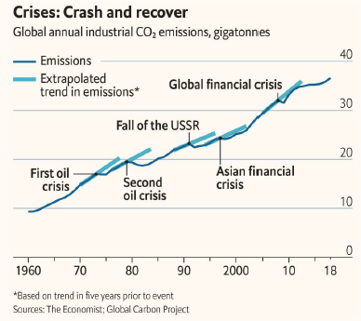
Figure 1: Global annual industrial CO₂ emissions in crashes and recoveries (in gigatons) (The Economist, 2020)
One feature of the economic recovery (in some quarters) is fuelling unprecedented demand for high efficiency HVAC (ACHR News, 2020). For example, as a result of the COVID pandemic in the USA, there has already been an increase in higher specification AC to improve comfort and indoor air quality for some high-income sectors of the population.
The Montreal Protocol could take this opportunity to support a “green” economic recovery, by supporting policies to drive towards more efficient RACHP equipment with low GWP refrigerants during the HFC phase-down.
Assessment of Climate and Development Benefits of Efficient and Climate-Friendly Cooling (Dreyfus, G. et al., 2020)
This review underscores that cooling is essential to human health and productivity, especially with accelerating global warming, and the need for cold chains for vaccine and medicines in response to the global COVID-19 pandemic. It estimates that if cooling consumes excessive energy, and continues to use high GWP refrigerants, this would contribute to drive us past the 1.5°C warming as soon as 2030. The review states that although the solutions already exist, they require urgent implementation. It estimates that widespread adoption of the best currently available technologies could reduce the climate emissions from stationary AC and refrigeration by 130-260 GtCO₂₋eq over 2030–2050. Of this, 25% is from phasing down HFCs, and 75% from improved energy efficiency and reduced electricity demand. As calculated by IEA in the 2018 Future of Cooling report, doubling the energy efficiency of stationary air conditioning would avoid about USD 3 trillion dollars in electricity generation and operation costs by 2050.
Electricity savings and greenhouse gas emission reductions from global phase-down of hydrofluorocarbons. (Purohit, P. et al., 2020)
This study developed a range of long-term scenarios for HFC emissions under varying degrees of stringency in climate policy, and assessed co-benefits in the form of electricity savings and associated reductions in GHG and air pollutant emissions. They calculate that the annual emissions of HFCs would increase from 0.5 billion metric tonnes (Gt) CO₂₋eq in 2005, to 4.3 Gt CO₂₋eq by 2050 and 6.2 - 6.8 Gt CO₂₋eq by 2100, driven by a strong increase in demand for refrigeration and air conditioning services, wealth in developing countries, and a warmer future climate. They estimated that full compliance with the Kigali Amendment would reduce cumulative global HFC emissions by 87 % against the projected values between 2018 and 2100. The opportunity to simultaneously improve energy efficiency in stationary cooling technologies during such a transition could bring about additional climate benefits of about the same magnitude as that attributed to the phase-down of HFCs. If technical energy efficiency improvements are fully implemented, then resulting electricity savings could exceed a fifth of future global electricity consumption. Together with an HFC phase-down, this means preventing between 390 and 640 Gt CO₂₋eq of GHG emissions between 2018 and 2100, thereby making a significant contribution towards keeping the global temperature rise below 2 °C. Reduced electricity consumption also means lower air pollution emissions in the power sector, estimated at about 10 % for SO₂, 16 % for NO_{x} and 9 % for PM_{2.5} emissions, compared with a pre-Kigali baseline.
Breaking the Vicious Cycle of Cooling and Climate Change in a HAT Country (Howarth, N., Odnoletkova, N., Alshehri, T. et al., 2020)
The complexities of the interactions between cooling, rising temperatures, and power generation in a hot country are described. Average summer temperatures have risen by 2.8°C in Riyadh over the last 40 years. Household ownership of AC is virtually 100%, and AC uses 70% of household electricity. In 2010, Lahn and Stevens in their report “Burning Oil to Keep Cool”, had predicted that the energy demand for increasing cooling in Saudi Arabia was unsustainable. In response, the Saudi Energy Efficiency Program was launched in 2010, which made a number of important interventions including improving building insulation standards, steadily improving MEPS, and providing financial support for more efficient split AC. Electricity prices, although low, have also increased. As a result, the steep rise in electricity demand has plateaued in the last 4 years. The paper suggests a number of interventions that could further reduce the carbon impact in this extreme example of cooling need, including a strong forward investment in renewables, pushing on HFC phase-down, together with strengthening of MEPS. It recommends a switch to a Seasonal rather than fixed EER, which could further reduce energy demand by 30%, by encouraging variable speed drive AC technology. Saudi Arabia is starting to address the vicious cycle of cooling driving the burning of fossil fuels, at the same time as phasing down HFCs.
PRAHA-II: Tests of Air Conditioning in HAT conditions. (UNEP, 2019)
This report provides recent data on performance of different refrigerants in ACs operating in high ambient temperature countries. PRAHA-I showed that ACs without design optimization could function with lower GWP refrigerants at comparable levels of energy efficiency in high temperature environments. PRAHA-II tested low GWP refrigerants in optimised equipment and found improved efficiency. This confirmed that alternatives to presently used refrigerants are viable, but that for optimal performance they require appropriate design and selection of components, especially compressor, heat exchangers and expansion devices for operation in HAT conditions. Dropping in a refrigerant does not provide optimal performance; it can also lead to an increased safety risk.
Environmentally Harmful Dumping of Inefficient and Obsolete Air Conditioners in Africa (CLASP, 2020)
This report reviews the level of environmentally harmful dumping of air conditioning equipment taking place in parts of Africa. From 2005 to 2019, the African market for new split room air-conditioners grew by 14%. CLASP carried out a wide-ranging investigation of the split Air Conditioner market and trading practices in four regions and 10 countries. (North Africa - Algeria, Egypt, Morocco, Tunisia; West Africa – Ghana, Nigeria; East Africa - Ethiopia, Kenya, Tanzania; South Africa).
The analysis revealed that most African countries rely exclusively on imported products and key components manufactured in other countries. Room ACs with low EE (EER<3) accounted for over one third of all sales and were mainly assembled locally, frequently through joint ventures. The non-African venture partner often produced higher efficiency ACs for their own domestic markets. The MEPS for China, South Korea, Japan and United States all exceed EER 3.0, would have forbidden the sale of these low EE room ACs in their own domestic markets, but they were allowed to be sold into export markets in Africa.
Overall, 74% of low EE ACs are assembled in Africa, and 26% imported as complete units (Figure 2). Almost all low EE room ACs continued to use high GWP refrigerants (HCFC-22 at least 78%; R-410A at least 15%). Only in South Africa were very few HFC-32 units sold, and all of these were also more efficient products. Of the HCFC-22 units, 82% were assembled locally in joint ventures between Egyptian or Nigerian manufacturers, with Asian companies. China, followed by Egypt are the largest sources of HCFC -22 room ACs. HCFC-22 AC units had an average EER of 2.9. Once these units are installed, they will consume high amounts of electricity, and require continued HCFCs for servicing for decades to come.
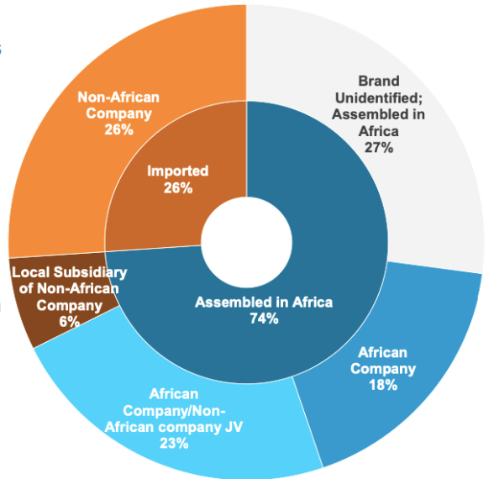
Figure 2: Market landscape of air conditioners in Africa (CLASP,2020)
Weak or non-existent MEPS and the lack of effective environmental dumping policies in many African countries have facilitated the sale of inefficient and high GWP air-conditioners into the African market. The report modelled policy interventions which combine ambitious MEPS (recommended by U4E), together with the introduction of lower GWP refrigerants (GWP < 750) by 2022, on the equivalent carbon impact for the period 2022 to 2030 across the region. They estimated the cumulative reduction in emission related to the EE improvement to be 40 million metric tonnes (Mt) CO₂₋eq, with the phase-down of high GWP refrigerants contributing an additional 10-15 Mt CO₂₋eq.
Unfinished business after five decades of ozone-layer science and policy. (Solomon, S. et al., 2020)
“The IPCC recently articulated the serious consequences of exceeding a global average temperature increase of 1.5°C (we have already reached a 0.9°C). Studies point out that we are far off course in staying even below 2°C. Hence there is unprecedented urgency in reducing as quickly as possible not only the original gases targeted by the protocol, but also all ODS and their substitutes that contribute to global warming.”
“Indeed, even after the Kigali amendment, the HFCs could still add over 20 Gt CO₂₋eq emissions to the atmosphere between 2020 and 2060. This suggests the need for a “Kigali-plus” amendment to the protocol which would accelerate their planned drawdown”.
Ensuring the Climate Benefits of the Montreal Protocol: Global Governance Architecture for Cooling Efficiency and Alternative Refrigerants. (Park, W.Y. et al ., 2021)
At their Thirtieth Meeting, the Parties to the Montreal Protocol “requested the Executive Committee, in dialogue with the Ozone Secretariat, to liaise with other funds and financial institutions to explore mobilizing additional resources and, as appropriate, set up modalities for cooperation, such as co-funding arrangements, to maintain or enhance EE when phasing down HFCs."
However, alongside consideration of co-funding arrangements for maintaining or enhancing energy efficiency while phasing down HFCs, it is important to note that energy efficiency compliance is different from compliance related to phasing down HFCs both in terms of institutional arrangements, enforcement, best practices and funding needs.
The Multilateral Fund has provided assistance to UNEP OzonAction’s Compliance Assistance Programme (CAP) since 2002 to assist 147 developing country Parties to the Montreal Protocol to comply with the Montreal Protocol. UNEP CAP teams’ successful results and day-to-day interaction with the National Ozone Units in each country are widely recognized .
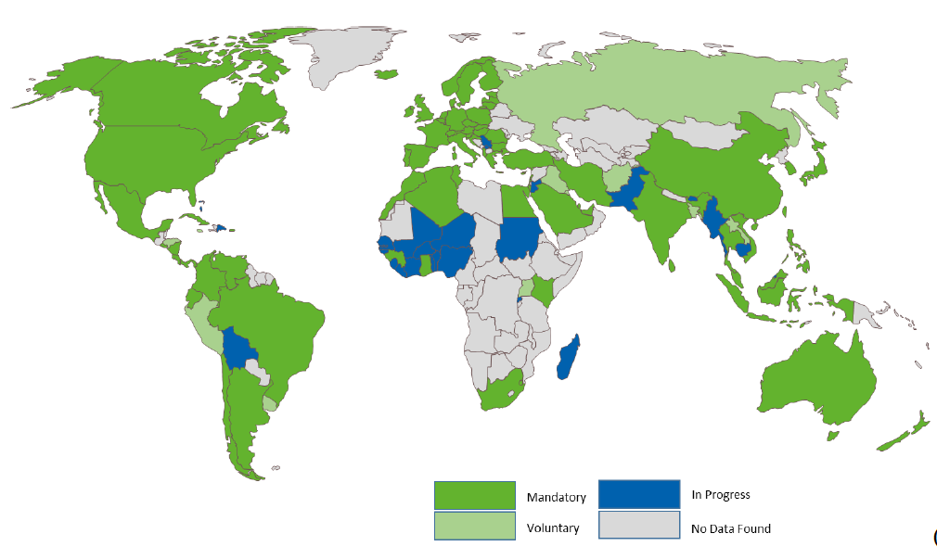
Figure 3: Worldwide status of MEPs for room AC. Source UNEP United for Efficiency (U4E) Initiative, cited in Park WY et al. (2021)
Nevertheless, national ozone units are not in charge of energy efficiency policy and regulations, and in many cases there is no coordination and/or interaction among different institutions dealing with ozone and energy related issues in the governments.
Capacity regarding energy efficiency compliance is not uniform across the Parties (see Figure 3). Showing data collected by the United for Efficiency (U4E) initiative, Park et al (2021) discuss both the non-uniformity enforcement of energy efficiency requirements and enforcement globally. The recommended compliance infrastructure includes:
- Internationally harmonized, market and climate appropriate, energy-efficiency standards program,
- Product certification and registration,
- Infrastructure for testing energy-efficiency performance, and
- Evaluation, measurement, and verification strategy for energy efficiency
Park et al. (2021) also recommends a global governance architecture for the simultaneous transition to efficient cooling equipment and refrigerants with low global warming potential, leveraging experience from energy-efficiency programs to optimize investments and help unlock the potential for climate change mitigation under the Kigali Amendment.
The Global Cooling Prize (May 2021)
The Global Cooling Prize3F (GCP) has presented a challenge to the room air conditioning industry to reduce the climate impact by five times compared with the baseline technologies while limiting the cost to about two times the baseline cost when manufactured at scale. Two teams were able to exceed the target climate impact reduction within the cost constraint. To achieve the five times lower climate impact target, these technologies used higher performance components, low-or-ultralow GWP refrigerants and advanced controls to sense temperature and humidity independently that allowed them to manage the cooling loads in the space much more effectively and efficiently as compared with the baseline technology. The GCP has also spurred innovation in not-in-kind technologies as indicated by the 8 finalist teams including: barocaloric cooling based on organic solid crystals, evaporative cooling, membrane-based dehumidification, and desiccant dehumidification.

UNFCCC COP-26
The United Kingdom is the President for COP-26 in Glasgow in November 2021. The UK is a member of the “Cool Coalition”, a global network connecting a wide range of organisations and governments that are collaborating to meet growing cooling demand, in the context of the SDGs, the Kigali Amendment to the Montreal Protocol, and the Paris Climate Agreement.
Cooling underpins all five themes chosen for UNFCCC COP-26. One COP-26 initiative aims to double efficiency standards in four product categories including room air conditioners and refrigerators. It specifically cites the Montreal Protocol in the context of opportunities to work collaboratively with the broader climate and energy communities and leveraging the Protocol’s years of experience working with the cooling sector. As efficient cooling gains traction at COP-26, there is likely to be substantial “pull through” to benefit from the synergies with HFC phase-down under the Montreal Protocol.

2021 Update on Lower GWP Refrigerants with Energy Efficiency Technologies
- The EETF continues to identify technical improvements to increase equipment energy efficiency (EE) such as sensors, controls, variable speed drives and condenser precooling.
- In general, new equipment using lower GWP alternatives has higher efficiency than the equipment it replaces.
- The Global Cooling Prize awarded in April 2021, showed that it is technically and economically feasible with innovative design in room air conditioners to achieve 5 times lower climate impact with a cost that is less than twice that of the baseline technology when manufactured at scale. The winners have developed units using higher performance components and lower or ultra-low GWP refrigerants.
- The EETF has confirmed it is possible to jump from HCFCs directly to lower GWP options in many sectors in different regions whilst maintaining/enhancing energy efficiency.
- The coordination of energy efficiency with the implementation of HCFC phase out and HFC phase-down enables industry to explore the synergies related to redesigning equipment and retooling manufacturing lines, in which the MLF and the implementing agencies have great experience. The unique in-depth knowledge of RACHP technologies held within the “Montreal Protocol family” can strongly support the combined reduction of direct and indirect GHG emissions.

Alternative Lower GWP Refrigerants

Background
A recent study (Booten et al., 2020) has estimated that refrigerants used in vapor compression systems are 83% fluorocarbon (HCFC, HFC, HFO, HCFO), 11% inorganic (HC-744, R-717, etc.), and 6% hydrocarbon (HC-600a, HC-290, etc.) as shown in Figure 4 .
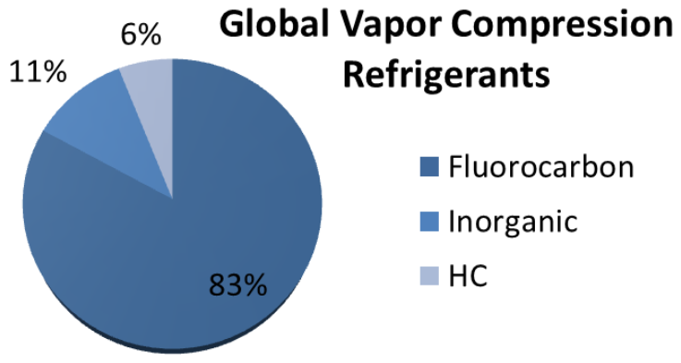
Figure 4: Refrigerant types in global vapor compression market (Booten et al., 2020)
The UNEP Ozone Secretariat Workshop on HFC Management: Technical Issues, Fact Sheet 2: Overview of HFC Market Sectors (2015) found that 65% of global HFC consumption in the RACHP sector in 2012 was used in air conditioning applications and 35% was used for refrigeration application. It is important to note that their analysis included applications beyond the scope of this report. In 2012, air-to-air air conditioning systems represented 45% of air conditioning HFC consumption while commercial refrigeration represent 73% of refrigeration HFC consumption. This indicates the importance of tackling room air conditioners (Room ACs) and self-contained commercial refrigerators (SCCRE) first.
Effective refrigerant management policies have been successful in reducing the consumption of greenhouse gases. One of the leading examples in the active F-Gas regulation 517/2014 (F-gas II) in Europe. This policy has resulted in 33% reduction in the European supply of high GWP fluorinated greenhouse gases between 2007 and 2018 as shown in Figure 5.
The EU progress towards the worldwide high GWP refrigerants phase-down under the Montreal Protocol is shown in Figure 5. The EU is 6 years ahead of schedule and has already achieved the 2024 Montreal Protocol commitments by 2018. This shows that with progressive legislation, alternative low GWP refrigerants are being implemented on a faster timeline. Other parties could consider how to follow the EU example.
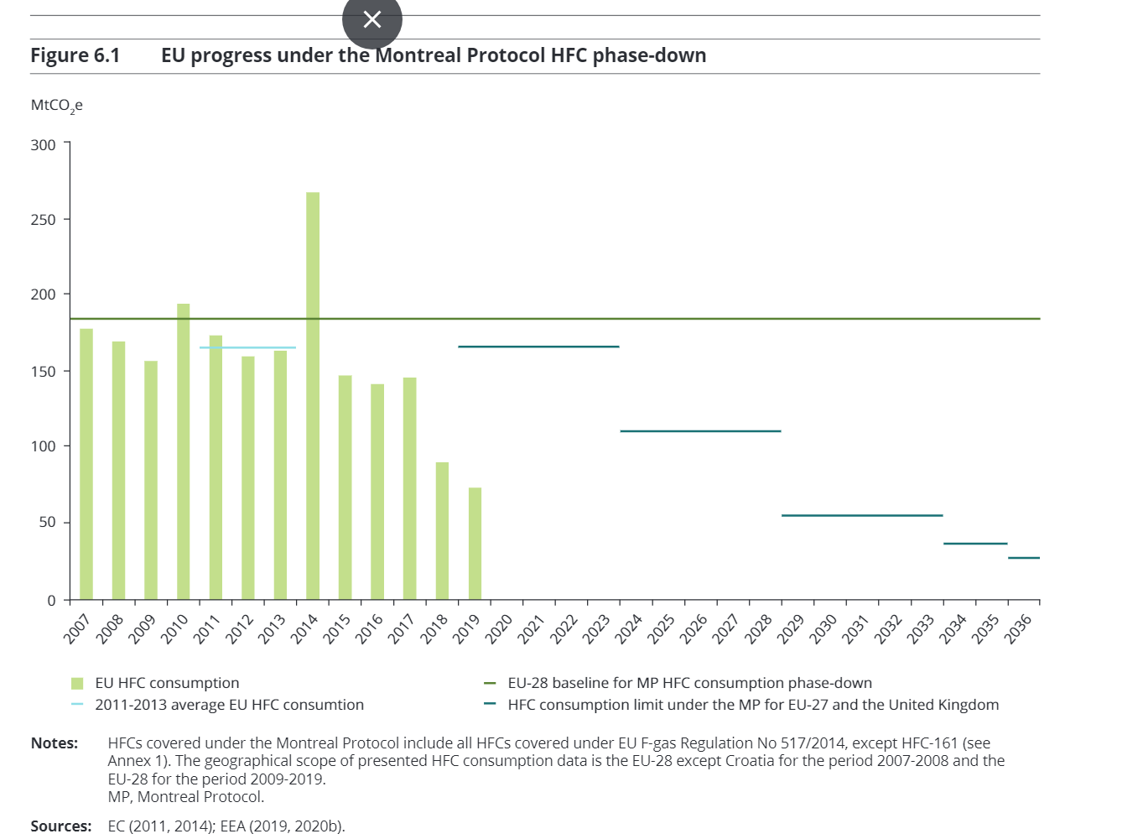
Figure 5: EU progress towards the worldwide hydrofluorocarbon consumption phase-down under the Montreal Protocol. (EEA, 2020)

New Refrigerants
Since the publication of the RTOC 2018 Assessment Report, one new single-component refrigerant (IFC-13I1) and eight new refrigerant blends have received a designation/classification from the American Society of Heating, Refrigerating, and Air-Conditioning Engineers (ASHRAE) Standard 34 and/or from the International Standards Organisation (ISO) 817. (See TEAP 2020 Progress Report for details)
IFC-13I1 is now classified in ASHRAE Standard 34 under safety class A1 (does not propagate flame and has (low) chronic toxicity). IFC-13I1 has not yet been submitted or listed in ISO 817. There is ongoing research about the chemical stability and the (low) chronic toxicity of IFC-13I1 (GWP = 1, ODP = 0.01 used as a component of multi-component refrigerant mixture for air conditioning applications).

Flammability and Safety
As shown in Figure 6, most of the lower GWP alternative refrigerants available on the market for high pressure applications, suitable for RACHP, have different degrees of flammability ranging from A2L (lower flammability) to A3 (higher flammability). As such, experts have worked together to address this challenge and worked on developing new safety standards requirements.
- IEC 60335-2-89 has recently increased the charge levels for flammable refrigerants (A2L/A2/A3s) and it is expected that this will positively impact the use of all lower GWP flammable refrigerants.
- IEC 60335-2-40 is currently under revision and a Committee Draft for Vote (CDV) has provisions for increased flammable refrigerant charge. The proposed increase in flammable refrigerant charge is controlled by the application configuration and additional safety measures used as shown in Annex 2.
These new revised safety standards will enable increased equipment refrigerant charge size for flammable refrigerants. Numerous research activities are underway to pave the path towards safe use of flammable refrigerants.
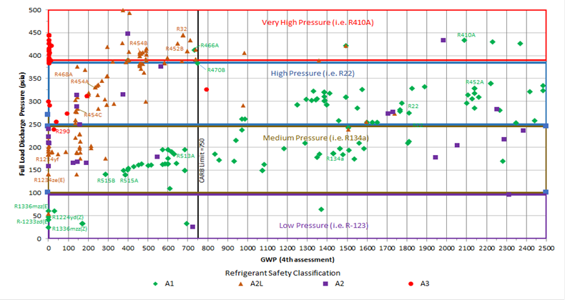
Figure 6: Refrigerant landscape: GWP and safety classifications at different full-load discharge pressure (Lord, R. Personal communication 2021)

Lower GWP Refrigerant Options for Room Air Conditioning
Alternatives are now widely available to replace most high GWP refrigerants, with both natural and lower GWP fluorinated refrigerants options covering key sectors. In many regions and sectors, it is possible to leapfrog to lower GWP options.
More than 50% of the globally produced AC units now use non-ODP refrigerants. However, in A5 parties, locally produced Room ACs remain relatively inefficient and have been dominated by the use of HCFC-22 (CLASP, 2020). The lack of high performance HCFC-22 compressors combined with more stringent Minimum Efficiency Performance Standards (MEPS) in some A5 parties resulted in starting a transition to HFC technologies. Where these more stringent MEPS have not yet integrated with future HFC phase-down schedule, there has been an unwelcome trend to switch to high GWP refrigerants, in particular R-410A (GWP 2088).
HFC-32 (GWP 675): has been introduced in many countries around the world as an energy efficient lower GWP refrigerant – an important step towards fulfilling the Kigali Amendment.
Blends involving HFO, HCFO, or IFC (GWP ~100 – 2000): some manufacturers are considering various blends of low GWP HFCs, HFOs, HCFOs, and/or IFC for Room AC. These blends have GWPs ranging from 100 to 750 with varying degrees of flammability. There have been successful conversion projects as presented during the 8Xth Meeting of the Executive Committee of the Multilateral Fund. In Lebanon, ExCom (2020a), 3 out of 5 manufacturers (Iceberg, Frigoliban, UNIC) have completed their conversion to HFC-32, and the 2 others (GGI Halawany and ICR) have started conversion to HFC-32. In India, ExCom (2020b) 4 of the 6 AC manufacturers, Blue Star, EVision, Leel Electricals and Universal Comforts (a wholly owned subsidiary of Voltas) have signed a memoranda of agreement for conversion to HFC-32 technology for the first tranche of stage II of HPMP.
Hydrocarbons (GWP ~ 1 – 20): India has shown leadership in the marketing of HC-290 in split type Room AC, after a national manufacturer introduced HC-290 in the local market since 2012, combined with a network of qualified installers trained to work safely with HC-290. There are projects that demonstrated the potential for using HC-290 in Room ACs in China, Saudi Arabia, South East Asia, and South America, in terms of R&D, production line conversions, training and service. Scalability and wide-scale adoption are further discussed in Chapter 3. HC-290 is limited to small capacity Room AC4F and portable or window AC due to the higher flammability. However, it should be noted that IEC 60335-2-40 is being updated5F (7th edition) to employ additional mitigation factors which should further enable A3 refrigerants (e.g., HC-290).
Unfortunately, there are some setbacks in the conversion of HCFC-22 towards HC-290 including the following cases:
- UNIDO reported that 3 Brazilian manufacturers (Climazon, Elgin and Gree) decided not to go for HC-290 but converted their HCFC-22 capacity to R-410A technology with their own resources, ExCom (2020c).
- According to previous UNIDO reports (MOP Rome December 2019) there was until then no sales of HC-290 Split AC in China, except for some government subsidized projects, ExCom (2020d).

Refrigerant Options for Self-contained Commercial Refrigeration Equipment (SCCRE)
In several countries and regions, commercial refrigeration installations using low charge and low leak designs (e.g., plug-in units) are already being used as alternatives to larger central systems.
In Europe, with accelerating HFC phase down, refrigerants such as R-744, HC-600a6F, and HC-290 are being increasingly used in the refrigeration sector. Also, lower GWP HFO blends (A1/A2L classified) are being applied in smaller charge commercial systems. The F-Gas regulation also sets a schedule with specific GWP limits for different types of product categories.
In the United States, New York recently joined five other states in adopting HFC regulations. For example, California SB-1383 has set an overall target to reduce HFC emissions to 40% below 2013 levels by 2030. Subsequent proposals will reduce the GWP value to below GWP 150 from 2022 for all new stationary retail food refrigeration equipment of more than 50 pounds refrigerant charge. In addition, there are proposals to reduce the impact of existing systems in supermarkets through a combination of retrofit and remodelling.

Refrigerant Cost Considerations
The cost of the refrigerant is typically 1-3% of the cost of the AC equipment. However, the servicing costs of top-up refrigerant can be a substantial and recurrent hidden cost.
For typical Room AC applications, HFC-32 is more expensive than HC-290 as a refrigerant. However, HC-290 requires a larger compressor and a different heat exchanger design and the overall equipment might be more expensive. Similarly, HFC-32 requires less refrigerant charge than R-410A, with a more compact design for the same capacity and performance. HFC-32 is currently more cost effective than both R-410A and HC-290.
Lessons learnt from previous refrigerant transitions have shown that whereas initial production costs tend to increase, this is later offset by improved product efficiency, production process improvements, and economies of scale. The production cost of a blend will generally be more expensive than any one of its components (e.g., R-410A compared to HFC-32). However, refrigerant prices in a given market reflect additional competitive and regulatory conditions. For example, in several regions, the single component HFC-32 price is significantly higher than R-410A, and this price differential has been cited as a barrier to greater introduction of HFC-32 equipment. The price of HFC-32 will likely come down with time.

Barriers for EE Improvement using Lower GWP Refrigerant
Self-contained units are widely adopted using lower GWP flammable refrigerants (A2, A2L and A3). However, for mini-split and split AC, safety, lack of qualified servicing technicians restrictive standards and regulations such as local building codes, transportation codes, and cost are considered to be the main barriers towards the use of EE lower GWP flammable refrigerants. Harmonization between the different bodies is needed to reduce these barriers – however this seems to be a difficult task. Experience in EU has shown that leakage rates went down due to the F gas certification programmes, which improved the quality and servicing of split type installations using HFCs. Technician Certification schemes for flammable refrigerants are required to be established worldwide to reduce leakage and improve safety. Higher flammability HC refrigerants operate at 1/3 of the typical charge used with HFC refrigerants, which results in increased EE performance relative to the charge. However, in spite of the anticipated increase in allowable flammable refrigerant charge with the revised IEC 60335-2-40 standard, there will still remain a difference on EE improvements for HCs compared to lower or non-flammable refrigerants. The current Room AC safety standard IEC 60335-2-40 limits the HC-290 applicability in accordance with the room size and is under revision. For a wall mounted indoor in a 30m² room for example, the refrigerant charge could be up to 0.718 kg if additional safety measures are applied (see Annex 2). Finally, HC refrigerants require larger compressors and heat exchangers due to the lower density compare with HFC refrigerants which would result in higher cost.
Room AC manufacturers, local distributors, installers and decommissioners in A5 parties have to develop the skills of technicians for safe installation and servicing of A3 and A2 refrigerants, at significant additional cost compared to A1 and A2L refrigerants. A strong regulatory and market signal encourages manufacturing to scale up their production, which lowers prices and increases experience and confidence with the technology, all of which drive up adoption. EXCOM (2020d) reported that a challenge in the market uptake of HC-290 AC was the higher cost to install the equipment relative to other equipment.

Developments in Energy Efficient Technologies for Room AC

2021 Update
Table 1 shows a summary of different energy efficient (EE) technologies and associated impact on incremental production cost of Room AC and incremental Capital cost. Many of these developments would act synergistically. For example, the combination of inverter driven compressors and electronic expansion valves may result in 50% or more improvement in SEER compared with baseline HCFC-22 fixed speed units. Those countries yet to adopt standards to measure performance of variable speed AC (using the seasonal metric SEER) do not favour the adoption of the inverter technology.

Sensors and Controls
Room AC has become more sophisticated, and more efficient.
- Sensors: Higher-grade models Room AC are equipped with high-precision infrared occupancy sensors, detecting the presence/absence of people, and the number/location/activity of people
- “Sensible heat ratio”. ASHRAE standard 55 (ANSI/ASHRAE, 2017) shows that the comfort is not just an absolute value, it is rather a complex range of operating conditions that ensure that occupants are comfortable based on their physiological and psychological responses to the immediate environment. It is possible to prevent unnecessary energy consumption by preventing unintended operation.
- There is great untapped potential for the internet control of AC through algorithms that improve comfort, usability, safety, and performance by optimising many variables in a complex system. For example, the system can be monitored for proactive Fault Detection and Diagnostics (FDD).
Table 1: Summary of Energy Efficient Technologies and Corresponding Costs for Room AC (TEAP EETF Report, 2019).
Component | Max. Potential EE improvement | Incremental Unit Operating Cost | Incremental Capital Cost | Comments
Compressors
Higher efficiency | 10% | 0 to 10% | NA
Two-stage | 10% | 10 to 20% | NA
Inverter driven | 30% | 20% | Medium | Better control and better seasonal energy efficiency
Heat Exchangers
Microchannel condenser coil | 15% | NA | High | Require significant capital cost
Smaller tube diameter for condenser coil | 10% | NA | Medium | Require manufacturing line modifications
Smaller tube diameter for evaporator coil | 10% | NA | Medium | Require manufacturing line modifications
Adiabatic condensers | 30% | 20 to 35% |  | Only applicable in high ambient dry regions
ECM fan motors | 15% | 15 to 25% | Medium | Potential for improved comfort
Electronic expansion valves | 20% | 15% | Medium | Require sophisticated control systems
Pipe insulation | <2% | NA
Refrigerant | See RTOC 2018 | Depends on region | Medium | Conversion costs associated with safety equipment, charging machines, etc.
Head pressure control | 2 to 3% per 1K reduction | Depends on OEM | Low

Condenser precooling
In a similar concept to evaporative cooling, condenser precooling is a new and effective way to improve EE, by using the condensate leaving the evaporator coil (or fresh water). This water can be effectively used to reduce the temperature of an air-over condenser by up to 7°C, depending on ambient humidity, with up to 20% improvement in EE. The Global Cooling Prize7F aim to encourage the development of ultra-high efficiency environmentally friendly Room AC. It allows for up to 14 litres of water consumption per day as means for improving EE. It is important to acknowledge water scarcity issues and that this practice might not be always preferred.

Technical Barriers
There are several technical barriers which continue to slow adoption of the EE measures discussed above. These include technical know-how, and manufacturing capacities.
Microchannel Heat Exchangers (MCHX) are more efficient than the Fin and Tube heat exchangers. In MCHX copper tubes are replaced by aluminium channels and fins which are brazed. Recent studies show that for the same surface area, MCHX offer up to 20% more efficiency while reducing the refrigerant charge by 30 to 70% (Zanetti et al., 2018, Zhou et al., 2017; Yanick, 2019). However, there are still some barriers to implementation, including lower material lifetime (aluminium versus copper) in coastal areas and in cities with vehicular pollution, difficulty in repairing at site, lack of trained manpower for aluminium welding and brazing, defrosting cycle in heating mode, and product reliability.
There are other EE technology options that are harder to implement. Larger airflow rates can improve EE, but at the cost of reduced comfort and/or increase noise. Larger heat exchanger surfaces improve EE, but at the cost of larger equipment sizes which in practice limit installation (e.g., indoor units often need to fit in limited space, e.g. above a door, under a window, in a false ceiling).

Case Study: Global Cooling Prize
The Global Cooling Prize has presented a challenge to the Room AC industry to reduce potentially the climate impact by 5 times compared with the baseline technologies while limiting the cost to 2 times that of the baseline technology when manufactured at scale. Eight finalist teams worked on meeting the target performance. The two teams were able to demonstrate prototype RACs that exceed the target climate impact reduction and cost constraint. To achieve the 5 times lower climate impact target, these technologies used higher performance components, low-or-ultralow GWP refrigerants (HFC-152a, and HFO-1234zeE), variable speed compressors, and advanced controls to sense temperature and humidity independently that allowed them to manage the cooling loads in the space much more effectively and efficiently as compared with the baseline technology. The first team adopted a multi-split method using HFO-1234zeE; they connected two indoor units with one outdoor unit to optimize refrigerant flow rate based on part-load conditions. The team also employed evaporative cooling to reduce the condensing temperature. Finally, the team employed advanced control technology to meet the space latent load efficiently without the need to overcool the space to meet the required EE levels. The second team integrated advanced vapor compression refrigeration, photovoltaic direct-driven technology, evaporative cooling, and ventilation, which efficiently utilizes renewable energy sources and free cooling sources. The team's solution operates in three modes: vapor compression refrigeration, evaporative cooling, and ventilation; individually or in parallel depending on the ambient conditions for optimized cooling and dehumidification. The second team adopted a parallel compression cycle with dual evaporating temperature. The team used an advanced compressor with HFC-152a, improved design of evaporator, evaporative cooled condenser, and advanced controls sensing indoor temperature and relative humidity. Finally, the team used photovoltaic direct-driven technology. The other finalists adopted a range of technologies for their prototypes that include advanced vapor compression and control strategies and not-in-kind technologies. Not-in-kind technologies used included: barocaloric cooling using organic solid crystals, evaporative cooling, membrane-based dehumidification, and desiccant dehumidification.

Development in Energy Efficient Technologies for Self-Contained Commercial Refrigeration
SSCRE is manufactured by local SMEs, in many different configurations, to suit the local retailers and food / drink product manufacturers who often want their own unique design of equipment. This makes the roll-out of high efficiency technologies slow and difficult, although savings can be dramatic through combining relatively simple measures. These include adding doors to cabinets, improving compressors and heat exchangers, and improved controls.
HC-290 and new A2L blends such as R-454C and R-455A (with GWPs below 150) are coming into use. The choice of refrigerant has relatively little impact on EE. This is shown by measurements undertaken of a new bottled drinks cooler (Figure 7) that showed an 80% reduction in energy use (SKM Enviros, 2014; UNEP, 2018). The state-of-the-art model uses doors, high efficiency components and sophisticated controls (e.g., soft drinks do not need to be cooled when the store is closed).
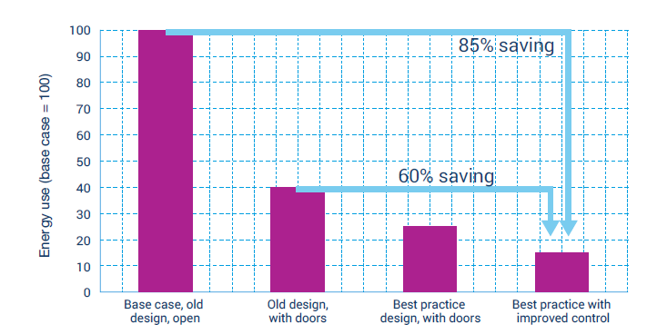
Figure 7: Bottle cooler efficiency improvement, baseline being open vertical display unit, incremental improvement includes first adding doors to minimize heat load, next improving equipment components, and finally employing improved controls to achieve almost 85% savings in energy consumption. (UNEP, 2018)
In addition to display SCCRE, chest freezers are used for many commercial applications including storage of ice cream and frozen food. These are often provided on lease or as promotion by the ice-cream/produce manufacturers. Variable speed compressor technology has the potential to provide up to 25% energy savings at the cost of 20 USD. However, the 20 USD incremental cost was considered to be a significant barrier due to the lack of labelling programs, and split incentive8F (the person/organisation responsible for equipment purchase did not pay the electricity bill).
An overview of the energy efficiency technology options and corresponding incremental operating cost based on a recent study (UNIDO, 2020) are summarized in Table 2.
Table 2: EE measures and corresponding IOC for different technologies in commercial refrigerators
Technology | EE (%) | Incremental Operating Costs (USD/Unit)
High Performance Insulated Glazing Unit (IGU) for doors | 23 – 33 | 20 – 22
Use High Efficiency Compressor | 8 | -5
Increase Insulation Thickness | 5 | 0.76 – 6
Optimize Gasket | 1.5 | 1 – 4
MCHX | 2 | 0 – 5
Smart Controller | 5 – 12.5 | 6 – 22.5
Vacuum Insulating Panels VIP | 4 | 5.33 – 35
Electronically Commutated Motors and Improved Fan Designs | 4 – 26.5 | 2 – 33.53
Digital Controller with Internet of Things (IOT) | 30 | 39.75 – 55
Use LED Lighting | 2 | 3.14

Incremental Manufacturing Capital Costs Related to EE and Low GWP Refrigerants for Room AC
Annex 3 presents a summary of the conversion costs associated with the demonstration project in Saudi Arabia for the conversion of a Room AC manufacturing line with “leapfrog” from HCFC-22 to HC-2909F. The participating company was able to manufacture and test a prototype HC-290 mini-split Room AC with improved Energy Efficiency Ratio (EER) compared with baseline HCFC-22 unit. The incremental capital cost was USD 660,000 as shown in Annex 3. It is expected that the incremental operating cost would be mainly due to the change in compressor. The company had an established 5-mm internally grooved tubing heat exchanger manufacturing line which reduced the conversion cost significantly while allowing for reduced refrigerant charge and higher EE Room AC. Unfortunately, the company has not yet found a reliable source for HC-290 compressors that are rated for high temperature operation, ambient temperature = 46°C, and running at 60 Hz.
The prototype HC-290 mini-split showed promising results but there was still room for improvement. The compressor supplier provided a second generation of prototype compressors to meet the planned future Saudi MEPS. The final prototype met the capacity requirements with EER of 12.5 at T1 and 9.4 at T310F.

Incremental Manufacturing Capital and Operating Costs Related to EE and Low GWP Refrigerants for Commercial Refrigeration
UNIDO (2020) investigated the incremental capital cost (ICC) associated with different EE technologies for self-contained commercial refrigeration (SCCRE) used in developing countries11F. The summary of this investigation is shown in Table 3. ICC related to refrigerant conversion from HFC to HC is summarized in Table 4 below.
Table 3: Incremental Capital Cost (ICC) in thousands USD for different EE technology options related to commercial refrigeration
EE Technology Option | ICC, kUSD
Door gasket (welding jigs, each) | 3 – 6
Triple pane glass door | 50
MCHX (change moulds, CNC codes for HX bracketing; assuming MCHX are procured from OEM) | 25
Table 4: Summary of equipment and ICC related to refrigerant conversion in thousands USD per production line12F.
Equipment | Quantity | ICC, kUSD
HC detectors (detectors lined with safety system) | 1 – 5 | 12 – 70
Portable HC detectors (needed for safe operation and leak detection) | 0 – 5 | 2.5 – 16.2
Helium charging and recovery (Helium is required to test heat exchanger tightness and ensure leakage is less than 0.1 g/year) | 1 – 3 | 45 – 75
Safety systems (a complete safety system including controller, exhaust fans, ducting, etc.) | NA | 51 – 109
Charging machines (required to ensure accurate filling of manufactured equipment) | 1 – 2 | 40 – 275
Storage and distribution (typically large storage tank located outside the building with steel piping network to the charging machines) | 1 | 5 – 222
Transfer pumps (ATEX certified pumps used to pump the liquid refrigerant) | 1 – 2 | 6.5 – 27.6
Ultrasonic welding (used to weld the charging port shut after charging) | 1 – 2 | 25 – 61
Accessories for charging unit | NA | 10
Refrigerant extraction unit (to extract flammable refrigerants from faulty equipment before repair) | 1 – 2 | 5 – 26.4
Calibrated leaks (to maintain HC detectors in calibration) | NA | 2.5 – 7.8
Vacuum pumps (ATEX certified to pull vacuum before charging of the equipment) | 4 – 6 | 55 - 64
Upgrade functional testing (typically involve software and sensor upgrades) | NA | 35 – 217
Installation, commissioning, and training | NA | 5 – 11.5
After sales | NA | 0 - 30
From the above, we can deduce that in SCCRE, the majority of the investment is the incremental capital cost (ICC) required to manufacture units operating with flammable refrigerants. In general, the ICC for refrigerant conversion ranged from USD 200k to USD 2M depending on the manufacturer development level, operation practices, and number of manufacturing lines. In contrast, the ICC for EE upgrades was much lower and ranged from USD 3k to USD 25k. It is important to note that the ICC for MCHX does not account for the production facility of the MCHX, but rather to the required assembly modification. Most SSCRE manufacturers depend on OEMs to supply their heat exchangers, as such, MCHX is usually a lower cost and more efficient approach.

Availability and Accessibility
- Availability (as defined in Section 3.2): Technology and refrigerants are now widely available to replace most high GWP HFCs, with both natural and lower GWP fluorinated refrigerants options covering key market sectors. This is supported by the numerous best practice case studies presented in this report.
- Accessibility (as defined in Section 3.2): Access to high EE / lower GWP products is improving, although it remains limited in many A5 parties and even in some non-A5 parties.
- Improved availability and accessibility to high EE/lower GWP products in A5 parties could be achieved sooner by:
  - faster ratification of the Kigali Amendment,
  - progress in operationalising the Kigali Amendment,
  - enabling individual Parties for fast action,
  - supporting policies designed to improve accessibility, e.g., tackling market barriers affecting the end consumer,
  - adopting ambitious and progressive energy performance standards across regions that are appropriately harmonized and coordinated with HFC phase-down strategies (e.g., U4E model regulations),
  - coordinating multi-agency funding for A5 enterprise conversions for both high EE and lower GWP refrigerants.

Findings from the 2019 EETF report
In response to Decision XXX/5, the TEAP Energy Efficiency Task Force 2019 reported on the availability of high efficiency RAC and SCCRE with lower-GWP refrigerants and the components to build those products.
The TEAP Energy Efficiency Task Force defined “availability” in 3 tiers of energy efficiency relative to local MEPS:
- Low-tier: AC units which meet a regional or country MEPS;
- Mid-tier: AC units which are up to 10% more efficient than the local MEPS;
- High-tier: AC units which are at least 10% higher than the local MEPS.
It is important to note that this is a relative value, because the EE tier varies according to local MEPS. The MEPS vary between regions and countries, and are substantially lower than the most stringent label, and the most efficient model
The TEAP TF concluded that products were available at all levels of efficiency, and for a range of refrigerants. It also noted that there was no higher efficiency development for RAC equipment using HCFCs. Higher EE developments were taking place for both high-GWP HFCs and lower-GWP HFCs and blends. However, the matrix could not capture the availability in specific regions, nor the accessibility of those products to consumers in specific countries.

Definition of Availability and Accessibility
The different stages of availability of technology were previously defined by the EETF as follows:
- Widely available: Can be obtained from more than one manufacturer, supplier, or retailer. Distribution networks are available.
- Available: Can be obtained from at least one manufacturer.
- Emerging technology: Prototype available at pilot or demonstration stage. An emerging technology may become available at a later stage or might not make it to the available stage.
- R&D: Still in testing phase with promising results. It may be commercialized within five years after passing through the emerging technology stage.
This 2021 Update report differentiates between availability of high-efficiency products with lower-GWP refrigerants from manufacturers and accessibility to the consumers and end-users.
“Availability” is the ability of the industry to manufacture products with new technologies of lower-GWP refrigerants and higher efficiency. Availability is controlled by the manufacturers and is related to technology. The factors affecting availability of products that are manufactured locally are described in section 3.3 and are summarized as:
- The ability of the industry in a country to absorb new technologies;
- Technical capabilities needed to implement the technology;
- Scalability of operations; and
- Technology barriers such as Intellectual Property Rights (IPR) and patents.
“Accessibility” on the other hand is focussed on the consumer and varies with location within a region, country, or even district within a country. Some of the factors which affect accessibility include:
- Supply chain; Importers/Suppliers for parts, refrigerant;
- Presence of local manufacturing and/or assembly;
- Regulations affecting energy efficiency and safety; Collaboration with Energy Departments on integrated MEPS
- Service sector capacity and quality;
- Electricity quality, reliability and price;
- Affordability;
- Acceptability and preferences; and
- Presence or absence of laboratories and certification/verification bodies.

Availability of high efficiency residential air conditioning and commercial refrigeration units with lower-GWP refrigerants
Air conditioning is considered either as essential or as a luxury depending on the climatic conditions and the disposable income of consumers. This report concentrates on split type AC, since Window type ACs have limited EE gains given the geometry and size of the units.
The best available RAC currently has a Seasonal Energy Efficiency Ratio (SEER) around 2.5 times better than the worst efficiency equipment still being sold. The actual range of SEER values depend on the climate conditions. For example, for average EU climate, the best SEERs for Split ACs are over 10 and the worst are the MEPS (4.6 for units that are less than 6 kW and 4.3 for units that are more than 6 kW).
A number of manufacturers already produce equipment with this high level of a SEER, hence it is reasonable to state that the high EE room ACs are “available” in some countries.
The situation is evolving with demand for AC increasing in many A5 parties due to climate change, and as they become affordable to an increasing number of people. There is a move towards more energy efficient ACs in A5 parties as the advantages are understood, both to the consumer and the country. However, in many countries, this move is still either slow or absent. Although there have been twinning initiatives, in many countries there is insufficient alignment between EE policy and HFC phase-down. One key reason is that environment and energy are often separate departments in governments and fail to maximise the synergy between them.
Since HCFC-22 is being phased out, AC compressor manufacturers and equipment OEMs are not investing in improving HCFC-22 units. All investments in inverter technology and other energy efficiency measures in ACs are being made with alternative refrigerants. Until recently much of this investment related to the high GWP R-410A, but recently most investment is directed at the lower GWP alternatives. There is no single refrigerant of choice. Some A5 parties with multinational manufacturing companies (e.g., in China, India, and Thailand) have mainly switched to HFC-32 while some have switched to both HFC-32 and HC-290. While HC-290 has lower GWP (3), the flammability (A3) limits the charge and requires extensive training of technicians. Egypt has selected HFC-32 and R-454B, a blend, after testing several refrigerants through their EGYPRA project (EGYPRA, 2019)
The self-contained commercial refrigeration equipment (SCCRE) market has developed standards in line with domestic refrigerators. HC refrigerants have been adopted throughout India, South East Asia, Europe, China, Japan and Oceania. Safety concerns are addressed by staying within the specified limits in self-contained factory sealed systems (reference IEC standard 603325-2-89). Inverter technology is being adopted. The European Union (EU) has developed MEPS and labels for commercial refrigeration, and India has initiated a labelling program in 2020. Beverage companies are adopting natural refrigerants and are improving the EE of drinks dispensers.

Local manufacturing landscape in A5 parties
Local manufacturing is driven by the size of the market (see also section 3.5.2 later in this chapter), the availability of a skilled technical workforce, and the potential for export and growth. This can range from small assembly units to full manufacturing capacity. Governments in many cases protect local enterprises from external competition by adopting economic and trade policies that effectively act as barriers for import of AC. In larger countries, multinationals have set-up manufacturing facilities independently or in joint ventures with local manufacturers. Countries with low GDP and low numbers of AC sales, are mainly equipment importers.
In Algeria for instance, the government encourages local manufacturing by imposing lower import tariffs on components than for finished products. Initially local industry assembled imported components, but then larger manufacturers set up their own production lines for coils and casings. A proposed regulation to reduce the sales tax for higher efficiency products has not yet been implemented; however, some manufacturers are planning the conversion to lower-GWP refrigerants to coincide with a move to higher efficiency inverter-type AC units.

Window Units vs. Split Systems
The proportion of window vs split AC varies widely around the world, from 9% in Algeria to 65% in the Philippines (Table 5). With the general trend away from window units towards split systems, there has been less development on higher energy efficiency lower-GWP alternatives technologies for window AC; with some exceptions13F.
Table 5: Window units as a percentage of total residential (JRAIA, 2019)
Country | Total Room AC 2018 in million units | % of Window AC
Algeria | 0.4 | 9%
Argentina | 0.94 | 11%
Brazil | 2.8 | 18%
Egypt | 0.76 | 12%
India | 7.2 | 12%
Iran | 0.45 | 31%
Mexico | 0.89 | 28%
Nigeria | 0.45 | 13%
Oman | 0.22 | 50%
Philippines | 0.86 | 65%
Qatar | 0.15 | 47%
Saudi Arabia | 1.23 | 63%
Sri Lanka | 0.1 | 26%
UAE | 0.45 | 44%

What do A5 parties need to adopt new technologies for HFC phase-down and higher EE?
It is clear that for room AC and commercial SCCRE, the technology for high EE and low GWP is available worldwide. The question is how to build the capacity in A5 parties to exploit these improvements, and to make them both accessible and affordable. This involves giving local manufacturers time to absorb the technology, and in parallel, developing a common framework of reference standards to include both EE and HFC phase-down, building a national regulatory and verification infrastructure framework, and developing local technician training programmes.

Technical capabilities enterprises need to implement the technology
Availability of technology does not mean the availability of finished products. Only when all the elements are satisfied, then the technology can be turned into a product. These elements are: design capability, standards for the technology, manufacturing process for new technologies, and vendor development. This is referred to as the design chain. The design chain is critical for optimization of technology.
The adoption of technology by enterprises in A5 parties, and the bridging of the technology accessibility gap with non-A5 parties, requires capabilities at all levels of stakeholders as listed below.
- Sufficient expertise to develop a framework for implementation of compliance and verification.
- Manufacturers need to be able to build their technical capabilities to absorb the new technologies. This is not limited to R&D but also includes manufacturing, installation & commissioning, and servicing. The capabilities include understanding of the mechanical and electrical working of the product, as well as the handling of flammable refrigerants.
- Development of human resources is key: Special training in the fields of MEPS program development, system and product up-grade, standards’ development, and upgrading curriculum for technicians with the inclusion of electronics are needed.
- Manufacturers and governments require access to testing laboratories with skilled personnel. A pool of engineers in the field of RACHP is essential for the management of the design chain and to support the new products. Independent laboratories provide testing services for both private enterprises and government agencies, which are essential to monitoring, verification, and enforcement activities.
- Laboratories should be accredited in order to give confidence in the results. An independent body which follows the process laid down by ISO 17250 is needed for accreditation of laboratories. The India EE labelling program has a precondition of test reports from labs accredited by NABL (National Accreditation Board for testing and calibration laboratories) for registration of models.
- A Consumer survey is necessary to understand their buying trends and the factors affecting their decisions.
Countries such as India and Thailand have developed these key capabilities, and both have higher-EE and lower-GWP products available in their markets. Specifically, India and Thailand have established EE programs, with periodic revisions to MEPS and labels, and both have independent laboratories, and an available pool of engineering talent.

Limitations of technology transfer and influence of scale
Technologies are not static and are continuously evolving. A constant update is essential, because a one-time transfer will result in obsolescence. Manufacturers should use technology transfer as a head start and simultaneously start building their own development capability.
Scale, which is dependent on the potential demand, impacts the absorption of high efficiency technologies. Table 6 is an indication of the relationship between the volume of manufacturing in millions of units to the possibility of technology absorption. It is evident that the larger the volume, the more readily is for a manufacturer to absorb a new technology and come up with the products. It is also easier for local companies with connections to multinationals to absorb new technologies. Larger local companies also have the capacity to do their own R&D. It is easier for manufacturers of finished goods to absorb new technologies, which may only involve integration in their assembly processes, than for manufactures of novel components, which requires design capabilities.
Table 6: Possibility of technology absorption according to the scale of local manufacturing in A5 parties (in million units)
Possibility of technology absorption | Scale of manufacturing within a country
 | Low ≤ 2M units | 2M > Medium < 10M | High ≥ 10M
By local assemblers of imported components | No | No | No
By local manufacturers of finished goods | No | Yes | Yes
By local manufacturers of components | No | No | Yes
For most of the countries with lower scale of manufacturing and without the presence of multi-nationals, accessibility to new technology will be a challenge.
For example, India produced around 8.8 million residential AC units in 2019, and the local manufacturers have absorbed high efficiency technology at the finished goods level; however, they have challenges in accessibility to technology for components for high EE including variable speed compressors, high efficiency motors and heat exchanger tubes such as micro-channels. This may get deteriorated with India’s new ban on imports. In contrast, China which manufactures the majority of the world’s compressors is applying new technology for both component manufacturing and in finished goods.
The presence of multinational manufacturers in A5 parties helps in the advancement of technology; however, there is often a delay in the introduction of the latest technology, for different reasons, but mainly because of increased cost. The “willingness” of a multinational provider to introduce improved equipment is related to the “readiness” of the market such as the growth rate of the market and the strategy of the provider. Market demand for high EE lower-GWP solutions is driven by economic and/or regulatory drivers, and the revision of building codes. This will incentivise multinational manufacturers to deliver new technology into an A5 party, either in components for local manufacturers, or in imported finished goods.

Effect of patents and IPR on technology transfer
Patents have an impact on the absorption of the latest technology. Patents are an outcome of matured R&D with few exceptions. Manufacturers with established R&D have well developed processes for patents which are used for competitive advantage and might be costly or complex. Patent transfer is a negotiated component of joint ventures.
The Montreal Protocol’s Multilateral Fund facilitates the transfer of technologies, with the Parties agreeing in Article 10 of the treaty to include the IPR costs in the indicative list of categories on incremental costs making them eligible for funding (Seidel and Ye, 2016). Parties may wish to consider requesting the Executive Committee to explore options to overcome barriers around patents related to the use of alternatives to HFCs and high-EE and low-GWP technologies.

Availability in the different regions
The demand for the country/region in Table 7 is taken from JRAIA as given. The manufacturing capabilities and technological accessibility are assessments by the task force members.
These specific countries with a substantial manufacturing capacity and potential high growth will mostly have greater access to high EE AC. Some A5 parties have higher import duties, which along with the smaller market size, discourages multinationals and encourages local manufacturers. There is a difficult economic balance, i.e. near-term jobs versus longer term energy savings.
Table 7: Overall Residential AC demand growth for some countries (modified from JRAIA, 2019)
Region | Sale |  |  | Manufacturing | Technology Accessibility
 | 2013  Million Units | 2018  Million Units | % Ave increase over 5 years | Local substantial | Present | Future potential -  5 years
Japan | 9.82 | 10.52 | 1.4 | Yes | High | High
China | 43.3 | 44.6 | 0.6 | Yes | High | High
India | 3.63 | 7.2 | 8.7 | Yes | Med | High
South & South East Asia | 10.0 | 12.61 | 5.1 | Yes | Med | High
Europe | 6.74 | 6.91 | 0.5 | Yes | High | High
Latin America | 7.94 | 6.83 | (-) 2.8 | Yes | Med | Med-High
North America* | 14.1 | 15.6 | 2.2 | Yes | High | High
M East | 5.3 | 4.3 | (-) 3.7 | Yes | Low-Med | High
N Africa | 1.3 | 2.32 | 18.7 | Yes | Low | Med
South Africa | 0.22 | 0.25 | 5.3 | No | Low | Low
Other African countries | 0.38 | 0.48 | 2.2 | No | Low | Low
Oceania | 0.97 | 1.3 | 6.8 | No | NA | NA
Total | 103.6 | 111.0 | 1.4
* Predominant US requirement is of Window type AC

Accessibility from the end-user point of view
The accessibility to high-efficiency RAC and SCCRE with lower-GWP refrigerants can vary between regions, adjacent countries or even between districts within a country. Accessibility will be influenced by multiple factors, including:
- Supply chain (does the market have easy access to the equipment through local manufacturing or imports?);
- Regulatory environment (are there MEPS and energy labels in place harmonized with MP requirements, safety and flammability standards, building codes, or other national requirements affecting energy efficiency and safety?);
- Affordability and return on investment (are consumers able to bear the initial additional cost of high EE equipment, and what is the payback period to break even with less expensive low EE products?)
- Servicing, including the availability of spare parts and refrigerants, trained technicians, electricity quality and reliability etc.

Influence of the Supply chain on accessibility: Imports versus local manufacture
Access to high-efficiency products with lower-GWP refrigerants in a country depends on the local supply chain and varies with local manufacturing vs importing countries. For example, in Thailand and Vietnam, multinational companies and local joint ventures have started manufacturing inverter ACs with HFC-32 which have a high market penetration, mainly due to imported units (34% and 42% respectively in 2019) (see Figure 8) (CLASP, 2019a and CLASP, 2019b). In contrast, in the Philippines, local manufacturers produce fixed-speed window units, and the market penetration of high energy efficiency HFC-32 ACs is much lower (8%) (Figure 9) (CLASP, 2019c). As a result, in Thailand and Vietnam, the combined percentage of HCFC-22 and R-410A is 66% and 58% of new ACs respectively, while in the Philippines it remains as high as 92%. In Africa, the joint ventures generally produce low EE AC containing HCFC-22 and R-410A (CLASP, 2020).
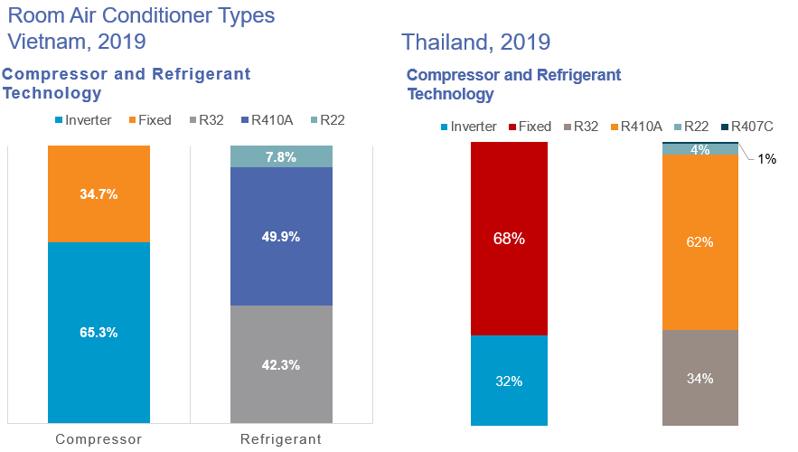
Figure 8: Accessibility to inverter ACs with the lower GWP refrigerant HFC-32 in Vietnam, Thailand (CLASP, 2019a; CLASP, 2019b)
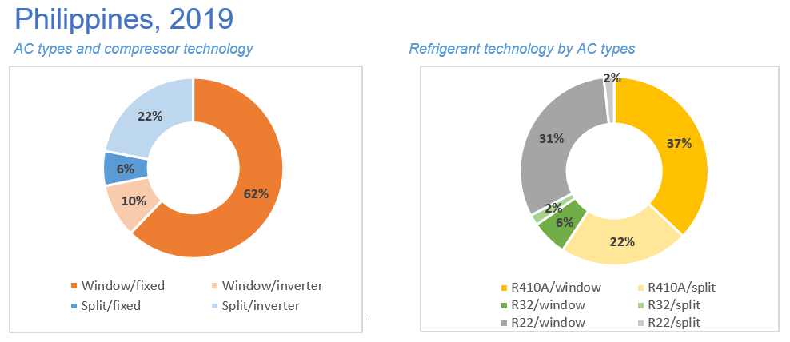
Figure 9: Accessibility to inverter ACs with the lower GWP refrigerant HFC-32 in the Philippines (CLASP, 2019c)
In importing countries, access to new technology is dependent on their regulatory environment, the affordability and return on investment, as described in the next sections.
For instance, South Africa does not have any AC manufacturing or assembly plants and imports all equipment; it is also one of the few countries in Africa with MEPS and a labelling program, requiring all ACs imported and sold in South Africa to have an energy efficiency rating of class B or better (~3.0W/W). Future MEPS adjustments could improve EE from the current median value to best available. Access to higher-efficiency ACs with lower-GWP refrigerants in South Africa is greater than other countries in Africa, which have no MEPS and labels in place and still have a majority of fixed speed ACs (Figure 10). On the other hand, the HCFC phase-out regulations, which have driven the shift to R-410A equipment, and the anticipated phase-down of high GWP HFCs are not integrated in the national MEPS although 91% of ACs use efficient inverter technology and 91% of those continue using R-410A (CLASP, 2020)
Access for local manufacturers to higher EE and/or lower GWP technologies may be facilitated by bilateral or multilateral government initiatives, by business agreements between manufacturers14F, or by alliances such as the International Copper Alliance (ICA)15F South East Asia, which is engaged in capacity building of AC manufacturers in the ASEAN region (ASEAN SHINE programme16F).
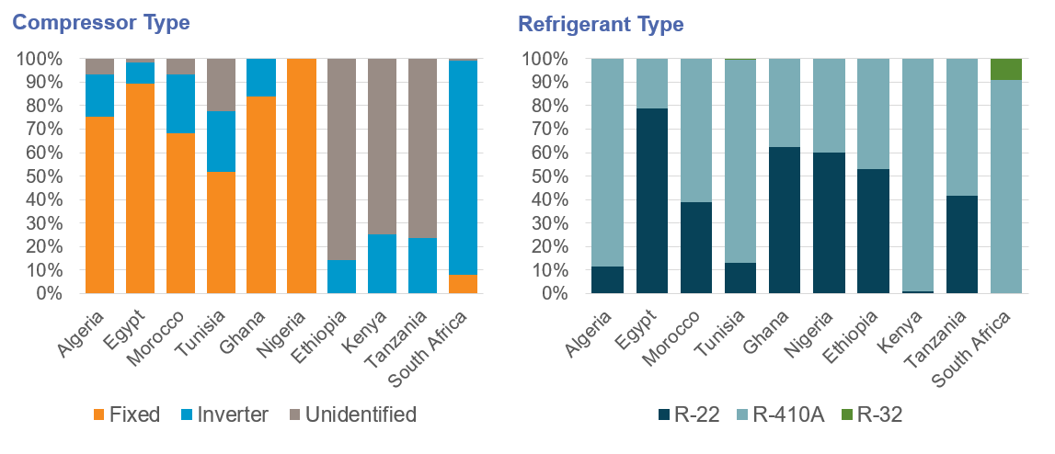
Figure 10: Access to inverter ACs with the lower GWP refrigerant HFC-32 in South Africa vs. other countries in Africa as share of new sales in 2018 (CLASP, 2020)

Influence of Regulatory Environment on Accessibility
MEPS remove the least efficient models and energy labels enable differentiation between products. Together these encourage the shift toward higher efficiency products and will facilitate their accessibility17F. By September 2020, more than 60 countries have implemented MEPS and labelling policies to regulate and improve the energy performance of the ACs sold in their markets. However, numerous A5 parties, many in Africa, have not yet implemented any form of energy performance standard. In other countries, MEPS are out of date, are not enforced or are circumvented, or have such low efficiency requirements that they maintain access to inefficient products.

MEPS
So far, MEPS are rarely linked to the HFC phase-down, and the opportunity to exploit the synergy is being lost with continued installation of low EE/high GWP equipment. Implementation of the integrated “Model Regulations” (see Case Study 4.1) would enhance the linkage between progressively increasing EE and phasing down HFCs, lowering up-front costs by linking to regionally harmonized standards and increasing scale of demand, benefiting consumers by lowering electricity bills, and avoiding expensive servicing tails of obsolete refrigerants. In many cases, to protect the competitiveness of the local industry, regulations follow the ability of local manufacturers to provide improving technology, rather than setting targets to drive improvement. Energy efficiency standards/legislations18F should be technology neutral (i.e., applied uniformly across a range of different underlying technologies that operate in any given application) to allow technologies to compete with each other to provide the best service to the end-user (CLASP, 2005).
In general, manufacturers will tend to sell low EE AC equipment into a country without MEPS or where they are not enforced.
In a country with MEPS, the majority of the RAC purchased by consumer has an EE which meets or just exceeds that standard. This is clear in Figure 11 where the market average EE only just exceeds the minimum EE. If the MEPS are low, then the EE of AC sold will be low, and lower than if the MEPS are high.
A country with low MEPS will inevitably continue to produce/import low EE equipment. MEPS in all countries are below the efficiency of the most efficient model, often by a considerable margin. To drive up EE, a country should continually revise its MEPS upwards, and stipulate SEER, as the performance metric, to favour variable speed compressors to reduce real life energy demand.
The IEA reports that in all major markets today, people are typically buying RACs whose average efficiencies are less than half of the best that is available (IEA, 2018) (Figure 11). A higher purchase price can become a major barrier if there is poor consumer understanding of the benefits of energy efficiency, and if the payback period of reduced energy charges is too long.
The AC with the best available SEER in most markets is around twice the market average SEER. (Figure 11).
The average SEER across different regions and countries is 4 - 6 (Wh/Wh), and is consistently lower in A5 parties (e.g. India, Indonesia, Saudi Arabia, and Thailand) (Figure 11). For SEER values, countries have adopted different temperature ranges and “bin hours” based on their climate. In order to correctly compare values with one another, the SEER values should be normalized. Nevertheless, more ambitious MEPS would increase the minimum and the market average AC performance.
The use of common regional or international calculation and measuring standards will facilitate accessibility and allow easier international benchmarking, whereas a proliferation of different national standards will adversely affect the accessibility. Common standards can remove trade barriers, and facilitate the establishment of common regional MEPS, energy labels and market surveillance programmes. Without common methods, benchmarking is more difficult though can be done through approximation (Figure 11). Improved harmonization allows easier international benchmarking and makes it easier for national and regional regulators to set their future performance requirements, for MEPS but also labelling thresholds.
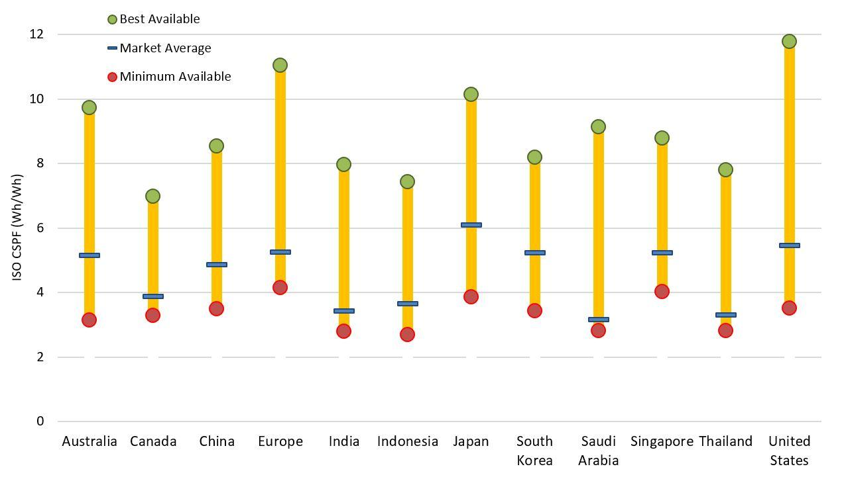
Figure 11: Best available RACs in comparison to the market average, IEA (2018).
MEPS landscape
In the European Union Ecodesign Framework Directive, for example, conditions are specified to establish (Ecodesign) criteria (including MEPS levels and other criteria). These conditions require no adverse effects on affordability, life cycle cost, industry competitiveness or imposing of proprietary technology (patents). Fixed speed and variable speed technologies have the same requirements, and with high MEPS, ACs without inverters have disappeared from the EU market.
In India, the Bureau of Energy Efficiency (BEE) energy labelling program requires both fixed-speed and inverter ACs to comply with the same efficiency requirements under the same mandatory framework19F. The accessibility of inverter ACs in the Indian market was promoted with the implementation of energy labelling for this technology: inverter ACs accounted for only 1% of the AC market in India before BEE’s labelling program was introduced in 2015, but by the end of 2019, inverter ACs accounted for 57%20F of the Indian market according to a report on the impact of energy efficiency measures by the Bureau Of Energy Efficiency (BEE, 2020).
In China, starting July 1, 2020, both fixed-speed and inverter ACs sold in China are rated according to the same variable speed metric, but the performance level requirements are higher for inverter ACs than fixed-speed ACs.
U4E Model Regulations for ACs consider non-inverter and inverter ACs under the same requirement since their functionality is the same.
MEPS in Latin America & the Caribbean
Of the 33 countries that make up the Latin America and Caribbean region, less than half have MEPS. Thirteen countries have MEPS for refrigerators, and 12 for air conditioners. The first challenge for the region is to agree the definition and implementation of a reference framework for MEPS, and the facilitation of the regional market for highly efficient products. It is estimated that the transition to efficient refrigeration, air conditioning and fans could make a potential energy saving of 138 billion kilowatt hours (the equivalent of USD 20 billion in electricity billing), avoiding ~44 million tons of CO₂ per year.
Argentina, Brazil, Costa Rica, Cuba, Ecuador, El Salvador, Honduras, Mexico, and Nicaragua have legislation in place for refrigerators, while Peru and Guatemala have voluntary standards. Costa Rica, Honduras, and Nicaragua have requirements for maximum energy consumption. Most were established between 2007 & 2013.
Most countries first focus on MEPS for AC equipment given the much larger number of units being put into the market. Mexico, Brazil, Cuba and Ecuador have established a complete system of EE standards. Elsewhere there are a variety of standards with different characteristics and classifications of products. Each country has independently developed its norms or adopted international standards. In some cases, local certification is needed, in others the certificate granted by the country of origin of the products is accepted, and in other cases they are limited to a labelling system. This lack of harmonization exposes countries without standards to the use of low-efficiency equipment, contributing to the use of excessive energy. In a region like Latin America and the Caribbean, where energy efficiency standards are so varied, there is a risk that those countries without standards will become the recipients of inefficient products, displaced from markets that have strict efficiency standards.
Standardised adoption of the U4E Model Regulations which are based on ISO standards, would facilitate the accessibility to energy efficient low GWP equipment in the region21F. Model regulations are being adopted in several countries; an example is Nigeria (see section 4.1) Most recently, U4E started a much-needed initiative model regulations for the commercial refrigeration sub-sector.

Labels
Labels achieve a market-pull effect and incentivize manufacturers to develop more efficient product. If the threshold value of the most stringent label is lower that the best available technology, there will be no incentive for manufacturers to develop better products because they cannot differentiate themselves with the label from their peers (Figure 12). For example, in Figure 12, in every country except South Korea the most efficient products will not be differentiated from less efficient products because the most stringent label is below the most efficient model. The most efficient models will not be identified as being superior from the rest.
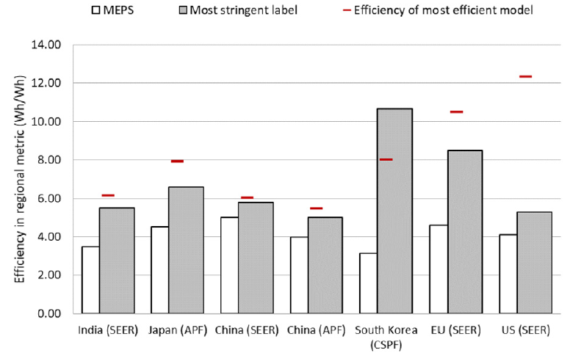
Figure 12: MEPS and labels vs. the efficiency of the most efficient model of RACs, Park et al. (2020)
Brazil has added the name of the refrigerants to their mandatory labelling program. In addition, as of 2022, the prestigious voluntary labelling programme (PROCEL) will grant its top label classification (A) only to air conditioners with ODP zero, therefore prohibiting HCFC-22. From 2023 on, the PROCEL Gold Label (an A+ version) will be operational, and will limit GWP to less of equal to 750 (see Case Study 4.7).

Safety standards
Safety standards support a safe transition to lower-GWP refrigerants, especially where refrigerants are flammable, but they can impact accessibility.
- Manufacturing: local safety regulations may not allow plants manufacturing products with flammable refrigerants to be set up in residential areas. There is a need to change the manufacturing process and factory layout, so there is an additional conversion cost. (Examples for the EU: ATEX Directive, Seveso Directive)
- Transportation: equipment containing more than 100 gr of flammable refrigerants per unit (UN code 3358) are not allowed to be transported by air (IATA rules).
- Use: Local Building regulations may disallow installation of equipment using flammable refrigerants.
- Waste phase: safety regulations may disallow or restrict equipment recyclers handling equipment containing flammable refrigerants.

Certification Body
A scheme operated by IECEE (system of conformity assessment based on IEC standards) referred to as CB scheme aims to facilitate trade by promoting harmonization of national standards with International Standards and increase cooperation among National Certification Bodies (NCBs) worldwide22F. The CB scheme is a multilateral agreement among participating countries and certification organizations which mainly focuses on safety but has recently introduced a programme for energy efficiency of pump motors. A similar scheme may be envisaged for energy efficiency standards based on ISO.
The advantages of the scheme are in facilitating market surveillance among countries without the need of setting individual test labs which can be expensive, as well as easing the market entry for manufacturers by avoiding multiple testing for the same product. As a result, products become more affordable and more reliable for end-users.
More than 50 countries currently take part in the CB scheme, including Austria, Belarus, Belgium, Czech Republic, Denmark, Finland, France, Germany, Greece, Hungary, Russian Federation, Saudi Arabia, Kenya, South Africa, India, China, South Korea, Singapore, Thailand, Japan, Canada, USA, Mexico and Argentina.

Trade policy
A ban on the import of used low EE equipment can have a positive effect on accessibility to high EE/low GWP equipment, while taxes and import duties (on assembled units or components) can adversely affect accessibility.
Ghana’s prohibition on the import of previously used ACs combined with MEPS and labels has enabled access to more efficient new appliances. Since the ban came into effect, the government of Ghana has seized 9,767 imported second-hand air conditioners.
Egypt imposes high tariffs on products imported from countries outside of the Gulf Cooperation Council, to protect local industries. This has resulted in a high portion (99%) of the low-efficiency products on the market being locally assembled. There is low penetration of high-efficiency inverter ACs in Egypt (9%) and no manufacturing or assembly of ACs containing HFC-32 (CLASP, 2020).
In Nigeria, lower import duties (5%) for components compared to imported assembled units (20%) is driving local assembly of ACs. Accessibility to high-efficiency inverter ACs products with lower-GWP refrigerants is low (20%). In 2018, Daikin launched an AC with HFC-32 specially designed for the African market which is now available in Egypt and Nigeria. The same holds true for Bangladesh (see section 3.5.4).
In Algeria, in a rare example of linking HFC phase down to EE, one local manufacturer is considering changing to inverter AC, when converting to lower-GWP refrigerants, due to lower duties on components coupled with a proposed sales tax incentive for higher efficiency products.
In the EU, the Ecodesign and Energy labelling requirements equally apply for locally manufactured and imported products, even if the latter ones are used or second-hand. To assure a level playing field for lower GWP refrigerant technologies, the EU F gas Regulation requires since 2017 that the imports of refrigeration, air conditioning and heat pump equipment pre-charged with HFCs are also covered in the HFC quota system (equipment importers can for example obtain import authorizations from HFC quota holders). By going beyond the scope of the Montreal Protocol-Kigali amendment (where the HFC phase down only applies to bulk gas consumption and production), the EU has accelerated the accessibility to RACHPs using lower GWP refrigerants. For example, the required transition for small single split ACs to a GWP below 750 is already going faster than the market prohibition date which was projected for 2025. The reason for this is that imports of equipment pre-charged with HFC-32 require 3 to 4 times less quota authorizations compared to imports of equipment pre-charged with R-410A, because the GWP of HFC-32 is 3 times lower and also less refrigerant quantity is needed for the same capacity.
The graph below from the European Environmental Agency (EEA, 2020) report illustrates the transition to lower GWP refrigerants in imported stationary RACHP equipment.
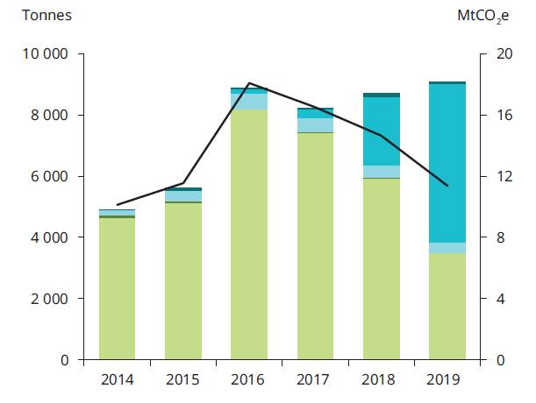 | 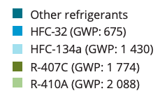
Figure 13: Refrigerants in imported stationary RACHP equipment (tonnes), EEA (2019, 2020)

Affordability and payback period
If high-efficiency products with lower-GWP refrigerants are available in a country, but the purchase price is high, then they are effectively inaccessible to the consumer. There are multiple factors affecting consumer price and affordability, and some are linked to the supply chain and regulatory environment described above. For instance, differential taxes on imported components or assembled AC increase the final cost to the consumer.
Typically, manufacturers integrate additional “bells and whistles” to high-efficiency products (i.e., better designs, additional functions such as dehumidification/humidification, air purification, etc.) that make them attractive for the higher priced segment of the market. The final consumer price depends mainly on these other factors, such as branding and extra functions.
A key factor is the payback period (time to recover the purchase cost through lower operating cost), and ensuring that customers understand this. The payback period is directly related to the cost of electricity versus the purchase price. In countries (both A5 and non-A5 parties) with low cost or subsidised electricity, the payback period is very long or may never occur. Consumers will not see any cost savings during the life cycle of the product, and there will be no incentive to purchase a more efficient AC. The two ways to drive up EE in countries with low electricity prices is by removing fuel subsidies, and strengthening MEPS to remove low EE AC from the market.
There are solutions to address the first-cost barrier such as the “cooling as a service (CaaS)” model. BASE and K-CEP launched the CaaS initiative to scale-up demand for efficient and clean cooling systems through the use and promotion of an innovative CaaS business model, with pilot projects in South America and Africa23F. Some companies have teamed up with Internet companies to develop subscription-based business models, for example a demonstration project was set up in Tanzania by an international supplier with WASSHA (an IT company).
Such models can create financial benefits for end-users and provide interesting business options for the solution providers, especially if the total life cycle cost (LCC) can be brought close to the least life cycle point (LLCC). Promoting equipment that goes beyond the LLCC point would need to be combined with other benefits for the consumer:
- Manufacturers and importers could include additional design features, extended warranty periods, and provide a high-quality service and repair network.
- Governments and energy providers could give subsidies or discounts or set up energy labelling programs to “pull” the demand towards higher energy efficient equipment.
- Countries could set MEPS even beyond the LLCC, to reduce energy consumption and avoid the need for new power plants.
- Countries could reduce electricity subsidies (see section 3.5.6).

Other factors: use limitations, trained service technician capacity, spare parts and refrigerants, quality of power supply & logistics

Use limitations
Some technological solutions to improve EE in laboratory conditions, are impractical. If a new high EE/low GWP AC is larger, because components such as heat exchangers need to be larger, then they may not fit into buildings (e.g., into false ceilings, above doors or below windows). High fan speeds and increased noise also, reduce acceptability to consumers.

Trained service technician capacity
The energy efficiency of an installed unit depends on location, good installation practices, routine and regular maintenance including cleaning of coil & filters and ensuring optimum charge. New installed systems may not meet the optimum energy performance unless they are installed and maintained appropriately. To achieve and maintain high EE, there has to be adequate numbers of appropriately trained technicians, and this needs advanced capacity planning. Technicians need to be trained to cope with the specific properties of alternative refrigerants such as flammability, toxicity, and high working pressures, and understand the pros and cons of the different refrigerants and equipment that uses them.
RACHP technicians without any formal educational background are still common especially in the developing world. Even formal educated technicians in A5 and non-A5 parties may not be familiar with the new RACHP technology, and their knowledge and skills need to be strengthened by national technician certification programs.
Some countries have mandatory certification or qualification programmes for installers and service technicians. The Draft regulation which is being approved in Chad24F for controlled substances includes several articles on service including articles on refrigerant handling and requirements for proper servicing.
The scope of those programmes may be limited to certain types of refrigerants. The EU for example has a legislation that requires mandatory certification for working on refrigerant circuits containing HFCs as part of the EU F-gas regulation, with the aim to reduce the climate impact of HFC emissions, thereby also increasing the safety of the installation and service works. As yet, there is no mandatory EU certification for non-HFCs that would require qualification or certification of technicians from a safety point of view.
In the absence of government programmes, manufacturers and importers may set up their own training and qualification schemes. The accessibility to end-users is typically impacted by the number of trained/qualified technicians available in a country or region, as the manufacturers, importer or distributors may decide to limit their sales/installation to trained/qualified technicians only (see section 3.5.1 on regional availability of products), because of quality and safety considerations.
The draft European standard (prEN) prEN ISO standard 22712 (currently in Final Draft International Standard - FDIS stage) provides an overview of the required skills for technicians working on a refrigerant circuit for any type of refrigerant, including an overview of which skills can be assessed by theoretical and practical examination methods. This standard can be used as a basis to develop voluntary or mandatory training, qualification or certification programmes.
Indonesia
Indonesia has a large number uncertified RACHP technicians representing a potential source of in-efficient energy RACHP systems because of their lack of skill and knowledge on installation and service. Indonesia is now implementing a national certification system for RACHP technicians starting from the basic service and installation to advanced levels such as central air conditioning. The certification system was formed by law under the National Professional Certification Agency. This body has the authority to set the Indonesian National Work Competency Standards for each professional sector. This scheme was developed to assure the quality and competencies of technicians because training schemes alone cannot guarantee that a technician has the three elements of competencies, namely knowledge, skills and attitude.
In addition to ensuring the quality of technical competence in achieving energy efficiency targets, this scheme also opens up opportunities for RACHP technicians with no educational background in the RACHP field to be able to meet international standard competitiveness. The certification scheme for RACHP technicians is still on voluntary basis; however, there are plans to make it mandatory.
European Union F-Gas regulation
In addition to promoting low GWP refrigerant technology programs; controlling direct emissions of F-gases is an important part of the efforts to fight climate change. The EU F-Gas Regulation was a landmark ruling that has affected manufacturers, installers, owners, service agents, and users of air conditioning equipment along with those in other refrigeration related sectors.
Therefore, training and certification are an important feature of the F-Gas Regulation since the first version in 2006 as it ensures that technicians understand how to minimize emissions during installation, maintenance and at end-of-life of equipment containing F-Gases. This approach has been continued in the revised F-gas regulation published in 2014, and extended to a wider scope of products, including refrigerated trucks and trailers.
Under this regulation, both companies and persons need a certification if they do activities that interfere with the refrigerant circuit (European Commission, 2015). See Table 8 that clarifies the scope.
Table 8: Activities requiring certification of personnel and companies under EU F-gas
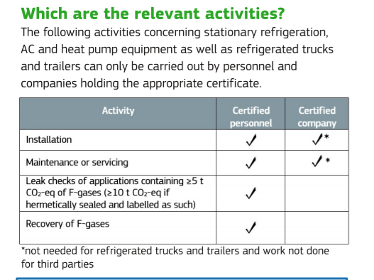 | 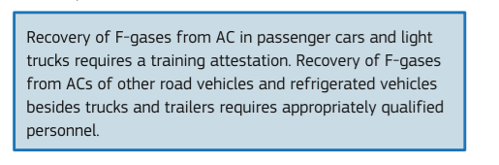
International Refrigerant Driving License (RDL)
The UNEP/AHRI Refrigerant Driving License (RDL) initiative sets minimum standards of competence for refrigeration and air conditioning technicians working with all refrigerants. Pilot projects are running in Rwanda, Grenada, the Maldives, Sri Lanka, Suriname Trinidad & Tobago and Bahrain. The certification establishes basic skills to ensure that technicians working with potentially dangerous refrigerants in A5 parties have some basic knowledge of how to handle and work with all refrigerant gases and an understanding of the specificities of different refrigerants in relation to flammability, toxicity, pressure, etc25F.

Supply chain for parts and refrigerant
It is recommended that importers also ensure the availability of refrigerants at the same time since manufacturers are generally not responsible for the purchase of refrigerants for maintenance. In Gambia, a UNIDO/GEF project supplied 200 HC-290 split units to be installed at key public and private locations as demonstration and for training and awareness purposes. Refrigerant suppliers took note of the arrival of the units and imported quantities of HC-290 gas to be in stock for future use.
The production of HC-290 in Nigeria was planned in view of the demand that will be created in Africa by the eventual switch to this low-GWP refrigerant. In this case, the accessibility to the refrigerant is preceding the accessibility to finished products.
For those countries or regions that do not have manufacturers, equipment importers need to ensure the accessibility of end-users to spare parts and refrigerants. This could be pursuant to local policies and regulations. Regulations will directly affect the affordability of products with certain refrigerants such as flammable ones.

Quality of Power Supply & Logistics
Power quality and reliability remain a perennial challenge in developing regions such as sub-Saharan Africa. Unlike rich countries where 24/7 stable electricity is the norm, outages are common in many African countries such as Nigeria which faces more than one a day26F. In addition to frequent outages, the quality of the power itself is low, characterized by voltage variability and other fluctuations which limit the utility of supplied power and can damage appliances (Jacome et al., 2019). These power quality issues can significantly weaken the value proposition of high-efficiency and low-GWP equipment that have higher upfront costs if the consumer expects a high likelihood of equipment damage from poor power quality. To mitigate power quality and stability issues, consumers may need equipment with special in-built or external surge protectors and other power supply management devices, which can add additional cost to the consumer, undermine efficiency gains, and limit interoperability across regions.
Tackling power quality issues in regions like sub-Saharan Africa and developing Asia require an ecosystem approach that involves the full range of power sector actors. This includes significant investments by supply-side actors to improve grid infrastructure and system operations to boost reliability and quality. Power utilities should also improve their customer service and encourage uptake of high efficiency equipment in both industrial/commercial and residential sectors, a potential win-win for both sides by helping customers derive more value from electricity while also creating a virtuous cycle for electricity demand to boost utility revenues.
At the same time, manufacturers of high-efficiency and low-GWP ACs and refrigerators need to tailor their devices for local contexts with unstable power supply. A possibility is equipping units with an auto restart function, a built-in stabilizer, or an additional AVS (automatic voltage switch) to be installed. Also, Direct Current (DC) bus voltage, compressor and Printed Circuit Board (PCB) components have to be carefully selected for their voltage tolerance. Special algorithms can be implemented on the compressor software to control its rotation and current. These design requirements add to the cost of the equipment and can also delay the accessibility for end-users and some manufacturers may decide not to develop such solutions if the market demand is low, or develop them only at a later stage.
In addition to power, ambient and transport conditions can also impact accessibility and should be accounted for during design and manufacturing stages. Transport and distribution logistics for example modification of packaging to withstand transport on rough roads also affect accessibility. To withstand severe road, storage and handling conditions, designs and packaging of the equipment may need to be reinforced. Also, such requirements add to the cost and may delay the accessibility to end-users if manufacturers do not or postpone such developments.
For locations that are prone to corrosion (e.g., close to the seaside), equipment needs special treatment, for example a special coating on the condenser coils.
Finally, lessons should also be learned from the innovative world of off-grid appliances, where constrained electricity supply has been used as a driver to improve rather than impede appliance efficiency. In these contexts, appliance manufacturers are innovating super-efficient residential appliances that can provide energy services such as cooling on an extremely limited energy budget while also integrating sustainability add-ons such as lower-GWP refrigerants where possible (Global LEAP Awards, 2019). Manufacturers and distributors supplying these off-grid markets have also built significant expertise in working in frontier markets and adapting products for rugged and difficult locations.

Improving Accessibility to High Efficiency Equipment Using Lower GWP Refrigerants
The single most important way to improve accessibility for high EE/low GWP equipment in A5 parties is to harmonise and implement ambitious MEPS and fully integrate them with HFC phase-down. The U4E Model Regulations are designed to drive the move to high efficiency equipment with lower GWP refrigerants. It is crucial to include some GWP controls with the MEPS if the synergies of cutting both direct and indirect greenhouse gas emissions are to be maximized. The U4E model regulations also include a low, medium and high tier for designing labelling or incentive programs. Setting and harmonising these tiers are important, as these will become living future MEPS threshold levels which can evolve with time.

Variability of Accessibility
The variable nature of accessibility within a country is illustrated in Figure 14, which shows the market penetration of the lower GWP refrigerant HFC-32 for new air-conditioning equipment purchased in Sri Lanka in 2019. In Colombo 22% of the market has switched to HFC-32, compared to 2% in the rest of Sri Lanka, where HCFC-22 is still being used in 75% of new equipment.
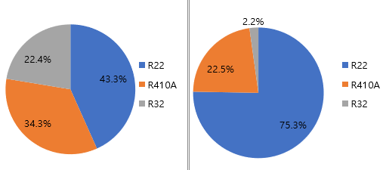
Figure 14: Split systems, air cooled & water cooled: packaged & VRV/VRF systems breakdown based on the refrigerant type in Colombo (left) and Other districts in Sri Lanka (right)
This large difference is likely related to technology awareness and training, because it takes time for new technology to diffuse to remote areas. Until local contractors become aware of the latest technologies and receive training in, for example, the use of A2L refrigerants, they are likely to recommend the old designs that they are comfortable with. Manufacturers are most likely to supply the new technologies to those that have followed training first.
There is substantial global variation in levels of accessibility. In South and South-East Asia, there is significant use of HFC-32 in new air-conditioning equipment, which compares to much lower accessibility in many South American countries. The CLASP report published in June 2020 (CLASP, 2020) examined market data for room air-conditioners being sold in 10 African countries27F. The report shows that:
- There is still widespread use of HCFC-22 in new room air-conditioners (47% of sales). The remaining sales are mostly R-410A based units.
- With the exception of South Africa, there is virtually no use of HFC-32 or R-290.
- The average efficiency level of HCFC-22 RAC units is around EER 2.9 W/W. This efficiency level is well below the MEPS of major trading partners (including China, South Korea, the US and the EU), which sell this AC equipment into African A5 markets.

Equipment Receivers vs. Equipment Producers
Before discussing ways of eliminating barriers to accessibility it is useful to characterize A5 parties into three groups as follows:
- Equipment receivers. The country has no factory production of any refrigeration or air-conditioning equipment. All equipment is imported. Many equipment categories are imported pre-charged with refrigerant (e.g., domestic refrigerators, split air-conditioners). Some equipment is imported as individual components and then assembled and filled locally (e.g., large industrial refrigeration). Most small-sized (low consumption) and many medium-sized A5 parties fall into this group.
- Equipment producers and receivers. The country has factory assembly of some types of pre-charged refrigeration or air-conditioning equipment. This equipment is usually sold in the local market and some might be exported. The most common types of equipment locally produced in medium and large sized A5 parties include room air-conditioning equipment and stand-alone commercial refrigeration equipment. These countries are also “technology receivers” for many types of equipment.
- Significant equipment producers. A few large A5 parties have local manufacturing for most types of refrigeration and air-conditioning equipment, often with significant exports.
The solutions to improve accessibility vary depending on which group the country is located.
The TEAP Replenishment Task Force in its 2020 report (TEAP RTF 2020) divides A5 parties according to their baseline consumption of HCFCs in metric tons (see Table 9 below). It is noteworthy that countries in the highest three brackets, i.e. those consuming above 2,000 metric tons of HCFC are all manufacturing countries, with the exception of Yemen. Almost all low-volume-consuming countries (LVCs) (bracket E) have no manufacturing or assembly of refrigeration and AC products.
Table 9: A5 parties characterization into brackets according to their baseline consumption
Bracket (mt HCFCs) | Countries
A: Over 25,000 | Group 1: China
B: 10,001 to 25,000 | Group 1: Brazil, Mexico, Thailand  Group 2: India, Saudi Arabia
C: 2,001 to 10,000 | Group 1: Argentina, Colombia, Egypt, Indonesia, Malaysia, Nigeria, Philippines, South Africa, Turkey, Venezuela (Bolivian Republic of), Viet Nam, Yemen  Group 2: Iran (Islamic Republic of), Kuwait, Pakistan
D: 360 to 2,000 | Group 1: Afghanistan, Algeria, Bangladesh, Benin, Cameroon, Chile, Côte d'Ivoire, Democratic People’s Republic of Korea, Dominican Republic, Gabon, Ghana, Guinea, Jordan, Kenya, Lebanon, Libya, Madagascar, Mauritania, Morocco, Nepal, Niger, Panama, Peru, Senegal, Somalia, Sudan, Syrian Arab Republic, Togo, Trinidad and Tobago, Tunisia, Uruguay  Group 2: Bahrain, Iraq, Oman, Qatar
E: HCFC LVCs | Group 1: Albania, Angola, Antigua and Barbuda, Armenia, Bahamas, Barbados, Belize, Bhutan, Bolivia (Plurinational State of), Bosnia and Herzegovina, Botswana, Brunei Darussalam, Burkina Faso, Burundi, Cambodia, Cabo Verde, Central African Republic, Chad, Comoros, Congo, Cook Islands, Costa Rica, Cuba, Democratic Republic of the Congo, Djibouti, Dominica, Ecuador, El Salvador, Equatorial Guinea, Eritrea, Eswatini, Ethiopia, Fiji, Gambia, Georgia, Grenada, Guatemala, Guinea Bissau, Guyana, Haiti, Honduras, Jamaica, Kiribati, Kyrgyzstan, Lao People’s Democratic Republic, Lesotho, Liberia, Malawi, Maldives, Mali, Marshall Islands, Mauritius, Micronesia (Federated States of), Mongolia, Montenegro, Mozambique, Myanmar, Namibia, Nauru, Nicaragua, Niue, North Macedonia, Palau, Papua New Guinea, Paraguay, Republic of Moldova, Rwanda, Saint Kitts and Nevis, Saint Lucia, Saint Vincent and the Grenadines, Samoa, Sao Tome and Principe, Serbia, Seychelles, Sierra Leone, Solomon Islands, South Sudan, Sri Lanka, Suriname, Timor-Leste, Tonga, Turkmenistan, Tuvalu, Uganda, United Republic of Tanzania, Vanuatu, Zambia, Zimbabwe

Improving accessibility for equipment receivers
Equipment Receivers have a good degree of flexibility: as an importer they can specify equipment standards, and in theory, they can move quickly to high efficiency equipment using lower GWP refrigerants. However, such a switch is not yet widespread.
Increasing awareness: Consumers and contractors may be unaware of the benefits of using high efficiency equipment with lower GWP refrigerants and its availability. This can be overcome by sharing best practice examples in regions, and by getting energy and environmental regulators to work in an integrated manner together. Consumers need to understand that the “total owning cost” (i.e. capital cost + lifetime energy costs) can be much lower using high efficiency equipment, with access to refrigerants that will be available long-term.
Contractor training. Contractors are unlikely to recommend equipment that they are unfamiliar with, especially containing A2L and / or A3 refrigerants. In relation to energy efficiency the training needs are quite broad, covering issues such as cooling load reduction and improved operation and maintenance as well as the core issue of supplying and maintaining high efficiency equipment. Each country needs to develop suitable training programmes with regional support using the excellent training material that is widely available (e.g. Real Alternatives, Refrigerants Driving License (RDL), OzonAction Guides), This needs to be timely and coincide with market uptake – there is no point in being trained on the use of A2L refrigerants if none are being sold in the country or local region.
Affordability. For many consumers, this is the key barrier even though purchase price is largely unrelated to EE. The price comes down as sales go up and economies of scale are achieved. The cost of more efficient equipment reduces even as energy efficiency standards are increasing (Abhyankar, Shah, Park, et al., 2017; Spurlock et al., 2013). These economies of scale can be kick-started through harmonizing MEPS and labelling requirements between markets as well as by combining market demand for high efficiency low GWP equipment through other types of policies (e.g., procurement).
Kick-starting market interest. Market intervention is required to move from an old established approach to new technologies. Some benefits are tangible to consumers, e.g. lower energy costs, but other benefits are not recognized, e.g. reduced CO₂ emissions or reduced electricity peak demand. To create a market transformation, it is necessary to put policies in place that will encourage consumer uptake, which will lead to growing awareness and will make training immediately relevant.
Enforcement. A5 parties should consider strengthening enforcement through inspection and penalties, especially at Customs and Excise.
Remove electricity subsidies to make consumers aware of the importance of energy efficiency and the burden on government.
The drive to high EE/low GWP equipment will be overcome by universal adoption of integrated standards including MEPS (minimum energy performance standards), energy labelling and maximum refrigerant GWP levels.
MEPS needs to be combined with a good programme of awareness raising and technician training. It also needs to be combined with tools to address the affordability issue. There are a number of possible tools available such as buyers’ clubs and grants for early adopters. See Section 3.5.6 about a possible solution to affordability issues related to the Electricity Supply Industry.

Improving Accessibility for Equipment Producers and Receivers
Locally produced air conditioning equipment usually has lower energy efficiency and uses HCFC-22 or high GWP HFCs such as R-410A.
Although the support for local industry is laudable, this will result in a very long-term economic penalty in terms of energy demand for the country through the installed base of low efficiency equipment, with an increased climate impact.
This can be overcome by technology transfer, which will require agency support through multiple financial mechanisms (MLF for HFC phase-down, integrated with Climate Funds for EE and possible others).
Local manufacturing companies should be mandated by the multi-agency funding rules to leapfrog to low GWP refrigerants, rather than switching from HCFC-22 to R-410A.
If local companies have switched to low EE/high GWP equipment production, then the country may need to activate a challenging MEPS schedule that specifies the use of low GWP equipment.
Most technology receiver and producer countries only produce a limited range of equipment locally. All imported equipment can be treated in the same way as for a technology receiver country.
One example of market distortion that protects local supply of inefficient equipment is Bangladesh which has imposed a higher duty on finished products than on components in order to encourage local manufacturing. This has resulted in many companies setting up assembly lines for the imported components (kits). The import duty structure on imported finished products is highest for smaller capacity units for which assembly lines exist and decreases as capacity goes up, see Table 10. This limits the absorption of new technologies as assemblers are not prepared to change their lines of production due to low volume.
Table 10: Bangladesh duty structure for finished AC products
Category | Capacity | HS Code | Total duty
AC - CBU | Up to 90,000 BTU/hr (<26.3 kW) | 8415.10.90 | 215.61%
AC - CBU | 90,000 – 200,000 BTU/hr (26.3 – 58.6 kW) | 8415.10.20 | 60.31%
AC - CBU | Above 200,000 BTU/hr (>58.6 kW/hr) | 8415.10.90 | 27.55%
In small and medium sized A5 parties many of the technology producers are also relatively small companies with limited R&D facilities – these extra challenges would need addressing. Parties could consider continuing the efforts to build the research and development capabilities of manufacturers in A5 parties started under PRAHA-II for high ambient temperature countries (UNEP PRAHA-II 2019) by extending those activities to other countries and expanding the scope of the support given.
This effort, when coupled with technology transfer initiatives, would improve the availability and accessibility of higher EE technologies to a larger number of countries.

Improving Accessibility for Significant Equipment Producers
Significant equipment producers usually have a large export market and many have access to good R&D facilities, either within the country or via commercial linkages with multi-national equipment manufacturers. These producers will be encouraged to produce high EE/low GWP equipment, by advanced warning that their export markets (i.e., equipment receiving countries) are introducing challenging MEPS/low GWP regulations. This gives time to switch production to high EE/low GWP AC equipment for local use and export. Market forces will ensure that significant producers will automatically respond and position themselves to supply best available equipment. However, this will only occur if demand for such equipment is created in their export markets – which relies on all regional countries coordinating on the introduction of challenging MEPS or similar market transformation policies. However, challenging MEPS without integrated/parallel HFC phase-down regulation risks driving up the use of high GWP HFCs

Working with the Electricity Supply Industry
The affordability issue is difficult to overcome if the purchasers of equipment do not recognise the full benefits of a shift to high efficiency equipment using lower GWP refrigerants. The benefits of such equipment can be summarised as:
- Reduction in lifetime energy consumption and cost.
- Reduction in direct CO₂ emissions through use of a lower GWP refrigerant.
- Reduction in indirect CO₂ emissions through reduced energy use.
- Reduction in electrical peak demand.
It is in the national interest to reduce electricity demand. In many A5 parties there is already a shortage of electricity generating capacity and significant growth in the use of refrigeration and air-conditioning equipment will exacerbate this problem.
Unfortunately, in many countries there is little interaction between the electricity supply industry and the purchasers of refrigeration and air-conditioning equipment. Funding bodies (such as multi-lateral development banks) find it easier to invest very large sums of money in a new power station than in numerous small investments that improve demand-side efficiency. This leads to an inappropriate split of investment between the supply and demand sides. All countries need to consider how improved cooperation between the supply and demand sides could overcome the affordability barrier. Providing financial support to encourage the uptake of high efficiency equipment will reduce peak demand and reduce the long-term investments required in power infrastructure.

Synthesis of Case Studies Illustrating Developments with Respect to Best Practices
- A5 parties creating a large installed base of low EE equipment, will be economically disadvantaged, as valuable electricity capacity is lost from other uses and because of the need to build more generating capacity. The economic disadvantage could last for decades due to the long product lifetimes of cooling equipment. Support for the development and enforcement of policies and regulations to avoid the market penetration of low efficiency RACHP equipment could stop environmentally harmful dumping and limit these economic impacts.
- Individual parties could consider adopting a fast mover status, with ambitious synergistic regulation for the HCFC phase out and HFC phase-down with progressive EE improvement.
- One facet of governmental cooperation that has proven absolutely essential is the coordination between senior energy efficiency officials and ozone officers. This expedites the further transition to lower GWP and higher EE equipment by the coordinated adoption of refrigerant policies with the revision of minimum energy performance standards (MEPS) and labels. In contrast, the implementation of ambitious MEPS alone can undermine the HFC phase-down by encouraging improved EE of cooling equipment, but with the use of high GWP refrigerants, especially in countries that are primarily equipment receivers.

Overview of Best Practices to Advance Energy-Efficiency Technologies in the RACHP Sector
Decision XXXI/7 requested the Energy Efficiency Task Force to provide Parties with an update on any new developments with respect to best practices, availability, accessibility and cost of energy efficient technologies in the refrigeration, air conditioning and heat-pump sectors as regards the implementation of the Kigali Amendment to the Montreal Protocol.
In this section the EETF has collected 27 recent case studies that illustrate several best practices and cautionary tales related to phasing down high-GWP refrigerants and increasing energy efficiency (Table 11). Based on these experiences, some general principles can be distilled and may serve as guidelines in the future. These general principles are described in brief in this section, with references to the additional information available in the full case studies, found in Annex 1.
The following sections present the institutional arrangements, capacities and capabilities, and regulatory environments needed to facilitate the HFC phase-down alongside promotion of energy efficiency. For countries that primarily import RACHP equipment, there is opportunity to build capacity to quickly prioritize imports of more energy-efficient and lower-GWP products alongside the HCFC phaseout and in preparation of the HFC phase-down, with the potential to leapfrog.
Table 11: Overview of case studies on best practices and cautionary tales related to phasing down high-GWP refrigerants and increasing energy efficiency
 | Geography | Policy type | Product type | Product source
1. Institutional Arrangements & National Cooling Plans
1.1 Institutional Arrangements in Ghana | Ghana | MEPS | All | Imported
1.2 India Cooling Action Plan | India | Cooling Plan | All | Imported and Domestic
1.3 China Green and High-Efficiency Cooling Action Plan | China | Cooling Plan | All | Imported and Domestic
1.4 National Cooling Action Plans | Multiple | Cooling Plan | All | Imported and Domestic
1.5 Rwanda National Cooling Strategy | Rwanda | Cooling Plan | All | Imported
1.6 Mexico Roadmap to Implement the Kigali Amendment | Mexico | Implementation roadmap | All | Imported and Domestic
1.7 National Cooling Action Plan Methodology | Global | Cooling Plan | All | Imported and Domestic
1.8 Cooling in the context of COP26 and updated Nationally Determined Contributions (NDCs) | Global | Nationally Determined Contribution | Varies | Varies
2. Best practices in national and regional capacity building
2.1 Twinning Workshop | Global | Training | All | Varies
2.2 Prohibition on importation of used refrigerators and used ACs | Ghana | Import Ban | Residential refrigerators; non-ducted AC | Imported
2.3 Product Registration Systems in ASEAN Region | ASEAN | Product Registration System | Residential refrigerators; non-ducted AC | Imported and Domestic
3. Supply Chain & Skilled Workforce (Installation, Maintenance & Servicing)
3.1 Effect of good service and maintenance on energy efficiency | Global | Servicing | All | Imported and Domestic
3.2 Argentina’s Experience Creating a Training Framework for RACHP Technicians | Argentina | Training | All | Imported and Domestic
3.3 Towards Changing the Landscape of the Air Conditioning Market in Brazil | Brazil | MEPS and Seasonal Metric | AC | Imported and Domestic
3.4 Case study on installation and servicing (A2L and A3 alternatives) in India for better accessibility | India | Training | All | Imported and Domestic
3.5 Accessibility of chest freezers and ACs in tier 3 and tier 4 cities | India | Supply Chain | All | Imported and Domestic
4. Regulatory Environment
4.1 United for Efficiency (U4E) Model Regulations | Global | MEPS and Seasonal Metric | Residential refrigerators; non-ducted AC; commercial refrigeration | Imported and Domestic
4.2 Energy efficiency metrics for air conditioners and impact on the product development | EU27 | MEPS and Seasonal Metric | AC | Imported and Domestic
4.3 Kenya AC MEPS update | Kenya | MEPS | AC | Imported
4.4 Case Study: Brazilian new national labeling for energy efficiency of Air Conditioners | Brazil | Label | AC | Imported and Domestic
4.5 EU Ecodesign and GWP “bonus” | EU27 | MEPS | AC | Imported and Domestic
4.6 Indian 24°C mandatory default setting | India | Default Temperature Setting | AC | Imported and Domestic
4.7 Integrating GWP into EE labels | Brazil and Burkina Faso | Label | AC | Imported and Domestic
5. Market-pull policies
5.1 Global Cooling Prize | Global and India | Challenge Competition | AC | Imported and Domestic
5.2 Rebate/replacement programme for low GWP energy efficient plug-in commercial refrigeration appliances. | Switzerland | Rebate | Commercial refrigeration | Imported
5.3 Bulk purchase of commercial plug-in | Global | Procurement | Commercial refrigeration | Imported
5.4 Demonstration project of HFC conversion by hydrocarbons as a coolant in manufacturing domestic refrigerators in Mexico | Mexico | Technology Substitution | Residential refrigerators | Domestic

Case Studies of Institutional Arrangements and National Action Cooling Plans
Institutional arrangements can facilitate or act as barriers to the adoption and implementation of best practice policies for enhancing access to low-GWP and energy efficient RACHP equipment. We present in Case Study 1.1 a case study of the interagency coordination in Ghana that supports effective development, implementation, and enforcement of policies controlling ozone depleting substances, second-hand product bans and MEPS. Ghana uses a “system leadership” approach and steering committee structure to get the needed buy in from the many institutions involved in regulating controlled substances, setting MEPS, regulating EE, and enforcing requirements at the ports of entry.
National cooling action plans (NCAPs) have emerged as a mechanism to coordinate strategies to maximize the economic and health benefits of cooling while reducing the environmental impacts. The process of developing national cooling plans can provide a mechanism for interagency coordination. India was the first country to develop a national cooling plan in 2018–2019. As of April 2021, seven countries have published national cooling plans, and 23 countries are in the process of developing plans (Table 11). India’s experience (Case Study 1.2) identifies several key success factors, including an inter-ministerial coordination mechanism, a collaboration framework to ensure multiple stakeholder engagement, creation of a living document that draws on data and analysis that continues to be gathered and sharing of knowledge to help countries develop their national cooling plans by standardising the country-level and segment-specific data collection process as a great example of South-South collaboration.
NCPs can also be used to set goals and targets, providing a framework for continued improvement in energy efficiency standards and coordination with promotion of low-GWP technologies. For example, China’s Green and High-Efficiency Cooling Action Plan (Case Study 1.3) sets out to achieve the following targets by 2030: (a) increase the cooling energy efficiency of large-scale public buildings by 30%; (b) improve overall cooling energy-efficiency levels by more than 25%; and (c) raise the market share of green and high-efficiency cooling products by more than 40%.
NCPs that set ambitious, achievable targets for near- and longer-term cooling send a clear market signal to manufacturers that their investments in more energy efficient and low-GWP cooling solutions will be recouped. Strong indication of follow-through is also important: full participation from each agency with a role to play helps ensure that the cooling plan targets will be implemented. Goals and targets for cooling have also been integrated into existing national climate, energy, and development plans, creating a strong potential link to HCFC phase-out management plans (HPMPs) and Kigali Phase-down Management Plans (KPMPs).
There is no rigid format for NCPs, but they often include:
- a market survey of the RACHP sector,
- a plan to strengthen MEPS and energy labels for appliances like room ACs and refrigerators,
- identification of potential financial mechanisms to support compliance,
- links to other national plans,
- a discussion of servicing needs,
- increasing focus on cold chain and mobile air-conditioning segments and consideration of barriers to climate-friendly cooling.
More recently, an NCP methodology has been developed (Case Study 1.7).
Over two dozen countries are developing national cooling plans as part of a broader framework supported by K-CEP (Case Study 1.4). For example, Rwanda (Case Study 1.5) used a consultative process and lessons learned from other markets to develop a comprehensive plan including financial mechanisms and the integration of model regulations. Building off of the National Cooling Plan, which called for the optimization of cold chain and off-grid cooling infrastructure, the Governments of Rwanda and the United Kingdom, the United Nations Environment Programme’s United for Efficiency (UNEP U4E) initiative, the Centre for Sustainable Cooling, and a range of academic institutions launched the Africa Centre of Excellence for Sustainable Cooling and Cold-chain (ACES) in October 2020.
Table 12: National Cooling Action Plans completed and in process, as of April 2021. * Denotes K-CEP support.
Completed plans:  India (March 2019)  China* (June 2019)  Rwanda* (June 2019)  Cuba* (April 2020)  Panama* (March 2020)  Trinidad & Tobago* (February 2020)  Chile * (April 2021) | In process:  Argentina*  Bahamas*  Bangladesh*  Barbados*  Cambodia  Colombia*  Costa Rica*  Dominican Republic*  Ghana* | Jamaica*  Kenya*  Lebanon*  Mexico*  Nigeria*  Philippines*  Saint Lucia*  South Africa*  Sri Lanka*  Thailand*  Uruguay*  Vietnam*
In May 2019, Mexico presented its Roadmap to implement the Kigali Amendment (Case Study 1.6). The roadmap presents the way forward to comply with the commitments derived from the Kigali Amendment, and is based on the national diagnosis on use, consumption and sector distribution of HFCs. In addition, it takes into account the results of the analysis of the national legal framework for the control of the consumption of substances regulated by the Montreal Protocol and its amendments.
In the lead up to the 26th Convention of the Parties to the UN Framework Convention on Climate Change, governments and other institutions are increasingly recognizing the opportunity to improve the energy efficiency and move to sustainable cooling solutions (Case Study 1.8).

Best Practices in National and Regional Capacity Building
One facet of governmental cooperation has proven absolutely essential is the coordination between senior energy efficiency officials and ozone officers. The twinning capacity building of National Ozone Officers and Energy Policymakers on Energy-Efficient and Climate-Friendly Cooling co-convened by UNEP United for Efficiency and OzonAction were designed to identify best practices and drive collaboration across energy, environment and other agencies so that the refrigerant transition of the Kigali Amendment could be paired with improvements in energy efficiency and conservation (Case Study 2.1). Workshops were organised according to the 8 OzonAction Compliance Assistance Program (CAP) regions, with an interactive approach and a mix of presentations by a variety of local and international experts. They presented data and information, demonstrated technologies, and conducted exercises within governments by the national counterparts and across countries to identify priority actions to undertake.
These training programmes were organized in 2018 on the side of regional network meetings and in 2019 on the side of the first inter-regional network meeting organized by OzonAction/ UNEP DTIE in Paris. In a follow-up survey of participants, 73 National Ozone Officers and National Energy Officers indicated they had started to consider the HFC phase down in their energy efficiency policies and 70 have already engaged their twinning counterpart to advance domestic cooperation on energy-efficient and climate-friendly cooling opportunities.
Strategic interagency planning and program implementation are best practice, but currently are not common practice without sustained direct financial and convening support. K-CEP, for example, provided some of the funding for the first two years of twinning workshops.

National capacity building
In many countries, particularly those with lower market adoption of cooling appliances, adopting and implementing best practices will require dedicated attention to building national capacity. A country’s ability to carry out effective, up-to-date national energy efficiency programs in coordination with HCFC phaseout and HFC phase-down depends on maintaining able staff to develop, coordinate, implement, and enforce policies and programs.
National cooling plans (Case Studies 1.2, 1.3, 1.4, 1.5) are one mechanism for characterizing market needs, reviewing policy options, and finally recommending policy for their market and situation.
Once a policy enters into force, proper enforcement becomes important to success. For enforcement, a different type of capacity must be built, as illustrated by Ghana’s experience with enforcing its prohibition on importation of used refrigerators and used ACs (Case Study 2.2). Staff at national points of entry must know what products are allowed to enter the market. Importers and retailers must also be familiar with what goods they can put on the market and therefore must be introduced to the new energy efficiency requirements and HCFC/HFC requirements.
National and regional product registries are a tool for knowing what products are on the market. It also provides an initial compliance gateway for products to enter into the market and monitor the evolution of the market over time (Case Study 2.3).
Regional product databases can also be used as a tool to communicate the results of market surveillance activities and avoid individual products being tested repeatedly by neighbouring countries. Cross-border intelligence sharing has not been common practice and can also help reduce the disparities in quality among product offerings shipped to different countries and as an end result, improves the accessibility to high-quality products.
Many national product registries do not track actual sales of specific models (with the exception of India’s Star Label database run by the Bureau of Energy Efficiency which tracks equipment stocks as manufacturers purchase a label for each unit intended for sale in India); rather, most product registries are limited to a list describing products available on the market, complicating efforts to characterize the actual stock of products in use at a given time. This becomes especially problematic when energy efficiency requirements need to be revised, and an ambitious energy efficiency threshold has to be determined. The U4E product registration resource collection (Case Study 2.3) provides examples of best practices, and those to avoid.
Product registries require resources to maintain, but well-run, cooperative programs to set them up can reduce redundancies and save significant cost over the long run.

Supply Chain & Skilled Workforce (Installation, Maintenance & Servicing)
Capacity is also needed in the servicing sector, both to properly maintain RACHP products for optimal energy efficiency and for safe maintenance of appliances using flammable refrigerants. The Task Force report on Decision XXIX/10 concluded that: “The impact of proper installation, maintenance, and servicing on the efficiency of equipment and systems is considerable over the lifetime of these systems while the additional cost is minimal” (TEAP EETF 2018). The report finds that measures taken to maintain a system in a good working condition could have an effect of limiting the degradation in efficiency up to 50% with a low-to medium cost, however there is a need for more evaluation to better characterize and prioritize proper installation, maintenance and servicing (Case Study 3.1).
As noted in Chapter 3, the presence of a skilled technician workforce is a factor in increasing access to new technologies. Since 2004, Argentina has been systematically evaluating service sector technician training needs and developing in-demand training courses, with over 12,700 service technicians trained (Case Study 3.2). Case Studies 3.3 and 3.5 describe examples of servicing capacity building and training in India for flammable refrigerants.

Regulatory environment
Strengthened national energy efficiency requirements for cooling appliances are the cornerstone of recent progress to increase energy efficiency alongside the HCFC phaseout and HFC phase-down. Minimum energy performance standards (MEPS), energy labels, and specific GWP limits comprise these regulations. These major regulations are mandatory and thus send manufacturers a strong signal to invest in efficient technologies while providing near certainty that those investments will be recouped.
Well-designed MEPS and labels balance ambition and achievability, at once pushing the market upward and leaving room for further innovation at the high end of the energy labelling scale. The regulations also apply to imported and exported equipment to ensure that dumping of noncompliant products does not undermines the benefits of the regulations.
MEPS, labels, and end-use HFC regulations can also be designed to strengthen one another. Case Study 5.4 describes the transition from HFC-134a to R-600a in residential refrigerators alongside a 10-25% increase in energy efficiency, in line with MEPS requirements at that time. Without MEPS to reinforce the inherent energy performance benefits of low-GWP refrigerants, those gains may be lost as manufacturers seek to save costs by using smaller heat exchangers and other less-costly components.
MEPS and labels regulations have recently been completed in Rwanda for air conditioners and refrigerators as a part of the Rwanda National Cooling Strategy (Case Study 1.5). The requirements were developed by tailoring the U4E Model Regulation Guidelines (Case Study 4.1), using Rwanda’s market assessment findings and undertaking consultations with civil society and industry representatives.
Kenya also recently updated its air conditioner MEPS, demonstrating how quickly an importing country can improve its market (Case Study 4.3). The regulation, finalized in April of 2019, entered force immediately and after six months the average energy efficiency of registered models increased 10% from 2.93 W/W to 3.23 W/W. Further, before the regulation 27% of models used HCFC -22, a fraction that fell to zero six months later, demonstrating how energy efficiency regulations can help expedite refrigerant transitions.
In Brazil, Ordinance # 234 (06.29.2020) changed the National Labelling Program (PBE) for air conditioning units to account for the energy savings benefits of variable speed compressors (inverters), calculating energy efficiency through the partial charge method and seasonal metric (INMETRO, 2020 a, b, c). The new top-level energy label exceeds the old rating by more than 50%, an increase that will rise to over 100% in 2025. More details are available in Case Study 4.4. Brazil has further revised its labeling to integrate refrigerant GWP, an approach also being explored in West Africa (Case Study 4.7).
Increasing attention is being paid to inefficient, outdated product dumping. Ghana has taken the step of prohibiting the import of used air conditioners and refrigerators (Case Study 2.2). That example also demonstrated a rapid change in the market from sales of over 80% used refrigerators, for example, to 95% new refrigerators. The experience also demonstrated a shift away from ODS-based models, further demonstrating the impact of national energy regulations on f-gas consumption.
There are additional recent examples of appliance standards that include performance requirements – specific criteria that must be met that do not relate directly to energy or refrigerant/foam blowing agent use, such as default temperature setpoints, availability of spare parts, voltage tolerances, and more. Case Study 4.6 describes a recent mandate set by the Indian government specifying that the default indoor temperature setpoint for all room ACs be 24°C, higher than common practice at the time and in line with the empirical findings that support principles of adaptive thermal comfort (Manu S. et. al, 2016, ASHRAE 55 Standard, 2003). The U4E Model Regulation Guidelines include several other performance requirements for air conditioners and refrigerators (Case study 4.1).
There are several notable challenges and pitfalls for these policies. Case Study 4.5 describes EU Ecodesign Regulation 206/2012, which allowed certain ACs using low-GWP refrigerants to consume 8% more energy than those with high-GWP refrigerants – an unnecessary extra allowance that fortunately went largely unexploited and, in the future, can be avoided. Similarly, Case Study 4.2 describes energy standards in the EU for portable ACs, which were allowed to continue certifying energy performance based on the single-speed EER metric while other ACs had to rate according to the seasonal SEER metric, resulting in significantly lower efficiency portable ACs persisting on the market. Care should be taken to level the playing field across different product types that are generally similar, such as different styles of ACs, when developing MEPS, labels, and testing methods and metrics.
Maintaining up-to-date regulatory programs for cooling appliances requires dedicated, well-trained staff and good institutional knowledge of and engagement with the affected markets and industries.
Implementing effective MEPS requires knowing what products are on the market in order to guarantee that the MEPS and energy label performance levels are appropriately set, currently and in the future, so the program effectively moves the market forwards (see product registries Case Study 2.3).
Regions that harmonise and use regional MEPS regulations can also set up regional product databases and exchange information among members. Regional MEPS avoid the cost and inconvenience for manufacturers to test products according to individual national test methods and lowers the barriers for them to penetrate a market. Indeed, product testing, even in the laboratories in their own domestic facilities, is very labour intensive and costly. It also avoids the hurdle that many importing countries do not have their own testing facilities, and thus must rely on unverified manufacturer data.

International harmonization of test standards and metrics
International harmonization of test standards and metrics has the potential to greatly increase national governments’ abilities to establish and maintain effective appliance energy efficiency programs during the HFC phase-down.
Testing standards and metrics prescribe the requirements for testing the energy efficiency of cooling appliances. Different standards and metrics produce energy efficiency measurements that cannot be easily compared, making it a challenge to compare energy performance across national borders. This effect may make it challenging for an importing country to align its MEPS with a larger regional partner, for example, so that it can share in the benefit of that country’s MEPS as well.
To solve this problem, a country can adopt national regulations that set MEPS and energy labels based on a well-known international test standard, such as those published by the International Standards Organization (ISO). Doing so increases accessibility of energy efficient products in importing markets in particular, because they then do not need to request additional testing to comply with national standards. It also should reduce costs for manufacturers and, in turn, consumers, because of the lessened need for specific testing and increasing economies of scale for international product offerings.
In the harmonization approach, it becomes particularly important to regularly update the details of the test standard, as any vulnerability becomes more profitable to exploit. It must also be a proven standard. The U4E Model Regulation Guidelines offers recommended standards which may be found in Case Study 4.1. The new Brazilian energy efficiency performance standards and labelling regulation is also an example of using an internationally recognized test standard, ISO 16358, which recognizes seasonal energy performance from variable-speed systems.

Market-pull policies

Financial incentives
Financial incentives help achieve market transformation by overcoming the initial price premium for efficient products for early adapters. Before the product becomes mainstream, its price will be higher than a standard efficiency product. Financial incentive programmes tackle this problem by lowering initial investment costs.

Rebate and tax incentives programmes
Rebates and tax incentives are specific financial mechanisms that can mitigate higher first costs of highly energy efficient equipment. They play an important role in building market share for the most energy efficient products, helping them more quickly achieve economies of scale. The programs can be implemented by national, regional, and local governments. In addition, certain electric utilities can implement customer rebate programs if they are regulated in a way that permits the utility to recover investment costs in customer energy efficiency through specially designed electricity rates.
The organizer of the rebate or tax incentive programme chooses what they intend to subsidize and defines the criteria such as high energy efficiency and low GWP refrigerants. A carefully developed specification that builds market share for cutting-edge products, with a rebate amount that allows the product to pay back reasonably quickly, is most likely to be successful. Care should be taken to incentivize only the very best products, as they are most in need of market support and stand to benefit society the most. Higher sums should be offered for appliance replacements – as they remove an old, inefficient appliance from the grid – but financial support should be available for newly purchased products as well.
In 2014, the Swiss government initiated a replacement and rebate programme for energy efficient low-GWP commercial plug-in refrigeration appliances. Business-owners replacing their products with highly efficient and low-GWP products received a subsidy up to 25% of the purchase price up to a fixed maximum amount of the new product. If a product did not replace an existing appliance but was a new purchase, the rebate went up to 15% of the purchase price. Over 3 years, 5’955 products were subsidized, which led to an energy saving of 54.5 million kWh. At the end of the programme, it was calculated that each kWh saved cost the government (including the administrative costs of the programme) 2.4 cents per saved kWh (2.49 US cents). More information is available in Case Study 5.2.
These programs have the potential to be highly cost effective, as noted, and drive market transformation. But they come at certain upfront cost: administering them requires overhead and, of course, the programs are grant-based or tax refund- based, cutting into other spending or income, respectively. They can also be part of utility obligation schemes, which do not have this downside. Though may rise fuel prices a little (an added future financial incentive for more efficient equipment).

Private & Public bulk purchasing
Another option to help purchasers offset higher upfront costs is bulk procurement. Rather than relying on a subsidy paid to the consumer, bulk procurement programs take advantage of pairing guaranteed demand with larger-scale, dedicated production to reduce per-unit price. Procurement guides, such as the procurement officer's guide to climate friendly refrigerants (Sustainable Leadership Procurement Council and IGSD, 2020), facilitate the identification of products and specifications to inform public or private bulk procurement.
Successful bulk procurements make certain of demand in advance for a significant quantity of the appliance, and ideally prescribes requirements for the appliance that will cause significant disruption in the market once offered at that price. Forthcoming regulatory requirements that mandate the better appliance types, such as those with high energy efficiency or low-GWP refrigerant, help secure the market transformation power of the procurement. The complexity of the process, paired to the need for careful analysis and the rapidly changing nature of the retail appliance market, can make proper timing and execution a challenge.
Case Study 5.3 describes a collaboration between Epta, the manufacturer of commercial refrigeration appliances and Lidl, a global retailer, to make and purchase plug-in units that fulfil Lidl’s strict requirements on refrigerants and energy efficiency. Lidl installed the first units in 2014 in 500 stores throughout Europe, and the unit was subsequently added to Epta’s product line and mass-produced in their factory in Italy. In 2018 Epta made several further improvements to the unit’s energy efficiency.
Unlike rebates and tax incentives, bulk procurement programs have the advantage that they do not cost the administrator money upfront, as least once the procured units are resold. In fact, they can be carried out by private entities at a profit, of which there are several examples. In either case, they do carry significant administration costs and additional costs during the transaction period.
A final notable approach to financial incentives, although not part of either category above, is a technology prize such as the Global Cooling Prize, which is described more fully in Case Study 5.1. That public-private partnership plans to award a financial prize to a team that can develop a prototype AC with potentially 5 times less climate impact than the baseline unit based on energy use and refrigerant GWP, provided it at-scale cost is no more than 2 times that of the baseline unit. The GCP has also spurred innovation in not-in-kind technologies as indicated by the 8 finalist teams including: barocaloric cooling based on organic solid crystals, evaporative cooling, membrane-based dehumidification, and desiccant dehumidification, as described in chapter 2.

Market surveillance
Market surveillance is a general term for the practice of monitoring a market to check that products out of compliance with national regulations, such as those on energy performance or refrigerants contained, do not enter the marketplace (see Case Study 1.1 for an example of institutional arrangement in Ghana that works with Ghana’s Revenue Authority, Customs Division, for enforcement of the refrigerant and energy efficiency requirements at the ports of entry). It is an essential part of a national appliance program, as it is the implementing authority ensuring that the regulations are applied and that it is effective. Such monitoring helps ensure that consumers can be confident in the environmental and energy performance of their purchases and that manufacturers are protected from competition from substandard, illicit models.
Market surveillance authorities may perform document checks on large samples of products, which is less costly or perform occasional laboratory checks on a sample of products, and, where non-compliance is found, enforce an appropriate sanction with the use of fines, withdraw products from the market, or a ban a manufacturer. If the authorities choose a soft sanctions approach, manufacturers will be informed of their non-compliance and told to change course.
Based on experience market surveillance authorities have gathered with their compliance checks, they are well positioned to contribute to the standardizing work for future measurement methods as they have seen what gaps exists in the measurement methods and how these could be misused.
Market surveillance can be resource intensive, particularly when it comes to laboratory testing of models suspected to be out of compliance. Clever program design can minimize these costs, as can several of the other strategies in this section, such as sharing market surveillance information across national borders. Harmonising testing and performance standards makes it easier to track internationally traded products28F.

Awareness raising
As described in EETF 2019 report, labelling provides a mechanism for increasing consumer awareness of the environmental and energy performance of products. Consumers, retailers, importers and manufacturers, servicing technicians should be well informed about national energy efficiency and refrigerant requirements and, in particular, labelling to maximize the benefits of those programs. See Case Study 3.2 for the central role of technician training in Argentina in raising awareness in both the servicing sector and among the general population.
Government outreach to educate these stakeholders helps guide purchasing decisions towards environmentally preferable models. It is an important part of the cycle, in which national standards and programs reward manufacturer investment in energy efficiency with greater sales. Consumers, in turn, are rewarded for greater upfront costs with lower life cycle costs of ownership and better environmental outcomes.
Retailers must display the label and be able to explain to customers the meaning of buying a more energy efficient appliance. If the retailers do not display the label next to their products, it is impossible for the consumer to factor energy efficiency in their purchase decisions. Importers must also be aware of the significance of the label because this determine what products can be imported or not. This avoids the risk that noncompliant products are unknowingly imported and burdens the market surveillance authorities.
When it comes to public outreach and awareness raising, programs can strive for simplicity over scientific and analytical rigor. Simple programs are best, and those that get bogged down in too much detail run the risk of having many consumers simply pass the label over entirely. A well-recognized energy label helps build market share for top products, contributing to a “race to the top” in which the manufacturers of the climate-friendliest appliances win.
Awareness raising may take dedicated time and resources at first. But, once well recognized, programs that have high awareness can enjoy its fruits for a long time to come. There are many examples, such as the voluntary Energy Star label in the United States and the mandatory 5-Star Rating System for ACs in India.

Modelling the Benefits Enhancing Energy Efficiency while Phasing Down HFCs
- Integrated modelling of the direct (refrigerant-related) GHG emissions and indirect (energy-related) GHG emissions from refrigeration, air-conditioning and heat pump (RACHP) markets provides valuable insights into the importance of linking improvements in energy efficiency with the HFC phase-down. A number of modelling tools are available and in development. Early outputs from the “HFC + Energy Outlook Model” suggest:
  - indirect energy-related GHG emissions represent around 70% of total GHG emissions from the RACHP sector,
  - there are substantial benefits from earlier action to prevent the increase in HFC use in reducing the total cumulative emissions,
  - combining faster phase-down of HFCs and improving efficiency provides substantial additional benefits in reducing the total cumulative emissions,
  - there is a large potential to reduce both direct (>90%) and indirect emissions (>98%) by 2050, compared to a business-as-usual scenario,
  - how to identify the measures that yield the greatest benefits through addressing both the refrigerant-related and the energy-related GHG emissions,
  - transitioning to the use of heat pumps is important in terms of the abatement of fossil fuel emissions from heating.
- Individual Parties could be encouraged to utilise outputs from such modelling as part of their HFC phase-down planning process.
- Parties may wish to consider asking TEAP to develop a detailed regional and world model to further assess the integration of energy efficiency and HFC phase-down measures.

Background
Variously, in decisions XXIX/10, XXX/5 and XXXI/7 Parties requested the TEAP to report on different aspects of the costs and benefits of maintaining and/or enhancing energy efficiency while phasing down HFCs under the Kigali Amendment to the Montreal Protocol.
In response, prior and current TEAP EE Task Forces have provided assessments of the costs and benefits of energy efficient technologies that can be adopted while implementing the Kigali Amendment. However, due to the limitations of time and available data, these reports have not yet included a comprehensive quantification of the costs and benefits of maintaining and/or enhancing energy efficiency while phasing down HFCs under the Kigali Amendment. It has been difficult to provide accurate estimates of the potential reductions in GHG emissions from increased energy efficiency, because such estimates depend on numerous variables such as evolving equipment efficiency, use patterns, climate conditions, and the quality of equipment maintenance. It is also dependent on how a country’s electricity is generated and the progress that has been made in the decarbonisation of the electricity supply. Modelling the costs of maintaining and/or enhancing energy efficiency while phasing down HFCs under the Kigali Amendment is also challenging as such estimates are evolving based on market conditions and also involve proprietary data.
Recently, UNEP and the IEA released an assessment of the development and climate benefits of efficient and climate friendly cooling by 2060 (Dreyfus, G., et al, 2020) finding that the world could avoid the equivalent of up to 210-460 Gt CO₂₋eq over the coming four decades through efficiency improvements and the refrigerant transition (Shah et al. 2019), depending on future rates of decarbonisation. This compares favourably with the estimated 135 Gt CO₂₋eq avoided between 1990 and 2010 as an incidental side-benefit of phasing out ODS. Achieving this target, would require that, starting in 2030, all stationary air conditioning and refrigeration equipment were replaced with the highest-efficiency and climate friendly refrigerants typical of the best technologies available in 2018. Three-quarters of the avoided emissions would come from energy efficiency (equivalent to an average 40% efficiency improvement) compared to one quarter from refrigerant phase down. The mobile air conditioning sector, where energy consumption is expected to almost triple by 2050, also offers significant mitigation potential (IEA, 2019).
Energy efficiency improvement could also be a key intervention to recover from the COVID-19 recession. The IEA recently found that spending on improving the efficiency of buildings for example, could generate between 9 and 30 jobs per million USD invested, much higher than the number of jobs generated from spending elsewhere in the energy sector (IEA, 2020b).

Modelling Requirements
To fully understand and realise the potential for enhanced energy efficiency linked to the HFC phase-down process, there is a requirement to develop detailed models to assess both the refrigerant-related (direct) and energy-related (indirect) GHG emission reductions that can be achieved in the refrigeration, air-conditioning and heat pump (RACHP) markets. This requires modelling of the whole stock of equipment in the multiple RACHP sectors, starting in individual countries and then integrating that data into a global picture. Factors such as climate conditions and electricity grid emission factors make the energy-related emissions highly country-specific. Therefore, an over-simplified model will likely be inaccurate and potentially misleading.
In assessing total GHG emissions impacts of a single country or a larger geographic region (i.e., direct, indirect, and embedded emissions), some or all of the following evolving issues should be considered:
- Estimates of the stock of all the equipment used in the wide range of different RACHP applications. From these estimates, a single stock model can be developed (i.e., common to both the refrigerant and energy analysis), to compare the relative contributions towards GHG reduction of HFC phase-down versus reduced energy-related emissions. This should take into account the distribution of equipment age, refrigerant-choices and efficiency-levels over the time period being modelled.
- Estimates of the likely rate of stock growth in the different RACHP market sectors over the coming decades. High growth rates are expected, especially in Article 5 countries.
- The impact of ambient temperature and humidity on the magnitude of cooling loads and the efficiency of cooling equipment.
- The impact of increased use of heat pumps as a policy response to decarbonise heating systems. Climate data are important to assess the performance of heat pumps under heating conditions (and heating/cooling conditions across the seasons in some regions).
- Modelling of scenarios that represent the HFC mitigation actions that can be taken to reduce the use and emissions of high-GWP HFCs and reduce direct GHG emissions. The actions to mitigate HFC emissions should include leak reduction, end-of-life gas recovery and retrofit of high-GWP refrigerants in existing equipment as well as the use of lower-GWP refrigerants in new equipment.
- Modelling of scenarios that represent the Energy mitigation actions that can be taken to reduce energy use and the related indirect GHG emissions. The actions to mitigate energy use should include cooling load reduction, improved operation, control and maintenance of existing equipment, and the use of new equipment with higher levels of efficiency.
- Modelling of scenarios that represent different levels of electricity generation carbon content. The future decarbonisation of electricity supply will have a major influence on energy-related emissions from RACHP.
- Energy use models should consider peak electricity demand in addition to annual energy use. Peak electricity demand has implications for electricity generation and transmission capacity, costs and savings.
The modelling of energy use requires substantially greater insight into the different application sectors compared to HFC phase-down modelling. For example, food retail refrigeration systems operate at two distinct temperature levels (for chilled food and for frozen food). To model HFC phase-down in the food retail sector it is not important to distinguish between these two temperature levels. However, for energy modelling, the application temperature is an important variable. For a given cooling load a frozen food system might use double the energy of a chilled food system. Similarly, energy modelling of space cooling systems requires a better understanding of climate and user behaviour than HFC phase-down modelling. Modelling of energy for both space cooling and refrigeration also requires a significant understanding of the energy efficiency metrics and test procedures used to assess the energy performance of such systems.

Modelling Tools and Resources
A number of modelling tools are available or under development to assess either refrigerant-related GHG emissions or energy-related GHG emissions or both. A brief summary of these tools is given below. Sections 5.4 to 5.6 provide a more detailed review of one of these tools, which is specifically designed to provide an in-depth analysis of both direct and indirect GHG emissions from RACHP.

Green Cooling Initiative
A programme operated by GIZ on behalf of the German Government focussed on implementation of sustainable cooling. They have created estimates of projected direct and indirect emissions under a reference and mitigation scenario for each country and for different regions. Their model includes a breakdown for 7 main market sectors.
https://www.green-cooling-initiative.org/country-data

The Cool Calculator Model
The Cool Calculator has been created by the Carbon Trust on behalf of the Cool Coalition. It is a simple spreadsheet model that is intended to represent the global stock of refrigeration and air-conditioning equipment (currently it does not model heat pumps). It provides a forecast of direct and indirect emissions from RACHP equipment in 2050, comparing a reference scenario with three levels of effort to reduce emissions. The objective of this model is to identify Net Zero cooling pathways to 2050.

HFC + Energy Outlook Model
The HFC + Energy Outlook Model has been developed to provide an in-depth analysis of both HFC phase-down and energy efficiency improvements. This model has been created by EPEE (a European RACHP Trade Association) with support from UNEP. It is a highly detailed model that incorporates data from all RACHP market sectors and can assess historic and future refrigerant and energy-related GHG emissions on an annual basis between 2000 and 2050.

MEPSY
A free online tool developed by CLASP to assess energy savings potential across a growing range of appliances and equipment, currently including space heating equipment, air conditioners, refrigerators, motors, fans, and televisions. Direct emissions are not currently included but are planned to be added in a forthcoming update.
https://www.clasp.ngo/tools/mepsy/

U4E Country Savings Assessments
U4E (United for Efficiency) is a global effort supporting developing countries and emerging economies to move their markets to energy-efficient appliances and equipment. U4E have created a set of country-level energy and indirect emissions savings estimates available for refrigerators, air conditioners, lighting, electric motors and distribution transformers. Direct emissions estimates are not currently available.
https://united4efficiency.org/countries/country-assessments/

Lawrence Berkeley National Laboratory (LBNL)
LBNL have created energy and indirect emissions savings estimates based on bottom-up single-stock modelling of stationary refrigeration and air-conditioning available for key countries and globally (Shah et al. 2019; Shah et al. 2015). LBNL also assists the US Department of Energy in estimating the costs of efficiency improvement for the purposes of setting energy efficiency standards for various refrigeration and air-conditioning equipment through “bottom-up” engineering analysis based on detailed data collection, testing and modelling of the more efficient equipment to identify the actual manufacturing cost (as opposed to the retail price) and the corresponding lifecycle cost of more efficient equipment. Similar methodologies have also been used to a more limited degree to support energy efficiency standards processes in countries such as India, China, Ghana, Mexico, Brazil, etc. (Shah et al., 2016; Lin and Rosenquist, 2008; Fridley et al., 2001; McNeil et al. 2007; Sanchez et al, 2007).

The HFC + Energy Outlook Model
The original HFC Outlook Model has been available since 2018, and only assessed refrigerant use and direct GHG emissions. It has been used to model HFC phase-down in the EU and in 10 Article 5 countries29F. It was designed to assess HFC phase-down under the Kigali Amendment.
A new model, the HFC + Energy Outlook Model, has recently been developed to integrate the assessment of energy use and the related indirect GHG emissions. This new model can forecast both direct and indirect emissions from RACHP equipment annually between 2000 and 2050, comparing a reference scenario with different levels of effort to reduce emissions. It also forecasts the amount of fossil fuel emissions that can be mitigated through the use of heat pumps and the potential to reduce peak electrical demand through use of more efficient RACHP equipment.
At the time of writing this report (May 2021), the HFC + Energy Outlook Model has been tested using data for the EU. By autumn 2021 the 10 Article 5 countries with an existing HFC Outlook refrigerants model will have outputs from the new HFC + Energy Outlook Model which will include all energy-related GHG emission outputs.
The HFC + Energy Outlook Model provides a wide range of outputs, allowing the trained user to obtain an in-depth assessment of refrigerant and energy-related GHG emissions for each year between 2000 and 205030F. Some important capabilities of the HFC + Energy Outlook Model include:
- modelling of the whole RACHP market – including the GHG emission reductions created by the replacement of fossil fuel heating with heat pumps
- assessment of all outputs on an annual basis between now and 2050 – this allows the design and evaluation of pathways that minimise cumulative emissions. It allows the model to assess the environmental benefits of early actions.
- modelling of all relevant substance types – including HCFCs, HFOs, hydrocarbons, CO₂, ammonia as well as HFCs
- modelling of non-RACHP sectors (e.g. aerosols, foams) – to assess all uses of HFCs that are covered under the Kigali Amendment
- assessment of HFC (and HCFC) consumption reductions on an annual basis – providing a forecast of progress towards compliance with the Kigali Amendment (and with the phase-out of HCFCs)
- assessment of a range of stock growth forecasts, to evaluate the sensitivity of outputs to future uncertainties about equipment use
- assessment of a range of “not-in-kind” mitigation scenarios such as reduced cooling load through building envelope improvement, modal technology shifts (e.g. from small air-conditioning equipment to district cooling) and of improved control, operation and maintenance.
Stock data: The model makes estimates of the stock of RACHP equipment by market sector. Main market sectors include domestic refrigeration, domestic air-conditioning, commercial refrigeration, commercial air-conditioning, industrial refrigeration, industrial air-conditioning, transport refrigeration, transport air-conditioning. The stock estimate is further sub-divided into 50 separate technologies, representing different equipment sizes and types. This includes a distinction between the stock of low temperature (frozen) and medium temperature (chilled) refrigeration applications, as the temperature level affects energy use. A single historical stock estimate is made from 1990 to 2020 and three forecasts are made of stock growth to 2050.
Pathways: Five GHG mitigation pathways are defined, to represent different levels of GHG reduction ambition. This includes a reference business-as-usual scenario (assuming continuing use of high GWP HFCs and low efficiency equipment) and four different levels of GHG mitigation. The pathways are based on assumptions for a number of important parameters, defined for each technology type on an annual basis. As the model uses annual data it is able to predict a transition that takes place over a period of years. Some of the assumptions include:
- for refrigerant emissions: split of refrigerants used in new equipment, refrigerant leakage in operation, refrigerant emissions at end-of-life, refrigerant recovery and re-use, retrofitting of existing equipment with lower GWP gases
- for energy-related emissions: efficiency level of new equipment, impact of heat load reduction, impact of improved control and maintenance, electricity grid carbon factor.
Climate conditions: Ambient temperature and humidity conditions have a major impact on RACHP energy consumption, affecting cooling (or heating) loads and also influencing the efficiency of RACHP equipment. The HFC + Energy Outlook Model uses location-specific weather data, with both dry-bulb and wet-bulb temperature profiles, to provide estimates of heat load and consequent energy use in a specific country or region.

Key Outputs from the HFC + Energy Outlook Model
The outputs are available for a single country or can be integrated into a larger region. The model has the capability to create a worldwide estimate. All outputs can be reviewed at different levels of detail, e.g. split by main market sector, by technology type or by gas type. Key outputs include:
- Annual consumption of each type of refrigerant
- Refrigerant emissions, with estimates for both operating and end-of-life emissions
- Refrigerant banks, gas in equipment reaching end-of-life, gas recovered and reused
- Annual energy consumption
- Indirect emissions from energy used
- Estimate of peak electricity demand

Example Outputs from the HFC Outlook Refrigerant Model
The following charts show outputs from the HFC Outlook model for a typical Article 5 Group 1 country.
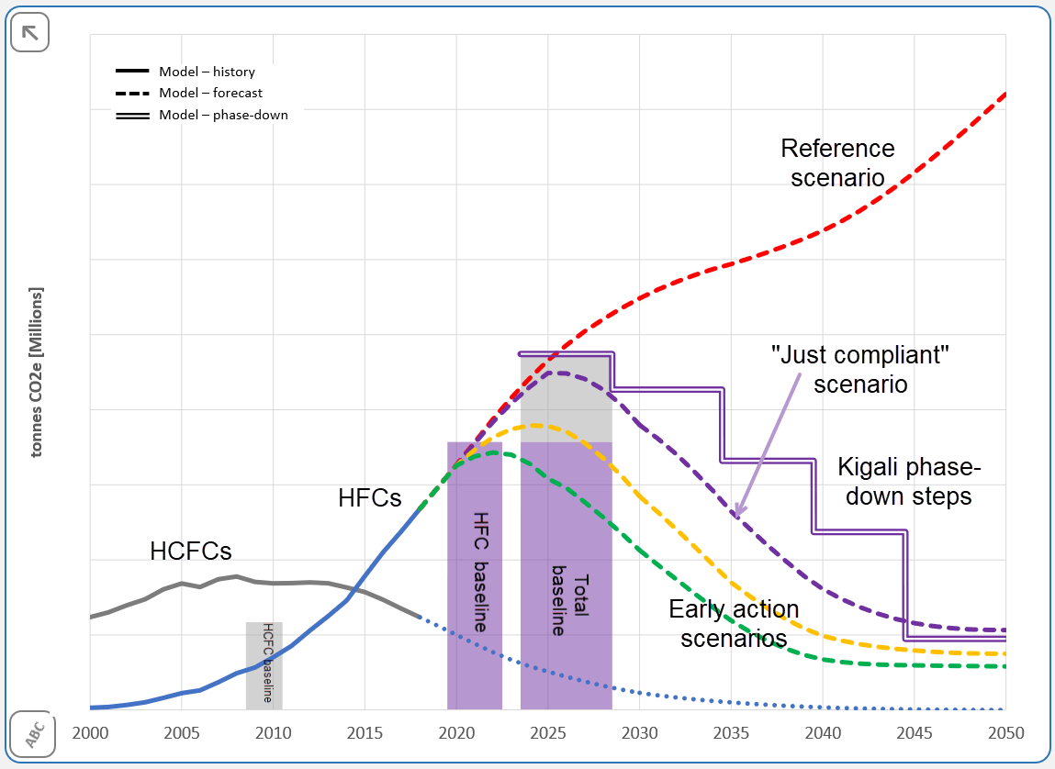
Figure 15: HFC Outlook, Compliance with Kigali Amendment for a typical A5 Group 1 Party
Figure 15 shows forecasts of HCFC and HFC consumption between 2000 and 2050. The modelled HFC forecasts are used to estimate the Kigali baseline31F and the HFC phase-down steps. The “Just Compliant” scenario is based on a pathway that just meets the Kigali Amendment phase-down steps. The two other scenarios show how earlier action can lead to lower cumulative emissions between now and 2050.
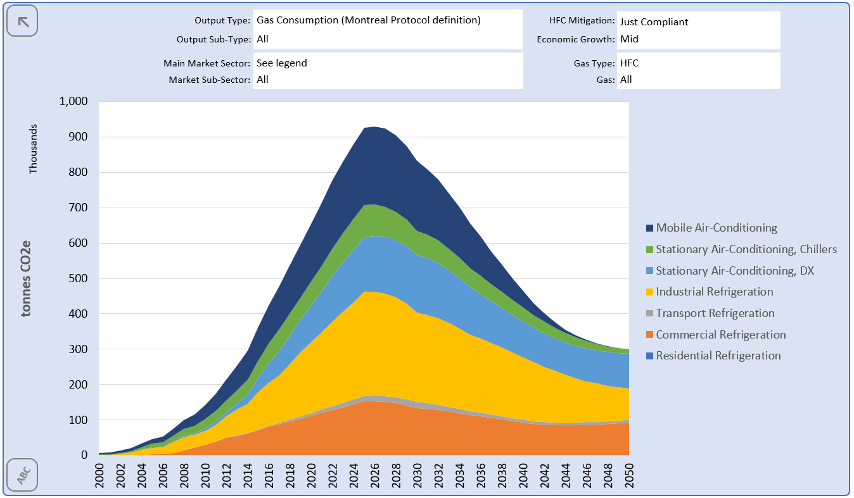
Figure 16: HFC Outlook, Split of HFC Consumption by Main Market Sector
Figure 16 shows a split of HFC consumption by main sector, for the “Just Compliant” scenario. This can be used to help identify the market sectors of most importance for policy actions.

Example Outputs from the HFC Outlook+ Integrated Refrigerant and Energy Model
Figure 17 to Figure 21 show initial outputs from the latest version of the HFC + Energy Outlook Model which combines refrigerant and energy-related emissions modelling. The data shown in these figures is based on a version of the model using data for the European Union.
The charts all show GHG emissions in terms of an “emissions index” for the tonnes CO₂e emissions.
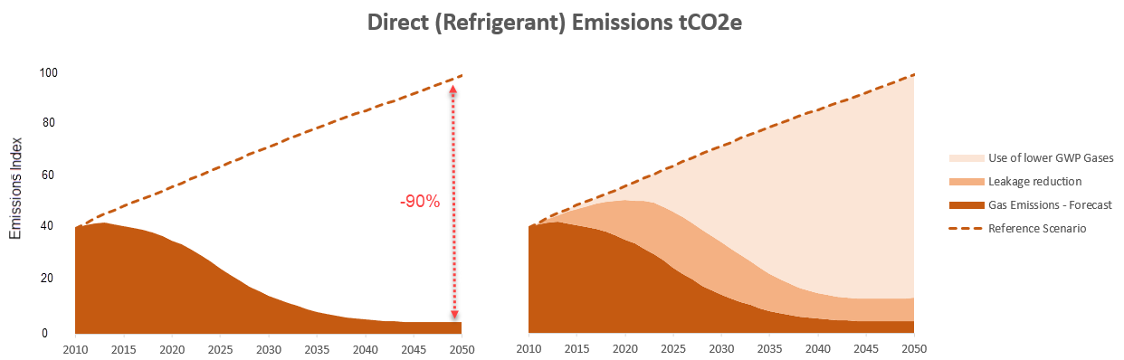
Figure 17: Modelling of HFC Gas Emissions
Figure 17 compares the HFC refrigerant emissions from the reference scenario with a scenario that is just compliant with the Kigali Amendment. The left-hand chart shows the reference scenario and the possible emissions pathway through the application of a range of HFC emission mitigation actions. The right-hand chart shows the same data, with an indication of which actions create the emission reduction.
This modelling of refrigerant emissions provides the following insights:
- a 90% reduction of direct emissions, compared to the reference scenario in 2050, is possible under the Kigali Amendment
- a greater reduction may be possible by 2050 if tougher targets are set
- the pathway taken impacts the total cumulative emissions through to 2050. With an earlier start and with faster and deeper phase-down steps the cumulative emissions can be reduced
- the cuts are achieved by a mixture of HFC mitigation actions including:
- the use of low GWP refrigerants in new equipment
- leak reduction
- retrofitting of some high GWP gases with lower GWP alternatives
- end-of-life gas recovery and re-use
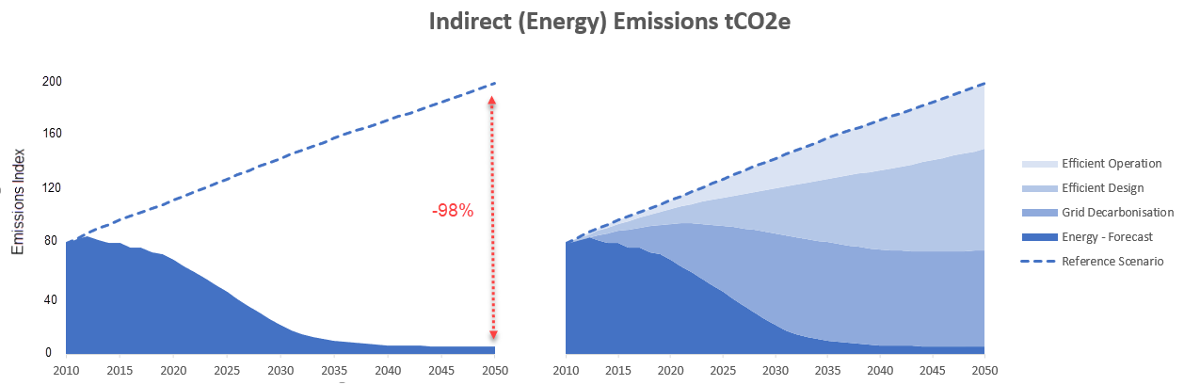
Figure 18: Modelling of Energy-Related Emissions
Figure 18 compares the energy-related emissions from the reference scenario with a scenario that assumes the uptake of a range of energy efficiency measures, and the use of electricity with a lower carbon content. The left-hand chart shows the reference scenario and one possible emissions pathway. The right-hand chart shows the same data, with an indication of which actions create the energy-related GHG emission reduction.
IMPORTANT NOTE: the energy emissions in Figure 18 are approximately 2 times higher than the HFC emissions in Figure 17 – see the different scales on y-axes.
Some interesting insights from this modelling of energy-related indirect emissions:
- the indirect emissions are much higher than the refrigerant emissions, emphasising the importance of accounting for energy efficiency during HFC phase-down.
- a 98% reduction of indirect emissions, compared to the reference scenario in 2050, is possible under the scenario modelled.
- the pathway taken affects the total cumulative emissions to 2050. With an earlier start and with a faster move towards efficiency the cumulative emissions can be reduced.
- the cuts in energy-related emissions are achieved by a mixture of actions including:
- reductions in cooling loads
- improved equipment design and efficiency
- better operation and maintenance
- use of a decarbonised electricity supply.
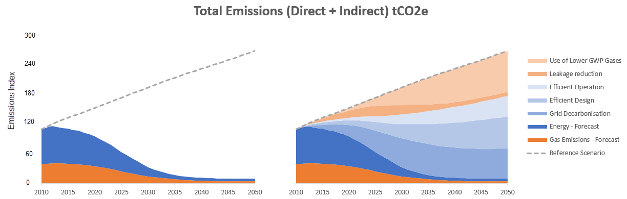
Figure 19: Modelling of Total Emissions
Figure 19 shows the combined refrigerant plus energy emissions pathway (left-hand chart) together with an indication of which actions create the emission reduction (right-hand chart). Again, please note that the y-axis scale is different to Figure 17 and Figure 18.

Modelling the GHG Benefits of Heat Pumps
Another important output from a refrigerants and energy model such as the HFC + Energy Outlook Model is an estimate of the benefits of using heat pumps to displace fossil fuel used for space heating. The stock model can include data on two types of heat pump:
- Reversible devices that can operate as air-conditioning units in hot weather and heating units in cold weather. Reversible operation is available on many types of air-conditioning equipment, such as small split units.
- Heating-only devices that are dedicated to a heating application such as space heating, domestic water heating or process heating.
The data in Figure 17 to Figure 19 includes both the direct refrigerant emissions and the indirect energy-related emissions from the heat pumps included in the stock model. These can be considered the “negative impacts” of using heat pumps. However, there are also “positive impacts” related to the fossil fuel displaced by the heat pumps. The HFC + Energy Outlook Model is able to calculate the quantity of heat being delivered annually from the heat pumps in the stock model. Assuming this heat is displacing heat provided by gas boilers it is possible to calculate the amount of fossil fuel emission that is abated through the use of heat pumps.
Figure 20 shows the abated fossil fuel emissions plotted together with the total emissions from the RACHP equipment. The abated emissions grow as the amount of heating supplied by heat pumps grows. As the electricity supply becomes decarbonised, the benefits of using heat pumps become much greater. Figure 20 shows that, for some countries, the avoided fossil fuel emissions due to the greater use of heat pumps may be significantly greater than the total future RACHP sector emissions. In the example used for Figure 20, the abated fossil fuel GHG emissions in 2050 are forecast to be over 10 times higher than the total direct and indirect and indirect GHG emissions from the whole RACHP market.
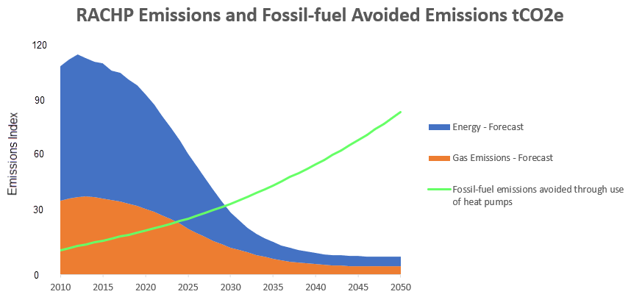
Figure 20: Modelling of Heat Pump Benefits

Overall Modelling of Carbon Footprint of RACHP
An alternative way of viewing the heat pump benefits is to consider the abated fossil fuel as an emission saving from the reference scenario. Figure 21 illustrates this. From around 2030 onwards, the net RACHP emissions fall below zero.
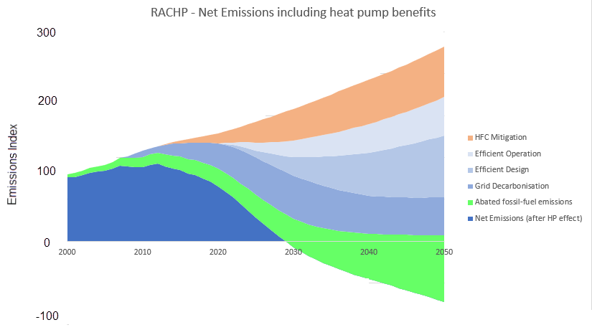
Figure 21: Modelling of Overall Carbon Footprint of RACHP

Next Steps for Modelling
With tools such as the HFC + Energy Outlook Model it is possible to develop a detailed model, building on multiple sectors of the RACHP market in individual countries, and which integrates refrigerant and energy-related GHG emissions. With a detailed model it is possible to better understand:
- The relative importance of refrigerant and energy-related emissions.
- The impact of different mitigation policy actions on emission reduction.
- The relative importance of each part of the refrigeration and air-conditioning market.
- The importance of using heat pumps to displace fossil fuel heating.
- The potential environmental benefits of faster and deeper cuts in emissions.
- The economic costs and benefits – especially important for many A5 parties who are currently rapidly increasing the stock of cooling equipment, with very long term impacts on their economies
Further efforts are required to extend the current modelling capabilities. In particular it would be very valuable for:
- Individual Parties to create a national model to help support policy development. Outputs from national models form an excellent starting point for HFC Phase-down Management Plans.
- TEAP to have access to a global model and regional sub-models to support their on-going analysis of HFC phase-down and its interaction with energy efficiency.
- For current models to be extended to include more analysis of the costs of different mitigation measures.
Parties may wish to consider asking TEAP to develop a detailed regional and world model to further assess the integration of energy efficiency and HFC phase-down measures.

A draft framework for outputs from previous TEAP and EETF Reports
- This report builds on the 2018 report in response to Decision XXIX/10 and subsequent EETF reports in response to Decision XXX/5 and Decision XXXI/7. The TEAP EETF has compiled information on relevant funding agencies, technology options, costs, availability, accessibility, and best practices for maintaining and/or enhancing energy efficiency in refrigeration, air-conditioning and heat pump (RACHP) sectors while phasing down HFCs under the Kigali Amendment.
- As part of this update and to assist parties with future planning, the EETF has proposed a draft framework to catalogue the diverse and extensive information that has been compiled in these reports and to assist Parties’ understanding. This framework considers options related to capacity-building, servicing sector, manufacturing and not-in-kind alternatives.
- Parties may wish to consider asking TEAP to further develop the draft framework to further inform the Parties as they move forward to operationalise the Kigali Amendment.
In responding to previous decisions, the TEAP EETF has compiled and reported a large amount of diverse and extensive information. Building on the 2018 report in response to Decision XXIX/10 and subsequent EETF reports in response to Decision XXX/5 and Decision XXXI/7, the EETF has compiled information on climate funding agencies, technology options, costs, availability, accessibility, and best practices for maintaining and/or enhancing energy efficiency in RACHP sectors while phasing down HFCs under the Kigali Amendment.
In order to structure the information from EETF reports more clearly, and to enable parties to utilize the information in moving forward, the EETF proposes a draft framework for consideration of the parties. The proposed framework divides the information related to EE in the context of refrigerant transition into three main components: 1) options and costs related to capacity-building, 2) options and costs related to the servicing sector, and 3) options and costs related to manufacturing. Manufacturing is further disaggregated into manufacturers that purchase key components for assembly, and manufacturers that also manufacture key components, such as compressors. A fourth component considers: 4) available information related to “not in kind” technologies. Some examples of how the previous information sits within the proposed framework are suggested below:

Options and costs related to capacity-building
Table 2.10 in the TEAP EETF 2018 report summarized capacity-building and related activities with associated cost examples (TEAP EETF, 2018). Low volume consuming countries that are technology takers (importing only) have the greatest potential to benefit from capacity building to implement policies to avoid risks associated with environmental dumping of inefficient technologies and obsolete refrigerants (TEAP EETF, 2019).
Additional cost-related information may be available based on country experience with enabling activities and training provided through the twinning workshops (Case Study 2.1).
The development of market enabling policies: In TEAP EETF Report XXX/5, the availability of efficient equipment and lower GWP technologies was found to be highest “[w]here markets and supporting policies provide clear signals towards alternative refrigerant choice, manufacturers invest in related R&D for those refrigerants while maintaining or enhancing energy efficiency.” (TEAP EETF, 2019) Policies that link efficiency requirements with policies supporting refrigerant transition, such as setting GWP thresholds, are associated with increasing access to higher efficiency and lower-GWP technologies, as observed in Europe (TEAP EETF, 2020). Earlier adoption of such policies lowers the risk of market penetration of energy-inefficient RACHP equipment that add to electricity costs and the associated build-up of expensive servicing tails of obsolete refrigerants (TEAP EETF, 2020).

Options and costs related to the servicing sector
Investment in the service sector is needed to improve familiarity and experience with alternative refrigerants and efficient technologies. It is important that affordable spare parts and replacement refrigerants are available for newly introduced equipment to ensure continuity of operation.
The impact of proper installation, maintenance, and servicing on the efficiency of equipment and systems is considerable over the lifetime of these systems while the additional cost is minimal (TEAP EETF, 2018). Appropriate maintenance and servicing practices both minimise refrigerant leak, and maintain the rated energy performance over the lifetime (2018 TEAP EETF report in response to Decision XXIX/10)

Options and costs related to equipment manufacturing
For manufacturing enterprises, technology options and costs can be further disaggregated based on whether the enterprise manufacturers key components, such as compressors, or whether the enterprise assembles equipment using purchased components.
The compressor is responsible for most of the electricity consumption in RACHP equipment, and hence will be a major factor in the energy efficiency of the system. Compressors are also designed to work with specific refrigerants. The compressor accounts for about 20% of the total manufacturing cost of AC systems (TEAP EETF, 2019).
It is important when considering costs of compressors purchased by manufacturers for assembly to distinguish between the material costs associated with higher-efficiency compressors and the “know how” involved in IP and integration of purchased compressors into a manufacturer’s assembled system.

Options for manufacturers of key components
As detailed in TEAP EETF (2019) and Chapter 2 of this report, manufacturers of variable-speed drive compressors have costs associated with: material costs for inverter, motor, controls, as well as testing facilities. As two anecdotal examples, the 2018 TEAP EETF Report presented the example of one Chinese brand where the price increase for an approximately 13-15% efficiency improvement for a 3.5 kW variable-speed AC using R-410A was about 6%. However, in this example, when both the efficiency and refrigerant were updated (i.e., from 5-8% improvement and from R-410A to HFC-32), the price increase was about 11% (Li, 2018). These gains and costs will vary according to scale and other factors.
Large-scale manufacturers of fixed speed compressors usually hold the IP for variable speed drive compressors, and in this case, there should be no additional IP costs.

Options for manufacturers using purchased components
A key cost for manufacturers using purchased components is the technical capacity and know-how to specify components and integrate the components into assembled system.
The 2018 TEAP EETF Report showed in Table 2.11 an example from India of efficiency improvement options for various components for a 5.27 kW mini-split AC with the expected energy savings from the “base case” model and their corresponding costs per unit (assuming that variable speed compressors were purchased for assembly). The analysis developed a manufacturing cost versus EE model based on the most feasible and least expensive design options available at the time. Retail and wholesale mark-ups were estimated based on this estimated manufacturing cost and the available retail price data on the market to arrive at a retail price versus EE curve.
Table 13: Efficiency improvement options, energy savings and manufacturing cost for a 5.27 kW mini-split AC in India (Shah et al., 2016)
Technology | Energy Saving Compared with Baseline | Incremental Manufacturing Cost (Rs)
Improved compressors | 5.5% - 15% | 100 – 860
Variable speed compressors | 21% - 23% | 1,800 – 8,100
Variable speed drives for fans and compressors | 26% | 3,150 – 9,450
Heat Exchanger improvement | 7.5% - 24% | 735 – 11,000
Expansion valve | 3.5% - 6.5% | 125 – 2,250

Options and costs for not-in-kind technologies
This category includes large projects, such as district cooling, as well as passive technologies that can reduce demand for cooling and refrigerant. Options and costs for not-in-kind technologies have been discussed in TEAP Decision XXVIII/5 Working Group Report (2017) and the 2018 TEAP EETF Report. Additional information on options and costs for not-in-kind technologies could be collected from stand-alone projects, development projects, and collaborations, such as the UNEP District Energy in Cities Initiative.
Parties could consider requesting the TEAP to develop this proposed framework further in future reports, to assist in understanding the benefits and costs of improving energy efficiency during the HFC phase-down.

For the consideration of Parties
An overarching conclusion of the EETF is that during the last five years, technology has developed rapidly. There is now availability of high EE/lower-GWP equipment for most market sectors. These technologies are increasingly accessible worldwide. Market examples suggest that it is possible in the right regulatory and financial environment to consider an accelerated timeline for the Kigali Amendment and the integration of energy efficiency.

References
Abdelaziz, O, Cotton, N., and Cazelles, P.. "Guidance Report on net benefits and cost for energy efficient refrigeration design options." UNIDO (2020). https://www.unido.org/cera
Abhyankar, N., Shah, N., Park, W. Y., & Phadke, A. (2017). Accelerating Energy Efficiency Improvements in Room Air Conditioners in India: Potential, Costs-Benefits, and Policies. Berkeley, California: Lawrence Berkeley National Laboratory report LBNL-1005798. Retrieved from http://eta-publications.lbl.gov/sites/default/files/lbnl-1005798.pdf
ACHR News (2020). HVAC Sees High-End Sales Boom due to COVID-19. August 10th 2020. Available at: https://www.achrnews.com/articles/143633-hvac-sees-high-end-sales-boom-due-to-covid-19.
Alvares, S.M. (2018). Desempenho térmico de habitações do PMCMV em paredes de concreto: estudo de caso em São Carlos-SP e diretrizes de projeto para a Zona Bioclimática 4 (in Portuguese). MSc Dissertation, University of Sao Paulo, São Carlos Brazil https://teses.usp.br/teses/disponiveis/102/102131/tde-26072018-160121/publico/DissCorrigidaSimoneMesquitaAlvares.pdf
ANSI/ASHRAE (2017). Standard 55 - Thermal environmental conditions for human occupancy. Atlanta, GA. https://www.ashrae.org/technical-resources/bookstore/standard-55-thermal-environmental-conditions-for-human-occupancy
Batista J, Peixoto I, Cavalcante K, Lima I, 2014. Desempenho térmico de habitação multifamiliar do programa Minha Casa Minha Vida (PMCMV) em Maceió – AL (in Portuguese). Conference Encontro Nacional de Tecnologia do Ambiente Construído. 409-418. 10.17012/entac2014.246, https://www.researchgate.net/publication/301434623_Desempenho_termico_de_habitacao_multifamiliar_do_programa_Minha_Casa_Minha_Vida_PMCMV_em_Maceio_AL/citation/download
Booten, Charles W, Nicholson, Scott R, Mann, Margaret K, and Abdelaziz, Omar (2020). Refrigerants: Market Trends and Supply Chain Assessment. United States. Web. doi:10.2172/1599577
Bureau of Energy Efficiency (2020), Impact of Energy Efficiency Measures for the year 2018-2019. Available at: https://powermin.nic.in/sites/default/files/webform/notices/e-book_on_Impact_assessment_of_various_energy_efficiency_measures_taken_during_2018_19_0.pdf
CLASP (2005). Energy-Efficiency Labels and Standards: A Guidebook for Appliances, Equipment, and Lighting, 2nd Edition.
CLASP (2018a). Technical and Economic Feasibility Study for a High Efficiency Compressor Market in Brazil. Available at: https://clasp.ngo/publications/technical-and-economic-feasibility-study-for-a-high-efficiency-compressor-market-in-Brazil
CLASP (2018b). Estudo de Viabilidade Técnica e Econômica para um Mercado de Compressores de Alta Eficiência no Brasil. Available at http://kigali.org.br/wp-content/uploads/2019/01/iCS-compressores.pdf
CLASP (2019a). Vietnam Room Air Conditioner Market Assessment and Policy Options Analysis. Available at: https://clasp.ngo/publications/vietnam-rac-market-assessment-and-policy-options-analysis-2019
CLASP (2019b). Thailand Room Air Conditioner Market Assessment and Policy Options Analysis. Available at: https://clasp.ngo/publications/thailand-rac-market-assessment-and-policy-options-analysis-2019
CLASP (2019c). Philippines Room Air Conditioner Market Assessment and Policy Options Analysis. Available at: https://clasp.ngo/publications/philippines-rac-market-assessment-and-policy-options-analysis-2019
CLASP (2020). Environmentally Harmful Dumping of Inefficient and Obsolete Air Conditioners in Africa. Available at: https://clasp.ngo/publications/environmentally-harmful-dumping-of-inefficient-and-obsolete-air-conditioners-in-africa
Dreyfus, G., Borgford-Parnell, N., Christensen, J., Fahey, D.W., Motherway, B., Peters, T., Picolotti, R., Shah, N., and Xu, Y. (2020). Assessment of climate and development benefits of efficient and climate-friendly cooling. Molina, M., and Zaelke, D., Steering Committee Co-Chairs. Available at: https://ccacoalition.org/en/resources/assessmentclimate-and-development-benefits-efficient-and-climate-friendly-cooling
The Economist Intelligence Unit (2019). The Cooling Imperative: Forecasting the size and source of future cooling demand. Available at: http://www.eiu.com/graphics/marketing/pdf/TheCoolingImperative2019.pdf
The Economist Intelligence Unit (2020). The Economic Benefits of a Clean Recovery: the Case of Energy-efficient Cooling. Available at: https://pages.eiu.com/rs/753-RIQ-438/images/EIUPPSTIMULUSPACKAGES.pdf?linkId=100000013961313
EEA (2019). Fluorinated greenhouse gases 2019: Data reported by companies on the production, import, export, destruction and feedstock use of fluorinated greenhouse gases in the European Union, 2007-2018. https://www.eea.europa.eu/publications/fluorinated-greenhouse-gases-2019
EEA (2020). Fluorinated greenhouse gases 2020: Data reported by companies on the production, import, export, destruction and feedstock use of fluorinated greenhouse gases in the European Union, 2007-2019. https://www.eea.europa.eu//publications/fluorinated-greenhouse-gases-2020
EGYPRA (2019). Promotion of Low-GWP Refrigerants for the Air Conditioning Industry in Egypt. https://wedocs.unep.org/bitstream/handle/20.500.11822/32719/EGYPRA.pdf?sequence=1&isAllowed=y
European Commission (2015). Information for technical personnel and companies working with equipment containing fluorinated greenhouse gases. https://ec.europa.eu/clima/sites/clima/files/f-gas/docs/technical_personnel_brochure_en.pdf
Fossati M, Scalco V, Linczuk V, Lamberts R. (2016). Building energy efficiency: An overview of the Brazilian residential labelling scheme. Renewable and Sustainable Energy Reviews. 65. 1216-1231. 10.1016/j.rser.2016.06.048.
Fridley, David, Gregory J Rosenquist, Jiang Lin, Li Aixian, Xin Dingguo, and Cheng Jianhong (2001). Technical and Economic Analysis of Energy Efficiency of Chinese Room Air Conditioners. Lawrence Berkeley National Laboratory. https://eta-publications.lbl.gov/sites/default/files/lbl-45550-economic-analysis-acfeb-2001.pdf
Global Leap Awards (2019). 2019 Buyer’s Guide for Outstanding Off-Grid Refrigerators. https://storage.googleapis.com/clasp-siteattachments/2019-Global-LEAP-Refrigerator-Buyers-Guide.pdf
Howarth N, Odnoletkova N, Alshehri T et al. (2020). Staying Cool in a Warm Climate: Temperature, Electricity and Air Conditioning in Saudi Arabia. Climate 2020; 8, 4; doi:10.3390/cli8010004. https://www.mdpi.com/2225-1154/8/1/4
IEA (2020). Sustainable Recovery. World Energy Outlook Special Report in collaboration with the International Monetary Fund. IEA, Paris. https:// www.iea.org/reports/sustainable-recovery
IEA (2020b). Global Energy Review 2020. April 2020. Available at: https://www.iea.org/reports/global-energy-review-2020#
IEA (2019) Cooling on the Move: The Future of Air Conditioning in Vehicles. Paris, France, International Energy Agency.
IEA (2018). The Future of Cooling, May 2018. Available at: http://www.iea.org/cooling/
IIR (2019). 38th Note on Refrigeration Technologies: The Role of Refrigeration in the Global Economy. Available at: https://iifiir.org/en/fridoc/142028
INMETRO (2020a). Ar-condicionado: Inmetro atualiza critérios para o Programa Brasileiro de Etiquetagem. (In Portuguese. Air conditioning: Inmetro updates criteria for the Brazilian Labeling Program). Brazilian National Intitute for Metrology, Quality and Technology. Available at https://www4.inmetro.gov.br/noticias/ar-condicionado-inmetro-atualiza-criterios-para-o-programa-brasileiro-de-etiquetagem
INMETRO (2020b). Portaria #234 June 29 2020. Available at https://www4.inmetro.gov.br/sites/default/files/media/file/portaria-234-29-de-junho-de-2020.pdf
INMETRO (2020c). Portaria #1, January 27 2020. Consulta Publica (in Portuguese. Public consultation) Available at http://www.inmetro.gov.br/legislacao/rtac/pdf/RTAC002618.pdf
Jacome et al. (2019). Power quality and modern energy for all. PNAS, August 2019. https://www.pnas.org/content/pnas/116/33/16308.full.pdf
JRAIA (2019). World Air Conditioner Demand by Region. June 2019. https://www.jraia.or.jp/english/World_AC_Demand.pdf
Letschert, V., Karali, N., Park, Y., Shah, N., Jannuzzi, G., Costa, F., Lamberts, R., Borges, K., Carvalho, S. (2020). The manufacturer economics and national benefits of cooling efficiency for air conditioners in Brazil. Lawrence Berkeley National Laboratory, https://ies.lbl.gov/publications/manufacturer-economics-and-national.
Letschert, Virginie E, Nihan Karali, Won Young Park, Nihar Shah, Gilberto Jannuzzi, Fernando Costa, Roberto Lamberts, Kamyla Borges, Suely Machado Carvalho. Eceee 2019 Summer Study, Belambra Presqu’île de Giens, France. Lawrence Berkeley National Laboratory. https://ies.lbl.gov/publications/manufacturer-economics-and-national.
Lin, Jiang, and Gregory J Rosenquist (2008). Stay cool with less work: China's new energy-efficiency standards for air conditioners" Energy Policy 36.3 1090 - 1095. https://dx.doi.org/10.1016/j.enpol.2007.11.019
Manu S. et al (2016). Field studies of thermal comfort across multiple climate zones for the subcontinent: India Model for Adaptive Comfort (IMAC). Building and Environment 98. doi: 10.1016/j.buildenv.2015.12.019. Available at: https://linkinghub.elsevier.com/retrieve/pii/S0360132315302171

McNeil, Michael A, Virginie E Letschert, and Robert D Van Buskirk (2007). Methodology for the Policy Analysis Modeling System. LBNL-179143. https://eta-publications.lbl.gov/sites/default/files/metholodology_for_pams.pdf
Mitsidi (2018). Kigali Project. Regulatory impact analysis: data collection phase. iCS: http://kigali.org.br/wp-content/uploads/2018/11/SET2018-webinar-2-mitsidi.pdf
Morais, JMSC (2013). Ventilação natural em edifícios multifamiliares do "Programa Minha Casa Minha Vida" (in Portuguese). PhD thesis, UNICAMP, Brazil, http://repositorio.unicamp.br/jspui/handle/REPOSIP/258057
Montenegro S (2020). Uso eficiente do ar condicionado pode economizar até 87,9 TWh. (in Portuguese: Efficient Air conditioner use can save 87.8 TWh until 2035). Canal Energia. Available at http://www.escolhas.org/wp-content/uploads/2020/07/Uso-eficiente-de-ar-condicionado-pode-economizar-879-TWh-at%C3%A9-2035-_-CanalEnergia-1.pdf
Moreno AC, (2013). Minha Casa Minha Vida: análise de desempenho térmico pela NBR 15.220-3, NBR 15.575, Selo Casa Azul e RTQ-R (in Portuguese). MSc Dissertation, Federal University of Minas Gerais, Brazil https://repositorio.ufmg.br/bitstream/1843/AMFE-9HXPCY/1/minha_casa_minha_vida_an_lise_de_desempenho_t_rmico_pela_nbr_15.220_3__nbr__15.575__selo_casa_azul.pdf
Öko-Recherche, Excerpt for Participants: Monitoring of refrigerant prices against the background of Regulation (EU) No 517/2014 Q1/2020 – June 2020. contract no.340201/2019/805240/ser/clima.a.2/0011 lot
Orsi, R, 2016. (Des) conforto térmico e qualidade de vida em conjuntos habitacionais periféricos construídos através do programa Minha Casa Minha Vida (in Portuguese). Urbanism and Architecture Faculty Alagoas Brazil – UFAL, https://fau.ufal.br/evento/pluris2016/files/Tema%204%20-%20Planejamento%20Regional%20e%20Urbano/Paper830.pdf
Park, Won Young; Shah, Nihar; Letschert, Virginie and Lamberts, Roberto. Adopting a Seasonal Efficiency Metric for Room Air Conditioners in Brazil. August 2019. Lawrence Berkeley National Laboratory, http://kigali.org.br/wp-content/uploads/2019/09/Case-Study-in-Brazil_03.pdf
Park, Won Young, Nihar Shah, Jun Young Choi, Hee Jeong Kang, Dae Hoon Kim, and Amol Phadke (2020). Lost in translation: Overcoming divergent seasonal performance metrics to strengthen air conditioner energy-efficiency policies. Energy for Sustainable Development 55 (2020): 56-68. Available at: http://www.sciencedirect.com/science/article/pii/S0973082619313560
Park W.Y., Shah N., Vine E., Blake P., Holuj B., Kim J.H., & Kim D.H. (2021) Ensuring the climate benefits of the Montreal Protocol: Global governance architecture for cooling efficiency and alternative refrigerants, Energy Research & Social Science 76 102068. Accessed at https://linkinghub.elsevier.com/retrieve/pii/S2214629621001614
Purohit, P., Höglund-Isaksson, L., Dulac, J., Shah, N., Wei, M., Rafaj, P., and Schöpp, W. (2020). Electricity savings and greenhouse gas emission reductions from global phase-down of hydrofluorocarbons, Atmos. Chem. Phys., https://acp.copernicus.org/articles/20/11305/2020/acp-20-11305-2020.pdf
Sanchez, I., Pulido, H., McNeil, M.A., Turiel, I. and della Cava, M., 2007. Assessment of the Impacts of Standards and Labeling Programs in Mexico (four products). https://escholarship.org/uc/item/0qz4b7qk
Sanchez, Marla C, Carrie A Webber, Richard E Brown, and Gregory K Homan (2007). 2008 Status Report - Savings Estimates for the ENERGY STAR Voluntary Labeling Program. LBNL-56380. https://eta-publications.lbl.gov/sites/default/files/lbnl-563802008.pdf
Sanyogita Manu, Yash Shukla, Rajan Rawal, Leena E. Thomas, Richard de Dear. (2016). Building and Environment, Volume 98, March 2016, Pages 55-70
Seidel, Steve and Ye, Jason (2016). Ten Myths about Intellectual Property Rights and the Montreal Protocol. C2ES. https://www.c2es.org/document/ten-myths-about-intellectual-property-rights-and-the-montreal-protocol/
Shah, N., Wei, M., Letschert, V. and Phadke, A. (2015). Benefits of Leapfrogging to Superefficiency and Low Global Warming Potential Refrigerants in Room Air Conditioning. Available at: https://eta-publications.lbl.gov/sites/default/files/lbnl-1003671.pdf
Shah, N., Abhyankar, N., Park, W. Y., Phadke, A., Diddi, S., Ahuja, D., Mukherjee, P.K., and Walia, A. (2016). Cost-Benefit of Improving the Efficiency of Room Air Conditioners (Inverter and Fixed Speed) in India. LBNL-1005787. https://eta-publications.lbl.gov/sites/default/files/lbnl-1005787.pdf
Shah, N., Wei, M., Letschert, V. and Phadke, A. (2019) Benefits of Energy Efficient and Low-Global Warming Potential Refrigerant Cooling Equipment, U.S.A: Lawrence Berkeley National Laboratory. https://eta.lbl.gov/publications/benefits-energyefficient-low-global.
Sherry, D., M. Nolan, S. Seidel, and S. O. Andersen. 2017. “HFO-1234yf: An Examination of Projected Long-Term Costs of Production.” Center for Climate and Energy Solutions. April 2017. https://www.c2es.org/docUploads/hfo-1234-yf.pdf.
SKM Enviros (2014), Use of Refrigeration in UK Soft Drinks Supply Chain. http://randd.defra.gov.uk/Document.aspx?Document=12085_UseofRefrigerationinSoftDrinksSupplyChainFinal.pdf
Solomon, S., Alcamo, J., Ravishankara, A.R. (2020) Nature Communications, http://www.nature.com/articles/s41467-020-18052-0
Spurlock, C. A., Yang, H.-C., & Dale, L. (2013). Energy Efficiency and Minimum Standards: a Market Analysis of Recent Changes in Appliance Eenrgy Efficiency Standards in the United States. Berkeley, California: Lawrence Berkeley National Laboratory report LBNL- 6353E. Retrieved from https://www.npd.com/wps/portal/npd/us/industry-expertise/home/
Stephen O. Andersen, Duncan Brack, and Joanna Depledge, A Global Response to HFCs through Fair and Effective Ozone and Climate Policies (London: Chatham House, 2014)
Sustainable Purchasing Leadership Council (SPLC) and the Institute for Governance & Sustainable Development (IGSD) (2020). Procurement Recommendations for Climate Friendly Refrigerants. https://www.sustainablepurchasing.org/wp-content/uploads/2020/09/2020.09.29_Climate_Friendly_Refrigerants_Action_Team_FINAL.pdf
TEAP EETF (2018). Volume 5: Decision XXIX/10 Task Force Report on issues related to energy efficiency while phasing down hydrofluorocarbons. Available at: https://ozone.unep.org/sites/default/files/2019-04/TEAP_DecisionXXIX-10_Task_Force_EE_September2018.pdf
TEAP EETF (2019). Volume 3: Decision XXX/5 Task Force Report on Cost and Availability of Low-GWP Technologies/Equipment that Maintain/Enhance Energy Efficiency. https://ozone.unep.org/system/files/documents/TEAP-TF-DecXXX-5-EE-september2019.pdf
TEAP EETF (2020). Volume 2: Decision XXX1/7 Continued provision of information on energy-efficient and low-global-warming-potential technologies. https://ozone.unep.org/sites/default/files/assessment_panels/TEAP_dec-XXXI-7-TFEE-report-september2020.pdf
TEAP (2020). Volume 1: Progress Report, May 2020. Available at: https://ozone.unep.org/sites/default/files/2020-06/TEAP-Progress-report-and-response-decXXXI-8-may2020_0.pdf
TEAP RTF (2020). Volume 3: Assessment of the funding requirement for the replenishment of the Multilateral Fund for the period 2021-2023. Available at: https://ozone.unep.org/sites/default/files/2020-07/TEAP_decision_XXXI-1_replenishment-task-force-report_may2020-corrigendum.pdf
United Nations Environment Programme and International Energy Agency (2020). Cooling Emissions and Policy Synthesis Report. UNEP, Nairobi and IEA, Paris.
UNEP (2015). FACT SHEET 2 Overview of HFC Market Sectors. Available at: https://ozone.unep.org/sites/ozone/files/Meeting_Documents/HFCs/FS_2_Overview_of_HFC_Markets_Oct_2015.pdf
UNEP (2019). Emissions Gap Report 2019. November 2019. Available at: https://www.unenvironment.org/resources/emissions-gap-report-2019.
UNEP (2019). PRAHA II: Promoting Low-GWP Refrigerants for Air-Conditioning Sectors in High Ambient temperature Countries Phase II. http://wedocs.unep.org/bitstream/handle/20.500.11822/32721/8152PRAHA-II_RRT.pdf?sequence=1&isAllowed=y
UNEP (2018). Drinks Case Study from UN Environment Workshop on efficiency opportunities in the context of phasing-down hydrofluorocarbons (HFCs), Vienna. Briefing Note B: “The Potential to Improve the Energy Efficiency of Refrigeration, Air-conditioning and Heat Pumps”
UNIDO (2020). Green Refrigeration Guidance Report, Abdelaziz et al., https://www.unido.org/sites/default/files/files/2020-07/Guidance%20Report%20on%20net%20benefits%20and%20cost%20for%20different%20energy%20efficient%20refrigeration%20design%20options%20Final%20200720.pdf
University of Birmingham (2018). A Cool World: Defining the Energy Conundrum of Cooling for All. https://www.birmingham.ac.uk/Documents/college-eps/energy/Publications/2018-clean-cold-report.pdf
Van Buskirk, Robert, Essel Ben Hagan, Alfred Ofosu Ahenkorah, and Michael A. McNeil (2007). "Refrigerator efficiency in Ghana: Tailoring an appliance market transformation program design for Africa." Energy policy 35, no. 4: 2401-2411.
Yanik, Mustafa (2019). Seven Design Changes That Reduce Refrigerant Charge. ACHR News. https://www.achrnews.com/articles/140971-seven-design-changes-that-reduce-refrigerant-charge
Zanetti, Emanuele; Azzolin, Marco; Bortolin, Stefano; Busato, Giulio; and Del Col, Davide, "Design And Testing Of a Microchannel Heat Exchanger Working As Condenser And Evaporator" (2018). International Refrigeration and Air Conditioning Conference. Paper 2033. https://docs.lib.purdue.edu/iracc/2033
Zhou, Jing; Yan, Zhiheng; and Gao, Qiang, “Development and Application of Micro Channel Heat Exchanger for Heat Pump”, 12th IEA Heat Pump Conference, 2017
- Case Studies on Best Practices
  - Institutional Arrangements & National Cooling Plans
- Institutional Arrangements in Ghana
Geography: Ghana
Policy type: MEPS development and enforcement: Interagency coordination.
Product type: All appliances
Product source: Imported
Description: In Ghana, MEPS and labelling regulation and enforcement cut across many institutions. The Energy Commission regulates energy efficiency, Ghana Standards Authority develops the MEPS, and Environmental Protection Agency regulates refrigerants. In addition, Ghana Revenue Authority (Customs Division) are responsible for enforcement of the refrigerant and energy efficiency requirements at the ports of entry. The Energy Commission’s success is determined by inputs by Ghana Standards Authority, Environmental Protection Agency and Ghana Revenue Authority (Customs Division) and its adoption of a “system leadership” approach, whereby the Energy Commission becomes a fulcrum around which all the relevant institutions revolve in order to show the strategic direction. There is a joint management committee between the Energy Commission and Ghana Standards Authority where standards development and enforcement issues are discussed periodically. The Energy Commission is represented on the National Committee on Ozone Depleting Substances phase out anchored at Environmental Protection Agency, where refrigerant issues are discussed. These arrangements help the Energy Commission to be apprised of developments so that its decisions on future MEPS are made from informed positions. The Energy Commission serves as a champion institution with champion individuals who do networking to get the needed buy in of other institutions.
The Energy Commission forms project steering committees that cuts across all the sectors, for projects implementation. The project steering committees are made up of representatives of the public and private sector agencies, NGOs, Civil Society Organizations and the Security Agencies. Formal and informal approaches are used to get senior officials from the sectors on the steering committees. These individuals are used to gain the buy in of their respective organizations after being exposed to the bigger picture. This setup has been very successful in bringing the ozone and energy departments together. The Energy Commission relies on the Environmental Protection Agency to intensify their regulation; phasing down of ODS and promoting of refrigerants that are ozone friendly and have a positive impact on EE, so that eventually will achieve better EE.
Additional Insight and Lessons learned
The individuals who serve on the steering committees serve as gatekeepers for the Energy Commission to access their respective organizations with minimum effort and by so doing, indirectly represents the interest of the Energy Commission in those organizations. They become the agents of the Energy Commission’s strategic direction in their respective organizations. The tendency for turf protection, which is common in the public service, is minimized significantly, as institutions become receptive, especially when they are recognized as important.
- India Cooling Action Plan
Geography: India
Policy type: Cooling Action Plan, long-term policy guidance over the next 20 years. The overarching goal of the ICAP is to provide sustainable cooling while securing many environmental and socio-economic benefits. The ICAP harmonizes energy efficiency of HVACR appliances with refrigerant transition pathways for enhanced climate action, as agreed in the 39th Meeting of the Parties to the Montreal Protocol.
Product type:
- Space cooling in buildings: Room ACs, chiller systems, VRF systems, packaged DX, fans, air coolers, and not-in-kind low energy cooling technologies
- Mobile AC: Passenger road transport vehicles (light and heavy) and the railways
- Cold-chain & refrigeration: Pack houses, cold storages, ripening chambers, reefer vehicles, domestic and commercial refrigerators
Product source: Imported and domestic
Description: The ICAP is formulated against the background of India’s growing cooling demand - India has one of the lowest access to cooling across the world but the growing population, increasing per capita income and urbanization will drive significant increase in cooling demand in the future. The ICAP recognises that while India’s cooling growth is in alignment with its developmental needs and drive for Sustainable developmental Goals, this growth comes with significant power-system and environmental impacts. In the ICAP, a thorough data-driven assessment of the current and future cooling demand, under different scenarios (business-as-usual and intervention scenarios), was carried out, which constituted the foundational logic behind the recommendations and priority areas of the ICAP. A previous study commissioned by the Indo-German Energy Forum (IGEF), and conducted by Alliance for an Energy Efficient Economy (AEEE) on the nationwide cooling demand assessment, across cooling sectors, for 2017 and 2027, was an important pre-ICAP resource that informed the development process significantly [3]. The mapping of different cooling segments, appliance and equipment penetration along with their energy consumption estimates - either from sales data or through any other national surveys, nationwide energy consumption and associated GHG emissions, helped create a starting point for baseline characterisation of the cooling and refrigeration sector across major end-use segments (space cooling, cold chain and refrigeration, mobile air conditioning, industrial cooling, etc.). It was very important in adopting an ambitious and comprehensive approach during the development of the India Cooling Action Plan. The ICAP charts the suggested future pathway for each of the cooling consumption sectors and the associated sectors, in steps of short (2022-23), medium (2027-28) and long-term (2037-38) recommendations, wherein the short-term recommendations are immediately actionable, and the long-term recommendations can be revisited as and when more rigorous information emerges that warrants a change of direction/pace. There was a concerted effort to dovetail the ICAP recommendations with ongoing government policies & programs so that the ICAP has a better chance of realizing its goals.
Enabling institutional infrastructure and capabilities: The ICAP was developed under the aegis of the Ozone Cell of the MoEF&CC using a multi-stakeholder engagement framework, comprising 6 working groups. A steering committee provided oversight during the development of the ICAP, and an inter-ministerial governance committee at the apex level helped achieve cross-sectoral integration & synthesis of the ICAP recommendations & targets. The ICAP includes preliminary guidance on the ICAP implementation governance structure: for example, the already existing Inter-ministerial Empowered Steering Committee for the implementation of the Montreal Protocol approved by the Union Cabinet could be additionally tasked with the overseeing the implementation of the ICAP; and the Ozone Cell, MoEF&CC can be strengthened and additionally tasked to act as a Cooling Secretariat in order to provide support to the Empowered Steering Committee and coordinate actions emerging from ICAP.
Additional insights and lessons learned:
Key success factors in the ICAP development process
- One nodal driving entity: The Ozone Cell of MoEF&CC was the nodal government entity which had the ‘ownership’ of driving the ICAP development and ensured inter-ministerial coordination and engagement.
- A collaboration framework to ensure multi-stakeholder engagement: The ICAP multi-stakeholder engagement framework, comprising 6 working groups, saw active representation from the triple sector, i.e. the public sector, private sector, and civil society & academia; the process was highly consultative and iterative to striving for a robust and actionable way forward.
- Living document: The ICAP is a living policy document that lends itself to future changes and amendments as and when more rigorous data/information emerges that warrants a change of direction/pace.
References and web-links:
[1] https://pib.gov.in/PressReleaseIframePage.aspx?PRID=1568328
[2] Ministry of Environment, Forest & Climate Change (2019). India Cooling Action Plan. New Delhi: Ministry of Environment, Forest & Climate Change.
[3] Kumar, S., Sachar, S., Kachhawa, S., Goenka, A., Kasamsetty, S., George, G. (2018). Demand Analysis of Cooling by Sector in India in 2027. New Delhi: Alliance for an Energy Efficient Economy.
Data/visualisation:
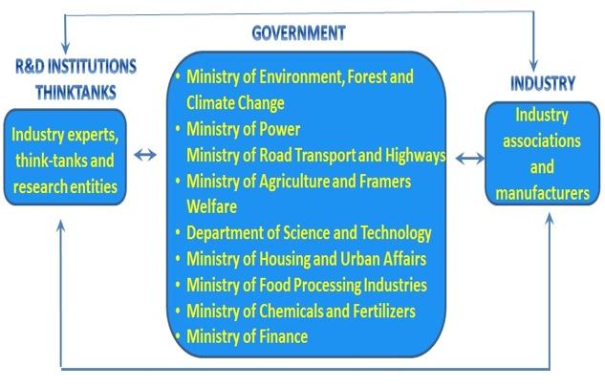
Figure 22: Interlinkages with ongoing initiatives that intersect with cooling
- China Green and High-Efficiency Cooling Action Plan
Geography: China
Policy type: national cooling action plan
Product type: all cooling
Product source: all
Description: On 13 June 2019, China released its Green and High-Efficiency Cooling Action Plan (绿色高效制冷行动方案). The Plan aims to achieve the following targets by 2030: (a) increase the cooling energy efficiency of large-scale public buildings by 30%; (b) improve overall cooling energy-efficiency levels by more than 25%; and (c) raise the market share of green and high-efficiency cooling products by more than 40%. Achieving these targets would yield annual electricity savings of 400 TWh. The Plan also describes key cooling-related priorities for China, including:
- Strengthening energy efficiency standards by 2022 with improvement targets of 30% for residential AC, 40% for variable refrigerant flow (VRF) systems, 20% for refrigerated display cabinets, and 20% for heat-pump water heaters. The Plan encourages continued improvement by targeting a further increase by more than 15% for cooling products by 2030. The Plan also calls for accelerating the promulgation and amendment of product and safety standards to promote the deployment of low-GWP refrigerants.
- Expanding the supply of green and high-efficiency cooling products, including through increased research on and development of low-GWP and high-efficiency refrigerants.
- Promoting green and high-efficiency cooling product consumption, including through government and enterprise green procurement.
- Advancing energy-saving transformations, including through demonstration projects involving retrofits of central air-conditioning systems, energy efficiency upgrades to data-center cooling systems, cooling-system retrofits for zones and parks, and upgrades of cold-chain logistics.
- Deepening international cooperation, including on hydrofluorocarbon (HFC) phaseout pursuant to the Montreal Protocol and on the promotion of green and high-efficiency cooling for all, in both domestic and export markets, through mechanisms such as the Belt and Road Green Cooling Initiative.
China has taken steps to implement the Plan with revisions to residential AC MEPS (Minimum Allowable Values of the Energy Efficiency and Energy Efficiency Grades for Room Air Conditioners, GB 21455-2019) that transitions to a single label and seasonal metric for both variable and fixed speed ACs, which will increase access to efficient and affordable variable speed ACs and heat pumps. Plans are underway for a further strengthening of the residential AC MEPS to meet the Plan’s aforementioned residential AC improvement target of 30% by 2022. VRF MEPS revisions are underway (Minimum allowable values of the energy efficiency and energy efficiency grades for multi-connected air-condition (heat pump) units (Draft for Comments)). The recently proposed draft ODS and HFC regulation (Regulation on the Administration of Ozone Depleting Substances and Hydrofluorocarbons (Draft Amendment for Comments)) 32F provides an additional opportunity for alignment and coordination to expand the supply and demand for low-GWP and high-efficiency cooling products, as called for in the Plan.33F
Enabling institutional infrastructure and capabilities: The Plan was developed through an interagency working group and was jointly issued by seven Chinese ministries: the National Development and Reform Commission, Ministry of Industry and Information Technology, Ministry of Finance, Ministry of Ecology and Environment, Ministry of Housing and Urban-Rural Development, State Administration for Market Regulation, and National Government Offices Administration.
Additional insights and lessons learned: The revision of China’s room AC efficiency standard, which started with stakeholder consultations in 2017 and went into effect in July 2020, has coincided with an over 30% decrease in the weighted-GWP of domestic sales between 2015 and 2020 (Figure). This indicates that manufacturers recognize the benefits of redesigning their products for both energy efficiency and refrigerant transition.
References and web-links:
- China’s Green and High-Efficiency Cooling Action Plan and the associated transmission circular are available at: https://www.ndrc.gov.cn/xxgk/zcfb/tz/201906/t20190614_962461.html; with translation available here: http://www.igsd.org/wp-content/uploads/2019/07/ENG-China-Cooling-Action-Plan.pdf
- Residential AC MEPS (Minimum Allowable Values of the Energy Efficiency and Energy Efficiency Grades for Room Air Conditioners, GB 21455-2019) available at: http://openstd.samr.gov.cn/bzgk/gb/newGbInfo?hcno=BC04CDC71AD8C36B62C0FF4AE58F633C
- Draft VRF MEPS (Minimum allowable values of the energy efficiency and energy efficiency grades for multi-connected air-condition (heat pump) units (Draft for Comments)) available at: https://www.cnis.ac.cn/bydt/bzyjzq/gbyjzq/202004/t20200421_49776.html
Data/visualization: The weighted-GWP of room ACs sold in China’s domestic market has decreased over 30% between 2015 and 2020, as manufacturers have transitioned from HCFC-22 and R-410A to HFC-32. In 2020, room AC using HFC-32 made up 55.5% of domestic sales. (Source: ChinaIOL)
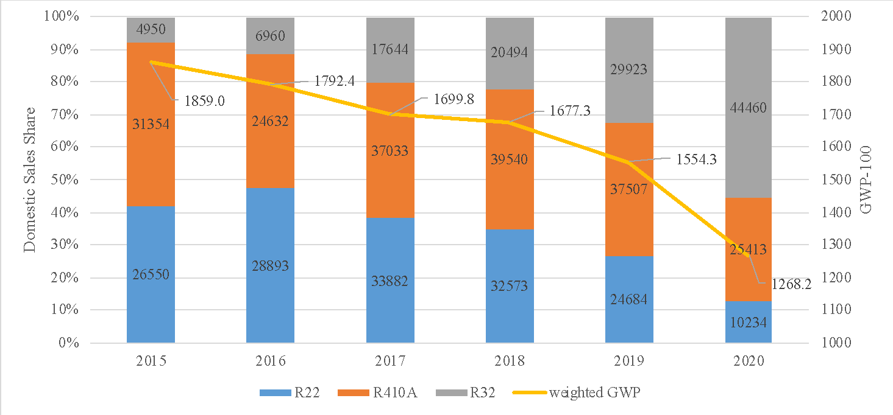

- National Cooling Action Plans
Geography: Multiple
Policy type: National Cooling Action Plan (NCAP)
Product type: All appliances
Product source: All
Description: One of the outcomes of the Kigali Amendment approval was the development of actions towards the adoption of sustainable refrigeration strategies by the Parties. K-CEP in conjunction with the implementing agencies established a program to support the development of NCAPs for A5 parties where they have supported more than 25 countries in the development of a NCAP.
The main goal is to elaborate a strategy to drive a transition to more sustainable cooling solutions, linking Montreal Protocol to climate protection efforts, taking into consideration energy efficiency and HFC phase down to support countries’s sustainable development goals. NCP benefits include the first step for the development of HFC plans.
See Table 11 for a current list of countries with activity on NCAPs.
NCAPs integrate existing climate, energy, or development plans, and link to existing energy and environmental policies. In this way, the HCFC phase-out management plan (HPMP) has an important role in the NCAPs.
The first NCAPs did not follow a rigid format. An NCAP methodology was developed in 2021 (see Case Study 1.7). The plan generally provides an overview of several cooling sectors including the RACHP sector, cold chain, transport, with a focus on one or two priority sectors. This overview is informed by surveys, contacts with stakeholders, information in HPMPs, modelled scenarios, trends and country basic needs. The NCAPs also provide a set of recommendations to address cooling demand.
In general, the main topics addressed in the documents are:
- Overview of the RACHP sector, presenting the most important RACHP applications for the country
- Information about the main factors driving future cooling demand in the country (e.g. population, household growth, GDP per capita, urbanization)
- Overview of the Energy sector and the existing regulations related to the RACHP sector
- Roadmaps and timetables to adopt enhance Minimum Energy Performance Standards, particularly for room ACs, heat pumps and residential refrigerators (also relevant for fans and related products)
- Links to the countries’ existing policies, refrigerant transition plans, Nationally Determined Contributions, etc.
- Identification of potential to use financial mechanisms, such as older appliance replacement incentive programme, bulk procurement, to address first cost barriers
- References to addressing cooling demand through building codes, cool roofs, shading, etc.
- References to the RACHP service sector. Improvement of EE through appropriate, installation, operation, and maintenance
- Identification of barriers for EE low-GWP equipment penetration in the market
- HPMP links (data, RACHP sector characterization, service sector)
- Cold chain enhancements
- Development of a plan of actions (projects) to be implemented
The NCP is based on a multidisciplinary approach. The National Ozone Units (NOU), is the focus for the NCP development, but it involves the creation of a governmental group integrating NOU and Energy and Climate areas. NCP was instrumental for the establishment of a link and common interests between NOU (generally in the Ministry of Environment) and Energy groups (Ministry of Energy). The results achieved so far are positive: Each country, somehow, established a model of work. Many hired a national consultant that is responsible for the interaction with the areas involved in the NCP elaboration. Other countries, in addition to the consultancy, created a group formed by NOU and people from energy area, from government and outside.
- Rwanda National Cooling Strategy
Geography: Rwanda
Policy type: National Action Cooling Plan (NCP) inclusive of: MEPS and labels (mandatory, EE and GWP), funding and finance, MVE, end of product life management, awareness raising.
Product type: Room Air Conditioners, Refrigerating Appliances, and overall system-scale strategies
Product source: Imported
Description: The National Cooling Strategy (NCS) was developed by the Government of Rwanda, U4E and a range of stakeholders based on the finding of a national market assessment and review of local and international best practices. It was championed by the Ministry of Environment, adopted by the Cabinet of interagency ministries, and published in June 2019. The drafting was achieved in 14 months and the activity was supported by K-CEP with a range of funding of USD 139’000 on average. The NCS underscores the Rwandan Government’s intent to demonstrate leadership and fast action in the Kigali Amendment and energy efficiency arenas. The NCS provides a comprehensive policy framework that is guiding the country’s transition to more energy-efficient and climate-friendly cooling. Recommendations range from large strategic opportunities to targeted policy interventions.
The first section provides context on the purpose of the strategy, it’s scope and the importance of cooling action in the global and national context. The document explores international commitments and technology trends that impact cooling. It includes an overview of the national energy sector and presents the results of the cooling market assessment. The second section outlines the national aim to undertake a comprehensive approach to market transformation through a range of voluntary and mandatory approaches, though it is largely focused on the built environment and further considerations for the transport sector, for example, are only noted at a high level.
MEPS and labelling for refrigerating appliances and room air conditioners are an illustrative example of policy interventions identified in the NCS. The requirements were developed by tailoring the U4E Model Regulation Guidelines using Rwanda’s market assessment findings and undertaking consultations with civil society and industry representatives. Rwanda will be the first country to officially apply the Guidelines in a regulatory fashion, with entry into force slated for January 2021. The following steps have been taken towards implementation:
- Awareness campaign: The awareness campaign strategy was developed and will start to be implemented by U4E and REMA from August 2020. Both are contributing to the budget for specific activities.
- Inclusion in the 2020/2021 action plan for both the Ministry of Environment and the Ministry of Infrastructure/Energy.
- Launch of an expression of interest to recruit a staff that will support with the implementation of the MEPS.
- Setup of a new institution for the enforcement of the MEPS as of January 2021. the new institution will ensure monitoring and verification of products entering into Rwanda.
- Development of a product registration system for market monitoring that will help to control entry of ACs and Refrigerators as well as refrigerants.
- Involvement of retailers and importers at the beginning of the NCS. Contact with these stakeholders is maintained to ensure that they will start to import compliant products.
The Government intends to share its experience with other countries in the East African Community, and more broadly, to inspire similar action and consistent approaches across markets.
In addition, the strategy covers financial mechanisms to address first cost and other barriers to adoption, collection and recycling of products that have reached the end of useful life, integration of HPMP and energy efficiency considerations, and calling for the optimization of cold chain and off-grid cooling infrastructure, among others.
Enabling institutional infrastructure and capabilities:
Each of the key elements of the NCS was developed based on recommendations gathered in consultations and informed by lessons learned from other markets. Inter-organisational collaboration is illustrated by the negotiated approach in which MEPS and labelling will be enforced by the Rwanda Standards Board upon market entry, in consultation with refrigerants oversight by Rwanda Environment Management Authority (REMA). Integrated efforts on such cross-cutting programmes are reinforced by the Cabinet-level authorization of the NCS, which entails ministers from across relevant agencies.
Financial mechanisms similarly cut across organisations and require collaboration for effective implementation. An on-bill financing scheme that is being developed as a result of the NCS will be implemented by commercial banks that offer loans to consumers through the utility company. Local stores install eligible products (efficiency and refrigerant criteria overseen and enforced through REMA based on the high-performance criteria in the U4E Model Regulation Guidelines) for participating customers, the utility collects the loan repayment through the electricity bill, and the bank loan is repaid over time.
Additional insights and lessons learned:
Rwanda has some of Africa’s fastest growth in expanding electrical grid connections with a goal of 100% electricity access by 2024. The country has a vision to become a developed, low-carbon economy by 2050, and more sustainable cooling is understood to be critical in realizing that vision.
Launch of African Centre of Excellence for Sustainable Cooling and Cold Chain:
Building off of the National Cooling Plan, which called for the optimization of cold chain and off-grid cooling infrastructure, the Governments of Rwanda and the United Kingdom, the United Nations Environment Programme’s United for Efficiency (UNEP U4E) initiative, the Centre for Sustainable Cooling, and a range of academic institutions launched the Africa Centre of Excellence for Sustainable Cooling and Cold-chain (ACES) in October 2020. Hosted by the University of Rwanda (UR) in Kigali, ACES will create a roadmap to net zero cold-chain and cooling, driving the adoption and uptake of energy efficient and climate friendly solutions and providing applied research, teaching and industrial collaboration to put into action integrated sustainable cooling solutions. ACES aims to show farmers and fishers how to reduce post-harvest food losses, protect quality and value and get their goods to market, whilst ensuring the wider community has access to life-saving vaccines, domestic cooling, and properly cooled community services. Living Labs in strategic locations across Africa will act as the deployment and implementation arms showcasing how such solutions can be used by communities.
The work of ACES also strongly supports the aims of the Rome Declaration on the Contribution of the Montreal Protocol to Food Loss Reduction through Sustainable Cold Chain Development. In particular the work will help in the exchange of knowledge and promotion of innovation of energy-efficient solutions and technologies that reduce the use of HFCs in the development of the cold chain, thereby contributing to the reduction of food loss and waste.
References and web-links: RNCS and African Centre of Excellence for Sustainable Cooling and Cold Chain
- http://www.fonerwa.org/sites/default/files/Rwanda%20National%20Cooling%20Strategy.pdf
- UNEP release, https://www.unenvironment.org/news-and-stories/story/rwandas-ambitious-plan-clean-and-efficient-cooling
- KCEP Annual report, https://www.k-cep.org/year-three-report/
- https://united4efficiency.org/resources/african-centre-of-excellence-for-sustainable-cooling-and-cold-chain/
Data/visualization:
Table 14: Projection of market transformation through the On-bill Financing.
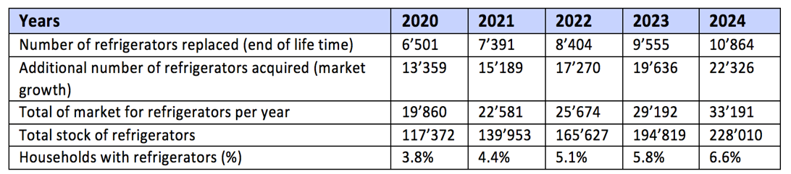
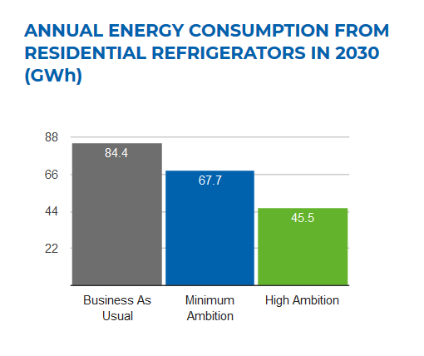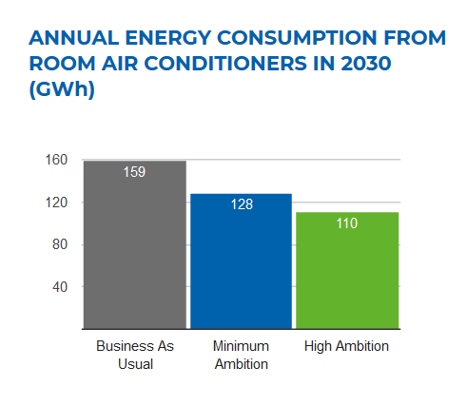
Figure 23: Country Savings Assessment conducted by U4E for ACs and refrigerators
- Mexico Roadmap to Implement the Kigali Amendment
Geography: Mexico
Policy type: Roadmap to Implement the Kigali Amendment in Mexico
Product type: Public Policy Instrument
Description: In May 2019, Mexico presented its Roadmap to implement the Kigali Amendment, a document that presents the way forward to comply with the commitments derived from the Kigali Amendment, and which is based on the national diagnosis on use, consumption and sector distribution of HFCs. In addition, it takes into account the results of the analysis of the national legal framework for the control of the consumption of substances regulated by the Montreal Protocol and its amendments.
The Roadmap includes public policy instruments that promote energy efficiency in the refrigeration and air conditioning sector, as well as the availability of environmentally friendly and highly energy-efficient technologies. Likewise, it was designed with a sectoral approach establishing short, medium and long-term actions with the aim of meeting the reduction goals to which Mexico has committed itself.34F
Additionally, the Road Map will contribute to the fulfilment of the mitigation goals established as a Nationally Determined Contribution within the framework of the Paris Agreement, at the same time that it promotes the creation of synergies with other agendas of national relevance in terms of energy efficiency and management of waste.
Since the signing of the Montreal Protocol, Mexico has fulfilled its commitments in advance. Currently, the consumption of CFCs, carbon tetrachloride (CTC), halons and methyl bromide (MeBr), as well as a large part of HCFCs, has been definitively phased-out. With these actions, by 2018, 99% of the ODS were phased-out in Mexico.
In this way, through the Kigali Amendment, Mexico has made a commitment to reduce 80% of HFCs by 2045, taking into account the levels of its baseline calculated as the average consumption of HFCs in the period 2020 through 2022, adding 65% of the HCFC baseline. The following table shows the Kigali Amendment schedule for Mexico:
Table 1. Kigali Amendment Schedule for Mexico.
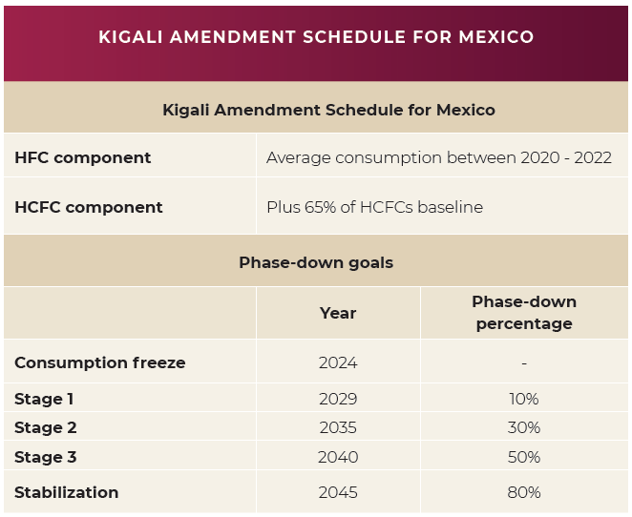
The roadmap to implement the Kigali amendment in Mexico also considers the integration of different national policy agendas, among which are: the national climate change policy and the national energy efficiency policy. It also considers the fulfilment of 5 sustainable development goals promoted by the United Nations.
Based on the above, the pillars of public policy that underpin the reduction of HFCs in Mexico for the fulfilment of its commitments during the next decade are: 1) Regulation, 2) Strategic planning, 3) Implementation and 4) The reporting and verification; elements that combined with the HFC consumption baseline, lead to the identification and prioritization of specific measures for each sector, leading to the following transition plan for each of the sectors that consume HFCs.
References and web-links:
- https://www.gob.mx/semarnat/documentos/hoja-de-ruta-para-implementar-la-enmienda-de-kigali-en-mexico
- http://dsiappsdev.semarnat.gob.mx/datos/portal/publicaciones/2019/Roadmap_EK_English_May_2019.pdf
- National Cooling Action Plan Methodology
Geography: Global
Policy type: On World Ozone Day in 2019, the UN Secretary-General António Guterres released a message calling upon countries to develop National Cooling Action Plans (NCAPs) to deliver efficient and sustainable cooling and bring essential life‐preserving services like vaccines and safe food to all people while driving climate action. Many countries are developing National Cooling Actions Plans (NCAPs) to coordinate action on energy efficiency with refrigerant transition, and to proactively address their growing cooling needs while reducing the climate impact of cooling practices, improving access to cooling and addressing several Sustainable Development Goals. Several of these NCAP pioneers have joined forces within the framework of the Cool Coalition with the goal of creating a NCAP Methodology. The NCAP Methodology has been developed by the Alliance for an Energy Efficient Economy (AEEE) in collaboration with and under the leadership of UNEP and UN ESCAP, and built on the expertise of the Cool Coalition’s NCAP Working Group facilitated by K-CEP. The NCAP Methodology is a uniform guide map for NCAP development that can be readily adapted to fit a country’s specific context and priorities. The Methodology charts a holistic but modular process for the development of NCAPs that covers cooling comprehensively, including various sectors and end-uses, and considers access to cooling for all.
Product type: The NCAP Methodology is comprehensive in its scope and advocates covering the full range of cooling consumption sectors and associated cooling sectors. Given below is an indicative––or most typical list of product types covered under the NCAP for the commonly applicable cooling consumption sectors:
- Space cooling in buildings: Room ACs, chiller systems, VRF systems, packaged DX, fans, air coolers, and not-in-kind low energy cooling technologies
- Mobile AC: Passenger road transport vehicles (light and heavy) and the railways
- Cold-chain & refrigeration: Pack houses, cold storages, ripening chambers, reefer vehicles, domestic and commercial refrigerators
Product source: The NCAP Methodology does not explicitly detail its applicability in terms of product sources – however, given the global applicability of the NCAP Methodology, it can be correctly assumed to apply to all commercially available cooling equipment that are likely to be used to meet the growing cooling demand in several countries.
Description: The intent of the NCAP Methodology is to outline a process that is within the reach of most countries today and can enable immediate and prioritized actions towards efficient and climate-friendly cooling. The proposed process for the NCAP development has two distinct elements:
- NCAP Methodology: An overarching Methodology lays out the sequence of steps and activities involved in the NCAP development, including guidelines, good practices, and available resources where applicable. The Methodology consists of three sequential stages––Contextual Assessment and Planning, Cooling Demand Assessment, and Synthesis and NCAP Creation––with each stage consisting of respective steps with progressive activities (figure 1).The Methodology can be customized and ‘owned’ by each country, specific to their priorities and unique context, and will cover guidelines for the entire range of activities a country should undertake - from the initial country assessment to the final development of the NCAP recommendations.

Data/visualisation:
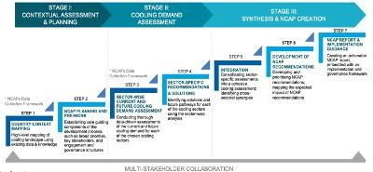
Figure 1: A Holistic Methodology for NCAP Development
- Data Assessment Framework: Data analysis is an integral and vital aspect of the NCAP Methodology. To adequately support this aspect, the Methodology includes a toolkit of Data Assessment Frameworks, one for each of the commonly applicable cooling consumption sectors––Space cooling in buildings; Food cold-chain; Healthcare cold-chain; Mobile air-conditioning; and Industrial process cooling. The Frameworks provide directional––rather than prescriptive–– guidance on the data analysis, identifying the key data inputs that can be used to estimate the current and future cooling demand and its impacts, and different pathways that the countries could adopt to go about the calculations.
Adaptability is foundational to the Methodology enabling countries high levels of discretion and flexibility to adapt to their unique context and needs characterized by national objectives, priorities, and development goals, the availability and quality of data, expertise, and resources. For addressing the cooling needs, the Methodology advocates an integrated approach – such an approach can most optimally address the cooling needs while maximizing the potential benefits through integrative effects. This approach calls to:
- First, reduce the cooling loads to the extent possible. Such as, through thermally efficient building design and construction, and passive cooling practices in case of the building sector
- Then, serve the cooling loads efficiently. Such as, with appropriate and efficient cooling equipment and solutions that deliver the required amount of cooling with less energy and lower overall emissions
- And, optimize the cooling operations and behaviors. Such as, through good O&M practices, user adaptations etc. to ensure that cooling is delivered only to where and when it is needed
Enabling institutional infrastructure and capabilities: Within the framework of the Cool Coalition, experts from around the world collaborated––as an NCAP Working Group––to develop an NCAP Methodology that looks at cooling in a comprehensive manner to ensure growing cooling demand can be met more sustainably by countries around the world. The Cool Coalition NCAP Working Group is facilitated by Kigali Cooling Efficiency Program (K-CEP), and the NCAP Methodology development is being undertaken by the AEEE in collaboration with and under the lead of ESCAP and UNEP as host of the Cool Coalition Secretariat. AEEE brings meaningful institutional knowledge from the India experience in developing its cooling action plan, which is a major building block of this work. Other important building blocks are the Needs Assessment approach formulated by Sustainable Energy For All (SEforALL) as well as the 29 NCAPs in development by multiple entities who are a part of the Cool Coalition Working Group. In addition to the core team of UNEP, ESCAP, K-CEP and AEEE, the Working Group consists of: Birmingham University /Heriot Watt University, CLASP, Energy Foundation China, GIZ, OzonAction, SEForALL, UNDP, United For Efficiency, and the World Bank Group.
Additional insights and lessons learned: At the moment, the NCAP Methodology is in the finalization stage, and is simultaneously being piloted for the NCAPs development in Cambodia and Indonesia. Some key lessons learned during the NCAPs completed thus far, and that are being reinforced during this process are:
- It is important to have one nodal government entity, early on in the process, that takes the ‘ownership’ of driving the NCAP development and ensuring inter-ministerial coordination and engagement. Often this has been the National Ozone Unit which usually holds the knowledge of the cooling sector, because of the work with Montreal Protocol but in other cases, it has been the Climate or Energy Efficiency bodies who have taken the lead.
- Given the cross-cutting and diverse areas of cooling, a collaboration framework to ensure multi-stakeholder engagement through the NCAP development process is important and ensures integrative solutions and synergies.
- When it comes to data, prioritization of the essential data elements is key –– too much detail can be counterproductive causing confusion and even resistance among stakeholders.
- The NCAP should be a ‘living’ document lending itself to future revisions as and when new information or technologies emerges that warrant a change of direction or pace.
Key References and web-links:
- Ministry of Environment, Forest & Climate Change (2019). India Cooling Action Plan. New Delhi: Ministry of Environment, Forest & Climate Change.
- Cooling for All Needs Assessment; a tool jointly created by Cooling for All Secretariat at Sustainable Energy for All and Heriot-Watt University; https://www.seforall.org/cooling-for-all/needs-assessment
- www.coolcoalition.org/
- Cooling in the context of COP26 and updated Nationally Determined Contributions (NDCs)
Geography: Global
Policy type: Technical support and consultations for including cooling-related measures in the 2020 NDC updates
Product type: Nationally Determined Contribution
Description: Nationally Determined Contributions (NDCs) are the main channel for countries to define national commitments undertaken under the Paris Agreement. Parties have agreed to prepare new/updated NDCs and communicate these to the UNFCCC secretariat prior to the 26th Conference of Parties. This is an opportunity for parties to increase ambition on climate action, increase the transparency of their commitments and expand the scope of sectors that will contribute to their targets35F. As of April 2021, “22 NDCs – representing 48 countries – have featured cooling commitments or reference to it, with at least seven countries signalling they will include action on climate-friendly cooling in their NDC when they go to print" according to an assessment by K-CEP.36F
Through energy-efficient and climate-friendly cooling, countries can avoid as much as 460 billion tonnes of greenhouse gas emissions – roughly equal to eight years of global emissions at 2018 levels – over the next four decades (see IEA and UNEP Cooling Emissions and Policy Synthesis report).
Technical support is needed from the expert community as cooling has not been often discussed within the climate change departments at country level. Several initiatives have been established to provide a platform to support countries in the NDC update process such as the NDC Partnership and the World Bank’s NDC Support Facility. UNEP and UNDP among others respond to technical requests by countries to inform their processes.
K-CEP’s NDC Support Facility for Efficient, Climate-Friendly Cooling was launched in 2020 to provide funding and guidance to organizations supporting governments that want to integrate energy-efficient and climate-friendly cooling solutions into their NDCs. The facility has developed 10 case studies (see link below).
In addition, as part of the UK COP26 presidency, a new effort is being launched to promote equipment efficiency. The UK-IEA Product Efficiency Call to Action aims to work with governments to rapidly raise the ambition of appliance policy using all available tools through the Super-Efficient Equipment and Appliance Deployment (SEAD) initiative. For some this will mean raising minimum energy performance standards, while for others this will involve making incentives available; each government will choose the best way for their economy to drive ambition and to signal a pathway for the next ten years. These pathways can be extension or complements to existing plans under development, such as national cooling plans, or delivering Nationally Determined Contributions. SEAD will support governments by providing an international platform for global and regional exchanges on policymaking for product energy efficiency including technical support, tracking progress and also developing new implementation models, for example digital approaches to appliance policies.
Links:
- https://k-cep.org/insights/news/ndc-support-facility-awardees-announced/
- 10 case studies: https://www.k-cep.org/wp-content/uploads/2021/05/K-CEP-Enhancing_NDCs_Brief.pdf
  - Best practices in national and regional capacity building
- Twinning Workshop
Geography: Global
Programme type: Twinning capacity building of National Ozone Officers and Energy Policymakers on Energy-Efficient and Climate-Friendly Cooling.
Description: UNEP U4E and OzonAction co-convened unprecedented Twinning capacity building of National Ozone Officers (NOO) and senior national energy officials (NEP) on sustainable cooling solutions in 2018 and 2019. The aim was to address the lack of awareness and resources for officials on why and how to simultaneously address refrigerant and energy efficiency opportunities in the cooling arena and drive collaboration across energy, environment and other agencies so that the refrigerant transition of the Kigali Amendment could be paired with improvements in energy efficiency and conservation. Workshops were organised according to 8 regions, with an interactive approach and a mix of presentations by a variety of local and international experts. They presented data and information, demonstrated technologies, and conducted exercises within governments by the national counterparts and across countries to identify priority actions to undertake. 160 NEPs and 261 NOOs participated from more than 140 countries.
Enabling institutional infrastructure and capabilities:
The 2018 Twinning set the stage on why sustainable cooling solutions matter. The first step was getting NEPs and NOOs acquainted with their respective remits and the context in which they operate, as many had never met prior to the Twinning and had limited experience with linking refrigerants with efficiency and energy conservation. It was conducted in each of the regions. Sessions included an introduction to energy efficiency for NOOs and an introduction to the Montreal Protocol for NEPs, a technology overview and live equipment demonstration, policy overview, resources for implementation and opportunities for regional collaboration. Introductory, scene-setting reports were shared, including case study examples, Policy guides on Accelerating the Global Adoption of Energy-Efficient Air Conditioners and Refrigerators, and OzonAction Factsheets.
The 2019 Twinning focused on how to action, with prioritisation of near-term and medium-term actions at a country and regional level, building upon the foundational insights of the 2018 session. Each of the 8 regional groups met in parallel sessions in Paris. Capacity building was conducted by over 30 international experts that rotated to each of the regions. Topics included: regional alignment on harmonised policies, market monitoring through product registration systems and the Kigali Tracker, opportunities for processing old equipment, leveraging funding and financing to transform markets, lessons learned from deploying new technology, communications and advocacy, and developing National Cooling Action Plans. Tools that the countries could readily put into practice were demonstrated, such as Model Regulation Guidelines for Room Air Conditioners and Refrigerating Appliances, Country Savings Assessments, and Product Registration System guidance notes.
Additional insights and lessons learned:
Pre-workshop surveys were conducted in 2018 for every session to determine an informal baseline of the level of familiarity and areas of interests of participants and tailor the contents accordingly. Surveys were also conducted at the conclusion of each session to understand areas of interest for follow-up support and to further improve the content before it was circulated to the participants. There were different advantages to the 2018 and 2019 approaches. The in-region sessions of 2018 were easier from a travel standpoint for trainees and allowed for site visits to facilities with applicability to most participants. The 2019 gathering in Paris with regions meeting simultaneously allowed for a more diverse group of expert trainers that could rotate to each regional meeting in the course of two days.
In a follow-up survey of participants, 73 National Ozone Officers and National Energy Officers indicated they had started to consider HFC phase down in their energy efficiency policies and 70 have already engaged their Twinning counterpart to advance domestic cooperation energy-efficient and climate-friendly cooling opportunities. An example of regional action building on the Twinning includes countries in the East African Community and Southern African Development Community initiating regional policy harmonisation on room air conditioners and refrigerating appliances informed in part by the Model Regulation Guidelines introduced during the Twinning.
References and web-links:
- Twinning workshop press release LAC, https://united4efficiency.org/twinning-of-the-montreal-protocol-and-energy-officials-to-find-energy-efficient-and-climate-friendly-cooling-solutions-in-latin-america/
- Twinning workshop press release Asia, https://united4efficiency.org/chinak-cep/
- KCEP Annual report, https://www.k-cep.org/year-three-report/
- Ozone Meetings directory Twinning of National Ozone Officers and Energy Policymakers 2019, http://www.ozonactionmeetings.org/parallel-twinning-national-ozone-officers-and-energy-policymakers-energy-efficient-and-climate
- Model Regulation Guidelines for Room Air Conditioners (https://united4efficiency.org/resources/model-regulation-guidelines-for-energy-efficient-and-climate-friendly-air-conditioners/) and Refrigerating Appliances (https://united4efficiency.org/resources/model-regulation-guidelines-for-energy-efficient-and-climate-friendly-refrigerating-appliances/), Country Savings Assessments (https://united4efficiency.org/countries/country-assessments/), and Product Registration System guidance notes (https://united4efficiency.org/resources/publications/?fwp_year=2019&fwp_resource_type=guidance-documents&fwp_integrated_policy_approach=monitoring-verification-and-enforcement).
Data/visualization: Video interviews with participants https://www.youtube.com/channel/UCE0WBHX3ODkbYW99fABC_HA/videos
- Prohibition on importation of used refrigerators and used ACs
Geography: Ghana
Policy type: Prohibition of importation of used refrigerators and used air conditioners
Product type: Residential refrigerators and Air conditioners (non-ducted).
Product source: imported
Description: Energy Commission (EC) Ghana caused a law to be passed in 2008 to prohibit the importation of used cooling appliances into Ghana. The prohibition law was passed for three major reasons:
- To transform the cooling appliance market from one of inefficient appliances to efficient ones. The used market controlled over 80% of the refrigerator market share.
- To reduce household energy demand. A study conducted in 2006 revealed that the average refrigerator consumes 1,200kWh as compared to 250kWh in Europe.
- To meet Ghana’s obligation under the Montreal protocol by phasing down HFCs and phasing out ODS because it was observed that most of the imported fridges were ODS laden.
The used cooling appliance employed thousands of people from importers to distributors, retailers, cleaners and porters. This group of people was scattered and to be able to engage them, the EC brought them together to form an Association with elected leaders to deal with the EC. Concessions were given to certain demands made by them, for example extension of deadline for enforcement. A transitional arrangement was agreed with the group and import quotas were distributed to them in the run up to total enforcement in July 2013. The EC spent resources to build their capacities to deal in new and efficient refrigerators. A consultant was procured to develop a business plan and feasibility study for them to seek a strategic partner to begin an assembling plant, although they could not find one. Travel arrangements were made for two of the executives to travel to China to find a supplier but internal squabbles did not allow them to utilize the opportunity. The EC operated an open-door policy with them; they could ask for meetings without a prior notice. Agitations were minimized by these gestures by the EC.
Ghana Revenue Authority (Customs Division) is the constitutionally mandated agency to enforce prohibition laws but the resistance in the form of demonstrations and media coverage of the remnant group of the importers deterred the agency from enforcing the law. The EC took over the enforcement responsibility from Customs and rode on the back of Environmental Protection Agency (EPA) that has a place at the ports by law to enforce laws on refrigerants, to secure a foothold at the ports. The presence of the EC at the port gave impetus to the enforcement of the ban. Between July 2013 and December 2015, more than 34,000 pieces of used refrigerators had been seized, Figure 3.
Additional insight and lessons
The enforcement of the ban has accelerated the country’s effort to phase down the ODS. Many of the seized and dismantled refrigerators contained CFCs, within one year of installing a degassing plant, 1,500kg of CFC had been recovered. Household energy consumption has also reduced significantly from 1,200kWh/year to less 380kWh/year, (Figure 24), which corresponds to a saving of 95 USD per unit and a payback period is three years. The refrigerating appliance market has been transformed, new appliances controls about 95% of the market. See Figure 25.
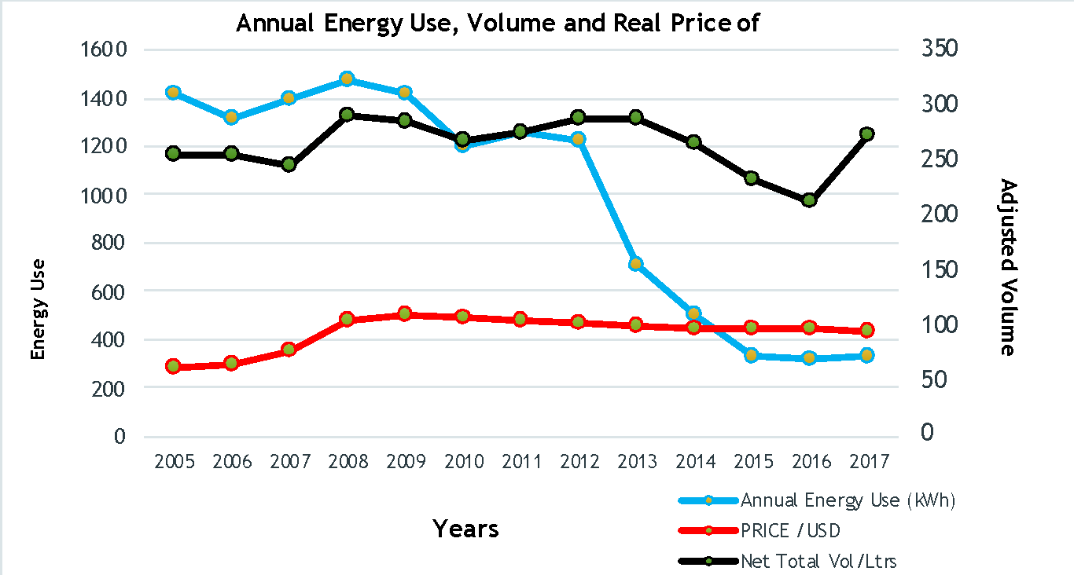
Figure 24: Evidence of reduced energy consumption in refrigerators

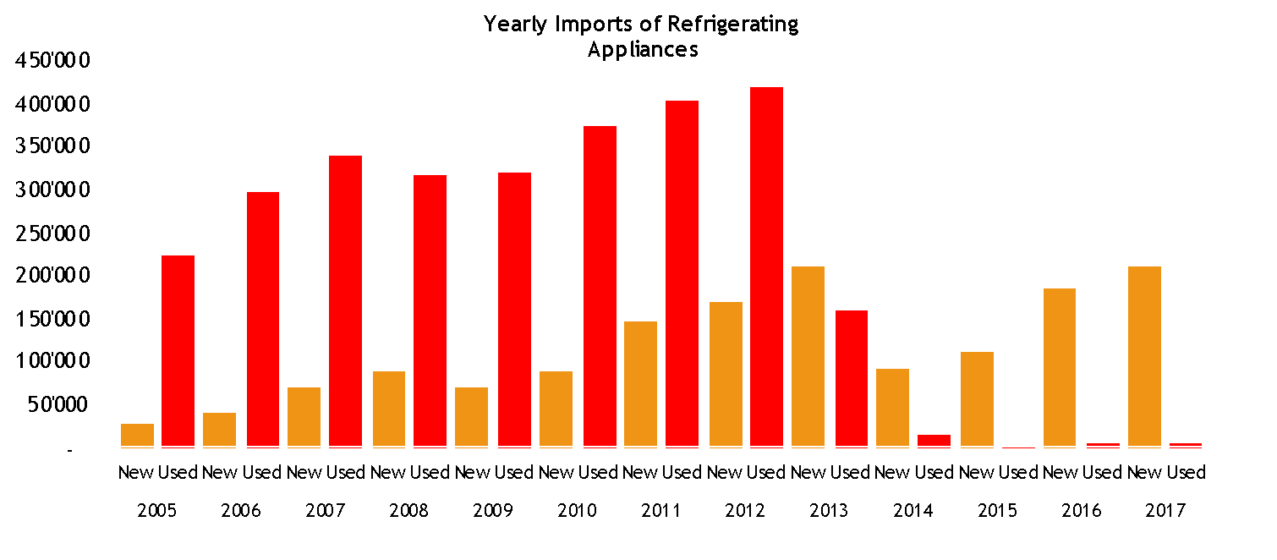
Figure 25: Evidence of transformed market with the disappearance of used imported units.

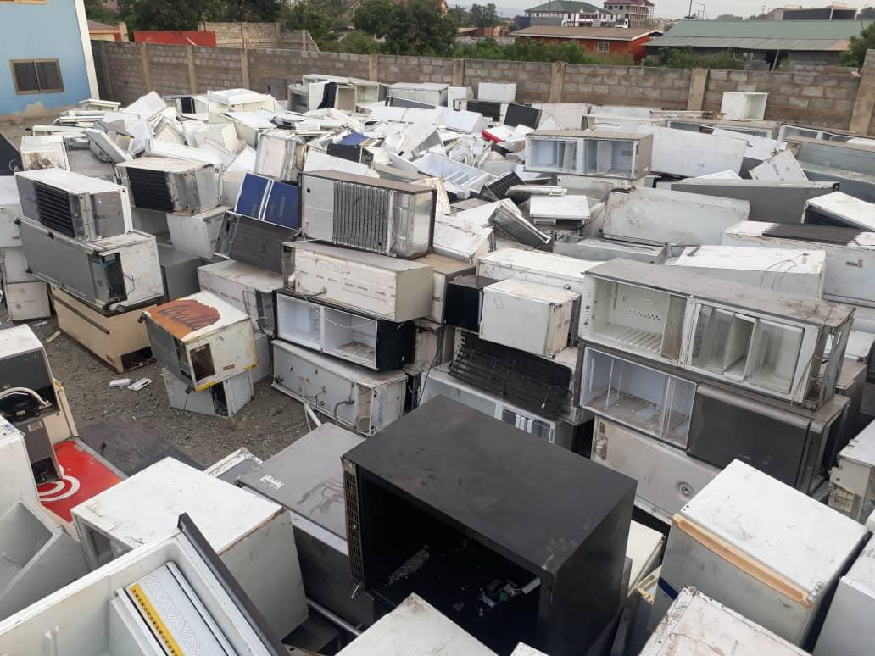
Figure 26: Seized ODS laden fridges at the Tema port
- Product Registration Systems in ASEAN Region
Geography: Global
Policy type: Product Registration Systems
Product type: Refrigerators, Room Air Conditioners, Lighting, etc.
Product source: Manufactured and/or assembled in-country; Imported
Description: The Southeast Asia region is predicted to account some of the world’s top growth in electricity use by cooling appliances. According to U4E Country Saving Assessments, by 2040 the electricity consumption used for air conditioners in the Association of Southeast Asian Nations (ASEAN) region is expected to almost double. An effective market transformation to energy efficient cooling options could save large amounts of electricity and reduce the impact on the environment through lowered CO₂ emissions. With the support of U4E and in collaboration with the ASEAN Centre for Energy (ACE) the countries have recognized that a harmonization of product registry activities is needed to accelerate the switch to energy-efficient and climate-friendly cooling solutions.
During a regional workshop in Bangkok in February 2020, the countries shared experiences and were advised on practical options to harmonize their activities. The region has adopted a common policy roadmap that includes, among other interventions, development of a regional product database that aligns with policies and databases in member States.
Enabling institutional infrastructure and capabilities:
U4E has developed tools and resources with partner organisations and manufacturers to disseminate best practices:
- Guidance Notes: Four guidance notes outline the benefits, overall context and recommended guidelines to build a Product Registration System. The series intends to assist policymakers in developing and emerging economies seeking to transform their markets with more energy-efficient products.
- Prototype: The Prototype illustrates the capabilities of a best-practice system, with portals for applicants, regulators and administrators, as well as template forms. U4E is developing additional software that will be demonstrated in several countries in Southeast Asia.
- Country Mapping: The mapping shows the commonalities and differences between different existing systems.
References and web-links:
Guidance notes:
- What is a Product Registration System and Why use one?
- Foundational Considerations in planning to build a Product Registration System
- Detailed Considerations in planning to build a Product Registration System
- Implementing a Product Registration System
Examples of Product Registration Systems
- Australia
- Canada
- European Union
- India
- Japan
- Malaysia
- Singapore
- Thailand
- USA – California
- USA – DOE Compliance Certification
- USA – EnergyStar
  - Supply Chain & Skilled Workforce (Installation, Maintenance & Servicing)
- Effect of good service and maintenance on energy efficiency
Geography: Global
Policy type: Servicing sector
Product type: All
Product source: All
Description: A web search for the effect of good service on maintaining efficiency or inversely the effect of improper maintenance on the degradation of energy efficiency yields a lot of advice but little measured effects. A common approach is to lay down the causes like, “The seven issues that affect the energy efficiency of an air conditioner37F” and which include main factors like bad installation and lack of maintenance but also specifics like dirty air filter and inefficient thermostat settings. What is lacking is the measurement of these effects. In a paper published in 2012, researchers at the University of Sunderland in the UK concluded that there is little real-world data is available from within the refrigeration industrial sector on the role of maintenance in energy saving in commercial refrigeration (Knowles and Baglee 2012). The paper surveyed the literature for evidence and concluded that monitoring the conditions and performance of individual parts of a system are crucial in obtaining optimal performance. The paper also found that, “The relationship between energy efficiency and maintenance is reciprocal, improving maintenance procedures for energy efficiency can also reduce maintenance costs. In a case study carried out at the Nestle Ice Cream Plant in Mulgrave, Australia, an energy and maintenance strategy based on improved control procedures led to a 20 per cent reduction in maintenance costs in addition to substantial energy savings (State Government of Victoria, 2002).”
Studies by the Carbon Trust38F in 2002 gave percentages of increase in energy consumption up to 25% due to pour maintenance of faulty seals and motors and a potential benefit of up to 50% from effective maintenance.
Another paper by researchers at the Universiti Sains Malaysia in 2019 concluded that even though energy savings can be obtained by the application of effective maintenance, maintenance and energy efficiency are usually researched separately (N. Fiduas et al 2019). The paper also referred to a study of a plant in the Middle East which concluded proper preventive maintenance along with availability of spare parts and of skilled maintenance personnel resulted in lower failures (Al Ghanim 2002).
Potential of service and maintenance to deliver energy reduction
At the request of the Australian Department of Agriculture, Water, and Environment, an extensive survey of the international literature on common faults in RACHP equipment was conducted which revealed a range of potentially large energy saving, leak reduction and emissions reduction opportunities. The study confirms that there are a limited number of common faults reported across large stocks of RACHP equipment that result in the great majority of energy penalties and refrigerant leaks. Possibly the single most important measure to improve RACHP equipment performance is to eliminate leaks of refrigerant gas. Apart from reducing direct emissions, ensuring equipment is operating on an optimal refrigerant charge delivers the additional benefit of reducing electricity use and electricity-related greenhouse gas emissions. Predictive maintenance, combined with condition monitoring techniques and fault detection & diagnosis, would reduce energy efficiency degradation over the lifetime of systems. (Brodribb 2021).
The industry needs a tool to estimate the scale of energy losses as a result of poorly installed or maintained refrigeration and air conditioning equipment in order to assess the cost and benefits of mandating improved maintenance and installation of air conditioning equipment.
A second part of the study is data mining to quantify fault prevalence and severity in Australia and targeted case studies. Another aim of the study is to standardise fault nomenclature and coding that can be promoted across industry
References
- Bodribb, P, Leaks, Maintenance and emissions: Refrigeration and air conditioning equipment. Expert Group February 2021
- Knowles and Baglee, The role of maintenance in energy saving in commercial refrigeration - University of Sunderland UK, 2012
- State Government of Victoria (2002), “Module 5 best practice design, technology and management”, available at: www.sustainability.vic.gov.au/resources/documents/ Module5.pdf
- N Firdaus H, A Samat and N Mohamad, Maintenance for Energy Efficiency: A Review. School of Mechanical Engineering, Universiti Sains Malaysia, Malaysia, 2019
- Al-Ghanim A 2003 A statistical approach linking energy management to maintenance and production factors J. Qual. Maint. Eng. 9 Issue: 1 p.25-37
- Argentina’s Experience Creating a Training Framework for RACHP Technicians
Geography: Argentina
Policy type: RACHP servicing sector training
Product type: RACHP (all)
Description: The government of Argentina, through leadership of the National Ozone Unit, established a training program for RACHP technicians in 2004 because the NOU recognized the need to fill a gap in available education and training. At the time of the program’s creation, Argentina had one technical high school providing education for RACHP technicians, other courses were delivered by private institutions. Over the past 17 years, the NOU has conducted regular surveys to determine training needs, developed training materials, and delivered more than 400 courses throughout the country. As a result, 12 700 skilled RACHP technicians have been trained. The NOU has also developed a national certification scheme for the safe handling of flammable refrigerants together with the national technological university, which will act as a certification body.
Enabling institutional infrastructure and capabilities: The NOU used surveys to identify needs in the service sector as a complement of the training courses. The program developed training programs that provided participants who met the selection criteria with a toolkit of the minimum equipment required. This created an incentive for participation. Tools and equipment were distributed in a case-by-case selection process based on a survey that technicians had completing, stating among other topics, which tools and equipment from a list drafted by the NOU they had, and which they would prefer to receive in order of preference. This was a very heavy workload but cost-effective in enabling the government to ensure that all technicians trained would have the minimum set of tools and equipment needed to deliver a good service when repairing equipment. While government provision of servicing toolkit was initially met with resistance from suppliers, increased demand for more and better tools from trained technicians was later recognized by suppliers as in their interest. The trainings also contributed to the professionalization of the activity through the combination of selection criteria that required official tax identification of participants. The support of the MLF has been vital for the support of all these activities.
Additional insights and lessons learned: Our experience showed that it’s important that Trainers must have both theoretical and practical experience in the field in refrigeration subjects and they should have skills to talk to technicians in their own language, not in an engineering one. Our training programs have been also very successful throughout the country. Nowadays our courses are very much demanded by technicians. Some companies like Coca Cola or electrical appliances store chains demand participation in this course for all who would want to work for them.
The trainings also created a high awareness in the sector about ozone layer depletion and the impact of their activities, had a great impact on the society and it turned out to be one of the best ways to raise awareness among the population.
References and web-links:
- Video Good Refrigeration Practices
The NOU distributed more than 10.000 copies of this video.
Video made by OPROZ was uploaded, in three parts to YouTube, by another user and obtained 228,063 visits (very high number considering the specificity of the subject and that it is not subtitled in English or other languages) https://www.youtube.com/watch?v=gbZKufTAIDM
- Video “How to change a compressor in a HC refrigerator”
The NOU distributed more than 1.000 of this video.
https://www.youtube.com/watch?v=g74glsaivmw
Visits: 15.976.
List of documents and manuals
Training manuals:
- Manual for “Good Refrigeration Practices”
- Manual on "Hydrocarbons as Refrigerants"
- Manual for “Low GWP Refrigerants Management”
- Manual "Good Practices in Flammable Refrigerants Management"
- Manual " Training on Split Air Conditioned Equipment Installation and Maintenance"

Brochures:
- "National CFC Recovery, Recycling and Regeneration Plan"
- "New Control Measures for HCFCs"
- "Good Practices for the Recovery and Recycling of Refrigerants"
- "Retrofit or Direct Replacement"
- "Reconversion or Direct Replacement of Refrigerants"
- What to do with Recovered Refrigerants in Córdoba Brochure?
- What to do with Recovered Refrigerants in the NOA brochure?
- What to do with Recovered Refrigerants in Comahue Brochure?
- "Recommendations for Working with R410A Refrigerant"
- "Hydrocarbons (HCs) as Refrigerants"
- "Commercial Refrigeration - Supermarkets"
- "Selection of Alternative Refrigerants for the Replacement of HCFCs"
- “What's New in the Montreal Protocol - New Controlled Substances”
- “How to build a home-made recovery equipment”
- “Energy Efficiency and Service of Refrigeration Equipment”

Data/visualization:
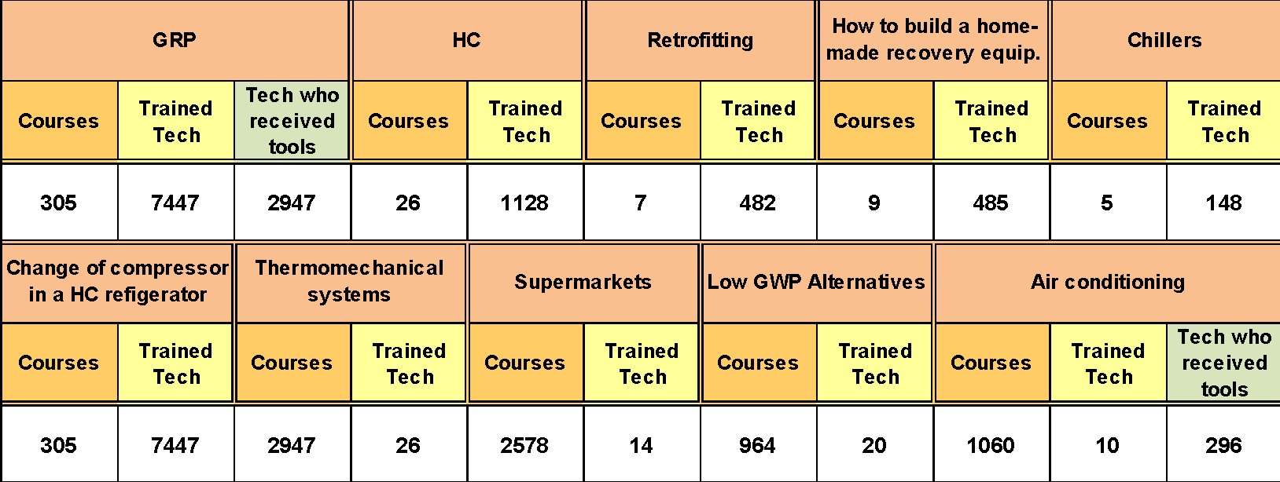

- Towards Changing the Landscape of the Air Conditioning Market in Brazil
Geography: Brazil
Policy type: Standards and Labelling
Product type: Air Conditioners up to 60,000 BTU/h
Product source: Manufactured and/or assembled in-country; Imported
Description: Brazil is the world´s fifth largest market for AC, with around 3.7 M units sold in 2017 (having reached around 4.7M in 2014), according to CLASP (2018). Split AC units dominate the market, which is shifting from HCFC-22 to R-410A. A new plant to produce R-410A AC equipment opened in Manaus in 2017.
Daikin worked with the Japan International Cooperation Agency (JICA), the federal government and NGOs on a demonstration project to introduce HFC-32 ACs in Brazil in 2019, first as imports from Thailand, and announced in the Manaus as of 2021. Other assemblers have expressed concerns about flammable low-GWP refrigerants.
In 2017, approximately 900,000 compressors were sold, all fixed-speed, for both split-type ACs and window units. Tecumseh is a local manufacturer with a production line for inverter compressors (capacity of 100,000 units per year) which is inactive due to lack of demand. The company is now producing fixed-speed compressors for lower-GWP refrigerants such as HC-290 or HFC-32 as per market demand.
Basic Production Process of Components
Local regulations under the Basic Production Process (PBB) effectively requires AC assemblers to purchase a certain percentage of fixed-speed compressors from the lone domestic manufacturer. The manufacturer has the ability to produce both inverter and fixed-speed compressors, but because of PBB barriers to competition sells only fixed-speed compressors which are more profitable. These compressors are more expensive and less efficient than those from the international market (CLASP, 2018). Lack of international competitiveness, and protectionist industrial and energy efficiency policies have limited investments in high efficiency compressors. In 2017, Brazil imported USD 378M of components for ACs (around 70% from China). High tariffs (14-18%) and challenging regulations have led multinational manufacturers to set up factories to assemble imported components from SE Asia, in the tax-exempted Manaus Free Zone. As a result, Brazil imported less than 100,000 units in 2017 (less than 2% of the total units).
MEPS in Brazil
Brazil MEPS have been in place for some years, but had been unambitious. The MEPS in place in 2016 are shown below, together with the market share. (Mitsidi, 2018).
Table 15: MEPS in place in 2016 and market shares of each energy efficiency class.
Level | EER (W/W) | Market share (models available)
A | > 3.23 | 45.8%
B | 3.02 > < 3.23 | 8.0%
C | 2.81 > < 3.02 | 41.4%
D | 2.60 > < 2.81 | 4.8%
E | < 2.60 | 0%
Then, in June 2019 categories C, D and E were banned for Split systems, and on July 1, 2020, INMETRO published new metrics and energy efficiency standards for Brazil, based on CSPF for both Split and Window type systems. Ordinance # 234 (06.29.2020) has changed the National Labelling Program (PBE) for air conditioning units to account for the energy savings benefits of variable speed inverter compressors, calculating energy efficiency through the partial charge method and seasonal metric (INMETRO, 2020 a, b, c). The new top-level energy label exceeds the old rating by more than 50%, an increase that will rise to over 100% in 2025. More details are available in Chapter 4 and Annex 1 Case Study 4.4. The new rating scale becomes mandatory in 2022.
Table 16: New MEPS in Brazil for split air conditioners (until end of 2022 and end of 2025)
Split Air Conditioners  (adequacy period for manufacturing and import until 12/31/2022) |  |  | Split Air Conditioners  (adequacy period for manufacturing and import until 12/31/2025)
Grades | SEER |  | Grades | SEER
A | 5.50 |  | A | 7.00
B | 5.00 |  | B | 6.00
C | 4.50 |  | C | 5.30
D | 4.00 |  | D | 4.60
E | 3.50 |  | E | 3.90
F | 3.14 |  | F | 3.50
Brazil has not yet ratified the Kigali Amendment. These very welcome changes in MEPS have yet to be integrated with the phase down of high GWP HFCs.
What additionally could be done?
- Build in a linkage between MEPS and phase-down of high GWP HFCs, so that manufacturers can leapfrog over R-410A to lower GWP alternatives.
- More flexibility in regulations would enable manufacturers to buy efficient components from a domestic supply chain which could include multinational manufacturers working in joint ventures. This would enable access to even higher EE components and know how.
- Tax and R&D incentives could be directed to the highest efficiency equipment (CLASP, 2018).
- Park et al (2019) recommend adopting the ISO cooling seasonal performance factor (CSPF) metric based on Brazil-specific temperature profile with values more realistic and consistent with ISO 16358, reducing compliance costs.
- Consider accelerating the timelines for higher MEPS
- Longer term targets. National Cooling plan or similar to provide a roadmap.
- Case study on installation and servicing (A2L and A3 alternatives) in India for better accessibility
Geography: India
Description: A2L Refrigerants
A few companies in India have adopted R32 as A2L refrigerant on a large scale in Room AC. To the best of the information in hand, A2L refrigerants are not adopted in any other product line. The training was imparted at three levels, manufacturing, installation and servicing post installation. The contents of the training were developed by the training department with the help of internal and external experts.
In manufacturing the focus was on the storage of refrigerant, getting the required license from the regulators PESO (Petroleum and Explosive Safety Organization) for the quantum of refrigerant and for safety & maintenance of the distribution network thru pipelines within the plant and of the storage tanks. Refrigerant leak sensors were fitted in the manufacturing plant where the refrigerants are stored.
The assembly line operators were trained on the handling of refrigerant which included both flammability and pressure and the instruments such as gauges. The supervisory staff was also trained. The training lasted approximatively one week and was funded by the company. Alterations were made in the manufacturing plant in the switchgear to meet flameproof requirements.
For installation technicians an elaborate plan was drawn to train the distributors owners and their technicians. The training included theory sessions for owners and technicians followed by hands on for the technicians. The products were introduced only after satisfactory completion of training. There is a restriction of maximum quantum of refrigerant that can be carried for servicing as per the approval of PESO.
A3 Refrigerants for chest freezers
An elaborate survey was conducted with help of an external expert of the plant and assembly lines which included electrical switchgear, all the equipment where the refrigerant was stored and used. The emphasis was on the detection and dilution using exhaust mechanism with flame proof grade equipment and two levels of safety. Manufacturing plants had to obtain the PESO license.
The training of operators was more elaborate with training of fire extinguishers and understanding of multi-level of alarm systems.
The training to the dealers and distributors was also more rigorous and approximatively dealers were instructed to handle the service calls through trained mechanics only. The limit as per the PESO directives to carry the refrigerants is limited to 0.250 kg in cans. The refrigerant cannot be transported by the technician in public transport.
Enabling institutional infrastructure and capabilities:
The skill sets required to adopt new refrigerants is at various levels. While the skill set at design and manufacturing level is high, it is possible to develop through self-learning by the engineers. The challenging part is the training of the service technicians who are scattered all over the country and large in number. In India RACHP technicians is a course as option where in the school passed student can opt for in the Industrial Training Institutes (ITI). The curriculum needs to be aligned with the Refrigerant technologies. For this, the teaching staff also needs to be trained. The India Cooling Action Plan targets to train 100,000 technicians in AC&R. Many business houses as a part of their CSR (Corporate Social Responsibility) activity which is mandated by the government have opted to train the technicians in various fields, AC & R being one of it. The association of Industry and government related to HVAC industry also run certification and training program.
A need is to plan in advance as part of adoption of alternative refrigerants, curriculum and certification courses.
Training material should be developed for online self-learning in form of videos and apps.
Another area is development of standards for A2L and A3 refrigerants in terms of safety, for storage and use.
Additional insights and lessons learned:
The A2L refrigerant was adopted in Room AC and availability and price points with respect to the current refrigerants in the upcountry was the most important criteria from the dealers and distributors perspective.
In order to implement technologies commercially apart from design and performance, manufacturing and service requirements are important. The need is of holistic approach end to end. One other important area where not enough attention is given, is the local supply chain specifically small and medium size entrepreneurs.
Acceptance of alternative and new technologies dependent on the availability of spare parts and service infrastructure.
- Accessibility of chest freezers and ACs in tier 3 and tier 4 cities
Geography: India
Policy type: Supply chain
Description:
A2L HFC-32 Refrigerant
The availability of refrigerant was resolved before the introduction of the product on the market. An initial informal survey was conducted by the sales team of the manufacturer to understand the reservation of the dealers and service providers. The availability of the refrigerant was the important criteria. The service providers were already trained by the training department of the manufacturer over a period of three days. It was also ensured that there was more than one vendor available to cater to the market to ensure the smooth supply and to arrest the monopolistic practice from the local distributor. The reservations, on one manufacturer who held the patents of HFC-32 were also addressed by the manufacturer of room ACs and a long-term plan of operation within the country was understood. The company developed a storage policy was developed for the dealers and distributors and assurance was given to them on support on the smooth supply of refrigerant. Cylinders/ Cans (0.250 kg) in smaller capacity as approved by PESO were made available. In short, the supply chain was developed before the introduction of products.
A3 HC-290 refrigerant
The challenges with respect to HC-290 was comparatively low as the supply chain was developed by domestic refrigerator manufacturers 15 years ago.
  - Regulatory Environment
- United for Efficiency (U4E) Model Regulations
Geography: Global and adaptable to specific country or region
Policy type: Minimum Energy Performance Standards (MEPS) and Labels; low-GWP refrigerant criteria; Harmonization of Test procedures.
Product type: room ACs, residential refrigerating appliances, and commercial refrigeration equipment
Description: U4E Model Regulation Guidelines for energy-efficient and climate-friendly room ACs, refrigerating appliances, and commercial refrigeration equipment (under development for later 2021) provide guidance for governments in developing and emerging economies, that are considering a regulatory or legislative framework for these products. The guideline set minimum requirements so that new products are energy-efficient and use refrigerants with a lower global warming potential (GWP) than typical legacy refrigerants. They also propose the ban of imported used products and regular revision to ensure that policies keep up with evolution in the cost and availability of new technologies.
While many countries have MEPS and energy labels for ACs and refrigerators, these are often outdated or poorly enforced, while other countries have yet to develop their MEPS and labelling policies and legislation. Inadequate MEPS and labels leave countries vulnerable as dumping grounds for products that cannot be sold elsewhere. The Model Regulation Guidelines provide a harmonized and consistent methodology based on widely adopted reference standards ISO 16358 for ACs and IEC 62552 for refrigerating appliances (while also noting other commonly used standards which may be appropriate depending on national circumstances). Measuring the energy efficiency of fixed-speed and variable-speed ACs with the same energy efficiency metric makes transparent the greater energy savings available from variable speed ACs. The energy efficiency levels in the Guidelines are designed to translate the same energy efficiency levels to seasonal metrics that are suited to each specific country or region based on climate conditions.
The Guidelines also include some requirement on low-GWP refrigerant that can be used to set upper limits on GWP for both room ACs and refrigerating appliances. The Guidelines consider the trends of the best available technology (BAT) globally, trends in best practice for test procedures and MEPS in large markets for ACs and refrigerating appliances and trends in availability of low GWP refrigerant using appliances. The contents are aligned with the 2020 China MEPS for variable speed ACs which China has announced in their national cooling plan will become the MEPS for all room ACs (both fixed and variable speed) in 2022. The anticipated energy, greenhouse gas emissions (direct and indirect), and utility bill impacts over the coming decades by implementing the Model Regulation Guidelines can be seen in unique Country Savings Assessments that have been prepared for over 150 countries. The contents currently cover the available Guidelines for room ACs and refrigerating appliances and they are being expanded to address commercial refrigeration equipment (anticipated for release around the third quarter of 2021 when those Model Regulations are available).
Thanks to the harmonization of the requirements with best practice examples from large markets, properly tailored application of the Guidelines (coupled with robust enforcement) is expected to have significant impacts on the cost and availability of energy-efficient and climate friendly room air conditioners and refrigerating appliances globally and allow adopting countries to benefit from the economies of scale that accrue from such harmonization. The Guidelines also include a “low”, “medium” and “high” tier of efficiency levels that can be used to design labelling programs or other types of market transformation programs (e.g., use of the high tier for sustainable public procurement, financial mechanisms, incentives, etc.) to accelerate the deployment and reduce the costs of energy-efficient and climate friendly room air conditioners and refrigerating appliances globally.
Enabling institutional infrastructure and capabilities: The model regulations were drafted by U4E because countries typically request technical assistance in adopting MEPS and labelling or enhancing existing policies based on international best practices. The contents were developed through consultation with a wide community including over 60 technical experts, government, civil society, and industry partners. A Cool Products Database is under development to give an idea of the availability of products meeting the Model Regulation Guidelines. It provides policymakers with such information so they can take an informed decision about adopting the U4E model regulations.
Additional insights and lessons learned: harmonization of the scope of coverage, test methods, and efficiency and GWP requirements across markets can reduce costs of compliance and capture economies of scale.
The benefit with aligning with China’s 2022 standard is the economies of scale and hence low cost of variable speed ACs. In summary, the total benefits are:
- Cost savings from economies of scale
- Lifecycle cost, energy, GHG, air quality savings from high efficiency low-GWP ACs
- Harmonization of test procedures and labels across large markets.
The Model Regulations are being leveraged by numerous parties. The East African Centre of Excellence for Renewable Energy and Efficiency (EACREEE), Southern African Development Community Centre for Renewable Energy and Energy Efficiency (SACREEE), technical committees from the regions, Lawrence Berkeley National Laboratory (LBNL), and U4E are working together to implement a large-scale harmonisation project for the member states of the East African Community and Southern African Development Community. The project is implemented in collaboration with the Energy Efficient Lighting and Appliances for East and Southern Africa (EELA) by UNIDO and CLASP and supported by the Swedish Energy Agency.
The ASEAN Centre for Energy is partnering with U4E, LBNL, IIEC leveraging funding support by the Global Environment Facility (GEF), K-CEP and the Japan-ASEAN Integration Fund (JAIF) to advance energy-efficiency air conditioners in ASEAN by introducing regulatory and market monitoring mechanisms also informed by the Model Regulations. The support has two components, adopting MEPS and assist in implementing a product registration system(s) to improve the data on the types of products in the market and to enhance compliance.
The contents are also the basis for voluntary financial mechanisms in Ghana and Senegal through the ECOWAS Refrigerators and Air Conditioners initiative and in the Rwanda Cooling Initiative, and they are referenced in five NCAPs in the Caribbean. The Model Regulations have been used to inform policy recommendations for Chile and other such national-level market transformation projects, and they are the basis for new activities getting underway, such as a K-CEP funded room air conditioner MEPS and labelling project in Nigeria. The World Bank, Carbon Trust, CLASP and other organizations offering technical assistance to developing and emerging economies have reported utilizing the materials in their projects. As the freely available materials have been heavily promoted in a variety of fora, it is anticipated that more widespread reference to the contents has and will continue to occur.
References and web-links:
ACs:
- https://united4efficiency.org/resources/model-regulation-guidelines-for-energy-efficient-and-climate-friendly-air-conditioners/
Refrigerating Appliances:
- https://united4efficiency.org/resources/model-regulation-guidelines-for-energy-efficient-and-climate-friendly-refrigerating-appliances/
Ensuring Compliance with MEPS and Labels:
- https://united4efficiency.org/resources/ensuring-compliance-with-meps-and-energy-labels/
Energy Labelling Guidance:
- https://united4efficiency.org/resources/energy-labelling-guidance-for-lighting-and-appliances/
Country Savings Assessments:
- https://united4efficiency.org/countries/country-assessments/
- Energy efficiency metrics for air conditioners and impact on the product development
Geography: EU27
Policy type: MEPS
Product type: Air conditioner
Product source: domestic (EU27 manufacture and assembly) and import
Description: The Ecodesign regulation that entered into force in 2013 for air conditioners set two different metrics to assess the energy efficiency of air conditioner according to the type of air conditioner (split, portable, double duct). The energy efficiency of single duct (portable air conditioners) and double duct air conditioners was determined by the EER while the energy efficiency of split units was assessed using the SEER.
The choice of these metrics had an impact on the development of the products on the market. While the market for split units completely shifted to variable speed compressors to reach better efficiency levels during the measurement of the seasonal, part-load values, single and double duct air conditioners were measured a full capacity and therefore remain almost 100% fixed speed. This is because the regulation doesn’t value variable speed compressors for portable and double duct units and no incentive exists to equip a unit with this technology.
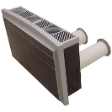  Figure 27: Example of a double duct air conditioner. | 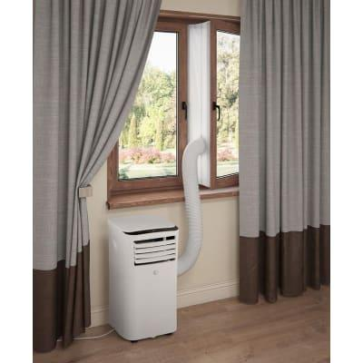  Figure 28: Example of a portable single duct air conditioner.
Another contributing factor is also that these two product groups both have an energy label but their scales are different: An A+-class portable air conditioner is equivalent to a F-class split unit but the consumer is not made aware of this because of the separate scales of each label.
Enabling institutional infrastructure and capabilities:
- Ecodesign regulation EU No 206/2012
- Labelling regulation (EU) No 626/2011
- Regulation (EU) 517/2014 for fluorinated gases.
Additional insights and lessons learned:
The regulation is more lenient towards a technology and penalizes more efficient products because of the metrics chosen to assess its energy efficiency and the method of communicating the product’s energy efficiency rating.
References and web-links: https://www.eco-airconditioners.eu/
- Kenya AC MEPS update
Geography: Kenya
Policy type: MEPS (mandatory, EE only)
Product type: residential air conditioners (ductless split)
Product source: imported
Description: Kenya Bureau of Standards (KEBS) finalized the residential air conditioners standard “KS 2463:2019 Non-ducted air conditioners-Testing and rating performance” in April 2019. The performance standard included energy efficiency requirements and testing protocol, but did not include refrigerant requirements or other environmental criteria, as these fall outside KEBS mandate and under the environmental regulator’s mandate. The energy efficiency performance level was proposed after preparation of a market assessment and consultation with businesses and other stakeholders. The change in the standard was communicated by an email blast to industry players and KEBS expects to carry out awareness seminars in various parts of the country. The standard went into effect immediately. Observed rapid shift in registered models within 6 months of implementation from an average efficiency of 2.93 W/W and 27% of the models using HCFC-22 to 3.23 W/W average efficiency and none of the registered models using HCFC-22. Newly registered products use entirely R-410A.
Enabling institutional infrastructure and capabilities: The regulatory framework in place allows definition of energy performance requirements. A market assessment gathered technical evidence to define appropriate energy efficiency levels for the local market. A product registry enabled tracking of registered models after standard implementation. An open consultation allowed stakeholders to submit comments on a draft standard, making the process transparent and participatory.
Additional insights and lessons learned: While Kenya’s residential air conditioners standard aimed to increase efficiency of RAC equipment, the standard also indirectly resulted in reducing the import of RACs containing ozone-depleting refrigerants with high GWP (HCFC-22), as high efficiency HCFC-22 RACs are not available. “According to the Ministry of Environment, Kenya is on track to completely phase-out the importation, use, and sale of ozone-depleting substances by 2026, four years ahead of the 2030 Montreal Protocol deadline.”39F
References and web-links: KEBS standard is available in the webstore (https://webstore.kebs.org/).
Data/visualization:
Efficiency levels distribution before and after standard implementation
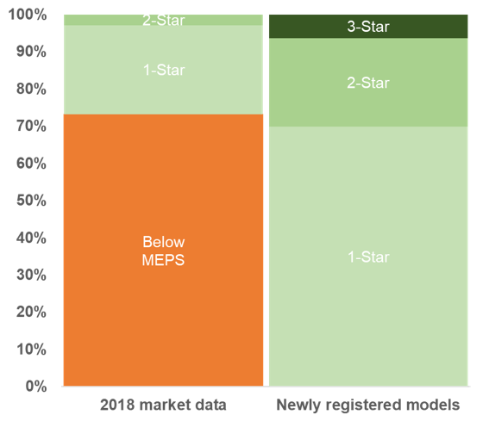
Range of efficiencies before and after standard implementation
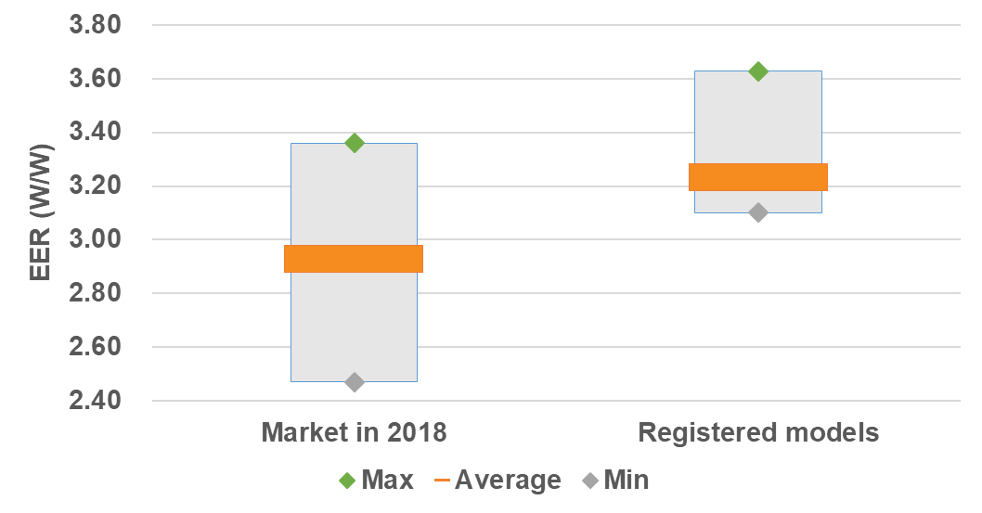
- Case Study: Brazilian new national labeling for energy efficiency of Air Conditioners
Geography: Brazil
Policy type: Labelling
Product type: Air conditioners
Product source: Local and imported
Description: In Brazil, Ordinance # 234 (06.29.2020) changed the National Labeling Program (PBE) for air conditioning units highlighting variable speed compressors (inverters), calculating energy efficiency through the partial charge method and seasonal metric (INMETRO, 2020 a, b, c). The seasonal metric criterion is based on both the average climatic data and equipment ownership data. The process started in February 2019 after a workshop showing the outcomes of a study commissioned by Eletrobras, the state-owned power utility. Stakeholder agreed with the revision process, despite some worries on the performance of on-off split units. Later, several conversations between INMETRO (National Metrology Institute) with specialists from ICS (Climate and Society Institute) and the Lawrence Berkeley National Laboratory Park et al, 2019 advanced the adoption of seasonal metrics based on ISO 16358 standard. In May 2019 a multi-stakeholder technical committee agreed on the adoption, which evolved in September to a discussion about test points, two (as per ISO) or three. In December a final proposal brought about consensus on two mandatory points and the third optional. From March to May 2020 a public consultation process was put in place. Consultation had 158 contributions from 20 different entities representing the productive sector. Larger companies which had already invested in inverter products defended ISO 16358, whilst few others with an on-off portfolio presented disagreements - what shows that Brazil has significant technological disparities caused by industrial protectionism (CLASP 2018, Montenegro 2020).The new “A” level has an energy efficiency index of 5.5 (SEER) compared to the previous 3.23 (EER). Manufacturers will have until December 2022 to adjust to the new criteria, but it will be possible to use the new label after the publication of the ordinance. Thus, until the deadline, the two labels will coexist on the market - the old one, for devices that are not adapted to the new rules; and the new one, for products already aligned with the new model. Despite up to 47% savings in electricity consumption, according to the rules still in force by the ENCE (National Energy Consumption Label), inverter and fixed speed compressor devices are still tested in the same way and classified with the same criteria, with the devices configured at full load. Thus, in the same class A, for example, inverter and non-inverter devices coexist, even though the former are more economical. Tests based on the new method and metric indicated that 37% of the devices tested (34 samples from 9 suppliers) have already reached the new ‘A’ established for 2022.
References
INMETRO, 2020a. Ar-condicionado: Inmetro atualiza critérios para o Programa Brasileiro de Etiquetagem. (In Portuguese. Air conditioning: Inmetro updates criteria for the Brazilian Labeling Program). Brazilian National Intitute for Metrology, Quality and Technology. Available at https://www4.inmetro.gov.br/noticias/ar-condicionado-inmetro-atualiza-criterios-para-o-programa-brasileiro-de-etiquetagem
CLASP 2018b. Estudo de Viabilidade Técnica e Econômica para um Mercado de Compressores de Alta Eficiência no Brasil. Available at http://kigali.org.br/wp-content/uploads/2019/01/iCS-compressores.pdf
INMETRO, 2020b. Portaria #234 June 29 2020. Available at https://www4.inmetro.gov.br/sites/default/files/media/file/portaria-234-29-de-junho-de-2020.pdf
INMETRO, 2020c. Portaria #1, January 27 2020. Consulta Publica (in Portuguese. Public consultation) Available at http://www.inmetro.gov.br/legislacao/rtac/pdf/RTAC002618.pdf
Montenegro S, 2020. Uso eficiente do ar condicionado pode economizar até 87,9 TWh. (in Portuguese: Efficient Air conditioner use can save 87.8 TWh until 2035). Canal Energia. Available at http://www.escolhas.org/wp-content/uploads/2020/07/Uso-eficiente-de-ar-condicionado-pode-economizar-879-TWh-at%C3%A9-2035-_-CanalEnergia-1.pdf
Park WY, et al. 2019. Adopting a Seasonal Efficiency Metric for Room Air Conditioners in Brazil. Energy Analysis and Environmental Impacts Division Lawrence Berkeley National Laboratory Roberto Lamberts Laboratory for Energy Efficiency in Buildings Federal University of Santa Catarina. Available at http://kigali.org.br/wp-content/uploads/2019/09/Case-Study-in-Brazil_03.pdf
- EU Ecodesign and GWP “bonus”
Geography: EU27
Policy type: MEPS
Product type: residential air conditioner
Product source: domestic (EU27 manufacture and assembly) and import
Description: The Europe Ecodesign regulation 206/2012 allowed split air conditioners under 12kW with a GWP < 150 to have minimum EU seasonal energy efficiency ratio (SEER) that is 8% lower than units with higher GWP. The intent was to promote GWP < 150 units in Europe. The preparatory study (2018) for the review of the Ecodesign and Energy Label regulations found that the low-GWP “bonus” had no effect on the mini-split ACs , with no units available on the market using a refrigerant with a GWP that was lower than 150. For a short while, Midea offered in 2018 a split 2.5kW and 3.5 kW unit containing HC-290 in Germany, however the unit could not be purchased and was therefore wasn’t accessible. The product however did not make use of the GWP bonus. On the contrary it received the German “Blue Angel” certification which requires a SEER that is higher than 7, which corresponds to an energy class of A++ (A+++ being the maximum).
In the portable AC market segment, one company offered a unit using HC-290 since 2006 (Delonghi). The market share of portable units using HC-290 increased over the years, because of the upcoming ban in January 2020 of portable room air conditioners containing a refrigerant with a GWP of 150 or more as prescribed in the F-Gas regulation. A similar ban is going to take place in January 2025 for single split air conditioning systems containing less than 3kg of refrigerant with a GWP of 750 or more. This upcoming ban partly explains the rapid increase in market share of HFC-32.
Enabling institutional infrastructure and capabilities:
- Ecodesign regulation EU No 206/2012
- Labelling regulation (EU) No 626/2011
- Regulation (EU) 517/2014 for fluorinated gases.
Additional insights and lessons learned: The low GWP “bonus” did not encourage the uptake of low GWP refrigerants for split units. It also shows that a trade-off in between energy efficiency and low GWP is not necessary, as shown by the low GWP model with the Blue Angel certification. In the case of portable units, the ban of high GWP refrigerants had a stronger role in the transformation of the market than the promotion of the GWP bonus.
References and web-links:
- https://www.eco-airconditioners.eu/
- Blue Angel webpage for room air conditioners: https://www.blauer-engel.de/en/products/electric-devices/stationary-air-conditioners/room-air-conditioner
- Blue Angel product certification criteria for room air conditioners: https://produktinfo.blauer-engel.de/uploads/criteriafile/en/DE-UZ%20204-201608-en%20Criteria.pdf
- Indian 24°C mandatory default setting
Geography: India
Policy type: Default temperature setting
Product type: room air conditioners, namely, multi-stage capacity air conditioners, unitary air conditioners and split air conditioners up to a rated cooling capacity of 10,465 W.
Product source: All room air conditioners manufactured, commercially purchased, or sold in India.
Description: On 29 June 2018, Bureau of Energy Efficiency (BEE) of the Ministry of Power (MoP), Government of India, issued guidelines on the optimum temperature (24°C) setting of air conditioners in major commercial establishments such as airports, hotels, shopping malls, offices and government buildings (ministries & attached offices, state government and public-sector undertakings) for voluntary adoption40F. On 6 Jan 2020, the central government in consultation with BEE made 24°C the default setting41F mandatory for all room air conditioners as of 1 Jan 202042F.
Studies on thermal comfort 43F, the temperature at which the person expresses satisfaction with the thermal environment, recommend using air-conditioning at higher setpoint temperatures – the AC compressor will work lesser and use less electricity if the setpoint is 24°C rather than 21°C. This would have a significant bearing on the energy consumption and GHG emission due to cooling in buildings, all whilst being ‘adaptively’ thermally comfortable.
According to BEE it was observed that the setpoint temperature in large commercial establishments, is 18-21°C. A commercial building survey conducted by Alliance for an Energy Efficient Economy (AEEE) found that most commercial buildings operators believed that 1°C -2°C increase from the existing setpoints would be acceptable to building occupants, without compromising their thermal comfort levels44F.
Per BEE’s estimates, increasing the setpoint by 1°C in commercial buildings, would save about 6% electricity; this implies that using the 24°C setpoint as compared to 20°C -21°C would save about 24% electricity. This could translate to a country-wide savings potential of 10 billion units, INR 5,000 crores (approximatively 680 million USD), and 8.2 million tCO2 annually (at 50% compliance). Significant savings could be accrued by nudging room air conditioner users to adopt behavioural energy efficiency, and use higher set-points.
Enabling institutional infrastructure and capabilities: The 24°C directives were issued by BEE. Per the press release in 2018, a public survey of major commercial buildings would be conducted after 4-6 months by MoP or BEE.
Additional insights and lessons learned:
Findings of AEEE residential RAC usage survey45F
- 24°C is the most preferred temperature in Indian homes. 66% of the population operates RACs at temperatures of 24°C or below, indicating that there is a wide band of population that lends itself to the applicability of ATC standards.
- A large share of RAC users (66%) prefer using a fan in conjunction with air-conditioning. The use of ceiling fans alongside elevated AC setpoint is strongly recommended to achieve adaptive thermal comfort in the residential sector, since air movement can help widen the ATC temperature range.
Findings from a 2018 study commissioned by Lawrence Berkeley National Laboratory (LBNL) and conducted by AEEE and CEPT University (Kumar et al., 2018)
- Energy savings potential due to setpoint increase: ~6% savings per 1°C increase in set-point in RACs; ~1% savings per 1°C increase in set-point in chiller systems. The high savings potential in room air conditioners is due to the proximity of the cooling appliance with the occupants, their simple controls, and the small number of energy-consuming auxiliary components.
- Nationwide Energy Savings Potential from the Adoption of ATC in 2030: The overall energy savings potential in room air conditioners, chillers and VRF system in 2030 is given in Table 2. The analysis shows that the nationwide energy savings potential through the adoption of ATC practices is 8%-13% of the total air-conditioning energy consumption of the building sector. This amounts to savings of 31-54 TWh in 2030. Relative to the respective energy consumption, room air conditioners show the maximum savings potential from ATC, as compared to the savings possible in chillers and VRF systems.
The policy doesn’t tackle the energy efficiency of the unit, but it touches the energy efficiency of the use of the unit and the demand for cooling. The energy savings from this measure are significant and they can be achieved at no incremental technological cost. Furthermore, above a certain amount, cooling can be detrimental to the user.
References and web-links:
- https://pib.gov.in/Pressreleaseshare.aspx?PRID=1537124
- https://pib.gov.in/PressReleasePage.aspx?PRID=1598508
- Manu, S., Shukla, Y., Rawal, R., Thomas, L., & de Dear, R. (2016, March). Lab studies of thermal comfort across multiple climate zones for the subcontinent: India Model for Adaptive Comfort (IMAC). Building and Environment, 98, 55-70.
- Kumar, S., Sachar, S., Kachhawa, S., Singh, M., Goenka, A., Kasamsetty, S., George, G., Rawal, R., Shukla, Y. (2018). Projecting National Energy Saving Estimate from the Adoption of Adaptive Thermal Comfort Standards in 2030. New Delhi: Alliance for an Energy Efficient Economy
- Sachar, S., Goenka, A., Kumar, S. (2018). Leveraging an Understanding of RAC Usage in the Residential Sector to Support India’s Climate Change Commitment. Presented at ACEEE Summer Study 2018, Asilomar, California, US.
Data/visualisation:
Table 2: Nationwide Energy Savings Potential from the Adoption of ATC in 2030
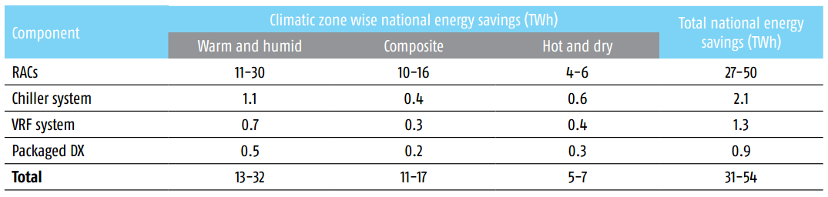
- Integrating GWP into EE labels
Geography: Brazil and Burkina Faso/West Africa
Policy type: Label
Product type: Air conditioner
Description: Brazil introduced GWP limits in its voluntary labelling programme as of 2023. Burkina Faso is in the process of replicating this integration on a regional level in Africa.
In Brazil, the National Electricity Conservation Program (PROCEL) has been operated by the electricity authority Eletrobras since 1985. It is a Federal Government Program coordinated by the Ministry of Mines and Energy, which strives for the efficient use electric energy by promoting actions in buildings, appliances, and the industry. PROCEL initiatives, accomplished with several partnerships, cover the efficient final use of energy with actions and programs that spread knowledge, training, and education. Eletrobras/PROCEL is the driving force for energy efficiency in Brazil.
In October 2020, POCEL launched a new PROCEL Label aiming to raise the level of energy efficiency levels in the country while supporting the use of lower-GWP refrigerants. To be awarded the PROCEL label, the product must simultaneously meet the criteria below:
- Meet the electrical safety requirements defined in the “Air Conditioner Conformity Assessment Requirements (RAC)” established, in force, by the Brazilian Labeling Program - PBE coordinated by the National Institute of Metrology, Quality and Technology – Inmetro;
- Manufacturers / importers wishing to use the PROCEL label for their models must prove that they meet the SEER values as given below. Testing has to be according to local standards.
Equipment | Present label | PROCEL label |  | PROCEL Gold label
Standard | EER (W/W) | SEER |  | SEER
Applicable date | Until  2022-05-02 | From  2022-05-03 | From  2023-11-03 | From  2022-05-03 | From  2023-11-03
Window  ≤17, 500 Btuh | 2.88-3.03 | ≥ 4.0 | ≥ 4.5 | ≥ 4.5 | ≥ 5.0
Window  >17,500 Btuh | 2.82-2.88 | ≥ 3.85 | ≥ 4.33
Split systems | 3.23 | ≥ 6.0 | ≥ 7.6 | ≥ 7.6 | ≥ 8.2
Apart from the stricter SEER values, PROCEL is also introducing requirements on ODP and GWP according to the table below:
 | Applicable Dates
 | From 2022-05-03 | From 2023-11-03
ODP | 0 | 0
GWP | ≤ 2088 | ≤ 750
The introduction of an ODP and GWP measure in the label is an outcome of the coordination between the ozone unit and the energy authorities to compliment the efforts in increasing energy efficiency while ensuring that this does not lead to a propagation of high GWP refrigerant products. The timeline of May 2022 is to give the industry time to ensure the proper application. Brazil coordinated the effort with representatives of the industry and with technical associations to ensure that the criteria can be met by both locally manufactured, as well as, imported products.
The effort by Brazil is easily replicable by other Parties following the same procedure of stakeholder consultation and coordination between the two competent authorities.
Burkina Faso has been seeking to introduce the same measures in their legislation as part of their Enabling Activities of the Kigali Amendment. Burkina Faso has to coordinate the effort on a regional basis as member of the Economic Community of West African States (ECOWAS) and of the monetary union for Francophone countries UMEOA. This ensures the application of the measure by all member states which is in line with the harmonization of efforts promoted by this report. Burkina Faso presented a suggestion to the energy department of the community which will consider it for the next update of the labeling directive in the coming two years.
  - Market-pull policies
- Global Cooling Prize
Geography: Global and India
Policy type: Challenge competition
Product type: residential air conditioner
Product source: new designs and innovations by OEMs and new entrants
Description: The Global Cooling Prize is a competition initiated by Rocky Mountain Institute (RMI) with India’s Department of Science and Technology and Mission Innovation, and administered by RMI, Conservation X Labs, CEPT University in Ahmedabad, India and the Alliance for an Energy Efficient Economy. The competition seeks to incentivize development of a residential cooling solution that will have at least five times (5X) less climate impact than standard Residential/ Room Air Conditioners (RAC) units in the market today. The competition was launched in November 2018 and received over 2100 registrations from 96 countries, 445 intent to apply submissions from 56 countries, and 139 detailed technical applications from 31 countries. An initial set of eight finalists were selected based on submitted design and performance specifications in November 2019 based on two primary criteria: climate impact 5X less than the baseline unit based on energy use and refrigerant GWP, and affordability i.e. cost at scale no more than 2X the cost of the baseline unit. The eight finalists include optimized designs pairing efficient vapor-compression technologies with PV, evaporative cooling, dessicants, and novel materials. Prototypes were be subjected to three tests:
- laboratory test using Indian Seasonal Energy Efficiency Ratio (ISEER) protocols,
- lab simulated year-round performance test,
- field test in an existing apartment building in India.
On April 29, 2021: Gree Electric Appliances, Inc. of Zhuhai with partner Tsinghua University; and Daikin with partner Nikken Sekkei Ltd. emerged as the two winners among eight Finalists after producing prototypes that demonstrated five times (5X) less climate impact than standard air conditioning units available in the market today at 2X the installed cost of the baseline AC unit when manufactured at a scale of 100,000 units per year. Both winning prototypes used variable-speed compressors optimized to achieve higher part-load efficiency and provide enhanced humidity control at lower loads, improved evaporator designs to separately sense sensible (temperature) and latent (humidity) loads, direct evaporative cooling of outdoor condensing units, photovoltaics or direct current components, and low-GWP refrigerant HFC-152a (Gree) and HFO-1234ze (Daikin).
When scaled, such technologies can prevent 132 Gt of CO₂-eq emissions cumulatively between now and 2050 and mitigate over 0.5°C of global warming by the end of the century.
Enabling institutional infrastructure and capabilities: Coalition of government, civil society, and industry partners; experienced prize competition management (ConservationXLab) and technical capacity; USD 3 million prize purse; strong and experienced governance and communications.
Additional insights and lessons learned: multiple promising technologies that could achieve 5X less climate impact and be produced affordably at scale. Challenge competitions can spur innovation and bring technologies to market at scale faster. Additional lessons include:
- Product testing requires consideration of low energy dehumidification and is consequently part of each finalist’s solution - preliminary analysis indicates that the current test standards (ISEER) recognize only 69% of the weighted energy reduction achieved by the winning technologies compared with the baseline unit when operating under simulated realworld conditions. ISEER and ISO based standards do not measure for low energy dehumidification and the market does not therefore incorporate smart dehumidification solutions which corresponds real world energy performance in tropical climates is significantly higher than rating systems would imply;
- Refrigerant profile of the finalist and opportunity to publicly test in high ambient and conditions - Water/Evap Cooling x2, R290 x2, R152a x1, R1234ze x1, R32 x1, Bromoadamantane x1;
- Industry and Industry Association engagement - often with prizes the incumbents choose not to play and the intentional engagement by the Cooling Prize organizers was a key success factor;
- Establishment of an investor marketplace with Carrier, Trane, Danfoss and Third Dimension VC to spur investment and connect emerging technologies to those that have capacity to scale.
References and web-links:
- globalcoolingprize.org
- Lessons learned report: https://globalcoolingprize.org/wp-content/uploads/2021/04/GlobalCoolingPrize_SolvingtheCoolingDilemma.pdf
- Rebate/replacement programme for low GWP energy efficient plug-in commercial refrigeration appliances.
Geography: Switzerland
Policy type: Rebate programme, Replacement programme
Product type: Plug-in commercial refrigeration
Product source: imported (100%)
Description: In 2014, the Swiss government initiated a replacement and rebate programme for energy efficient low-GWP commercial plug-in refrigeration appliances. Business-owners replacing their products with energy efficient products using low-GWP refrigerants received a subsidy of 25% of the purchase price of the new product up to a fixed maximum amount (25% or 500 CHF). If a product did not replace an existing appliance but was a new purchase, the subsidy amounted to 15% of the purchase prize.
To be eligible for the programme a product had to fulfil the energy efficiency criteria of the programme and contain a refrigerant with a GWP lower than 3.
The programme organizer received 1.3 million CHF (1.35 million USD) to distribute to buyers of low-GWP energy efficient products. Over 3 years, 5’955 products were subsidized, which led to an energy saving of 54.5 million kWh. At the end of the programme, it was calculated that each kWh saved cost the government (including the administrative costs of the programme) 2.4 cents per saved kWh (2.49 US cents).
The data on the energy efficiency of the product gathered during the project served as a basis for a European project in 8 countries to promote energy efficiency and low GWP appliances46F drawing more manufacturers to submit their products. As the products lists grew, the programme organizer strengthened the selection criteria.
Finally, the data was used during the process to define the European MEPS and Energy Label for commercial refrigeration that is expected to enter into force in March 2021 guaranteeing that the new product requirements are sufficiently ambitious and will further drive the transformation of the market.
Enabling institutional infrastructure and capabilities:
In Switzerland (population of 8.5 million) there are over 300’000 plug-in commercial refrigeration appliances. In 2014, at the start of the rebate programme, there were no product information requirements in place and no MEPS. The energy consumption values that were declared by manufacturers were measurements that they had taken independently and didn’t correspond to a same testing procedure making comparisons in between products impossible.
As a first step, the programme organizer chose an existing measurement method for the products that would be used as the reference for energy consumption. Manufacturers that wanted their products to be eligible for the rebate programme needed to test their products according to the chosen measurement method and declare the product’s energy consumption accordingly.
As the first manufacturers listed their products on the platform, additional manufacturers joined in to benefit from the increase in product sales through the rebate programme. The programme organizer required that the manufacturer submit the test reports of the product according to the required standard to check the accuracy of the data.
Additional insights and lessons learned:
While Switzerland is a small market for large manufacturers, the rebate programme was enough of an incentive for manufacturers to invest in additional product testing and deliver standardized data to the programme organizer. Buyers also put pressure on the manufacturers because they wanted to benefit from the subsidy or would select another product that could receive the subsidy. The Austrian government reproduced an identical rebate programme, using the data gathered in Switzerland.
In countries where electricity is subsidized, if the cost of a subsidy for an energy efficient product is lower than the electricity subsidy, it is economically beneficial to promote energy efficiency.
References and web-links:
- Commission Regulation (EU) 2019/2024 of 1 October 2019 laying down ecodesign requirements for refrigerating appliances with a direct sales function pursuant to Directive 2009/125/EC of the European Parliament and of the Council. https://eur-lex.europa.eu/legalcontent/EN/TXT/?uri=uriserv:OJ.L_.2019.315.01.0313.01.ENG&toc=OJ:L:2019:315:TOC
- Commission Delegated Regulation (EU) 2019/2018 of 11 March 2019 supplementing Regulation (EU) 2017/1369 of the European Parliament and of the Council with regard to energy labelling of refrigerating appliances with a direct sales function. https://eur-lex.europa.eu/legal-content/EN/TXT/?qid=1575538096087&uri=CELEX:32019R2018
- ProCold: European project for Sustainable professional refrigerators. https://www.topten.eu/private/page/pro-cold
- Lists of eligible products for the rebate programme: www.topten.eu
- Prokilowatt. Rebate programme framework of the Swiss Confederation. https://www.prokw.ch/de/home/
Data/visualization:
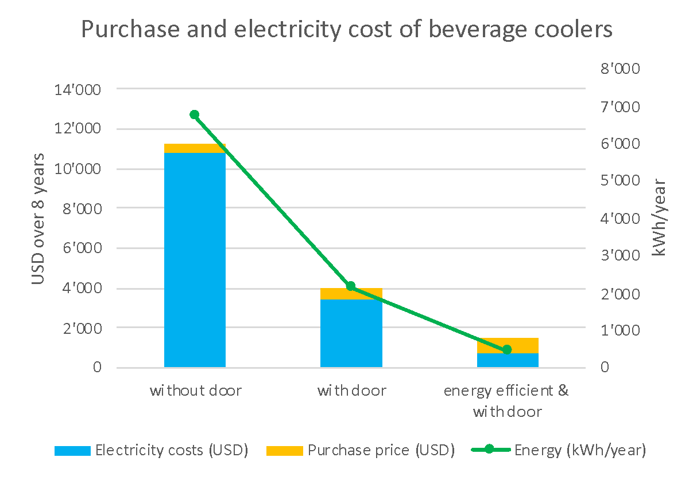
Figure 29: Energy and cost savings of a commercial beverage cooler
Table 17: Comparison of an energy efficient and inefficient beverage cooler
 | without door | with door | energy efficient & with door
Net Volume | 500 liters | 500 liters | 327 liters
Energy (kWh/year) | 6’753 | 2’168 | 449
Electricity costs (USD) | 10’805 | 3’469 | 718
Purchase price (USD) | 500 | 580 | 830
Total costs | 11’305 | 4’049 | 1’548
- Bulk purchase of commercial plug-in
Geography: World
Policy type: Bulk procurement and product customisation
Product type: Plug-in commercial refrigeration
Product source: Imported
Description: In 2014, Epta, multinational Group in commercial refrigeration for Retail, Ho.Re.Ca and F&B developed with the German supermarket chain Lidl, Sound Top by Costan, a plug-in unit that fulfilled their strict requirements on refrigerants and energy efficiency.
The main requirements were to have a propane unit allowing for the vertical display of products that could be placed on top of an existing horizontal display unit to maximise the use of space in the stores. With its larger glass surface and vertical configuration, the main challenge was to develop a unit of that size using only 150 g of propane. To achieve this, components needed to be expressly developed to fulfil these requirements. Thermodynamic insulation was guaranteed by doors with triple glass and by structure with polyurethane foam with natural blowing agent. The units were equipped with LED lighting, high efficiency fans and doors without electric heating.
The first units were installed in 2014 in 500 stores throughout Europe. The product was also made available to other supermarkets. Epta made further improvements to the energy efficiency of the unit during the following years, leading to the release of the fifth version of Sound Top in 2018. This last version ensured a reduction in energy consumption of 50% compared to the first version. In addition, Sound Top can be connected with every monitoring system to guarantee the best operating temperature and the utmost quality of products. Another achievement was the improvement of the Total Display Area of the cabinet thanks to an optimized use of full glass surfaces.
Enabling institutional infrastructure and capabilities: The F-Gas regulation signalled to the market the need to reduce HFCs consumption in the coming years. These units are fully in line with regulatory requirements following roadmaps and phase-out plans imposed by authorities.
Additional insights and lessons learned: Bulk procurement can have a significant influence on what products the manufacturer decides to invest in. Successful procurement programmes do not have to be public procurement programmes but can also be led by private entities. Once the product is developed for the initial client, all other market players can benefit from this new technology. The positive signal from the regulation and the ambitious environmental targets of the retailer led to the development of the such a unit, that was low-GWP, energy efficient and respecting the strict safety standard on A3 refrigerant quantity.
References and web-links:
https://www.costan.com/en/products/retail-plug/soundtop-energy#photo
https://www.ki-portal.de/14650/epta-und-lidl-entwickeln-neues-kuehlmoebel-sound-top/
- Demonstration project of HFC conversion by hydrocarbons as a coolant in manufacturing domestic refrigerators in Mexico
Geography: World
Policy type: Technological substitution
Product type: Manufacture of domestic refrigerators
Description: Mexico is the world’s largest exporter of two-door refrigerators with a value of more than 3 billion dollars annually. In this context, Mabe, a Mexican manufacturer of white goods develops a technological reconversion project in order to eliminate the use of HFC-134a refrigerant gas by mid-2021 at its refrigerator plant located in Celaya, Mexico, to be replaced by HC-600a hydrocarbon gas, a low-potential alternative of global warming, and no impact on the depletion of the ozone layer.
With a production of two million refrigerators per year, during the two years of project operation, Mabe will have managed to avoid the emission of 240,000 tCO2e per year as a result of replacing HFC-134a refrigerant. This means reducing the impact of climate change by 98% as an effect of the Global Warming Potential of HC-600a refrigerant Gas, while depletion of the ozone layer remains with a zero contribution to this phenomenon.
Additionally, with the introduction of HC-600a gas, technological improvements have been developed that allow increasing the energy efficiency of refrigerators between 10 and 25% based on the requirements of the Official Mexican Standard 015 that regulates the energy efficiency of refrigerators in Mexico. Among the technological improvements and innovations made are: the optimization of electrical components, heat exchangers, improvements in defrost systems, air flow and improvements at the level of the compressors.
The industrial reconversion project is partially financed by the Multilateral Fund for the Implementation of the Montreal Protocol, with technical assistance from the United Nations Development Program (UNDP), in coordination with the Ministry of Environment and Natural Resources of Mexico (SEMARNAT).
References and web-links:
- Secretaría de Medio Ambiente y Recursos Naturales (2020). Success stories on alternatives to HFCs, https://www.gob.mx/semarnat/documentos/casos-de-exito-sobre-alternativas-a-los-hfc

- Refrigerant safety
Safety
The safety of Room ACs and SCCRE are governed by IEC 60335-2-40 and IEC 60335-2-89 respectively. In this summary, we consider single split room air conditioner with a wall mounted indoor unit for the charge limit determination. It should be noted that standard ISO 5149, also cover other the use of flammable refrigerants in Room ACs, SCCRE, and other types of products. We consider HC-290, HFC-152a, HFC-32 as a proxy for A3, A2, and A2L flammability categories, respectively. Refrigerants not covered in the table below should be checked case by case in the relevant standards.
 |  |  | 61D/455/CDV IEC 60335-2-40 (Edition 7) |  | IEC 60335-2-89 (Edition 3)
No room size limitation | A3 (e.g. HC-290) | ≤ 0.15 kg |  | ≤ 0.15 kg
 | A2 (e.g. HFC-152a) | ≤ 0.52 kg |  | ≤ 0.52 kg
 | A2L (e.g. HFC-32) | ≤ 1.84 kg |  | ≤ 1.2 kg
With room size limitations and possibility for additional measures | A3 (e.g. HC-290) | > 0.15 kg ≤ 1.00 kg |  | > 0.15 kg ≤0.49 kg
 | A2 (e.g. HFC-152a) | > 0.52 kg ≤ 3.38 kg |  | > 0.52 kg ≤1.2 kg
 | A2L (e.g. HFC-32) | > 3.38 kg ≤ 15.69 kg |  | N/A
With further additional measures, such as ventilation | A3 (e.g. HC-290) | > 0.15 kg ≤ 1.00 kg |  | N/A
 | A2 (e.g. HFC-152a) | > 0.52 kg ≤ 3.38 kg |  | N/A
 | A2L (e.g. HFC-32) | > 15.69 kg ≤ 79.82 kg |  | N/A
N/A = not applicable
NOTE:
- Example of room size limitations for IEC 60335-2-40 (wall mounted single split room air conditioner):
- For a room of 30 m², the allowed charge is 0.414 kg of R290 refrigerant.
- However, if additional measure(s) is/are applied for the same room of 30 m² the allowed charge of R-290 may be up to 0.718 (with enhanced tightness design) or up to 0.99 kg refrigerant (with incorporated circulation airflow). This is a proposed change in the 7th edition for A2 and A3 refrigerants, in the 6th edition this was only an available option for A2L.
- Example of room size limitations for IEC 60335-2-89 (self-contained commercial refrigeration appliance):
- For a room of 20 m² the allowed charge would be maximum 0.42 kg for R-290.
- The scope of the IEC 60335-2-89 standard for self-contained refrigeration systems is limited to products with a refrigerant charge not exceeding 13xLFL or 1.2 kg whichever is smaller (per circuit). For self-contained refrigeration systems with higher charges, the standard ISO5149 can be used. For example, in ISO5149 a room of area 55 m² would allow to have a sealed system with a charge up to 0.9 kg of R-290.
- For A2L refrigerants room size limitations are not applicable because the scope of the standard is limited to 1.2 kg (for higher charges, instead the standard ISO5149 can be used)
- All appliances with a refrigerant charge exceeding 150g of flammable refrigerant in any refrigerant circuit shall be constructed such that a leak of refrigerant shall not result in a flammable refrigerant concentration surrounding the appliance.
- If room size limitations apply, they shall be indicated (by marking on the unit in the case of IEC60335-2-89 or by instructions in the installation manuals in the case of IEC60335-2-40)
Overview of safe refrigerant handling
In terms of refrigerant safe handling training, the situation differs widely amongst countries, due to the variety of national legislation. The IIR has published an information note on qualification and competence of technicians,47F which offers an overview of schemes available in many countries.
Some international and regional standard touch on the topic. An international standard is under preparation, FDIS-ISO 22712 - Refrigerating systems and heat pumps — Competence of personnel (currently in the form EN 13113), which addresses the required competence of technicians for all refrigerant types and tasks. More specifically, IEC 60335-2-40 includes an Annex (DD) covering requirements for operation, service and installation manuals of appliances using flammable refrigerants, which is essentially a compilation of procedures. Another annex (HH) addresses “Competence of service personnel”. Whilst neither IEC 60335-2-89 nor ISO 5149 contains any such material, EN 378-4 does have a short annex on competence of persons working with flammables.
Most countries tend to operate training programmes that are either national or private schemes. There are also a number of regional training programmes in existence, such as the “Real Alternatives” scheme, which covers most of the European countries.48F In North America there are two such schemes: North America Training Excellence (NATE) for HVAC49F and AHAM-Home Appliance50F. China operates a national training scheme for flammables as does JRAIA in Japan.

- Incremental capital cost for Room AC production line conversion from HCFC-22 to HC-290
The production line is shown in Figure A3.1 with all conversion elements enumerated from 1 to 11. The capital cost for these items are shown in Table A3.1.
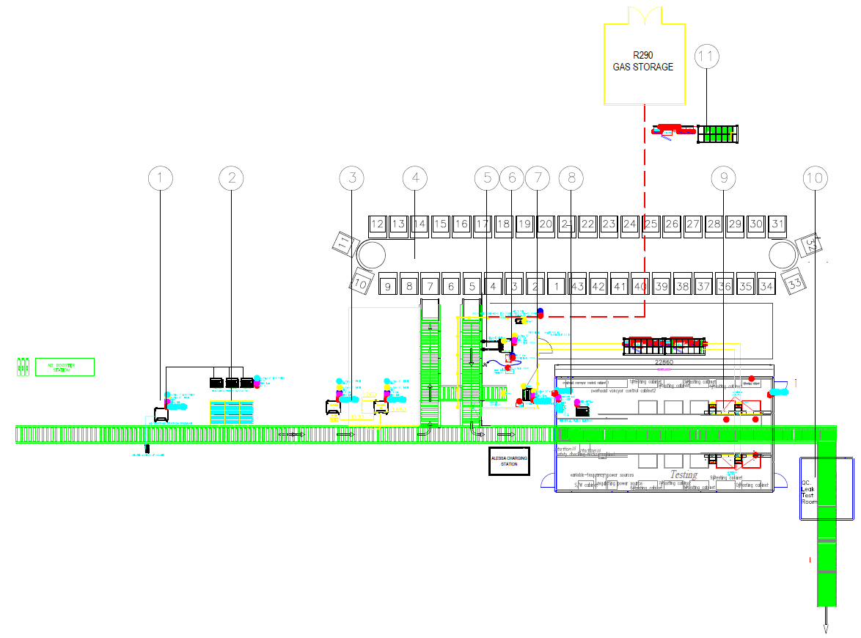
Figure A3.1. An aerial view of the Installed manufacturing line
The different stations enumerated on Figure include:
- Pressure testing with Nitrogen
- Pre-evacuation
- Helium leakage testing
- Pre-charging evacuation
- Charging
- Leakage testing
- Maintenance area rejected units
- Electrical testing
- Full performance testing
- Quality control leakage testing package units
- Outside of the building refrigerant HC-290 storage and pumping station

Table 18: Incremental capital cost for Room AC production line conversion from HCFC-22 to HC-290
Item | Description | ICC USD / Quantity
Heat Exchanger Manufacturing |  | $135,000
Helium, nitrogen testing heat exchangers | High pressure testing with measurement for leakage | 2
Pressure testing equipment | Pressurisation and measurement of the pressure decay with data registration on the production line | 2
Helium leakage testing | Helium leakage tester | 2
Helium recovery unit | Helium recovery unit for recovering the helium used for leakage testing heat exchangers | 1
Lab Equipment |  | $51,250
Lockring kit | Lockring wrench and set of pipe connections | Set
Evacuation | EX vacuum pump with vacuum measurement and evaluation unit | 1
Leakage testing | Leakage testing (e.g. Inficon model HLD 6000 or similar) R290, the unit must be easily mobile to be used in different area of the laboratory | 1
Hand held gas sensor | Hand held gas sensor for R290 to be used in the laboratories | 1
EX ventilator | EX ventilator (3000 m3/h) with flexible hose. The hose would then be placed in the area where required and ventilator manually started upon alarm of gas sensor. Length of hose app. 10 m | 1
Torque wrench | Torque wrench with digital indicator of applied torque | 1
Real life testing equipment |  | $18,750
Data Logger | Datalogger, software and PC for recording of the measurement data | Set
Room temperature sensor | Temperature sensors to be placed inside the room | 3x4
Room humidity sensor | Sensor for measuring the room humidity | 3x1
Air Conditioning temperature sensor | Temperature sensors to be placed on the pipes of the air conditioner | 3x3
AC pressure sensor | Pressure sensors to be placed on schraeder valve | 3x2
AC energy consumtion | Power consumption measurement 220 V / 50 Hz | 3
External environment temperature, humidity and air pressure unit | External ambient measurement of temperature, humidity and pressure | 1
Air flow sensor | For measurement of evaporator air flow | 3x1
Production line equipment |  | $470,000
Pressure testing equipment | Pressurisation and measurement of the pressure decay with data registration on the production line | 1
Evacuation | Vacuum pumps with vacuum measurement and data registration | 3
Refrigerant charging | for R290 as well as suitable for HFO, charge per unit max 150 - 600 gram | 1
Protective fence | Around charging unit protective fence and evacuation of app. 4x4 m | 1
U-welding | Ultrasonic welding tool | 1
Leakage testing | Multi gas leak tester for as well as R290 and HFO (HFO type still to be determined) on the production line | 2
Electrical safety testing | with earth, flash etc. tests | 1
Performance testing | Dataloggers. 1 PC 2 x pressure, 2 x temperature, humidity, air flow, power (out and indoor unit) | 3
Final leak testing | handheld units for checking the packaged goods | 2
Repair area | Ex Vacuum pump | 1
Refrigerant storage and supply | Refrigerant gas cylinders earth connection | 2
 | Gas cylinder connection to refrigerant pump | 2
 | Gas cylinder switch over unit for pairs of gas cylinders | 1
 | Gas cylinder weighing for verification that sufficient refrigerant is available, can be combined with switch over unit | 2
 | Refrigerant supply pumps for R290 and HFO | 1
 | Piping to production with pressure control and monitoring | set
 | Control unit | 1
Safety system | Safety control cabinet | 1
 | Gas sensors | 10
 | Evacuation ventilators, storage, charging, performance testing, leak test room | 4
 | Potential free contacts for switch-of power supply to different areas | 6
 | Evacuation ducts engineering | Set
Workstations | Model A. pressure testing with protective "cover" | 1
 | Model A. evacuation | 3
 | Model A. performance testing | 3
 | Model B. leak testing with rotating table | 2
 | Model B. E-safety test | 1
 | Model C. Repair area | 1
Spare parts |  | $32,500
Training and technical assistance |  | $100,000
Transportation |  | $17,500
Total |  | $660,000

Decision XXVIII/3 recognizes the opportunities and appreciates co-benefits: “Recognizing that a phase-down of hydrofluorocarbons under the Montreal Protocol would present additional opportunities to catalyse and secure improvements in the energy efficiency of appliances and equipment, Noting that the air-conditioning and refrigeration sectors represent a substantial and increasing percentage of global electricity demand, Appreciating the fact that improvements in energy efficiency could deliver a variety of co-benefits for sustainable development, including for energy security, public health and climate mitigation, Highlighting the large returns on investment that have resulted from modest expenditures on energy efficiency, and the substantial savings available for both consumers and Governments”.
Brazil and Yemen have not requested enabling activities to date. Those two countries have not sent letters of intent to ratify the Kigali Amendment to the MLF Secretariat
This includes projects funded by the additional, voluntary contributions amounting of over US$ 25.5 million from a group of donor countries to finance fast-start activities for the implementation of the HFC phase-down.
https://globalcoolingprize.org
See Annex 2 for further details about the allowable charge. For example, up to 414 grams of HC-290 can be used in a 30 m² room.
The revision process started in 2015 and is currently in the CDV stage. At the approval stage, the Committee Draft for Vote (CDV) is submitted to all National committees for a 12 weeks voting period. Publication is expected in 2021.
HC-600a is more efficient compared with HC-290; however, it is currently being limited to small ice cream cabinets due to compressor size limitation.
https://globalcoolingprize.org/
Split incentives refer to the fact that initial purchase is driven by first cost since the electric utility cost savings are not impacting the buying decision.
UNEP/OzL.Pro/ExCom/76/46
SASO planned MEPS are 12.4 at T1 (35°C ambient conditions) and 9.3 at T3 (46°C ambient conditions)
Having cooling capacity generally less than 1 kW.
Quantity and ICC variations are related to the production line volume, manufacturer location, and level of manufacturer development
Midea U-Shaped Window AC with HFC-32. https://www.midea.com/us/Air-Conditioners/Window-Air-Conditioners/10,000-BTU-U-shaped-Air-Conditioner-MAW10V1QWT
An example is the joint venture Daikin – Gree which was set up in 2008 where Daikin shared its energy efficiency expertise with Gree. https://www.daikin.com/press/2009/090218/
International Copper Alliance (ICA) is active in promoting energy efficiency in terms of policy improvement in ASEAN. Because an energy efficiency AC needs more copper e.g. for heat exchanger. http://www.aseanshine.org/asean-shine-task-force/d/capacity-building-of-ac-manufacturers
Air conditioner technology improvement educational videos are also available. http://www.aseanshine.org/videos/c/air-conditioner-technology-improvement-educational-videos
The term "standard" has different meanings in different countries. Standards can be voluntary or mandatory, depending on whether there is a legislation, and how the legislation deals with it. For example, India’s Bureau of Energy Efficiency has introduced voluntary requirements for newly covered products, which later became mandatory. Local regulations on energy efficiency affect the technologies in the market and can improve accessibility or create barriers to high-efficiency products with lower-GWP refrigerants.
In the EU, a standard is “voluntary”, compared to “legislation” which is mandatory. While “MEPS” includes the word “Standard” it does refer to something that would be mandatory. For this report, MEPS would mean a mandatory or voluntary (self-regulating) requirement, which would need to be embedded in the local legislation, and not just as a voluntary standard.
India had different ISEER requirements for non-inverters and inverters in the past, but later put them under the same requirement.
https://beeindia.gov.in/sites/default/files/BEE_Final%20Report_Website%20version.pdf
https://united4efficiency.org/resources/model-regulation-guidelines-for-energy-efficient-and-climate-friendly-air-conditioners/
https:??www.iecee.org/about/cb-scheme/
Cooling as a Service. https://www.caas-initiative.org/
Draft Order 2019-059 referring to Decree No. 904/PR/PM/MERH/2009
RDL is supported by many association and institutes such as Brazilian trade association that represents refrigeration, air conditioning, ventilation, heating, and air treatment equipment manufacturers (ABRAVA); Colombian air conditioning and refrigeration association that represents business, institutes, professional members, technicians, correspondents, and students in the industry (ACAIRE ), Air conditioning and Refrigeration European Association (AREA), Air conditioning and Refrigeration Equipment Manufacturers Association of Australia(AREMA), American Society of Heating, Refrigerating and Air-Conditioning Engineers (ASHRAE), European Partnership for Energy and the Environment (EPEE), and Japan Refrigeration and Air Conditioning Industry Association (JRAIA).
https://data.worldbank.org/indicator/IC.ELC.OUTG?end=2019&locations=NG&start=2006
North Africa (Algeria, Egypt, Morocco, and Tunisia), West Africa (Ghana and Nigeria), East Africa (Ethiopia, Kenya, and Tanzania), and Southern Africa (South Africa)
This could be promoted by a Certification Boddy (CB) Scheme. CB is a multilateral agreement among participating countries and certification organizations, which aims to facilitate trade by promoting harmonization of national standards with International Standards and cooperation among accepted National Certification Bodies (NCBs) worldwide. By achieving this, it brings product manufacturers a step closer to the ideal concept of "one product, one test, one mark, where applicable'
Currently available HFC Outlook models for Article 5 countries: Bahrain, Bosnia and Herzegovina, Dominican Republic, Gabon, Guatemala, Honduras, Kuwait, Mali, Senegal, Sri Lanka
Whilst a sophisticated model is an obvious advantage, setting up a model for an individual country or for a larger region takes a significant amount of effort (to collect good quality input data) and making best use of the model requires some training and expertise.
The Kigali baseline for an Article 5 Group 1 country is the sum of: - 65% of average HCFC consumption in 2009 and 2010 - plus 100% of average HFC consumption from 2020 to 2022 (all measured in tonnes CO₂e) In Figure 15, these baseline amounts are plotted in the relevant years and the total baseline is plotted during the freeze period, which is 2024 to 2028 for an Article 5 Group 1 country.
An English translation of the draft Regulation is available at the following link for reference purposes: http://www.igsd.org/china-releases-public-comment-version-of-amendment-to-the-national-regulation-on-administration-of-ozone-depleting-substances/.
The Green and High-Efficiency Cooling Action Plan (绿色高效制冷行动方案) states: “Promulgation and amendment of product and safety standards for environment-friendly refrigerants utilized by the cooling industry will be accelerated in order to promote the deployment of low global warming potential (GWP) refrigerants... As a trial, information will be added such as energy efficiency forerunners and refrigerant GWP on the energy efficiency labels of the main cooling products... Increase research and development of environment-friendly refrigerants and actively promote the reuse and safe disposal of refrigerants. Ensure implementation of the Regulation on Ozone-Depleting Substances Management and the Montreal Protocol, and guide enterprises to quickly convert to AC production lines that use low-GWP refrigerants, accelerate phaseout of hydrochlorofluorocarbon (HCFC) refrigerants, and limit usage of hydrofluorocarbons (HFCs). Cooling product manufacturers are encouraged to build green factories and strictly control refrigerant leaks and emissions during production processes... In addition, technical assistance, low-interest loans, and grants from international financial institutions can be used to raise cooling efficiency and promote environmental-friendly refrigerant alternatives.”
https://www.gob.mx/semarnat/documentos/hoja-de-ruta-para-implementar-la-enmienda-de-kigali-en-mexico
https://unfccc.int/event/preparing-new/updated-ndcs-in-2020-experiences-and-lessons-learned
https://www.k-cep.org/insights/news/enhanced-ndcs-feature-crucial-solution-for-turning-down-global-temperatures/
https://www.jerrykelly.com/blog/7-issues-that-affect-the-energy-efficiency-of-your-air-conditioner
www.carbontrust.com
According to a representative of the National Ozone Office at the Ministry of Environment. Quoted at: https://clasp.ngo/updates/2019/kenyas-new-ac-standards-increase-efficiency-baseline-while-reducing-harmful-refrigerants
https://pib.gov.in/Pressreleaseshare.aspx?PRID=1537124
Default setting is the setting at which a room air conditioner comes from the factory. Therefore, when the room air conditioner is switched on it will have a pre-set temperature of 24°C. However, a user can adjust or set the air conditioner at a lower (or higher) temperature.
https://pib.gov.in/PressReleasePage.aspx?PRID=1598508
Manu, S., Shukla, Y., Rawal, R., Thomas, L., & de Dear, R. (2016, March). Lab studies of thermal comfort across multiple climate zones for the subcontinent: India Model for Adaptive Comfort (IMAC). Building and Environment, 98, 55-70.
Kumar, S., Sachar, S., Kachhawa, S., Singh, M., Goenka, A., Kasamsetty, S., George, G., Rawal, R., Shukla, Y. (2018). Projecting National Energy Saving Estimate from the Adoption of Adaptive Thermal Comfort Standards in 2030. New Delhi: Alliance for an Energy Efficient Economy
Sachar, S., Goenka, A., Kumar, S. (2018). Leveraging an Understanding of RAC Usage in the Residential Sector to Support India’s Climate Change Commitment. Presented at ACEEE Summer Study 2018, Asilomar, California, US.
https://www.topten.eu/private/page/pro-cold
http://www.iifiir.org/userfiles/file/publications/notes/NoteTech_28_EN.pdf
https://www.realalternatives.eu/learning-platform
https://www.natex.org/site/1/Homehttp://
www.aham.org/AHAM/Safety/Safe_Servicing_of_Cold_Appliances/AHAM/Safety/Safe_Servicing_of_Cold_Appliances.aspx?hkey=23d1344d-f8b0-410a-9e21-8181048b2b82

