MONTREAL PROTOCOL ON SUBSTANCES THAT DEPLETE THE OZONE LAYER
Report Of The
Technology And Economic Assessment Panel

September 2026

Volume 4: Supplement to the May 2026 TEAP Replenishment Task Force Report
“Assessment of the Funding Requirement for the Replenishment of the Multilateral Fund for the Period 2027–2029”


Montreal Protocol on Substances that Deplete the Ozone Layer
United Nations Environment Programme (UNEP)
Technology and Economic Assessment Panel
Replenishment Task Force

September 2026

Volume 4: Supplement to the May 2026 TEAP Replenishment Task Force Report “Assessment of the Funding Requirement for the Replenishment of the Multilateral Fund for the Period 2027–2029”

The text of this report is composed in Times New Roman.

Co-ordination: TEAP Decision XXXVII/6 Replenishment Task Force
Composition of the report: Suely Carvalho and Bella Maranion
Date: September 2026

Under certain conditions, printed copies of this report are available from:

UNITED NATIONS ENVIRONMENT PROGRAMME
Ozone Secretariat
P.O. Box 30552
Nairobi, Kenya

This document is also available in portable document format from the UNEP Ozone Secretariat's website:
https://ozone.unep.org/science/assessment/teap

No copyright involved. This publication may be freely copied, abstracted and cited, with acknowledgement of the source of the material.

ISBN: 978-9914-733-71-6

Disclaimer
The United Nations Environment Programme (UNEP), the Technology and Economic Assessment Panel (TEAP) Co-chairs and members, the Technical Options Committees Co-chairs and members, the TEAP Task Forces Co-chairs and members, and the companies and organisations that employ them do not endorse the performance, worker safety, or environmental acceptability of any of the technical options discussed. Every industrial operation requires consideration of worker safety and proper disposal of contaminants and waste products. Moreover, as work continues - including additional toxicity evaluation — more information on health, environmental and safety effects of alternatives and replacements will become available for use in selecting among the options discussed in this document.
UNEP, the TEAP Co-chairs and members, the Technical Options Committees Co-chairs and members, and the TEAP Task Forces Co-chairs and members, in furnishing or distributing this information, do not make any warranty or representation, either express or implied, with respect to the accuracy, completeness, or utility; nor do they assume any liability of any kind whatsoever resulting from the use or reliance upon any information, material, or procedure contained herein, including but not limited to any claims regarding health, safety, environmental effect or fate, efficacy, or performance, made by the source of information.
Mention of any company, association, or product in this document is for information purposes only and does not constitute a recommendation of any such company, association, or product, either express or implied by UNEP, the TEAP Co-chairs or members, the Technical Options Committee Co-chairs or members, the TEAP Task Forces Co-chairs or members or the companies or organisations that employ them.

Acknowledgements
The Technology and Economic Assessment Panel, its Technical Options Committees and the TEAP Task Force Co-chairs and members acknowledge with thanks the outstanding contributions from all the individuals and organisations that provided support to Panel, Committees and TEAP Task Force Co-chairs and members. The opinions expressed are those of the Panel, the Committees and TEAP Task Forces and do not necessarily reflect the reviews of any sponsoring or supporting organisation.

Foreword
The TEAP Decision XXXVII/6 Replenishment Task Force:
Co-chairs | Affiliation | Country
Suely Carvalho | TEAP Senior Expert | Brazil
Bella Maranion | TEAP Co-chair | United States of America (USA)
Members
Omar Abdelaziz | Refrigeration, Air Conditioning, and Heat Pumps Technical Options Committee (RTOC) Co-chair | Egypt
Adam Chattaway | Fire Suppression Technical Options Committee (FSTOC) Co-chair | United Kingdom (UK)
Sukumar Devotta | TEAP Senior Expert | India
Gabrielle Dreyfus | RTOC Member | USA
Bassam Elassaad | TEAP Senior Expert and RTOC Member | Lebanon
Carlos Froes Lima | Independent consultant | Brazil
Marco Gonzalez | TEAP Senior Expert | Costa Rica
Mary Najjuma | Independent consultant | Uganda
Marta Pizano | TEAP and Methyl Bromide Technical Options Committee (MBTOC) Co-chair | Colombia
Pallav Purohit | RTOC Member | India
Rajan Rajendran | RTOC Co-chair | USA
Bettina Schreck | Medical and Chemical Technical Options Committee (MCTOC) Member | Argentina
John Telesford | Independent consultant | Grenada
Helen Tope | MCTOC Co-chair | Australia
Helen Walter-Terrinoni | Flexible and Rigid Foams Technical Options Committee (FTOC) Co-chair | USA
Shiqiu Zhang | TEAP Senior Expert | People’s Republic of China
Consulting Expert
Rick Cooke | MCTOC Member | Canada

UNEP
Report of the
TEAP Decision XXXVII/6 Replenishment Task Force
September 2026 Report

TABLE OF CONTENTS
Disclaimer iv
Foreword v
EXECUTIVE SUMMARY 1
CHAPTER 1 INTRODUCTION 13
1.1 Terms of reference 13
1.2 Scope and coverage 13
1.3 TEAP May 2026 report and OEWG-48 14
1.4 Approach to supplementary report 16
CHAPTER 2 Update to RTF may 2026 report for estimated funding requirement for 2027–2029 triennium and future triennia 2030-2032 and 2033-2035 19
2.1 Introduction 19
2.2 Updated HCFC phase-out estimated funding for 2027-2029 and future triennia 20
2.3 Updated HFC phase-down funding requirement for 2027-2029 and future triennia 24
2.4 Institutional strengthening and standard activities 28
2.5 Summary of updated estimated funding for 2027-2029 and future triennia 2030-2032 and 2033-2035 29
CHAPTER 3 Additional information and scenarios: overall suggestions/methodological approach 31
3.1 Introduction 31
3.2 HPMPs New Scenarios applying CE factors 32
3.3 HFC New Scenarios applying CE factors 40
3.4 Additional scenarios for KIPs 45
3.5 Summary of updated ranges of total funding requirement for HCFC and HFC activities in 2027-2029 triennium 51
CHAPTER 4 ADDITIONAL INFORMATION AND SCENARIOS: LVCS/VLVCs 53
4.1 Introduction 53
4.2 Scenario: Possible increase for LVC and VLVC countries for KIPs Stage II 53
4.3 Capacity of LVC and VLVC parties to absorb increased funding 55
4.4 Additional considerations for funding KIP Stage II 56
CHAPTER 5 ADDITIONAL INFORMATION AND SCENARIOS: Lifecycle Refrigerant Management 58
5.1 Introduction 58
5.2 Estimated cost scenario for potential funding window 58
ANNEX 1: LIST OF PARTIES PENDING RATIFICATION OF THE KIGALI AMENDMENT (as of 10 AUGUST 2026) 62
ANNEX 2: ESTIMATED FUNDING METHODOLOGY FOR HCFC CONSUMPTION SECTOR (UPDATED RTF May 2026 report) 63
A2.1 Sources of Information 63
A2.2 HCFC Phase-out funding methodology for the consumption sector 64
A2.3 Verification costs for HPMPs 70
A2.4 Project preparation for HPMPs 70
A2.5 Energy efficiency (Decision 89/6) 71
A2.6 Updated estimated funding requirement for the total HCFC consumption sector phase-out 71
ANNEX 3: METHODOLOGY TO ESTIMATE FUNDING REQUIREMENTS FOR HFC PHASE-DOWN IN THE CONSUMPTION SECTOR (UPDATED RTF May 2026 Report) 73
A3.1 Sources of information 73
A3.2 HFC Phase-down funding methodology for the consumption sector 73
A3.3 HFC Scenario 1 updated estimated funding 79
A3.4 HFC Scenario 2 updated estimated funding 83
A3.5 Verification: Consumption sector 87
A3.6 Project preparation: consumption sector 87
A3.7 Energy efficiency (decisions 91/65, 94/60, and 95/87) 87
A3.8 Pilot projects to enhance regional atmospheric monitoring 89
A3.9 Updated total estimated funding requirement for the HFC consumption sector 91
Annex 4: MLFS information to support new scenario 1c : CE based on average funding levels for each a5 party over the past six years 95
ANNEX 5: Fixed-cost and activity-based scale-up analyses 97
A5.1 Fixed-cost analysis 97
A5.2 Activity-based scale-up analysis 98
A5.3 Bracket-level calculations 100
A5.4 Aggregate results and interpretation 103
ANNEX 6: Description of LRM calculation model 105
A6.1 Module 1 – Recovery 105
A6.2 Module 2–Reclamation 109
A6.3 Module 3 – destruction - generates conditions for destruction, by enabling local facilities to destroy F-gases 111
Annex 7: project preparation for kips and cost details 115

ACRONYMS
A5 Article 5
A7 Article 7
AC Air conditioning
ACC Additional capital cost
AOC Additional operating cost
ASP Asia and the Pacific
BAT Best-available technology
BAU Business-as-usual
BP Business Plan
CAP Compliance Assistance Programme
CE Cost-effectiveness
EE Energy Efficiency
EPR Extended Producer Responsibility
ExCom Executive Committee of the Multilateral Fund
FERM Fixed-exchange-rate mechanism
EOL End-of-life management and disposal
GCF Green Climate Fund
GEF Global Environment Facility
GTF General Trust Fund
GWP Global Warming Potential
HCFC Hydrochlorofluorocarbon
HFC Hydrofluorocarbon
HFO Hydrofluoroolefin
HPMP HCFC Phase-out Management Plan
HPPMP HCFC Production Phase-out Management Plan
IBRD International Bank for Reconstruction and Development (World Bank)
ICR Industrial and Commercial Refrigeration
IOC Incremental operating costs
IS Institutional Strengthening
KA Kigali Amendment
KIPs Kigali HFC Implementation Plans
KPPMP Kigali HFC Production Phase-down Management Plan
LVC Low-volume consuming
MAC Mobile Air Conditioning
MEPS Minimum Energy Performance Standards
MLF Multilateral Fund
MLFS Multilateral Fund Secretariat
MMTCO₂eq Million metric tonnes carbon dioxide equivalent
MT Metric tonnes
MOP Meeting of the Parties
MYA Multi-year Agreement
NOU National Ozone Unit
NPP National Phase-out Plans
ODP Ozone depletion potential
ODS Ozone-depleting substances
OEWG Open-Ended Working Group
OS Ozone Secretariat
PIC Prior Informed Consent
PMU Project Management Unit
PRP Project Preparation
PUR Polyurethane
RAC Refrigeration and Air Conditioning
RACHP Refrigeration Air-conditioning and Heat-pump
RTF Replenishment Task Force
RMP Refrigerant Management Plan
RTOC Refrigeration, Air Conditioning and Heat Pumps Technical Options Committee
SA Standard Activities
SMEs Small and Medium-sized Enterprises
TEAP Technology and Economic Assessment Panel
TOR Terms of reference
TOC Technical Options Committee
UNDP United Nations Development Programme
UNEP United Nations Environment Programme
UNIDO United Nations Industrial Development Organization
VER Verification
VLVC Very low-volume consuming
XPS Extruded Polystyrene

EXECUTIVE SUMMARY

The replenishment of the Multilateral Fund (MLF) for the Montreal Protocol on Substances that Deplete the Ozone Layer for the 2027-2029 triennium will provide financing to Article 5 (A5) parties for the incremental costs of completing the phase-out of ozone-depleting substances (ODS) and continuing the phase-down of hydrofluorocarbons (HFCs). Annex C Group I (hydrochlorofluorocarbons (HCFCs) and Annex F (HFCs) substances are the only substances under the Montreal Protocol where consumption and production are still allowed.
- For Annex C, Group 1, controlled substances (HCFCs), the compliance target for the 2027-2029 triennium for A5 parties is a 97.5% reduction from baseline by 1 January 2030.
- Annex F controlled substances (HFCs), the compliance targets for the 2027-2029 and the subsequent two triennia for A5 parties are as follows:
  - Group 1 parties: A 10% reduction from baseline by 1 January 2029 and a 30% reduction from baseline by 1 January 2035.
  - Group 2 parties: A freeze of production and consumption by 1 January 2028 and a 10% reduction from baseline by 1 January 2032.
At the Thirty-seventh Meeting of the Parties to the Montreal Protocol (MOP-37), parties adopted Decision XXXVII/6 which provided the terms of reference (TOR) for the work of the Technology and Economic Assessment Panel (TEAP) to prepare a report on the appropriate level of the replenishment of the MLF for the triennium 2027-2029. The parties requested the TEAP to prepare a report for submission to MOP-38, and presentation to the Open-ended Working Group at its Forty-eighth Meeting (OEWG-48), to enable parties at MOP-38 to take a decision.
The TEAP established a Decision XXXVII/6 Replenishment Task Force (RTF), with members from TEAP, its Technical Options Committees, and other outside experts. The RTF presented its “May 2026 TEAP Decision XXXVII/6 Replenishment Task Force Report” (May 2026 Report) at OEWG-48 and responded to clarifying questions from parties. Subsequently, the Working Group established a Contact Group to further consider the report. During the discussions, the RTF provided clarification and additional information for the members of the Contact Group. The Contact Group then discussed several topics and agreed on a list of suggestions for additional analysis to be addressed by the RTF in a supplementary report on MLF replenishment for the period 2027-2029.
Table ES.1 indicates the relevant chapters of this report where the suggestions are addressed.

Table ES.1: Suggestions/Scenarios: Potential changes to funding requirement for 2027–2029
Item | Suggestions/Scenarios | Relevant chapter
ExCom-98 Decisions
1 | Adjust all elements of the funding requirements based on relevant decisions taken at the 98th meeting of the Executive Committee and make any additional necessary updates to accurately reflect amounts in approved HCFC Phase-out Management Plans (HPMPs) and Kigali Implementation Plans (KIPs); | 2
Overall Suggestions
2 | When estimating the funding requirements for HPMPs and KIPs, apply CE factors according to three scenarios:  - one based on historical Cost-effectiveness (CEs);  - a second one based on CE factors for each A5 party over the past 6 years; and  - a third one based on average funding levels for each A5 party over the past 6 years | 3
3 | To request the Panel to present revised funding ranges with alternative scenarios that assess the impact of the following:  - A low-end scenario based on the most recently reported consumption data for HCFCs and HFCs and a high-end scenario based on established HFC baselines and HCFC remaining eligible consumption | 3
3 | - Realistic project implementation timelines such as modifying resources allocation schedule A for Stage II KIPs and to take into account rates of ratification for remaining non-parties to the Kigali Amendment | 3
3 | - HFC-23 mitigation scenarios that account for the ongoing operating costs, IOCs of approved MLF projects | 2
3 | - A low-end scenario for energy efficiency (EE) (decision 94/60) based on projects included in the business plan of the MLF and a high-end scenario reflecting full utilization of remaining funds in the 94/60 funding window aimed at promoting EE improvements in the context of the HFC phase down in the next triennium | 2
3 | - The distribution of funding across different levels of country consumption to address the needs of A5 parties to enable compliance is adequately reflected | 2
Low Volume Consuming (LVCs) and Very Low Volume Consuming (VLVCs) Parties
4 | To provide a high-end scenario for a possible increase to the funding estimate in the resource allocation tables in chapter 3 for LVC and VLVC countries for Stage II of their KIPs, in consultation with the MLF secretariat, taking into account the capacity of those countries to absorb increased funding | 4
Lifecycle Refrigerant Management (LRM)
5 | Include a cost estimate for a high-end scenario for the potential funding window to be considered at the 100th ExCom meeting for the period 2027-2029 to support the implementation of national plans developed pursuant to decision 91/66, taking into account that activities to recover, recycle and reclaim refrigerants are also financed under HPMPs and KIPs | 5

Approach to Supplementary Report
For this supplementary report (September 2026 Report), the RTF’s approach was to first update its estimates using the same modelling approach as in its May 2026 Report (TEAP, 2026) with updated data and available information since that report was finalised, including the following:
- ExCom documents and decisions, including cost guidelines, up to and including ExCom-98;
- A7 consumption data as reported to the Ozone Secretariat (OS), as of 17 July 2026;
- Country Programme data submitted to the MLF Secretariat (MLFS), as of 17 July 2026;
- Information provided by the MLFS on approved HCFC Phase-out Management Plans (HPMPs) and Kigali HFC Implementation Plans (KIPs), including agreed reductions from baseline consumption, funding and tranche schedules, project preparation and verification activities, as well as updated information on HFC-23 mitigation and energy efficiency (EE) and the status of funding windows;
- Maintained the classification of low-volume consuming countries (LVCs) based on HCFC and HFC baseline consumption (as presented in Annex 5 of the RTF May 2026 Report);
- RTF continued to rely on the Consolidated Business Plan of the Multilateral Fund for 2026-2028 (BP), as the 2027-2029 Business Plan is not yet available, and would only be available once the MLFS finalises the (pre-session) 2027-2029 business plan;
- Parties’ ratification status of the Kigali Amendment (KA), as of 10 August 2026 (Annex 2 of this report);
- Included applicable project management unit (PMU) costs to non-LVC parties (5 % for the largest consuming A5 party, 7% for the next top 10 A5 consuming parties, and 10% for remaining A5 parties) (not included in the RTF May 2026 Report);
- Maintained the estimates for institutional strengthening and standard activities (IS and SA) as in the RTF May 2026 Report; and
- Continued to apply average 9.6% for agency support costs and 15% discount for foreign ownership for manufacturing sectors.

With the above updates, the RTF May 2026 Report is referred to as the “Updated RTF May Report”.

Once the above updates to funding estimates were made, then RTF addressed the suggestions from OEWG-48, described in the remaining chapters of this report.

UPDATES TO THE RTF MAY 2026 REPORT
Chapter 2 of this report provides further discussion and the updated estimates as in Table ES.2 below based on the above information and assumptions. RTF notes that these updates also incorporate the following suggestions from parties from OEWG-48 as in Table ES.1:
- Adjust all elements of the funding requirements based on relevant decisions taken at the 98th meeting of the Executive Committee and make any additional necessary updates to accurately reflect amounts in approved HPMPs and KIPs;
- HFC-23 mitigation scenarios that account for the ongoing operating costs, IOCs of approved MLF projects;
- A low-end scenario for EE (decision 94/60) based on projects included in the business plan of the MLF and a high-end scenario reflecting full utilization of remaining funds in the 94/60 funding window aimed at promoting EE improvements in the context of the HFC phase down in the next triennium; and
- The distribution of funding across different levels of country consumption to address the needs of A5 parties to enable compliance is adequately reflected.

Important to note that the model developed by RTF to estimate funding needs already considers the last suggestion, therefore, no further action was taken by RTF to address this suggestion.

The updated ranges of total estimated funding requirements based on the updated information as provided in Chapter 2 for the triennium 2027-2029 are shown in Table ES.2.

Table ES.2: Updated ranges of total funding requirement for the replenishment of the MLF 2027–2029 (US$ million)
2027-2029 Triennium | May 2026 Report Estimates | Updated May Report Estimates
SUBTOTAL – HCFC ACTIVITIES | 451 – 573 | 437 – 564
SUBTOTAL – HFC ACTIVITIES | 702 – 1,053 | 664 – 999
SUBTOTAL – IS & SA | 129 | 129
GRAND TOTAL  (US$ million) | 1,282 – 1,755 | 1,230 – 1,692

The funding ranges for the Updated May Report applied the same HCFC and HFC scenarios and proposed resource allocations as in the RTF May 2026 Report.

- The updated range for the total estimated funding requirement (including support costs) for the replenishment of the MLF in the 2027–2029 triennium is US$ 1,230 – 1,692 million.

OEWG-48 CONTACT GROUP SUGGESTIONS AND RTF APPROACH

In Chapters 3, 4, and 5 of this report, the RTF addresses the suggestions from parties at OEWG-48 for additional funding scenarios. Given the varied scenarios requested by parties, the RTF presents these scenarios without presuming which ones the parties may wish to use, combine, or discard. The range of funding for this triennium would then be dependent on these choices. Prior to addressing the OEWG-48 new scenarios, RTF had consultations with the MLFS to discuss the approach and clarify information the Secretariat provided.

Following parties' guidance and discussions at OEWG-48 and understanding the need to present a wider range of funding to guide parties at MOP-38, the RTF applied the new CEs (and other parameters requested in the new scenarios), mostly to the low-end of the funding range, unless the suggestion specifically instructs the application to the high-end estimated funding, such as in the suggested new LVCs/VLVCs scenario.
The updates to the RTF May 2026 Report, as presented in Chapter 2, provide the basis for the new scenarios. As an example, the use of the Updated RTF May Report model as a Scenario 1 allowed RTF to compare low-end funding ranges with the new estimates from the OEWG-48 suggested scenarios.
RTF named the new scenarios suggested by the OEWG-48 as indicated in Table ES.3.

Table ES.3: OEWG-48 suggestions and new scenarios
OEWG-48 Suggestions | New Scenarios
Overall Suggestions
- When estimating the funding requirements for HPMPs and KIPs, apply CE factors according to three scenarios:  - one based on historical Cost-effectiveness (CEs); | 1a: HPMP and KIPs
- a second one based on CE factors for each A5 party over the past 6 years; and | 1b: HPMP and KIPs
- a third one based on average funding levels for each A5 party over the past 6 years | 1c: HPMP and KIPs
- To request the Panel to present revised funding ranges with alternative scenarios that assess the impact of the following:  - A low-end scenario based on the most recently reported consumption data for HCFCs and HFCs and a high-end scenario based on established HFC baselines and HCFC remaining eligible consumption | 2a: HPMP and KIPs
- Realistic project implementation timelines such as modifying resources allocation schedule A for Stage II KIPs and to take into account rates of ratification for remaining non-parties to the Kigali Amendment | 2b: KIPs
LVCs and VLVCs
To provide a high-end scenario for a possible increase to the funding estimate in the resource allocation tables in chapter 3 for LVC and VLVC countries for Stage II of their KIPs, in consultation with the MLF secretariat, taking into account the capacity of those countries to absorb increased funding | LVCs/VLVCs
LRM
Include a cost estimate for a high-end scenario for the potential funding window to be considered at the 100th ExCom meeting for the period 2027-2029 to support the implementation of national plans developed pursuant to decision 91/66, taking into account that activities to recover, recycle and reclaim refrigerants are also financed under HPMPs and KIPs | LRM

ADDRESSING NEW OEWG-48 SUGGESTED NEW SCENARIOS

HCFC New Scenarios

The low-end funding range for all HCFC activities for the 2027-2029 triennium, with 90% resource allocation applied and using as Scenario 1 the “Updated RTF May Report”, is US$ 437 million, which includes US$ 408 million for HPMPs (without funding for production sector, project preparation, verification, and EE for LVCs). For the application of the new CEs in scenarios, the estimated funding for the production sector, project preparation, verification, and EE were modelled separately and included in the final funding figures. As these amounts remain constant across all scenarios, they are presented only in the final total funding estimate and do not affect the modelling conditions or the comparison of results among scenarios.

New Scenarios for HCFCs applying CE factors based on 1a) historical CEs, 1b) CE factors for each A5 party over the past 6 years, and 1c) average funding levels for each A5 party over the past 6 years

The results of the new estimates calculated for HCFC activities when applying OEWG-48 New Scenarios 1a, 1b, and 1c for HPMPs, and compared to the Updated RTF May Report estimates are in Table ES.4 below. The three new scenarios are discussed in detail in Chapter 3.

Table ES.4: Summary of estimated funding 2027-2029 for HCFC phase-out applying New Scenarios 1a, 1b, and 1c and compared to Updated RTF May Report estimates (US$ million)
HCFCs Consumption and Production Sector Activities for Low-End Scenario 2027-2029 using 90% Resource Allocation Schedule | Updated RTF May Report Estimates  2027-2029 Triennium | New Scenario 1a (CE historical) | New Scenario 1b (CE past 6 years) | New Scenario 1c (CE average funding past 6 years)
New Scenarios Reduction | NA | 87.10 | 201.8 | 207.1
Total* | 437 | 350 | 235 | 230
*Numbers may differ slightly from figures in Chapter 3 due to rounding.

In summary:
- The impact of the New Scenario 1a-HPMPs (based on the application of historical CE factors) is a reduction of US$ 87.10 million from the Updated RTF May Report Scenario 1 (low-end)”.
- The impact of the New Scenario 1b-HPMPs (based on CE factors for each A5 party over the past 6 years) is a reduction of US$ 201.82 million from the “Updated RTF May Report-Scenario 1 (low-end)”.
- The impact of the New Scenario 1c-HPMPs (CE based on average funding levels for each A5 party over the past 6 years) is a reduction of US$ 207.10 million from the “Updated RTF May Report-Scenario 1 (low-end)”.

Additional New Scenario 2a for HCFCs: A low-end scenario based on the most recently reported consumption data for HCFCs and a high-end scenario based on HCFC remaining eligible consumption

For HCFCs, where the eligible remaining consumption differs from the most recently reported A7 data, the lower of the two values was used in the calculation. The funding estimates and adjustments presented in the “Updated RTF May Report” scenarios and funding ranges, already take this suggestion into consideration. Therefore, the funding estimates presented in the “Updated RTF May Report” are the same for this new scenario.

The new estimated ranges considering all new scenarios are presented in Table ES.5.

Table ES.5: Summary of estimated funding 2027-2029 for HCFC phase-out applying the lowest funding in a New Scenario, compared to the "Updated RTF May Report" estimates (US$ million)
2027-2029 Triennium | Updated May Report Estimates | Supplementary Report Estimates Applying New Scenarios
SUBTOTAL – HCFC ACTIVITIES | 437 – 564 | 230 – 564

The lowest funding estimate is from applying New Scenario 1c, a reduction of US$ 207 million, providing the low-end of the estimated funding range for this RTF Supplementary Report, that is US$ 230 million. The high-end funding estimated of US$ 564 million is kept the same as in the Updated RTF May Report.

- The estimated funding range for HCFC activities for the 2027-2029 triennium is US$ 230-564 million (as in Table ES.5).

KIPs New Scenarios

The OEWG-48 suggestions for New Scenarios 1 (a, b, and c) were also applied for HFCs. The estimates from the Updated May Report as a Scenario 1 (low-end) for the 2027-2029 triennium were used as the basis to compare with the estimates calculated for the CE-based New Scenarios.
New Scenario 1a for KIPs (based on historical CEs)
RTF used the information provided by the MLFS on CEs by investment projects (across different manufacturing sectors for approved KIPs) based on 37 HFC conversion projects in 18 parties. The CE values vary widely, from 2.64 US$/kg for polyurethane (PU) foam to 116.8 US$/kg for mobile air conditioning (MAC). Chapter 3 details the CEs applied and the way RTF used the information provided by the MLFS. In order to estimate funding based on this new scenario, RTF applied the new sector CEs to the model for the “Updated RTF May Report Scenario 1” (low-end), using the same Resource Allocation Schedules A and B.

- The impact of applying new Scenario 1a for KIPs using Allocation Schedule A is a reduction of US$ 65.2 million and using Allocation Schedule B is a reduction of US$ 38 million, as detailed in Chapter 3.

The new funding estimates when applying New Scenario 1a for KIPs are summarised in Table ES.6.

Table ES.6: Summary of the 2027-2029 estimated funding for HFC phase-down applying Historical CEs (US$ million) *
HFCs Consumption and Production Sector Activities for Low-End Scenario 1 Allocation Schedules A and B | Updated May Report  2027-2029  Scenario 1  Resource  Allocation A | New Scenario 1a (CE Historical)  Allocation A | Updated May Report  2027-2029  Scenario 1 Resource Allocation B | New Scenario 1a (CE Historical)  Allocation B
New Scenario 1a Reduction | NA | 65.2 | NA | 38
Total HFC Activities | 962 | 896 | 663 | 625
*Compared with Updated RTF May Report Scenario 1, low-end. Some numbers may differ slightly due to rounding
New Scenario 1b for KIPs: Based on CE factors for each A5 party over the past 6 years
It was not feasible for RTF to address this request for lack of information on CE factors for each A5 party over the past 6 years. While CEs for 37 HFC investment projects in 18 countries in the period 2020-2025 were compiled by the MLFS and shared with RTF, the information was used to calculate the estimated funding under Scenario 1a- for KIPs (historical CE). No additional information was available or could be compiled for each party. Many of the 91 approved KIPs are for LVC countries (with only servicing sector).
New Scenario 1c for KIPs: CEs based on average funding levels for each A5 party over the past 6 years
MLFS provided for each A5 party with approved KIP, the funding level for that KIP for the last 6 years (2020-2025). Information is presented in Chapter 3. From this information, it was not feasible to extract CEs thresholds based on the average funding for each party for the period 2020-2025. The definition of CEs thresholds used by the MLF is sector-based, and generating CEs from funding received in a 6-year period represents a new concept which requires discussion based on proper understanding of its desired output. RTF discussed with the MLFS, and the understanding was that without an ExCom approved metric to define CEs from average funding levels to be applied to all parties, the RTF could only present without further analysis the financial data compiled on the funding amounts per party in the 2020-2025 period. There are a large number of LVCs and smaller countries with KIPs approved; funding information available for approved KIPs does not include the largest HFC consumption party nor all the G1 parties under the “top 10” cluster consumption category (that did not have a KIP approved as of ExCom-97), and none of the G2 parties who do not have an approved KIP. Therefore, RTF could not derive CEs based on funding information that is missing for a significant number of large consuming parties and therefore cannot be representative of all A5 parties.
Table ES.7 summarises the estimated funding for HFC activities comparing the New Scenario 1a for KIPs with the "Updated RTF May Report" and providing a low- and high-end funding range.

Table ES.7: Summary of estimated funding 2027-2029 for HFC phase-down applying New Scenario 1a and compared to Updated RTF May Report estimates (US$ million)

2027-2029 Triennium | Updated May Report Estimates | Supplementary Report Estimates Applying New Scenarios
SUBTOTAL – HFC ACTIVITIES | 664– 999 | 625* – 999
* New Scenario 1a – CE historical for KIPs with Resource Allocation B

Funding ranges for the Updated RTF May Report as in Table ES.2 were selected by considering the low-end and high-end values according to both HFC Scenarios 1 and 2 and their respective Resource Allocations A and B. For this Supplementary Report, ranges considered only Scenario 1(low-end) of the Updated May Report as the basis for comparison with the New Scenarios low-end ranges.

Additional New Scenarios for KIPs

New Scenario 2a for KIPs: A low-end scenario based on the most recently reported consumption data for HCFCs and HFCs and a high-end scenario based on established HFC baselines and HCFC remaining eligible consumption.

To estimate funding for New Scenario 2a, RTF considered the most recently reported A7 HFC consumption data for all parties that had reported data. The Updated RTF May Report methodology considered the Kigali Amendment HFC established baselines. To address Scenario 2a, RTF had to introduce a considerable change in methodology. Nevertheless, for parties with KIPs approved, and because RTF cannot modify the funding commitments nor the agreed percentage reductions targets with the ExCom, the new methodology could not be applied. For A5 parties without KIPs approved, the most recently reported consumption data for HFCs was used, as requested in New Scenario 2a. Chapter 3 presents details on the sector distribution and data used.

- The funding estimated for New Scenario 2a for KIPs indicated a reduction of US$ 146 million and US$ 117 million from the Updated RTF May 2026 report, when applying schedules A and schedule B, respectively.

Scenario 2a is an illustrative sensitivity scenario and is not directly comparable with the main estimated funding range. It involves a considerable change in methodology, including the use of recently reported consumption for Parties without KIPs, while approved KIPs are not recalculated because their funding commitments and agreed reductions have already been established.

New Scenario 2b for KIPs: Realistic project implementation timelines such as modifying resources allocation schedule A for Stage II KIPs and to take into account rates of ratification for remaining non-parties to the Kigali Amendment.
RTF modified the Resource Allocation Schedule A (from RTF May Report) to account for a series of proposed new percentage allocations for the 2027-2029 triennium, using a reduced pace for the introduction of Stage II KIPs, and for the ratification pace applied to the non-parties to the KA (as of 10 August 2026) in both G1 and G2 groups. The new suggested allocation for the consideration of parties is shown in Chapter 3.
- Modifying the KIPs Stage II Resource Allocation Schedule A percentages results in a reduction of US$ 24.9 million, when compared with the estimated funding for the “Updated RTF May Report, Scenario 1” Resource Allocation A.

Additional Information and Scenarios on LVCs/VLVCs and LRM
New Scenario LVCs/VLVCs: "to provide a high-end scenario for a possible increase to the funding estimate in the resource allocation tables in chapter 3 for LVC and VLVC countries for Stage II of their KIPs, in consultation with the MLF secretariat, taking into account the capacity of those countries to absorb increased funding".
Chapter 4 addresses in detail the suggestions from parties at OEWG-48 related to low-volume-consuming and very low-volume consuming (LVC/VLVC) countries. The calculation for the 2027-2029 triennium for a possible increase in resource allocation in comparison to resource allocation schedules A and B of the May 2026 RTF report is shown in Table ES.8.
Table ES.8: Estimated funding for the High-end Resource Allocation New Scenario for KIPs for the 2027-2029 triennium for LVCs/VLVCs (US$ million)
Status | Total Funding | Resource Allocation Schedule A Updated May Report | Resource Allocation Schedule B Updated May Report | High-end  Supplementary Report
Total* | 34.35 | 16.36 | 4.78 | 28.2
*The total (of 73 LVCs/VLVCs) does not consider the 10 countries that have 30% or more reduction in Stage I of the KIP

The US$ 28.2 million estimated represents 82% of the total funding for Stages I and II. In this scenario, the resource allocation for the 2027-2029 triennium is increased by 73% over resource allocation schedule A, and by 491% over resource allocation schedule B of the updated May 2026 RTF Report.
RTF consulted with the MLFS and also discussed, to a limited extent, due to lack of available information, the ability of LVCs/VLVCs to absorb increased funding. The RTF notes that these countries have generally been able to absorb increased levels of funding; however, this capacity varies across countries. Over time, LVCs have absorbed additional funding due to changes in funding level, concurrent implementation of several projects, changes in resource allocation allowing front loading, and to implement additional new activities and projects. Additionally, the harmonisation of activities under the HPMPs and KIPs has allowed the countries and the implementing agencies to optimise their processes and maximise delivery.
New Scenario LRM: "Include a cost estimate for a high-end scenario for the potential funding window to be considered at the 100th ExCom meeting for the period 2027-2029 to support the implementation of national plans developed pursuant to decision 91/66, taking into account that activities to recover, recycle and reclaim refrigerants are also financed under HPMPs and KIPs.”
RTF addresses the OEWG-48 suggestion from parties related to lifecycle refrigerant management (LRM) in Chapter 5. RTF presents a modular approach to calculating the additional funding for implementing the national LRM action plans, designed to complement existing HPMPs and KIPs in supporting the phase-out and phase-down of controlled substances under the Montreal Protocol.
Most servicing-sector infrastructure, training, and institutional strengthening are expected to continue to be funded through HPMPs and KIPs. The proposed supplementary LRM funding window would address critical gaps that prevent countries from transitioning from planning and basic recovery toward scaled recovery, aggregation, recycling, reclamation, and preparation for destruction.
The modular approach considers the different activities needed for LRM, including recovery and collection, reclamation and destruction. The approach allows parties to select interventions based on their level of system development and priority gaps.
Table ES.9 provides a summary of the estimated high-end new scenario cost estimate for LRM activities for a potential funding window for 2027-2029 (more detail and information in Annex 6). It represents a reasonable level of implementation support rather than a forecast of actual expenditure. Annex 6 provides information on the RTF cost model for evaluating the additional costs associated with the different LRM activities.
Table ES.9: Summary of high-end new scenario cost estimate for LRM activities based on RTF cost model
Module | LRM Activities | Additional funding required for A5 parties (US$ million)
Module 1a | Improved recovery rates at servicing | 18.21
Module 1b | Recovery at end-of-life (EOL) | 18.21
Module 2a | Reclamation | 25.92
Module 2b | Export | 7.42
Module 3a | Destruction | 1.00
 | Total | 52.55

The estimated high-end new scenario for a potential funding window for 2027- 2029 triennium is US$ 52.55 million. This is meant to be an illustrative estimate to implement long-term LRM measures identified through national inventories and action plans prepared under Decision 91/66. Sources of potential funding for these activities would be for the consideration and decision of parties.

SUMMARY OF UPDATED RANGES OF TOTAL FUNDING REQUIREMENT BASED ON SUGGESTED NEW SCENARIOS
Table ES.10 summarises the updated ranges of total funding requirements for 2027-2029 and the reduction impact of the application of the new parameters in different scenarios, as suggested by parties at OEWG-48.
Table ES.10: Updated ranges of total funding requirements for the replenishment of the MLF 2027–2029 with Application of New Suggested Scenarios (US$ million)
2027-2029 Triennium | May 2026 Report* Estimates | Updated May Report Estimates | Supplementary Report Estimates applying highest reduction from New Scenarios to low-end** | Supplementary Report Estimates applying Scenario 2a (most recently reported HFC consumption)
SUBTOTAL – HCFC ACTIVITIES | 451 – 573 | 437 – 564 | 230 – 564 | 230 – 564
SUBTOTAL –  HFC ACTIVITIES | 702 – 1,053 | 664 – 999 | 625 – 999 | 479***– 999
SUBTOTAL –  IS & SA | 129 | 129 | 129 | 129
GRAND TOTAL  (US$ million) | 1,282 – 1,755 | 1,230 – 1,692 | 984 – 1,692 | 838 – 1,692
*RTF May 2026 Report did not include applicable costs of PMUs. Updated May 2026 Report included PMU costs.
**Based on highest reduction amongst Scenarios 1a, 1b, or 1c.
***US$ 146 million reductions as result of application of Scenario 2a, noting the different calculation methodology which is not directly comparable with the one used in the Updated RTF May Report.

RTF provided scenarios for the further consideration by parties for the high-end of the range of the 2027-2029 triennium for the possible increase in the resource allocation for LVCs/VLVCs (US$ 28.2 million, as in Table ES-8), and the potential funding window for LRM (US$ 52.55 million as in table ES-9) to be considered at ExCom-100.

CHAPTER 1: INTRODUCTION

1.1 Terms of reference
“Decision XXXVII/6: Terms of reference for the study on the 2027–2029 replenishment of the Multilateral Fund for the Implementation of the Montreal Protocol,” adopted at the Thirty-seventh Meeting of the Parties (MOP-37), provided the terms of reference (TOR) for the work of the Technology and Economic Assessment Panel (TEAP) to prepare a report on the appropriate level of the replenishment of the Multilateral Fund for the Implementation of the Montreal Protocol (MLF) for the triennium 2027-2029. The parties requested the TEAP to prepare a report for submission
MOP-38, and to present it to the Open-ended Working Group at its Forty-eighth meeting (OEWG-48), to enable parties at MOP-38 to take a decision.

1.2 SCOPE AND COVERAGE
The text of Decision XXXVII/6 is as follows:
The Thirty-Seventh Meeting of the Parties,
Recalling the decisions of the Meetings of the Parties on previous terms of reference for studies on the replenishment of the Multilateral Fund for the Implementation of the Montreal Protocol on Substances that Deplete the Ozone Layer,
Recalling also the decisions of the Meetings of the Parties on previous replenishments of the Multilateral Fund,
Decides:
- To request the Technology and Economic Assessment Panel to prepare a report for submission to the Thirty-Eighth Meeting of the Parties to the Montreal Protocol on Substances that Deplete the Ozone Layer, and to submit it through the Open-ended Working Group of the Parties to the Montreal Protocol at its forty-eighth meeting, to enable the Thirty-Eighth Meeting of the Parties to adopt a decision on the appropriate level of the 2027–2029 replenishment of the Multilateral Fund for the Implementation of the Montreal Protocol;

- That, in preparing the report referred to in paragraph 1 above, the Panel should take into account, among other things:
- All control measures and relevant decisions agreed upon by the parties to the Montreal Protocol and the Executive Committee of the Multilateral Fund, including those relevant to decision XXVIII/2, and the decisions of the Meeting of the Parties up to and including the Thirty-Seventh Meeting of the Parties and of the Executive Committee up to and including its ninety-eighth meeting, insofar as those decisions will necessitate expenditure by the Multilateral Fund during the period 2027-2029;
- The special needs of low-volume-consuming and very-low-volume-consuming countries, taking into account relevant decisions of the Executive Committee pertaining to those countries;
- The need to allocate resources to enable all parties operating under paragraph 1 of Article 5 of the Montreal Protocol to comply with Articles 2A to 2J of the Protocol, and the reductions and extended commitments made by parties operating under paragraph 1 of Article 5 under approved hydrochlorofluorocarbon phase-out management plans and Kigali implementation plans;
- The integration of digital technologies and tools within the servicing sector;
- A scenario to allocate resources for a funding modality to support a limited number of pilot projects to enhance regional atmospheric monitoring of substances controlled by the Montreal Protocol, taking into account decision XXXVI/1 and any other decisions of the Meetings of the Parties and the Executive Committee;

- That, in estimating the funding requirement associated with the reduction targets, the Panel will use a clearly explained compliance-based methodology that is informed by, but independent of, the business plan of the Multilateral Fund, and that applies a range of cost-effectiveness figures for the manufacturing sectors based on historical experience rather than only on cost-effectiveness thresholds approved by the Executive Committee;

- That, separately from the main estimated funding requirement, the Panel should prepare scenarios for varying numbers of Article 5 parties that have not yet submitted Kigali implementation plans for phasing down hydrofluorocarbons in advance of the Montreal Protocol targets on a voluntary basis;

- That, in preparing the report, the Panel should consult widely, including all relevant persons and institutions and other relevant sources of information deemed useful;

- That the Panel should strive to complete the report in good time to enable it to be distributed to all parties two months before the forty-eighth meeting of the Open-ended Working Group;

- That the Panel should provide indicative figures for the periods 2030-2032 and 2033-2035 to support a stable and sufficient level of funding, on the understanding that those figures will be updated in subsequent replenishment studies;

- That the Panel should share the details of the calculations in the form of an appendix to the report to enable parties to fully understand the Panel’s analysis.

1.3 TEAP May 2026 report and OEWG-48
The replenishment of the MLF for the 2027–2029 triennium represents a significant milestone in assistance to developing countries to comply with the terms of the Montreal Protocol in that the MLF will provide financing for the incremental costs to complete the phase-out of ozone-depleting substances (ODS) and to continue implementing the phase-down of HFCs. Annex C Group I (hydrochlorofluorocarbons (HCFCs)) and Annex F (HFCs) substances are the only substances under the Montreal Protocol where consumption and production are still allowed.
- For Annex C, Group 1, controlled substances (HCFCs), the compliance target for the 2027-2029 triennium is a 97.5% reduction from baseline by 1 January 2030.
An annual average of 2.5% is restricted to the servicing of refrigeration and air-conditioning equipment existing during 2030-2040. Decision XXX/2 referring to Annex I of the MOP-30 report, adjusted this part of A5 (as well as 2F) to include other uses, i.e., the servicing of fire suppression and fire protection equipment existing on 1 January 2030; solvent applications in rocket engine manufacturing; and topical medical aerosol for applications for the specialised treatment of burns.
- For Annex F controlled substances (HFCs), the compliance targets for the 2027-2029 and the subsequent two triennia are as follows:
Group 1 parties: A 10% reduction from baseline by 1 January 2029, and for future triennia 2030-2032 and 2033-2035, a 30% reduction from baseline by 1 January 2035.

Group 2 parties: A freeze of production and consumption by 1 January 2028, and for future triennia 2030-2032 and 2033-2035, and a 10% reduction from baseline by 1 January 2032.

The Decision XXXVII/6 TEAP Replenishment Task Force (RTF) Report was published by UNEP in May 2026 as volume 2 of the TEAP 2026 Progress Report, entitled “Assessment of the funding requirement for the replenishment of the Multilateral Fund for the period 2027–2029” (RTF May 2026 Report). In that report, the RTF estimated the funding requirements for the 2027–-2029 triennium and future triennia informed by the “Consolidated Business Plan of the Multilateral Fund for 2026–-2028,” relevant decisions of the Executive Committee (ExCom) up to its 97th meeting, information available through the Multilateral Fund Secretariat (MLFS), and information available to the RTF as of 8 April 2026, the cut-off date used by the RTF in order to fix its modelling assumptions and complete its report drafting and consensus review process in time for submission of its report to OEWG-48. The RTF relied on existing cost guidelines under the MLF, Article 7 (A7) reporting data, calculated baselines, and Country Programmes (CP).
The RTF presented its report at OEWG-48 and responded to clarifying questions from parties. Subsequently, the Working Group established a Contact Group to further consider the report. The Contact Group was co-chaired by Ms. Miruza Mohamed (Maldives) and Mr. Ralph Brieskorn (Netherlands). The Contact Group held several sessions, which were attended by members of the RTF and by representatives of the MLFS, as resource persons. During the discussions, the members of the Contact Group received clarification and additional information from the RTF. The Contact Group held extensive discussions before agreeing on the suggestions for additional analysis to be addressed by the RTF in a supplementary report on MLF replenishment for the period 2027–2029.
The list of categories and suggestions by item number follows below and can also be found in the report of OEWG-48:
ExCom-98 Decisions
- Adjust all elements of the funding requirements based on relevant decisions taken at the 98th meeting of the Executive Committee and make any additional necessary updates to accurately reflect amounts in approved HPMPs and KIPs;
Overall Suggestions/Methodological Approach
- When estimating the funding requirements for HPMPs and KIPs, apply CE factors according to three scenarios: one based on historical CEs; a second one based on CE factors for each A5 party over the past 6 years; and a third one based on average funding levels for each A5 party over the past 6 years;
- To request the Panel to present revised funding ranges with alternative scenarios that assess the impact of the following:
- A low-end scenario based on the most recently reported consumption data for HCFCs and HFCs and a high-end scenario based on established HFC baselines and HCFC remaining eligible consumption;
- Realistic project implementation timelines such as modifying resources allocation schedule A for Stage II KIPs and to take into account rates of ratification for remaining non-parties to the Kigali Amendment;
- HFC-23 mitigation scenarios that account for the ongoing operating costs, IOCs of approved MLF projects;
- A low-end scenario for EE (decision 94/60) based on projects included in the business plan of the MLF and a high-end scenario reflecting full utilization of remaining funds in the 94/60 funding window aimed at promoting EE improvements in the context of the HFC phase down in the next triennium;
- The distribution of funding across different levels of country consumption to address the needs of A5 parties to enable compliance is adequately reflected;
LVCs - VLVCs
- Recalling the TOR in decision XXXVII/6, requests the RTF to provide a high-end scenario for a possible increase to the funding estimate in the resource allocation tables in chapter 3 for LVC and VLVC countries for Stage II of their KIPs, in consultation with the MLF secretariat, taking into account the capacity of those countries to absorb increased funding;
LRM
- Include a cost estimate for a high-end scenario for the potential funding window to be considered at the 100th ExCom meeting for the period 2027-2029 to support the implementation of national plans developed pursuant to decision 91/66, taking into account that activities to recover, recycle and reclaim refrigerants are also financed under HPMPs and KIPs.

1.4 Approach to supplementary report
For this supplementary report (September 2026 Report), the RTF’s approach was to first update its estimates using the same modelling approach as in its May 2026 report with updated data and available information since that report was finalized, including the following:
- A7 consumption data as reported to the Ozone Secretariat (OS), as of 17 July 2026;
- CP data submitted to the MLFS, as of 17 July 2026;
- Information provided by the MLFS on approved HCFC Phase-out Management Plans (HPMPs) and Kigali HFC Implementation Plans (KIPs), including agreed reductions from baseline consumption, funding and tranche schedules, project preparation and verification activities, as well as updated information on HFC-23 mitigation and energy efficiency (EE) and the status of funding windows;
- ExCom documents and decisions, including cost guidelines, up to and including ExCom-98;
- Classification of low-volume consuming countries (LVCs) based on HCFC and HFC baseline consumption (unchanged as presented in Annex 5 of the RTF May 2026 report);
- The Consolidated Business Plan of the Multilateral Fund for 2026-2028 (BP), used to inform the RTF on future requests to implementing agencies (IAs) for projects to be submitted to MLFS, therefore guiding RTF to forecast potential new funding needed; RTF is unable to use updated information on planned costs in the 2027-2029 Business Plans of agencies, as such information is not available now and would only be available once the MLFS finalises the (pre-session) 2027-2029 business plan;
- Parties’ ratification status of the Kigali Amendment (KA), as of 10 August 2026 (Annex 1); and
- Applicable project management unit (PMU) costs.
RTF notes that the above updates also address some of the above suggestions from parties from OEWG-48. Further discussion and updated estimates based on this information are presented in Chapter 2.
For the range to its estimated funding for the 2027–2029 triennium and future triennia, the RTF refers to the suggestions by parties at OEWG-48 as in above section 1.3. Given the many varied scenarios requested by parties, the RTF presents these scenarios without presuming which ones the parties may wish to use, combine, or discard. The range of funding for this triennium would then be dependent on these choices. When developing scenarios, the respective results were presented in the chapter where the item was addressed, as they could not be compared.
In this report, the RTF did its best to address the suggestions, including scenarios, by the OEWG-48 Contact Group to the extent information was available to the RTF, and within the timeline to prepare this supplementary report for MOP-38.
The chapters of this report are organised as follows:
Chapter 1 Introduction
Chapter 2 Updates to RTF May 2026 Report for estimated funding requirement for 2027–2029 triennium and future triennia 2030-2032 and 2033-2035
Chapter 3 Additional information and scenarios: Overall suggestions/methodological approach
Chapter 4 Additional information and scenarios: LVCs/VLVCs
Chapter 5 Additional information and scenarios: LRM

CHAPTER 2: Update to RTF may 2026 report for estimated funding requirement for 2027–2029 triennium and future triennia 2030-2032 and 2033-2035

2.1 Introduction
This chapter presents updates to the RTF May 2026 Report estimated funding for 2027-2029 triennium and next two triennia, based on updated data and available information since that report was finalized including the following:
- A7 consumption data as reported to the OS, as of 17 July 2026;
- CP data submitted to the MLFS, as of 17 July 2026;
- Information provided by the MLFS on approved HPMPs and KIPs, including agreed reductions from baseline consumption, funding and tranche schedules, project preparation and verification activities, as well as updated information on HFC-23 mitigation and EE and the status of funding windows;
- ExCom documents and decisions, including cost guidelines, up to and including ExCom-98;
- Classification of LVCs based on HCFC and HFC baseline consumption (unchanged as presented in Annex 5 of the RTF May 2026 report);
- BP, used to inform the RTF on future requests to IAs for projects to be submitted to MLFS, therefore guiding RTF to forecast potential new funding needed;
- Parties’ ratification status of the KA, as of 10 August 2026 (Annex 1); and
- PMU costs were included.
As per the MLFS information received after ExCom-98, there were no changes/adjustments needed on the funding estimates for Institutional Strengthening and Standard Activities (IS & SA). Therefore, RTF maintained the estimates as presented in the RTF May 2026 Report.
It is important to note that updates also address some of the requests from the OEWG-48 Contact Group where the same methodology was used, as in the May 2026 Report, to estimate funding. Suggestions by the OEWG that required new methodology are presented separately as the funding results cannot be compared with the ones in May report and can only be used as indicative.
Specifically, the Decision XXXVII/6 TOR requests the RTF to adjust funding requirements based on any relevant decisions taken at ExCom-98:

Decision XXXVII/6, paragraph 2(a): “That, in preparing the report…, the Panel should take into account…[all] control measures and relevant decisions agreed upon by parties to the Montreal Protocol and the Executive Committee of the Multilateral Fund…, and the decisions of the Meeting of the Parties up to and including the Thirty-Seventh Meeting of the Parties and the Executive Committee up to and including its ninety-eighth meeting, insofar as those decisions will necessitate expenditures by the Multilateral Fund during the period 2027–2029”.

The updates to the May 2026 Report estimated funding also address the following categories and specific suggestions from the OEWG-48 Contact Group:

ExCom-98 Decisions
- Adjust all elements of the funding requirements based on relevant decisions taken at the 98th meeting of the Executive Committee and make any additional necessary updates to accurately reflect amounts in approved HPMPs and KIPs;

Overall Suggestions/Methodological Approach
- To request the Panel to present revised funding ranges with alternative scenarios that assess the impact of the following:
- HFC-23 mitigation scenarios that account for the ongoing operating costs, IOCs of approved MLF projects
- A low-end scenario for EE (decision 94/60) based on projects included in the business plan of the MLF and a high-end scenario reflecting full utilization of remaining funds in the 94/60 funding window aimed at promoting EE improvements in the context of the HFC phase down in the next triennium
- The distribution of funding across different levels of country consumption to address the needs of A5 parties to enable compliance is adequately reflected

2.2 UpdateD HCFC Phase-out estimated funding REQUIREMENT for 2027-2029 and future triennia

2.2.1 Total estimated funding for remaining phase-out in the consumption sector
Annex 2 provides details on the HCFC phase-out estimated funding model structure and flow chart, which remains the same as in the May 2026 report but showing updated data and estimates.

The estimated funding requirements for the HCFC consumption sector include the following:
- Committed funding for approved HCFC Phase-out Management Plans (HPMPs);
- New estimated funding required to achieve 100% phase-out of HCFCs;
- Estimated funding for project preparation costs;
- Estimated funding for HPMP verification;
- Estimated funding for new HPMPs stages for 14 parties (8 non-LVCs and 6 LVCs) with approved HPMPs that do not address the complete phaseout by 2030 and for three parties for re-submission of their cancelled HPMPs;
- Estimated funding for EE (ExCom Decision 89/6 for LVCs).
Key assumptions made by the RTF for its estimates were the same as in the May 2026 Report, except for the addition of PMUs costs:
- IAs’ support costs were considered at an average of 9.6%, unless indicated otherwise;
- A 15% deduction was applied to account for ineligible foreign ownership in the manufacturing sectors. As the RTF explained in its May 2026 Report, for HPMPs the general practice was to defer enterprises with non-Article 5 (A5) ownership to later stages which would impact the resource allocation calculations for this triennium and the next triennium to varying degrees;
- PMU costs for non-LVCs with remaining consumption to be funded were applied as follows, based on consultation with the MLFS and IAs: 5% for China and 10% for Iraq, Kuwait, Libya, Mauritania, Qatar, Senegal, Syrian Arab Republic, Afghanistan and Yemen (the last two assuming re-submission of their cancelled HPMPs).
As it did in its May 2026 Report, the RTF considered a range for the estimated funding requirements for the HCFC consumption sector based on two cost-effectiveness (CE) values scenarios, and applied to non-LVC parties in manufacturing sectors, as follows:
- HCFC scenario 1: Applying average historical CE thresholds in manufacturing sectors for those non-LVCs with remaining eligible consumption;
- HCFC scenario 2: Applying CEs in cost guidelines, in manufacturing sectors, for those non-LVCs with remaining eligible consumption.

ExCom Decision 62/17 “requested the bilateral and IAs, when preparing multi-year HPMPs, to ensure that the last tranche comprised 10% of the total funding for the refrigeration servicing sector in the agreement and was scheduled for the last year of the plan.” RTF considered that the last tranche of the HPMPs would occur in 2030; consequently, the RTF assumed 90% of the total phase-out resource allocation would be within the 2027-2029 triennium and the 10% for the last tranche would be allocated to the next triennium 2030-2032, following Decision 62/17.
The updated range for the estimated funding requirement for the HCFC consumption sector total phase-out for the 2027-2029 and future triennia are summarised in Table 2.1. A committed amount of US$ 26.61 million has been approved for the 2030–2032 triennium, together with a final tranche of US$1.96 million for a single country, approved for 2033. In order to simplify presentation of figures in tables, which for all other HCFC calculations do not go beyond 2032, this single tranche is included in the 2030-2032 triennium.

Table 2.1: Updated range of estimated funding requirement for total HCFC consumption sector phase-out for 2027-2029 and future triennia (US$ million)
HCFC CONSUMPTION SECTOR | 2027-2029 and future triennia  Total Estimated Funding for Complete Phaseout  (US$ million) |  | Estimated Funding per triennium by Resource Allocation  (US$ million) |  | Estimated Funding per triennium by Resource Allocation  (US$ million)
HCFC CONSUMPTION SECTOR |  |  | 2027-2029 | 2030-2032 | 2027-2029 | 2030-2032
HCFC CONSUMPTION SECTOR | 2 Scenarios  Applying different CEs to manufacturing sectors |  | HCFC Scenario 1 |  | HCFC Scenario 2
HCFC CONSUMPTION SECTOR | Scenario 1 | Scenario 2 | 90% | 10% | 90% | 10%
Funding Committed for Approved HPMPs | 117.75* | 117.75* | 89.18* | 28.57** | 89.18* | 28.57**
Estimated New Funding for Project Preparation (PRP) | 0.263 | 0.263 | 0.24 | 0.03 | 0.24 | 0.03
Estimated New Funding to Address Remaining Consumption in 14 Parties | 346.47 | 488.15 | 311.82 | 34.65 | 439.34 | 48.81
Estimated New Funding for re-submission of 3 cancelled HPMPs | 8.14 | 8.14 | 7.33 | 0.81 | 7.33 | 0.81
HCFC Verification Funding | 1.77 | 1.77 | 1.59 | 0.18 | 1.59 | 0.18
Energy Efficiency Funding for LVCs (Decision 89/6) | 2.52 | 2.52 | 2.27 | 0.25 | 2.27 | 0.25
Total for HCFC Consumption Sector*** | 476.91 | 618.59 | 413.33 | 64.59 | 540.85 | 78.75
*The values for committed funding follow the exact amount in tranches agreed, and the suggested 90/10% allocation by triennium does not apply.
** An amount of US$26.61 million has been approved for tranches committed in the 2030–2032 triennium, together with a final tranche of US$1.96 million for a single country for 2033. In order to simplify presentation of figures in tables, which for all other HCFC calculations do not go beyond 2032, this single tranche is included in the 2030-2032 triennium.
*** PMU costs using 10% for parties and 5% for China and 9.6% of support cost.
NOTE: Numbers may differ slightly due to rounding.

In summary, Table 2.2 presents the following updated rounded ranges per triennium for the estimated funding requirement for the HCFC consumption sector (considering resource allocation as per Decision 62/17).

Table 2.2: Summary of range of total estimated funding requirement for HCFC consumption sector phase-out for 2027-2029 and 2030-2032 (US$ million)
Triennium | HCFC CONSUMPTION SECTOR ESTIMATED  FUNDING RANGE (US$ million)
Triennium | Scenario 1 with 90%/10% Allocation | Scenario 2 with 90%/10% Allocation
2027–2029 | 413 | 541
2030–2032 | 65 | 79

2.2.2 Total estimated funding requirement for the HCFC production sector (2027-2029)
The total funding requirement for the 2027-2029 triennium for the production sector is unchanged from the May 2026 Report and estimated at US$ 23.54 million, including agency support costs of 5.6% (Table 2.3). RTF notes that, for non-LVCs, the verification costs are included in the agency’s support costs and are not a separate item for the production sector.
Table 2.3: Estimated funding requirement for HCFC production sector (US$ million)
HCFC Production Sector | 2027-2029 Triennium Estimated Funding  (US$ million)
HCFC Production Sector Stage III HPPMP (China) | 23.54
Subtotal – HCFC Production Sector (including support costs of 5.6%) | 23.54

2.2.3 Summary of updated estimated total HCFC funding requirement for 2027-2029 and 2030-2032
Adding the range of estimated total funding requirement for the HCFC consumption and production sectors as presented above, the updated estimated total funding requirement for 2027-2029 and 2030-2032 are summarised below Table 2.4.

Table 2.4: September 2026 updated estimated total funding requirement for HCFC phase-out for 2027-2029 and future triennia (US$ million)
Triennium | Sector | HCFC ESTIMATED  FUNDING RANGE (US$ million)
Triennium | Sector | Scenario 1 with 90%/10% Allocation | Scenario 2 with 90%/10% Allocation
2027-2029 | HCFC Consumption sector with scenarios and resource allocations | 413.33 | 540.85
2027-2029 | HCFC Production sector | 23.54 | 23.54
2027-2029 | TOTAL RANGE | 436.87 | 564.39
2030-2032 | HCFC Consumption sector with scenarios and resource allocations | 64.59 | 78.75
2030-2032 | HCFC Production sector | 23.54 | 23.54
2030-2032 | TOTAL RANGE | 88.13 | 102.29

2.3 UPdaTED HFC PHASE-DOWN Estimated Funding Requirement for 2027-2029 AND future Triennia

2.3.1 Total estimated funding for HFC phase-down in the consumption sector
Annex 3 provides details on the HFC phase-down estimated funding model structure and flow chart, which remains the same as in the May 2026 report but showing updated data and estimates.

The estimate for the HFC phase-down funding requirement for the 2027-2029 triennium and future triennia, 2030-2032 and 2033-2035, is based on A5 parties meeting the relevant G1 and G2 reduction targets.
Estimated funding requirement for the HFC consumption sectors include the following:
- Funding committed for approved Kigali HFC Implementation Plans (KIPs);
- Funding estimated for new KIPs;
- Funding for project preparation costs;
- Funding for KIP verification;
- Funding for EE (ExCom Decision 91/65, 94/60 and 95/87); and
- Funding to support pilot projects to enhance regional atmospheric monitoring (Decision XXXVII/6).

Estimated funding requirement for the HFC production sectors include the following:
- Funding for project preparation;
- Funding for Kigali HFC Production Phase-down Management Plan (KPPMP), if any;
- Funding for HFC-23 mitigation project preparation; and
- Funding for approved HFC-23 mitigation project

Key assumptions made by the RTF for its estimates were the same as in the May 2026 Report, except for the addition of PMUs costs:
- IAs’ support costs were considered at an average of 9.6%, unless indicated otherwise;
- A 15% deduction was applied to account for ineligible foreign ownership in the manufacturing sectors. As the RTF explained in its May 2026 Report, for HPMPs the general practice was to defer enterprises with non-Article 5 (A5) ownership to later stages which would impact the resource allocation calculations for this triennium and the next triennium to varying degrees.
- PMU costs for non-LVCs with remaining consumption to be funded were applied as follows, based on consultation with the MLFS and IAs: 5% PMU for China, as for China HPMP II, 7% PMU for large top 10 consumption parties, and 10% PMU for other smaller non-LVC parties.
The summary of updated estimated funding requirements to address Stage I and Stage II for the HFC phasedown in the consumption sector based on HFC Scenarios 1 and 2 and the resource allocation schedules A and B is presented in Tables 2.5 and 2.6.

Table 2.5: Total updated funding estimate for HFC consumption sector for HFC Scenario 1 to address Stages I and II targets (US$ million)
HFC CONSUMPTION SECTOR | Total for 3 Triennia  (2027 to 2035 period) | Resource Allocation A |  |  |  | Resource Allocation B
HFC Scenario 1  (CE in cost guidelines) | Funding for Stages I and II | 2027-2029 | 2030-2032 | 2033-2035 | 2027-2029 |  | 2030-2032 | 2033-2035
Funding Committed * for Approved KIPs | 80.96 | 65.3 | 15.3 | 0.37 | 65.3 |  | 15.3 | 0.37
Estimated New Funding to Address Stage II for parties with KIPs Stage I approved | 249.17 | 149.5 | 99.67 | 0 | 0 |  | 149.5 | 99.67
Estimated New Funding to Address Stages I and II for parties without approved KIPs | 1,788 | 633.3 | 715.19 | 439.48 | 494.42 |  | 840.09 | 453.48
Estimated New Funding to Address KIPS Stages I and II for countries pending ratification / RTF assumed all will ratify by 2029 | 36.91 | 16.44 | 14.79 | 5.74 | 6.46 |  | 23.22 | 7.29
Sub-Total 1 | 2,155.08 | 864.55 | 844.94 | 445.59 | 566.18 |  | 1,028.1 | 560.8
 |  | 2,155.08 |  |  | 2,155.08
Funding for Project Preparation (PRP) | 21.73 | 21.73 | 0 | 0 | 21.73 |  | 0 | 0
Funding for KIP Verification | 24.20 | 8.07 | 8.07 | 8.07 | 8.07 |  | 8.07 | 8.07
Energy Efficiency (low-end option) | 61.70 | 61.70 | 0 | 0 | 61.70 |  | 0 | 0
Pilot Projects for Regional Atmospheric Monitoring | 9.25 | 1.93 | 7.30 | 0 | 1.93 |  | 7.30 | 0
Sub-Total 2 | 116.88 | 93.43 | 15.37 | 8.07 | 93.43 |  | 15.37 | 8.07
Total for HFC Consumption Sector | 2,271.96 | 957.98 | 860.31 | 453.66 | 659.61 |  | 1,043.47 | 568.87
Table 2.6 Total updated funding estimate for HFC consumption sector for the HFC Scenario 2 to address Stages I and II targets (US$ million)
HFC CONSUMPTION SECTOR | Total for 3 Triennia  (2027 to 2035 period) | Resource Allocation A |  |  | Resource Allocation B
HFC Scenario 2  (CEs for SMEs) | Funding for Stages I and II | 2027-2029 | 2030-2032 | 2033-2035 |  | 2027-2029 | 2030-2032 | 2033-2035
Funding Committed * for Approved KIPs | 80.96 | 65.3 | 15.29 | 0.37 |  | 65.3 | 15.29 | 0.37
Estimated New Funding to Address Stage II for parties with KIPs Stage I approved | 252.96 | 151.78 | 101.18 | 0 |  | 0 | 151.78 | 101.18
Estimated New Funding to Address Stages I and II for parties without approved KIPs | 1,851 | 655.28 | 740.57 | 455.57 |  | 512.52 | 869.03 | 469.87
Estimated New Funding to Address KIPS Stages I and II for countries pending ratification / RTF assumed all will ratify by 2029 | 37.36 | 16.66 | 14.94 | 5.76 |  | 6.48 | 23.54 | 7.34
Sub-Total 1 | 2,222.69 | 889.01 | 871.99 | 461.70 |  | 584.3 | 1,059.64 | 578.76
 |  | 2,222.69 |  |  |  | 2,222.69
Funding for Project Preparation (PRP) | 21.73 | 21.73 | 0 | 0 |  | 21.73 | 0 | 0
Funding for KIP Verification | 24.20 | 8.07 | 8.07 | 8.07 |  | 8.07 | 8.07 | 8.07
Energy Efficiency (high-end option) | 74.29 | 74.29 | 0 | 0 |  | 74.29 | 0 | 0
Pilot Projects for Regional Atmospheric Monitoring | 9.25 | 1.93 | 7.30 | 0 |  | 1.93 | 7.30 | 0
Sub-Total 2 | 129.47 | 106.02 | 15.37 | 8.07 |  | 106.02 | 15.37 | 8.07
Total for HFC Consumption Sector | 2,352.17 | 995.03 | 887.36 | 469.77 |  | 690.32 | 1,075.01 | 586.83

Table 2.7 below summarises the total updated estimated funding requirement for the HFC consumption sector for the 2027-2029 and future triennia and presents a range per triennium.

Table 2.7: Summary of the total updated estimated funding ranges for the HFC consumption sector for 2027-2029 and future triennia (US$ million)
Triennium | HFC CONSUMPTION SECTOR ESTIMATED  FUNDING RANGE
Triennium | Resource Allocation A | Resource Allocation B
2027–2029 | 958 – 995 | 660 – 690
2030–2032 | 860 – 887 | 1,043 – 1,075
2033–2035 | 454 – 470 | 569 – 587

2.3.2 Total updated estimated funding requirement for the HFC production sector phase-down and HFC-23 mitigation for 2027-2029
From its May 2026 Report, the RTF total estimated funding requirement for the 2027-2029 triennium for the HFC production sector and HFC-23 mitigation is US$ 11.76 million.
The RTF estimated US$ 150,000 for project preparation of HFC-23 emissions mitigation for China, and US$ 8,000,000 for HFC-23 mitigation investment project for control and phase out HFC-23 by-product emissions in India during 2027-2029 triennium.
The OEWG-48 Contact Group suggested to RTF for its supplementary report to consider “HFC-23 mitigation scenarios that account for the ongoing operating costs, IOCs of approved MLF projects.” In response to this request, the RTF updated its estimates for the HFC production sector and HFC-23 mitigation. The funding requirement for both India and China is removed, with funding retained solely for projects approved for Argentina and Mexico. As summarised in Table 2.8, the total estimated funding requirement for HFC-23 mitigation over the 2027-2029 triennium amounts to US$ 1.61 million. This scenario yields a reduction of US$ 8.15 million in the updated estimated funding for the 2027-2029 triennium.
Table 2.8: HFC production sector phase-down and HFC-23 mitigation updated estimated funding requirements for the triennium 2027-2029 (US$ million)
HFC Production Sector | 2027-2029 Estimated funding requirement
HFC Production Sector Project Prep (China and India) | 2.00
HFC Production Sector KPPMP (China and India) | 0
HFC-23 Mitigation Project Prep (China) | 0
HFC-23 Mitigation Project Approved (Argentina and Mexico) | 1.61
HFC-23 Investment Project Estimated (India) | 0
Subtotal – HFC Production and HFC-23 Sector | 3.61

2.3.3 Updated total estimated funding requirement for the HFC phase-down for 2027-2029 and future triennia
Table 2.9 provides a summary of the updated estimated total funding requirement for the HFC phase-down for the 2027-2029 and future triennia 2030-2032 and 2033-2035.
Table 2.9: Estimated total funding requirement for HFC phase-down for 2027-2029 and future triennia (US$ million)
Triennium | Sector | HFC ESTIMATED  FUNDING RANGE (US$ million)
Triennium | Sector | Resource Allocation A | Resource Allocation B
2027-2029 | HFC Consumption sector with scenarios and resource allocations | 958 – 995 | 660 – 690
2027-2029 | HFC Production sector and HFC-23 mitigation | 3.61 | 3.61
2027-2029 | TOTAL HFC RANGE | 961 – 999 | 664 – 694
2030-2032 | HFC Consumption sector with scenarios and resource allocations | 860 – 887 | 1,043 – 1,075
2030-2032 | HFC Production sector and HFC-23 mitigation | 0.51 | 0.51
2030-2032 | TOTAL HFC RANGE | 861 – 888 | 1,044 – 1,076
2033-2035 | HFC Consumption sector with scenarios and resource allocations | 454 – 470 | 569 – 587
2033-2035 | HFC Production sector and HFC-23 mitigation | - | -
2033-2035 | TOTAL HFC RANGE | 454 – 470 | 569 – 587

2.4 Institutional strengthening and standard activities
As per the MLFS information received, there were no changes/adjustments needed on the funding estimates for Institutional Strengthening and Standard Activities (IS & SA) presented in RTF May Report when accounting for ExCom-98 approvals/decisions. Therefore, RTF maintained the same funding estimates.

The estimated funding for the 2027-2029 triennium for institutional strengthening (IS) and standard activities (SA) is US$ 129 million, which include the operating costs of UNEP CAP, Core Unit costs of UNDP, UNIDO and the World Bank, ExCom, MLFS (including monitoring and evaluation) and Treasurer functions, as shown in Table 2.10.

Table 2.10: 2027-2029 funding requirements for IS and SA (US$ million)
2027-2029 Triennium | Estimated Funding (US$)
IS | 44.8
UNEP Compliance Assistance Programme | 39.4
UNDP, UNIDO, World Bank Core Unit | 18.4
ExCom, MLFS, M&E | 24.9
Treasurer functions | 1.5
SUBTOTAL - IS & SA | 129

2.5 Summary of updated estimated funding for 2027-2029 and future triennia 2030-2032 and 2033-2035
In this section, RTF summarises the ranges of total estimated funding requirements for the replenishment for the MLF in the 2027-2029 triennium, including support costs, as presented in Table 2.11 and in future triennia as in Tables 2.12 and 2.13. IS and SA are unchanged from the RTF May 2026 Report. The updated range for the total estimated funding requirement (including support costs) for the replenishment of the MLF in the 2027–2029 triennium is US$ 1,230 – 1,692million.

Table 2.11 Updated ranges of total funding requirement for the replenishment of the MLF for 2027–2029 (US$ million)
2027-2029 Triennium | May 2026 Report Estimate (without PMU) | Updated May 2026 Report Estimate (with PMU)
SUBTOTAL – HCFC ACTIVITIES | 451 – 573 | 437 – 564
SUBTOTAL – HFC ACTIVITIES | 702 – 1,053 | 664 – 999
SUBTOTAL – IS & SA | 129 | 129
GRAND TOTAL | 1,282 – 1,755 | 1,230 – 1,692

Table 2.12 Updated ranges of indicative funding requirement for the replenishment of the MLF for 2030-2032 (US$ million)
2030-2032 Triennium | May 2026 Report Estimate (without PMU) | Updated May 2026 Report Estimate (with PMU)
SUBTOTAL – HCFC ACTIVITIES | 83 – 96 | 88 – 102
SUBTOTAL – HFC ACTIVITES | 877 – 1,085 | 861 – 1,076
SUBTOTAL – IS & SA | 137 | 137
GRAND TOTAL | 1,097 – 1,318 | 1,086 – 1,315

Table 2.13 Updated ranges of indicative funding requirement for the replenishment of the MLF for 2033-2035 (US$ million)
2033-2035 Triennium | May 2026 Report Estimate (without PMU) | Updated May 2026 Report Estimate (with PMU)
SUBTOTAL – HCFC ACTIVITIES | - | -
SUBTOTAL – HFC ACTIVITES | 488 – 600 | 454 – 587
SUBTOTAL – IS & SA | 145 | 145
GRAND TOTAL | 633 – 745 | 599 – 732

CHAPTER 3: Additional information and scenarios: overall suggestions/methodological approach

3.1 Introduction
In order to address the suggested new scenarios at the OEWG-48, RTF and MLFS met immediately after the end of the OEWG-48 in Bangkok on 18 July 2026. RTF and the MLFS discussed the suggested scenarios to align information and common understanding of parties’ suggestions, define what was needed from the MLFS and timeline to receive information.
In late July and mid-August 2026, RTF received the updated MLF projects approval database taking into account the decisions and adjustments of ExCom-98 and additional data requested by RTF to address new scenarios. RTF scheduled a second meeting with the MLFS on 24 August 2026 to discuss and clarify information received, which was very substantive and very much appreciated. Some information requested regarding new scenarios presented challenges to compile, for both MLFS and RTF. MLFS helped by sending additional information in early September. Still, some information could not be easily compiled and/or presented in the timeframe given to RTF to complete its supplementary report for submission ahead of MOP-38.
RTF spent considerable time reviewing information and discussing the best way to address scenarios. While some suggestions were clear to address, others specifically on HFCs CEs scenarios and funding over the past 6 years for KIPs, presented significant challenge to interpret and analyse. This is better explained in the following sections.
The updated estimated funding from the May 2026 Report as presented in Chapter 2 of this report, was used as the starting point to address new scenarios and compare results. Those updates also addressed the requests related to HFC-23 mitigation and EE, with estimated funding figures adjusted accordingly. The updates also included PMU costs.
The request regarding LVCs/VLVCs, specifically “to provide a high-end scenario for a possible increase to the funding estimate in the resource allocation tables in chapter 3 for LVC and VLVC countries for Stage II of their KIPs, in consultation with the MLF secretariat, taking into account the capacity of those countries to absorb increased funding” is addressed in Chapter 4.
The new scenario requested, related to LRM (“to include a cost estimate for a high-end scenario for the potential funding window to be considered at the 100th ExCom meeting for the period 2027-2029 to support the implementation of national plans developed pursuant to decision 91/66, taking into account that activities to recover, recycle and reclaim refrigerants are also financed under HPMPs and KIPs”), is addressed in Chapter 5.
The following OEWG-48 Contact Group suggested items 1 and 2 addressed in this chapter are outlined in Table 3.1.

Table 3.1: OEWG-48 suggestions and new scenarios
OEWG-48 Suggestions | New Scenarios
Overall Suggestions
- When estimating the funding requirements for HPMPs and KIPs, apply CE factors according to three scenarios:  - one based on historical Cost-effectiveness (CEs); | 1a: HPMP and KIPs
- a second one based on CE factors for each A5 party over the past 6 years; and | 1b: HPMP and KIPs
- a third one based on average funding levels for each A5 party over the past 6 years | 1c: HPMP and KIPs
- To request the Panel to present revised funding ranges with alternative scenarios that assess the impact of the following:  - A low-end scenario based on the most recently reported consumption data for HCFCs and HFCs and a high-end scenario based on established HFC baselines and HCFC remaining eligible consumption | 2a: HPMP and KIPs
- Realistic project implementation timelines such as modifying resources allocation schedule A for Stage II KIPs and to take into account rates of ratification for remaining non-parties to the Kigali Amendment | 2b: KIPs

3.2 HPMPs New Scenarios applying CE factors

3.2.1 New Scenario 1a for HPMPs: Based on the application of historical CE factors
In order to respond to this suggested request, RTF focused on parties that still have eligible remaining consumption to complete the phase out. As of ExCom-98, there are 8 non-LVCs (China, Iraq, Kuwait, Libya, Mauritania, Qatar, Senegal and Syria), and 2 non-LVCs (Afghanistan and Yemen) with cancelled projects. Details can be seen in the updates to the May 2026 Report in Chapter 2 of this report and Annex 2.

RTF used the “Updated RTF May report assumptions”, which included PMU costs in the model calculations, and applied new historical CEs. Where the eligible remaining consumption differs from the reported A7 data, the lower of the two values, based on the most recent year reported, was used in the calculation.

Because CEs applied were historically different, RTF presented estimated funding separately for the one largest and the other 7 lower consumption parties and the 2 with cancelled HPMPs. For the lower consuming parties, RTF extracted information from ExCom document 89/10 rev1 (on the analysis of CEs for manufacturing sectors in approved HCFC conversion projects) and consulted with the MLFS on HPMPs approved for the 7 non-LVC parties and 2 parties with cancelled projects, including discussion on their potential sector distribution of the remaining eligible consumption before selecting what CE to apply. The remaining consumption is in commercial refrigeration (3 parties) and in servicing sector (all 7 parties) is indicated in the CP. For 3 parties (out of 7) RTF extracted information on CEs for commercial refrigeration from ExCom 89/10 rev1. For servicing RTF applied 4.8 $/kg, as the practice. Same approach was used for 2 non-LVC parties with cancelled HPMPs, considering all remaining consumption in servicing sector.

For China, eligible consumption is in Industrial and Commercial Refrigeration and AC (ICR) and Residential AC and Heat Pumps, and servicing. RTF used the average CE of those sectors applied to HPMP I and II as “CE historical”.

Regarding RTF analysis of commercial refrigeration projects in document ExCom 89/10rev1, important to note that RTF used table 4 of 89/10/Rev.1. In this table, Stage I is mixed (equipment and foam) and it was not feasible to get the same CE values when re-calculating the mix based on total values. Therefore, RTF could only use Stage II CEs. For Stage II, RTF excluded China and Iran, since the costing also included a servicing element which affected the CE calculations, and averaged the projects for Brazil and Vietnam to get 10.7 US$/kg for commercial refrigeration CE. Table 3.2 details the information used in document 89.10 rev1 to reach the CE value of 10.7 US$/kg.

Table 3.2: Commercial Refrigeration CEs analysis from ExCom 89/10 rev1 to apply to 3 non-LVC parties with remaining consumption in the manufacturing sector*
 |  | ODPt |  | kg |  |  |  | Cost (US $)
Country | Sector | HCFC-22 | HCFC-141b | HCFC-22 | HCFC-141b | Replacement technology | Approved | ICC | IOC | CE  (US $/ kg)
Stage 1
Armenia (1) | Comm. Ref. | 1.4 | 0.87 | 25,455 | 7,909 | R-290 | 534,353 | 534,353 | 0 | 16.19
Bosnia and Herzegovina (6) | Comm. Ref. | 0.8 | 0.2 | 14,545 | 1,818 | R-410A, R-404A | 247,923 | 166,108 | 81,815 | 15.24
Indonesia (33) | Comm. Ref. | 9.1 | 45.4 | 165,455 | 412,727 | HFC-32/CO₂/ NH₃/HC | 4,022,649 | 3,464,450 | 438,199 | 8.11
Stage II
Brazil (25) | Comm. Ref. | 15.74 | 0 | 286,182 |  | R-290, R-600a, CO₂, HFOs pure/ blends | 2,695,332 | 2,472,500 | 222,832 | 9.42
Viet Nam | Comm. Ref. | 16.67 | 0 | 303,091 |  | low-GWP | 3,636,000 | 2,484,600 | 1,151,400 | 12.00
*Information Extracted from ExCom 89/10 rev1- Table 4.

The following information in Table 3.3 was used to derive CEs for China to be applied as CE Historical under New Scenario 1a.

Table 3.3: Average HPMP I and II Sector-based CEs used for China
CHINA |  | HPMP I | HPMP II | HPMP I and II
Sector | Chemical | CE (US$/kg)  (Without PMU) | CE (US$/kg)  (Without PMU) | Average CE (US$/kg)
Industrial and Com. Ref. and AC | HCFC-22 | 7.33 | 2.59 | 4.96
Residential AC and Heat Pumps | HCFC-22 | 6.75 | 1.29 | 4.02
Solvents* | HCFC-141b | 7.45 | 6.01
PU Foam* | HCFC-141b | 4.72 | 0.77
XPS Foam* | HCFC-142b | 4.82 | 1.08
Servicing Sector |  | 4.8 | 1.36 | 3.08
*No eligible remaining consumption in those sectors

The following Table 3.4 compares the funding estimates when using the Updated RTF May Report (Low-end Scenario 1), with the estimates when applying the historical CEs to non-LVC parties as per New Scenario 1a Historical CE.

Table 3.4: Funding Estimates for HCFC Consumption Sector for New Scenario 1a Historical CE
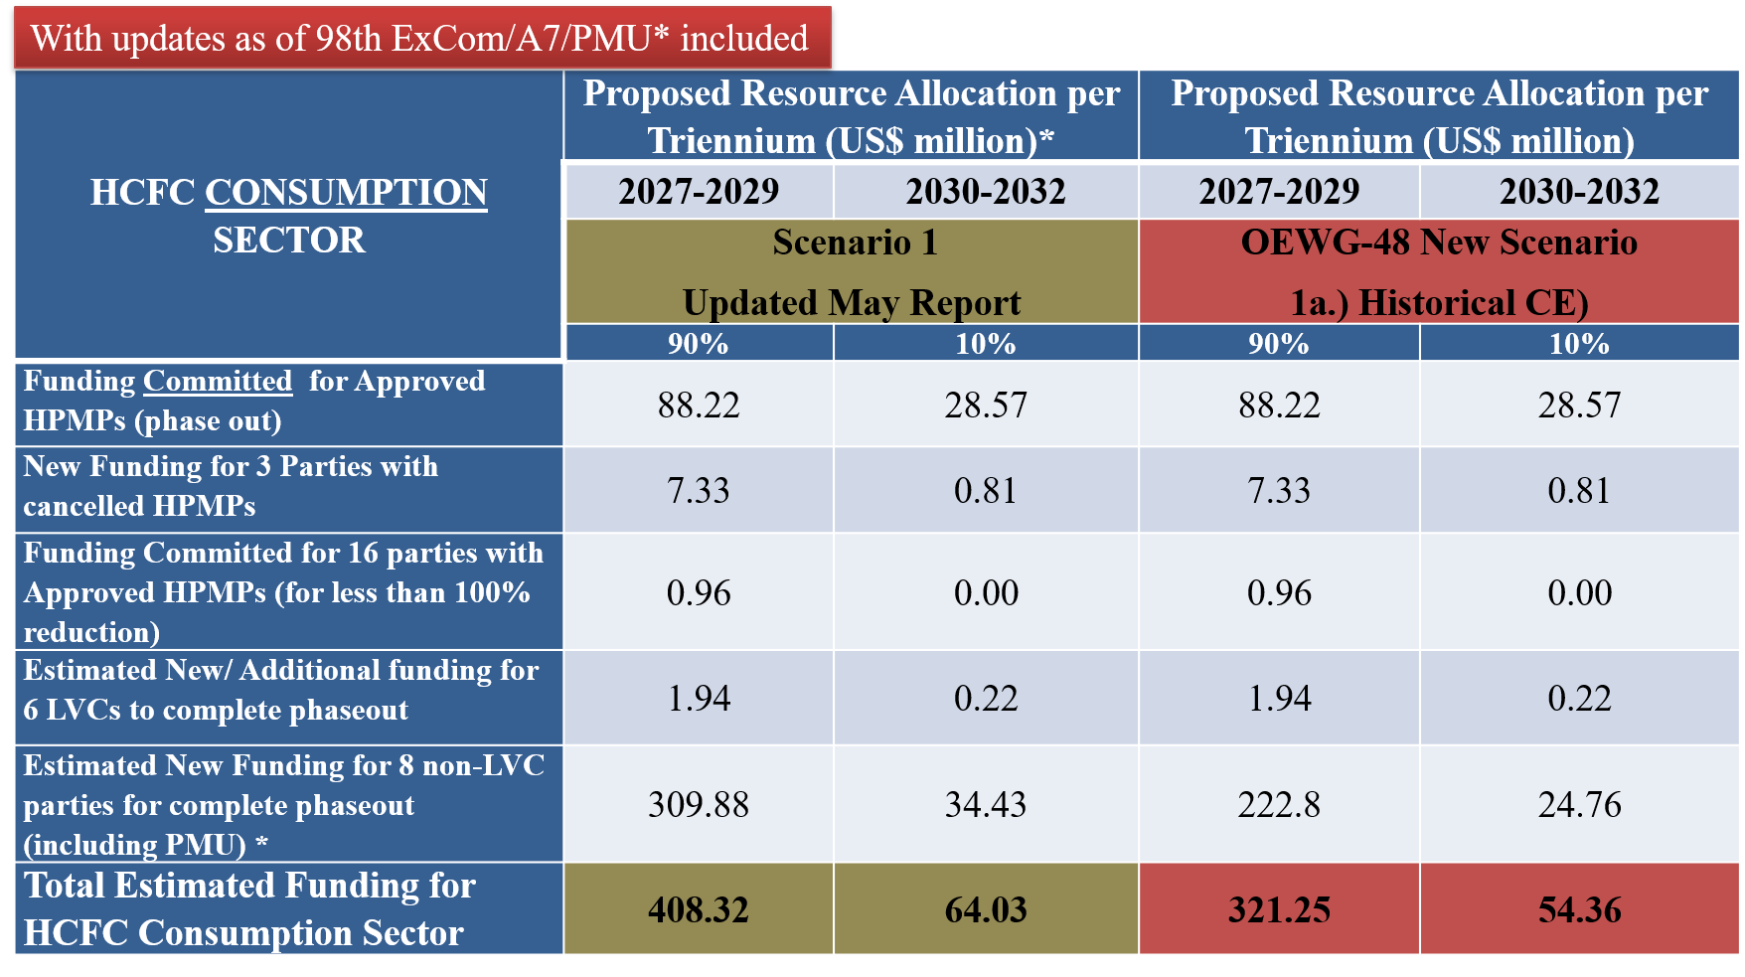
*Percentage PMU applied: 5 % for China and 10% for other parties.

In order to simplify presentation of figures in tables, which for all other HCFC calculations do not go beyond 2032, the final committed tranche for one party for 2033 is included in the 2030-2032 triennium.

Estimated funding figures include 15% foreign ownership, PMU and 9.6% support costs. The total estimated funding for HCFC consumption sector in Table 3.3 does not include project preparation (PRP), verification (VER), and energy efficiency (EE), which are accounted for, and included, separately.

3.2.2 New Scenario 1b for HPMPs: Scenario based on CE factors for each A5 party over the past 6 years
For most parties CE thresholds from projects over the past 6 years covered different HPMP stages, Therefore, for the 3 parties with remaining consumption in Commercial Refrigeration sector and 7 with servicing sector consumption only, the same CEs used for New Scenario 1 a. (Historical) were applied. They are 10.7 US$/kg for Commercial Refrigeration and 4.8$/kg for servicing sectors. For China, RTF used CE information per sector for the past 6 years from the HPMP II approved, as in Table 3.5.

Table 3.5: CEs applied to China under New Scenario 1b (CE for the past 6 years)
CHINA | HPMP I | HPMP II | New Scenario 1 b.  CE for past 6 years  (2020-2025 period)
SECTOR | CE (US$/kg)  (Without PMU) | CE (US$/kg)  (Without PMU) | CE for HPMP II (US$/kg)
Industrial and Commercial Ref. and AC | 7.33 | 2.59 | 2.59
Residential AC and Heat Pumps | 6.75 | 1.29 | 1.29
Servicing Sector | 4.8 | 1.36 | 1.36

The following Table 3.6 shows the comparison funding estimates when applying the CEs for New Scenario 1b (CEs for the past 6 years) with the Updated RTF May Report Low-end Scenario1.

Table 3.6: Funding Estimates when applying New Scenario 1b (CEs for the past 6 years)
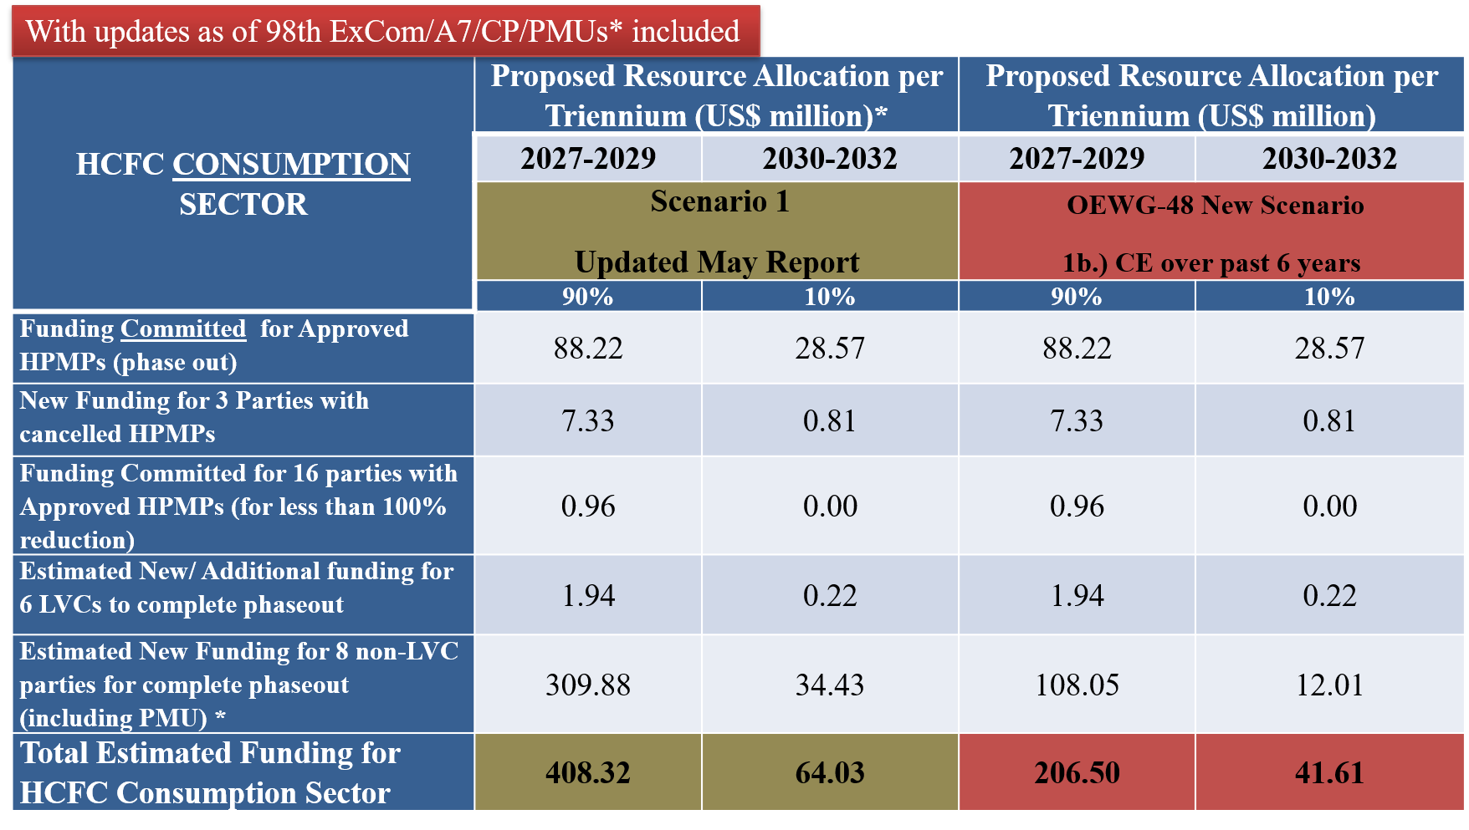
*Percentage PMU applied: 5% for China and 10% for other parties.

In order to simplify presentation of figures in tables, which for all other HCFC calculations do not go beyond 2032, the final committed tranche for one party for 2033 is included in the 2030-2032 triennium.

The estimated funding figures in Table 3.6 include 15% foreign ownership, PMU and 9.6% support costs. The total estimated funding for HCFC consumption sector in Table 3.6 does not include PRP, VER, and EE, which are accounted for and included separately.

3.2.3 New Scenario 1c for HPMPs: CE based on average funding levels for each A5 party over the past 6 years
RTF requested the MLFS for support to compile data required on CEs based on the average funding levels for each A5 party. While RTF received the list with all the parties, RTF focused on the CEs for those parties in the list that have eligible remaining consumption, that is, 8 no-LVCs, including China and 2 non-LVC with cancelled HPMPS. RTF used CE provided by the MLFS for each individual party. For Yemen, as no information was available RTF used 4.8 US$/kg for remaining consumption in servicing sector. The MLFS information on CEs applied is presented in Table 3.7.

Table 3.7: Scenario 1c CEs based on average funding levels for each A5 party over the past 6 years
Country | 2020-2025 Funding  (US$, with Support Cost) | Phase-out  in 2020-2025 (mt) | CE 2020-2025  (US $/kg) | Stage
China (no production included) | 126,760,897 | 81,251.58 | 1.56 | II
Kuwait | 3,917,817 | 1,911.58 | 2.05 | I and II
Syrian Arab Republic | 3,082,658 | 661.32 | 4.66 | I
Libya | 1,886,162 | 367.28 | 5.14 | II
Iraq | 1,052,950 | 207.44 | 5.08 | II
Senegal | 978,160 | 160.25 | 6.10 | I and II
Qatar | 647,270 | 207.66 | 3.12 | II
Afghanistan* | 420,672 | 154.50 | 2.72 | I and II
Mauritania | 386,326 | 46.88 | 8.24 | I
Yemen* | 0 | 0 | n/a | n/a
Source: MLFS

Table 3.8 below compares the funding estimates when using the Updated RTF May Report (Low-end Scenario 1), with the estimates when applying New Scenario 1c. (CEs based on average funding levels over the past 6 years).

Table 3.8: Funding Estimates for HCFC Consumption Sector for New Scenario 1c (CEs based on average funding levels over the past 6 years)
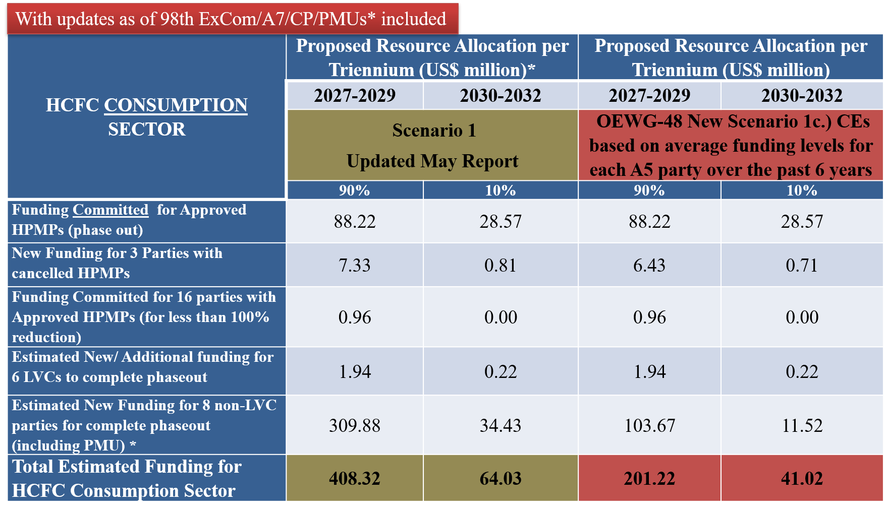
*Percentage PMU applied: 5 % for China and 10% for other parties.

In order to simplify presentation of figures in tables, which for all other HCFC calculations do not go beyond 2032, the final committed tranche for one party for 2033 is included in the 2030-2032 triennium.

The estimated funding figures include 15% discount for foreign ownership in manufacturing sectors, PMU and 9.6% support costs. The total estimated funding for HCFC consumption sector in Table 3.7 does not include project PRP, VER, and EE, which are accounted for and included separately. This is because, for the application of the new CEs in scenarios, the production sector, PRP, VER, and EE were modelled separately and included in the final funding figures. As these amounts remain constant across all scenarios, they are presented only in the final compilation and do not affect the modelling conditions or the comparison of results among scenarios.
The new estimates for HCFC activities applying new OEWG-48 scenarios 1a, 1b, and 1c are in Table 3.9 below. To clarify and better explain final funding figures, RTF detailed the breakdown of the calculations.

Table 3.9: Breakdown of Funding Calculations and Impact on Funding Estimates for all New Scenarios based on CEs for all HCFCs Activities* (US$ million)
HCFCs Consumption and Production Sector Activities for Low-End Scenario 1 using 90% Allocation Schedule | Updated RTF May Report Estimates  2027-2029 | New Scenario 1a (CE Historical) | New Scenario 1b (CE past 6 years) | New Scenario 1c (CE based on average funding past 6 years)
HCFC Activities Scenario 1 (without PRP/VER/EE) | 408.32 | 321.22  (408.32-87.10) | 206.50  (408.32-201.82) | 201.22  (408.32- 207.10)
PRP/VER/EE for LVCs | 5 | 5 | 5 | 5
Sub-Total | 413.33 | 326 | 211.5 | 206.22
Production Sector | 23.54 | 23.54 | 23.54 | 23.54
New Scenarios Reduction |  | 87.1 | 201.82 | 207.10
Total HCFC ACTIVITIES | 437 | 350 | 235 | 230
*Numbers may differ slightly due to rounding.
The new lowest funding estimate for HCFC activities is US$ 230 million for the 2027-2029 triennium. Therefore, the range (using the largest reduction new scenario that brings the largest funding reduction and keeping the high-end scenario as in the Updated RTF May Report), is US$ 230-564 million for the 2027-2029 triennium as shown in Table 3.10.

Table 3.10: Summary of estimated funding 2027-2029 for HCFC phase-out applying New Scenario 1c (largest reduction) compared to Updated RTF May Report estimates (US$ million)
2027-2029 Triennium | Updated May Report Estimates | Supplementary Report Estimates Applying New Scenarios
SUBTOTAL – HCFC ACTIVITIES  US$ million | 437 – 564 | 230*– 564
*Lowest funding estimate from applying New Scenario 1c, a reduction of US$ 207 million from the May Report low-end range for HCFC activities for 2027-2029.

Additional New Scenario 2a for HCFCs: A low-end scenario based on the most recently reported consumption data for HCFCs and a high-end scenario based on HCFC remaining eligible consumption
- For HCFCs, where the eligible remaining consumption differs from the most recently reported A7 data, the lower of the two values was used in the calculations. The funding estimates and adjustments presented in the “Updated May Report” scenarios and funding ranges, already take that suggestion into consideration. Therefore, the funding estimates presented in the “Updated RTF May Report” are the same for this new scenario.

3.3 HFC New Scenarios applying CE FACTORS

3.3.1 New Scenario 1a for KIPs: Based on the application of historical CE factors
For estimating funding based on this scenario, RTF used as the basis the analysis that the MLFS shared, based on CEs for manufacturing sectors in 37 HFC conversion projects in 18 countries, as in Table 3.11 below.

Table 3.11: Analysis of 37 projects in 18 countries to determine Historical CEs for Scenario 1a

Sector | No. of projects | Metric tonnes phased out | CO₂ eq. tonnes replaced | Approved cost (US $) | ICCs (US $) | IOCs (US $) | CE (US $ /kg)
PU foam | 3 | 1,230.09 | 1,087,534 | 3,244,089 |  |  | 2.64
Dom ref | 6 | 785.88 | 1,123,812 | 6,890,919 |  |  | 8.77
Res AC | 6 | 650.26 | 1,357,417 | 5,538,039 |  |  | 8.52
Light commercial refrigeration | 1 | 307.77 | 539,775 | 7,425,000 |  |  | 24.13
Com ref | 7 | 268.02 | 722,762 | 4,794,939 | 340,515 | 83,250 | 17.89
XPS foam | 1 | 227.00 | 28,148 | 853,021 |  |  | 3.76
Industrial Refrigeration | 4 | 69.87 | 249,891 | 1,031,122 |  |  | 14.76
Large commercial AC | 1 | 66.84 | 139,530 | 1,007,815 |  |  | 15.08
light commercial AC | 1 | 34.91 | 63,383 | 422,561 | 244,500 | 178,061 | 12.10
Com ref and assembly | 2 | 18.10 | 66,319 | 234,800 | 14,000 |  | 12.97
Local installation and assembly | 1 | 13.14 | 26,643 | 67,014 |  |  | 5.10
Rail AC | 1 | 12.00 | 21,286 | 250,000 |  |  | 20.83
Mobile AC | 1 | 8.10 | 11,583 | 946,700 |  |  | 116.88
Res AC (Cold-Water Dispensers) | 1 | 4.03 | 5,759
Small commercial refrigeration | 1 | 2.07 | 3,753 | 67,627 |  |  | 32.67
GRAND TOTAL | 37 | 3,698.08 | 5,447,595 | 32,773,646 | 599,015 | 261,311 | 8.86

Source: MLFS, as received.

As the CEs thresholds in the MLF cost guidelines are by sector and not by subsector, RTF bundled subsectors CEs, such as, light commercial, commercial, commercial ref. and assembly, and small commercial, as “Commercial Refrigeration” and used the average CEs.

For Commercial AC, RTF combined large commercial with light commercial AC. RTF removed the project on local assembly, as CEs applied are considered for servicing sector, and the cold-water dispenser project (no information). RTF did not consider projects for Rail AC and MAC (RTF considered them as demonstration projects as the first ones to come in HFCs phasedown). Average CEs used by RTF The CE values widely vary from US$ 2.64 for PUF to US$ 116.8 for MAC. by bundling subsectors, are shown in Table 3.12 as below.
Table 3.12: RTF Historical CEs by Sector Applied to New Scenario 1a. for KIPs
Sector | # of projects | Metric tonnes phased out | CO₂ eq. tonnes replaced | Approved cost (US$) | ICCs  (US$) | IOCs  (US$) | CE  (US$/kg)
PU foam | 3 | 1,230.09 | 1,087,534 | 3,244,089 | - | - | 2.64
Dom ref | 6 | 785.88 | 1,123,812 | 6,890,919 | - | - | 8.77
Res AC | 6 | 650.26 | 1,357,417 | 5,538,039 | - | - | 8.52
Commercial refrigeration | 11 | 595.96 | 1,332,609 | 12,522,366 | 354,515 | 83,250 | 21.01
XPS foam | 1 | 227 | 28,148 | 853,021 | - | - | 3.76
Industrial Refrigeration | 4 | 69.87 | 249,891 | 1,031,122 | - | - | 14.76
Commercial AC | 2 | 101.75 | 202,913 | 1,430,376 | 244,500 | 178,061 | 14.06

In order to estimate funding, RTF used the above new sector CEs, and the same Resource Allocation (Schedules A and B) as in the “Updated May Report Scenario 1” (low-end) model, reproduced in Table 3.13 below.

Table 3.13: Resource allocation schedule A and B
Group | KIP Stage | Schedule A  (% per triennium) | Schedule B  (% per triennium)
G1 parties without KIPs | I | 100% - 2027-2029 | 90% - 2027-2029  10% - 2030-2032
G1 parties without KIPs | II | 60% - 2030-2032  40% - 2033-2035 | 60% - 2030-2032  40% - 2033-2035
G1 parties with KIPs | II | 60% - 2027-2029  40% - 2030-2032 | 60% - 2030-2032  40% - 2033-2035
G2 parties without KIPs | I | 60% - 2027-2029  40% - 2030-2032 | 90% - 2030-2032  10% - 2033-2035

As explained in the RTF May Report, the two suggested resource allocation schedules differ in the percentage of the KIP funding to be allocated to each different triennium. For instance, for G1 and G2 parties without KIPs, the schedule A for funding Stage I is faster, while schedules A and B are the same for funding Stage II for G1 parties without KIPs. For G1 parties with KIPs Stage I, schedule A proposes faster funding for Stage II.

The estimated funding results for Scenario 1a for KIPs are presented in Tables 3.14 and 3.15 for Resource Allocation Schedule A and B respectively.

Table 3.14: Estimated Funding for Scenario 1a for KIPs: Historical CE using Resource Allocation Schedule A*
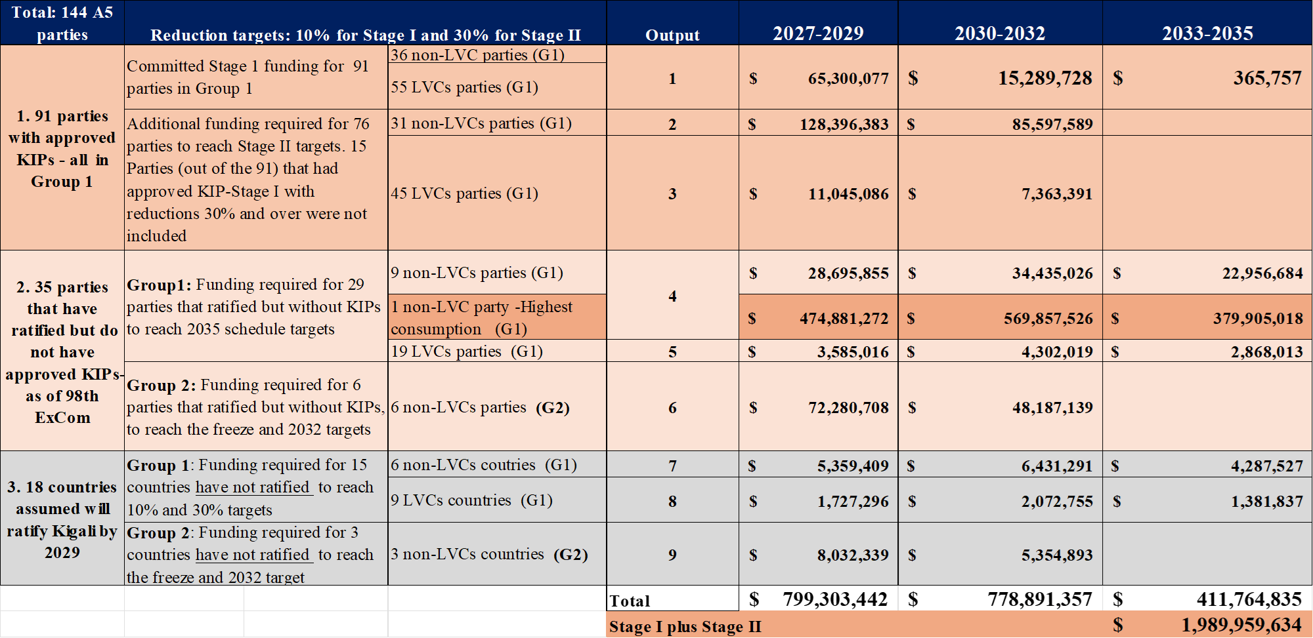
*Includes PMUs. CEs historical applied to “updated Scenario 1” funding estimates, and same Resource Allocation Schedule A as May Report

Table 3.15: Estimated Funding for Scenario 1a for KIPs: Historical CE using Resource Allocation Schedule B*

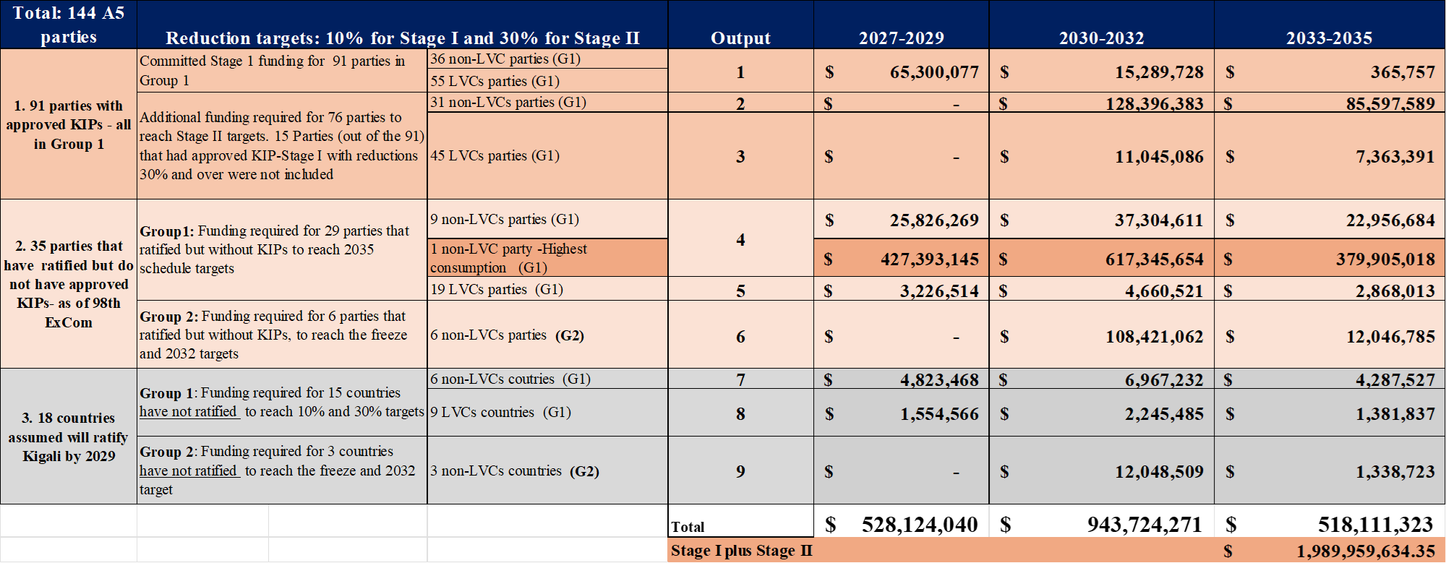

*Includes PMUs. CEs historical applied to “updated Scenario 1” funding estimates, and same Resource Allocation Schedule B as May Report

The new estimates for all HFCs Activities applying new OEWG-48 scenario 1a, with Resource Allocations A and B, are in Table 3.16 below. To clarify and better explain final funding figures, RTF detailed the breakdown of the calculations.

Table 3.16: Breakdown of Funding Calculations and Impact on Funding Estimates for New Scenario 1a. with Resource Allocations A and B (US$ million)

HFCs Consumption and Production Sector Activities for Low-End Scenario 1 Allocation Schedules A and B | Updated RTF May Report Scenario1  2027-2029  Resource Allocation A | New Scenario 1a.  (Using CE Historical)  Resource Allocation A | Updated RTF May Report Scenario1  2027-2029  Resource Allocation B | New Scenario 1a.  (Using CE Historical)  Resource Allocation B
HFC Activities without PRP/VER/EE/ATM | 864.55 | 799.30  (864.55-65.2) | 566.2 | 528.10  (566.2- 38)
PRP/VER/EE /ATM | 93.43 | 93.43 | 93.43 | 93.43
Sub-Total | 957.98 | 892.73 | 659.61 | 621.53
Production Sector/HFC-23 mitigation | 3.61 | 3.61 | 3.61 | 3.61
TOTAL HFC ACTIVITIES | 961.59 | 896.34 | 663.22 | 625.14
Funding Reductions when Applying Scenario 1a. | N/A | 65.2 | N/A | 38
*Numbers may differ slightly due to rounding.
The impact of applying new Scenario 1a. for KIPs using Allocation Schedule A is a reduction of US$ 65.2 million. The impact of using Allocation Schedule B is a reduction of US$ 38 million when compared with RTF Updated May Report.

3.3.2 Scenario 1b for KIPs: Based on CE factors for each A5 party over the past 6 years
It was not feasible to address this request for lack of information on CE factors for each A5 party over the past 6 years. While CEs for 37 HFC investment projects in 18 countries in the period 2020-2025 were compiled and shared with RTF by the MLFS, the information was used to calculate the estimated funding under New Scenario 1a for KIPs (historical CE), and no other information was available or could be compiled for each party. A large number of the 91 approved KIPs are for LVC countries (with only servicing sector). These CE values are not likely to be applicable for large volume consuming countries with manufacturing and servicing.

3.3.3 Scenario 1c for KIPs: CEs based on average funding levels for each A5 party over the past 6 years
MLFS provided for each A5 party with approved KIP, the funding level for that KIP for the last 6 years (2020-2025). The information is presented in Annex 4 as submitted by the MLFS.
From this information, it was not feasible to extract CEs thresholds based on the average funding for each party for the period 2020-2025. The CEs thresholds in cost guidelines approved by the MLF are sector-based, and generating CEs from funding received in a 6-year period represents a new concept which requires discussion based on proper understanding of its desired output. RTF discussed with the MLFS, and the understanding was that without an ExCom approved metric to define CEs from average funding levels to be applied to all parties, the RTF could only present without further analysis the financial data compiled on the funding amounts per party in the 2020-2025 period. There are a large number of LVCs and smaller countries with KIPs approved; funding information available for approved KIPs does not include the largest HFC consumption party nor all the G1 parties under the “top 10” cluster consumption category (that did not have a KIP approved as of ExCom-97), and none of the G2 parties who do not have an approved KIP. Therefore, it was not feasible for RTF to derive CEs based on funding information that is missing for a significant number of large consuming parties and therefore cannot be representative of all A5 parties.
In summary, the lowest funding estimate for HFC activities is US$ 625 million for the 2027-2029 triennium and resulted from applying New Scenario 1a (historical CE applying Resource Allocation B) as shown in Table 3.17 below.

Table 3.17: Summary of estimated funding 2027-2029 for HFC phase-down applying New Scenarios 1a, compared with the Updated RTF May Report estimates (US$ million)
2027-2029 Triennium | Updated May Report Estimates ⁶ | Supplementary Report Estimates Applying New Scenarios
SUBTOTAL – HFC ACTIVITIES | 660 – 995 | 625* – 995
* The low-end value selected is the estimate when applying New Scenario 1a. – CE historical for KIPs with Resource Allocation B. High-end value is based on Scenario 2 high-end estimates in the Updated RTF May Report.

Ranges for the Updated May Report Scenario 1 (A and B), and Scenario 2 (A and B) in Table ES-2, considered low-end values of estimates according to both Scenario 1 and 2 and their respective Allocations A and B. Ranges for the Supplementary Report, consider only Scenario 1(Low-End) as the basis for comparison with the New Scenarios.

3.4 ADDITIONAL SCENARIOS FOR KIPS

3.4.1 Scenario 2a for KIPs: A low-end scenario based on the most recently reported consumption data for HFCs and a high-end scenario based on established HFC baselines
To estimate funding for Scenario 2a, RTF considered the most recently reported A7 HFC consumption data for all parties that had reported data. It is the case that there could be a drawdown from stockpiles if 2024 data was used in certain countries. Nevertheless, the latest reported HFC consumption data was not adjusted for possible inventory reductions.
For parties without HFC data, the HFC component of consumption baselines was used to estimate the most recent A7 HFC consumption data. This HFC data was estimated using the process described in Annex 3 of RTF May Report (Methodology for Filling Baseline Data Gaps - Estimates and Assumptions).
The Updated RTF May Report methodology used to estimate funding considered the Kigali Amendment HFC established baselines. To address Scenario 2a, RTF had to introduce a considerable change in methodology. Nevertheless, for parties with KIPs approved, and because RTF cannot modify the funding commitments nor the agreed percentage reductions targets with the ExCom, the new methodology could not be applied.
For A5 parties without KIPs approved, the most recently reported consumption data for HFCs was used, as requested in New Scenario 2a. The CP data from the MLFS and A7 data from the OS were reviewed again by application of market sectors by chemical and applied to A7 HFC reported data to derive a new percentage sector distribution by party cluster (and without 65% HCFC component). The new sector distribution is shown in Table 3.18. For the single country in the Top 10 G1 parties’ cluster without a KIP, RTF used the country sector distribution reported in its Country Programme.

Table 3.18 Sector Distribution of Consumption for parties without KIPs (%) applied to New Scenario 2a
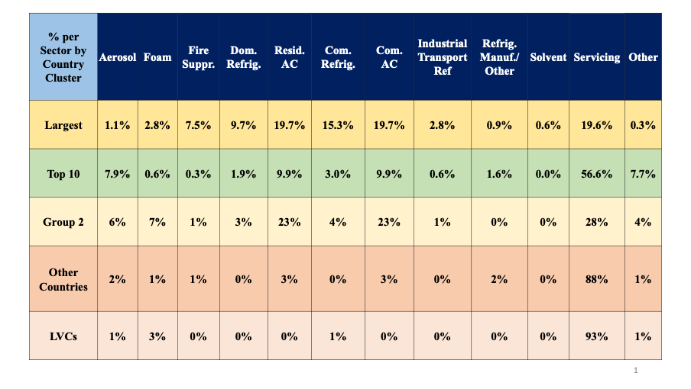

Estimated funding results can be seen in the following Tables 3.19 and 3.20.

Table 3.19: Estimated Funding Applying New Scenario 2a (HFC Consumption) with Resource Allocation Schedule A*
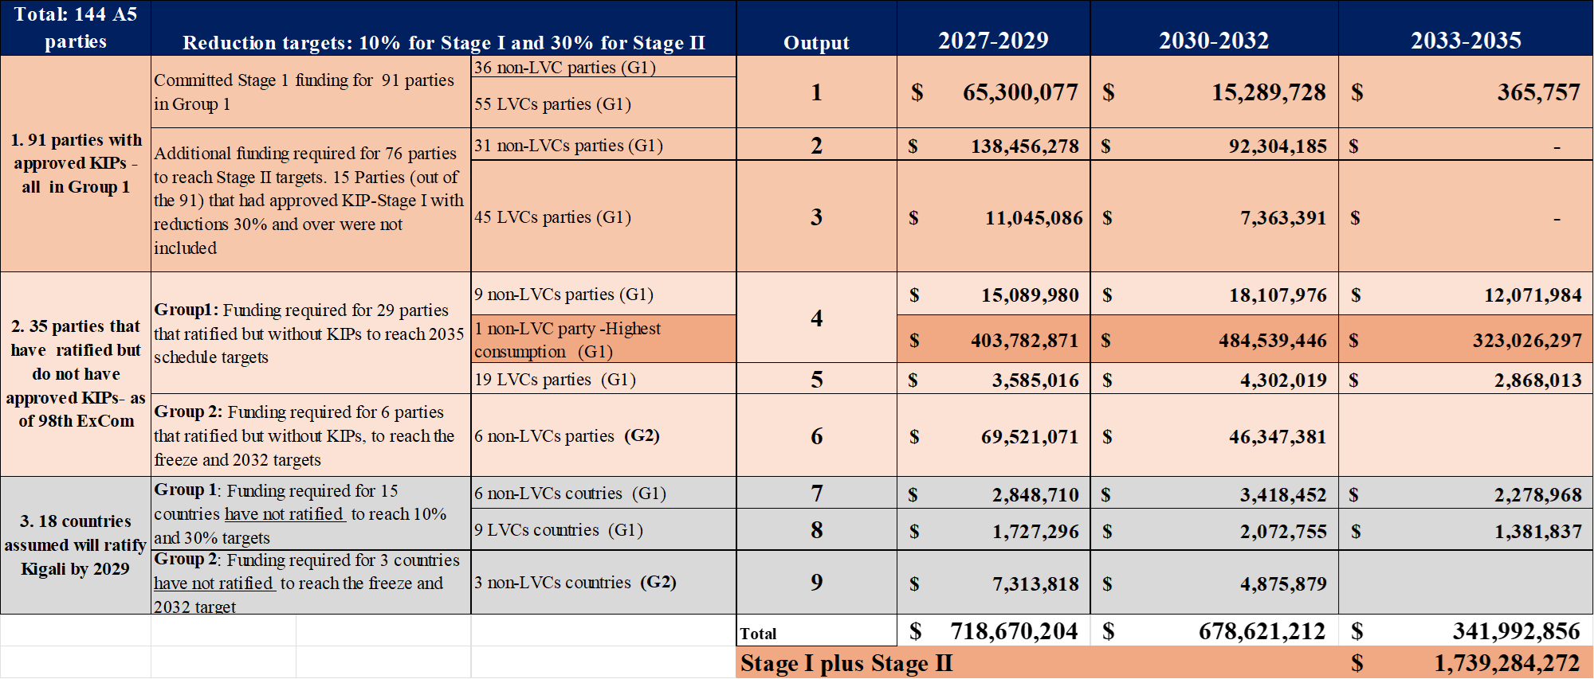
*Using as the basis the “updated RTF May Report, Scenario 1” and applying Resource Allocation Schedule A, including PMUs

Table 3.20: Estimated Funding Applying New Scenario 2a (HFC Consumption) with Resource Allocation B*
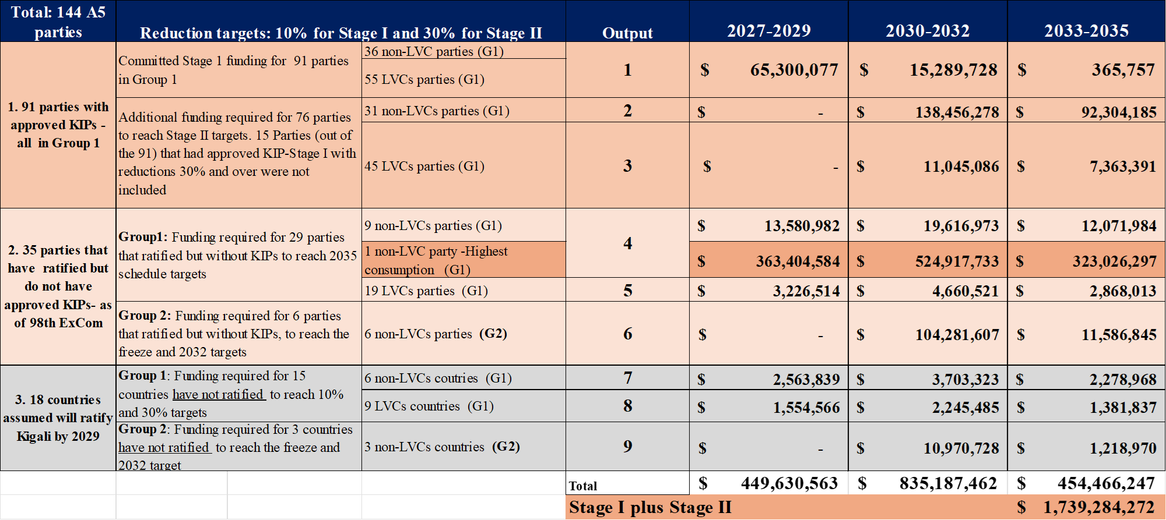
*Using as the basis the “updated RTF May Report, Scenario 1” and applying Resource Allocation Schedule B, including PMUs
The funding estimated for New Scenario 2a for KIPs, using Resource Allocation A and B, shows a reduction of US$ 146 million (US$ 864 - US$ 718) and US$ 117 (US$ 516 – US$ 449) million respectively when compared with the Updated RTF May Report. Nevertheless, Scenario 2a is an illustrative sensitivity scenario and is not directly comparable with the main estimated funding range. It involves a considerable change in methodology, including the use of recently reported consumption for Parties without KIPs, while approved KIPs are not recalculated because their funding commitments and agreed reductions have already been established.

3.4.2 Scenario 2b for KIPs: Realistic project implementation timelines such as modifying resources allocation schedule A for Stage II KIPs and to take into account rates of ratification for remaining non-parties to the Kigali Amendment
RTF modified the Resource Allocation Schedule A (from RTF Updated May Report) to account for a series of proposed new percentage allocations for the 2027-2029 triennium, using a reduced pace for the introduction of Stage II KIPs, and for the ratification pace applied to the non-parties to the KA (as of 10 August 2026) for both A5 G1 and A5 G2 groups. The following changes in resource allocation (in red), are presented in Table 3.21.
Table 3.21: New suggested changes in resource allocation to Schedule A for Stage II KIPs
Group | KIP Stage | Schedule A  (% per triennium) | Modified Schedule A for KIPs Stage II  (% per triennium)
G1 parties without approved KIPs | I | 100% - 2027-2029 | No change
G1 parties without approved KIPs | II | 60% - 2030-2032  40% - 2033-2035 | 30% - 2030-2032  70% - 2033-2035
A5 G1 parties with approved KIPs Stage I | II | 60% - 2027-2029  40% - 2030-2032 | 50% - 2027-2029  50% - 2030-2032
A5 G2 parties without approved KIPs | I | 60% - 2027-2029  40% - 2030-2032 | No change

Additionally, for non-parties to Kigali Amendment (as of 10 August 2026) both in G1 and G2 Groups, RTF considered for KIP Stage II that, the percentage of total funding to be allocated to each triennium would be 30% in 2030-2032 and 70% in 2033-2035.
The funding estimated based on the application of the suggested new percentage allocations are presented in Table 3.22.

Table 3.22: New funding estimates to account for changes in Resource Allocation A for Stage II KIPs and ratification pace as per Scenario 2b
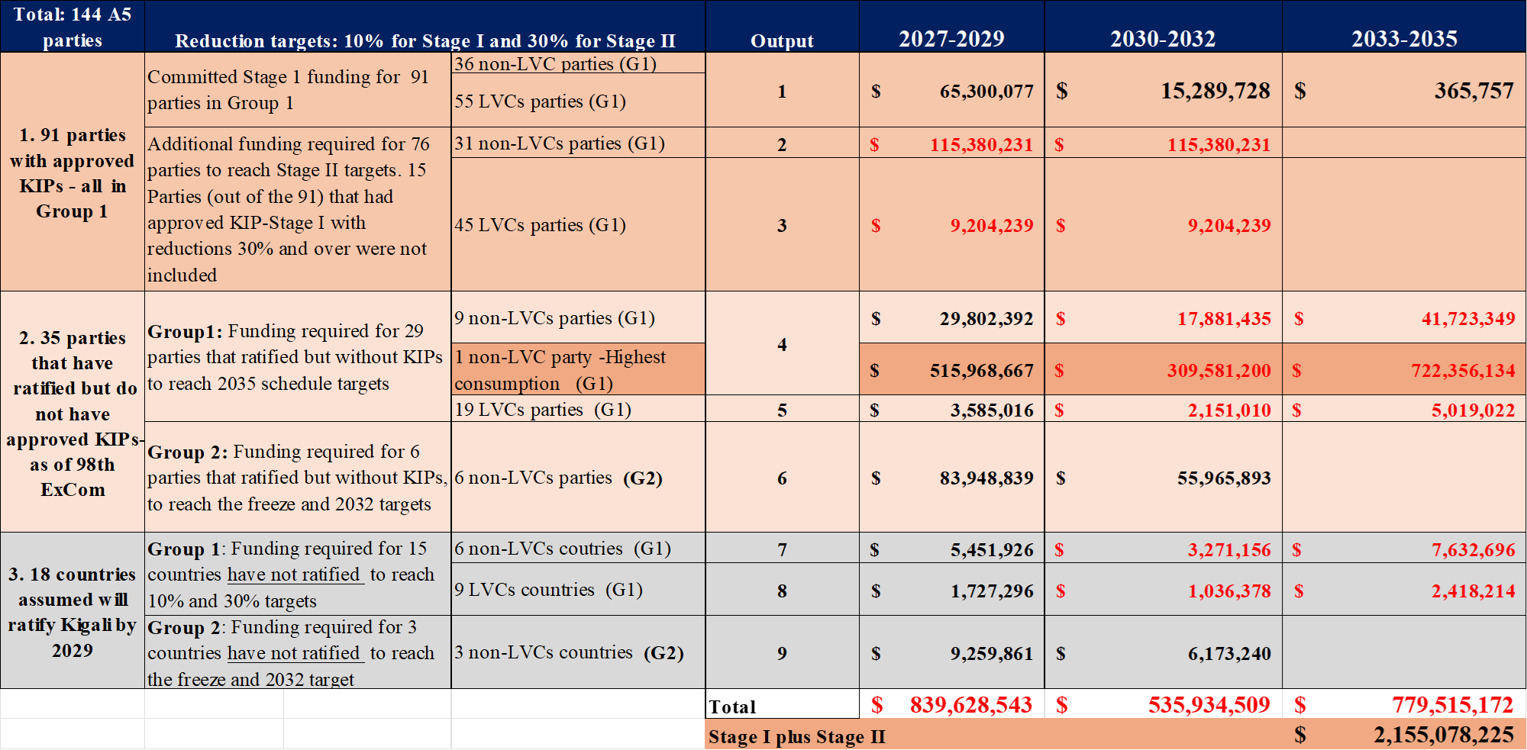
* Revised figures to reflect this new scenario are shown in red.

Modifying the KIPs Stage II Resource Allocation Schedule A percentages results in a reduction of US$ 24.9 million, when compared with the estimated funding for the “Updated RTF May Report, Scenario 1” Resource Allocation A.

3.5 Summary of updated ranges of total funding requirement for HCFC and HFC Activities in 2027-2029 Triennium
Table 3.23 summarises the updated ranges of total funding requirements for HCFC phaseout and HFC phase-down activities in 2027-2029 with the application of the new parameters and assumptions requested in different scenarios suggested by OEWG-48.
Table 3.23: Updated ranges of estimated funding requirement for the 2027-2029 triennium with application of suggested New Scenarios (US$ million)

2027-2029 Triennium | May 2026 Report Estimates | Updated May Report Estimates | Supplementary Report Estimates Applying highest reduction New Scenarios to low-end* | Supplementary Report Estimates considering highest reduction Scenario 2a (most recently reported HFC consumption)
SUBTOTAL – HCFC ACTIVITIES | 451 – 573 | 437 – 564 | 230 – 564 | 230 – 564
SUBTOTAL –  HFC ACTIVITIES | 702 – 1,053 | 664 – 999 | 625 – 999 | 479– 999
* Based on highest reduction amongst Scenarios 1a, 1b, or 1c

Table 3.23 does not include the suggested high-end scenario for possible increase in the resource allocation for LVCs/VLVCs for the triennium as shown in Table 4.3 in Chapter 4, nor the scenario for a possible funding of LRM as shown in table 5.3 in Chapter 5. The estimates for these requested scenarios are US$ 28.2 million (LVCs) and US$ 53 million for the potential funding window for LRM in the high-end range.

CHAPTER 4: ADDITIONAL INFORMATION AND SCENARIOS: LVCS/VLVCs

4.1 Introduction
This chapter details the approach and information needed to estimate funding to address the following OEWG-48 suggestion:
"Recalling the TOR in decision XXXVII/6, requests the RTF to provide a high-end scenario for a possible increase to the funding estimate in the resource allocation tables in chapter 3 for LVC and VLVC countries for Stage II of their KIPs, in consultation with the MLF secretariat, taking into account the capacity of those countries to absorb increased funding".

4.2 SCENARIO: possible increase for lvc and vlvc countries for kips stage ii
In its May 2026 Report for LVCs and VLVCs, the RTF had estimated funding for HPMPs and KIPs with budget allocation by category based on ExCom decisions 74/50 for HPMPs and 92/37 for KIPs. For HPMPs, decision 62/17 requires that the last tranche be a minimum 10% of the total funding for the refrigeration servicing sector and applied to the last year of the HPMP, which is 2030; consequently, the resource allocation for the 2027-2029 triennium is 90% as was estimated in the May 2026 RTF report. For KIPs, the assumption was that LVCs and VLVCs with Stage I KIPs having a reduction from the baseline of less than 30% would submit Stage II requests within the 2027-2029 triennium and that the maximum funding for the first tranche of Stage II, which falls within the 2027-2029 triennium, would be 60% of Stage II as per decision 94/59.
In considering the above request from the OEWG-48 Contact Group, the RTF created a High-end Resource Allocation Scenario for both HPMPs and KIPs.

4.2.1 High-end scenario for HPMPs
There are a few LVCs/VLVCs for which the last stage of the HPMP has not been requested, so there is negligible impact on the estimated resource allocation to warrant a change from the May 2026 Report.

4.2.2 High-end scenario for KIPs
For KIPs, table 3.4 for the resource allocation in Chapter 3 of the May 2026 Report is reproduced in Table 4.1 below with the allocation for 2027-2029 triennium shown in blue
Table 4.1: Copy of Table 3.4 from the May 2026 Report as applicable to LVCs/VLVCs
LVCs/VLVCs – May report | KIP Stage | Schedule A  (% per triennium) | Schedule B  (% per triennium)
Parties without KIPs | I | 100% - 2027-2029 | 90% - 2027-2029  10% - 2030-2032
Parties without KIPs | II | 60% - 2030-2032  40% - 2033-2035 | 60% - 2030-2032  40% - 2033-2035
Parties with KIPs | II | 60% - 2027-2029  40% - 2030-2032 | 60% - 2030-2032  40% - 2033-2035
Note: 2027-2029 triennium percentages are shown in blue
The discussion below is based on the KIP stages for LVCs/VLVCs.
- For KIP Stage I, the resource allocation scenarios for LVCs/VLVCs without KIPs are already funded at the maximum possible for the triennium; the High-end Resource Allocation Scenario adopts the 100% allocation for the 2027-2029 triennium.

- For KIP Stage II, and for countries without approved KIP Stage I, the High-end Resource Allocation Scenario considered that there would be resource allocation for the 2027-2029 triennium (whereas the May 2026 RTF report considered that the first allocation would be in the 2030-2032 triennium) and that this allocation would be 60% of Stage II in conformity with ExCom decision 94/59.

- For KIP Stage II, and for countries with approved KIPs, the May 2026 RTF report considered a 60% allocation in the 2027-2029 triennium in conformity with ExCom decision 94/59. The High-end Resource Allocation Scenario is based on the following considerations:
  - Stage II KIPs are comprised of only two tranches;
  - The first tranche is extended over five years out of the six-year normal span of Stage II (2030- 2035);
  - LVCs and VLVCs are able to request funds for the first tranche that exceed decision 94/59, in this case up to 90% of Stage II for that first tranche and that funding will be within the 2027-2029 triennium; and
  - the second tranche would be over a one-year period and would be for 10% of Stage II total funding, in line with ExCom decision 62/17.

RTF new High-end Resource Allocation scenario as percentages of total funding per triennium is shown in Table 4.2 below.
Table 4.2: High-end resource allocation percentages compared to the schedules in the May 2026 Report
LVCs/VLVCs | KIP Stage | Schedule A  (% per triennium) | Schedule B  (% per triennium) | New High-end Resource Allocation Scenario  (% per triennium)
Parties without KIPs | I | 100% - 2027-2029 | 90% - 2027-2029  10% - 2030-2032 | 100% - 2027-2029
Parties without KIPs | II | 60% - 2030-2032  40% - 2033-2035 | 60% - 2030-2032  40% - 2033-2035 | 60% - 2027-2029  40% - 2030-2035
Parties with KIPs | II | 60% - 2027-2029  40% - 2030-2032 | 60% - 2030-2032  40% - 2033-2035 | 90% - 2027-2029  10% - 2030-2035
Note: 2027-2029 triennium percentages are shown in blue
As requested, the RTF considered the funding for the HFC Scenario 2 of the May 2026 RTF report (applying CEs for SMEs’ participation) and presented a possible increase to the funding estimate in the resource allocation for LVC and VLVC countries for Stage II of their KIPs (for parties with and without approved KIP Stage I). This is presented as a separate column entitled High-end Resource Allocation Scenario in Table 4.2
The calculation for the 2027-2029 triennium for the High-end Resource Allocation Scenario in comparison to schedules A and B of the May 2026 RTF report is shown Table 4.3 below.

Table 4.3: Calculation of the high-end scenario for KIPs for the triennium in comparison to resource allocation schedules A & B of the May 2026 Report
Status | Number of parties | Stage | Total Funding | Schedule A May report | Schedule B May report | New High-end for Supplementary Report
Parties without KIPs | 28* LVC  /VLVC parties | I | 5,312,312 | 5,312,312 | 4,781,081 | 5,312,312
Parties without KIPs | 28* LVC  /VLVC parties | II | 10,624,624 | - | 0 | 6,374,774
Parties with approved KIPs | 45* LVC/VLVC parties | II | 18,408,477 | 11,045,086 | 0 | 16,567,630
Total (US$) |  |  | 34,345,413 | 16,357,398 | 4,781,081 | 28,254,716
*The total of 73 LVCs/VLVCs does not take into account the 10 countries that have 30% or more reduction in Stage I of the KIP
The new high-end resource Allocation Scenario represents 82% of the total funding for Stages I and II. In this scenario, the resource allocation for the 2027-2029 triennium is increased by 73% over schedule A, and by 491% over schedule B of the May 2026 RTF report. RTF notes that some parties have had extended tranches; however, the normal practice is for shorter tranche periods to enable steady disbursement and effective reporting and monitoring. On the other hand, RTF also notes that extending the tranche and increasing the allocation does not impact the ability of LVCs/VLVCs to implement the tranche.

4.3 Capacity of lvc and VLVC Parties to absorb increased funding
In consultation with the MLFS, the RTF was advised that the ExCom has not determined a metric related to the capacity of countries to absorb funding. RTF notes that factors like rate of disbursement or frequency and amount of returned funding by agencies are impacted by other elements than the capacity of the country to absorb and consequently those factors cannot be used as measures of the LVC and VLVCs’ ability to manage an increase in funding.
Many LVC and VLVC parties are implementing their HPMPs and KIPs simultaneously. As noted in Section 6.4 of the 2026 May RTF report, “to phase out HCFCs and transition to alternatives other than HFC while also reducing HFC baseline by 10 per cent, LVCs and VLVCs would be receiving funds that are on average 2.64 times higher than KIP-I funding.” In addition,
- The funding for LVCs for servicing was increased for KIPs relative to the funding for HPMPs as can be seen when comparing decision 92/37 for KIP funding to decision 74/50 for HPMP funding.
- In addition, the ExCom decided to change the funding allocation for KIPs, (up to 60% as per decision 94/59) allowing more front loading of funding than had been the case for HPMPs.
- The ExCom decided to provide additional funding for HPMPs for LVCs to address EE in the servicing sector as per decision 89/6.
- Some LVCs have also included projects to phase-out consumption in the manufacturing sector, example Serbia as per decision 62/46.
- The ExCom. approved US$4.165 million for Ghana (an LVC) for a revolving fund project as per decision 98/54(d)(ii)) demonstrating the ability of the LVC to implement complex projects.

RTF also notes that the scale of procurement activity is not linear and that it can be absorbed with the same or with a small increase in resources for the countries. LVCs and VLVCs allocate part of their budget to project coordination, monitoring, and reporting. An increase in funding for KIP stage II, or the front loading of the stage would have a proportional increase in the appropriation for project coordination and monitoring as larger tranches demand more extensive procurement, broader geographic and sub-sector coverage, and more intensive compliance and financial reporting.
While the evidence above suggests that LVCs and VLVCs have generally been able to absorb increased levels of funding, the RTF recognises that this capacity varies across countries. Some LVCs may face challenges related to institutional capacity, national procurement processes, regulatory frameworks, or limited technical expertise at the national level.
The high-end scenario presented in this chapter assumes that countries have sufficient capacity to implement the expanded and front-loaded tranches. This highlights the continued need for institutional strengthening, targeted implementation support, and flexible project management arrangements, as provided through existing MLF activities. Such support will be important to help ensure that all LVCs and VLVCs are able to effectively use the increased funding and meet their phase-down targets.
In conclusion, the LVCs have absorbed additional funding due to changes in funding level, concurrent implementation of several projects, changes in resource allocation allowing front loading, and to implement additional new activities and projects. Additionally, the harmonisation of activities under the HPMPs and KIPs have allowed the countries and the implementing agencies to optimise their processes and maximise delivery.

4.4 additional considerations for funding KIP stage II
While taking into consideration the needs of the LVCs and VLVCs as was requested by Decision XXXVII/6 of RTF Replenishment TOR, the RTF in its May 2026 report noted two factors that are impacting the ability of LVCs and VLVCs to transition to lower-GWP, energy-efficient alternatives. The first factor is related to fixed costs that the LVCs and VLVCs incur irrespective of their consumption, and the second factor is that the training costs and associated capacity building activities constitute a major portion of the budget which, if funded to meet the actual needs, will deplete the budget and leave other activities with little or no funding.
The analysis in the 2026 May RTF report also demonstrated that the lower three brackets of funding are under-funded when compared with the other five brackets and noted that the lowest two brackets could eventually be funded at the same level as the third bracket. To illustrate an example of the funding needs for Stage II, the report compared the combined funding for the last stage of the HPMP and the first stage of the KIP that most LVCs and VLVCs have available until 2030 with the funding for Stage II calculated at double the Stage I funding to further reduce consumption by 20% to a total of 30% reduction from the baseline for the stage.
Stage II funding is assumed to be twice the Stage I level because it addresses a 20% reduction compared with 10% under Stage I; however, doubling assumes that costs increase linearly with the reduction target. It does not demonstrate whether the resulting funding is sufficient for wider national coverage, additional regulatory framework, providing equipment, or continuing implementation and monitoring.
For this report, the RTF made further analysis to what was presented in the May 2026 RTF report to address the two factors and developed methodologies based on calculating increments above the assumed doubling of Stage I funding, then doing a sensitivity analysis and a stress test for the proposed expansion levels. The exercise is an assumption for modelling rather than an empirical finding.

4.4.1 Methodology
RTF did a further analysis to test the assessment in the May 2026 Report, which reviewed all KIPs that were approved up to ExCom-97. As a reminder, fixed costs comprise the minimum system-building functions required to operationalise HFC controls, including policy and regulatory development; licensing, quota and reporting systems; customs and enforcement procedures; standards and standard operating procedures; training curriculum and certification; regulatory framework; and project coordination, monitoring and reporting. The other activities such as technician training and certification, delivery of equipment, demonstration projects, broad awareness campaigns and gender-outreach activities are scale-sensitive and are impacted by consumption.
For this report, the RTF tested a scenario providing, as sensitivity parameters, an additional allowance equal to 50 or 75% of the fixed-cost amount previously identified for each bracket and the conducted a sensitivity analysis for a scenario which incorporates additional funding for capacity building including training to complement the fixed cost analysis. Two sensitivity factors equal to the allowances used for the fixed cost were selected for funding above the doubling of Stage I funding. The 50% factor represents a lower case sensitivity scenario, reflecting the need to update and extend Stage I systems including policy/regulatory frameworks, training curricula, and institutional arrangements to cover the additional 20% reduction target under Stage II. The 75% factor serves as an upper stress test sensitivity scenario, assuming broader national coverage, additional subsectors, or more ambitious technology transitions. Both factors are modelling assumptions for scenario-testing purposes.

4.4.2 Results
The assumptions and the detailed calculations are found in Annex 5. The results of the calculations for the two factors are shown in Table 4.4 below and compared with the example for funding that was provided in the May 2026 RTF report.
Table 4.4 Presentation of the two funding scenarios compared to the funding example provided in the May 2026 Report (US$)
Bracket | lower scenario outcome | Example of funding provided May 2026 RTF report | Upper stress-test scenario outcome
1 | 345,000 | 418,000 | 375,000
2 | 364,500 | 418,000 | 399,750
3 | 402,900 | 418,000 | 438,450
4 | 425,690 | 462,500 | 467,845
5 | 459,000 | 488,750 | 499,500
6 | 482,500 | 515,000 | 526,250
7 | 818,425 | 845,000 | 896,712
8 | 916,364 | 945,000 | 998,182

The results indicate that the assumptions made in the May 2026 RTF report were within the bracket for the calculations based on the calculations of the two factors. Table 4.4 is presented as an illustration to provide the parties with a range of funding options and a basis for discussion in preparation for the revision of funding levels expected in 2028.

CHAPTER 5: ADDITIONAL INFORMATION AND SCENARIOS: Lifecycle Refrigerant Management

5.1 Introduction
ExCom has had a long history of discussions on the importance of LRM and interest in meaningful actions to address the issue. This is evidenced in decisions taken by ExCom and by the MOP on this issue. LRM was most recently discussed at ExCom-97 where in its Decision 97/89, ExCom decided:

- To note the report prepared pursuant to decision 93/104 on life-cycle refrigerant management with a view to considering the establishment of a funding window in line with decision XXXV/11 of the Thirty-Fifth Meeting of the Parties contained in document UNEP/OzL.Pro/ExCom/97/87;

- To encourage the bilateral and implementing agencies to intensify their efforts to assist Article 5 countries in finalizing projects under decision 91/66 as soon as feasible and in submitting the final reports and a copy of the resulting national inventories and national action plans in line with decision 91/66(e)(iii);

- To request the Secretariat to update, for the 99th meeting, the information in document UNEP/OzL.Pro/ExCom/97/87 in light of completed inventory projects and national plans and other relevant information, including on the movement of controlled substances for destruction or reclamation; and

- To request the Secretariat to prepare, for the 100th meeting, a document on funding modalities, including elements for draft cost guidelines to implement plans developed in accordance with decision 91/66, with a view to considering the establishment of a funding window in line with decision XXXV/11, taking into consideration the information provided in the report referred to in subparagraph (c) and the views on that report expressed by the Executive Committee.

Even though LRM was not explicitly included in the Decision XXXVII/6TOR, item 4 above indicates the potential for the establishment of a funding window to implement LRM plans. If agreed by the ExCom, a decision would come but not earlier than ExCom-100 in 2027 prompting the RTF to include information to support those ongoing discussions on LRM in Chapter 10 and Annex 10 of its May 2026 Report.

This chapter inform on the approach taken by RTF, updates the information on LRM, and details the funding calculations needed to, in the supplementary report, estimate a high-end funding for a potential LRM funding window, for consideration by the Executive Committee at its 100th meeting, as well as updated information on LRM.

5.2 estimated cost scenario for potential funding window
In discussions at OEWG-48, the Contact Group on Replenishment made the following suggestion related to end-of-life (EOL) management of controlled substances:

Include a cost estimate for a high-end scenario for the potential funding window to be considered at the 100th ExCom meeting for the period 2027-2029 to support the implementation of national plans developed pursuant to decision 91/66, taking into account that activities to recover, recycle and reclaim refrigerants are also financed under HPMPs and KIPs.

5.2.1 Context
The scope and scale of LRM support currently remains within is funding provided under HPMPs and KIPs, and under decisions 91/66 which required,
“That national plans that might include, in addition to approaches for the collection, transport storage and disposal, specifically the destruction of waste-controlled substances, would contain a description of a potential business model detailing the arrangements with the various stakeholders and the private sector commitment and involvement in those activities, from waste collection to eventual destruction;
That the final plan would also contain a description of the policies and regulations describing the roles and obligations of manufacturers and distributors, including any recovery, recycling and reclamation programmes;
That the national plan would include consideration of the development of regulations under national phase-out/phase-down plans (i.e., HPMPs or KIPs) on refrigerant recovery, recycling and reclamation that would support the actions identified for the collection, transport, storage and disposal of those used and unwanted waste-controlled substances;”

A substantial gap persists between existing funding provisions and the broader elements of the action plans developed under decision 91/66, including collection networks, reclamation capacity, destruction infrastructure, and national regulatory and monitoring frameworks as outlined in Table 5.1. Bridging this gap is essential to ensure that refrigerant banks are managed in a manner that maximises both ozone and climate benefits.

Table 5.1: Gap between current funding provisions and comprehensive LRM needs
Aspect | Current MLF funding / provision | Scope of Actions Plans developed under decisions 91/66
National inventories and action plans | Funded under ExCom Decision 91/66 (preparation/initial planning phase only) for most Article 5 Parties | Full lifecycle management planning, including implementation pathways for collection, reclamation, and destruction
Infrastructure | Limited to servicing-sector equipment and reclamation activities where HPMP/KIP scale allows | Dedicated infrastructure for refrigerant storage and collection, reclamation facilities/labs, and destruction capacity
Institutional support | Limited technical assistance | Strengthened regulatory frameworks, monitoring and enforcement systems, extended producer responsibility (EPR) schemes, and mechanisms to enable environmentally sound transboundary movement and destruction (i.e., carbon finance integration, export of unwanted ODS/HFC for destruction)
Coverage | Focused on selected HCFC/HFC sectors | Comprehensive coverage of all controlled substances (ODS and HFCs) across all relevant sectors (RACHP, foams, fire protection)

This section adopts a modular approach to calculating the additional funding for implementing the national LRM action plans, designed to complement existing HPMPs and KIPs in supporting the phase-out and phase-down of controlled substances under the Montreal Protocol. Most servicing-sector infrastructure, training, and institutional strengthening are expected to continue to be funded through HPMPs and KIPs. The proposed supplementary (additional to service sector activities) LRM funding window would address critical gaps that prevent countries from transitioning from planning and basic recovery toward scaled recovery, aggregation, recycling, reclamation, and preparation for destruction. LRM programme would benefit from pilot demonstration to showcase feasibility of the different LRM elements at different scales while phasing down HFCs.

Each of these activities corresponds to a specific function within the LRM chain and can be implemented independently or in combination. This modular structure allows parties to select interventions based on their level of system development and priority gaps. This chapter presents a high-end scenario of estimated funding for A5 parties across different levels of refrigerant consumption including the options of creating enabling conditions for destruction and export for destruction.
Box 5.1. Definition of the high-end LRM funding scenario
The high-end scenario provides an illustrative estimate of the potential funding required during 2027–2029 to implement long-term LRM measures identified through national inventories and action plans prepared under Decision 91/66. It represents a reasonable level of implementation support, rather than a forecast of actual expenditure.
The scenario covers all A5 Parties potentially eligible for support under a future LRM funding window, with the level of support differentiated, as appropriate, based on the size of the national refrigerant consumption and existing LRM infrastructure.
The estimate covers incremental activities not already financed through approved or ongoing HPMPs, KIPs or other MLF mechanisms. These may include expanding recovery and collection systems, strengthening aggregation and chain-of-custody arrangements, establishing or strengthening reclamation capacity, facilitating export where domestic reclamation is not viable, and ensuring environmentally sound final destruction of refrigerants that cannot be reclaimed.
The scenario is based on the potential scale-up of recovery equipment and technician support, collection and aggregation points and related logistics, domestic reclamation capacity where justified, and appropriate export or final-treatment arrangements. It aims to increase the quantities of used and unwanted controlled refrigerants entering documented recovery, collection, reclamation and final-treatment pathways.
The resulting estimate should be understood as an illustrative high-end funding envelope for LRM implementation, rather than an assessment of the funding requirements of individual Parties. Actual country-level requirements would be determined through national inventories, action plans and subsequent project proposals, taking into account existing infrastructure and financing.

Annex 6 provides information on the RTF developed cost model for evaluating the additional costs associated with the different LRM activities. This model considers different scenarios and is therefore constructed as combinations of modules, rather than as fixed pathways. The rationale is that parties can select the modules they need to implement their LRM action plans as per ExCom Decision 91/66. A summary of this approach and estimated high-end scenario cost estimates are provided in Tables 5.2 and 5.3 for the information and further consideration of parties. The RTF estimates that pilot demonstration activities under LRM that cover all six activities would cost roughly 25% of the estimated additional funding presented in Table 5.3.

Table 5.2: LRM Modular approach
Module | Name | Function in the LRM chain | Scope of intervention
Module 1a | Improved recovery rates at servicing | Improves used and unwanted refrigerant recovery at the point of servicing to increase collection to justify EOL services | - Increase equipment (recovery machine, digital weighing scale and digital charging hoses, cylinders) beyond current HPMP and KIP scale  - Provide economic incentives  - Develop basic market framework
Module 1b | Recovery at EOL | Captures refrigerant from equipment reaching end of life to increase collection to justify EOL services | - Creating collection centres  - Create capacity building for EOL stakeholders to increase recovery
Module 2a | Reclamation (domestic) | Enables reuse and recycle of recovered refrigerant through quality verification | - Refrigerant identification, laboratory testing, quality certification,  - Reclamation equipment, Reclamation process  - Business models
Module 2b | Export of used gases (for reclamation) | Creating the export conditions to enable gas treatment (reclamation or destruction when needed) abroad | - Aggregation, transport, coordination with receiving facilities.  - Basel Convention procedures, logistics, aggregation, transport
Module 3a | Domestic destruction | Enables local capacity to destroy non-reclaimable refrigerant | - Facility adaptation, regulatory approvals, system setup
Module 3b | Export of used gases (for destruction) | Enables export of waste refrigerant for destruction abroad | Same as 2b

The model is described in Annex 6. The high-cost estimate for the potential funding window is presented below

Table 5.3 Summary of high-end scenario cost estimate for LRM activities based on RTF cost model (see Annex 6)
Module | LRM Activities | Additional funding required for A5 countries (US$)
Module 1a | Improved recovery rates at servicing  Upgrading technician equipment (beyond HPMP and KIP), establishing a chain of custody tracking system for recovered refrigerant marketplace, and developing refrigerant collection centres. | 18,212,000
Module 1b | Recovery at EOL  Capacity building on chain of custody and collection. Market study for used gas volume and pricing. | 18,212,000
Module 2a | Reclamation  Establishing reclamation centres where needed. Technical studies for RRR centre creation. Equipment and start-up of RRR centres in LVCs. | 25,920,000
Module 2b | Export  Creating the export conditions to enable gas treatment (reclamation or destruction when needed) abroad. Capacity building of export stakeholders. Used gas identification equipment. Basel convention support. Safety equipment for storage of flammable used gases | 7,416,000
Module 3a | Destruction  Enabling destruction as a pilot funding window in which 20 new cement kilns can be retrofitted to feed gas into the kiln and flue gas monitoring to verify how the incineration occurred. Also includes support to kiln owners to obtain licensing or environmental permitting | 1,000,000
 | Total | 52,548,000

ANNEX 1: LIST OF PARTIES PENDING RATIFICATION OF THE KIGALI AMENDMENT (as of 10 AUGUST 2026)

Countries | Cluster By  Consumption Level | Group
Afghanistan | Other Non-LVC | 1
Algeria | Other Non-LVC | 1
Democratic Republic of the Congo | Other Non-LVC | 1
Libya | Other Non-LVC | 1
Sudan | Other Non-LVC | 1
Yemen | Other Non-LVC | 1
Antigua And Barbuda | LVC | 1
Dominica | LVC | 1
Equatorial Guinea | LVC | 1
Guyana | LVC | 1
Jamaica | LVC | 1
Myanmar | LVC | 1
South Sudan | LVC | 1
Suriname | LVC | 1
Timor-leste | LVC | 1
Iran (Islamic Republic Of) | Other Non-LVC | 2
Iraq | Other Non-LVC | 2
Qatar | Other Non-LVC | 2

ANNEX 2: ESTIMATED FUNDING METHODOLOGY FOR HCFC CONSUMPTION SECTOR (UPDATED RTF May 2026 report)

This annex provides information on the updated estimated funding methodology for the HCFC consumption sector. For HCFC consumption, the assessment considers funding estimates for the completion of the HCFC phase out by 2030, with no additional funding for new HCFC phaseout activities assumed for triennia after 2030, other than funding already committed under approved HPMPs. In addition, the assessment includes funding the HPMP VER, PRP, and EE, as applicable under relevant ExCom decisions, including Decision 89/6 (LVCs). Implementing agency support costs were considered at an average of 9.6%. The RTF also applied a 15% deduction to the estimated eligible costs for foreign- owned enterprises in the manufacturing sector. For the non-LVC parties with remaining eligible consumption to reach a complete phase out, the RTF applied PMU costs which were not included in the RTF estimates for its May 2026 report.
HCFC activities are approaching completion for most A5 parties, whereas HFC-related activities, while progressing, remain at an earlier stage. The models are structured and customized to reflect the different stages of the two regimes while following, to the extent possible, the MLF project cycle, and consequently the required MLF replenishment. The RTF also proposes an indicative resource allocation for the 2027-2029 triennium and the following two triennia, for consideration by parties. The objective is to produce an assessment that is transparent, policy consistent, and with defensible funding projections, aligned with the compliance obligations of A5 parties.

A2.1 Sources of Information
The RTF modelling approach consolidates updated data from the following sources:
- A7 consumption data as reported to the OS, as of 17 July 2026;
- CP data submitted to the MLFS, as of 17 July 2026;
- Information provided by the MLFS on approved HPMPs, including agreed reductions from baseline consumption, funding and tranche schedules, project preparation and verification activities, as well as information on EE and the status of funding windows;
- ExCom documents and decisions, including cost guidelines, up to and including ExCom-98.
- Classification of LVCs based on HCFC and HFC baseline consumption (unchanged as presented in Annex 5 of the RTF May 2026 report);
- The Business Plan (BP), used to inform the RTF on future requests to IAs for projects to be submitted to MLFS, therefore guiding RTF to forecast potential new funding needed;
- Parties’ ratification status of the KA, as of 10 August 2026 (Annex 1);
- PMU costs applied based on consultations with MLFS and IAs: 5% PMU for China, consistent with the approach applied for China’s HPMP II, 7% PMU for the 10 largest-consuming parties, and 10% PMU for other smaller non-LVC parties;
- Due to no change in the MLFS information on funding required for IS and SA, as of ExCom-98, RTF maintained funding estimates the same as in the RTF May Report.

A2.2 HCFC Phase-out funding methodology for the consumption sector
The estimated funding requirements for the 2027-2029 triennium for the HCFC consumption sector include:
- Committed funding for approved HPMPs;
- New estimated funding required to achieve 100% phaseout of HCFCs;
- Funding for PRP;
- Funding for verification;
- Funding for PMU; and
- Funding for EE, in line with ExCom Decision 89/6.

Key assumptions made by the RTF for its estimates were the same as in the May 2026 Report, except for the addition of PMU costs:
- IAs’ support costs were considered at an average of 9.6%, unless indicated otherwise;
- A 15% deduction was applied to account for ineligible foreign ownership in the manufacturing sectors. As the RTF explained in its May 2026 Report, for HPMPs the general practice was to defer enterprises with non-Article 5 (A5) ownership to later stages which would impact the resource allocation calculations for this triennium and the next triennium to varying degrees;
- PMU costs for non-LVCs with remaining eligible HCFC consumption requiring funding were applied as follows, based on consultation with the MLFS and IAs: 5% for China and 10% for Iraq, Kuwait, Libya, Mauritania, Qatar, Senegal, Syrian Arab Republic, Afghanistan and Yemen. For Afghanistan and Yemen, the estimates assumes re-submission of their cancelled HPMPs.
RTF treated the 144 A5 parties based on their HPMPs’ approval and implementation status and grouped them accordingly, for funding calculation purposes. Funding for project preparation, verification, PMU, and EE are presented as separate lines. For HCFC, the model is simplified to encompass new estimated funding calculations for the 17 parties that still need additional funding to complete their phaseout, and all the committed funding for all the other parties with approved HPMPs.
With the HCFC phase-out deadline approaching and implementation of HPMPs progressing, most of the 144 A5 parties have received assistance to address their HCFC phaseout obligations. The number of parties requiring additional funding is limited to 17, comprising 8 non-LVC parties, 6 LVC parties and 3 parties with cancelled HPMPs.
For this assessment, the RTF grouped parties according to their HPMP status and applied the funding estimation approach described in the steps below:
STEP 1. Parties (125) with approved HPMPs and ExCom agreements covering 100% of their agreed phase out obligations
For these 125 parties, funding for the agreed HCFC phase-out activities has already been approved by the ExCom. Accordingly, other than the funding already committed, no additional funding is projected for these parties. No additional funding is projected for the 2.5% HCFC servicing tail for the one party for which 2.5% remain (one party). Committed funding amounts to US$ 88.22 million for the 2027-2029 triennium and US$ 28.57 million for 2030-2032, based on information provided by the MLFS. A committed amount of US$26.61 million has been approved for the 2030–2032 triennium, together with a final tranche of US$1.96 million for a single country (Thailand), approved for 2033. Accordingly, the total amounts presented in the HCFC tables of this report cover the period 2030–2033 and include this final tranche. This methodological step is shown in the flow chart in Figure A2.1 flow chart below, and the committed funding is presented under Output 1.

Figure A2.1 Flowchart for estimating funding for Output 1: 125 parties with approved HPMPs and ExCom agreements covering 100% of their agreed phase-out
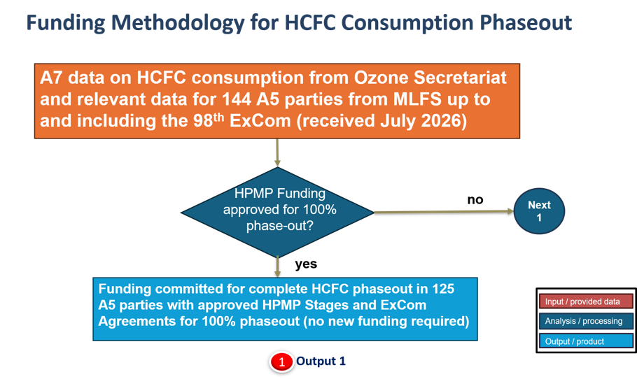
STEP 2. Funding for three A5 parties with cancelled HPMPs
The RTF understands that the current status of cancelled HPMPs includes two LVC parties, with one not planning to re-submit their HPMP, and two non-LVC parties. Funding requirements were calculated separately for LVC and non-LVC parties. For non-LVC parties, calculations were based on the CE values established in the applicable cost guidelines, while for the LVC parties, the cost framework as per ExCom Decision 74/50 was applied.
For the remaining three parties with cancelled HPMPs, future funding requests remain uncertain and would depend on the preparation and subsequent approval of new submissions. The RTF estimated the funding needs for these three parties based on the assumption that they could request all eligible funding in the next triennium and achieve the complete phase out of HCFC consumption in accordance with the control measures under the MP. Reduction estimates were based on reported 2024 HCFC consumption for the three parties.
This methodological step is shown in the Figure A2.2 below under Output 2, resulting in estimated funding requirements of US$ 8.14 million in for the 2027-2029 triennium, including US$ 0.58 million for PMU costs, with no additional funding assumed for subsequent triennia.

Figure A2.2 Flowchart for Outputs 2 and 3: estimating funding for three parties with cancelled HPMPs and committed funding for 14 parties with approved HPMPs covering less than 100% of their agreed phase-out obligations
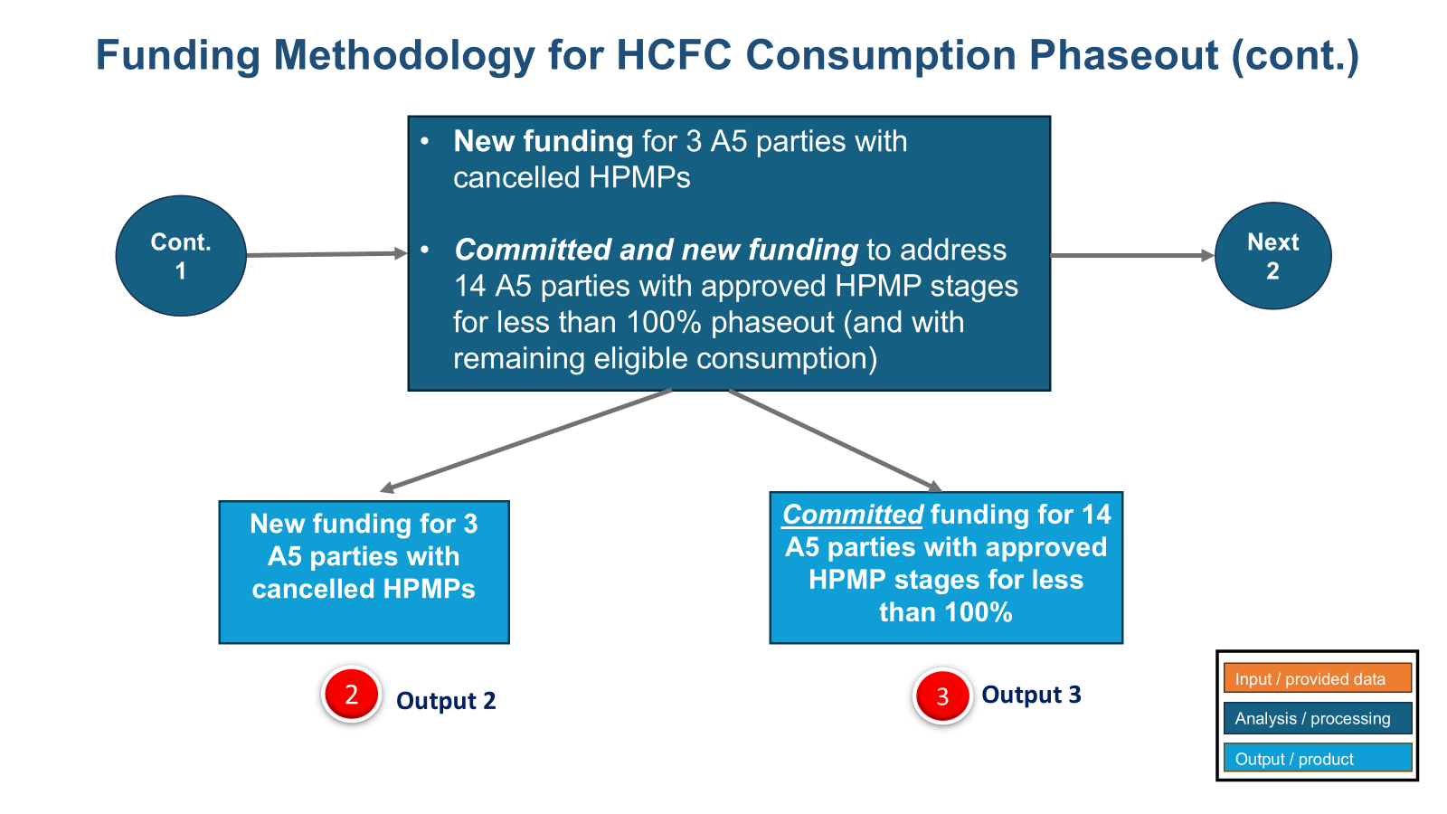
STEP 3. Calculation of committed and new funding estimates for 14 parties with remaining eligible consumption and HPMP agreements that do not cover the complete phase-out
Step 3.1. Committed funding for approved HPMPs stages for the 14 A5 parties for which the HCFC phase-out has not yet been completed is US$ 0.96 million, based on information provided by the MLFS. This methodology step is shown in Figure A2.2 flow chart above, and the committed funding is included under Output 3.
Step 3.2. Estimated new funding for the 14 parties with ExCom-approved HPMP agreements that do not cover the complete phaseout, additional funding is estimated to address the remaining eligible HCFC consumption before 2030. The remaining eligible HCFC consumption for each party was provided by MLFS to the RTF, and new funding was calculated individually, taking into account each party’s specific reduction schedule under the approved HPMP agreement. The RTF used CP reports, as of 17 July 2026, to inform the sectoral distribution of HCFC consumption reported under A7 data.
When the remaining eligible consumption provided by the MLFS differed from the consumption reported under A7 data, the lower value from the most recent year of reported data was used. This approach provides a conservative basis for estimating the remaining consumption to be addressed, while taking into account the agreed value-reductions under the HPMP.
8 Non-LVC Parties out of total of 14 (Non-LVCs and LVC) parties
Out of the total of 14 parties, 8 are non-LVCs. For these parties, the CP data indicate that consumption is predominantly in the servicing sector. For some parties, consumption was also reported in one or more manufacturing sectors, such as refrigeration and AC manufacturing sectors. For the largest HCFC consuming party among the A5 parties, remaining eligible consumption is reported in three sectors: residential AC, industrial and commercial refrigeration and AC (ICR/AC), and servicing. Consumption in these three sectors was used to estimate the new funding requirements.
The methodology used to estimate new funding was based on sector-specific CEs applied to the remaining eligible HCFC consumption (in tonnes), in each sector, as shown in the equation below. Where the eligible remaining consumption differs from the reported A7 data, the lower of the two values, based on the most recent year reported, was used in the calculation.

For each party:
Decision XXXVII/6 on the TOR for the replenishment requested the TEAP/RTF to consider funding estimates using the applicable cost guidelines and historical CE values for manufacturing sectors, so that a range of funding estimates could be provided. The flow chart in Figure A2.3 presents the scenarios developed to address this request to the extent possible.
Figure A2.3 Flowchart for Outputs 4, 5, and 6: estimating new funding for 8 non-LVC parties using two CE scenarios and 6 LVC parties to achieve complete HCFC phase-out
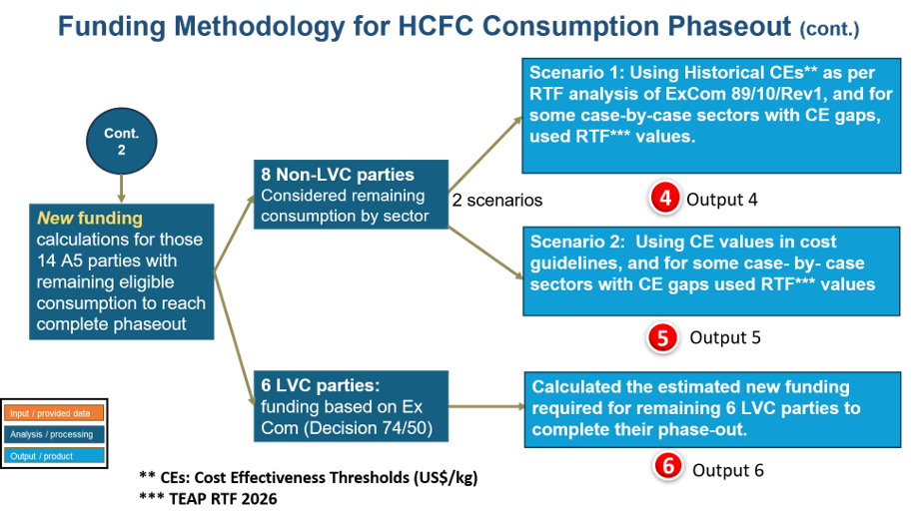
Estimated Funding for 8 Non-LVC Parties: HCFC Scenario 1 – under HCFC Scenario 1, historical CEs were used, based on the “RTF analysis of document ExCom 89/10/Rev1” presented in Annex 2 of the RTF May 2026 report. New funding was estimated for the 8 non-LVC parties under Output 4 in Figure A2.3.

For its analysis, the RTF treated projects in the largest HCFC consuming party, China, separately from those of the other 7 parties and derived average historical sector specific CE values for each group. Sectors with no remaining eligible consumption were excluded from the analysis, including foam, fire extinguishing, and solvents.

For HCFC Scenario 1, the RTF applied the corresponding historical CEs described below to estimate new funding. The total estimates is therefore the sum of funding estimates for the 7 parties and a separate funding estimate for China.
The historical sector-specific CEs applied to manufacturing sectors by the RTF are presented in Table A2.1. The estimated funding for these 8 parties for 2027-2029 is shown in Table A2.2.
Table A2.1: Historical CEs applied to manufacturing sectors for HCFC Scenario 1 (US$/kg)
HCFC  Sector | XPS Foam | PU Foam | Fire Ext.* | ICR (Ind./  Com Ref.  & AC ** | Resid.AC | Solvents | Servicing
Historical CE (US$/kg) applied to 7 parties | 5.74 | 7.37 | 4.8 | 14.57 | 10.05 | 10.51 | 4.8
Historical CE (US$/kg) applied to China |  |  |  | 6.97 | 4.79 |  | 4.8
* RTF considered that, in the fire extinguishing sector, the activities are currently similar to those in the servicing sector (CE 4.8 US$/kg).
** RTF used the average of the historical CE for Commercial Refrigeration (CE, 10.96 US$/kg) and the one for Commercial Air Conditioning (CE, 18.18 US$/kg), that can be found in RTF analysis of Document 89/19/Rev1, in Annex 2 of the May 2026 Report, as there is no information on historical Industrial Refrigeration and the Air Conditioning in the document. For China RTF applied the average of the historical CE for Commercial Refrigeration in China (CE, 9.15 US$/kg) and the one for Commercial Air Conditioning (CE, 4.79 US$/kg), as in the RTF analysis document.

Table A2.2: 2027 -2029 updated funding estimates for 8 parties with remaining HCFC consumption in different sectors (US$ millions)
Estimated Funding  (in US$ million) | XPS Foam | ICR | Resid. AC | Servicing | Total | Total (with 9.6% ASC)
1 party (China) | - | 94.31 | 66.10 | 144.37 | 304.79 | 334.05
7 parties | 0.10 | 2.62 | - | 16.09 | 18.81 | 20.61
Total for 8 parties | 0.10 | 96.93 | 66.10 | 160.46 | 363.28 | 398.15
Total with 15% deduction* | 0.08 | 82.39 | 56.18 | 160.46 | 299.12 | 327.84
* Includes 15% deduction for foreign ownership in manufacturing sectors
PMUs are not included in the total funding presented in Table A2.2. PMUs, including the 9.6% Agency Support Costs (ASC), represent an additional US$ 16.47 million.
Estimated Funding for 8 Non-LVC Parties: HCFC Scenario 2 - Using the CE values specified in the cost guidelines, and CE values provided by RTF to fill gaps for certain case-by-case sectors, RTF calculated new funding estimates for the 8 parties under Output 5 in Figure A1.3.
Upon the ExCom cost guidelines, CE values are defined for the domestic refrigeration (PU panel), foam, and commercial refrigeration sectors. Other sectors, such as fire extinguishing, domestic AC manufacturing (room AC and domestic heat pumps), and other refrigeration and AC manufacturing (heat pumps, transport, chillers, and industrial applications), are funded based on CE values determined on a case-by-case basis. For these sectors, RTF used CE values suggested by TEAP/TOC/RTF expert members to fill gaps where CE values are not specified in the cost guidelines. Manufacturing sectors with no remaining eligible consumption were disregarded. The CE values applied under scenario 2 are presented in Table A2.3 below.
Table A2.3: Cost Guidelines/ RTF CEs applied to Manufacturing Sectors for HCFC Scenario 2 (US$/kg)
HCFC  Sector | XPS Foam | PU Foam |  | Fire Ext. * | ICR (Ind./Com Ref.& AC** | Residential AC## | Solvents## | Servicing
CE applied to 8 parties (US$/kg) | 8.22 | 7.83 |  | 4.8 | 15.21 | 7.15 | 10.13 | 4.80
*RTF considered that in fire extinguishing sector the activities are currently similar to the ones in servicing sector (CE 4.8 / US$/kg).
For Commercial and Industrial Ref./AC, RTF applied the CE in cost guidelines for commercial refrigeration (15.21 US$/kg).
#For Residential AC, RTF applied CE of 7.15 US$/kg (average of the CE for China, 4.74 US$/kg, and for projects elsewhere, 10.05 US$/kg (Annex 2 of the May 2026 Report))
##RTF used CE of 10.13 US$/kg for Solvents, using average of all projects in Solvents sector in document 89/10/rev1.

The estimated funding required to address the remaining consumption by sector for the 8 non-LVC parties, based on the methodology explained above, is presented in Table A2.4 below. This scenario does not include the additional 25% funding for the introduction of low-GWP alternatives allowed under decision 74/50(c)(iii) for sectors subject to a CE threshold (PU foam and commercial refrigeration), nor the additional 40% funding for foam SMEs.
Table A2.4: Funding estimates addressing 8 parties with remaining HCFC consumption in different sectors (US$ millions)
Estimated Funding  (in US$ million) | XPS Foam | ICR | Resid. AC | Servicing | Total | Total (with 9.6% ASC)
Total for 8 parties | 0.14 | 208.55 | 99.70 | 160.46 | 468.86 | 513.87
Total with 15% deduction* | 0.12 | 177.27 | 84.75 | 160.46 | 422.60 | 463.17
*A 15% deduction was applied for foreign ownership in the manufacturing sector. Only sectors with remaining eligible consumption for each individual party were considered.
PMUs are not included in the total funding presented in Table A2.4. PMUs, including the 9.6% Agency Support Costs (ASC), represent an additional US$ 22.83 million.
6 LVC Parties (out of total of 14 non-LVC and LVC parties)
Of the 14 parties, 6 are LVCs. For these parties, RTF estimated new funding considering a separate cost framework, in accordance with ExCom Decision 74/50. The new funding estimates are presented under Output 6 in Figure A1.3. Taking into account the amounts already committed for the remaining 6 LVC countries, as well as the funding levels established under Decision 74/50 for the phaseout, the total amount to be allocated to these countries is US$ 2.16 million.
The total estimated new funding for 14 parties (8 non-LVCs plus 6 LVCs) was calculated by adding the estimated funding for the non-LVCs (Output 4 or 5) to the estimated funding for the LVC parties (Output 6). This results in a range based on two different CE scenarios.
Accordingly, the total estimated funding for 14 parties, which have eligible remaining consumption to be addressed in order to achieve complete phaseout, is:
- HCFC Scenario 1: US$ 330.00 million
- HCFC Scenario 2: US$ 465.32 million

A2.3 Verification costs for HPMPs
Regarding verification costs, the Adjusted Consolidated 2026-2028 Business Plan includes provisions for 2027 and 2028, but not 2029. A total of US$ 588,600 per year for 2027 and 2028 is included in the “Adjusted Consolidated Business Plan of the Multilateral Fund for 2026-2028”. ^{[1]} These amounts have not been updated and remain unchanged from those included in the May 2026 RTF report (TEAP, 2026), as reproduced in Table A2.5 below.
Table A2.5: Estimated funding requirement for HPMP verification for 2027-2029 (US$)
HPMP Verification | 2027 | 2028 | 2029 | Total  2027-2029
18 LVC countries | 588,600 | 588,600 | 588,600 | 1,765,800

A2.4 Project preparation for HPMPs
The updated remaining project preparation (PRP) requests for HPMPs, as provided by the MLF Secretariat, are reflected in the list of countries requiring PRP in Table 2.6 below. The total estimated funding required for HPMP project preparation, excluding China, for 2027-2029 is US$ 263,040, including support costs. Table 2.6 updates the amounts presented in May 2026 RTF report which identified a total requirement of US$ 43,840, including agency support costs and excluding China.

Table A2.6: Estimated funding requirement for HPMP project preparation (US$)
Country | Status | HPMP PRP Required for Total Phase-Out | Funding Eligibility for Servicing (Excluding Support Costs) | HPMP PRP in 2026-2028 Business Plan
Afghanistan | Non-LVC | Yes | 40,000 | Yes
China | Non-LVC | Yes | Case by case basis | Yes
Democratic People's Republic of Korea (the) | Non-LVC | Yes | 70,000
Libya | Non-LVC | Yes | 60,000
Mauritania | Non-LVC | Yes | 30,000 | Yes
Senegal | Non-LVC | Yes | 40,000 | Yes
Total (excluding China) |  |  | 240,000
Total (excluding China) including 9.6% support costs |  |  | 263,040

A2.5 Energy efficiency (Decision 89/6)
In Decision 89/6, the ExCom established a funding table and defined additional EE-related activities for inclusion in existing and future HPMPs for LVC countries in response to paragraph 16 of Decision XXVIII/2 and paragraph 2 of Decision XXX/5 of the parties. The ExCom in Decision 91/37 decided that Decision 89/6 applies to LVC countries that have already completed their HPMPs.

The maximum funding eligibility for decision 89/6 based on 95 LVC countries and 11% support costs (based on historical average) is US$ 11,135,360. By ExCom-98, 75 Parties and 1 region have approved projects funded under Decision 89/6 with a total funding of US$ 8,614,179. The remaining parties may apply for funding for support during the upcoming triennium or in future triennia.

The RTF estimates, based on previous ExCom approval rates, may approve zero or up to US$ 1,080,000 at ExCom-99. As such, the amount needed for the next triennium is
- Low-end funding estimate: US$ 1,441,181 including support cost;
- High-end funding estimate: US$ 2,521,181 including support cost.

The RTF estimates that up to US$ 2,521,181 may be required to support the remaining LVCs in the 2027-2029 triennium.

A2.6 Updated estimated funding requirement for the total HCFC consumption sector phase-out
The total HCFC phase-out is scheduled for 2030 with the special allowances for the servicing tail. ExCom Decision 62/17 “requested the bilateral and IAs, when preparing multi-year HPMPs, to ensure that the last tranche comprised 10% of the total funding for the refrigeration servicing sector in the agreement and was scheduled for the last year of the plan.”

RTF considered that the last tranche of the HPMPs would occur in 2030; consequently, 90% of the total phase-out resource allocation would be within the 2027-2029 triennium and the 10% for the last tranche would be allocated to the next triennium 2030-2032, following decision 62/17.
Applying the HCFC scenarios 1 and 2 based on historical versus cost guidelines CEs, respectively, and considering Decision 62/17, and allocating funding resources 90% to 2027-2029 and 10% to 2030-2032, the ranges for the estimated funding requirement for the HCFC consumption sector total phase-out for the 2027-2029 and 2030-2032 are summarised in Table A1.5.
As in the May 2026 Report, the ranges for the estimated funding for the HCFC consumption sector for 2027-2029 and 2030-2032 are derived by applying the HCFC scenarios 1 and 2 based on historical versus cost guidelines CEs, respectively, and considering Decision 62/17, and allocating funding resources 90% to 2027-2029 and 10% to 2030-2032. RTF believes that this methodology provides a consistent and transparent basis for estimating remaining funding requirements for complete phaseout of HCFCs, using information available based on actual implementation experience and the policy ceilings defined by existing cost guidelines.

Table A2.7: Updated range of estimated funding requirement for total HCFC consumption sector phase-out for 2027-2029 and future triennia (US$ millions)
HCFC CONSUMPTION SECTOR | 2027-2029 and future triennia  Total Estimated Funding for Complete Phaseout  (US$ million) |  | Estimated Funding by Resource Allocation  US$ million) |  | Estimated Funding by Resource Allocation  (US$ million)
HCFC CONSUMPTION SECTOR |  |  | 2027-2029 | 2030-2032 | 2027-2029 | 2030-2032
HCFC CONSUMPTION SECTOR | 2 Scenarios  Applying different CEs to manufacturing sectors |  | HCFC Scenario 1 |  | HCFC Scenario 2
HCFC CONSUMPTION SECTOR | Scenario 1 | Scenario 2 | 90% | 10% | 90% | 10%
Funding Committed for Approved HPMPs | 117.75* | 117.75* | 89.18* | 28.75* | 89.18* | 28.57*
Estimated New Funding for Project Preparation (PRP) | 0.263 | 0.263 | 0.24 | 0.03 | 0..24 | 0.03
Estimated New Funding to Address Remaining Consumption in 14 Parties for Complete Phaseout | 346.47 | 488.15 | 311.82 | 34.65 | 439.34 | 48.81
Estimated New Funding for re-submission of 3 cancelled HPMPs | 8.14 | 8.14 | 7.33 | 0.81 | 7.33 | 0.81
HCFC Verification Funding | 1.77 | 1.77 | 1.59 | 0.18 | 1.59 | 0.18
Energy Efficiency Funding for LVCs (Decision 89/6) | 2.52 | 2.52 | 2.27 | 0.25 | 2.27 | 0.25
Total for HCFC Consumption Sector | 476.91 | 618.59 | 413.33 | 64.59 | 540.85 | 78.75
*The values for committed funding follow the exact amount in tranches agreed, and the suggested 90/10% allocation by triennium does not apply. In order to simplify presentation of funding values in the tables, which for all HCFC calculations do not go beyond 2032, the final committed tranche for one party for 2033 is included in the 2030-2032 triennium.

** PMU costs using 5% for China and 10% for other parties and 9.6% of support cost.
NOTE: Numbers may differ slightly due to rounding.

ANNEX 3: METHODOLOGY TO ESTIMATE FUNDING REQUIREMENTS FOR HFC PHASE-DOWN IN THE CONSUMPTION SECTOR (UPDATED RTF May 2026 Report)
This annex provides information on the updated estimated funding methodology for the HFC phasedown in the consumption sector. The methodology was originally presented in Chapter 3 and Annex 4 of the May 2026 Report.
For HFCs consumption, the assessment considers funding estimates for both Stage I and Stage II KIPs, to reach compliance targets for the 2027-2029 and next two triennia as follows:
- G1 parties: a 10% reduction from baseline by 1 January 2029 and a 30% reduction from baseline by 1 January 2035
- G2 parties: a freeze of production and consumption by 1 January 2028; and a 10% reduction from baseline by 1 January 2032.
The estimate for the HFC phase-down funding requirement for the 2027-2029 triennium and future triennia, 2030-2032 and 2033-2035, is based on A5 parties meeting the relevant G1 or G2 reduction targets.
The estimated funding requirement for the HFC consumption sectors include the following:
- Funding committed for approved KIPs;
- Funding for project preparation costs;
- Funding estimated for new KIPs;
- Funding for EE (ExCom Decision 91/65, 94/60 and 91/65);
- Funding for KIP verification.

A3.1 Sources of Information
The RTF modelling approach consolidates updated data from the following sources:
- A7 consumption data as reported to the OS, as of 17 July 2026;
- CP data submitted to the MLFS, as of 17 July 2026;
- Information provided by the MLFS on approved KIPs, including agreed reductions from baseline consumption, funding and tranche schedules, project preparation and verification activities, as well as information on EE and the status of funding windows;
- ExCom documents and decisions, including cost guidelines, up to and including ExCom-98
- Classification of LVCs based on HCFC and HFC baseline consumption (unchanged as presented in Annex 5 of the RTF May 2026 report);
- BP, used to inform the RTF on future requests to IAs for projects to be submitted to MLFS, therefore guiding RTF to forecast potential new funding needed;
- Parties’ ratification status of the KA, as of 10 August 2026 (Annex 2); and
- PMU costs applied based on consultations with MLFS and IAs: 5% PMU for China, as for China HPMP II, 7% PMU for large top-10 consumption parties, and 10% PMU for other smaller non-LVC parties.

A3.2 HFC Phase-down Funding Methodology for the Consumption Sector
The RTF compliance model methodology calculates funding needs for addressing both 10% reduction from the baseline by 2029 (Stage I KIP) and 30% reduction by 2035 (Stage II KIP) for G1 parties, plus, a freeze by 2028 and a 10% reduction from the baseline by 2032 for G2 parties (Stage I KIP). The Stages I and II total funding estimates were then allocated among the three triennia for the period between 2027 and 2035 covering different compliance targets for G1 and G2 and addressing the diversity of national circumstances and different groups’ control targets.
The RTF compliance model to estimate required total funding requirements for both Stages I and II for 3 triennia (9-year period) and also provides a funding range based on two scenarios and two resource allocation proposals (A and B):
- HFC Scenario 1 considers the approved HFC KIP Stage I cost guidelines (CE) thresholds for all enterprises in the manufacturing sectors. When CE values were not available for specific case-by-case sectors, the RTF used CE estimates based on guidance from TEAP /TOC/RTF sector experts. Funding was also estimated for Stage II KIPs, using Stage I CEs, without considering any potential impact of the guidelines review expected in 2028;

- HFC Scenario 2 considers the application of the higher CE thresholds approved by Decision 95/86 for SMEs in the different sectors (32% for RAC, and 40% for PU Foam above the CE threshold). RTF did not consider funding at 2.5 times CE thresholds for umbrella projects by micro enterprises as these projects would have to cover all enterprises in the sector with no additional funding in later stages, which is difficult to determine at present. Without implementation experience with HFCs and lack of information that RTF could access in the short timeframe for this report, TOC experts were consulted to estimate the percentage of SMEs' participation in sectors. For both scenarios, a 15% deduction was applied to account for ineligible foreign ownership in the manufacturing sectors, and Stage I cost guidelines CEs were applied to Stage II funding calculations, and no potential impact of the expected guidelines review in 2028. RTF will consider further how this should be applied in the supplementary report with guidance from parties.
The model takes into consideration each individual country reduction addressed under a KIP.
For this assessment, the RTF estimated funding approach grouped parties following their KIPs status according to the steps below:

STEP 1. 91 parties in G1 have approved KIP-Stage I for a 10% reduction from the baseline.

Those parties have different agreed % reductions from the baseline, with some even higher than 30% reduction required by 2035. The model was designed to consider:
- The committed funding for all 91 approved Stage I KIPs amounts to US$ 65.3 million in 2027-2029 triennium and US$ 15.3 million in 2030-2032 and US$ 0.37 million in 2033-2035 triennia, as per information received from the MLFS. This methodology step is shown in the Figure A3.1 flow chart below, and the committed funding is presented under Output 1.

Figure A3.1 Flowchart for Outputs 1: estimating committed funding for 91 G1 parties for 10% reduction from baseline
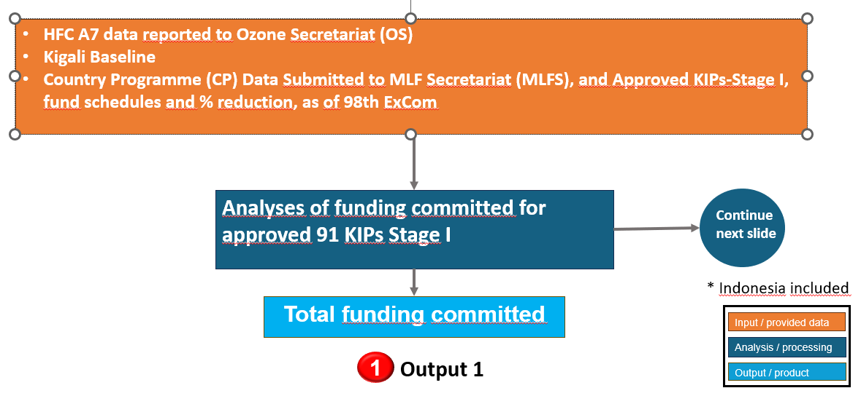

b. New funding for KIP-Stage II for 76 parties that have reductions from the baseline below 30% are shown as Output 2 for 31 non-LVC parties and Output 3 for 45 LVC parties in the Figure A3.2 flowchart below. 15 parties that have reductions from the baseline equal to or above 30% are not considered for new funding in this 2026 RTF assessment.

Figure A3.2 Flowchart for Outputs 2 and 3: estimating new funding for 31 non-LVC parties and 45 LVC parties to reach 30% reductions of the baseline by 2035
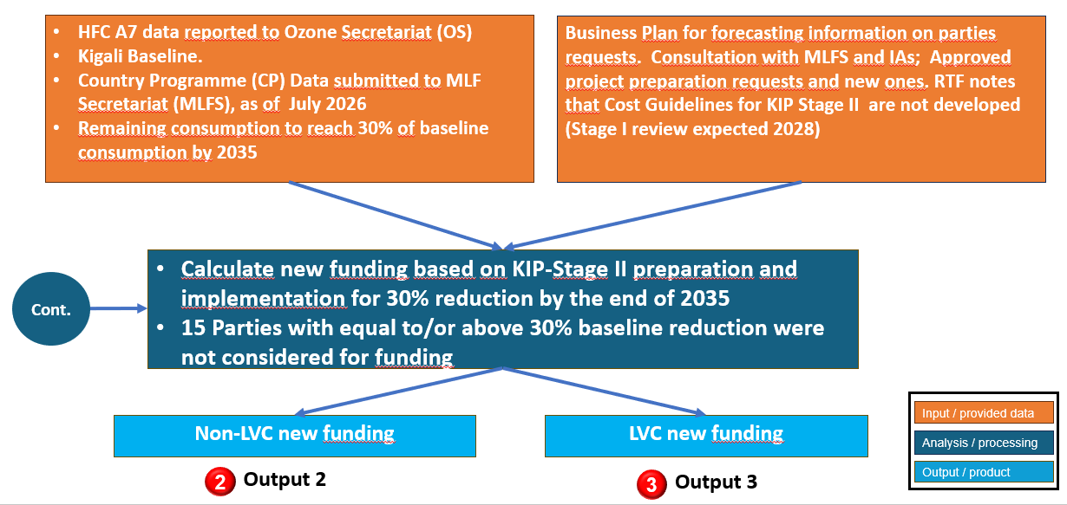

As explained, for this assessment the RTF calculated funding needs for parties to reach Stage I and Stage II targets for G1, and Stage I target for G2. For each of the modelling steps explained, RTF presented funding estimates in two Scenarios 1 and 2, and for each scenario (including G1 and G2), the total estimated funding for KIP Stages I and II (G1) and Stage I (G2), was then divided according to two resource allocation proposals A and B, in different triennia, suggested by RTF. That means, the model database was set for each individual party and shows each agreed reduction from the baseline in the previous approved KIP stage. Any additional funding is then calculated based only on the consumption not yet addressed for that party and required attention so the party can achieve a certain control target.

STEP 2. 35 parties in G1 and G2 without approved KIP-Stage I (as of ExCom-98), and that ratified KA (as of 10 August 2026)

- G1: New Funding for 29 A5 parties to prepare and/or submit KIP-Stage I and Stage II (10% by 2029; 30% by 2035) (Output 4 for 10 non-LVC parties (including China) and Output 5 for 19 LVC parties) as shown in Figure A3.3 flowchart.

Figure A3.3 Flowchart for Outputs 4 and 5: estimating new funding for G1 parties (10 non-LVC and 19 LVC) to submit KIP-Stage I
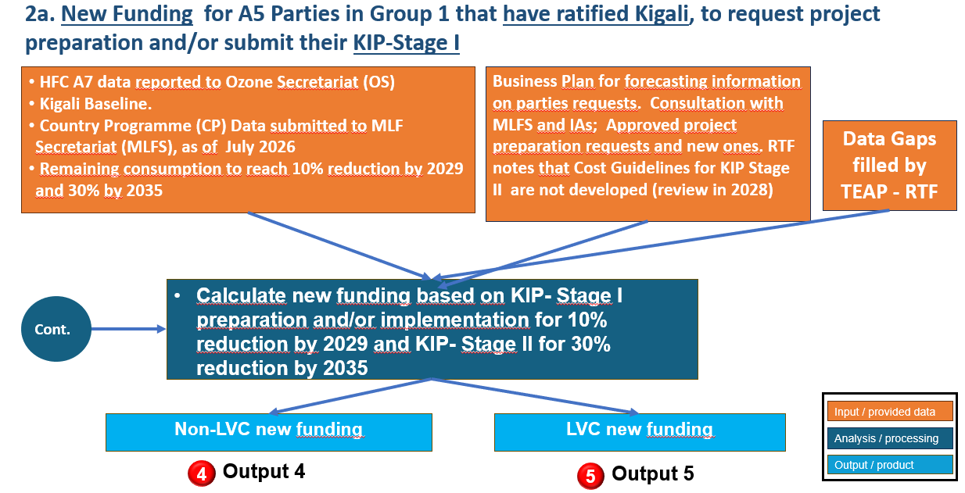

- G2: New funding to six parties (freeze by 2028 and 10% reduction by 2032) (Output 6) as shown in Figure A3.4.

Figure A3.4 Flowchart for Output 6: estimating new funding for G2 parties to submit KIP-Stage I
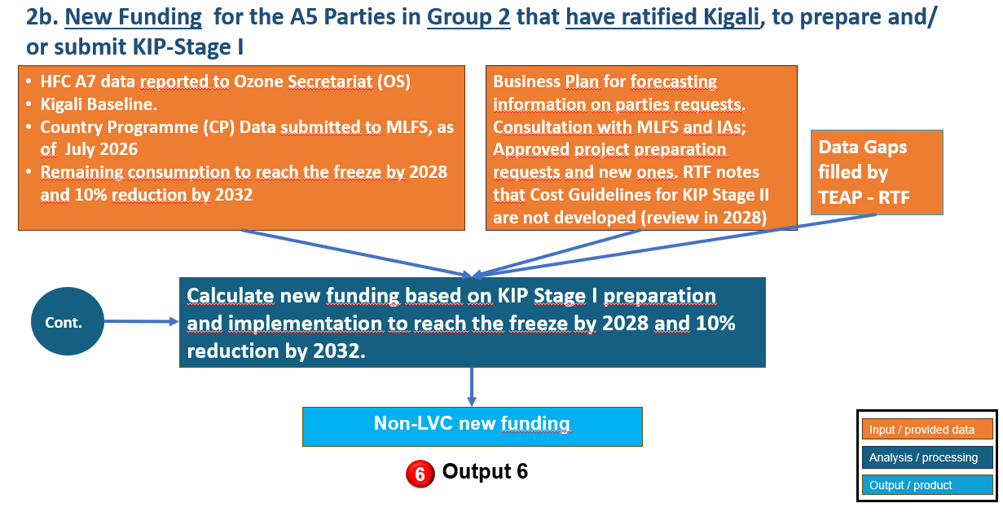
STEP 3. 18 parties that have not ratified the KA yet (RTF forecasted 100% ratification by 2029)

- G1: New funding for 10% reduction by 2029 and 30% by 2035 (15 parties) (Output 7 for 6 non-LVC parties and Output 8 for 9 LVC parties).

Figure A3.5 Flowchart for Outputs 7 and 8: estimating new funding for G1 parties who have not yet ratified KA
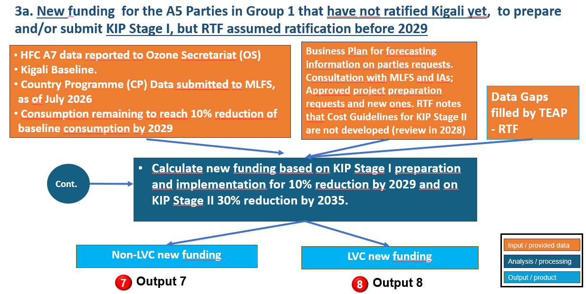

- G2: New funding for the freeze by 2028 and 10% reduction by 2032 for 3 parties that have not ratified Kigali yet. RTF assumed ratification by 2029, as it is critical to access technical and financial support in time to meet compliance targets (Output 9)

Figure A3.6 Flowchart for Output 9: estimating new funding for G2 parties who have not yet ratified KA
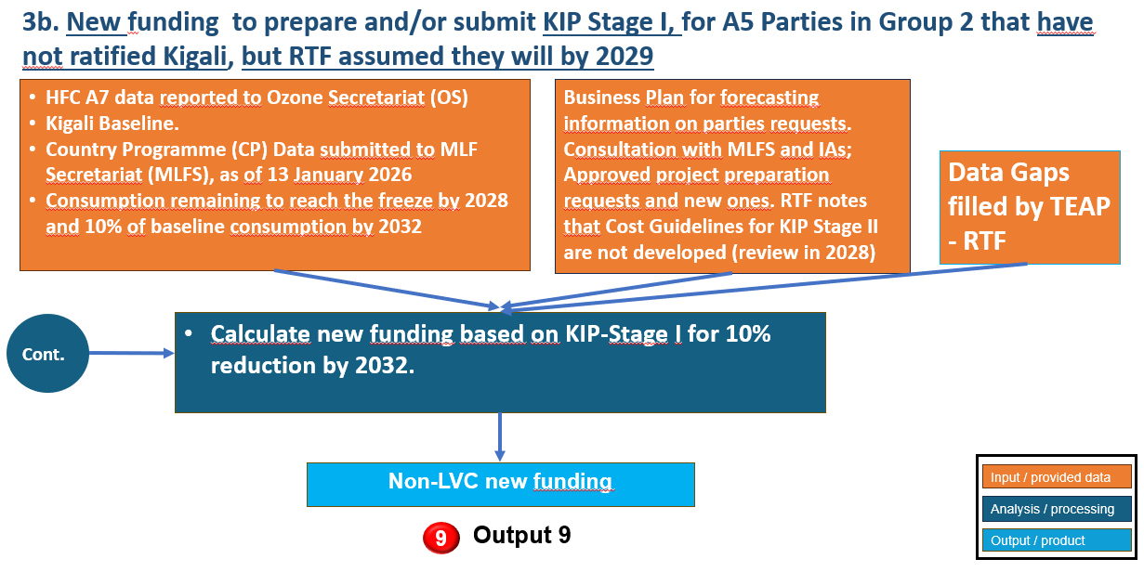

For G2 parties, where baseline years extend to 2024–2026, estimates relied more heavily on trend extrapolation based on available data. Where complete datasets were not available, the RTF filled the gaps as per methodology detailed in Annex 3 of its May 2026 Report based on reported A7 data and gross domestic product (GDP) growth rates. In order to reflect uncertainty, a range was developed with a low-end value, assuming conservative consumption levels and limited growth, and a high-end value, assuming continuation of recent growth trends. These assumptions introduce additional uncertainty into the funding estimates, which is reflected in the range presented.

In order to estimate funding requirements for the HFC phasedown to meet the reductions targets in Stage I and Stage II KIPs, discussed in Chapter 3 of the May 2026 Report, RTF model organization is summarised in the Table A3.1 below.

Table A3.1: Summary of estimated funding methodology for HFC phase-down
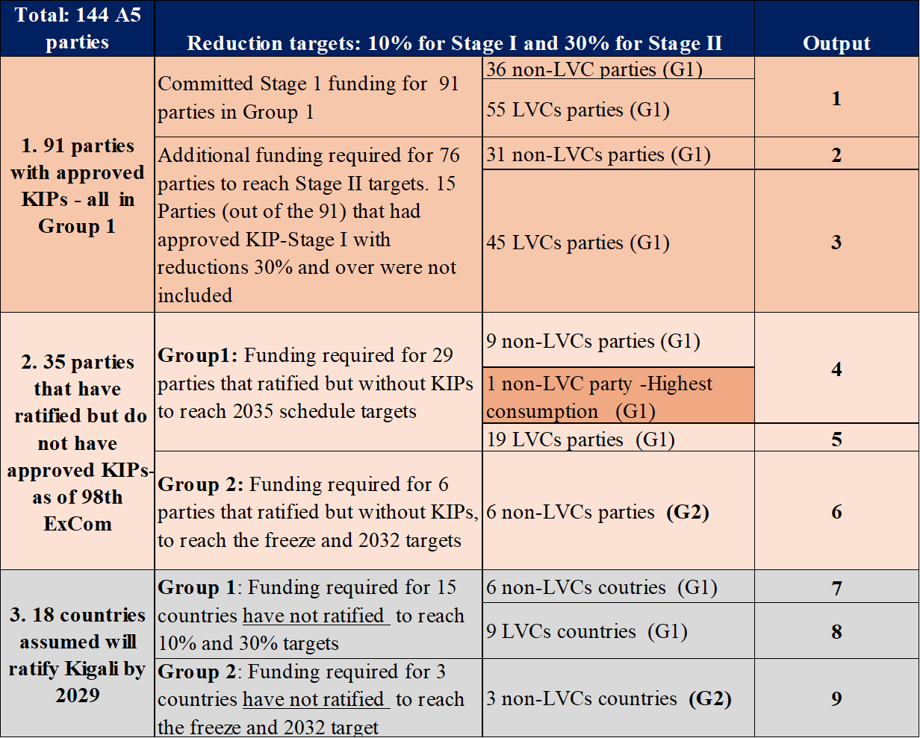
Information on CE thresholds used in the different sections of the model, methodology for filling baseline data gaps, and explanations regarding sector distribution of chemicals utilized, are detailed in Annex 3 and Chapter 3 of the RTF May 2026 Report.
The same resource allocation proposals A and B described in Chapter 3 of the RTF May 2026 Report are indicated in the Table A3.2 below.

Table A3.2: Resource allocation proposals A and B
Group | KIP Stage | Schedule A  (% per triennium) | Schedule B  (% per triennium)
G1 parties without KIPs | I | 100% - 2027-2029 | 90% - 2027-2029  10% - 2030-2032
G1 parties without KIPs | II | 60% - 2030-2032  40% - 2033-2035 | 60% - 2030-2032  40% - 2033-2035
A5 G1 parties with KIPs | II | 60% - 2027-2029  40% - 2030-2032 | 60% - 2030-2032  40% - 2033-2035
A5 G2 parties without KIPs | I | 60% - 2027-2029  40% - 2030-2032 | 90% - 2030-2032  10% - 2033-2035
For both proposals (A and B), RTF assumed full ratification for G1 and G2 parties by 2029.
The resource allocation proposals are applied to both scenarios. It is important to emphasise that the total funding for the 3 triennia for Stage I plus Stage II, changes depending on the scenario, but the allocation does not affect the total funding. The total funding per scenario only shifts from one triennium to another.

A3.3 HFC SCENARIO 1 updated estimated funding
The methodology used for funding calculations for HFC Scenario 1, was based on cost guidelines sector CEs applied to sector remaining consumption (converted to metric tonnes), and according to the reduction target for each individual party (bearing in mind the consumption already addressed by approved KIP Stage I). The CE values applied are shown in Table A3.3 below.

Table A3.3: CE thresholds used for HFC Scenario 1*
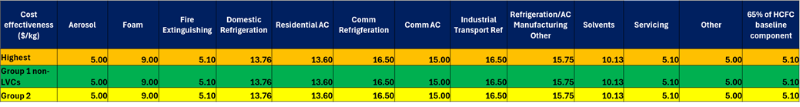
*Case by case sector CEs: For industrial/transport refrigeration RTF used same CE as for commercial refrigeration (16.50 $/kg); for Solvents used average in Table 12 of document 89/10/Rev1 (10.13 $/kg); for Refr. and Air Conditioning (AC) manufacturing/other, used 15.75, that is the average of 10.50 and 15 (CEs for Com Refr. and Com. AC). Other case by case sectors, RTF suggested CEs (Aerosol, Fire Extinguishing. and Other). Same CEs for all countries/groups. RTF included mobile air conditioning (MAC) in Refrigeration AC Manufacturing/ Other.
The updated total funding estimates for three triennia (9 years) to reach Stage I (10% reduction by 2029), and Stage II (30% reduction by 2035), for CE Scenario I, are presented in Table A3.4, totaling US$ 2,155.08 million (rounded) (compared to US$ 2,190.44 million from the May 2026 Report).

Table A3.4: Updated Funding Estimates for HFC Scenario 1 considering Stages I and II Targets (US$ million)
Total: 144 A5 | Reduction targets: 10% for Stage I and 30% for Stage II |  |  | Output | Funding for Stage I  (US$ ) | Funding for Stage II (US$)
1. 91 parties with approved KIPs - all A5 Group 1 | Committed Stage 1 funding for 91 parties in Group 1 |  | 36 non-LVC parties (G1)  55 LVC parties (G1) | 1 | 80,955,562
1. 91 parties with approved KIPs - all A5 Group 1 | Additional funding required for 76 parties to reach Stage II targets. 15 Parties (out of the 91) that had approved KIP-Stage I with reductions 30% and over were not included |  | 31 non-LVC parties (G1) | 2 |  | 230,760,463
1. 91 parties with approved KIPs - all A5 Group 1 |  |  | 45 LVC parties (G1) | 3 |  | 18,408,477
2. 35 parties that have ratified but do not have approved KIPs- as of 98th ExCom | Group1: Funding required for 29 parties that ratified but without KIPs to reach 2035 schedule targets |  | 9 non-LVC parties (G1) | 4 | 29,802,392 | 59,604,784
 |  |  | 1 non-LVC party with highest baseline consumption (G1) | 4 | 515,968,667 | 1,031,937,334
 |  |  | 19 LVC parties (G1) | 5 | 3,585,016 | 7,170,032
 | Group 2: Funding required for 6 parties that ratified but without KIPs, to reach the freeze and 2032 targets |  | 6 non-LVCs parties (G2) | 6 | 139,914,732
3. 18 countries assumed will ratify Kigali by 2029 | Group 1: Funding required for 15 countries that have not ratified - to reach 10% and 30%targets |  | 6 non-LVC countries (G1) | 7 | 5,451,926 | 10,903,852
3. 18 countries assumed will ratify Kigali by 2029 |  |  | 9 LVC countries (G1) | 8 | 1,727,296 | 3,454,592
3. 18 countries assumed will ratify Kigali by 2029 | Group 2: Funding required for 3 countries that have not ratified, to reach the freeze and 2032 target |  | 3 non-LVC countries (G2) | 9 | 15,433,101
 |  |  |  | Total | $ 792,838,691 | $ 1,362,239,534
*With Support Costs/Region ASP, and PMU included.  PMU is US$ 108.92 million (in the US$ 2,155 million total for Scenario 1). |  |  |  | TOTAL Stage I plus Stage II |  | $ 2,155,078,225
The updated funding per triennium for the HFC Scenario 1, applying resource allocation schedule A is in Table A3.5 below.
Table A3.5: Resource Allocation A proposed by RTF for HFC Scenario 1 (US$ million)
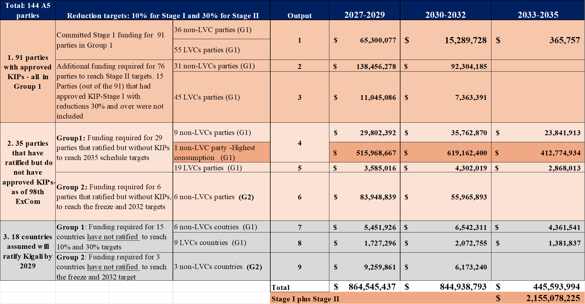
Applying resource allocation schedule A, the updated new funding estimates for each triennium for HFC Scenario 1 are:
- 2027-2029: US$ 864.55 million (compared to US$ 853.01 million in the May 2026 Report)
- 2030-2032: US$ 844.94 million (compared to US$ 858.61 million in the May 2026 Report)
- 2033-2035: US$ 445.59 million (compared to US$ 478.82 million in the May 2026 Report)

The updated funding per triennium, for HFC Scenario 1, applying resource allocation schedule B is presented in Table A3.6 below.

Table A3.6: Resource Allocation B proposed by RTF for HFC Scenario 1 (US$ million)
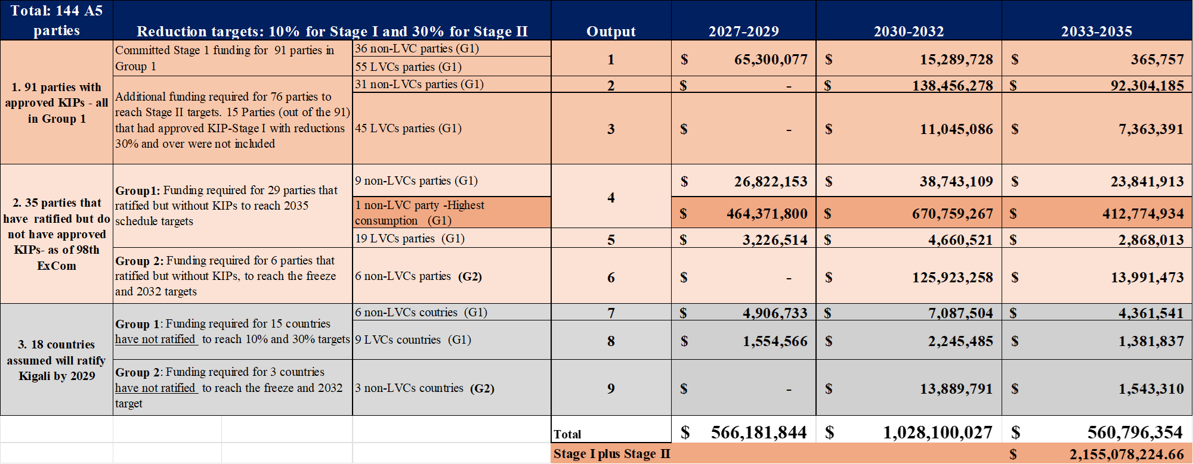
Applying resource allocation schedule B, the new funding estimates for the HFC Scenario 1 are:
- 2027-2029: US$ 566.18 million (compared to US$ 585.50 million in the May 2026 Report)
- 2030-2032: US$ 1,028.10 million (compared to US$ 1,031.12 million in the May 2026 Report)
- 2033-2035: US$ 560.80 million (compared to US$ 573.81 million in the May 2026 Report)

A3.4 HFC scenario 2 updated estimated funding
Decision 95/87 defines “SMEs in the commercial RAC manufacturing sector as enterprises with HFC consumption of 15 metric tonnes or less, and 20 metric tonnes for polyurethane foam” with certain considerations and limitations. The decision accorded SMEs “32 per cent above the CE threshold” for RAC enterprises with HFC consumption of 15 metric tonnes or less, and 40 per cent for polyurethane foam enterprises with 20 metric tonnes or less.”

RTF reviewed documents UNEP/OzL.Pro/ExCom/93/96, UNEP/OzL.Pro/ExCom/92/45, and UNEP/OzL.Pro/ExCom/92/46 for information on the number and percentage participation of SMEs in the different sectors but did not find such information which can feed a scenario on the impact of SME funding. RTF made its own estimation of the percentage participation of SMEs in some sectors based on TEAP/TOC and RTF sector experts. Table A3.7 shows the commercial refrigeration sector having the highest percentage at 55 per cent with other sectors in RAC, and foam polyurethane with up to 15 per cent participation of SMEs in the sector. RTF did not consider micro enterprises benefitting up to 2.5 times through umbrella projects as mentioned in sub-paragraph e) of decision 95/86.

Table A3.7: RTF Assumptions for SMEs’ Participation in some sectors and CE Thresholds Applied*
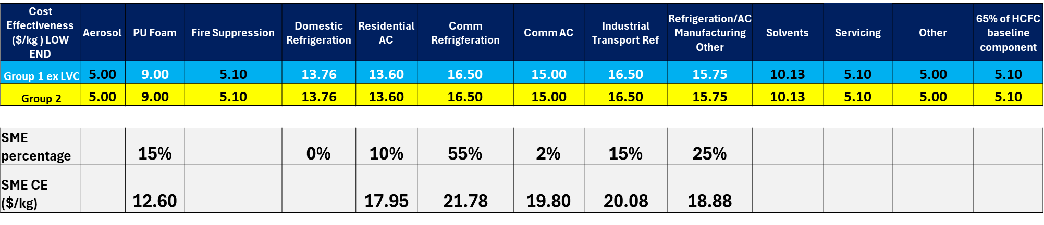
* Not considering installation and assembly

Based on the above considerations, an HFC Scenario 2 was developed to estimate funding for both Stages I and II, considering higher CEs applied for the assigned percentage participation of SMEs in specific manufacturing sectors. Tables A3.8, A3.9, and A3.10 show the updated total estimated funding for Stage I and Stage II and application of two resource allocation schedules A and B.

Table A3.8: Updated Funding Estimates for the HFC Scenario 2 considering Stages I and II Targets (in US$ million)
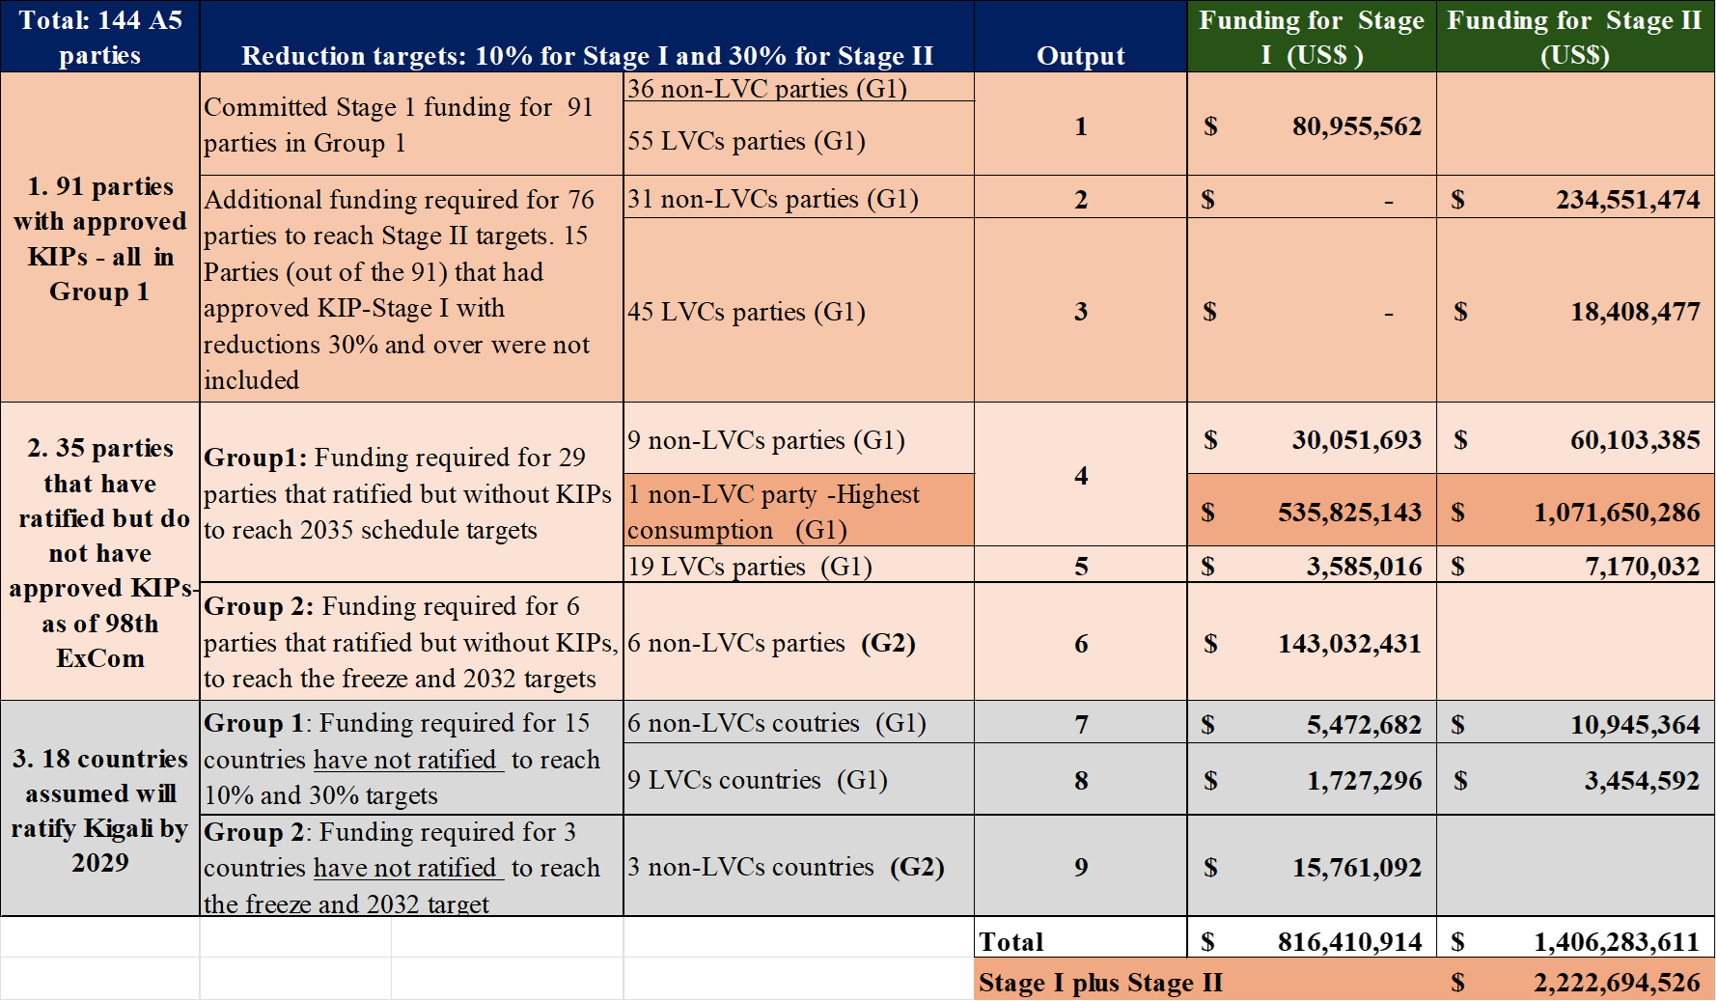

Table A3.9: HFC Scenario 2, using Resource Allocation A considerations proposed by RTF (US$ million)
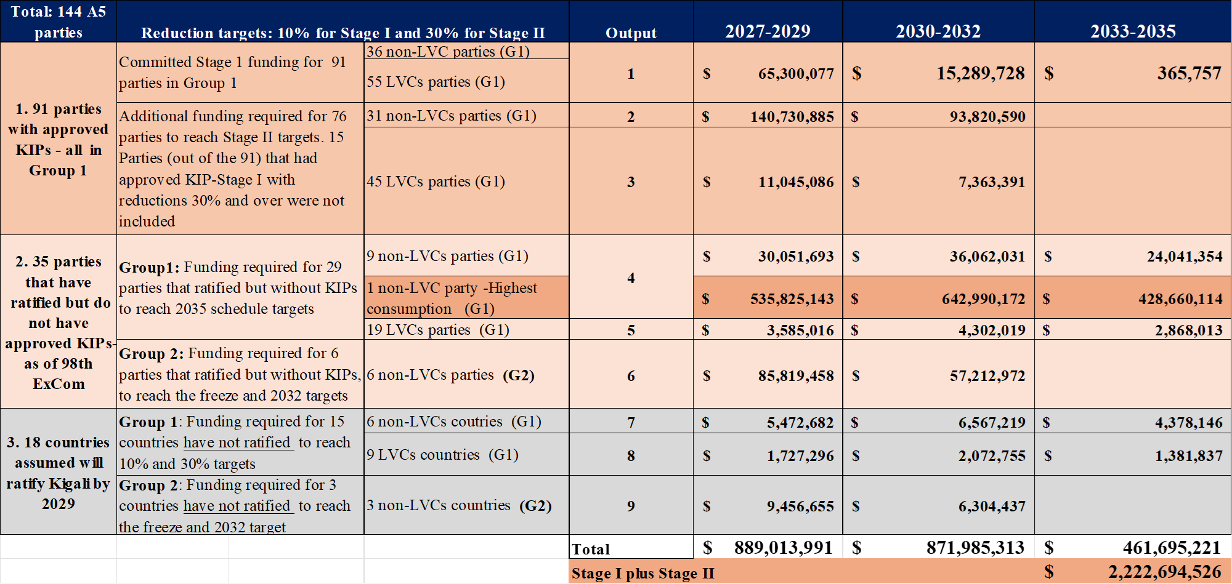
Applying resource allocation schedule A, the updated new funding estimates for each triennium for HFC Scenario 2 are:
- 2027-2029: US$ 889.01 million (compared to US$ 876.37 million in the May 2026 Report)
- 2030-2032: US$ 871.99 million (compared to US$ 884.72 million in the May 2026 Report)
- 2033-2035: US$ 461.70 million (compared to US$ 494.62 million in the May 2026 Report)

Table A3.10: HFC Scenario 2, using Resource Allocation B considerations proposed by RTF (US$ million)
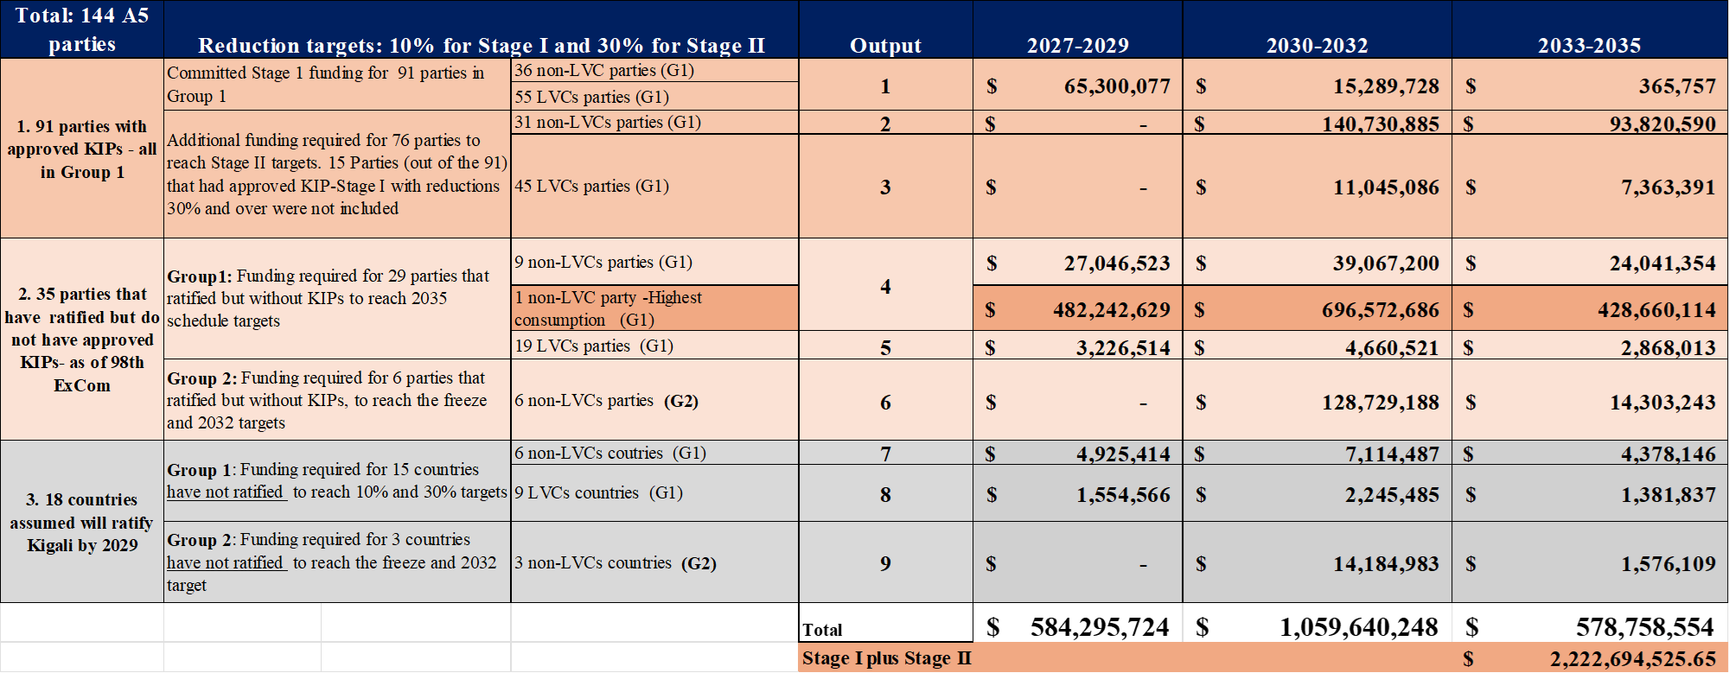

Applying resource allocation schedule B, the updated new funding estimates for each triennium for HFC Scenario 2 are:
- 2027-2029: US$ 584.30 million (compared to US$ 603.28 million in the May 2026 Report)
- 2030-2032: US$ 1,059.64 million (compared to US$ 1,061.32 million in the May 2026 Report)
- 2033-2035: US$ 578.76 million (compared to US$ 591.11 million in the May 2026 Report)

A3.5 verification: consumption sector
The May 2026 Report assumed that all 144 parties will have KIPs Stages I and II in the next three triennia; consequently, the RTF considered for each triennium three tranches per party, and two tranche verification requests per triennium each, for a total of six tranche verifications for the three triennia, for each of the 144 A5 parties. With this in mind, RTF estimated for three triennia (2027 to 2035 period), approximately US$ 26 million in verification costs (at US$ 30,000 each, used for LVCs).

The amount used in this report is however based on the original calculations subtracting the approved amounts for KIP verification, including combined HPMP and KIPs, which amount to US$ 1.8 million and deducting them from the estimate in the May 2026 RTF report for a revised total of US$ 24.2 million.

A3.6 project preparation: consumption sector
For the forecast of project preparation (PRP) needs for the consumption sector in 2027-2029, RTF considered that for every new KIP to be submitted, the country can request project preparation. Several parties already received PRP as of ExCom-97, according to the MLFS information provided.

The updated list of remaining parties eligible for Stage I KIP PRP contains 26 parties without PRP request, and 18 of them have included PRP requests in the BP.

The updated total estimated funding requirement after approvals from ExCom-98 for 25 countries, not including China which is case-by-case, is US $ 4,570,320 including 9.6% support costs if all is requested for the 2027-2029 triennium. Annex 7 shows the details for the 25 countries for which PRP funding for KIP Stage I is needed.

For KIP Stage II, RTF considered that all countries with approved project preparation funding for Stage I would be eligible for project preparation funding for KIP Stage II since they would have progressed in their implementation of Stage I and would be ready to submit requests for Stage II, except for those countries that exceeded 30% reduction from their baseline or went beyond 2030 for Stage I. This assumption has not changed for the supplementary report and funds for preparation of KIP Stage II remains at US$ 15,660,000, and cost including agency support cost is US$ 17,163,360.
Table A3.11 provides a summary of the estimated funding requirement for PRP for KIP Stages I and II in the 2027-2029 triennium.
Table A3.11: Estimated funding for PRP for KIP Stages I and II for 2027-2029 (US$)
KIP Stage | Total project preparation cost (US$) | Total including Agency Support Cost @ 9.6% (US$)
I | 4,170,000 | 4,570,320
II | 15,660,000 | 17,163,360
Total for Stages I and II | 19,830,000 | 21,733,680

A3.7 energy efficiency (decisions 91/65, 94/60, and 95/87)
As discussed in its May 2026 Report, in the context of estimated funding for EE-related items for the HFC phase-down, the RTF considered the following relevant decisions agreed upon by the ExCom:
- Decision 91/65 established a funding window for pilot projects in the amount of US $20 million with the possibility of augmenting that funding window at a future meeting to maintain and/or enhance EE in the context of HFC phase-down as specified in decision XXVIII/2, following the criteria identified in subparagraph (b) of the decision;
- Decision 94/60 established a funding window in the amount of US $100 million with the possibility of augmenting that funding window at a future meeting to maintain and/or enhance EE in the context of HFC phase-down as specified in decision XXVIII/2, following the criteria identified in subparagraph (b) of the decision’;
- Decision 95/87 established a funding window in the amount of US $40 million in the context of HFC phase-down as specified in decision XXVIII/2, following the criteria identified in subparagraph (b) of the decision’.

Decision 91/65
Decision 91/65² has established a “funding window for pilot projects in the amount of US$ 20 million with the possibility of augmenting that funding window at a future meeting to maintain and/or enhance EE in the context of HFC phase-down as specified in decision XXVIII/2, following the criteria identified in subparagraph(b)”. This funding window is currently extended till the 100th ExCom meeting for servicing only activities.³

During ExCom-98, the ExCom approved 16 projects worth US$ 1,133,772. The total funding amount available in this funding until ExCom-100 is US$ 5,235,856 including support costs. Parties are actively ramping up their proposals for EE pilot projects and are expected to fully utilise this funding window based on the business plan.

The RTF estimates, based on previous approval rates, that ExCom-99 may approve up to US$ 2 million. As such, the estimated funding requirement for ExCom-100 in the next triennium is:
- Low-end funding: US$ 3,235,856 including support costs;
- High-end funding: US$ 5,235,856 including support costs.

Decision 94/60
Decision 94/60⁴ has established a “a funding window of US $100 million for projects developed and implemented under the framework, subject to further augmentation by the Executive Committee”. These projects focus on enhancing energy efficiency when phasing down HFCs in the manufacturing of domestic refrigerators, commercial refrigeration display cabinets, commercial refrigeration chest freezers, residential air conditioners and commercial air conditioners. These activities were later extended to include compressors, heat exchangers, and heat pumps according to Decision 95/87⁵ paragraphs (b) and (c).

The ExCom has approved 8 project preparation proposals and 7 investment projects for 11 parties with a total funding of US$ 30,946,243 including support costs. The RTF estimates, based on current approval rates, that ExCom-99 may approve up to US$ 10,320,000. A5 parties may wish to continue to submit proposals and request funding at the current rate which would result in fully utilizing the fund by 2029. Assuming such is the case, the estimated funding requirement for ExCom-100 in the next triennium is:
- Low-end funding: US$ 58,733,757 including support costs.
- High-end funding: US$ 69,053,757 including support costs.

Decision 95/87
Decision 95/87⁶ has established in paragraph f a “funding window of US$ 40 million for two EE end-user projects using a revolving fund mechanism developed and supported by implementing agencies, over a duration of eight years, after which funds would be returned to the [MLF], on the understanding that it would not be operationalized until the [ExCom] had agreed on the modalities for operationalizing the revolving fund;” and in paragraph g agreed to “provide funding, for the preparation of no more than five projects, of no more than US$ 100,000 per project, on the understanding that those proposals would be submitted to the 96th meeting and that only up to two projects would be selected for the funding window referred to in subparagraph (f) above;”. At ExCom-98, the ExCom approved two revolving fund projects covering four countries, with a total funding allocation of US $42.8 million, and five technical assistance projects, totalling US $1,417,750. Hence no additional funding is expected in the next triennium.

Table A3.12 summarises the updated estimated funding requirement, taking into consideration the approved funding window (dec 91/65), without considering the possibility of augmentation.

Table A3.12: Updated Estimated Funding Requirement for EE activities during the HFC phasedown for 2027-2029 (US$)
Funding Window for Energy Efficiency | Low | High
Dec 91/65 | $3,235,856 | $5,235,856
Dec 94/60 | $58,733,757 | $69,053,757
Total US$ (with support costs) | $61,696,613 | $74,289,613

A3.8 pilot projects to enhance regional atmospheric monitoring
Decision XXXVII/6, providing the TOR for the current replenishment of the MLF, requested TEAP to provide “a scenario to allocate resources for a funding modality to support a limited number of pilot projects to enhance regional atmospheric monitoring of substances controlled by the Montreal Protocol.” The RTF considered the above, relevant decisions of the MOP and ExCom along with relevant documents and discussions related to support for enhancing regional atmospheric monitoring. The RTF considered a funding timeline based on the OS’s report on Decision XXXVI/1 to MOP-37 which outlined the potential timeline of supported activities, assuming the ExCom established a funding window at ExCom-98. Based on this assumption and relevant information, the RTF estimated the funding requirement to support three pilot projects over a five-year period to enhance regional atmospheric monitoring with the recognition that funding for the 2027-2029 triennium would focus primarily on project preparation activities, i.e., proposals for the three pilot stations.
At ExCom-98, parties reviewed a document prepared by the MLFS, “Matters relating to pilot projects to enhance regional atmospheric monitoring of substances controlled by the Montreal Protocol (Decision 96/56).” In Decision 98/62, ExCom decided to “establish a funding window of US$ 9,250,000 for three pilot projects to enhance regional atmospheric monitoring of substances controlled by the Montreal Protocol, including preparation, implementation and capacity-building activities as specified in table 1 of document UNEP/OzL.Pro/ExCom/98/61. Table A3.13 below provides the summary of expected costs. In Decision 98/62, ExCom also decided to “add to the funding window the amount of US$ 1,800,000 for the continuation of operation of three atmospheric monitoring stations to be established with the support of the General Trust Fund (GTF), on the understanding that project proposals to access the funding would be submitted to the ExCom.” The RTF assumes the timing for this addition to the funding window to be beyond the 2027-2029 triennium.
A schematic of these activities and estimated timeline of the three funding streams is presented in Figure A3.7.

Figure A3.7 Action areas and estimated timeline of the three existing and potential funding streams to support the establishment and operation of stations for the atmospheric monitoring of controlled substances
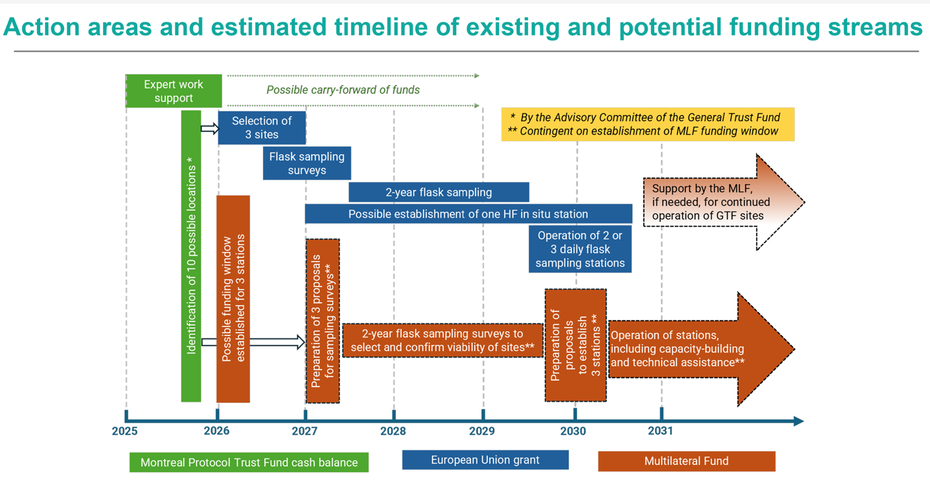
Based on the estimated timeline of activities, the RTF updated allocation of the funding window for the 2027-2029 and 2030-2032 periods is show in Table A3.13.

Table A3.13: Updated indicative costs for 2027-2029 and future triennia for a funding window for three pilot projects over five years (based on Table 1 of UNEP/OzL.Pro/ExCom/98/61)
Activity | Unit cost  (US $) | Quantity | Cost  (US $) | Triennium
Preparation
Preparation of a pilot project to establish an atmospheric monitoring station | 576,813 | 3 | 1,730,440 | 2027-2029
Implementation
Establish and operate an atmospheric monitoring station | 1,546,967 | 3 | 4,640,900 | 2030-2032
Capacity-building
Training and technical assistance for five years per station established under the Multilateral Fund | 150,000 | 3 | 450,000 | 2030-2032
Technical assistance for data storage and management per station established under the Multilateral Fund | 150,000 | 3 | 450,000 | 2030-2032
Support for calibration standards and an international conference in the fourth year to share results and lessons learned | 1,000,000 | 1 | 1,000,000 | 2030-2032
Subtotal |  |  | 8,271,340
Agency support costs (11.8%*) |  |  | 976,018
Total |  |  | 9,247,358
* Based on table 1 of document UNEP/OzL.Pro/ExCom/93/101.

Table A3.14 provides the updated estimated funding for a funding window for three pilot projects for 2027-2029 and 2030-2032.
Table A3.14: Updated indicative costs for funding window for pilot projects over five years (Decision 98/62) (US$)
 | 2027-2029* | 2030-2032
Regional atmospheric monitoring for three pilot projects | $ 1,730,440 | $ 8,271,340
Agency support costs (11.8%) | $ 204,192 | $ 976,018
Subtotal – Regional Atmospheric Monitoring | $ 1,934,632 | $ 9,247,358
*Estimated costs only cover project preparation

A3.9 updated total estimated funding requirement for the hfc consumption Sector
The summary of the updated estimated funding requirements to address Stage I and Stage II for the HFC phasedown in the consumption sector based on HFC Scenarios 1 and 2 and the resource allocation schedules A and B is presented in Tables A3.15 and A3.16.
Table A3.15: Total funding estimate for HFC consumption sector for HFC Scenario 1 to address Stages I and II targets (US$ million)
HFC CONSUMPTION SECTOR | Total for 3 Triennia  (2027 to 2035 period) | Resource Allocation A |  |  | Resource Allocation B
HFC Scenario 1  (CE in cost guidelines) | Funding for Stages I and II | 2027-2029 | 2030-2032 | 2033-2035 | 2027-2029 | 2030-2032 | 2033-2035
Funding Committed * for Approved KIPs | 80.96 | 65.3 | 15.3 | 0.37 | 65.3 | 15.3 | 0.37
Estimated New Funding to Address Stage II for parties with KIPs Stage I approved | 249.17 | 149.5 | 99.67 | 0 | 0 | 149.5 | 99.67
Estimated New Funding to Address Stages I and II for parties without approved KIPs | 1,788 | 633.3 | 715.19 | 439.48 | 494.42 | 840.09 | 453.48
Estimated New Funding to Address KIPS Stages I and II for countries pending ratification / RTF assumed all will ratify by 2029 | 36.91 | 16.44 | 14.79 | 5.74 | 6.46 | 23.22 | 7.29
Sub-Total 1 | 2,155.08 | 864.55 | 844.94 | 445.59 | 566.18 | 1,028.1 | 560.8
 |  | 2155.08 |  |  | 2155.08
Funding for Project Preparation (PRP) | 21.73 | 21.73 | 0 | 0 | 21.73 | 0 | 0
Funding for KIP Verification | 24.20 | 8.07 | 8.07 | 8.07 | 8.07 | 8.07 | 8.07
Energy Efficiency (low-end option) | 61.70 | 61.70 | 0 | 0 | 61.70 | 0 | 0
Pilot Projects for Regional Atmospheric Monitoring | 9.25 | 1.93 | 7.30 | 0 | 1.93 | 7.30 | 0
Sub-Total 2 | 116.88 | 93.43 | 15.37 | 8.07 | 93.43 | 15.37 | 8.07
Total for HFC Consumption Sector | 2,271.96 | 957.98 | 860.31 | 453.66 | 659.61 | 1,043.47 | 568.87

Table A3.16: Total funding estimate for HFC consumption sector for the HFC Scenario 2 to address Stages I and II targets (US$ million)
HFC CONSUMPTION SECTOR | Total for 3 Triennia  (2027 to 2035 period) | Resource Allocation A |  |  | Resource Allocation B
HFC Scenario 2  (CEs for SMEs) | Funding for Stages I and II | 2027-2029 | 2030-2032 | 2033-2035 | 2027-2029 | 2030-2032 | 2033-2035
Funding Committed * for Approved KIPs | 80.96 | 65.3 | 15.29 | 0.37 | 65.3 | 15.29 | 0.37
Estimated New Funding to Address Stage II for parties with KIPs Stage I approved | 252.96 | 151.78 | 101.18 | 0 | 0 | 151.78 | 101.18
Estimated New Funding to Address Stages I and II for parties without approved KIPs | 1,851 | 655.28 | 740.57 | 455.57 | 512.52 | 869.03 | 469.87
Estimated New Funding to Address KIPS Stages I and II for countries pending ratification / RTF assumed all will ratify by 2029 | 37.36 | 16.66 | 14.94 | 5.76 | 6.48 | 23.54 | 7.34
Sub-Total 1 | 2,222.69 | 889.01 | 871.99 | 461.70 | 584.3 | 1,059.64 | 578.76
 |  | 2,222.69 |  |  | 2,222.69
Funding for Project Preparation (PRP) | 21.73 | 21.73 | 0 | 0 | 21.73 | 0 | 0
Funding for KIP Verification | 24.20 | 8.07 | 8.07 | 8.07 | 8.07 | 8.07 | 8.07
Energy Efficiency (high-end option) | 74.29 | 74.29 | 0 | 0 | 74.29 | 0 | 0
Pilot Projects for Regional Atmospheric Monitoring | 9.25 | 1.93 | 7.30 | 0 | 1.93 | 7.30 | 0
Sub-Total 2 | 129.47 | 106.02 | 15.37 | 8.07 | 106.02 | 15.37 | 8.07
Total for HFC Consumption Sector | 2,352.17 | 995.03 | 887.36 | 469.77 | 690.32 | 1,075.01 | 586.83

Table A3.17 below summarises the total estimated funding requirement for the HFC consumption sector for the 2027-2029 and future triennia and presents a range per triennium.

Table A3.17 Summary of the total estimated funding ranges for the HFC consumption sector for 2027-2029 and future triennia
Triennium | HFC CONSUMPTION SECTOR ESTIMATED  FUNDING RANGE (US$ million)
Triennium | Resource Allocation A | Resource Allocation B
2027–2029 | 958 – 995 | 660 – 690
2030–2032 | 860 – 887 | 1,043 – 1,075
2033–2035 | 454 – 470 | 569 – 587

Annex 4: MLFS information to support new scenario 1c : CE based on average funding levels for each a5 party over the past six years

Country | 2020-2025 funding (US$, including ASC) | Average annual funding (US$, including ASC)
Albania | 202,711 | 33,785
Angola | 412,552 | 68,759
Armenia | 186,535 | 31,089
Benin | 200,575 | 33,429
Bolivia (Plurinational State of) | 219,220 | 36,537
Bosnia and Herzegovina | 244,080 | 40,680
Botswana | 107,915 | 17,986
Burkina Faso | 183,625 | 30,604
Cambodia | 277,672 | 46,279
Cameroon | 380,385 | 63,398
Chad | 244,080 | 40,680
Chile | 945,297 | 157,550
Colombia | 3,026,307 | 504,385
Congo | 92,095 | 15,349
Costa Rica | 417,775 | 69,629
Cuba | 180,800 | 30,133
Dominican Republic | 581,693 | 96,949
Ecuador | 599,719 | 99,953
Egypt | 11,541,528 | 1,923,588
El Salvador | 203,400 | 33,900
Eritrea | 101,596 | 16,933
Eswatini | 71,755 | 11,959
Ethiopia | 115,260 | 19,210
Fiji | 115,260 | 19,210
Gambia | 90,570 | 15,095
Georgia | 231,085 | 38,514
Ghana | 212,440 | 35,407
Grenada | 81,925 | 13,654
Guatemala | 279,890 | 46,648
Guinea | 453,542 | 75,590
Guinea-Bissau | 189,275 | 31,546
Honduras | 321,903 | 53,651
Indonesia | 3,338,838 | 556,473
Jordan | 2,718,528 | 453,088
Kyrgyzstan | 91,530 | 15,255
Lao People’s Democratic Republic | 124,300 | 20,717
Lebanon | 2,000,677 | 333,446
Lesotho | 92,660 | 15,443
Liberia | 81,925 | 13,654
Malawi | 76,840 | 12,807
Malaysia | 6,729,446 | 1,121,574
Mauritius | 116,390 | 19,398
Mexico | 13,739,356 | 2,289,893
Mongolia | 91,530 | 15,255
Montenegro | 130,006 | 21,668
Morocco | 952,658 | 158,776
Mozambique | 191,535 | 31,923
Nicaragua | 224,870 | 37,478
Niger | 315,835 | 52,639
Nigeria | 2,937,894 | 489,649
North Macedonia | 117,017 | 19,503
Pacific island countries | 1,105,140 | 184,190
Panama | 354,277 | 59,046
Paraguay | 252,172 | 42,029
Peru | 302,960 | 50,493
Republic of Moldova | 107,915 | 17,986
Rwanda | 85,767 | 14,295
Saint Lucia | 79,100 | 13,183
Senegal | 326,265 | 54,378
Serbia | 324,900 | 54,150
Seychelles | 92,299 | 15,383
Sierra Leone | 97,745 | 16,291
Somalia | 219,220 | 36,537
South Africa | 1,840,575 | 306,763
Sri Lanka | 267,276 | 44,546
Togo | 211,875 | 35,313
Trinidad and Tobago | 581,277 | 96,880
Tunisia | 1,689,926 | 281,654
Turkmenistan | 290,410 | 48,402
Türkiye | 2,984,690 | 497,448
United Republic of Tanzania | 107,915 | 17,986
Uruguay | 199,769 | 33,295
Viet Nam | 2,183,683 | 363,947
Zimbabwe | 272,895 | 45,483
Source: MLFS

ANNEX 5: Fixed-cost and activity-based scale-up analyses

A5.1 Fixed-cost analysis
The fixed-cost analysis isolates the minimum institutional and system-building requirements identified in the May 2026 RTF report while the activity-based analysis that follows then considers the wider package of substantive and continuing implementation activities. The two analyses are complementary and should not be interpreted as alternative calculations of the same cost base.

A5.1.1 Methodology for fixed-cost analysis
RTF updated the fixed-cost analysis presented in the May 2026 report. That analysis used one representative country for each of the eight funding brackets.
Fixed costs cover the minimum systems needed to implement and maintain HFC controls. These include policy and regulatory development; licensing, quota and reporting systems; customs and enforcement procedures; standards and standard operating procedures; development of training curricula and certification frameworks; and project coordination, monitoring and reporting.
Costs that depend on the scale of implementation, such as delivery of technician training and per-technician certification, equipment, demonstrations, broad awareness activities and gender-related outreach, are excluded from the fixed-cost incremental calculation.
For Stage II, the starting point is an overall funding envelope equal to twice the Stage I funding. RTF then applied an additional allowance equal to either 50% or 75% of the Stage I fixed-cost amount. The resulting Stage II fixed-cost amount is therefore 150% or 175% of the Stage I fixed-cost amount. The allowance is intended to cover the extension and strengthening of national systems during Stage II; it is not intended to finance the same Stage I activities a second time.

A5.1.2 Analysis of fixed costs
Table A5.1 presents the fixed system-building costs identified in the previous analysis and the additional allowances used for the two scenarios. Agency support costs are excluded.
Table A5.1: Fixed-cost analysis for the eight funding brackets (US$)
Bracket | Stage I funding | Fixed amount | Fixed share | Lower allowance: 50% | Stress allowance: 75%
1 | 135,000 | 47,500 | 35.2% | 23,750 | 35,625
2 | 145,000 | 58,500 | 40.3% | 29,250 | 43,875
3 | 158,000 | 60,000 | 38.0% | 30,000 | 45,000
4 | 170,000 | 94,935 | 55.8% | 47,468 | 71,201
5 | 180,000 | 112,700 | 62.6% | 56,350 | 84,525
6 | 190,000 | 116,400 | 61.3% | 58,200 | 87,300
7 | 325,000 | 118,800 | 36.6% | 59,400 | 89,100
8 | 360,000 | 120,100 | 33.4% | 60,050 | 90,075
Table A5.2 shows the proposed Stage II fixed-cost amount as a share of the resulting total Stage II funding envelope. The proposed fixed-cost amount comprises the Stage I fixed-cost amount plus the applicable 50% or 75% allowance.
Table A5.2: Stage II fixed costs as a percentage of the total Stage II funding envelope
Bracket | Lower fixed-cost share | Stress-test fixed-cost share
1 | 24.3% | 27.2%
2 | 27.5% | 30.7%
3 | 26.0% | 29.1%
4 | 36.8% | 40.4%
5 | 40.6% | 44.4%
6 | 39.8% | 43.6%
7 | 25.1% | 28.1%
8 | 23.1% | 25.9%
Aggregate | 29.6% | 32.9%

A5.1.3 Interpretation
Across the eight illustrative brackets, the proposed fixed-cost amount represents an aggregate 29.6% of the Stage II funding envelope under the 50% lower-case scenario and 32.9% under the 75% stress test. At bracket level, the corresponding shares range from 23.1% to 40.6% in the lower case and from 25.9% to 44.4% in the stress test.
The higher shares in brackets 4-6 reflect the larger proportion of Stage I funding used for fixed system-building activities in those brackets. The lower shares in brackets 7-8 mainly reflect their larger overall funding allocations. These results are based on one representative country per bracket and should not be interpreted as fixed entitlements for all countries in a bracket.
The fixed-cost analysis provides a transparent way of recognising additional institutional and system requirements that may not be fully reflected by simply doubling Stage I funding.

A5.2 Activity-based scale-up analysis
The activity-based analysis extends the assessment beyond fixed system-building requirements. It considers the wider Stage II package, including scalable implementation activities and the continuation of coordination, monitoring and reporting.

A5.2.1 Definition and calculation
The analysis begins with a linear Stage II funding envelope equal to twice the Stage I project funding. This reflects the additional 20 percent reduction addressed during Stage II compared with the 10% reduction under Stage I. An additional activity-based allowance is then calculated for each bracket as shown in table A5.3 below.

Table A5.3: Calculation of additional activities
Term | Definition
Bracket (_{i}) | One of the eight funding categories used for LVC and VLVC Stage I KIPs.
Stage I funding (FI_{i}) | The Stage I project funding amount for the representative example in bracket _{i}, excluding agency support costs.
Linear Stage II envelope (F_{L}II_{i}) | Twice Stage I funding: F_{L}II_{i} = 2FI_{i}.
Substantive activities (S_{i}) | Activities whose scale may expand during Stage II, including policy and enforcement work, training and certification, equipment or technical interventions, demonstrations, awareness and sector engagement.
Continuing functions (M_{i}) | Coordination, implementation, monitoring and reporting functions required throughout Stage II. These receive a 100% continuation allowance in both cases.
Expansion rate (r) | The proportion applied to substantive activities: r = 0.50 in the lower-case scenario and r = 0.75 in the stress-test scenario.
Additional allowance (∆_{i}(r)) | The funding added above linear doubling: ∆_{i}(r) = rS_{i} + M_{i}.
Stage II scenario outcome (FII_{i}(r)) | The resulting funding envelope: FII_{i}(r) = 2FI_{i} + ∆_{i}(r).

The 50% and 75% factors are sensitivity parameters as applied to the fixed cost analysis, not estimates that every country requires the same percentage increase. Completed Stage I investments are not automatically repurchased. The additional allowance represents expansion, updating, justified replacement or new Stage II work, together with the continued implementation and monitoring functions required for the new stage.

A5.2.2 Classification and treatment of activities
Activity group | Classification | Lower treatment | Stress treatment | Interpretation
Policy/regulation/  enforcement | Substantive | 50% | 75% | Further implementation, updating and broader enforcement.
Training/  certification | Substantive | 50% | 75% | Additional personnel, institutions, regions or subsectors.
Equipment/  technical interventions | Substantive | 50% | 75% | Additional capacity, justified replication or new Stage II technologies.
Demonstrations | Substantive | 50% | 75% | Replication, expansion or introduction of Stage II technologies.
Awareness/sector engagement | Substantive | 50% | 75% | Wider or more targeted market coverage.
Coordination/monitoring/reporting | Continuing | 100% | 100% | Required throughout the Stage II implementation period.

The 50% lower-case scenario assumes substantial expansion while recognizing that Stage I systems and capacity remain available. The 75% stress test assumes that most substantive activities require further expansion. A 100% factor is excluded because it would imply complete replication of the substantive Stage I cost based on top of linear doubling.

A5.3 Bracket-level calculations
The same calculation is presented for both cases in each bracket. Amounts are based on the representative Stage I activity budgets used in the underlying analysis. Minor differences may arise from rounding to the nearest US dollar.

A5.3.1 Bracket 1
Stage I funding: US$135,000; linear Stage II envelope: US$270,000.
Activity group | Stage I amount | Lower treatment | Lower increment | Stress treatment | Stress increment
Substantive activities | US$120,000 | 50% | US$60,000 | 75% | US$90,000
Coordination/monitoring | US$15,000 | 100% | US$15,000 | 100% | US$15,000

Outcome. Under the 50% lower-case scenario, the additional allowance is US$75,000 and the resulting Stage II envelope is US$345,000 (27.8% above linear doubling). Under the 75% stress test, the additional allowance is US$105,000 and the resulting Stage II envelope is US$375,000 (38.9% above linear doubling).

A5.3.2 Bracket 2
Stage I funding: US$145,000; linear Stage II envelope: US$290,000.
Activity group | Stage I amount | Lower treatment | Lower increment | Stress treatment | Stress increment
Substantive activities | US$141,000 | 50% | US$70,500 | 75% | US$105,750
Coordination/monitoring | US$4,000 | 100% | US$4,000 | 100% | US$4,000

Outcome. Under the 50% lower-case scenario, the additional allowance is US$74,500 and the resulting Stage II envelope is US$364,500 (25.7% above linear doubling). Under the 75% stress test, the additional allowance is US$109,750 and the resulting Stage II envelope is US$399,750 (37.8% above linear doubling).

A5.3.3 Bracket 3
Stage I funding: US$158,000; linear Stage II envelope: US$316,000.
Activity group | Stage I amount | Lower treatment | Lower increment | Stress treatment | Stress increment
Substantive activities | US$142,200 | 50% | US$71,100 | 75% | US$106,650
Coordination/monitoring | US$15,800 | 100% | US$15,800 | 100% | US$15,800

Outcome. Under the 50% lower-case scenario, the additional allowance is US$86,900 and the resulting Stage II envelope is US$402,900 (27.5% above linear doubling). Under the 75% stress test, the additional allowance is US$122,450 and the resulting Stage II envelope is US$438,450 (38.8% above linear doubling).

A5.3.4 Bracket 4
Stage I funding: US$170,000; linear Stage II envelope: US$340,000.
Activity group | Stage I amount | Lower treatment | Lower increment | Stress treatment | Stress increment
Substantive activities | US$168,620 | 50% | US$84,310 | 75% | US$126,465
Coordination/monitoring | US$1,380 | 100% | US$1,380 | 100% | US$1,380

Outcome. Under the 50% lower-case scenario, the additional allowance is US$85,690 and the resulting Stage II envelope is US$425,690 (25.2% above linear doubling). Under the 75% stress test, the additional allowance is US$127,845 and the resulting Stage II envelope is US$467,845 (37.6% above linear doubling).

A5.3.5 Bracket 5
Stage I funding: US$180,000; linear Stage II envelope: US$360,000.
Activity group | Stage I amount | Lower treatment | Lower increment | Stress treatment | Stress increment
Substantive activities | US$162,000 | 50% | US$81,000 | 75% | US$121,500
Coordination/monitoring | US$18,000 | 100% | US$18,000 | 100% | US$18,000

Outcome. Under the 50% lower-case scenario, the additional allowance is US$99,000 and the resulting Stage II envelope is US$459,000 (27.5% above linear doubling). Under the 75% stress test, the additional allowance is US$139,500 and the resulting Stage II envelope is US$499,500 (38.8% above linear doubling).

A5.3.6 Bracket 6
Stage I funding: US$190,000; linear Stage II envelope: US$380,000.
Activity group | Stage I amount | Lower treatment | Lower increment | Stress treatment | Stress increment
Substantive activities | US$175,000 | 50% | US$87,500 | 75% | US$131,250
Coordination/monitoring | US$15,000 | 100% | US$15,000 | 100% | US$15,000

Outcome. Under the 50% lower-case scenario, the additional allowance is US$102,500 and the resulting Stage II envelope is US$482,500 (27.0% above linear doubling). Under the 75% stress test, the additional allowance is US$146,250 and the resulting Stage II envelope is US$526,250 (38.5% above linear doubling).

A5.3.7 Bracket 7
Stage I funding: US$325,000; linear Stage II envelope: US$650,000.
Activity group | Stage I amount | Lower treatment | Lower increment | Stress treatment | Stress increment
Substantive activities | US$313,150 | 50% | US$156,575 | 75% | US$234,863
Coordination/monitoring | US$11,850 | 100% | US$11,850 | 100% | US$11,850

Outcome. Under the 50% lower-case scenario, the additional allowance is US$168,425 and the resulting Stage II envelope is US$818,425 (25.9% above linear doubling). Under the 75% stress test, the additional allowance is US$246,713 and the resulting Stage II envelope is US$896,713 (38.0% above linear doubling).

A5.3.8 Bracket 8
Stage I funding: US$360,000; linear Stage II envelope: US$720,000.
Activity group | Stage I amount | Lower treatment | Lower increment | Stress treatment | Stress increment
Substantive activities | US$327,273 | 50% | US$163,637 | 75% | US$245,455
Coordination/monitoring | US$32,727 | 100% | US$32,727 | 100% | US$32,727

Outcome. Under the 50% lower-case scenario, the additional allowance is US$196,364 and the resulting Stage II envelope is US$916,364 (27.3% above linear doubling). Under the 75% stress test, the additional allowance is US$278,182 and the resulting Stage II envelope is US$998,182 (38.6% above linear doubling).

A5.4 Aggregate results and interpretation
Bracket | Stage I | 2 x Stage I | Lower increment | Lower outcome | Stress increment | Stress outcome
1 | US$135,000 | US$270,000 | US$75,000 | US$345,000 | US$105,000 | US$375,000
2 | US$145,000 | US$290,000 | US$74,500 | US$364,500 | US$109,750 | US$399,750
3 | US$158,000 | US$316,000 | US$86,900 | US$402,900 | US$122,450 | US$438,450
4 | US$170,000 | US$340,000 | US$85,690 | US$425,690 | US$127,845 | US$467,845
5 | US$180,000 | US$360,000 | US$99,000 | US$459,000 | US$139,500 | US$499,500
6 | US$190,000 | US$380,000 | US$102,500 | US$482,500 | US$146,250 | US$526,250
7 | US$325,000 | US$650,000 | US$168,425 | US$818,425 | US$246,713 | US$896,713
8 | US$360,000 | US$720,000 | US$196,364 | US$916,364 | US$278,182 | US$998,182
Total | US$1,663,000 | US$3,326,000 | US$888,379 | US$4,214,379 | US$1,275,690 | US$4,601,690

Scenario | Substantive expansion | Total increment | Stage II outcome | Above linear
Lower-case | 50% | US$888,379 | US$4,214,379 | 26.7%
Stress-test | 75% | US$1,275,690 | US$4,601,690 | 38.4%

Across the eight illustrative brackets, the 50% lower-case scenario adds US$888,379 to the linear Stage II baseline of US$3,326,000, producing a total of US$4,214,379, or 26.7% above linear doubling. The 75% stress test adds US$1,275,690 and produces US$4,601,690, or 38.4% above linear doubling.
The difference between the fixed-cost-only assessment and these activity-based outcomes represents the additional provision for scalable implementation activities, including technician training, equipment, demonstrations, awareness and sector engagement. The results are illustrative bracket-level scenarios based on one representative Stage I budget per bracket. They are not uniform country entitlements and would require refinement through Stage II country proposals.

ANNEX 6: Description of LRM calculation model

A6.1 Module 1 – Recovery
Module 1 addresses the first stage of lifecycle refrigerant management: increasing the quantity of refrigerant recovered from equipment and ensuring that recovered refrigerant enters a documented collection chain. For the purposes of the model, recovery refers to the removal of refrigerant from equipment into a suitable recovery cylinder during servicing or end-of-life (EOL) processing; collection refers to the subsequent transfer and aggregation of recovered refrigerant at a designated collection point or facility; reclamation refers to the processing of recovered refrigerant to restore it to a quality suitable for reuse; and destruction refers to the treatment of refrigerant that is not intended or suitable for reuse or reclamation. These distinctions are important for the calculation framework because recovery does not necessarily result in the refrigerant entering a formal collection chain, and collected refrigerant may not always be suitable for reclamation.

A6.1.1 Module 1a. Improved recovery at servicing
The first and most foundational activity under LRM is improving the collection rate of waste refrigerant recovery during servicing.

Currently HPMPs/KIPS fund the recovery through the servicing sector efforts, yet the ratio of recovery achieved is about 5-10% of the available volume that could be obtained. The low collection volumes do not justify the investment in reclamation or destruction services. Thus, this module addresses the gap between current servicing-sector activities in HPMP/KIPS to create conditions to increase collection of used and unwanted gases to a level that justifies the creation of EOL services.

The constraint addressed in this module is not the lack of technical knowledge, but the absence of conditions for routine recovery. While training has been widely delivered, access to recovery equipment remains uneven, and in many cases, equipment is not available at the point of servicing. This requires equipping technicians with appropriate tools, including recovery machines and cylinders, digital charging gauges, and related equipment. The estimated cost of equipping one technician is US$ 1,500 (UNEP, 2024).

In addition to equipment provision, it is important to incentivise recovery behaviour through a structured framework for refrigerant collection and profit sharing. Establishing a chain of custody and recovered refrigerant trading platform is estimated at a one-time cost of US$ 10,000 per party, plus an annual technician subscription fee of US$ 250.

The adoption threshold of approximately 40–60% of technicians equipped reflects the point at which recovery transitions from an occasional practice to a routine activity. Below this level, recovery remains fragmented and dependent on specific programmes or facilities.

Assumptions are that:
- There is lack of availability of recovery cylinder and recovery machines in LVCs and that LVCs would not have equipped technicians.
- The adoption or the technology would need at least 40% of technicians are equipped (inflection zone in the technology S-curve would be 40-60%).In modelling three cases were considered, a low end in which 20% of technicians are equipped, a central-case in which 40% are equipped and a high end in which 60% are equipped
- This four- to eight-fold increase from 5-10% to 40% in recovery depends not only on supplying equipment, but equipment and training are pre-conditions to an effective recovery system.
- For countries that have supplied tools under the HPMP/KIP, this model sets different levels of support for increasing the access: this is the gap to be bridged. For example, if a party already equipped 10-20% of their technicians, this component seeks to equip 20-30% more, in order to reach minimum 40%.
- Servicing training is sufficiently covered by HPMP/KIP so no additional technician training would be covered in the LRM component.
- The model is based on small AC units, simplifying the calculation to units with 1 kg refrigerant charge.

The objectives that can be achieved by Module 1a are:
- To provide recovery equipment (machines and cylinders) to sufficient technicians to reach a tipping point that shifts common practice from venting to recovery;
- To provide a direct incentive (payment) to technicians to recover refrigerants during servicing through recovered refrigerants trading platforms;
- To create a digitised tool or “app” to support the process of refrigerant recovery and reverse supply chain, establishing a chain of custody and payment mechanism for technicians which bring gas to collection centres, to incentivise recovery; and
- To create collection points or support value chain stakeholders, such as refrigerant distributors, in collecting recovered refrigerant.

Modelling assumptions

A bottom-up model is used to estimate the costs of recovery activities. Starting with a party’s HFC consumption in the servicing sector, the model uses the information to approximate the stock of relevant equipment, the number of servicing events, and the number of technicians involved. The model then estimates the additional equipment and support needed to enable a sufficient share of technicians to undertake refrigerant recovery. This is referred to as reaching the recovery “tipping point”, the point at which enough trained and equipped technicians and collection points are in place for recovery to become feasible beyond isolated or pilot activities.

The model applies a non-linear S-curve-inspired tipping-point logic to estimate the number of technicians that would need to be equipped for refrigerant recovery to become operational at scale. The underlying assumption is that recovery does not increase linearly with each additional equipped technician. When only a small share of technicians have the necessary recovery equipment and cylinders, recovery is assumed to remain fragmented and limited. As coverage increases and a sufficient share of technicians has the necessary equipment, together with access to collection points and other supporting infrastructure, recovery can begin to function as a broader network rather than as isolated or pilot activities. To reflect this non-linear relationship, the model considers three technician-equipment coverage scenarios, as shown in Table A6.1. These coverage levels are modelling assumptions used for sensitivity analysis and should not be interpreted as empirically established thresholds for achieving operational recovery.

Table A6.1: Technician-equipment coverage scenarios
Scenario | Share of technicians equipped | Interpretation
Low case | 20% | Minimum level of coverage; recovery remains limited, but some activity becomes possible
Central case | 40% | Approximate tipping point; enough technicians are equipped for recovery to become more systematic
High-end case | 60% | Stronger coverage; recovery is more likely to operate at scale

The model also considered the bottom up for three illustrative country sizes: a VLV, an LVC-type country, and a non LVC. For each case, it estimates the number of technicians implied by the servicing demand, then calculates how many technicians would need to be equipped to reach a recovery “tipping point” for the 3 scenarios

A6.1.2 Module 1b - Recovery at EOL
There are limited efforts being made to improve recovery at EOL. This scope considers the creation of collection centres

This module addresses recovery at end of life, where the main constraint is not technical capacity but system organization. Unlike servicing, where recovery is linked to a defined intervention, EOL recovery depends on the existence of accessible collection points, adequate transport conditions, and clear responsibilities across actors. The module assumes that collection centres are needed to improve access and reduce the distance between equipment retirement points and locations where recovered refrigerant can be received.

Assumptions are that the activity includes:
- Economic incentives to technicians: payments or rebates
- Transport conditions: classification of used gas as special and/or hazardous waste requires transportation with special licensing
- Sufficient equipment: larger cylinder to collect, identification equipment, recovery units in all collection centres

The focus on system/recovered refrigerant collection centres reflect the need to reduce logistical barriers and enable aggregation of volumes that would otherwise remain dispersed. This module is complementary to improving servicing recovery and captures additional refrigerant flows that are not recovered during maintenance activities, for example, gas that is confiscated at customs

Allocation mechanism

The modelled estimates produced an indicative range of costs for each country group rather than a single cost.

A second step of the model was to compare these modeled costs with the fixed funding amounts currently available under the KIP Stage I servicing-sector cost guidelines. The comparison showed that the modelled estimates were in a similar order of magnitude, that 50 per cent of the existing KIP Stage I servicing-sector fixed-cost allocation. On that basis, the RTF considered that a simplified allocation rule would be preferable to applying the detailed bottom-up model separately to each country.

Table A6.2 presents the modelled costs, while Table A6.3 below presents the allocated funding for fixed costs in servicing sector under Stage I of the KIPs.

Table A6.2: Modelled costs – bottom-up calculation
 | Case 1 VLVC | Case 2 LVC | Case 3 non LVC
Module 1a – cases – increased recovery at servicing
Supplying toolkits to 20% technicians (low end) | 5,750 | 24,545 | -
Supplying toolkits to 40% technicians (central case) | 10,000 | 49,091 | 98,455
Supplying toolkits to 60% technicians (high end) | 15,750 | 73,636 | 147,682
Module 1a – high end
High end estimate for toolkit supply | 15,750 | 73,636 | 147,682
Marketplace costs | 20,000 | 30,455 | 51,250
Creation of Collection Centers | 8.000 | 16,000 | 32,000
subtotal 1a | 43,750 | 120,091 | 230,932
Module 1b – cases – increased recovery at EOL
Stakeholders’ capacity building workshop | 10,000 | 10,000 | 10,000
Market price assessment | 10,000 | 10,000 | 15,000
subtotal 1b | 10,000 | 20,000 | 25,000
Total (1a +1b) | 63,750 | 140,091 | 255,932

Table A6.3: Fixed cost estimate for increased recovery – allocation
Average HFC consumption in servicing in baseline years (MT) | Funding for meeting the 10 % Montreal Protocol HFC reduction target (US $) * | Module 1 - increased recovery | Funding for Module 1 – Recovery (US $) *
 |  | Description
>0 <15 | 135,000 | a 50% increase in the Servicing sector allocation under KIP Stage I | 67,500
15 <40 | 145,000 |  | 72,500
40 <80 | 158,000 |  | 79,000
80 <120 | 170,000 |  | 85,000
120 <160 | 180,000 |  | 90,000
160 <200 | 190,000 |  | 95,000
200 <300 | 325,000 |  | 162,500
300 <360 | 360,000 |  | 180,000
larger countries | >360 000 | Capped | 180,000

Using the allocation method rather than the bottom-up costs, the high-end estimate is calculated in Table A6.4 as follows:

Table A6.4: Modelled cost – high-end estimate calculation
Module 1a increased recovery + module 1b capacity building for increased collection
Average HFC consumption in servicing in baseline years (Mt) | Cost per country in US-$ | Number of countries | Total funding in US-$
>0 <15 | 67,500.00 | 23 | 1,552,500
15 <40 | 72,500.00 | 14 | 1,015,000
40 <80 | 79,000.00 | 13 | 1,027,000
80 <120 | 85,000.00 | 11 | 935,000
120 <160 | 90,000.00 | 9 | 810,000
160 <200 | 95,000.00 | 3 | 285,000
200 <300 | 162,500.00 | 11 | 1,787,500
300 <360 | 180,000.00 | 10 | 1,800,000
larger countries | 180,000.00 | 50 | 9,000,000
Total |  |  | 18,212,000

In total, the RTF estimates that this recovery activity would require an additional funding of US$ 18,212,000.

A6.2 Module 2–Reclamation
Module 2 addresses the downstream management of refrigerant that has been recovered and collected under Module 1. The objective is to increase the proportion of recovered refrigerant that can be safely returned to the market through reclamation or, where domestic reclamation is not viable, through export to an appropriate reclamation facility.

A6.2.1 Module 2a - RRR centres have been created in countries during the HPMP and further improved at KIPs but not in many LVCs

This module provides for parties the opportunity to establish national business models for reclamation. Depending on market size, geography, and existing distribution networks, the optimal structure may differ from one party to another. The model does not prescribe a single institutional form, but it does assume that better refrigerant identification, laboratory support, and verification systems increase the share of recovered refrigerant that can be safely returned to the market. The institutional form might be identified in the action plans funded under 91/66

Assumptions are that:
- Basic reclamation infrastructure (RRR centres) already exists in some LVCs;
- A gap is identification and testing capacity;
- Market uptake of reclaimed refrigerant depends on confidence in quality;
- Without testing and certification, recovered refrigerant has limited value.

The presence of reclamation infrastructure does not necessarily result in effective reclamation. In many cases, RRR centres are underutilized due to both limited gas recovery reaching the Centre (demand) and limited confidence in the quality of recovered refrigerant (supply).

Parties have had set-up RRR centres, but these might not be sufficient to cover the entire region or area within a country, and this module could provide funding, particularly for LVCs and VLVCs, for their set-up.

Among the activities and resources considered in the module is testing and verification. First, centres should have the ability to identify, test, and verify refrigerant streams. Without these functions, recovered refrigerant cannot reliably enter the market, regardless of available infrastructure.

Table A6.5: Cost estimate for reclamation centre (2a)
Activity | Cost in US$ | Description
Feasibility study to define business model | 30,000 | Technoeconomic assessment to determine operational conditions, business model, gas price
Equipment to set-up 1 Center (CapEX) | 120,000 | Includes reclamation machine, cylinders, recovery machines, scale, fire safety equipment, and gas quality testing equipment (sampling or laboratory set-up)
Start-up operation support cost (OPEX) | 30,000 | Funding to start operation while the centre creates network to collect sufficient gas for profitable operation (business has to be profitable to avoid closures after MLF support is over)
Total | 180,000

As summarised in table A6.6, the model assumes that a low-end cost estimate would allow every one of the 94 LVCs to establish 1 reclamation centre and a high-end cost estimate that every one of the 144 A5 parties creates one reclamation centre.

Table A6.6: Summary of low-end and high-end estimated for reclamation centre
Module 2a | Cost per country (US$) | Number of LVCs | Total funding in (US$)
Low-end | 180.000 | 94 | 16.920.000
High-end | 180.000 | 144 | 25,920,000

A6.2.2 Module 2b – Exports of used gas
Module 2b considers that a party might not have access nor refrigerant recovery volumes to justify cost-effective domestic reclamation or destruction capacity. In this case, parties must rely on exporting recovered refrigerants to facilities in other parties.

The purpose of this module is therefore not to finance reclamation itself, but to enable the full export chain, from the point where refrigerant is classified to its final delivery to an approved reclamation facility abroad, as per applicable Basel Convention procedures and national requirements.

This module does not include destruction. Refrigerant that is not suitable for reclamation is addressed under Module 3.

Goals:
- Enable regulatory readiness, i.e., that the party has the capacity to classify refrigerant as waste where appropriate and to implement the procedures required under the Basel Convention, including prior informed consent and documentation for transboundary movements;
- Establish the logistical conditions for export, including the aggregation of sufficient volumes, temporary storage, and preparation of shipments; and
- Facilitate access to reclamation facilities, either by supporting agreements with receiving countries or by creating predictable frameworks for shipment and acceptance; this reduces uncertainty and allows the export pathway to function as a routine component of the lifecycle chain rather than as an ad hoc solution.

Table A6.7: Cost estimate for export of used gas (2b)
Activity | Cost (US$) | Description
Capacity building to customs and relevant stakeholders | 10,000 | Training to environmental management units dealing with Basel convention + port staff to handle and test refrigerants
Refrigerant gas identifier | 6,000 | Verify that product contained is what is declared
Hanging scales and floor weight | 500
Basel convention compliance | 10,000 | Specific training to all stakeholders on handling the Basel convention requirement sin the Party
Safety equipment for flammability for storage space at the Ports | 25,000
Total | 51,5000

As summarised in Table A6.8, the model assumes that a high-end cost estimate would allow every one of 144 A5 parties to create conditions to export used or unwanted gases

Table A6.8: High-end cost estimate for exports of used or unwanted gases
Module 2b | Cost per country (US$) | Number of LVCs | Total funding (US$)
 | 51,500 | 144 | 7,416,000

A6.3 Module 3 – destruction - generates conditions for destruction, by enabling local facilities to destroy F-gases
Module 3 addresses the final treatment of recovered refrigerant that is not suitable or intended for reuse or reclamation. It considers the technical, regulatory, and logistical conditions necessary for the compliant destruction of this residual fraction. As the final stage of the lifecycle management chain, the module applies to refrigerant remaining after recovery and, where applicable, reclamation that has been determined to require destruction.

A6.3.1 Module 3 a – enabling local destruction
This module establishes the conditions required for the final destruction of refrigerant that is not suitable for reclamation, either through domestic facilities or export pathways.

Assumptions are that:
- The module applies only to non-reclaimable refrigerant.
- Refrigerant is treated as waste.
- Two pathways are possible: domestic destruction or export for destruction.
- Export for destruction requires Basel Convention compliance.
- The module does not fund destruction itself, only enabling conditions.
- Cement kiln owners and/or rotary kiln owners are supported in adopting licensing by environmental control authority
- Local capacity is created for managing Basel Convention waste definition, PIC procedure and facilitation of transit.

Goals of Module 3 are:
- To ensure a final pathway for non-reclaimable refrigerant;
- To enable domestic destruction where feasible;
- To enable export for destruction where necessary; and
- To ensure compliance with environmental and international regulations.

Two pathways are considered within this module: domestic destruction, where suitable facilities can be adapted or utilized, and export for destruction, where domestic capacity is not viable. Both pathways serve the same function within the model, namely providing a compliant and operational route for final treatment of waste refrigerant.

A6.3.2 Module 3b – destruction exports to another party
In many A5 parties, the scale of the refrigerant bank, the limited and irregular volumes of waste refrigerant, and the high capital cost of destruction technologies mean that establishing a national destruction facility is not economically viable. Even where industrial infrastructure exists, such as cement kilns or rotary kilns, technical, regulatory, or economic constraints may limit their suitability for routine destruction of fluorinated gases. As a result, export-based solutions often represent the most practical and cost-effective pathway for managing the residual fraction of refrigerant that cannot be reclaimed.

The model included the calculations of this component as in Table A6.9

Table A6.9: Estimated cost for cement kiln support (US$)
Module 3a | Cost in US $ | Description
Supporting cement kiln | 50,000 | Includes retrofits to feed gas into the kiln and flue gas monitoring to verify how the incineration occurred. Also includes support to kiln owners to obtain licensing or environmental permitting

A6.3.3 Examples
Party examples are constructed as combinations of modules, reflecting different levels of system development and policy ambition. The model does not assume a single pathway but allows for alternative configurations depending on which functions are prioritized.

The cost estimates therefore reflect the cumulative effect of selected modules rather than a fixed sequence of interventions.

Example 1 – LVC with 108 Mt HFC servicing consumption in baseline years

Party A has begun adopting measures to improve recovery and reclamation since Stage I of the HPMP.
In Stage I they first set-up an RRR centre which began operating successfully but could not collect sufficient gas and closed operations after 5 years. In Stage II they did not undertake any LRM related activities In Stage III they are developing 2 RRR new centres and revitalising the closed RRR centre and received funding for all 3 centres equipment and capacity building. They agreed that instead of setting up a quality laboratory, they will randomise sampling and send the samples to a private laboratory to test gas quality. In KIP Stage I they will equip 50 technicians.

What is the gap in this country?
- For Module 1: to reach the tipping point of at least 50% of technicians equipped: the HPMP + KIP has not equipped any technicians. It would be required to equip 40 technicians. Thus, the LRM module could fund 40 technician kits + creating a virtual marketplace for chain of custody and reporting of gas recovered + creating 2 additional collection centers.
- For module 2: the 3 centers created are considered sufficient and with the increased recovery they should improve their business model.
- For module 3: the country does not have destruction facilities, so enabling destruction could be considered (perhaps under a different window or through climate finance under voluntary carbon markets).

The funding window would close the gap in country A, when they request funding for modules 1a and 1b (Recovery focused)

Example 2 – VLVC with 42 Mt HFC servicing consumption in baseline years

Party B focused their phase down efforts in servicing activities that were related to technician training. There were no EOL activities

What is the gap in this country?
- For Module 1: to reach the tipping point of at least 50% of technicians equipped: the HPMP + KIP has not equipped any technicians. It would be required to equip 11 technicians. Thus, the LRM module could fund 14 technician kits, creating a virtual marketplace for chain of custody and reporting of recovered gas, and creating a collection center
- For module 2a: the country has decided not to create a local RRR center but export to a larger neighbouring country that has capacity for reclamation and destruction. The 2 countries have a land border and are signatories of the Basel Convention
- For module 3: the country does not have destruction facilities, so enabling destruction could be considered (perhaps under a different window or through climate finance under voluntary carbon markets).

The LRM funding window would close the gap in country A, when they request funding for modules 1a, 1b and 2b.

Table A6.10 shows examples of different combinations of scenarios.

Table A6.10 Example combinations (scenarios)

Scenario | Modules included | Objective
Recovery focused | 1a + 1b | Increase recovery volumes
Recovery +  Recovery at servicing +recovery at EOL + and reclaimed market stimulation | 1a + 1b + 2a | Enable reuse of refrigerant
Full lifecycle of used gas management – recovery at servicing, recovery at EOL, creating 1 RRR centre and enabling destruction | 1a + 1b + 2a + 3 | Complete LRM chain
Export-based  recovery at servicing, recovery at EOL, and enabling export if used or unwanted gas for reclamation or destruction abroad | 1a+ 1b + 2b | No domestic reclamation nor destruction needed

References

- TEAP. 2026. Volume 2: Assessment of the funding requirement for the replenishment of the Multilateral Fund for the period 2027–2029: TEAP Decision XXXVII/6 Replenishment Task Force report. Technology and Economic Assessment Panel (TEAP), United Nations Environment Programme, Nairobi, Kenya. Available at: https://ozone.unep.org/system/files/documents/TEAP-DecisionXXXVII6-replenishment-TF-report-May2026-RTF-report.pdf
- COPA. 2023. ODS/HFC Reclamation and Destruction Technologies: A Review for Article 5 Countries, Climate and Ozone Protection Alliance (COPA), Bonn, Germany. Available at: https://www.copalliance.org/imglib/publications/COPA_Publication_ODS_HFC_%20Destruction_Reclamation.pdf
- Theodoridi, C.; Hillbrand, A.; Starr, C.; Mahapatra, A.; Taddonio, K. (2022). The 90-Billion-Ton Opportunity: How Minimizing Leaks and Maximizing Reclaim Can Avoid Up to 91 Billion Tons of CO₂-equivalent Emissions; Environmental Investigation Agency (EIA): Washington, DC.
- TEAP, 2022. 2022 Assessment Report of the Medical and Chemical Technical Options Committee. Technology and Economic Assessment Panel (TEAP), Ozone Secretariat, Nairobi, Kenya.
- UNEP, 2024. Lifecycle Refrigerant Management Task Force Report. Technology and Economic Assessment Panel (TEAP). United Nations Environment Programme (UNEP), Nairobi, Kenya.
- UNEP. 2025. Report Pursuant to Decision 93/104 on Life-Cycle Refrigerant Management with a View to Considering the Establishment of a Funding Window in Line with Decision XXXV/11 of the Thirty-Fifth Meeting of the Parties. Document UNEP/OzL.Pro/ExCom/97/87, Multilateral Fund Executive Committee. https://www.multilateralfund.org/api/drupal-documents/download/file/ef438aee-6b5b-4868-b2c6-ce12d8eb3ab8?filename=9787.pdf
- UNEP & Climate and Clean Air Coalition (CCAC). Literature on refrigerant banks and lifecycle refrigerant management.
- Andersen, S.O., Ferris, R.T., Gonzalez, M. 2025. Destruction of Surplus Refrigerants in Local Cement Kilns. Global Environmental Research, 29 (2), 133-141, https://doi.org/10.57466/ger.29.2_133
- The Yale Carbon Containment Lab, https://carboncontainmentlab.org/updates/posts/global-ods-hfc-destruction-capacity. Accessed April 2026.

Annex 7: project preparation for kips and cost details

Table A7.1: Status of approved KIP project preparation for Stage I and KIP investment preparation projects as per MLFS information
Country | Agency | Funds Approved (US$) | Support Costs Approved (US$) | Total (US$)
Albania | UNEP | 45,000 | 5,850 | 50,850
Albania | UNIDO | 85,000 | 5,950 | 90,950
Angola | UNDP | 170,000 | 11,900 | 181,900
Argentina | UNIDO | 220,000 | 15,400 | 235,400
Armenia | UNEP | 170,000 | 22,100 | 192,100
Bahamas | UNIDO | 39,000 | 2,730 | 41,730
Bahamas | UNEP | 91,000 | 11,830 | 102,830
Bahrain | UNDP | 190,000 | 13,300 | 203,300
Bangladesh | UNEP | 40,000 | 5,200 | 45,200
Bangladesh | UNDP | 150,000 | 10,500 | 160,500
Barbados | UNEP | 130,000 | 16,900 | 146,900
Belize | UNDP | 39,000 | 2,730 | 41,730
Belize | UNEP | 91,000 | 11,830 | 102,830
Benin | UNIDO | 57,000 | 3,990 | 60,990
Benin | UNEP | 133,000 | 17,290 | 150,290
Bhutan | UNDP | 25,000 | 1,750 | 26,750
Bhutan | UNEP | 75,000 | 9,750 | 84,750
Bolivia | UNIDO | 170,000 | 11,900 | 181,900
Bosnia and Herzegovina | UNIDO | 130,000 | 9,100 | 139,100
Botswana | UNIDO | 51,000 | 3,570 | 54,570
Botswana | UNEP | 119,000 | 15,470 | 134,470
Brazil | Germany | 40,000 | 5,200 | 45,200
Brazil | UNIDO | 63,500 | 4,445 | 67,945
Brazil | UNDP | 126,500 | 8,855 | 135,355
Brunei Darussalam | UNIDO | 35,000 | 2,450 | 37,450
Brunei Darussalam | UNEP | 135,000 | 17,550 | 152,550
Burkina Faso | Germany | 190,000 | 24,700 | 214,700
Burundi | UNIDO | 51,000 | 3,570 | 54,570
Burundi | UNEP | 119,000 | 15,470 | 134,470
Cambodia | UNDP | 35,000 | 2,450 | 37,450
Cambodia | UNEP | 135,000 | 17,550 | 152,550
Cameroon | UNIDO | 190,000 | 13,300 | 203,300
Cape Verde | UNEP | 130,000 | 16,900 | 146,900
Chad | UNIDO | 51,000 | 3,570 | 54,570
Chad | UNEP | 119,000 | 15,470 | 134,470
Chile | UNEP | 20,000 | 2,600 | 22,600
Chile | UNDP | 170,000 | 11,900 | 181,900
Colombia | UNDP | 220,000 | 15,400 | 235,400
Colombia | Germany | 70,000 | 9,100 | 79,100
Colombia | UNDP | 50,000 | 3,500 | 53,500
Colombia | UNDP | 150,000 | 10,500 | 160,500
Comoros | UNEP | 100,000 | 13,000 | 113,000
Congo | UNEP | 51,000 | 6,630 | 57,630
Congo | UNIDO | 119,000 | 8,330 | 127,330
Costa Rica | UNDP | 170,000 | 11,900 | 181,900
Cote D'Ivoire | UNIDO | 57,000 | 3,990 | 60,990
Cote D'Ivoire | UNEP | 133,000 | 17,290 | 150,290
Cuba | UNDP | 170,000 | 11,900 | 181,900
Dominican Republic | UNDP | 190,000 | 13,300 | 203,300
Ecuador | UNIDO | 190,000 | 13,300 | 203,300
Egypt | UNDP | 40,000 | 2,800 | 42,800
Egypt | UNIDO | 180,000 | 12,600 | 192,600
Egypt | UNIDO | 150,000 | 10,500 | 160,500
El Salvador | UNDP | 170,000 | 11,900 | 181,900
Eritrea | UNIDO | 39,000 | 2,730 | 41,730
Eritrea | UNEP | 91,000 | 11,830 | 102,830
Eswatini | UNDP | 30,000 | 2,100 | 32,100
Eswatini | UNEP | 100,000 | 13,000 | 113,000
Ethiopia | UNIDO | 39,000 | 2,730 | 41,730
Ethiopia | UNEP | 91,000 | 11,830 | 102,830
Fiji | UNEP | 35,000 | 4,550 | 39,550
Fiji | UNDP | 95,000 | 6,650 | 101,650
Gabon | UNIDO | 57,000 | 3,990 | 60,990
Gabon | UNEP | 133,000 | 17,290 | 150,290
Gambia | UNIDO | 39,000 | 2,730 | 41,730
Gambia | UNEP | 91,000 | 11,830 | 102,830
Georgia | UNEP | 130,000 | 16,900 | 146,900
Ghana | UNEP | 60,000 | 7,800 | 67,800
Ghana | UNDP | 130,000 | 9,100 | 139,100
Grenada | UNDP | 40,000 | 2,800 | 42,800
Grenada | UNEP | 60,000 | 7,800 | 67,800
Guatemala | UNEP | 51,000 | 6,630 | 57,630
Guatemala | UNIDO | 119,000 | 8,330 | 127,330
Guinea | UNIDO | 57,000 | 3,990 | 60,990
Guinea | UNEP | 133,000 | 17,290 | 150,290
Guinea-Bissau | UNIDO | 39,000 | 2,730 | 41,730
Guinea-Bissau | UNEP | 91,000 | 11,830 | 102,830
Honduras | UNIDO | 170,000 | 11,900 | 181,900
India | UNDP | 30,000 | 2,100 | 32,100
India | UNDP | 30,000 | 2,100 | 32,100
India | UNDP | 30,000 | 2,100 | 32,100
India | UNDP | 30,000 | 2,100 | 32,100
Indonesia | IBRD | 220,000 | 15,400 | 235,400
Indonesia | IBRD | 80,000 | 5,600 | 85,600
Jordan | UNIDO | 190,000 | 13,300 | 203,300
Kenya | Germany | 95,000 | 12,350 | 107,350
Kenya | UNEP | 95,000 | 12,350 | 107,350
Kuwait | UNDP | 220,000 | 15,400 | 235,400
Kyrgyzstan | UNEP | 39,000 | 5,070 | 44,070
Kyrgyzstan | UNDP | 91,000 | 6,370 | 97,370
Lao, PDR | UNDP | 35,000 | 2,450 | 37,450
Lao, PDR | UNEP | 95,000 | 12,350 | 107,350
Lebanon | UNDP | 190,000 | 13,300 | 203,300
Lebanon | UNDP | 70,000 | 4,900 | 74,900
Lesotho | UNIDO | 39,000 | 2,730 | 41,730
Lesotho | UNEP | 91,000 | 11,830 | 102,830
Liberia | Germany | 130,000 | 16,900 | 146,900
Malawi | UNIDO | 51,000 | 3,570 | 54,570
Malawi | UNEP | 119,000 | 15,470 | 134,470
Malaysia | IBRD | 220,000 | 15,400 | 235,400
Malaysia | IBRD | 30,000 | 2,100 | 32,100
Malaysia | IBRD | 80,000 | 5,600 | 85,600
Maldives | UNDP | 35,000 | 2,450 | 37,450
Maldives | UNEP | 95,000 | 12,350 | 107,350
Mali | UNDP | 35,000 | 2,450 | 37,450
Mali | UNEP | 135,000 | 17,550 | 152,550
Mauritius | Germany | 170,000 | 22,100 | 192,100
Mexico | UNEP | 30,000 | 3,900 | 33,900
Mexico | UNDP | 85,000 | 5,950 | 90,950
Mexico | UNIDO | 115,000 | 8,050 | 123,050
Moldova, Rep | UNEP | 130,000 | 16,900 | 146,900
Mongolia | UNEP | 130,000 | 16,900 | 146,900
Mongolia | UNIDO | 80,000 | 5,600 | 85,600
Montenegro | UNIDO | 100,000 | 7,000 | 107,000
Morocco | UNIDO | 190,000 | 13,300 | 203,300
Morocco | UNIDO | 30,000 | 2,100 | 32,100
Mozambique | UNDP | 51,000 | 3,570 | 54,570
Mozambique | UNEP | 119,000 | 15,470 | 134,470
Namibia | UNIDO | 51,000 | 3,570 | 54,570
Namibia | UNEP | 119,000 | 15,470 | 134,470
Nicaragua | UNIDO | 170,000 | 11,900 | 181,900
Niger | UNIDO | 170,000 | 11,900 | 181,900
Nigeria | UNIDO | 25,000 | 1,750 | 26,750
Nigeria | UNEP | 58,000 | 7,540 | 65,540
Nigeria | UNDP | 137,000 | 9,590 | 146,590
North Macedonia | UNIDO | 130,000 | 9,100 | 139,100
Oman | UNIDO | 30,000 | 2,100 | 32,100
Oman | UNEP | 160,000 | 20,800 | 180,800
Pakistan | UNEP | 45,000 | 5,850 | 50,850
Pakistan | UNIDO | 175,000 | 12,250 | 187,250
Panama | UNDP | 190,000 | 13,300 | 203,300
Papua New Guinea | Germany | 130,000 | 16,900 | 146,900
Paraguay | UNDP | 170,000 | 11,900 | 181,900
Peru | UNDP | 190,000 | 13,300 | 203,300
Philippines | UNDP | 220,000 | 15,400 | 235,400
Philippines | UNDP | 80,000 | 5,600 | 85,600
Region: ASP | UNEP | 780,000 | 95,800 | 875,800
Rwanda | UNIDO | 39,000 | 2,730 | 41,730
Rwanda | UNEP | 91,000 | 11,830 | 102,830
Saint Lucia | UNIDO | 40,000 | 2,800 | 42,800
Saint Lucia | UNEP | 90,000 | 11,700 | 101,700
Saint Vincent and the Grenadines | UNIDO | 30,000 | 2,100 | 32,100
Saint Vincent and the Grenadines | UNEP | 70,000 | 9,100 | 79,100
Sao Tome and Principe | UNEP | 130,000 | 16,900 | 146,900
Senegal | UNIDO | 55,000 | 3,850 | 58,850
Senegal | UNEP | 135,000 | 17,550 | 152,550
Serbia | UNEP | 55,000 | 7,150 | 62,150
Serbia | UNIDO | 115,000 | 8,050 | 123,050
Seychelles | Germany | 49,000 | 6,370 | 55,370
Seychelles | UNEP | 81,000 | 10,530 | 91,530
Sierra Leone | UNIDO | 39,000 | 2,730 | 41,730
Sierra Leone | UNEP | 91,000 | 11,830 | 102,830
Somalia | UNEP | 51,000 | 6,630 | 57,630
Somalia | UNIDO | 119,000 | 8,330 | 127,330
South Africa | UNIDO | 220,000 | 15,400 | 235,400
Sri Lanka | UNEP | 35,000 | 4,550 | 39,550
Sri Lanka | UNDP | 135,000 | 9,450 | 144,450
Sri Lanka | UNDP | 80,000 | 5,600 | 85,600
Syria | UNIDO | 66,000 | 4,620 | 70,620
Syria | UNEP | 154,000 | 20,020 | 174,020
Tanzania | UNIDO | 39,000 | 2,730 | 41,730
Tanzania | UNEP | 91,000 | 11,830 | 102,830
Thailand | IBRD | 220,000 | 15,400 | 235,400
Togo | UNIDO | 51,000 | 3,570 | 54,570
Togo | UNEP | 119,000 | 15,470 | 134,470
Trinidad and Tobago | UNDP | 190,000 | 13,300 | 203,300
Tunisia | UNIDO | 190,000 | 13,300 | 203,300
Turkey | UNDP | 100,000 | 7,000 | 107,000
Turkey | UNIDO | 120,000 | 8,400 | 128,400
Turkey | UNIDO | 150,000 | 10,500 | 160,500
Turkmenistan | UNEP | 170,000 | 22,100 | 192,100
Turkmenistan | UNIDO | 10,000 | 700 | 10,700
Uganda | UNIDO | 30,000 | 2,100 | 32,100
Uganda | UNEP | 70,000 | 9,100 | 79,100
Uruguay | UNDP | 190,000 | 13,300 | 203,300
Venezuela | UNIDO | 220,000 | 15,400 | 235,400
Vietnam | UNEP | 35,000 | 4,550 | 39,550
Vietnam | IBRD | 185,000 | 12,950 | 197,950
Vietnam | IBRD | 30,000 | 2,100 | 32,100
Zambia | UNIDO | 39,000 | 2,730 | 41,730
Zambia | UNEP | 91,000 | 11,830 | 102,830
Zimbabwe | UNDP | 51,000 | 3,570 | 54,570
Zimbabwe | UNEP | 119,000 | 15,470 | 134,470
India | UNDP | 60,000 | 4,200 | 64,200
Haiti | UNDP | 130,000 | 9,100 | 139,100
India | UNDP | 450,000 | 31,500 | 481,500
Saint Kitts and Nevis | UNEP | 65,000 | 8,450 | 73,450
Saint Kitts and Nevis | UNIDO | 35,000 | 2,450 | 37,450
Total |  |  |  | 21,902,740

An annual average of 2.5% is restricted to the servicing of refrigeration and air-conditioning equipment existing during 2030–2040. Decision XXX/2 referring to Annex I of the MOP-30 report, adjusted this part of Article 5 (as well as 2F) to include other uses, i.e., the servicing of fire suppression and fire protection equipment existing on 1 January 2030; solvent applications in rocket engine manufacturing; and topical medical aerosol for applications for the specialised treatment of burns.
Decision XXVIII/2, para. 2, under the Montreal Protocol refers to Article 5, group 2, parties as Bahrain, India, the Islamic Republic of Iran, Iraq, Kuwait, Oman, Pakistan, Qatar, Saudi Arabia, and the Unted Arab Emirates.
https://ozone.unep.org/system/files/documents/TEAP-DecisionXXXVII6-replenishment-TF-report-May2026-RTF-report.pdf
https://ozone.unep.org/meetings/48th-meeting-open-ended-working-group-parties/contact-groups/contact-group-replenishment-report
As of ExCom-97 and information received by TEAP as of 8 April 2026. For HFCs, assuming all parties ratify.
As of ExCom-98 and information received by TEAP as of 15 August 2026. For HFCs, assuming all parties ratify.
Note: figures may not sum due to rounding.
As of ExCom-97 and information received by TEAP as of 8 April 2026. For HFCs, assuming all parties ratify. May 2026 Report did not include PMU costs. Updated May report includes PMUs.
As of ExCom-98 and information received by TEAP as of 15 August 2026. For HFCs, assuming all parties ratify KA. PMU costs applied.
https://ozone.unep.org/treaties/montreal-protocol/meetings/thirtieth-meeting-parties/decisions/annex-i-adjustments
Decision XXVIII/2, para. 2, under the Montreal Protocol refers to Article 5, group 2, parties as Bahrain, India, the Islamic Republic of Iran, Iraq, Kuwait, Oman, Pakistan, Qatar, Saudi Arabia, and the Unted Arab Emirates.
UNEP/OzL.Pro.WG.1/48/5, section A of annex II.
When reviewing the final version of the RTF Supplementary report, the MLFS noted a difference in the total estimated cost for HPMP verification. The difference from what is in the Table 2.1 is US$588,600. Due to low impact in the totals and the lateness of the report finalization, RTF did not correct the verification costs for HPMPs.
When reviewing the September last version of the RTF report, the MLFS advised RTF that the verification costs for non-LVCs are part of the KIP funding. RTF could not change the numbers in time as the change would impact many tables where this cost is included.
When reviewing the September last version of the RTF report, the MLFS advised RTF that the verification costs for non-LVCs are part of the KIP funding. RTF could not change the numbers in time as the change would impact many tables where this cost is included.
Note: figures may not sum due to rounding.
As of ExCom-97 and information received by TEAP as of 8 April 2026. For HFCs, assuming all parties ratify
As of ExCom-98 and information received by TEAP as of 15 August 2026. For HFCs, assuming all parties ratify
With thanks to UNDP for detailed information provided.
Energy efficiency (EE) activities under HPMPs are implemented in accordance with decision 89/6.
As of ExCom-97 and information received by TEAP as of 8 April 2026. For HFCs, assuming all parties ratify.
As of ExCom-98 and information received by TEAP as of 15 August 2026. For HFCs, assuming all parties ratify.
A sensitivity analysis is a "what-if" method used to determine how changing input variables or assumptions affects the final output of a model or study.
Stress Test is a validation whether systems are prepared to handle a projected increase in volume.
UNEP/OzL.Pro/ExCom/97/91
The updates to account for new approvals and decisions as of ExCom-98 do not change assumptions, parameters nor the methodology used for the RTF May 2026 Report.
DPRK is not funded due to United Nations Security Council sanctions. Committed funding for regional activities, designated in ExCom documents as “Region: ASP”, is included.
Nicaragua, an LVC party, requested cancellation of its HPMP, so the RTF considered that the party will not re-submit its HPMP and did not include in its funding estimate. DPRK not included, due to UN sanctions.
For the purpose of the present modelling exercise, KIPs approved under regional implementation arrangements were compiled and allocated to individual A5 parties. Accordingly, the amount of US$ 303,405 allocated to Stage I for Region: ASP through UNEP and Australia was included in the estimates and calculations presented in this report.
When reviewing the September last version of the RTF report, the MLFS advised RTF that the verification costs for non-LVCs are part of the KIP funding. RTF could not change the numbers in time as the change would impact many tables where this cost is included.
UNEP/OzL.Pro/ExCom/98/61
When reviewing the September last version of the RTF report, the MLFS advised RTF that the verification costs for non-LVCs are part of the KIP funding. RTF could not change the numbers in time as the change would impact many tables where this cost is included.
When reviewing the September last version of the RTF report, the MLFS advised RTF that the verification costs for non-LVCs are part of the KIP funding. RTF could not change the numbers in time as the change would impact many tables where this cost is included.
Substantive activities are those whose scale may expand during Stage II, including policy and enforcement work, training and certification, equipment or technical interventions, demonstrations, awareness and sector engagement.
Continuing activities include coordination, implementation, monitoring and reporting functions required throughout stage II
HPMP Project-specific evidence indicates that only around 5–10 per cent of the estimated recoverable refrigerant volume currently enters the documented recovery or formal return chain. This figure should be treated as a project-specific estimate rather than a global HPMP/KIP average, since public Multilateral Fund and Ozone Secretariat documents do not yet provide a harmonized recovery-to-available-volume indicator.
The module therefore aims to convert existing servicing-sector capacity into measurable recovery, collection and environmentally sound end-of-life management. Evidence from Japan and Australia suggests that a system-level recovery benchmark of approximately 40–44% is achievable, while Japan has set policy targets of 60% and 75%. Controlled equipment-level demonstrations have achieved recovery efficiencies above 90%, showing that the main remaining constraints are not solely technical but also institutional, logistical, economic and related to enforcement
LRM TF report page 56: “Access to tools and infrastructure is still limited in Africa with a range of 16% to 19%. Though the infrastructure is available in mainly training centres, local technicians/end users have limited access to the tools outside the training. The technicians may receive free hands-on training with the tools; however, a high percentage cannot afford them for their workshops.”
While the exact threshold depends on Parties' conditions, transaction costs, regulatory enforcement, and the commercial value of recovered refrigerants, diffusion-model literature suggests that the main inflection point in an "S-curve" occurs near 50 per cent of market saturation. Bass, F. M. (1969). A New Product Growth for Model Consumer Durables. Management Science, 15(5), 215–227. https://doi.org/10.1287/mnsc.15.5.215
Increasing the number of cement kilns - at least 13 known in: Algeria, Argentina, Brazil, China, Colombia, Costa Rica, Cuba, Ecuador, Indonesia, Mexico, Nigeria, South Africa, Venezuela

